**Assignment Description:**

The objective of this assignment is to apply the techniques from the lecture to static testing of your Triangles program.    Specifically:

* You will run a static code analyzer on your code, e.g. Pylint, identify and fix any problems reported by the static code analyzer;
* You will run a code coverage tool on your code, e.g. Coverage.py, and extend your test cases to demonstrate at least 80% code coverage;

In this assignment, you will need to download and install the tools that you will need for static code analysis and code coverage.  You will then run those tools locally on your laptop to get the results.

Any changes that you make to your programs should be pushed up to GitHub.

**Author:** Sadie Stokes

**Detailed Results:**

1. The GitHub URL containing the code that was analyzed
   * <https://github.com/fitrepoz/SSW-HW02>
2. The name and output of the static code analyzer tool you used
   * Pylint
3. The name and output of the code coverage tool you used
   * Coverage

In the first test I ran the static code analysis and code coverage on my original code with my test cases and it was interesting to see how although I thought I had an extensive amount of test cases it didn’t cover every part of my function. I also saw how my code coverage was lacking as well. I really liked seeing the errors or warnings in the static analysis, I didn’t know python had that and the fact that it let me know all the things that would not only improve readability but also help me better adhere to best practices was very cool see and a useful tool I will use from now on.

**Static Original**

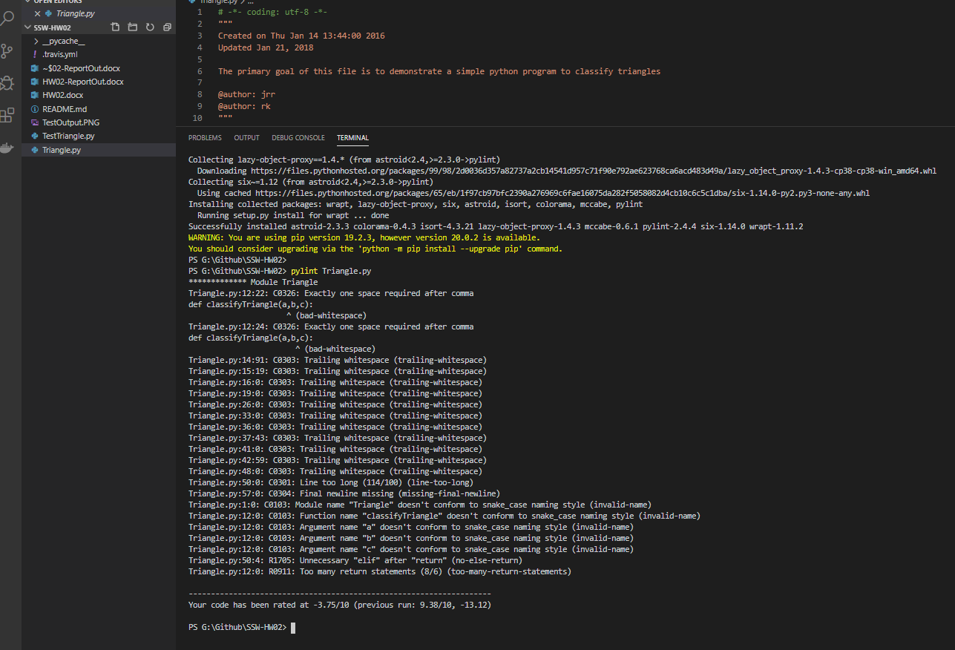

**Coverage Original**

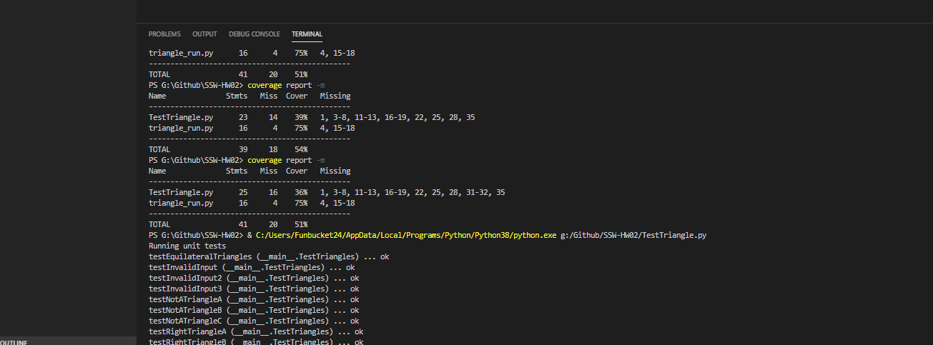

Below are the results after I made my changes and it was very interesting to see how some minor changes helped but it was very easy to use and as I said before these tools will be used in my future projects. I was able to improve to 100% coverage and 5/10 for static analysis.

**PyLint After**

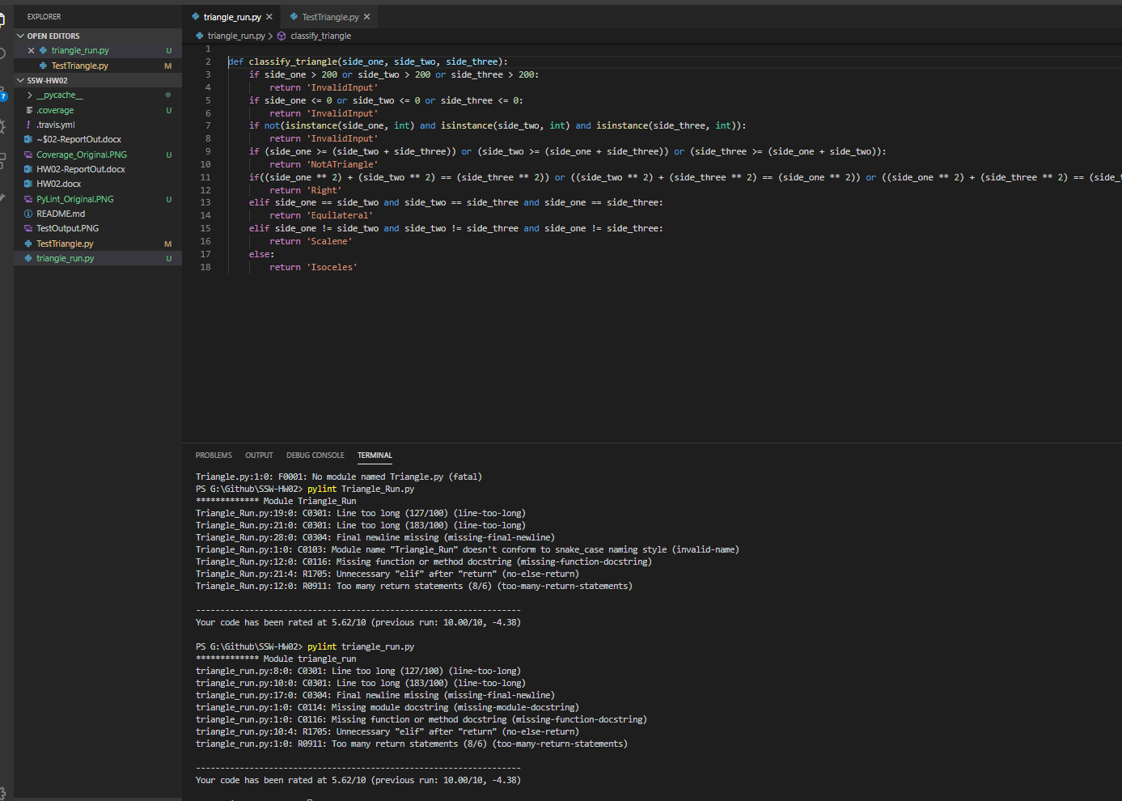

**Coverage After**

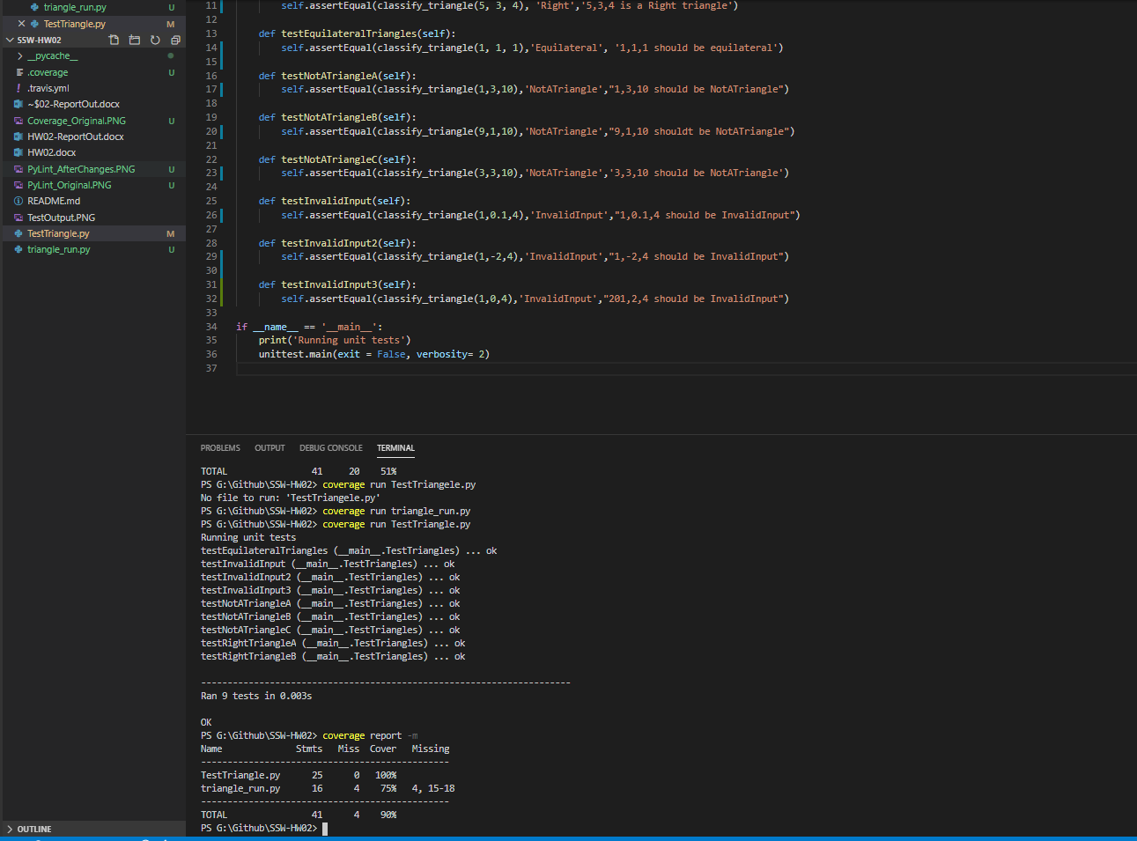

**Honor Pledge:**

I pledge my honor that I have abided by the Stevens Honor System.