**Nama : Fitria Ismanto**

**NPM : 4511210012**

**PEMOGRAMAN 2**

**LAPORAN PERTEMUAN 4**

mvn archetype:create -DgroupId=com.p2.jdbc -DartifactId=belajar-jdbc

package com.p2.jdbc.latihan;

import java.sql.Connection;

import java.sql.DriverManager;

import java.sql.PreparedStatement;

import java.sql.SQLException;

import java.util.logging.Level;

import java.util.logging.Logger;

import java.math.BigDecimal;

public class Main

{

public static void main( String[] args )

{

try{

//paramenter yang dikirim adalah host,port , nama database ,user,password

Connection conn = DriverManager.getConnection("jdbc:mysql://localhost:3306/p2","root","");

String query = "INSERT INTO produk(nama,harga) values (?,"+new BigDecimal(23000)+")";

PreparedStatement ps = conn.prepareStatement(query);

ps.setString(1,"lala");

ps.executeUpdate();

}catch(SQLException se){

Logger.getLogger(Main.class.getName()).log(Level.SEVERE,null,se);

}

}

}

package com.p2.jdbc.latihan;

import java.sql.*;

import java.util.logging.Level;

import java.util.logging.Logger;

import java.math.BigDecimal;

import javax.swing.*;

public class Update

{

public static void main( String[] args )

{

try{

//paramenter yang dikirim adalah host,port , nama database ,user,password

Connection conn = DriverManager.getConnection("jdbc:mysql://localhost:3306/p2","root","");

Statement atm = conn.createStatement();

String query = "UPDATE produk set nama='dipsi' ,harga='4500' WHERE nama='lala'";

int hasil = atm.executeUpdate(query);

if(hasil == 1){

JOptionPane.showMessageDialog(null,"berhasil update");

}

else{

JOptionPane.showMessageDialog(null,"gagal update");

}

}catch(SQLException se){

Logger.getLogger(Main.class.getName()).log(Level.SEVERE,null,se);

}

}

}

PRINT SCREEN

mvn clean package

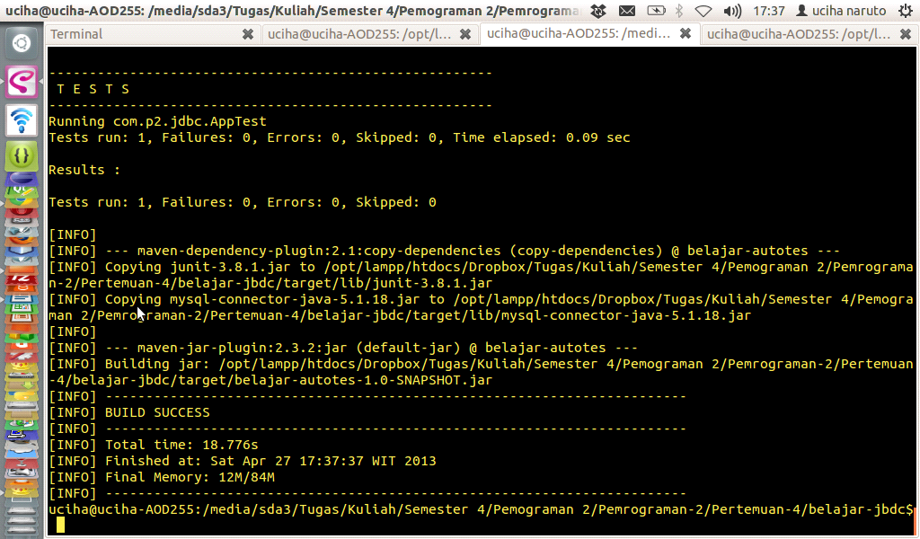

mvn exec:java -Dexec.mainClass=com.p2.jdbc.latihan.Main

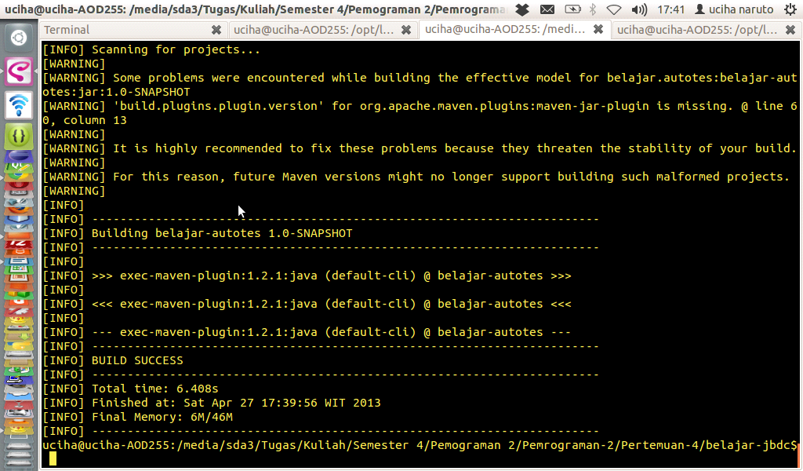

mvn exec:java -Dexec.mainClass=com.p2.jdbc.latihan.Update

create table create table pembelian(

id_brg int PRIMARY KEY,

nama_brg varchar(20) ,

jumlah_brg int,

tgl_beli date,

ket text,

berat_brg decimal );

package com.p2.jdbc.soal;

import java.sql.Connection;

import java.sql.DriverManager;

import java.sql.PreparedStatement;

import java.sql.SQLException;

import java.util.logging.Level;

import java.util.logging.Logger;

import java.math.BigDecimal;

public class Insert

{

public static void main( String[] args )

{

try{

//paramenter yang dikirim adalah host,port , nama database ,user,password

Connection conn = DriverManager.getConnection("jdbc:mysql://localhost:3306/p2","root","");

String query = "INSERT INTO pembelian(id_brg,nama_brg,jumlah_brg,tgl_beli,ket,berat_brg) values ( 1 ,'Java',"+new Integer(5)+",'2012-04-04','baru', 3 )";

PreparedStatement ps = conn.prepareStatement(query);

ps.executeUpdate();

}catch(SQLException se){

Logger.getLogger(Insert.class.getName()).log(Level.SEVERE,null,se);

}

}

}

PRINT SCREEN

mvn clean package

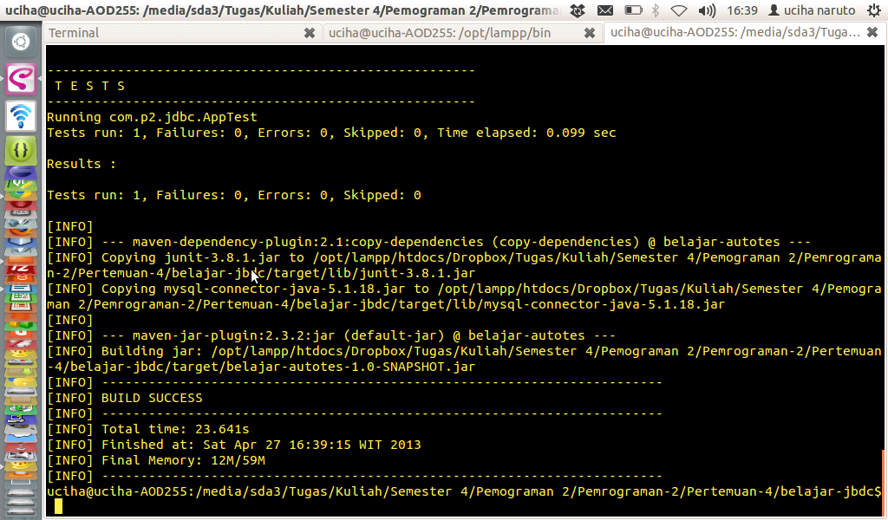

mvn exec:java -Dexec.mainClass=com.p2.jdbc.soal.Insert

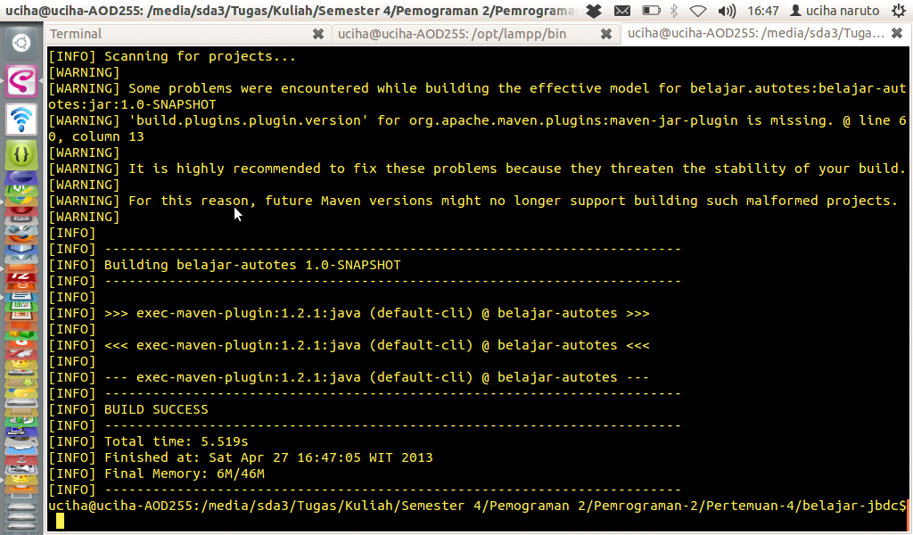

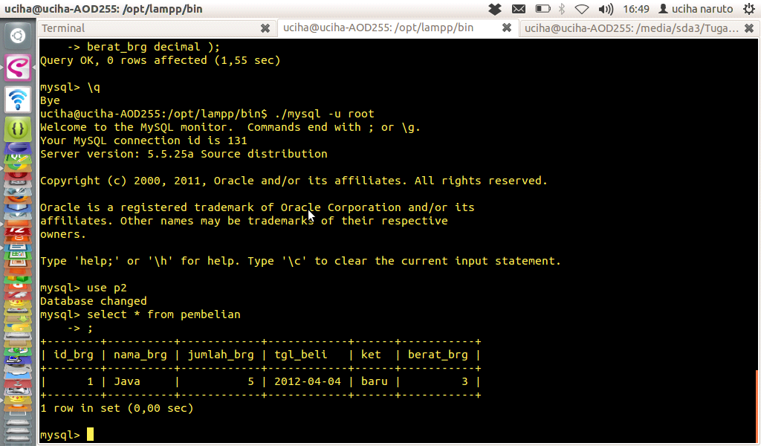

package com.p2.jdbc.soal;

import java.sql.Connection;

import java.sql.DriverManager;

import java.sql.PreparedStatement;

import java.sql.SQLException;

import java.util.logging.Level;

import java.util.logging.Logger;

import java.math.BigDecimal;

public class Update

{

public static void main( String[] args )

{

try{

//paramenter yang dikirim adalah host,port , nama database ,user,password

Connection conn = DriverManager.getConnection("jdbc:mysql://localhost:3306/p2","root","");

String query = "UPDATE pembelian set id_brg=1,nama_brg='Apel',jumlah_brg="+new Integer(3)+",tgl_beli='2012-04-05',ket='bekas',berat_brg=5 where id_brg = 1";

PreparedStatement ps = conn.prepareStatement(query);

int hasil = ps.executeUpdate();

if(hasil == 1){

System.out.println("Berhasil Diupdate");

}

else{

System.out.println("Gagal Diupdate");

}

}catch(SQLException se){

Logger.getLogger(Update.class.getName()).log(Level.SEVERE,null,se);

}

}

}

PRINT SCREEN

mvn exec:java -Dexec.mainClass=com.p2.jdbc.soal.Update

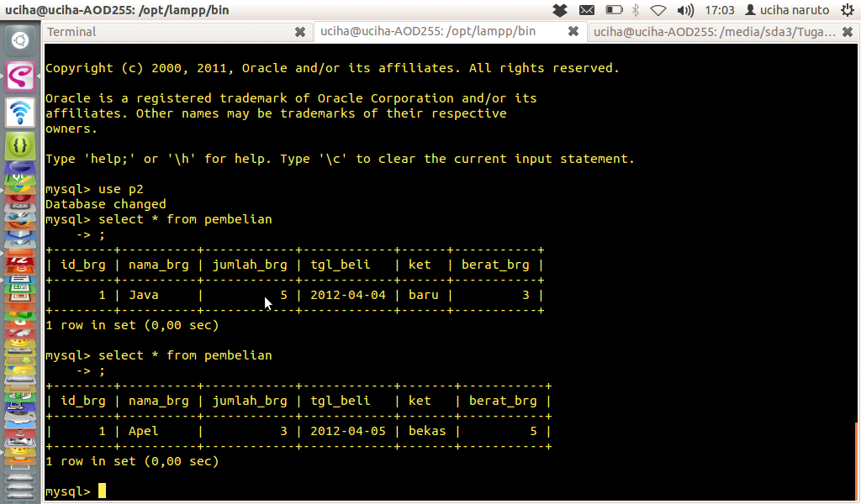

Buat Delete.java difolder soal berisi

*package com.p2.jdbc.soal;*

*import java.sql.Connection;*

*import java.sql.DriverManager;*

*import java.sql.PreparedStatement;*

*import java.sql.SQLException;*

*import java.util.logging.Level;*

*import java.util.logging.Logger;*

*import java.math.BigDecimal;*

*public class Delete*

*{*

*public static void main( String[] args )*

*{*

*try{*

*//paramenter yang dikirim adalah host,port , nama database ,user,password*

*Connection conn = DriverManager.getConnection("jdbc:mysql://localhost:3306/p2","root","");*

*String query = "DELETE from pembelian where id_brg = 1";*

*PreparedStatement ps = conn.prepareStatement(query);*

*int hasil = ps.executeUpdate();*

*if(hasil == 1){*

*System.out.println("Berhasil Didelete");*

*}*

*else{*

*System.out.println("Gagal Didelete");*

*}*

*}catch(SQLException se){*

*Logger.getLogger(Delete.class.getName()).log(Level.SEVERE,null,se);*

*}*

*}*

*}*