**M231 - Pattern Recognition and Machine Learning**

**DUCK-HA HWANG**

**UID#: 404589112**

**Project 0: Experiments on Deep Learning with Cov. Neural Networks**

There are 3 steps for you to do in this project. We will also ask you to run this code again

in later projects for comparison.

We will host a Tutorial Session on Tuesday evening.

1. Download CIFAR-10, and learn a LeNet as described in Table 2 on it. Plot the

training error and testing error against the training iteration.

Problem (1): Answer



2. Keep the Block5, learn a ConvNet only with : a) Block1; b) Block1 and Block2;

c) Block1, Block2 and Block3 respectively. Compare the _nal training errors and

testing errors with LeNet in a table. (Hint: You need to change the _lter size in

Block5 to match the output from previous block.)

Problem2-(a) Answer

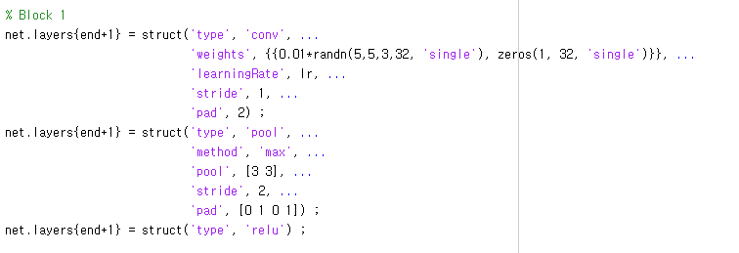

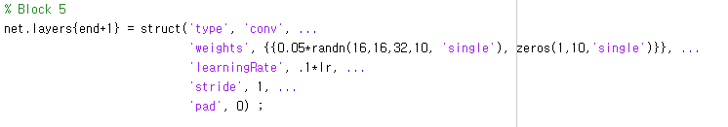

Changed opts.train.learningRate -> (opts.train.learningRate)*1/100

opts.train.learningRate = [0.05*ones(1,15) 0.005*ones(1,10) 0.0005*ones(1,5)] ;

opts.train.learningRate = [0.0005*ones(1,15) 0.00005*ones(1,10) 0.000005*ones(1,5)] ;

It will allow the model to train slowly, as there are too many nodes as an input to final connected layer, convergence is difficult to achieve. Reducing leaning rate will increase the chances of attaining convergence if exists.



Problem2-(b) Answer

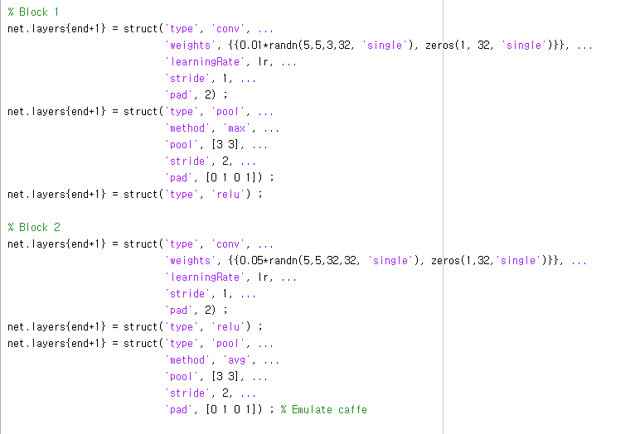

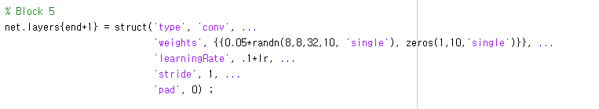



Problem2-(c) Answer

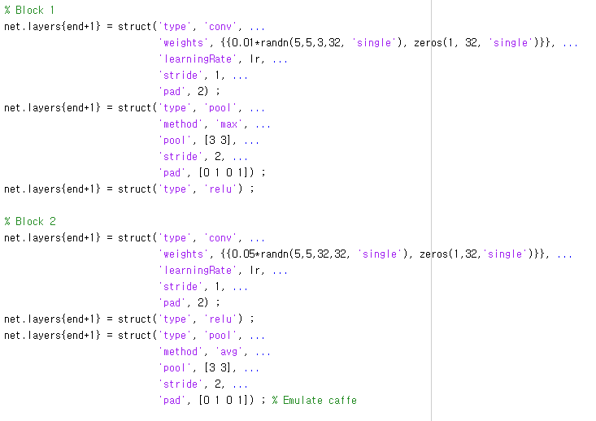

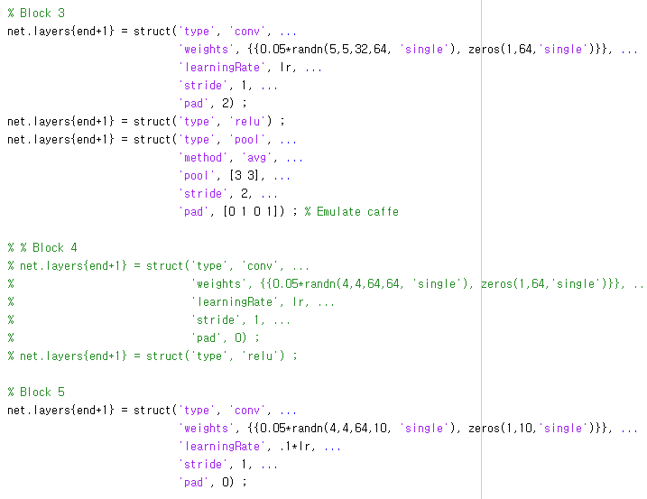



**Problem Compare case (a), (b), (c)**

|  |
| --- |
|  |
|  |
|  |

Analysis:

Using every Block (1, 2, 3, 4, 5) show the best result. (Converges to 0.2 error rate)

(a) Case converge to 0.63 error rate

(b) Case converge to 0.45 error rate

(c) Case converges to 0.35 error rate.

3. Filter response visualization. Figure 4 displays the visualization of filter responses computed by 32 filters in the first layer. The first color image is the input image, and the rest of 32 heat images are the corresponding filter response maps. The directory of ./code/examples/images/ contains 10 images from each category. For each image, visualize the filter response maps of 32 filters in the first layer. (Hint: For each image, you need to preprocess it by subtracting the mean image of CIFAR-10. The mean image is saved in net.averageImage. You can use res = vl_simplenn (net, image) to compute filter responses, and all filter responses computed by the first layer filters are saved in res(2).x)

Problem3-Answer

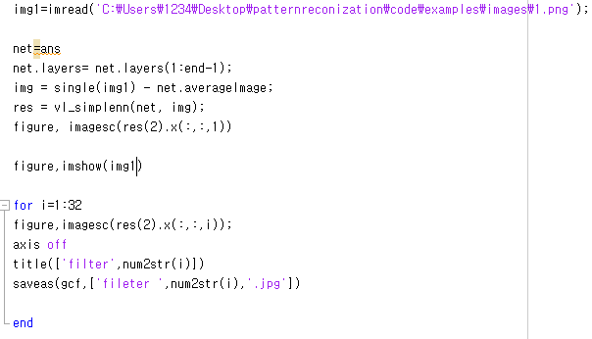

Original image_1

1.png

Each filter:

|  |  |  |  |  |  |  |  |  |  |
| --- | --- | --- | --- | --- | --- | --- | --- | --- | --- |
| fileter 1.jpg | fileter 2.jpg | fileter 3.jpg | fileter 4.jpg | fileter 5.jpg | fileter 6.jpg | fileter 7.jpg | fileter 8.jpg | fileter 9.jpg | fileter 10.jpg |
| fileter 11.jpg | fileter 12.jpg | fileter 13.jpg | fileter 14.jpg | fileter 15.jpg | fileter 16.jpg | fileter 17.jpg | fileter 18.jpg | fileter 19.jpg | fileter 20.jpg |
| fileter 21.jpg | fileter 22.jpg | fileter 23.jpg | fileter 24.jpg | fileter 25.jpg | fileter 26.jpg | fileter 27.jpg | fileter 28.jpg | fileter 29.jpg | fileter 30.jpg |
| fileter 31.jpg | fileter 32.jpg |  |  |  |  |  |  |  |  |

Original image_2

2.png

Each filter:

|  |  |  |  |  |  |  |  |  |  |
| --- | --- | --- | --- | --- | --- | --- | --- | --- | --- |
| fileter 1.jpg | fileter 2.jpg | fileter 3.jpg | fileter 4.jpg | fileter 5.jpg | fileter 6.jpg | fileter 7.jpg | fileter 8.jpg | fileter 9.jpg | fileter 10.jpg |
| fileter 11.jpg | fileter 12.jpg | fileter 13.jpg | fileter 14.jpg | fileter 15.jpg | fileter 16.jpg | fileter 17.jpg | fileter 18.jpg | fileter 19.jpg | fileter 20.jpg |
| fileter 21.jpg | fileter 22.jpg | fileter 23.jpg | fileter 24.jpg | fileter 25.jpg | fileter 26.jpg | fileter 27.jpg | fileter 28.jpg | fileter 29.jpg | fileter 30.jpg |
| fileter 31.jpg | fileter 32.jpg |  |  |  |  |  |  |  |  |

Original image_3

3.png

Each filter:

|  |  |  |  |  |  |  |  |  |  |
| --- | --- | --- | --- | --- | --- | --- | --- | --- | --- |
| fileter 1.jpg | fileter 2.jpg | fileter 3.jpg | fileter 4.jpg | fileter 5.jpg | fileter 6.jpg | fileter 7.jpg | fileter 8.jpg | fileter 9.jpg | fileter 10.jpg |
| fileter 11.jpg | fileter 12.jpg | fileter 13.jpg | fileter 14.jpg | fileter 15.jpg | fileter 16.jpg | fileter 17.jpg | fileter 18.jpg | fileter 19.jpg | fileter 20.jpg |
| fileter 21.jpg | fileter 22.jpg | fileter 23.jpg | fileter 24.jpg | fileter 25.jpg | fileter 26.jpg | fileter 27.jpg | fileter 28.jpg | fileter 29.jpg | fileter 30.jpg |
| fileter 31.jpg | fileter 32.jpg |  |  |  |  |  |  |  |  |

Original image_4

4.png

Each filter:

|  |  |  |  |  |  |  |  |  |  |
| --- | --- | --- | --- | --- | --- | --- | --- | --- | --- |
| fileter 1.jpg | fileter 2.jpg | fileter 3.jpg | fileter 4.jpg | fileter 5.jpg | fileter 6.jpg | fileter 7.jpg | fileter 8.jpg | fileter 9.jpg | fileter 10.jpg |
| fileter 11.jpg | fileter 12.jpg | fileter 13.jpg | fileter 14.jpg | fileter 15.jpg | fileter 16.jpg | fileter 17.jpg | fileter 18.jpg | fileter 19.jpg | fileter 20.jpg |
| fileter 21.jpg | fileter 22.jpg | fileter 23.jpg | fileter 24.jpg | fileter 25.jpg | fileter 26.jpg | fileter 27.jpg | fileter 28.jpg | fileter 29.jpg | fileter 30.jpg |
| fileter 31.jpg | fileter 32.jpg |  |  |  |  |  |  |  |  |

Original image_5

5.png

Each filter:

|  |  |  |  |  |  |  |  |  |  |
| --- | --- | --- | --- | --- | --- | --- | --- | --- | --- |
| fileter 1.jpg | fileter 2.jpg | fileter 3.jpg | fileter 4.jpg | fileter 5.jpg | fileter 6.jpg | fileter 7.jpg | fileter 8.jpg | fileter 9.jpg | fileter 10.jpg |
| fileter 11.jpg | fileter 12.jpg | fileter 13.jpg | fileter 14.jpg | fileter 15.jpg | fileter 16.jpg | fileter 17.jpg | fileter 18.jpg | fileter 19.jpg | fileter 20.jpg |
| fileter 21.jpg | fileter 22.jpg | fileter 23.jpg | fileter 24.jpg | fileter 25.jpg | fileter 26.jpg | fileter 27.jpg | fileter 28.jpg | fileter 29.jpg | fileter 30.jpg |
| fileter 31.jpg | fileter 32.jpg |  |  |  |  |  |  |  |  |

Original image_6

6.png

Each filter:

|  |  |  |  |  |  |  |  |  |  |
| --- | --- | --- | --- | --- | --- | --- | --- | --- | --- |
| fileter 1.jpg | fileter 2.jpg | fileter 3.jpg | fileter 4.jpg | fileter 5.jpg | fileter 6.jpg | fileter 7.jpg | fileter 8.jpg | fileter 9.jpg | fileter 10.jpg |
| fileter 11.jpg | fileter 12.jpg | fileter 13.jpg | fileter 14.jpg | fileter 15.jpg | fileter 16.jpg | fileter 17.jpg | fileter 18.jpg | fileter 19.jpg | fileter 20.jpg |
| fileter 21.jpg | fileter 22.jpg | fileter 23.jpg | fileter 24.jpg | fileter 25.jpg | fileter 26.jpg | fileter 27.jpg | fileter 28.jpg | fileter 29.jpg | fileter 30.jpg |
| fileter 31.jpg | fileter 32.jpg |  |  |  |  |  |  |  |  |

Original image_7

7.png

|  |  |  |  |  |  |  |  |  |  |
| --- | --- | --- | --- | --- | --- | --- | --- | --- | --- |
| fileter 1.jpg | fileter 2.jpg | fileter 3.jpg | fileter 4.jpg | fileter 5.jpg | fileter 6.jpg | fileter 7.jpg | fileter 8.jpg | fileter 9.jpg | fileter 10.jpg |
| fileter 11.jpg | fileter 12.jpg | fileter 13.jpg | fileter 14.jpg | fileter 15.jpg | fileter 16.jpg | fileter 17.jpg | fileter 18.jpg | fileter 19.jpg | fileter 20.jpg |
| fileter 21.jpg | fileter 22.jpg | fileter 23.jpg | fileter 24.jpg | fileter 25.jpg | fileter 26.jpg | fileter 27.jpg | fileter 28.jpg | fileter 29.jpg | fileter 30.jpg |
| fileter 31.jpg | fileter 32.jpg |  |  |  |  |  |  |  |  |

Original image_8

8.png

Each filter:

|  |  |  |  |  |  |  |  |  |  |
| --- | --- | --- | --- | --- | --- | --- | --- | --- | --- |
| fileter 1.jpg | fileter 2.jpg | fileter 3.jpg | fileter 4.jpg | fileter 5.jpg | fileter 6.jpg | fileter 7.jpg | fileter 8.jpg | fileter 9.jpg | fileter 10.jpg |
| fileter 11.jpg | fileter 12.jpg | fileter 13.jpg | fileter 14.jpg | fileter 15.jpg | fileter 16.jpg | fileter 17.jpg | fileter 18.jpg | fileter 19.jpg | fileter 20.jpg |
| fileter 21.jpg | fileter 22.jpg | fileter 23.jpg | fileter 24.jpg | fileter 25.jpg | fileter 26.jpg | fileter 27.jpg | fileter 28.jpg | fileter 29.jpg | fileter 30.jpg |
| fileter 31.jpg | fileter 32.jpg |  |  |  |  |  |  |  |  |

Original image_9

9.png

Each filter:

|  |  |  |  |  |  |  |  |  |  |
| --- | --- | --- | --- | --- | --- | --- | --- | --- | --- |
| fileter 1.jpg | fileter 2.jpg | fileter 3.jpg | fileter 4.jpg | fileter 5.jpg | fileter 6.jpg | fileter 7.jpg | fileter 8.jpg | fileter 9.jpg | fileter 10.jpg |
| fileter 11.jpg | fileter 12.jpg | fileter 13.jpg | fileter 14.jpg | fileter 15.jpg | fileter 16.jpg | fileter 17.jpg | fileter 18.jpg | fileter 19.jpg | fileter 20.jpg |
| fileter 21.jpg | fileter 22.jpg | fileter 23.jpg | fileter 24.jpg | fileter 25.jpg | fileter 26.jpg | fileter 27.jpg | fileter 28.jpg | fileter 29.jpg | fileter 30.jpg |
| fileter 31.jpg | fileter 32.jpg |  |  |  |  |  |  |  |  |

Original image_10

10.png

Each filter:

|  |  |  |  |  |  |  |  |  |  |
| --- | --- | --- | --- | --- | --- | --- | --- | --- | --- |
| fileter 1.jpg | fileter 2.jpg | fileter 3.jpg | fileter 4.jpg | fileter 5.jpg | fileter 6.jpg | fileter 7.jpg | fileter 8.jpg | fileter 9.jpg | fileter 10.jpg |
| fileter 11.jpg | fileter 12.jpg | fileter 13.jpg | fileter 14.jpg | fileter 15.jpg | fileter 16.jpg | fileter 17.jpg | fileter 18.jpg | fileter 19.jpg | fileter 20.jpg |
| fileter 21.jpg | fileter 22.jpg | fileter 23.jpg | fileter 24.jpg | fileter 25.jpg | fileter 26.jpg | fileter 27.jpg | fileter 28.jpg | fileter 29.jpg | fileter 30.jpg |
| fileter 31.jpg | fileter 32.jpg |  |  |  |  |  |  |  |  |