Query:

SELECT o.orderNumber,

o.orderDate,

c.customerName,

c.city,

c.country,

od.quantityOrdered,

p.productName

FROM orders o

JOIN customers c ON o.customerNumber = c.customerNumber

JOIN orderdetails od ON o.orderNumber = od.orderNumber

JOIN products p ON od.productCode = p.productCode

WHERE p.productName = '1992 Ferrari 360 Spider red'

AND o.orderDate BETWEEN '2004-08-01' AND '2004-12-01'

Result:

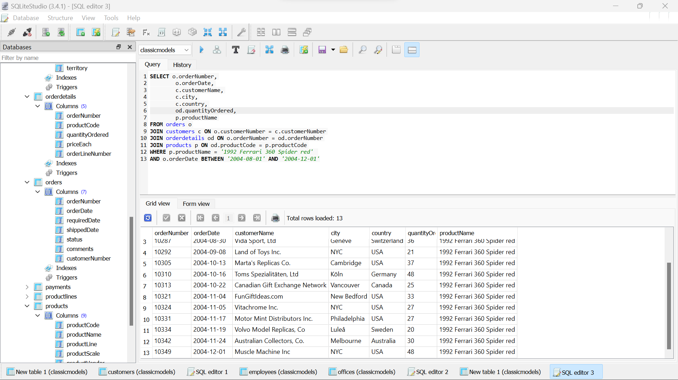

Screenshot:

