**Addis Ababa University (ITSC)**

**Software Design Specification for Restaurant Locator**

**Submitted To: Mr.Lisanu**

**Group Members:-**

1. **Nathnael Moges**
2. **Henok Fassil**
3. **Dagmawi Tsegaye**
4. **Betelehem Dejene**
5. **Robel Debebe**

**Class Diagram**

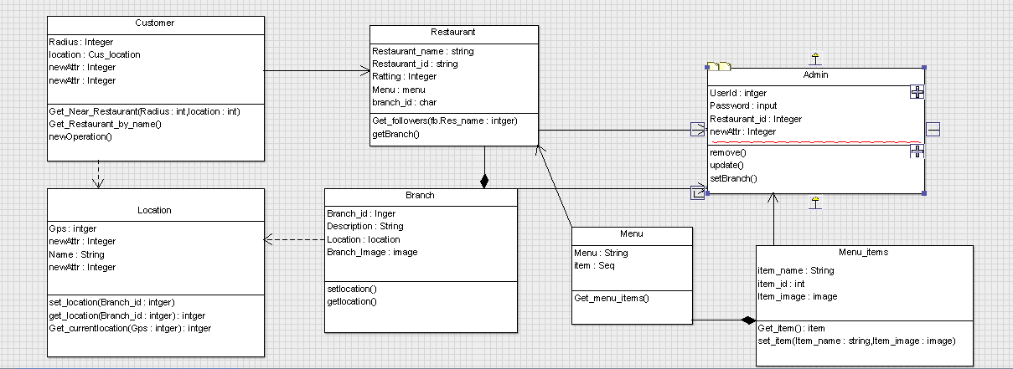

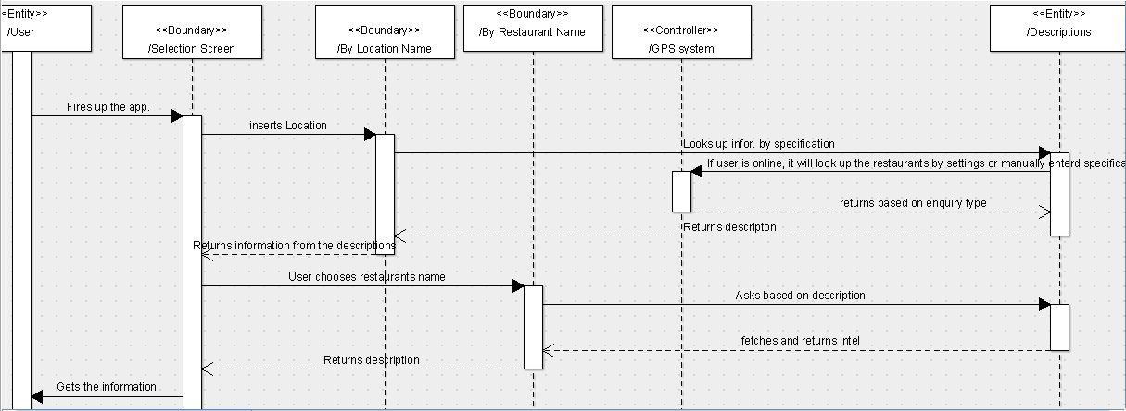**User side Sequence Diagram**

**User Search by current location**

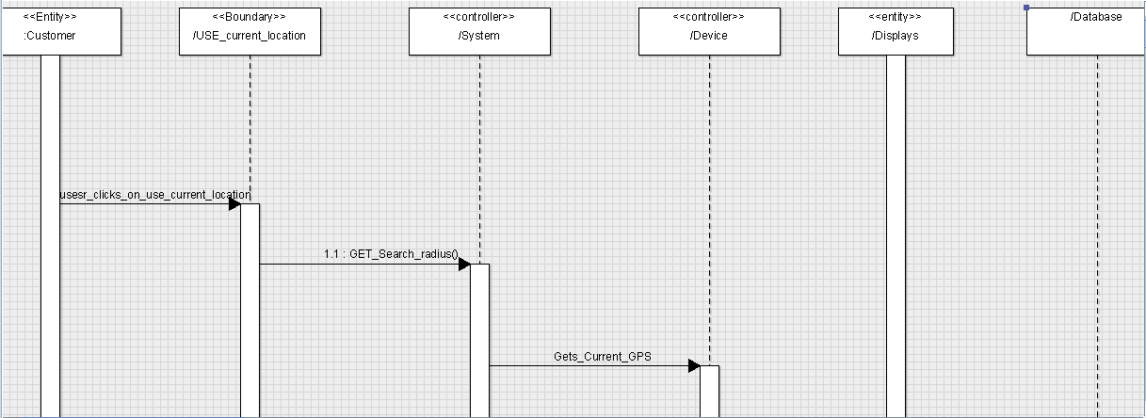

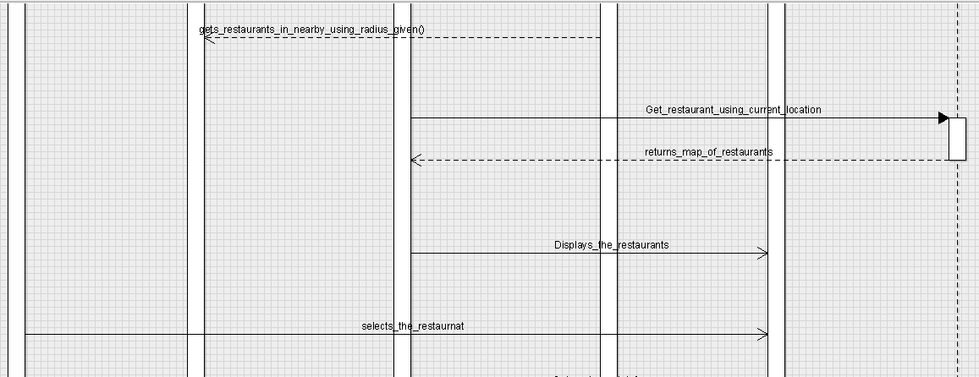

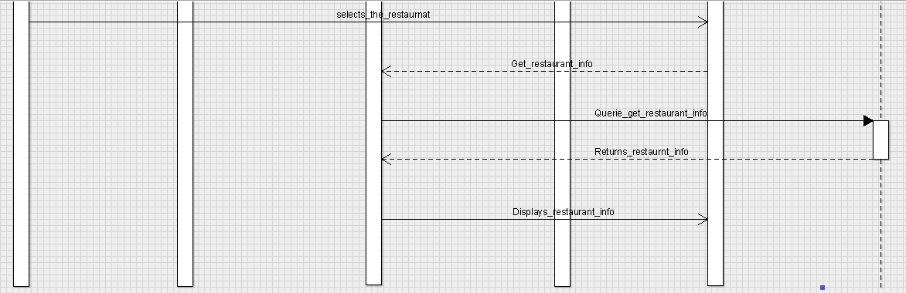

**Admin Adds Menu**

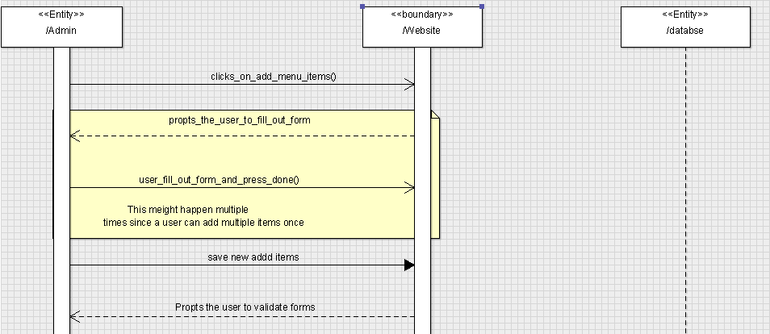

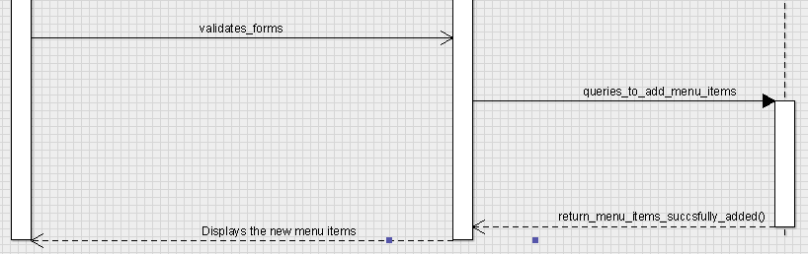

**Admin Edits Menu**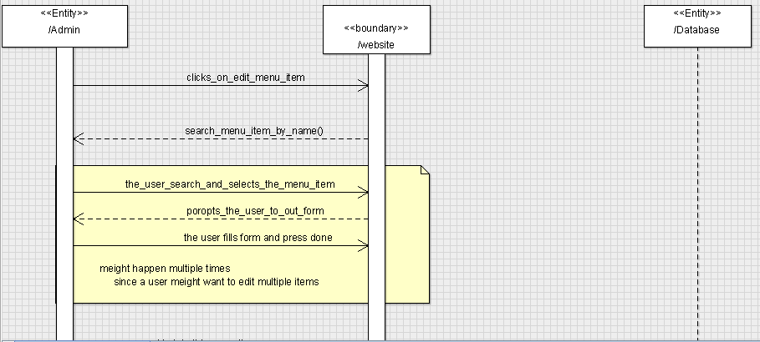

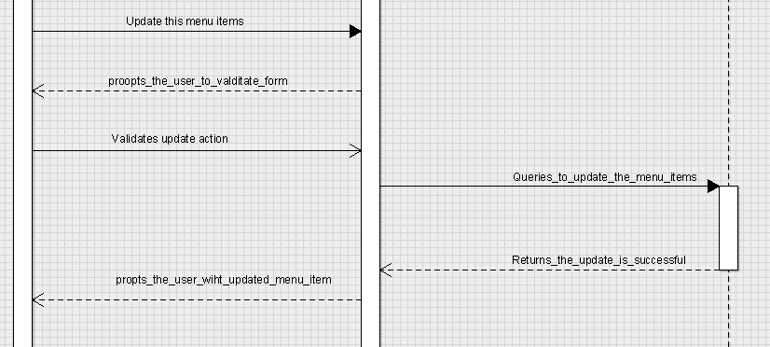

**User Search By Restaurant name**

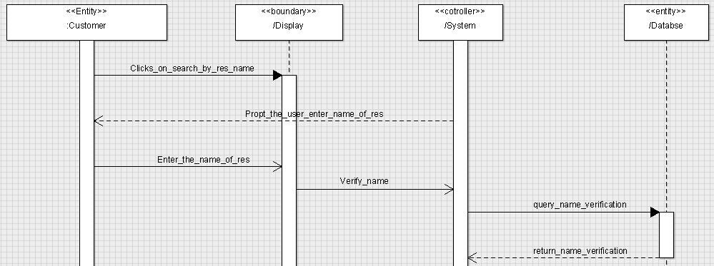

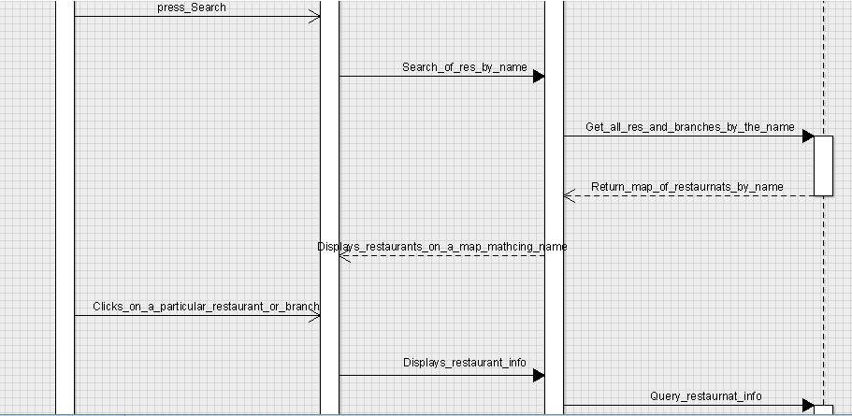

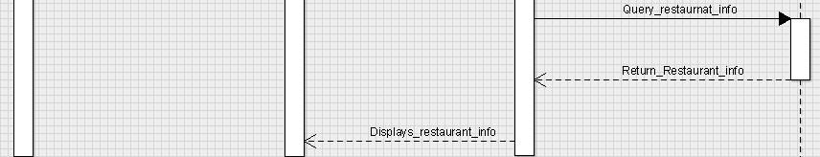

**Admin Login**

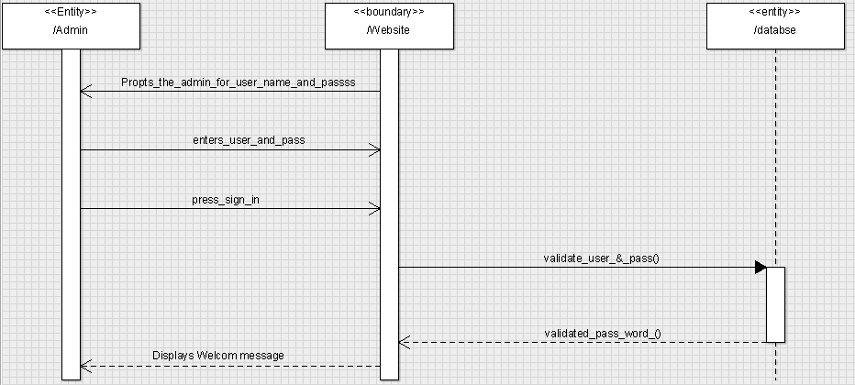

**Admin adds Branch**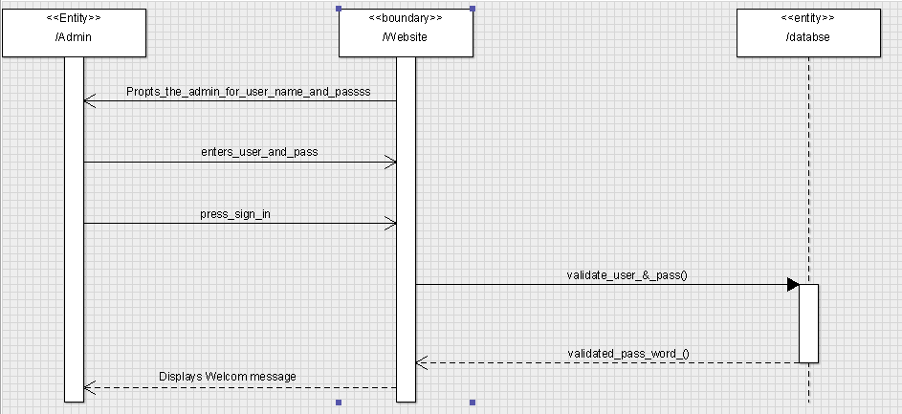

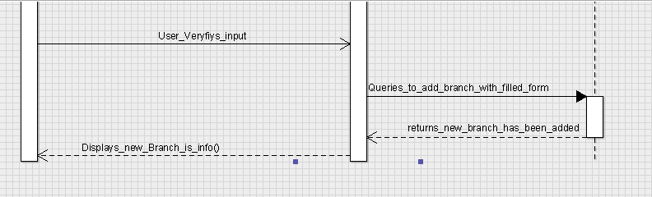

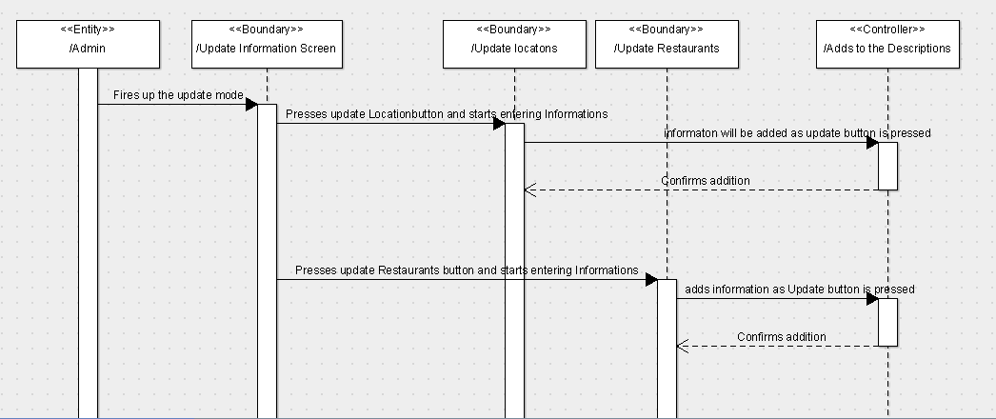**Admin Side Sequence Diagram**

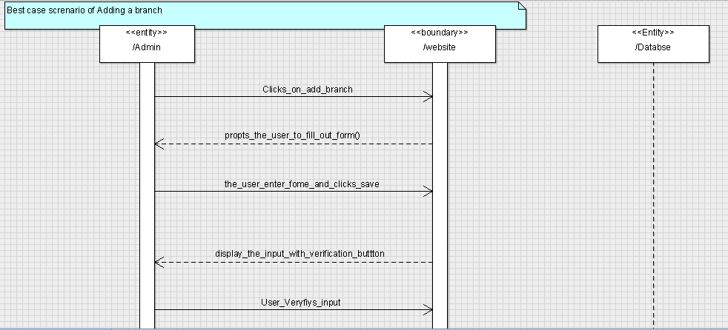

**Admin Edit Branch**

