
Software Design Specification
R I T

For

InserterVision Report System
Release 1.0
Revision 2.0
by VDK-RIT
5/19/2004

Revision History

Name | Date | Reason for Change | Version
Greg Dicheck | 2/9/2004 | Initial draft | Draft 1
Greg Dicheck | 3/3/2004 | Added use case descriptions and logical views | Draft 2
Greg Dicheck | 3/14/2004 | Added database structures | Draft 3
Greg Dicheck | 3/22/2004 | Added UI prototypes | Draft 4
Greg Dicheck | 3/27/2004 | Updated UI prototypes and database structures | Draft 5
Greg Dicheck | 3/28/2004 | Updated database structures;  Added deployment and data flow diagrams  Added size/performance and quality criteria | Draft 6
Greg Dicheck | 3/28/2004 | Updated database structures;  Added deployment and data flow diagrams  Added size/performance and quality criteria | Draft 6
Adam Beck | 3/30/2004 | Revise structure and content | Revision 1
Adam Beck | 4/23/2004 | Revise structure and content per alpha and Beta | Revision 1.1
Adam Beck | 5/19/2004 | Revise structure and content per gamma | Revision 2.0

Table of Contents
1. Introduction 4
1.1 Purpose 4
1.2 Scope 4
1.3 Intended Audience 4
1.4 References 4
1.5 Definitions, Acronyms, and Abbreviations 4
2. System Overview 5
2.1 System Context Diagram 6
3. Design Considerations 6
3.1 Assumptions and Dependencies 6
3.2 General Constraints 6
3.3 Goals and Guidelines 6
3.4 Development Methods 7
4. Architectural Strategies 7
5. System Architecture 9
5.1 Primary Components 9
5.1.1 System High Level Collaboration Diagrams 9
5.1.1.1 Login/Authentication 9
5.1.1.2 Data Management and Display 10
5.1.1.3 Auxiliary Functionality 11
6. Detailed System Design 13
6.1 Subsystem Architecture 13
6.2 Detailed Subsystem Design 13
6.2.1 Diagram Legend 13
6.2.2 High Level Classes 14
6.2.3 Page Interaction Diagram 15
6.2.4 Displayable Pages 16
6.2.5 Data Set 17
6.2.6 Data Set creation Interaction Diagram 18
6.2.7 Template 19
6.2.8 Template Editors 21
6.2.9 Editor Data Flow Diagram 22
6.2.10 DBHandler 22
6.2.11 Authentication 23
6.2.12 IDMaker 23
6.2.13 Other Important Files 23
6.2.14 MySQL database 23
6.3 Features Not Included 24
6.4 Features Wished to be Included 24
6.5 Deployment View 25
6.6 Original User Interface Prototype Pages 26
6.6.1 Login/Authentication 26
6.6.2 Logout 26
6.6.3 Data Sets 26
6.6.4 View Report 27
6.6.5 Templates 28
6.6.6 Template Editors 28
7. Appendix 31
7.1 Glossary 31
7.2 Data Dictionary 32
7.3 MySQL Schema 32
7.4 Directory Structure 35
7.5 PHPDocs 36

Introduction

Purpose
This document will outline in detail the software architecture and design for the InserterVision Report System (IVRS). This document will provide several views of the system's design in order to facilitate communication and understanding of the system. It intends to capture and convey the significant architectural and design decisions that have been made for the IVRS.

Scope
This document provides the architecture and design of Release 1.0 of the IVRS. It will show how the design will accomplish the functional and non-functional requirements detailed in the VDK-RIT Software Requirements Specification (SRS) document.

Intended Audience

This document is written on a technical level to address the technical department of the customer that will continue the system after VDK-RIT and the team's technical management.

References

- VDK-RIT Software Requirements Specification (SRS) Revision 1.2
- VDK-RIT Use Case Document (UCD) Revision 1.1
- VDK-RIT Vision and Scope Document Revision 1.0

Definitions, Acronyms, and Abbreviations

- DBMS – Database Management System. A programmable interface which provides a common layer of abstraction between a physical database and a user or external program.
- HTML – Hypertext Markup Language. Set of markup symbols or codes intended for display on a World Wide Web browser page. The markup instructs a web browser on how to display words and images for a web page.
- IVRS - InserterVision Report System
- PHP – Hypertext Preprocessor. An extensible scripting language, suited for web-based development, typically embedded in HTML.

System Overview

The project is a low cost management and reporting system accessible over a network to be built for Videk, a local Rochester company. Videk has proposed a product that can accompany their existing commercial product, called InserterVision. InserterVision is a camera based scanning system for recording and monitoring machinery that automatically stuffs envelopes and seals envelopes for mass mailings. Videk supplies the camera equipment and software to accomplish this. Videk's software provides control of current jobs but has no recording or display of past jobs. A job is all the mailings done on one machine in one session. The product that Videk wants us to develop is a low cost software/hardware system to provide this capability in a stand-alone application.

The scope of the project is to make a client-server architecture for one to thirty users who can access, format and print reports with data collected from the Videk camera scanning equipment for completed jobs. Videk will develop and provide the interface for populating the IVRS's Database Management System (DBMS) from the Camera System. The IVRS to be developed by VDK-RIT, the RIT team developing this reporting system, will provide a controlled and user friendly interface to this data from any PC within the internal network of Videk's customer. In order to provide an intelligent low-cost system, open source licensed components and tools will be considered preferable. This initial version of the IVRS is meant to be deployed with the InserterVision software. The IVRS designed by VDK-RIT will be implemented as a functional proof of concept and be turned over to Videk for deployment and further development.

Customers of Videk that purchase InserterVision have their mailing jobs scanned by the hardware/software package. IVRS is to be a stand-alone application deployed in conjunction with this package to supply reporting, sorting and data management of the data sets of completed mailing jobs. The Context diagram (2.1) illustrates the external entities and system interfaces for release 1.0.

System Context Diagram

Report
System
User Web Browser
User Web Browser
DBMS
Login
Data Request
Sort Data
Formatted Data in Web Page
Formatted Data in Web Page
Manager Web Browser
Delete Data Set(s)
InserterVision
Camera
System
Data Set(s)
Data
Request Data
Delete Data Set(s)
File
System
Export Data Set(s)
Exported
Data
in Export
Format
Sys Admin
Web Browser
User Management
Formatted Data in Web Page

Design Considerations

Assumptions and Dependencies

See VDK-RIT Software Requirements Specification Revision 1.2 Section 2.8 for details.

General Constraints

See VDK-RIT Software Requirements Specification Revision 1.2 Section 2.6 for details.

Goals and Guidelines

- Emphasis shall be placed on Usability as the User Interface will be used by users without much training.
- The design must reflect the quality of Modifiability as the customer, Videk, must be able to adapt it for various uses by the final end users, Videk's customers.
- The system must be fully functional, tested and deployable within the scheduled time frame.
- The system must be able to be modified by the user to display the target data in various reports for various purposes.

Development Methods

This project is being conducted using a modified waterfall paradigm with three implemental builds (alpha, beta, gamma). The development process is formal with document and code reviews.

Architectural Strategies

The architecture and design has been influenced by the following design decisions and strategies:
- The design shall use Object Oriented Principles (OOP). The trade-off of increased code overhead and object message passing is considered justified by the gain of modularization of functionality, data encapsulation, communication through interfaces and re-use through polymorphism. In addition, the entire team is familiar with this paradigm and a design of this type will facilitate communication amongst the developers.
- Entry points for PHP script activation will be standard PHP code constructs but will immediately transition to OOP PHP functions. This is the compromise in a language that is still transitioning to full OOP functionality.
- The overall system is designed upon a client-server approach. This is an established and well-understood architecture and presents no problems to the team.
- Authentication will be limited to password checking on initial login and a session ID subsequently. This is considered sufficient to the low risk nature of the data.
- The primary purpose of the system is the formatted and filtered dissemination of data captured by the Videk Camera System stored in the DBMS. Formatting and filtering of this data is by the use of Templates, both pre-defined and user created, Editors will be provided for the creation and modification of these Templates to provide the necessary modifiability and the interfaces to these editors will be as intuitive as possible. Advanced Templates with the most open -ended functionality will be kept separate from the more limited and easier to learn Standard and Combined Templates. This separation of functionality and intuitive interface will help provide the necessary Usability.
- The DBMS will be shared by the system and Videk's Camera System that populates it. There is no direct interface between these systems so concurrency will be handled by the built-in functions in MySQL. It will be necessary to not lock the database in such a way that the camera system cannot populate it.
- Details of sessions, Templates, User accounts and the data from the camera system will reside in the DBMS. Access to this data will be easier and more secure than creating files on file system.
- Subsequent to login, all external contacts from the users will be directed to the IVRS.php file. This entry point creates an appropriate session object, of class VDKSession, which will handle the requests of the user. VDKSession.php will act as a facade to the user and a mediator to the system for the life of each request. The VDKSession will also limit the life of the contact for users that exceed a time limit with no activity. This is a standard housekeeping and security measure.
- Communication with the users will be by the HTML protocol as this is well-supported by the selected browsers and PHP.
- PHP and MySQL were selected because they had the necessary capabilities to provide the needed services to the user and their GNU licenses will reduce product cost.
- The team decided to not use PHP's built in session functions but to provide our own for increased flexibility.
- The system is meant to be modifiable:
  - By the use of new pre-defined templates created by Videk as well as the end-customer.
  - By having the system adapt to additional fields added by Videk to the database schema to established tables defined by VDK_RIT team only.
  - By changes in functionality through code modification and replacement by Videk.

System Architecture

Primary Components

System High Level Collaboration Diagrams

Login/Authentication
Controller
Timer
DBMS Interface
<< external interface>>
Client
Interface
<< external interface>>
<< controller>>
Commands
Display
Authorization Request
Create Session
Display Data
Requests
<<service>>
User Account
<<entity>>
Get Permissions
Query Account Info
Create
Set Timeout
Session
<< state dependent>>

Client Interface: The browser in use by the user.

Controller: The initial point of contact for browser requests prior to Log-in.

Session: The point of contact for all browser requests for users that are logged-in and authenticated.

User Account: Contains data retrieved from the DBMS specifying the user's access level and permissions.

Timer: System object attached to a session to determine if a user has been inactive long enough to be logged off the system.

DBMS Interface: Retrieves/Stores data in the system from/to the DBMS.

Data Management and Display

Create Data Set
File System Interface
Controller
Timer
Report
Generation
Template
Data Set
DBMS Interface
DB Schema
Get Schema
Retrieve data
Retrieve format
<< external interface>>
<< external interface>>
Client
Interface
<< external interface>>
<< controller>>
Commands
Display
Authorization Request
Create Session
Create Display
Display
Display Data
Requests
Session
<< state dependent>>
<< service>>
<<entity>>
<<entity>>
<<entity>>
<<service>>
Sort
Criteria
<<entity>>
Query Data Set List
Get Keys
Set Keys
User Account
<<entity>>
Get Permissions
Query Account Info
Create
Template
Editor
<<service>>
Give access to Sessions
Create/Modify/
Delete
Import/Delete
Data Sets
Import/Export
Data Sets
Set Timeout
Controller: Mediates communication between the sub-systems.

Template: Pre-defined format and order and filtering to apply to a Data Set. Template information is stored in the DBMS.

Sort Criteria: Multiple Sort criteria used to re-order the records in the Data Set.

Data Set: Retrieved data from the DBMS encompassing the results of one or more DBMS Data Sets.

Report Generation: Brings together the Data Set, Template and Sort Criteria and generate a formatted Report in a web page.

Template Editor: Service to create and modify Templates.

DB Schema: Schema of table and field layout in the DBMS.

File System: Computer file system for alternate storage of Data Sets.

Auxiliary Functionality

File System Interface
Controller
Timer
Report
Generation
Template
Data Set
DBMS Interface
DB Schema
Retrieve Help
Get Schema
Retrieve data
Create Data Set
Retrieve format
<< external interface>>
<< external interface>>
Client
Interface
<< external interface>>
<< controller>>
Commands
Display
Authorization Request
Create Session
Create Display
Display
Display Data
Requests
Session
<< state dependent>>
<< service>>
<<entity>>
<<entity>>
<<entity>>
Help
<<service>>
<<service>>
Sort
Criteria
<<entity>>
Query Data Set List
Get Keys
Set Keys
User Account
<<entity>>
Get Permissions
Query Account Info
Create
<<service>>
Give access to Sessions
Create/Modify/
Delete
Import/Delete
Data Sets
Import/Export
Data Sets
Get
text
Logger
<<service>>
Log Events
Record Events
Set Timeout
Template
Editor

Controller: Tasked with creation of logical components and mediation of communication between them.

File System: Storage of help pages and System Log.

Help: Tasked with creation of help pages when requested. Information is stored in the File System.

Logger: Tasked with maintaining a System Log of system user actions on the File System.

Detailed System Design

Subsystem Architecture

Detailed Subsystem Design

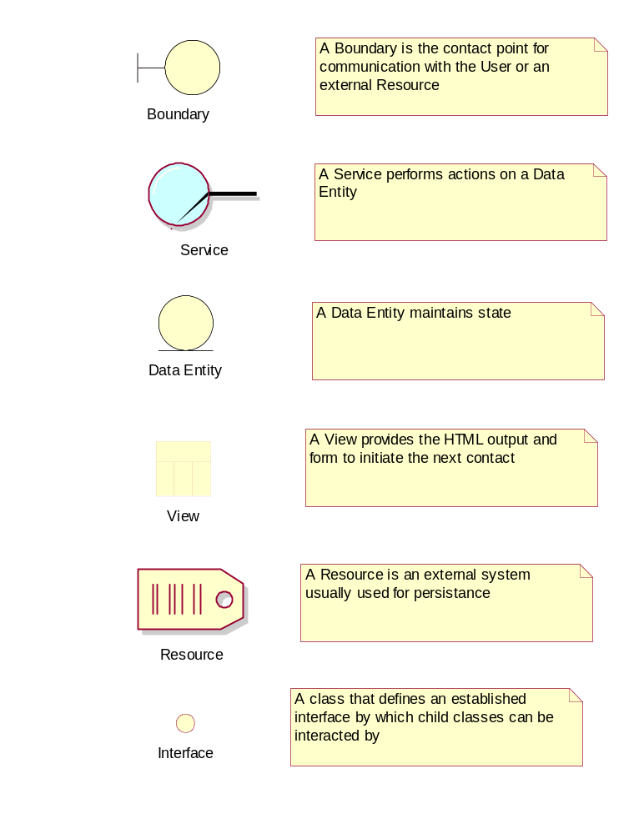
Diagram Legend

High Level Classes
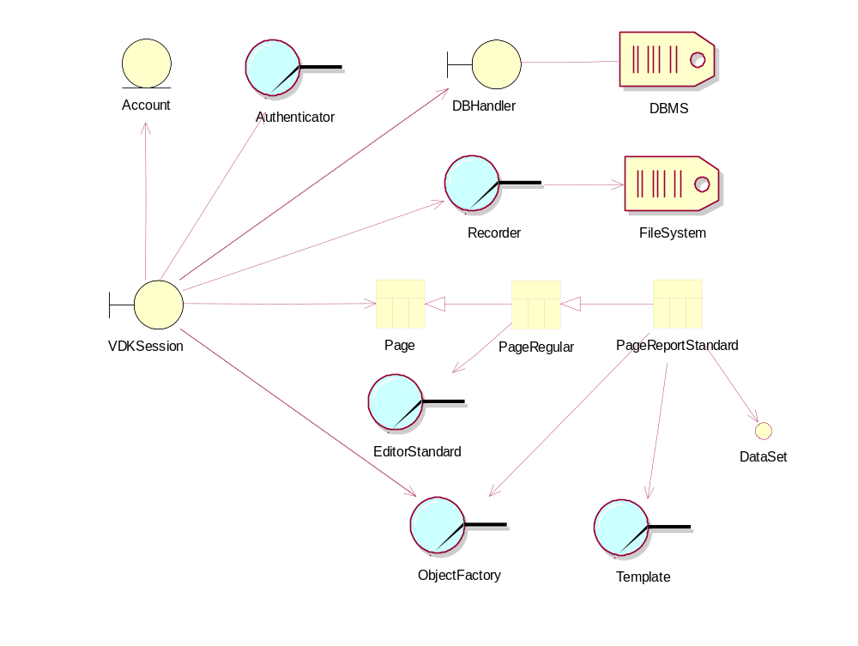

The IVRS.php contact point creates a VDKSession object. This object creates a Login object that accomplishes the authentication, and if successful, creates a record in the DBMS for this session with a unique session key. Subsequent browser contacts will be to the IVRS contact points which will instantiate the VDKSession object which returns itself to a valid state from the information in the DBMS for this session, accessed via the session key.

The VDKSession object acts as a mediator between the Pages and the resources it has created (e.g. the DBHandler). It provides full authentication at the start of a session and checks the session id and the URL on subsequent contacts in that session. Beyond this authentication it does not try to influence the flow of control. The VDKSession object was not meant to encapsulate control logic. The control logic is in the individual Pages.

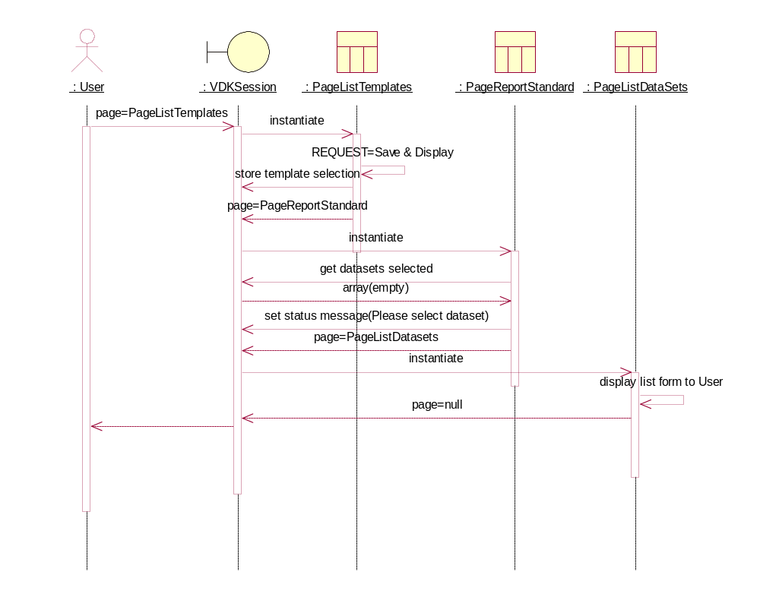
Page Interaction Diagram

The VDKSession looks at the "page" REQUEST variable to determine what page object to instantiate and passes control to it at the execute() method. The return of that method can be a name of another page to give control to or null which causes an end and the system waits for the next incoming post. The contract between the VDKSession and the individual pages is that they can handle execution according to their function and the REQUEST variables coming in and the control will keep coming back to that page as long as it returns null. If unable to execute or execution is done it can pass back what the name of the page to execute or DEFAULT_PAGE constant.

The above scenario attempts to show this. It begins when the user looking at the form provided by PageListTemplates has selected a template and selects Save & Display. The action would be then to display the currently selected dataset(s) according to this template. But there are no data sets selected so PageReportStandard cannot provide a report and must instead redirect to PageListDatasets to have the User make that selection.

VDKSession also acts as a source of resources to the Pages. Access to the ObjectFactory, DBMS, Account information on the User, the Recorder for logging and session info are available.

Displayable Pages
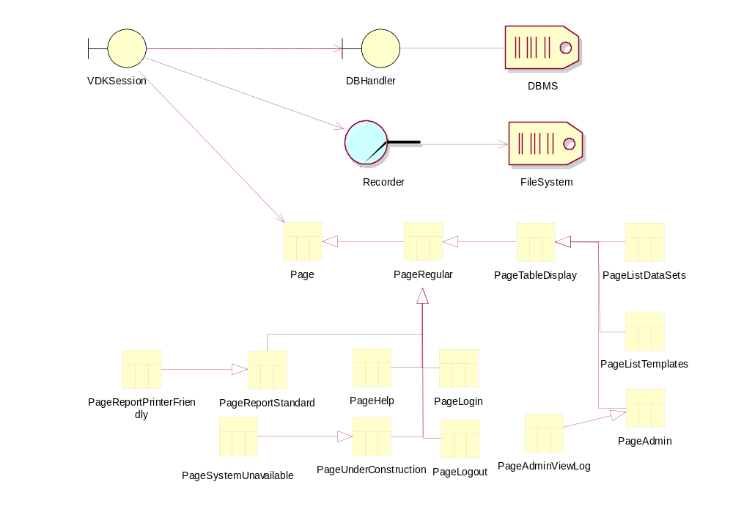

Pages are concerned with providing HTML pages to the User and capturing his interaction. Each Page has an area of functionality.

Page and PageRegular provide common functionality such as displaying the Navigation Bar (Nav Bar) at the top of the page.

PageReportStandard provides a formatted report of the selected Data Sets and PageReportFriendly provides the same report (child class) but with no controls and in a new window.

PageTableDisplay provides a common output of an object table. These are tables such as User Accounts, Templates and Data Sets. Each of the individual pages, PageListDataSets, PageListTemplates and PageAdmin, use this functionality to display their respective tables and handle all changes to the DBMS for that kind of table.

The other pages, PageLogin, PageLogout, PageHelp, PageUnderConstruction and PageSystemUnavailable, only need the Nav bar and provide the rest of the content.

The ObjectFactory, when requested, will build the appropriate Data Set. Given a Data Set ID or IDs and a Template, the factory queries the DBMS via the DBHandler. If the resultant return set from the DBMS is less than a pre-set limit a DataSetLocal object is created and returned and a DataSetRemote otherwise.
The DataSetLocal retains the resultant information in its own internal data representation and no new queries to the DBMS are necessary,
The DataSetRemote maintains the state of the resultant ID only. All queries for data are passed to the DBHandler associated on instantiation. Therefore all information continues to reside on the database.

All Pages get service access to the DBMS by using the DBHandler attached to the VDKSession and log their respective activities via the session object to the Recorder.

Data Set

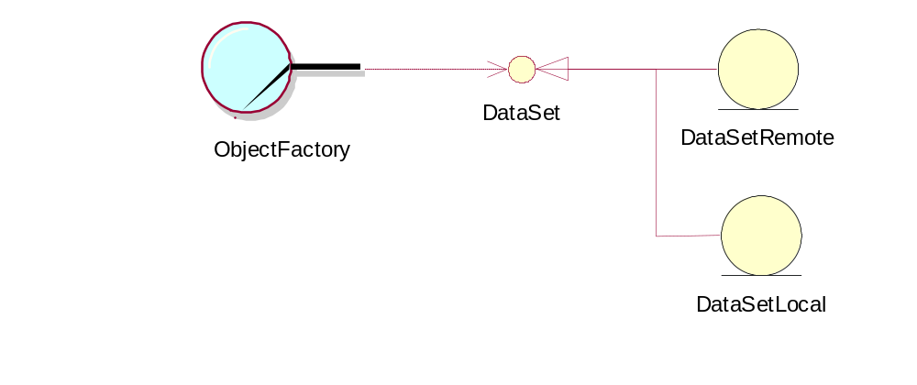

The DataSet contains the information gathered by the selection of data sets on the PageListDataSets and is filtered and sorted by the criteria contained in the selected Template. When PageReportStandard starts the Data Set IDs and the Template Id is passed to the ObjectFactory. The ObjectFactory instantiates the Template and queries the DBMS using a WHERE clause obtained from the Template. The resultant information is given to the newly instantiated DataSet object and this data is again filtered and sorted by passing the Template to it as a visitor.

If the information returned from the query exceeds a defined limit, a DataSetRemote object is created otherwise a DataSetLocal object is instantiated. This is a trade-off between the speed of having the information immediately available (DataSetLocal) with the corresponding hit in memory or the reduced memory consumption of leaving the data in the DBMS with the DataSetRemote object accessing it there with the subsequent reduction in speed. Both objects maintain the DataSet interface and therefore can be treated as one by the system.

Data Set creation Interaction Diagram
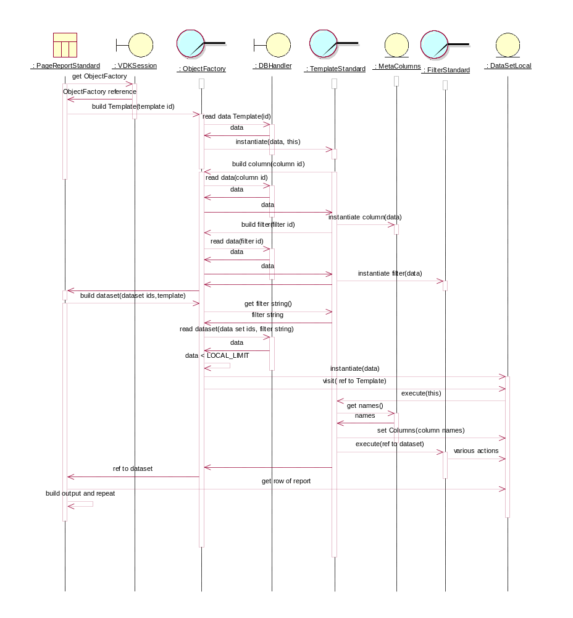

The above scenario is meant to show how a Data Set is created by the PageStandardReport to obtain the data for the report. The scenario starts when control has been given to the Page and after it has outputted the standard page header. The actual access to the DBMS and the loops creating columns and filters has been left out for clarity.

Template
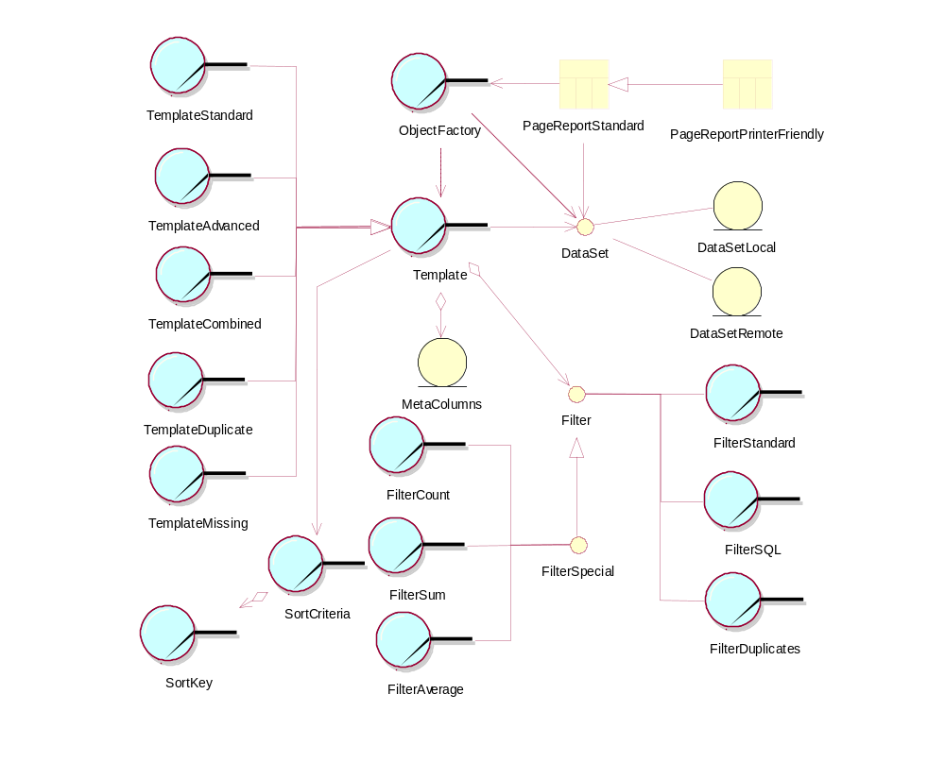

The Templates provide format, filtering and sorting of the Data Set object. This service is provided at Data Set creation.

The Template interface is maintained by the individual types of templates.
The TemplateStandard uses a stored order to determine the order of the columns in the data. In addition, an aggregation of Filter objects are included which act to remove records that do not meet its criteria. The filters can be applied to a defined Data Set or can be queried for the WHERE portion of a query string.
The TemplateAdvanced uses the same ordering scheme but instead of filters it maintains a query string that defines and filters the data request. This provides an open ended functionality to the user to refine his display of data.
The TemplateDuplicate is a special use Template that searches for duplicates in a given field and only those records are displayed.
The TemplateMissing is another special use that searches a given field, removes all the data, and then displays a report listing what sequence numbers are missing from the given numeric field.
The TemplateCombined provides a report that consists of a number of the other kinds of Templates.

The templates provide the filtering by the use of an aggregation of Filter objects.
The FilterStandard uses an operator (=,!=,>,>=,<,<=) and an operand on a specific field. Those records that do not meet the filter's criteria are removed from the DataSet.
The FilterSQL is in a TemplateAdvanced and provides a User defined SQL WHERE clause to the initial creation of the DataSet.
The FilterDuplicates is in a TemplateDuplicate and looks for duplicates in a specified field.
The FilterCount, FilterSum and FilterAverage filters provide an addition at the bottom of the DataSet records that have the result of count, sum or average respectively.

With the exception of the TemplateCombined, the templates keep information about the ordering of the columns (fields) and their display width and other information in data objects called MetaColumns.

With the exception of TemplateCombined, TemplateMissing and TemplateDuplicate the template objects contain a single SortCriteria object. This object contains and manages an aggregation of SortKeys. These keys sort the DataSet as a visitor. The order of the sort keys is reversed as the first is primary.

Template Editors
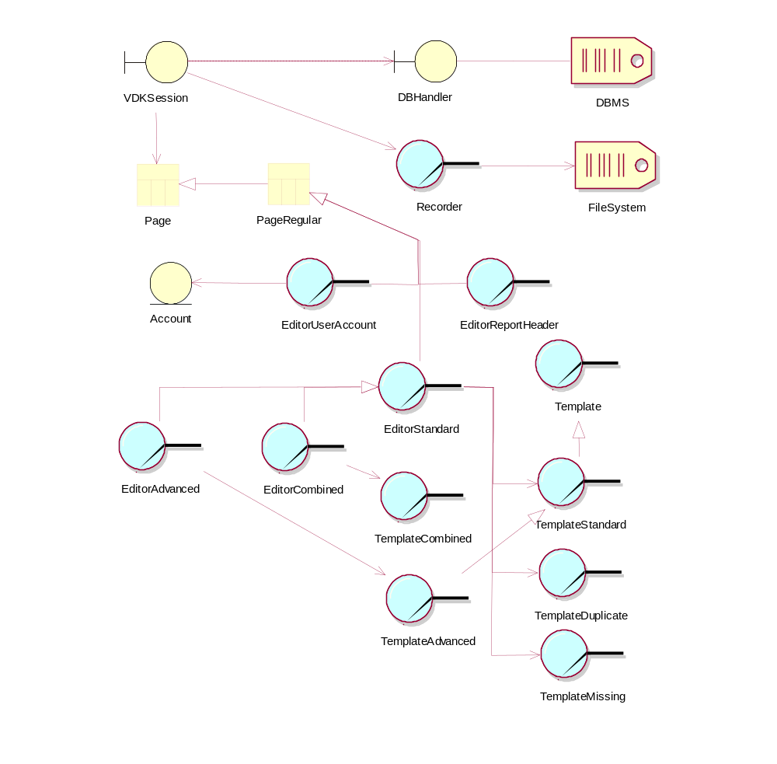

To provide the level of Usability and Extensibility required in this project it was necessary to create a series of Editors to provide the easy to learn ability to create and modify Templates. Each of these Editors trace back to PageRegular to provide the Nav bar as each Editor must be an html form. Initial creation or edit request is passed to TemplateStandard which instantiates the Template and queries it for the appropriate Editor name. If that name is not EditorStandard, the name is passed back to VDKSession which instantiates the correct Editor and passes it the Template. The Template Editors use services defined in EditorStandard and override or provide new functionality where necessary.

EditorReportHeader and EditorUserAccount are special editors for the modification and creation of a Company Header or a User Account respectively.

Editor Data Flow Diagram

User

Recorder
log actions
display Forms

submit
Forms
log
Save

Log File

Editor
save data
from posted vars

Interim Data Structure
Save Template

get Initial Data
read data into form

Template
Save Template Data

DBMS

getTemplate Data

When a Template Editor starts, it instantiates the template which then draws its state from the DBMS. The template then draws this state from the Template which forms the initial load of data to its interim data structure. The displayed form incorporates this data and each subsequent submittal refreshes the interim data structure from the REQUEST variables. When the Save command is submitted the interim data structure is again refreshed from the posted variables and the Template is again instantiated. The Template state is set by providing it an appropriately formatted data structure for it to read containing the interim data. The Template is then told to Save which it does to the DBMS. The action is logged via the VDKSession and the Recorder to the Log File.

The code for the Editors tries to break up the methods into four areas. Init functions that initialize the interim data structure for the first time for the initial display to the User. Restore functions that draw the data back out from the REQUEST variables back into the interim structure between page submit-re-display cycles. Display functions that create the HTML form for the User to interact with. Last, Save functions that store the changed object back to the DBMS.

DBHandler

The DBHandler was made with two main thoughts in mind. To create a single point of access to the DBMS so that a change of DBMS will require changes in this class only. Also, the DBHandler knows about the DBMS but does not need to know the details of the object fields. It should take in a request for a record from a table and return the record without having to understand the fields within.

Authentication

The authentication is through a simple user id and password combination. However this process is encapsulated in the Authenticator class in order to facilitate changes to the security scheme. The passwords are stored in the DBMS in a one-way encryption using PHP's crypt() function. There is no way to decrypt. Instead incoming passwords are encrypted and then compared.

IDMaker

IDMaker creates a session key. It is guaranteed to be unique as it is based on time and date.

Other Important Files

Constants.php: A file of Define statements that contains the constants used throughout the system. Places where only one class has to be aware of a value, such as Pages using variable names for the Forms they write to pass back data, may not use the defines as they are the only one using the term. Classes using a constant value, or name, that more than one class sees should have that constant declared here. Serialized defines provide a capability to convert data. The un-serialized define becomes an array that has key => value pairs that can convert one kind of value to another.

Vdkrit.css: This is the style sheet that the tables conform to. Changing the colors or look of the system can be facilitated by changes here.

php.ini: This is a PHP defined file name that can contain any settings defined in the PHP language to vary the behavior of the system. In example, the only setting in the file at present is the set command to suppress all errors. This suppresses error messages from the compiler and interpreter. This would not suppress error messages from MySQL but this was accomplished by functionality in the system. When development is being done on the system, this statement should be commented out.

MySQL database

The DBMS has two general kinds of tables. One is for the system and one is populated by the camera system with the results of a job. The cameras populate a top level table called jobs and the individual scan data is stored in the results table and referenced by its id and the job id.

The system tables are several and are divided by object. The system table is used for general system information and the others are specific to a kind of object. The data is retrieved by the DBHandler and passed to the object as part of instantiation or as part of a method. But it is the object itself that knows how to parse the data to restore its state as well as how to package the data to pass it to the DBHandler for storage. No intermediary classes need to understand the database schema. The exception to this are the editors that need to know how to get the object state, change it and pass it back to the object to save itself. Only the object sends information to the DBMS via the DBHandler which acts as a pass-thru and does not need to understand the data or structure.

The details of the tables are specified in Appendix 7.3.

Features Not Included

The only feature that was left out due to time constraints was the ability to import and export a Data Set to/from the system. The user interface has the appropriate controls and they are checked and the appropriate function is called but the functions called are only stubs.

Features Wished to be Included

The team wanted to incorporate a feature on the displayed report generated by PageReportStandard that would make the column headings actual buttons so a quick resort could be done based on the column clicked on. The first sort would be ascending and another click on the same column would make the sort descending.

An effort was made to make all shared constant values define statements in Constants.php. However time constraints may have left some out.

Deployment View
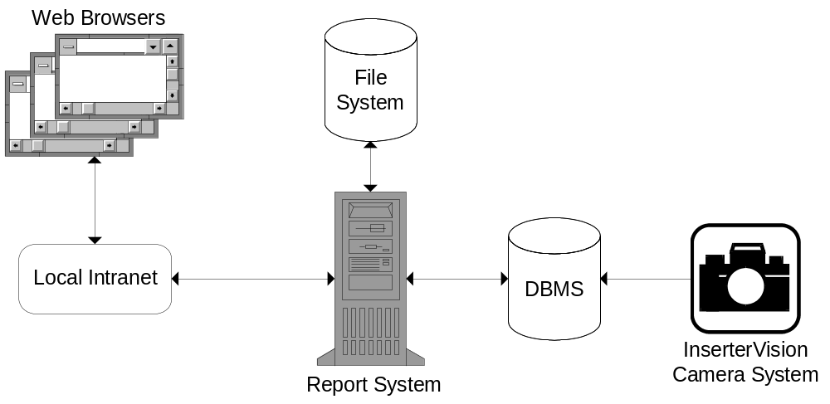

Original User Interface Prototype Pages

Login/Authentication
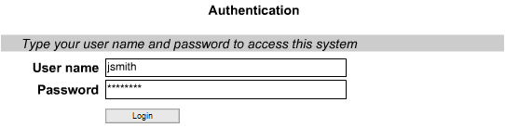

Logout



Data Sets
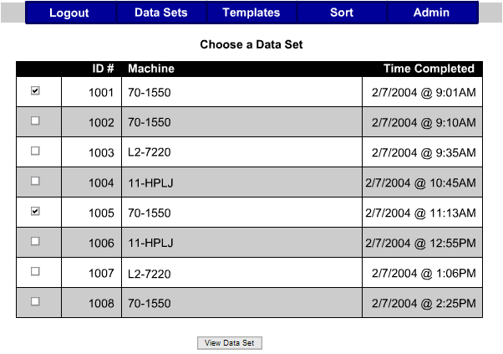

View Report
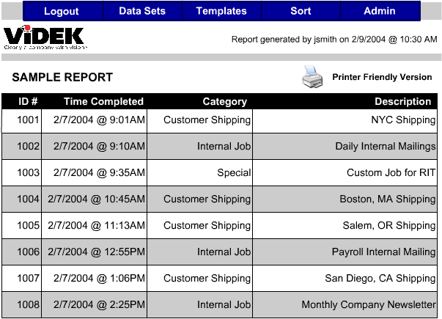

Templates
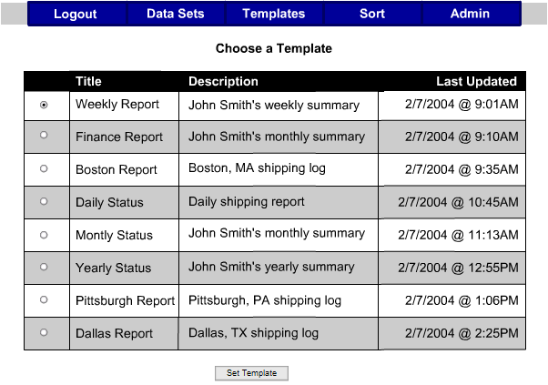

Template Editors

Standard Editor

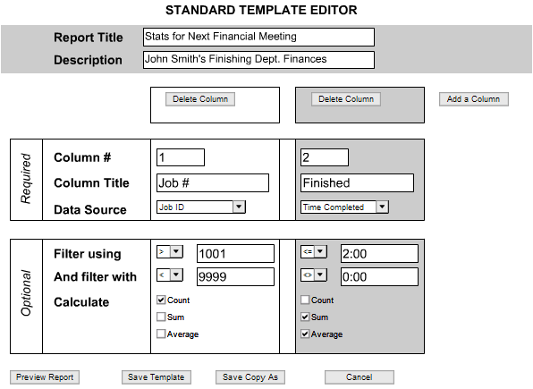

Advanced

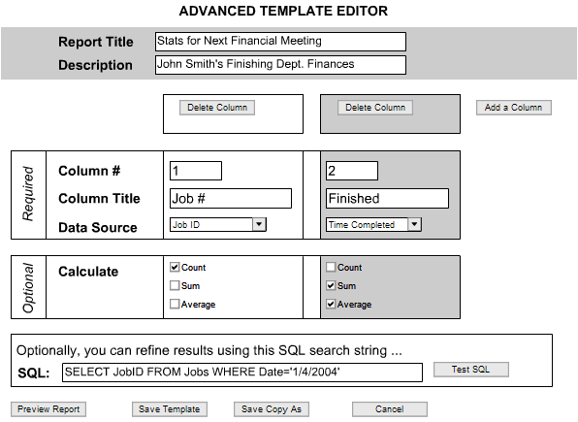

Combined
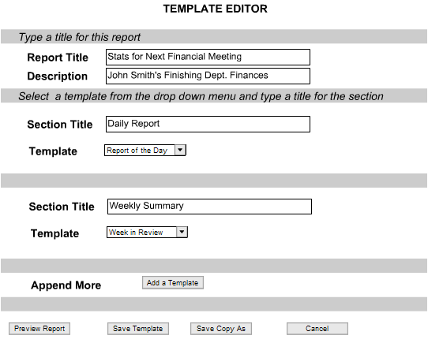

Sort Criteria
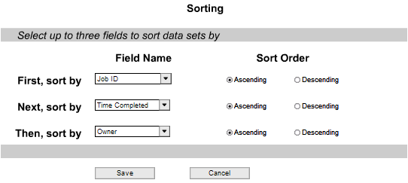

Appendix

Glossary

Term | Name | Description
DBMS | Database Management System | A programmable interface which provides a common layer of abstraction between a physical database and a user or external program
HTML | Hypertext Markup Language | Set of markup symbols or codes intended for display on a World Wide Web browser page. The markup instructs a web browser on how to display words and images for a web page
IVRS | InserterVision Report System | System under development
PHP | PHP Hypertext Preprocessor | An extensible scripting language, suited for web-based development. Typically embedded in HTML
Login | Login | To supply the User ID and password for authentication and get access to the system
Export Format | = | VDK-RIT defined format for the storage of Data Sets
Job | = | All the pieces of mail read by the scanner done on a single sorting machine in a single session.
Data Set | = | All the data from a job stored in the DBMS by the scanner interface.
ID | = | Unique alpha-numeric string, beginning with an alpha
password | = | Alpha-numeric string, beginning with an alpha and at least 6 characters long
Sort | = | Re-display of displayed data in either ascending or descending order based on a Primary Key and an optional Secondary Key and an optional Tertiary Key
Primary Key | = | A field chosen from the displayed options; This field will mandate the initial sort
Secondary Key | = | A field chosen from the displayed options; This field will mandate the sort where the Primary Key is equal between data records
Tertiary Key | = | A field chosen from the displayed options; This field will mandate the sort where the Primary Key is equal and the Secondary Key is equal between data records
Template | = | A re-defined format of fields from a Data Set

Data Dictionary

MySQL Schema

System Table: system
Field Name | Type | Description
id_name | varchar(32) | unique identifier (primary key)
data1 | text | Data
data2 | text | Data

id_name | data1 | data2
log | comma separated log group identifiers | not used
version | version of this system | not used

User Accounts: accounts
Field Name | Type | Description
user_id | varchar(64) | unique identifier (primary key)
password | varchar(64) | encrypted password
user_name | varchar(64) | user's name
access_level | varchar(32) | access level identifier
permissions | varchar(64) | comma separated list of permission identifiers
access_title | varchar(64) | displayable name for access level*
* This was meant to be removed and replaced by a conversion string in constants to translate the access identifier into the title.

Session Table: sessions
Field Name | Type | Description
id | varchar(64) | unique session id
username | varchar(64) | user's id
start_time | datetime | start of session
last_updated | datetime | last action taken
dataset_id | varchar(64) | comma separated list of data set ids or null
template_id | smallint(6) | template id selected or null
URL | varchar(64) | URL of client
page_parameter | varchar(64) | optional parameter persistence between pages
screen_width | smallint(6) | client's screen width reported by javascript
Returning contacts are authenticated by the combination of the session ID and the URL.

Template Table: templates
Field Name | Type | Description
id | smallint(6) | unique id (primary key)
type | varchar(64) | type of Template identifier
type_name | varchar(64) | name of template
title | varchar(64) | report title
description | text | description for list display
number_columns | tinyint(4) | number of column objects
number_filters | tinyint(4) | number of filter objects
data1 | text | used by combined for a comma separated list of template names
data2 | varchar(64) | used by combined as a comma separated list of template ids
heading | varchar(64) | report heading

Column Table: data_columns
Field Name | Type | Description
template_id | smallint(6) | unique id of template this column is part of (key)
field_name | varchar(64) | name of field in this column
position | smallint(6) | position of this column 1..n (key)
title | varchar(64) | report title for this column
width | smallint(6) | report width of this column
The template_id and the position form the unique key.

Filter Table: filters
Field Name | Type | Description
id | smallint(6) | unique id given by template and unique only to that template (key)
template_id | smallint(6) | template id for the template this filter is part of (key)
type | varchar(64) | filter type identifier
src | varchar(64) | field name to act on
operator | varchar(32) | operator (EQUAL,GREATER_THAN,...)
operand | varchar(64) | data to compare to field data
sql | text | optional SQL statement (WHERE clause)
The id and template_id form the unique key.

Jobs Table: jobs
Field Name | Type | Description
id | bigint(20) | unique id for this job (one run on one machine) (primary key)
machine | varchar(64) | machine identifier
operator | varchar(64) | operator identifier

Results Table: results
Field Name | Type | Description
results_id | bigint(20) | unique id for the results (each mail piece) (key)
job_id | bigint(20) | unique id for the job (key)
date_time_stamp | datetime | date-time of scan
The results_id and job_id form the unique key.

Directory Structure

Top level IVRS system directory on the Server contains the all the php files, the style sheet file and the php.ini file:

FilterSQL.php | FilterSpecial.php | DataSetRemote.php
Template.php | PageUnderConstruction.php | PageHelp.php
Authenticator.php | PageLogout.php | DataSetLocal.php
TemplateCombined.php | PageListTemplates.php | MetaColumn.php
DataSet.php | PageRegular.php | ObjectFactory.php
FilterDuplicates.php | TemplateAdvanced.php | IdMaker.php
DBHandler.php | Page.php | SortKey.php
Visitor.php | VDKSession.php | PageLogin.php
PageListDataSets.php | PageReportStandard.php | FilterSpecialCount.php
FilterStandard. | Filter.php | SortCriteria.php
IVRS.php | EditorCombined.php | Recorder.php
FilterSpecialSum.php | PageReportPrinterFriendly.php | EditorAdvanced.php
Comparator.php | EditorStandard.php | PageAdminViewLog.php
FilterSpecialAverage.php | TemplateMissing.php | PageSystemUnavailable.php
TemplateStandard.php | EditorMissing.php | EditorReportHeader.php
PageAdmin.php | TemplateDuplicate.php | EditorUserAccount.php
Account.php | EditorDuplicate.php | php.ini
PageTableDisplay.php | Constants.php | vdkrit.css

The sub-directory Images contains the image files:

disk.gif | help.png | templates.png
admin.png | logout.png | trash.gif
data sets.png | printer friendly.png

The sub-directory Data contains information needed the stored Company Header:

reportHeader.txt

The sub-directory Data contains information needed for the on-line help:

HelpAdmin.txt | HelpDuplicateEditor.txt | HelpSetHeader.txt
HelpAdvancedEditor.txt | HelpMissingEditor.txt | HelpStandardEditor.txt
HelpCombinedEditor.txt | HelpListTemplates.txt | HelpUserEditor.txt
HelpDataSet.txt | HelpReport.txt

PHPDocs

Included with the package are the PHPDocs. This is a third party program that scanned the source code and created a series of linked web pages that incorporate all the classes, show the inheritance tree, the methods and attributes of each class and the comment headers. You start to use them by opening index.html in the top directory with your browser and navigate from there.

* One note if you decide to use the GNU licensed program and make changes: The comment block for the includes in each file is necessary even if there are no includes for this program, in order to parse the file correctly.

