# **EER Diagram**

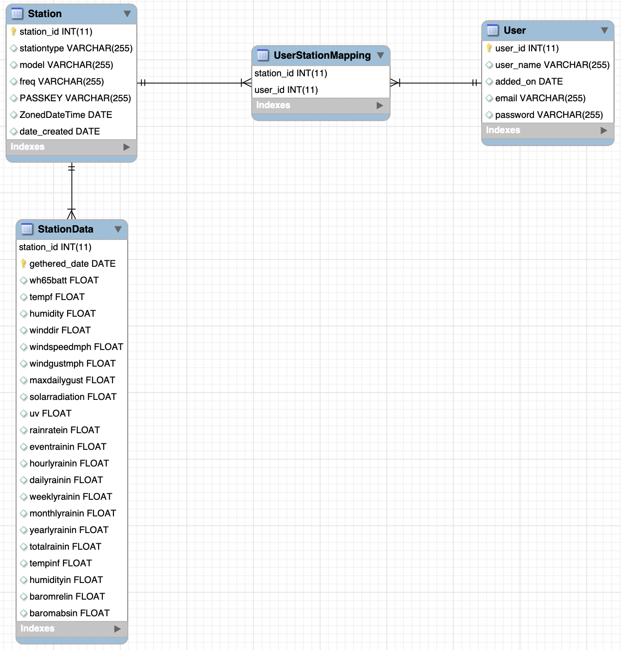

I’ve split the model into three subject areas:

* Station data
* Station Info
* User Info

# **Station data**

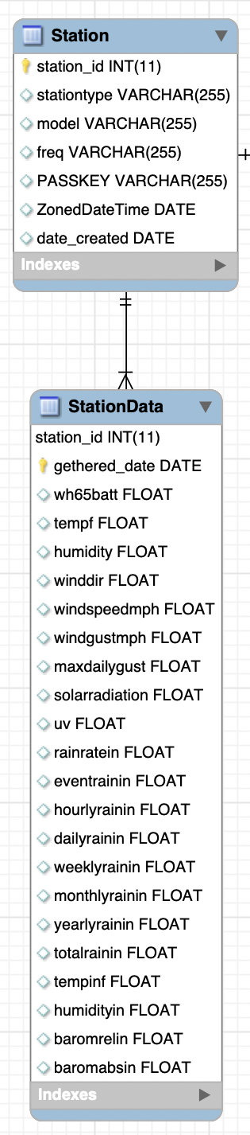

This is the most important subject area. Any weather app should capture these basic details:

* Date when information was gathered
* Temperature inside
* Humidity
* Direction of wind
* Wind speed in mph
* Wind gust in mph
* Maximum daily gust
* Solar radiation
* Ultraviolet radiation
* Rain rate in inches
* Hourly raining
* Daily raining
* Weekly raining
* Monthly raining
* Yearly raining
* Total raining
* Temp outside
* Humidity
* Barometric pressure

Together, these give a holistic view of current weather condition. This is the information that will be presented to users, usually through one or more intuitive screens.

# **User Info**

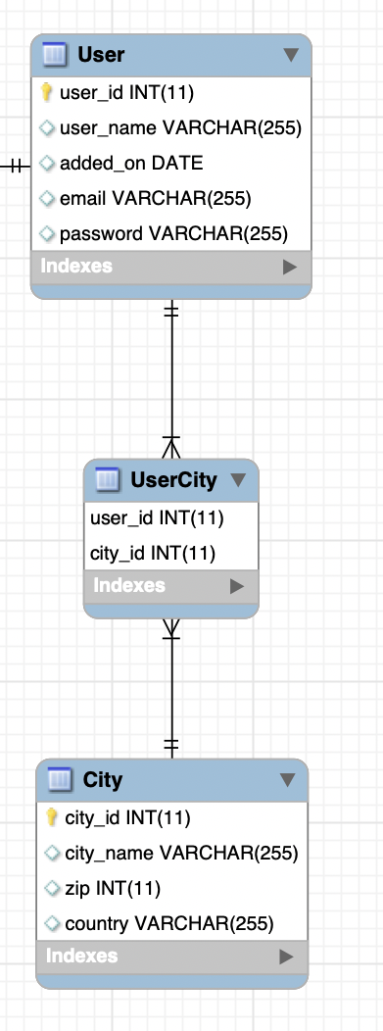

This subject area mainly handles user’s location information. Most of the columns are self-explanatory, so we will just briefly explain the purpose of each table.

The User table holds basic info about users, like email address and password. The user_id column assigns a unique number to every user who registers with the application.

UserCity and City tables are optional (see EER Diagram Optional) for the future use. This will allow to map data to the location.

The UserCity table is just in between of many to many relationships of User and City tables.

The City stores a list of cities and their location details (postal code, country). The columns in this table are self-explanatory.

# **Station Info**

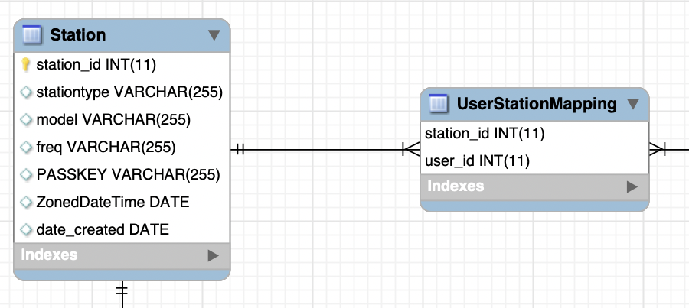

The UserStationMapping table maps the relationship between users and Stations.

Since the application allows users to monitor the weather in as many cities as they want, this subject area handles associating one or more cities with each user’s profile.

The Station table stores a list of stations with their model details, Passkeys, station types, dates created, Time zones and frequency of getting data.