wishingarden website comments 001

Concept | Element | Comments | Screenshot
01 | Headline | Like this copywriting style
01 | Headline | Like this copywriting style | 
03 | Headline | keep | 
- | Headline | Add buttons to allow scrolling, ss from ssfw | 
01 02 | 1st section | Section title & navigation description:  wishingarden dome workshop  A hands-on workshop to craft your own wishingarden. Therapeutic, gentle, and yours to shape.  wander in >  Also open to suggestions on copywriting for SEO | Keep this, taken from 02 
01 | 2nd section photos | Remove photos, section 2nd will be featuring new collection: Lily of The Valley - will send photo tmr or thurs  Give more white space between photos and sections  - tagline: Wearable blooms from our garden.  Also open to suggestions | 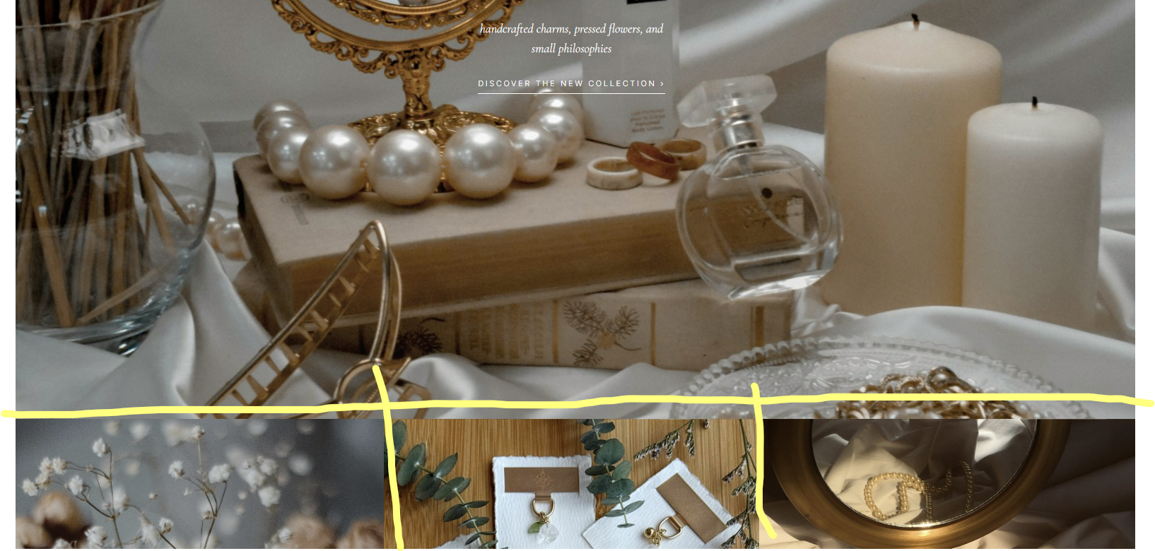
01 and 02 | 3rd section | - Keep the photo chosen  - Replace tagline to tagline from 02 -  — a letter from the garden  Some things, we believe,  are best made slowly & intentionally.  - Amend description - handcrafted gemstone charms on brass, presented on deckle-edge paper cards embossed with our flower-and-star mark. Made in small batches, in a garden of our own. |   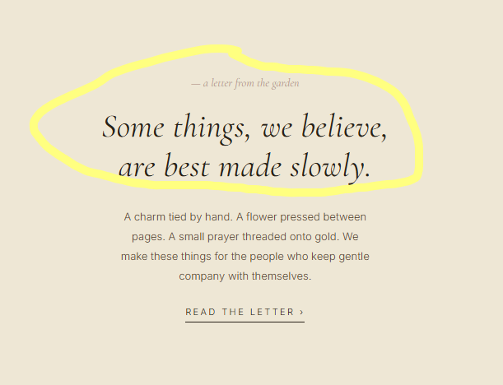
01 | Products section with prices | More white space. Keep to 3 horizontal images
03 | Navigation bar | I like this layout the best.  - Small logo above brand name  - Note that wishingarden has a single g and stylized all small caps  - top navigation bar sequence 1) new arrivals 2) workshops 3) trinkets 4) gemstones <logo> 5) bookmarks 6) suncatchers 7) gifting 8) our philosophy  - Some to have dropdown list - work in progress (wip)  - I like these symbols, can place them at navigation bar and headline |   
02 03 | 4th section - bench | - I like - “--- our small practice” from 02  - tagline header is good keep “Made by hand, in small batches, with chosen stones.”  - Tagline description: Each trinket handcrafted at our bench in Singapore. (wishingarden domes, too.)  Some things, we believe, are best made slowly & intentionally.  Also open to suggestions | 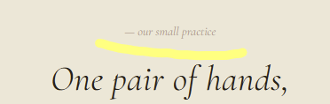  
Bottom footer | Contact us | - move contact us section on headline right corner  - For next time when i get a work number, able to link whatsapp under contact us?

3.

