MEYER-PETGRAVE, FITZROY (Student)

teesside university | england

ADVANCED PRACTICE REPORT

INTERNSHIP WITH THINK PACIFIC

Table of Contents

INTRODUCTION 2

About Think Pacific Foundation 2

Introduction to the Fiji Islands 2

Think Pacific Internship 2

ACTIVITIES UNDERTAKEN 2

The 5 D Journey 2

Discovery Phase 2

Discussion Phase 3

Decide Phase 4

Design Phase 4

Delivery Phase 5

CONTRIBUTION TO THE ORGANISATION 6

Easy to implement codes 6

Safer online payment platform 6

Access to further improvement of the model 6

REFLECTION 6

PERSONAL BENEFITS 6

Presentation skills 6

Deep learning application 7

Project management 7

PROFESSIONAL VALUES AND BEHAVIOUR 7

Resilience: 7

Accountability: 7

Collaboration: 7

Aspiration: 7

# INTRODUCTION

## About Think Pacific Foundation

Think Pacific Foundation (FIJI) works year-round to support sustainable development in Fiji’s rural communities to help them achieve holistic health. The foundation is a locally registered Fijian charity and NGO behind Think Pacific virtual internships.

The Think Pacific virtual internship is the evolution of 10 years of sustainable development programs in the Fiji Islands, at the same time offering interns the opportunity and platform to develop skills, create new connections and make contributions from home independently.

Through partnerships with large Fijian ministries and small NGOs, the mission of this online program is to make small but consistent contributions toward helping the Fijian people implement the Fiji National Development Plan and inspire its youth to achieve transformational change by 2037.

## Introduction to the Fiji Islands

The Fiji Islands are located at heart South Pacific. Fiji is an archipelago made up of some 333 islands surrounding the Koro Sea in the South Pacific Ocean. Today, the indigenous people of Fiji are usually ethnically classified as Melanesian, although their social and political system is closer to that of Polynesia.

## Think Pacific Internship

The Think Pacific Internship kicked off with a live briefing session and introduced the online learning and collaboration environments.

The internship structure also allowed interns to join live workshops to support themselves and engage with fellow interns.

We were given access to virtual platforms such as a Private Facebook Group, live workshops, and a mobile application (Mighty Networks) created for discussion, engagement, and support all through the 12 weeks.

# ACTIVITIES UNDERTAKEN

## The 5 D Journey

The activities I carried out during the 12-week internship were split into five phases called the 5 D journey. This helped break down the program into sections with timeframes for easy project management and efficiency.

The 5 D journey is a workflow that all interns use to create and deliver action projects in a way that will be beneficial and efficient for both the intern and the Think Pacific partner organization. The five different phases are Discovery, Discussion, Decide, Design, and Deliver Phases.

### Discovery Phase

A discovery phase to learn about Fijian people and culture and Think Pacific’s partner organizations. During this phase, I acquired knowledge about the Fijian people and culture through webinars, videos, websites, and other online resources.

During this phase, I virtually explored the Fiji Islands and the people's culture, ranging from food to traditions, language, leadership, occupations, and general lifestyle. This provided some profound insights into the problems, challenges, and opportunities in that area.

Another critical aspect of the discovery phase was exploring the Think Pacific Foundation’s vision for the Fiji Islands. This was vital for understanding the reason for the organization’s goals and activities and how every action project aligns with these.

### Discussion Phase

The discussion phase aimed to discuss various project opportunities and identify suitable projects that align with personal and organizational goals.

With the support of my assigned mentor, I was able to identify 3 Think Pacific projects that I discovered to be in alignment with my personal and professional goals, as listed below.

* Data Visualisation – Creating Think Pacific Impact Report
* Covid 19 Infographics for online platforms
* Designing a machine learning model for fraud detection

#### Data Visualisation – Creating Think Pacific Impact Report

Think Pacific has been operating in the Fiji Islands since 2009, so this project was aimed at detailing various projects over the past decade and the impact the organization has had on the island.

Here, the task was to create engaging content that allows Think Pacific to showcase its impact using animations, infographics, or other suitable ideas.

I considered this for my action project because it directly applies to my data science skills. However, I wanted something more challenging, so I decided to view other projects.

#### Covid 19 Infographics for online platforms

The vaccine rollout in Fiji has been successful, and most of the adult population has now been vaccinated. However, the reception of the vaccine wasn’t entirely well-received in lots of communities, with conspiracies about the vaccine itself putting people off receiving it.

The resources to be created will aim to show the impact of covid 19 and the vaccine, demystifying conspiracy theories and health concerns about the vaccine itself and misunderstandings of the science surrounding the vaccines. The content created will be shared with partners in Fiji, distributing this information.

This seemed like a great way to explore my skills and gain more insights into the covid 19 situation in Fiji while demonstrating my talent to a global audience. However, I found another project better suited for my career aspirations in machine learning and artificial intelligence.

#### Designing a machine learning model for fraud detection

This was my choice for an action project as it was best suited for my career aspirations. The idea was to contribute to designing software that can help detect fraud on Think Pacific’s online payment platform using machine learning. More descriptions of the design and delivery can be found in the sections below.

### Decide Phase

The deciding phase requires interns to choose just one action project among the three projects selected during the discussion phase. This final choice would be designed independently and delivered to Think Pacific.

After critically considering the three options for personal development and career advancement, I created a credit card fraud detection software.

Secondly, the opportunity for growth was more evident than in the other two projects. The design options could get me on the path to artificial intelligence by applying deep learning models in the design.

### Design Phase

This phase was aimed at two outcomes. The first was to create a project proposal that considers the partner organization's vision, resources, and challenges to provide a comprehensive, culturally relevant, and sustainable project proposal.

The second aim was to enhance the interns’ development and maximize impact through seeking feedback and upskilling via the skills series and research.

#### Designing a Credit Card Fraud Detection Software

Think Pacific offers online card payment and wants to use a fraud detection program to identify frauds with sufficient accuracy.

My task was to use Python or R to analyze the customer’s usual spending behavior and map these spendings location to detect possible fraud. I was given access to the customer’s transaction history to ingest it into predictive models. The model’s logistic regression and artificial neural network. Predictive models.

**Project Aim**

This project aims to design an algorithm that can read input details of a customer's transaction and then classify the transaction as either fraudulent or not fraudulent with high accuracy.

**Project Objectives**

* Use Machine Learning to create a predictive model that is an improvement of the current solution.
* Improve Machine Learning solutions with Deep Learning

**Method**

To detect fraud, our models should be able to read input details of a customer's transaction and then classify the transaction as either fraudulent or not fraudulent, making it a Binary Classification problem (only two possible outcomes). This binary classification problem is solved by training a machine learning model by exposing it to a dataset containing credit card transactions collected over a period. The dataset amongst other variables (columns) contains one column with a class label for each instance which is either 0 for non-fraudulent or 1 for fraudulent. Model performance is then evaluated by exposing the trained model to detect fraud on new transactions (data excluded during the model training). In this experiment, python language was used to code the binary classification models: Log: Logistic Regression from Scikit-Learn Neural Networks from Tensorflow library. They are then compared to get the best prediction accuracy while avoiding errors such as overfitting and underfitting.

Here is a link to the notebook containing the codes on Kaggle: <https://www.kaggle.com/code/fitzroypetgrave/credit-card-fraud-detection-scikit-and-tensorflow>

**Results**

The objective of improving the current machine learning model was fully satisfied with improved performance.

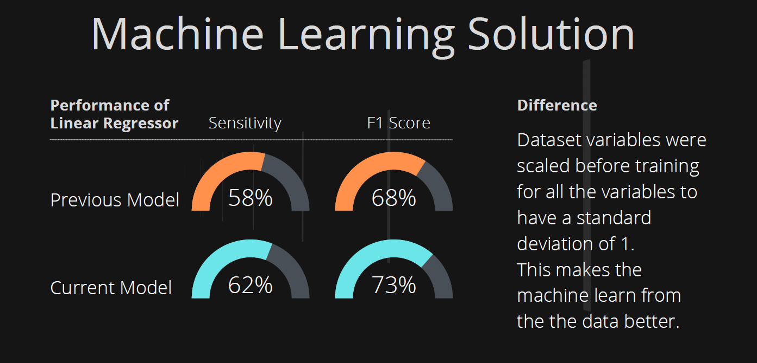

The Deep Learning model also gave a high accuracy of 99.99%, which is desirable. However, there is still a chance that it can make a wrong prediction due to the vast difference between the size of the fraud and non-fraud instances.

My recommendation is to optimize this model by resampling the dataset before training the models to have an equal representation of both classes in our training data.

### Delivery Phase

The delivery phase aimed to leave an impact by sharing my project as a proposal with the partner organization. The objectives were clearly outlined to ensure the best delivery for a better effect on the organization and the intern.

#### Delivery objectives

* Sharpen your presentation skills and prepare to leave your impact
* Produce a 5-minute recorded presentation for your proposal
* Submit your Action Project and all relevant files
* Reflect on your internship experience and share any feedback

All objectives were met as required.

First, I used the resources provided by Think Pacific to upskill myself in making an excellent presentation virtually; this was helpful when creating the content for the slides. Then, with my mentor’s guidance, I started a project proposal with details of the project carried out and the results. My submission contained

1. A python notebook with the working codes ready for deployment
2. The proposal presentation slides
3. A 5-minute recorded video of myself making the presentation with the slides.

# CONTRIBUTION TO THE ORGANISATION

## Easy to implement codes

I designed the project to ensure easy implementation using hash (#) to comment out explanations so that non-coders can understand the functions of the individual code pieces. I also stuck to using a user-friendly design that maintained usability without plagiarism.

## Safer online payment platform

As a result of the improved model with deep learning, Think Pacific can now operate an online payment platform with integrity in terms of safety for the organization, customers, and users.

## Access to further improvement of the model

The next step of this project is to make the model more efficient and less likely to make wrong predictions. So, I have included a link to my GitHub repository where Think Pacific can access the code base and be able to copy and implement the updated version of the model.

# REFLECTION

Looking back at the whole experience, the fact that I already had a strong interest in machine learning and deep learning made it seamless to understand the deliverables required and how to embark on the project with minimal guidance and supervision, which was a crucial element in the virtual internship.

One challenge I experienced was my limited knowledge of product development, which limited my testing of the model in a natural working system. However, I was not granted access to the actual website where it would be deployed, so it wasn’t mandatory to explore the product development aspect of the model.

Another learning point for me was recording a virtual presentation without live feedback to adjust the presentation style to suit the audience. However, I had access to several resources on the Think Pacific platform and personal research, which helped me record a video with effective communication in perspective.

# PERSONAL BENEFITS

## Presentation skills

I developed my presentation skills as I was required to create a 5-minute video presenting my project work to the organization or its partners.

## Deep learning application

I improved my technical skill in machine learning by exploring a deep learning model that I had previously not considered. I also learned to optimize deep learning models by using more advanced pre-processing steps that I had not utilized.

## Project management

The project execution steps used to execute a Think Pacific internship – The 5D Journey –turned out to be an effective project planning and execution method that I can always apply to subsequent projects during my data science career.

# PROFESSIONAL VALUES AND BEHAVIOUR

Resilience: The whole experience presented a challenging environment where I had to develop the strength to achieve my deliverables independently despite not having live and on-demand collaboration.

Accountability: I developed a fault as it was necessary to take responsibility for the energy I put in, my impact, and the standard of project design and delivery. This, I believe, would be very valuable in a data science career where most of the work is being done independently.

Collaboration: As much as I was required to work independently, there was also the need to collaborate with other interns virtually, discuss project progress, and attend virtual coffees. This helped other team members deal with apparent physical isolation. This can be translated into career mode to ensure more efficient virtual collaboration.

Aspiration: During the discussion and decision phases on what action to take, I was inspired to take on a challenging project other than one I was comfortable with deploying. This aspiration led me to discover new ways to solve problems by improving my skills. Applying this behavior in my future career will lead to accelerated growth in personal and professional skills.