Using independent Component Analysis to solve the cocktail party problem

Joel Mintz¹ and Kathleen Fitzsimons²
Department of Biomedical Engineering¹, Department of Mechanical Engineering²
Northwestern University^{1,2}
Evanston IL

Abstract: Independent Component Analysis (ICA) is one method to separate the components of a mixed source signal. This type of analysis can be performed on a multitude of mixed signals source signals, including EMG, EEG, and output from other biophysical systems. This paper presents an ICA based method for solving the “cocktail party problem”. Analysis was performed using seven simultaneous recordings of multiple persons speaking at the same time.

Introduction
Many signals are sampled by taking discrete time measurements at specific sampling frequencies. These can be used to reconstruct curves that represent the signal itself. Unfortunately for many real-world signals, the data that is recorded at any sampling time is the combination of a multitude of signals. This makes it extremely difficult to extract the physical signal of interest when analyzing data.
` This is doubly true when analyzing biophysical signals. Biophysical signals are often generated at the micron level, limiting the ability of the recording signal to analyze the signal of interest, like a corticospinal action potential [1]. Therefore a single recording device (such as an electrode on the surface of the skin) often records a wide array of signals from the areas nearby in addition to the area of interest. This paper presents a method for extracting biophysical signals, namely that of sound.
The “cocktail party problem” is an ideal model to study multiple source signal extraction from, where the extraction signal is that of a “source” voice. This technique can be especially helpful to law enforcement and counter-terrorist operations in thwarting potential criminal enterprises [2]. Our method of colleting many observations, namely recordings that were done on phones at various points in a room, while a multitude of individuals spoke aloud.
The main method of data separation was done by independent component analysis (ICA). ICA represents an ideal way to perform signal extraction for a wide array of function analysis.

Preliminaries

Cocktail Party Problem
The night before Dr. Dewald’s big speech at an IEEE conference there spreads a rumor that some mischief-maker is trying to dump water all over him for rejecting their academic paper. Apparently a group of individuals had been talking about it at the cocktail party the night previously. Thankfully the head of security installed microphones at various locations around the room. This in essence outlines the cocktail party problem. Is it possible to separate each of the conversations from the night previous to catch the person(s) up to no good? Though the presented scenario is a hypothetical one, this could have vast implications for certain professions, especially those involving law-enforcement or international sabotage.

FastICA
The FastICA is an open source package available at http://research.ics.aalto.fi/ica/fastica/ . It was developed to perform independent component analysis in MATLAB . The package can be used with a graphical user interface or by calling the fastica function in a script. The package does two preprocessing steps, demeaning and whitening the data. In our analysis we utilized those optional preprocessing steps and experimented with the optional input parameters of the FastICA function. [3]

Independent Component Analysis
Independent component analysis considers a situation where there are n number of sources (S) and at least n number of observations (X). It is necessary for the number observations to be at least equal to the number of sources, so that each source can be extracted from one observation. It is often beneficial to have more observations than sources—this redundancy can help account for noise in the observations. These signals are related to each other by a mixing matrix (A). The relationship between the sources, mixing matrix and signals is expressed in equation (1).

X=AS (1)

The goal of ICA is to separate the combined observations of X, to the sources, S. If we can estimate A, we can take its pseudoinverse and multiply it the observations to generate the matrix of separated source signals as in equation (2).

S=A⁻¹X (2)

The main two ambiguities that exist with ICA method are the fact that X can exist as any scalar multiple of S within the matrix A itself. Therefore, the exact amplitude of the signals that are extracted is unknown. To fix this, it is assumed that there is unit variance within the system itself, though the ambiguity of sign remains. The second ambiguity is the fact the order of the sources cannot be determined. For this application of the ICA method, it is irrelevant the order of the sources, only the actual sources themselves, though it could pose issues in biophysical signal processing. The only true constraint on the ICA method is that the signals must be independent and uncorrelated with each other. In other words all the sources must be non-Gaussian. If this condition is met than the central limit theorem holds and the mixing matrix can be estimated. The central limit theorem states that the sum of all independent variables is itself a Gaussian distribution.
By minimizing the non-Gaussian of the weighting cost function, a matrix is return that has a single non-zero component, thus getting back a single source signal. This signal is then removed and the ICA process is repeated again, Since the single source is uncorrelated with other sources and removed before another iteration of the FastICA is computed, multiple maximum conditions can be found, each corresponding to a unique source signal.
ICA uses one of the following measures to estimate non-Gaussianality. The first measure that can be use to determine non Gaussianality is that the Kurtoris function (3). This is most non-Gaussian when the Kurtoris function is non-zero. The second measure that can be used to determine non-Gaussianality is the mutual information. Non-Gaussianality of the mutual information occurs when function (4) is minimized. Either of these two cost functions can be used in addition to the equations given by Eqn 5 or Eqn 6, which are measures of the entropy, or information found in the system. The programmer of the ICA chooses the specific cost function, where each of the cost functions could give slightly different results. After a pre-whitening step, the FastICA package uses a random guess to seed an algorithm that optimizes over this quantity.
Kurt(y)=E{y⁴}-3(E{y²})² (3)
I(y₁, y₂,..., y_{m} ) = H(y_{i})− H(y) (4)
H(y) = - (5)
J (y)= H( y_{gauss})- H(y) (6)

Methods

Signals
The source signals used in this simulation were five voices of students that were distintly different from one another. Each student could say whatever they wanted. One student read the gettysburg adress, while other students spoke in different languages and two had a conversation with each other. In total 5 signals were generated.

Recordings
The signals were recorded from cellphones from 8 students in the class. Since the length of X depends on the number of sampling points, each of the signals was processed to ensure that they were all the same length in time and frequency. This allowed for all the observations to be the same length, thus allowing them to be separated. In total 8 unique source recordings were taken.

Software Program
A custom MATLAB software package was constructed to perform ICA on the set of input signals. The software works by first specifying the number of extracted signals, given by the function expression NumSig. Then each of the MP3 files were input into matlab using the audioread function. The FastICA was ran twice. For the first run, all 8 of the recording were read and fed though the software. The second run used only 6 of the 8 signals Once each audio file was read in matlab, the software created a matrix of the signals equivalent to the observation matrix X. The number of samples of the recording was then determined by finding the length of the rows. From this the total time of the signals was recorded, with each time point cooresponding to the recording sampling period. Each observation signal was graphed over the time interval. The mix of signals was then ran though the ICA against the total number of recordable signals (8 for the first part of this experiment, 6 for the second). The sperated signals and the mixing Matrix A were recorded. It is important to note that the FastICA software demeans and whitens the input function(s), performing an important data processing step for ICA.

Alignment of Observations
One of the many challenges with using source recording from various students is that the recorded data is not aligned. To align the data there are two ways to do this, both of which were used for our ICA analysis.. One way is manual alignment. Audacity, a third party software, can be used, which automatically aligns the recordings, and sets them to the same sampling rate. The second method of alignment is using cross correlation to align the data. To use the cross-correlation method, an anchored recording is used to align the other entire set of recordings in respect to it. The anchoring recording was chosen because it appeared to lead 6 out of the 7 recordings. and we were trying to crop to the beginning of that observation. Then the cross correlation function in MATLAB is used, to determine the cross correlation between each of the floating signals and the anchored signal. This will produce a paired result: the first is the cross correlation coefficient and the second is the lead/lag value time for the entire data set. Then the floating signal is shifted by the lead/lag value at the point of maximum correlated, which aligns the observations;. This is done for each of the remaining floating signals, where they can be returned into observation matrix X.

Results
Results of Manual Sync and Qualitative Analysis. In the initial analysis, a trial and error process was used to determine what combination of the synced recordings yielded qualitatively better source separation. The five observations used in this analysis is shown in fig. 1.
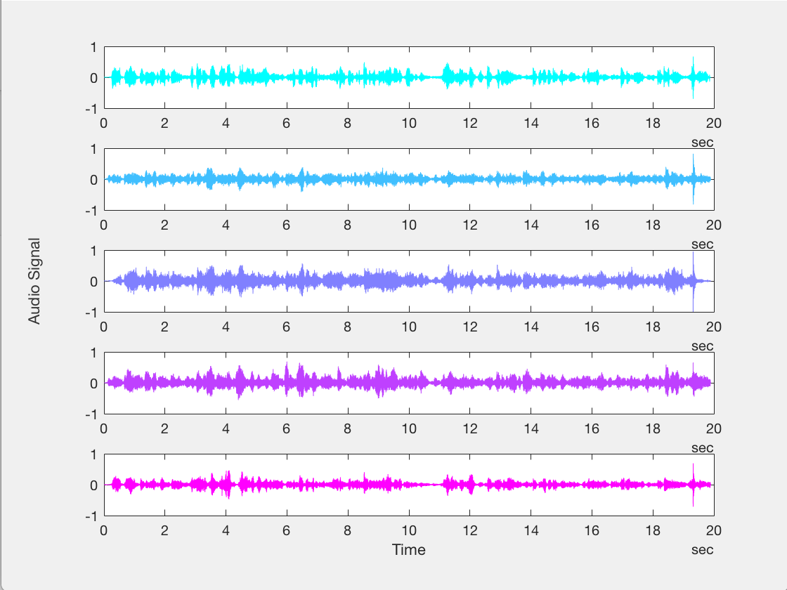
Figure 1. Source Recordings for 5 different observational recordings.

Again, based on the subjective quality of the audio recordings and resulting separated audio signals, we determined that there were only three distrinct signals, so we set the FASTICA to extract three sources from the observations in fig. 1. These results are shown in fig. 2.

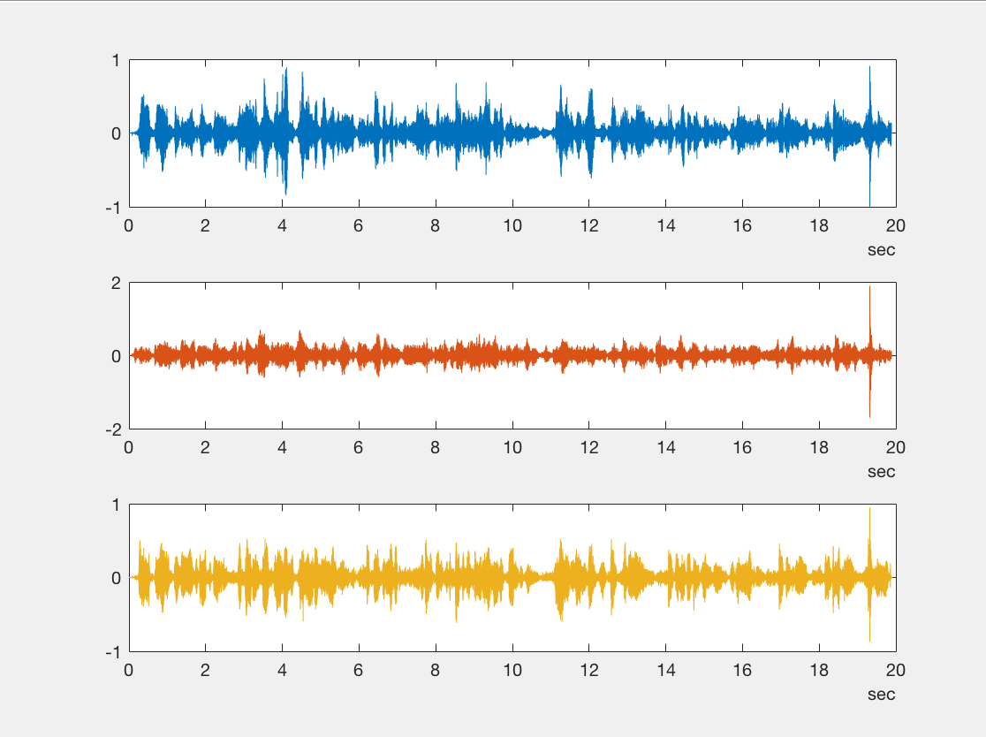
Figure 2. Results of ICA after first source separation.

To assess if the low quality of the separated source signals was not due to a convergence criterion of the optimization, we performed ICA on the separated source signals. There was some marginal qualititavie improvement observed in this second iteration.

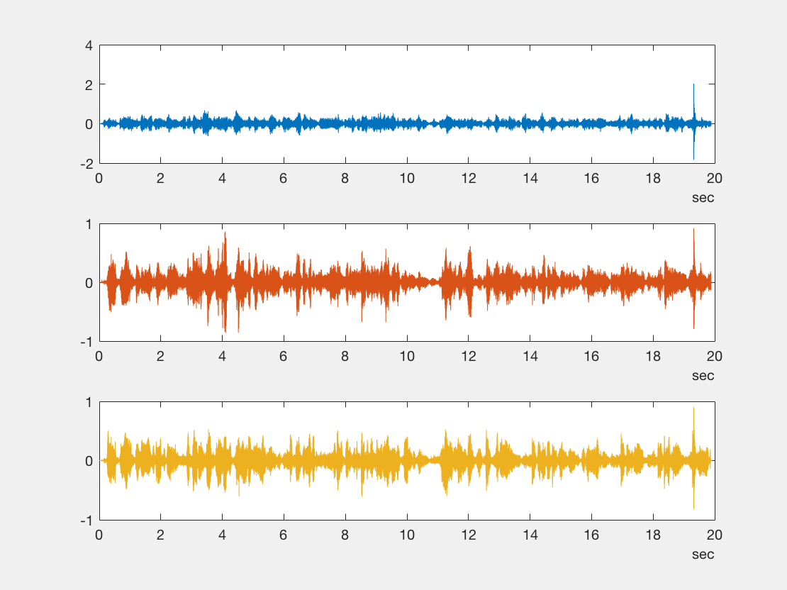
Figure 3. Results of ICA on initial source separation.

Results of Cross-Correlation Synchronization. The anchored observation used to synchronize the remaining 7 observations is shown in the fourth line in figure 4. After determining the lead-lag values of each observation pair, it was obvious that this signal lead all of the remaining observations except for observation 1.
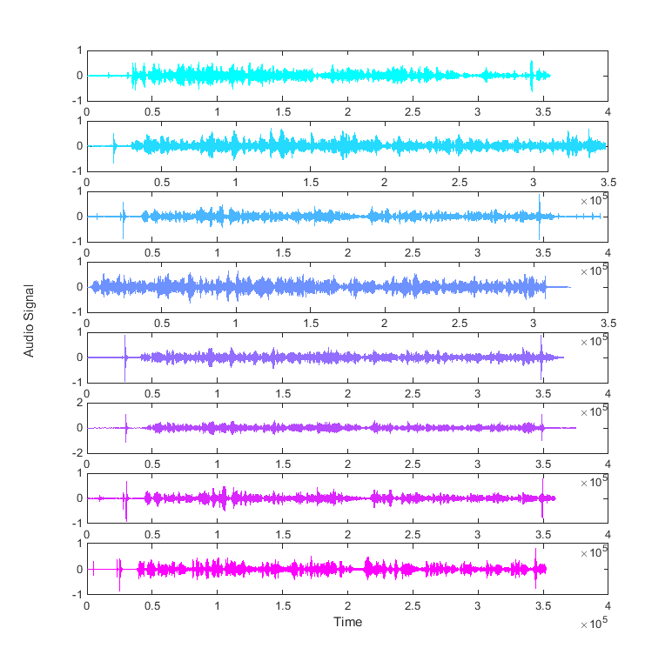
Figure 4. Raw observations-unsynchronized.

The actual signals used in our secondary ICA analysis are shown in fig. 5. There was no way to minimize the lead/lag between the first observation and the remaining 7 signals. It is possibility that this was corrupt or that the resampling that was necessary to have all data sampled at 16kHz degraded the quality of this signal.
Figure 5. Cross-correlation synchronized observations

Using the standard Matlab function snr, we did not find any significant differences in the signal to noise ratio of the 8 signals. However, we did determine that observations 8 was highly correlated (coeff>0.5) with observations 3 and 7. The results of the ICA performed with all 8 signals is shown in fig. 6 and the results with the removal observations 1 and 8 are shown in figure 7.

Discussion
Though the cocktail party problem is an ideal situation in which to study blind source separation, though there are many limitations to the methodology used in this paper. First, some of the source signals were unable to extracted and separated using the FastICA software. Some of the signals, especially that of the Gettysburg Address reader, end up drowning out some of the other signals making it difficult to hear those sources, in any of the original recordings, and even more difficult to extract these sources. Also two of the sources sat very close together and spoke softly, with no observational recording separating them. Therefore, it was very difficult to pick up and separate those sources from the cocktail party. In fact, upon performing source separation, it was evident that other sources could still be picked up from these independent components. Upon amplification, the background noise increased, generating an unusable signal. It is hypothesized that locating more signal recordings in the vicinity of the two un-extracted sources would enhance the source separation process and allow for the two undetermined source signals to be extracted.
It is important to note that only 5 signal recordings were used in the first analysis, which was mainly based on subjective observations. The effect of adding additional sources into the ICA, thereby creating a redundant system where there are more signals than sources, was minimal. Though in theory this effect should provide additional data for source separation, the spatial distribution of the signals was poor, leading to no additional information for source separation.
It should also be noted that running additional FastICA processing on the source signal leads to marginally better quality source separation of the signals themselves. By running the components through the software multiple times, background noise attributed to other signals slowly gets filtered into the correct signal.
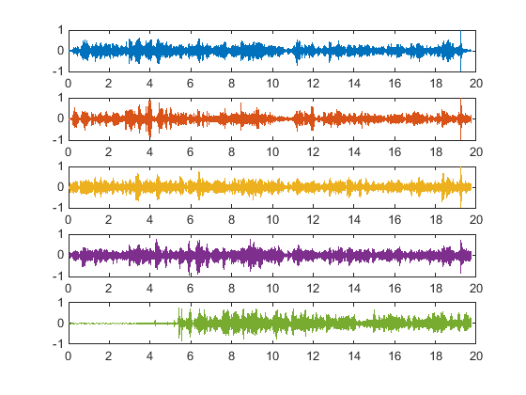
Figure 6. Results of Blind Synchronization and Source Separation

Figure 6, shows five separated source signals, the low initial amplitude of the last signal was largely due to the leading zeros that were added to synchronize observation 1 to observation 4. After listening to this recording it was clear that this recording was actually not taken at the same time as the other recordings, which explains why it was so asynchronous. Largely due to the removal of observation 1, the separated signals in figure 7, do not include this zero-amplitude portion of the signal.

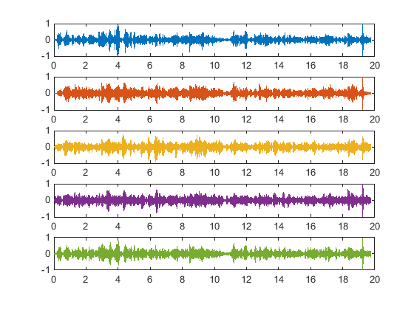
Figure 7. Results after removing asynchronous observation 1 and redundant observation 8.

It should be noted that the ordering of the sources changes between one trial and the next. The ordering is not
preserved from one run of the ICA to the next because the optimization algorithms (of FastICA) initial guess is seeded randomly. The output of the algorithm might be improved by using an informed guess as the starting point of A, the mixing matrix. Running the FastICA algorithm twice does seem to qualitatively improve the quality of the output in terms of singling out a source particularly in the case of the Gettysburg Address Signal. This informed guess might be the mixing matrix from the first run of ICA, or be based off of the expected contributions of each source to a given recording, though remains deeply hidden inside the FastICA algorithm. In the case of an EMG or EEG array, for a similar blind source separation, this guess might be based off previous data and knowing what muscle contributes most to the motion you are recording and weighting the electrode corresponding to that muscle to be higher in your initial guess of the mixing matrix.
The source code for this analysis can be found at:
https://github.com/fitzsi28/BME463

References

- Jankowska, Elzbieta, and Stephen A. Edgley. "How Can Corticospinal Tract Neurons Contribute to Ipsilateral Movements? A Question With Implications for Recovery of Motor Functions." The Neuroscientist 12.1 (2006): 67-79. Web.
- Sutin, Alexander, Barry Bunin, Alexander Sedunov, Nikolay Sedunov, Laurent Fillinger, Mikhail Tsionskiy, and Michael Bruno. "Stevens Passive Acoustic System for Underwater Surveillance." 2010 International WaterSide Security Conference (2010): n. pag. Web.
- (2013) FastICA package for MATLAB. Aalto University ICA and BSS group. [Online] . Available: http://research.ics.aalto.fi/ica/fastica/.

