## Loading an unpacked extension

From: [https://developer.chrome.com/docs/extensions/mv3/getstarted/development-basics/#load-unpacked](https://developer.chrome.com/docs/extensions/mv3/getstarted/development-basics/" \l "load-unpacked)

To load an unpacked extension in developer mode:

1. Go to the Extensions page by entering chrome://extensions in a new tab. (By design chrome:// URLs are not linkable.)
   * Alternatively, click on the Extensions menu puzzle button and select Manage Extensions at the bottom of the menu.
   * Or, click the Chrome menu, hover over More Tools, then select Extensions.
2. Enable Developer Mode by clicking the toggle switch next to Developer mode.
3. Click the Load unpacked button and select the extension directory.

Ta-da! The extension has been successfully installed. Because no extension icons were included in the manifest, a generic icon will be created for the extension.

## 

Once the extension is loaded you can then either pin it to quickly click multiple times or just load it from your extensions tab (see below)

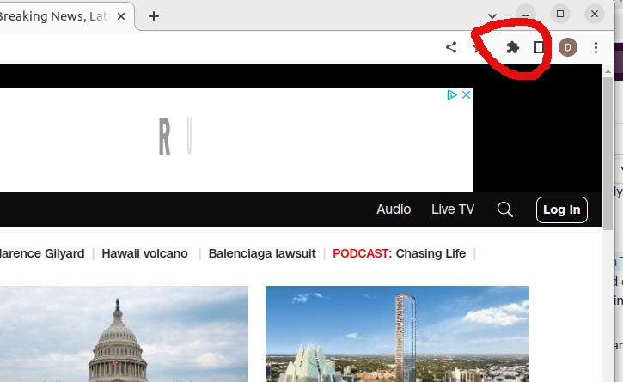Figure 1: Extensions selection icon on chrome browser.

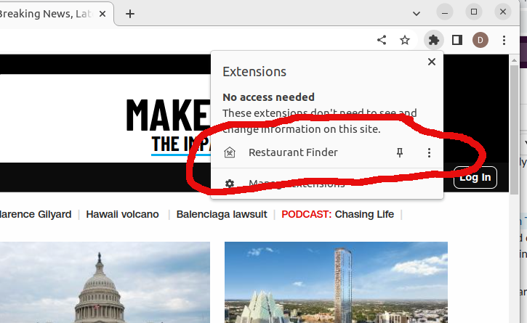From this icon a drop down of all your available extensions will appear, in that list you should now see RestaurantFinder, you can either pin it or just select it to run the extension.

If you choose to pin it, then you will see a house with fork and knife crossed inside (see below).

