Getting Started :: PlotCsv

Note: The application is not yet fully implemented and the user should expect several bugs or none-working features.

Requirements:

* Anaconda - Python 3.5
  + Numpy
  + PyQt
  + Pandas
  + Pyqtgraph

Setup:

* Install Anaconda packages and the Python executable to the environment path.
  + Suggested name of the virtual environment – python35
  + python35 preconfigured package is available in PHX test rig – to be copied to the envs directory inside the Anaconda installation directory.

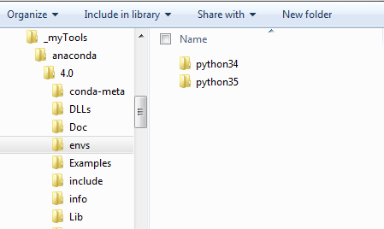

* Run the PlotCsv.bat file

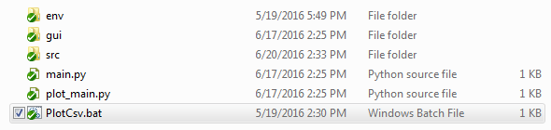

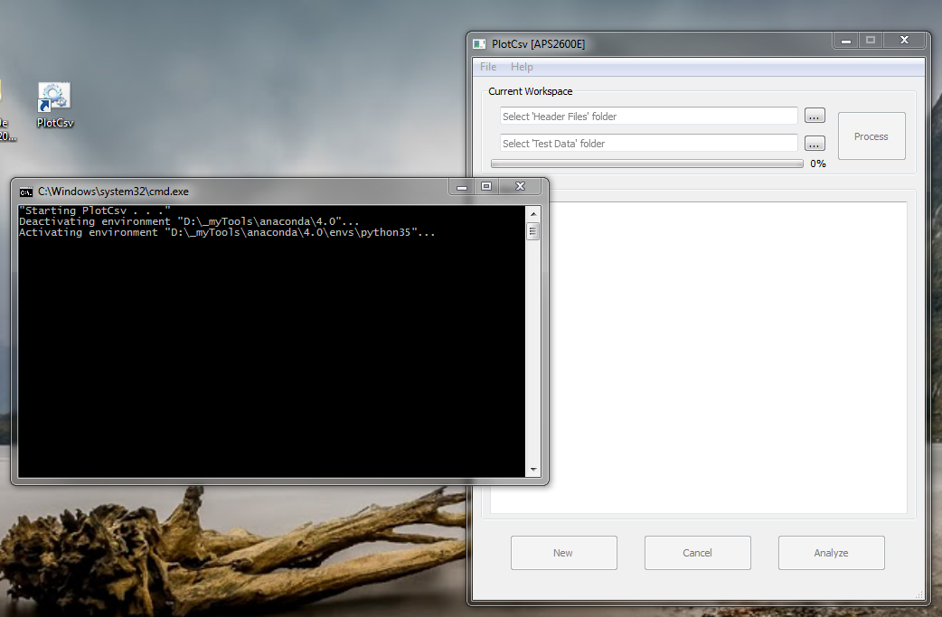

Operations:

* Browse or drag Header Files and Test Data folders on each fields accordingly.
  + Process button will activate.
  + If the test data were previously processed, the Analyze button gets activated as well.

Bug Note: New and Cancel button are not yet working as expected.

Bug Note: Avoid clicking the Analyze button while the conversion is running, the files are being generated and old files are overwritten.

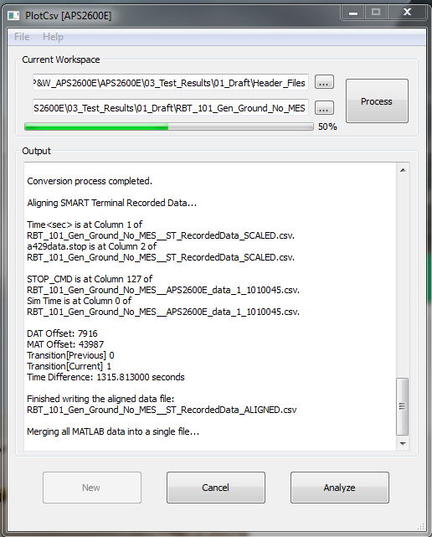

* After the conversion of data files is finished, click the Analyze button and the PlotViewer window is launched with the test name on its title bar and the alignment plot at the lower part. It is suggested to maximize the window for better viewing.

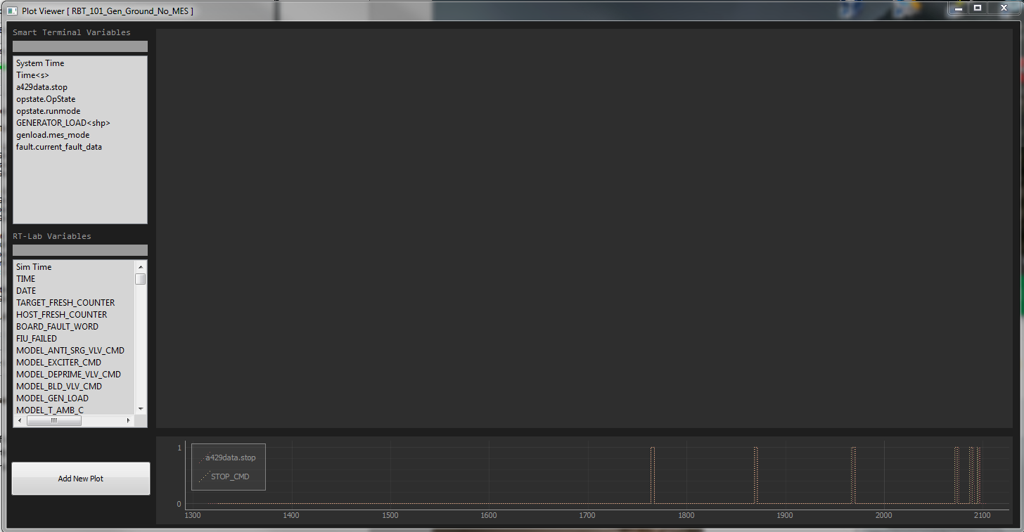

* + Smart Terminal variables list and RT-Lab variables list have their filter box that filters the names as the user type in the query.
  + To create a new plot, click the Add New Plot button and click and drag the variable from the list to the plot area. The graph will be automatically scaled

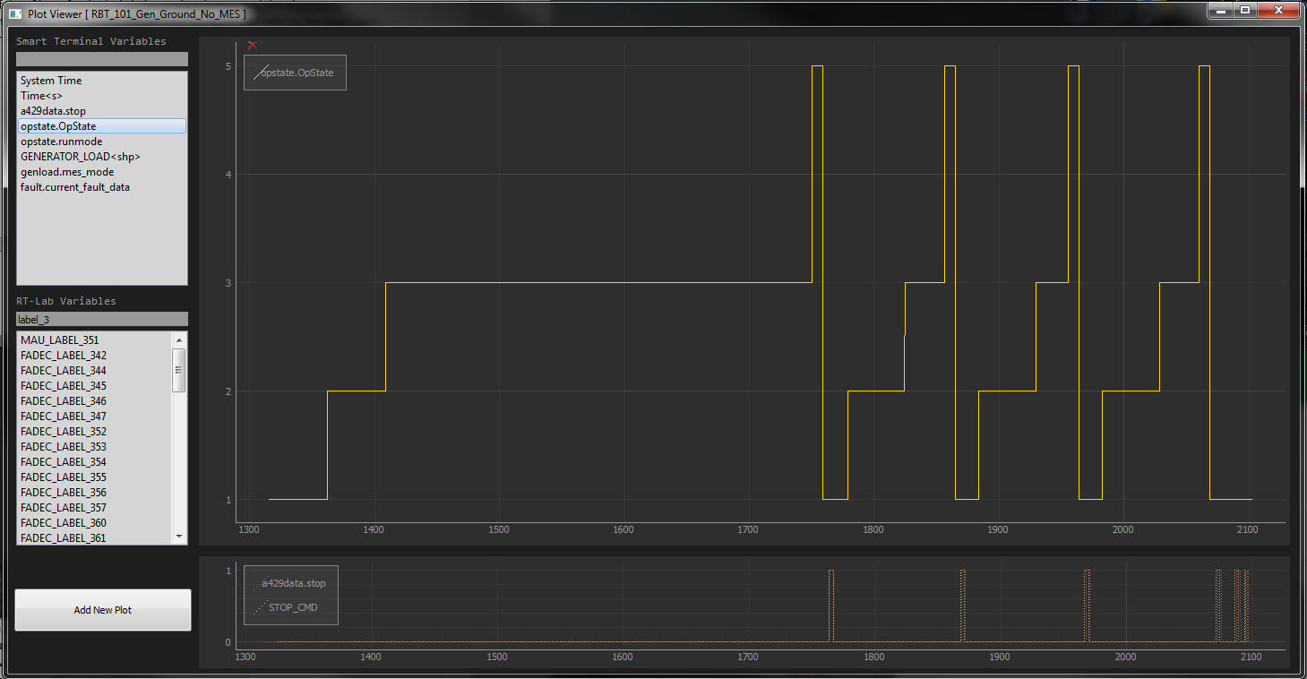

* Interactivity
  + Filter search
  + Drag and drop of data to plot area
  + Selecting a plot curve and pressing Delete key to delete it
  + Right-Click menu
  + Pressing Escape key will refresh the currently active plot
  + Double-clicking inside the plot area will add a vertical line marker
  + Shift-double-clicking inside the plot area will add a horizontal line marker
  + Line markers can be dragged anywhere inside the plot area
  + Panning and Zooming by using the mouse wheel or click-dragging in the plot area
  + Exporting images can be done with the Right-click Menu or screen capturing
  + Resetting the scale can be done by hovering on the plot area and clicking the A button

