

Practices for Secure Software Report

Table of Contents
Document Revision History 3
Client 3
Instructions 3
Developer 4
1. Algorithm Cipher 4
2. Certificate Generation 4
3. Deploy Cipher 4
4. Secure Communications 4
5. Secondary Testing 4
6. Functional Testing 4
7. Summary 4
8. Industry Standard Best Practices 4

Document Revision History

Version | Date | Author | Comments
1.0 | October 17, 2026 | Kyle Atkins | Initial version

Client
Artemis Financial



Instructions

Submit this completed practices for secure software report. Replace the bracketed text with the relevant information. You must document your process for writing secure communications and refactoring code that complies with software security testing protocols.

- Respond to the steps outlined below and include your findings.
- Respond using your own words. You may also choose to include images or supporting materials. If you include them, make certain to insert them in all the relevant locations in the document.
- Refer to the Project Two Guidelines and Rubric for more detailed instructions about each section of the template.

Developer
Kyle Atkins

Algorithm Cipher

For Artemis Financial I recommend a layered approach that fits the three jobs the company needs done. SHA-256 provides the checksum that proves a file was not changed in transit. AES with a 256-bit key, used in Galois/Counter Mode (AES-256-GCM), protects client data at rest and encrypts the bulk of the traffic once a connection is open. RSA with a 2048-bit key, carried in an X.509 certificate, lets the server prove who it is and lets the browser and server agree on a session key during the TLS handshake. The code in this project deploys the SHA-256 checksum and the RSA certificate for HTTPS, and AES-256-GCM is the recommended cipher for anything Artemis stores or archives.
A hash function is a one-way function that turns data of any size into a fixed-length digest. SHA-256 belongs to the SHA-2 family published by NIST and produces a 256-bit digest (64 hexadecimal characters). Changing even one bit of the input changes the digest completely, and it is not feasible to find two inputs with the same digest or to work backward from a digest to the input. That makes it suitable for verifying integrity. MD5 (128 bits) and SHA-1 (160 bits) have known collision attacks and should not be used. SHA-512 offers a longer digest but SHA-256 is sufficient and widely supported. A bare hash does not prove who sent the data, so the checksum is delivered over HTTPS, which authenticates the server.
AES is a symmetric block cipher with a 128-bit block and key sizes of 128, 192, or 256 bits. Symmetric encryption uses one shared secret key to encrypt and decrypt, so it is fast and well suited to large amounts of data, but the key must be shared and stored safely. Asymmetric encryption such as RSA uses a public and private key pair, so the public key can be handed out freely. It is much slower, so in TLS it is used only to authenticate the server and establish a shared symmetric session key. GCM mode adds authentication to AES so tampering is detected as well as hidden. Random numbers matter because the strength of every key depends on unpredictability. Keys, initialization vectors, and nonces must come from a cryptographically secure generator (SecureRandom in Java), and a GCM nonce must never repeat with the same key.
Encryption has changed a great deal over time. DES, adopted in 1977 with a 56-bit key, became too easy to brute force, and Triple DES stretched its life but is slow and now deprecated. NIST selected Rijndael as the Advanced Encryption Standard in 2001, and AES remains the standard today. RSA, published in 1977, made public key cryptography practical. Hash functions followed a similar path: MD5 and SHA-1 were broken, SHA-2 became the standard, and SHA-3 was standardized in 2015 as a backup design. Transport protocols moved from SSL to TLS, and TLS 1.3 (2018) removed older weak options. Today the main open concern is quantum computing, which could break RSA, so NIST has standardized post-quantum algorithms and organizations are beginning to plan migrations. AES-256 and SHA-256 are considered to hold up well against that threat.

Certificate Generation
I generated a self-signed certificate with the Java keytool using RSA with a 2048-bit key and the SHA256withRSA signature algorithm, stored in a PKCS12 keystore (keystore.p12) with the alias artemisfinancial. The certificate is issued to CN=localhost and includes localhost and 127.0.0.1 as subject alternative names so a browser can match it to https://localhost:8443. It is valid for 365 days. I then exported the public certificate to server.cer with keytool -exportcert.

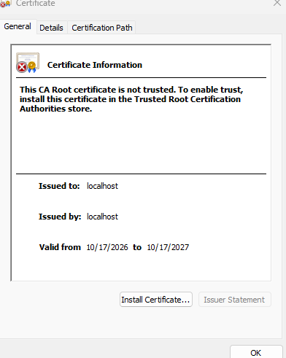

Deploy Cipher
I added a ChecksumController class with a /hash route. It takes the static string "Hello Kyle Atkins - Artemis Financial Check Sum!", computes its SHA-256 digest with Java's MessageDigest using UTF-8 bytes, converts the result to lowercase hexadecimal, and returns the data, the algorithm name, and the checksum. The expected checksum for that string is 30d2c618420ce5cf462d02bdd0ac8ad04946908ad123d579ed9b325262fa8ee3, which I confirmed independently with sha256sum so the browser output can be compared to a second source.

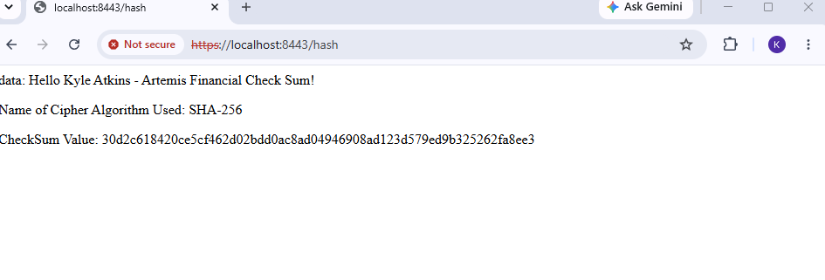

Secure Communications
In application.properties I replaced the placeholder entries with HTTPS settings: server.port=8443, server.ssl.enabled=true, the keystore location (classpath:keystore.p12), the keystore type (PKCS12), and the key alias. The keystore password is read from the KEYSTORE_PASSWORD environment variable, with a local development default so the project runs for grading; a production deployment would set the variable and use a CA-signed certificate. After starting the application, https://localhost:8443/hash is served over TLS. Because the certificate is self-signed, the browser shows a warning until the certificate is trusted manually.

Secondary Testing
I ran the OWASP dependency-check Maven plugin (version 12.1.0) against the refactored project using the National Vulnerability Database as the data source. The Sonatype OSS Index analyzer was turned off because it requires a login and returned a 401 error, so the results come from NVD data. The scan completed successfully and wrote an HTML report. The report shows 49 dependencies scanned (31 unique), with 16 vulnerable dependencies and 295 known vulnerabilities in total. These are all in libraries that were already part of the original Spring Boot 2.2.4 project, including the Spring Framework, embedded Tomcat, Jackson, SnakeYAML, Logback, and Log4j libraries. None of the findings relate to the code I added: the checksum controller uses only Java's built-in java.security.MessageDigest and introduces no new third-party libraries. The long-term fix for the existing findings is to upgrade Spring Boot to a current supported release, which was outside the scope of this refactoring.
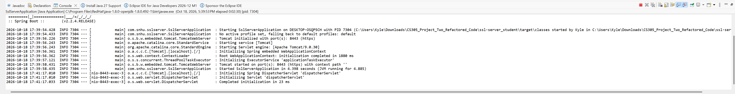
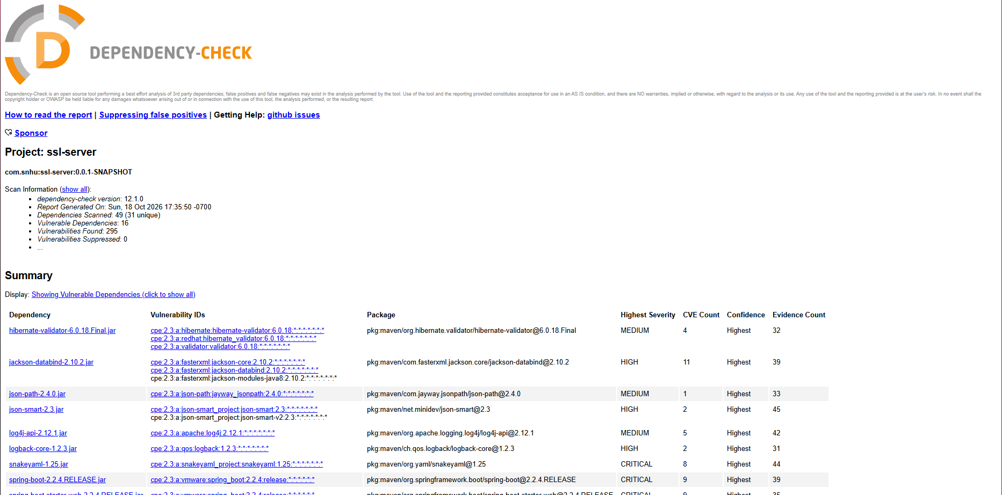

Functional Testing
I reviewed the added code by hand for syntax, logic, and security problems. Syntax: the controller imports only classes it uses, and all code paths return a value. Logic: the checksum is computed from UTF-8 bytes so the result does not depend on the platform's default character set, and each byte is formatted with two hex digits so leading zeros are not lost. Security: the endpoint accepts no user input, so there is no injection path; SHA-256 is used instead of MD5 or SHA-1; the failure case returns a generic error message instead of exposing internal details; HTTPS is enforced through the SSL properties; and the keystore password is not hard-coded without an override. One remaining concern is that the project still runs on Spring Boot 2.2.4, an old release that should be upgraded in a real deployment.

Summary

Using the vulnerability assessment process flow, I focused on encryption, client/server communication, and input and output handling. Encryption was addressed by recommending AES-256-GCM, RSA-2048, and SHA-256 and deploying the last two. Communication was addressed by enabling TLS on port 8443 with a self-signed RSA certificate. Integrity was addressed by adding the /hash route that returns a SHA-256 checksum so a recipient can confirm data was not changed. The code uses standard Java and Spring libraries, so there is no custom cryptography to maintain.
I added security in layers rather than relying on one control. First the transport is encrypted and the server is authenticated by HTTPS. Second the checksum lets the receiver detect any change in the data itself, even if it is stored or relayed elsewhere. Third the dependency-check scan looks for known vulnerabilities in the libraries, and manual review looks for flaws in the code I wrote. After each change I rebuilt and retested so that no step introduced a new problem.

Industry Standard Best Practices

I relied on well-established libraries and standards instead of inventing my own: Java's MessageDigest for hashing, the platform TLS implementation through Spring Boot, and the standard PKCS12 keystore format. I chose a current algorithm (SHA-256) over deprecated ones, used explicit UTF-8 encoding, kept the endpoint free of user input, avoided leaking details in error messages, and moved the keystore password into an environment variable with documented fallback. I also kept the existing dependency-check plugin in the build so that vulnerable libraries are flagged every time the code is compiled, and I commented the code so future developers understand what each part does.
These practices protect Artemis Financial's overall well-being. Clients trust the company with savings, retirement, and insurance information, and a breach would bring financial loss, regulatory trouble, and damage to its reputation. Secure coding is far cheaper to build in at the start than to fix after an incident, and a consistent, standards-based approach makes the software easier to audit, maintain, and defend to customers and regulators.

