1. What is the uniqueness/novelty added by you to the defined problem statement?

* Differentiate between “WHERE” used in English and “WHERE” used in Databases like SQL with the help of Custom Model trained on WATSON KNOWLEDGE STUDIO.
* All the answers should be arranged in an order of decreasing relevancy and should be accessed via Right and Left Arrow keys given in the UI
* User will be able to see the Backend Process live on Command Prompt to understand how many relevant questions are filtered.
* Best Answers are shown highlighted first. Next answers can be seen by next arrow
* Complex features are made based on Question title to check the text similarity with the user's query

1. How is the proposed solution impacting the business? How are the business processes simplified or bringing value over the existing process?
   1. Our Application can be easily tailored for a particular Programming Language,

So an organization can make their fresh developers in a specific domain learn faster as their query will be more accurately answered.

* 1. India alone has about 2.75 million developers and more than double of it are in the learning pipeline.

Our solution provides them easy to interact UI to search solution to their programming queries without any sign in.

* 1. This application can be easily containerised and thus easily portable.

1. Architectural flow of the proposed solution, with the mention of technologies to be used in developing the solution.

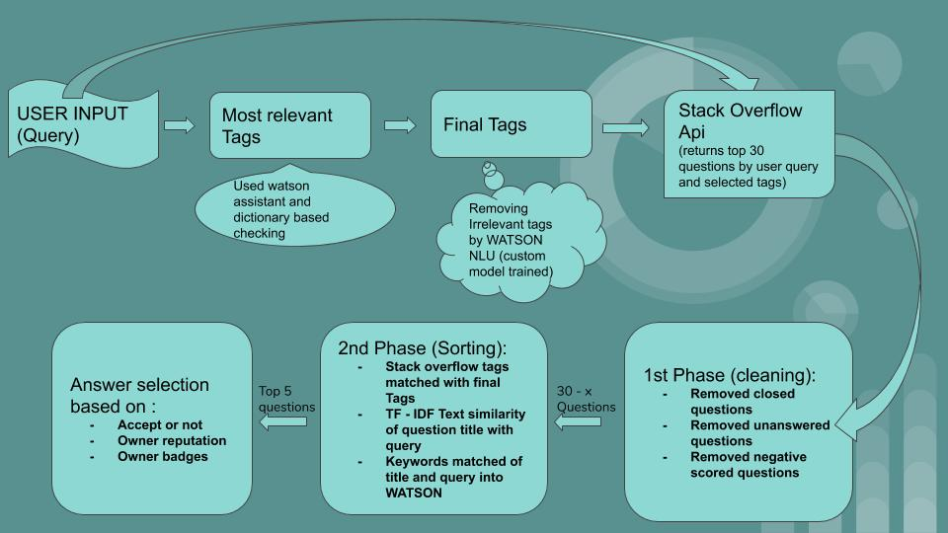

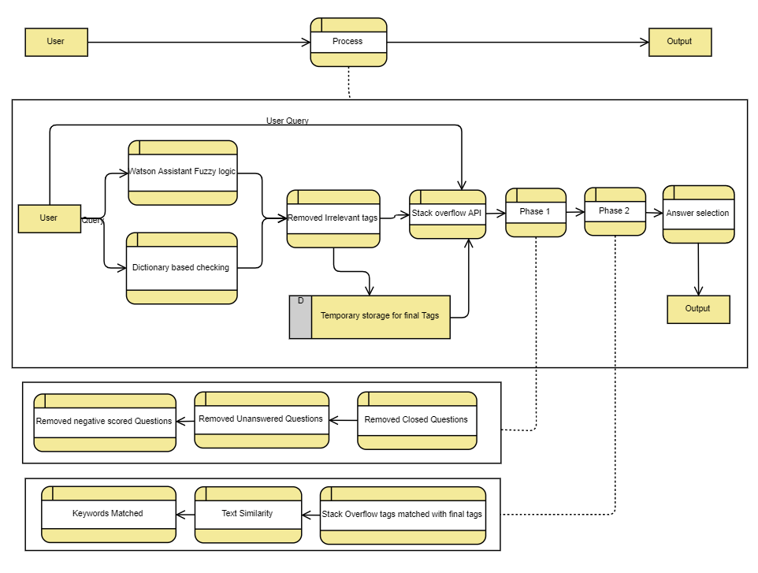  
4. Define the scope of work to be implemented in the project with modules etc.

* 1. Project Objectives:
     1. To identify most relevant questions to a query [text similarity]
     2. Identify the matching tags and pick top relevant questions from stack overflow.
     3. To identify top k solutions of the problem. (sentiment analysis of review content)
  2. Modules Needed:
     1. NLTK (open source library)
     2. SPACY (open source library)
     3. WATSON KNOWLEDGE STUDIO, WATSON ASSISTANT ,WATSON NLU
     4. PYQT FOR MAKING GUI
  3. Future Scope:
     1. Currently our application is using only the feature of Fuzzy logic ( just to get relevant Tags such as representing *.py* with *Python* ) from Watson assistant
     2. Further we are trying to implement a full **Chabot.** There is a possibility that the new users might not be able to form a structured query to get relevant answers hence this Chabot will start with collecting some tags Then further suggesting some common issues or can prompt user for a query using **Watson Assistant** just to give our user a friendly experience that they are talking to a human which is always there to help although it’s a simple Chabot.