**mount nfs: //mount 就是顯示你要動作的資料夾的指令**

//在進行之前要先創一個maps_nfs的資料夾 把資料丟進去

mkdir maps_nfs

//加入host表 目的是為了讓下面的執行句可以認得domain name

1.連到172.19.88.111(存放domain name的host端)

2. 輸入vim /etc/hosts 進入host表 將所有ip複製

3. 到本地端 輸入sudo vim /etc/hosts 之後輸入密碼 就可以進去 將下列IP貼進去並儲存離開

//除了maps_nfs的ip不用更動外 其餘的都要改成測試環境的IP

10.63.3.150 maps_services

10.63.3.150 maps_jobmanager

10.63.3.150 maps_frontend

10.63.3.150 maps_backend

10.63.3.150 maps_database

10.63.2.177 maps_nfs

10.63.3.150 maps_portal

10.63.3.150 micro_services

10.63.3.150 micro_services_db

10.63.3.150 maps_internal_portal

10.63.3.150 maps_update_server

10.63.3.150 maps_internal_update_server

10.63.3.150 maps.x1apps.com

//接著加入每次開機都要做的事情(這邊要注意的是修改重要指令都要加sudo才可以修改內容 離開時 記得在後面打! Ex: wq!)

sudo vim /etc/rc.local

//把下面這句加進去裡面//這裡的formal_maps_nfs是正式環境裡的資料夾 所以在測試環境裡的話請把formal_maps_nfs改為maps_nfs

sudo mount -t nfs maps_nfs:/home/foxconn/formal_maps_nfs /home/foxconn/maps_nfs

//確認 mount是否有成功 可以先reboot在進入mount的資料夾看裡面的檔案是否有mount到

sudo reboot

(測試環境不要用mount 怕會修改到共同資料 所以改用scp(copy的方式) 查詢指令是ls 查詢隱藏檔是ls -al)

scp -r /home/foxconn/.maps.config foxconn@10.63.3.150:/home/foxconn/

scp -r /home/foxconn/maps_nfs foxconn@10.63.3.150:/home/foxconn

ls→cd 資料夾名稱→看資料有沒有在 然後再打 mount |grep nfs 確認mount路徑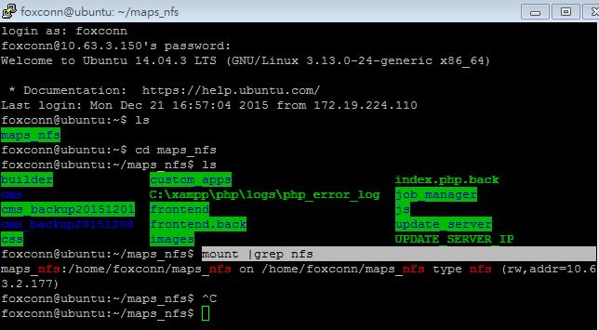

**Update server: (灰色部分暫時不作)**

sudo vi /etc/apache2/apache2.conf

<Directory /var/www/update>

Options Indexes FollowSymLinks Includes ExecCGI

AllowOverride All

Require all granted

Allow from all

</Directory>

sudo a2enmod rewrite && sudo service apache2 restart

//接著可以進行測試用手機連web 輸入http://你的ip /iOS/apps/ 或是 輸入 http://你的ip

如果有看到畫面的話就是成功了

**DB**

**//前置作業先到一個好的環境把DB資料抓出來 可以到10.63.3.152抓**

**//** DB schema export **(好的環境裡 ex:10.63.3.152 大於是寫入的意思)**

mysqldump -u root -p "Notification Pusher" > schema.sql

//將資料傳到自己的環境(很常用)

scp -r schema.sql foxconn@10.63.3.150:/home/foxconn/

(sc用法 scp –r 來源+目的:傳送的位置 )

Ex: scp –r /home/foxconn/maps/schema.sql foxconn@10.63.3.150:/home/foxconn/schema.sql

/home/foxconn/maps/schema.sql→來源

foxconn@10.63.3.150→目的

:/home/foxconn/schema.sql→傳送的位置(冒號一定要加)

//接著要建置DB的table

1. mysql –u root –p //會進入以下畫面

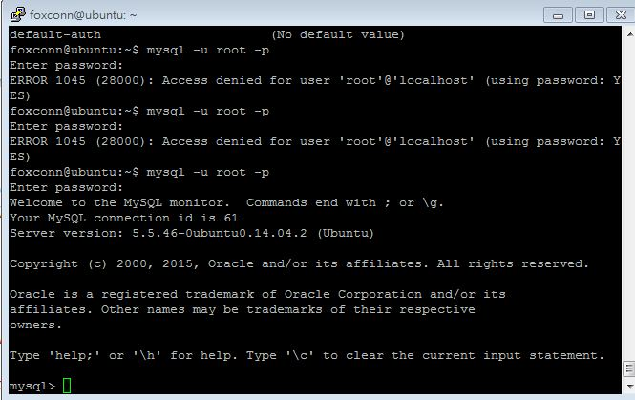

2.輸入CREATE DATABASE `Notification Pusher` CHARACTER SET utf8 COLLATE utf8_unicode_ci;

//確認DB的指令 show databases;

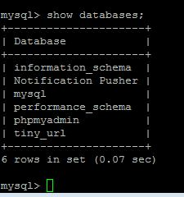

//進入DB的指令 use `DB name`; ex:use `Notification Pusher`;

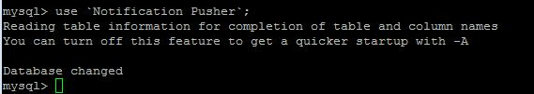

//確認table的指令 show tables;

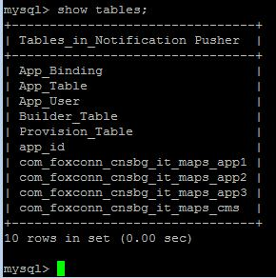

// DB schema import 把抓下來的資料匯入(自己的環境 小於就是匯入的意思)

mysql -u root -p "Notification Pusher" < schema.sql

#建立DB

//以下都是Mysql指令 所以記得進入DB mysql –u root –p

mysql> create database tiny_url;

#測試用 開啟對外連線(要做或不做都可以)-----------------------------------------

//開放全線

db$ GRANT ALL ON *.* TO 'root'@'%' IDENTIFIED BY 'Foxconn' WITH GRANT OPTION;

//套用 按鈕

db$ FLUSH PRIVILEGES;

#測試用 開啟對外連線(要做或不做都可以)

vi /etc/mysql/my.cnf

# 找到下列兩行，拿掉或加上註解後儲存離開(要做或不做都可以)-------------------------------

skip-external-locking

bind-address = 127.0.0.1

# UTF-8

sudo vi /etc/mysql/my.cnf

[mysqld](從下面開始 加進去)

init_connect='SET collation_connection = utf8_unicode_ci'

init_connect='SET NAMES utf8'

character-set-server=utf8

collation-server=utf8_unicode_ci

# 重新啟動服務

sudo /etc/init.d/mysql stop

sudo /etc/init.d/mysql start

# stored procedures(儲存 程序):

mysql -u root –p

//進入使用的DB裡 這裡是Notification Pusher

use `Notification Pusher`;

(建議)

delimiter //

CREATE PROCEDURE select_usable_provision_id (in app_name varchar (20))

BEGIN

DECLARE app_id varchar(50);

START TRANSACTION;

select provision_app_id into app_id from Provision_Table where status = 'standby' LIMIT 1;

update Provision_Table set status = 'using' , bundle_app_name = app_name where provision_app_id = app_id;

select app_id;

COMMIT;

END;//

delimiter ;

delimiter //

CREATE PROCEDURE select_usable_builder_ip (in os varchar (50))

BEGIN

DECLARE ip varchar(50);

START TRANSACTION;

select Builder_IP into ip from Builder_Table where Builder_Status = 'Ready' and Builder_OS = os LIMIT 1;

update Builder_Table set Builder_Status = 'processing' where Builder_IP = ip;

select ip;

COMMIT;

END;//

delimiter ;

測試連線(看provision有沒有加入)

**Maps Services**

sudo vi /etc/apache2/ports.conf (編輯完要restart 指令sudo /etc/init.d/apache2 restart)

//將下面這行加入

Listen 81

sudo apt-get install libapache2-mod-jk

sudo vim /etc/libapache2-mod-jk/workers.properties

//將下列指令加入或修改

worker.list=worker1,loadbalancer

worker.worker1.port=8009

worker.worker1.host=maps_internal_portal

worker.worker1.type=ajp13

worker.worker1.lbfactor=1

worker.loadbalancer.type=lb

worker.loadbalancer.balance_workers=worker1

sudo vim /etc/libapache2-mod-jk/httpd-jk.conf

//將下列指令加入

<VirtualHost *:81>

JkMount /axis2/services/UrlManager worker1

JkMount /axis2/services/UrlManager/* worker1

JkMount /axis2/services/MAPsService worker1

JkMount /axis2/services/MAPsService/* worker1

</VirtualHost>

!//如果是正式環境下請把下面指令也加入(測試環境不用)

<VirtualHost *:445>

SSLEngine on

SSLCipherSuite ALL:!ADH:!EXP56:RC4+RSA:+HIGH:+MEDIUM:+LOW:+SSLv2:+EXP:+eNULL

SSLCertificateFile "/etc/letsencrypt/live/maps.x1apps.com/cert.pem"

SSLCertificateKeyFile "/etc/letsencrypt/live/maps.x1apps.com/privkey.pem"

JkMount /axis2/services/UrlManager worker1

JkMount /axis2/services/UrlManager/* worker1

JkMount /axis2/services/MAPsService worker1

JkMount /axis2/services/MAPsService/* worker1

</VirtualHost>

//將檔案移動

sudo ln -s /var/lib/tomcat7 /home/foxconn/tomcat

sudo vim ~/tomcat/conf/server.xml (編輯完要restart 指令: sudo /etc/init.d/tomcat7 restart)

//將下列程式加入或修改

<Listener className="org.apache.catalina.core.AprLifecycleListener" SSLEngine="on" />

<Connector port="8080" maxHttpHeaderSize="8192"

maxThreads="150" minSpareThreads="25" maxSpareThreads="75"

enableLookups="false" redirectPort="8443" acceptCount="100"

connectionTimeout="20000" disableUploadTimeout="true"

compression="on"

compressionMinSize="128"

noCompressionUserAgents="gozilla, traviata"

compressableMimeType="text/html,text/xml,text/plain,text/css,text/ javascript,application/x-javascript,application/javascript"

URIEncoding="UTF-8"

/>

<Connector port="8009" protocol="AJP/1.3" redirectPort="8443" />

<Engine name="Catalina" defaultHost="localhost" jvmRoute="worker1">

<Cluster className="org.apache.catalina.ha.tcp.SimpleTcpCluster"/>

//從10.63.3.160那copy tomcat 到測試環境(這裡是10.63.3.150)

scp -r /home/foxconn/tomcat foxconn@10.63.3.150:/home/foxconn/apache-tomcat-maps

//開始將webservice複製到 tomcat下

sudo cp -r ~/apache-tomcat-maps/webapps/axis2.war

~/tomcat/webapps/

sudo cp -r ~/apache-tomcat-maps/webapps/host-manager/

~/tomcat/webapps/

sudo cp -r ~/apache-tomcat-maps/webapps/manager/

~/tomcat/webapps/

sudo cp -r ~/apache-tomcat-maps/webapps/axis2/WEB-INF/lib

~/tomcat/webapps/axis2/WEB-INF/lib

sudo cp -r ~/apache-tomcat-maps/webapps/axis2/WEB-INF/services

~/tomcat/webapps/axis2/WEB-INF/

測試:

//http://172.20.10.10:81/axis2/services/listServices

http://10.63.3.150:81/axis2/services/MAPsService?wsdl