This guide shows how to configure an SMTP server and an LDAP Directory Service in order to run unit tests. The SMTP server used is James from the Apache foundation and the LDAP Directory Service is OpenDS.
James

How to generate Self-Signed Certificate
- Create a private key for the certificate:
You will be prompted for two passwords: the first one to protect the contents of the key store and the second one to protect the private key. To ease the configuration, both passwords will be the same ie “secret”.

keytool -genkey -alias james -keyalg rsa -dname "CN=bonita,O=ow2,C=org" -keystore keystore -storetype JKS

- Generate a self-signed certificate for the key:
Enter the same password as above ie “secret”

keytool -selfcert -alias james -validity 1825 -keystore keystore -storetype JKS

- Export the public key for the certificate

keytool -export -alias james -file james.crt -rfc -keystore keystore -storetype JKS

- Create a new trust store and import the server certificate into it either in a new file (in order to use certificate file) or in the JRE's database of trusted certificates
  - New trust store (in a file)

keytool -import -alias james -file james.crt -keystore trustjames -storetype JKS

  - trust store in the server's certificate in the JRE's database of trusted certificates

keytool -import -alias james -file james.crt -keystore <database> -storetype JKS

for example : <database> could be this:
"C:\Program Files\Java\jdk1.5.0_17\jre\lib\security\cacerts"

How to install the SMTP Server:

In order to install James, you need to install Java 2 Standard Edition, version 1.4 or higher and you need to set the environment variable JAVA_HOME before running James.

- Download the last version of James from James release mirrors and unpack the archive whenever you want to use it.

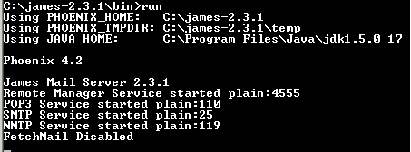
- Go to {james}\bin directory and execute the run command as below:
Note: To stop James, press CTRL+C

- Make the following changes in the {james}\apps\james\SAR-INF\config.xml
  - change the login and the password of the administrator account:

<administrator_accounts>
<account login="admin" password="jamessecret"/>
</administrator_accounts>
  - add a new domain
<servernames autodetect="true" autodetectIP="true">
<servername>localhost</servername>
<servername>bonita.org</servername>
</servernames>
  - enter the IP address of you DNS server or set the domain in your host file if no local DNS is installed
    - DNS server:

<dnsserver>
<servers>
<server>192.168.1.254</server>
</servers>
<autodiscover>false</autodiscover>
<authoritative>false</authoritative>
</dnsserver>
    - Hosts:
      - open the hosts file (.../etc/hosts)
      - add these lines at the end of the file
127.0.0.1 smtp.bonita.org
127.0.0.1 pop.bonita.org
  - change the port number of the SMTP server
<smtpserver enabled="true">
…
<port>10025</port>
…
</smtpserver>

- Add authentication (in the {james}/apps/james/SAR-INF/config.xml)
    - Comment or remove the mailet tag containing the class attribute “RemoteAddrNotInNetwork”. This tag can be found in the spoolmanager configuration block, in the root processor configuration.
    - Set the authRequired element of the smtpserver configuration block to true.
    - If you wish to ensure that authenticated users can only send email from their own account, you may optionally set the verifyIdentity element of the smtpserver configuration block to "true".

- Add TLS support
  - In config.xml, setup a different service for ssl/tls, using port 10465 (just duplicate the existing entry for the smtpserver service, change the name to smtpserver-tls and change the entries as shown below):

<smtpserver-tls enabled="true">
<port>10465</port>
<useTLS>true</useTLS>
…
</smtpserver-tls>
  - Enable the ssl factory section of <server-sockets> (shared with POP3S), replacing <file> with the appropriate certificate keystore address and setting the correct keystore password and private key password.

<factory name="ssl"
class="org.apache.avalon.cornerstone.blocks.sockets.TLSServerSocketFactory">
<ssl-factory>
<keystore>
<file>conf/trustjames</file>
<password>secret</password>
<key-password>secret</key-password>
<type>JKS</type>
<protocol>TLS</protocol>
<algorithm>SunX509</algorithm>
<authenticate-client>false</authenticate-client>
</keystore>
</ssl-factory>
</factory>
  - The smtpserver-tls service must be declared in assembly.xml (just duplicate the existing entry for the smtpserver service and change the name to smtpserver-tls):

<block name="smtpserver-tls" class="org.apache.james.smtpserver.SMTPServer">
<provide name="James" role="org.apache.mailet.MailetContext"/>
<provide name="mailstore" role="org.apache.james.services.MailStore"/>
<provide name="users-store" role="org.apache.james.services.UsersStore"/>
<provide name="sockets"
role="org.apache.avalon.cornerstone.services.sockets.SocketManager"/>
<provide name="connections"
role="org.apache.avalon.cornerstone.services.connection.ConnectionManager"/>
<provide name="James" role="org.apache.james.services.MailServer"/>
<provide name="thread-manager"
role="org.apache.avalon.cornerstone.services.threads.ThreadManager" />
</block>
  - Also add this to environment.xml to get log files (set the log-level as appropriate) (just duplicate the existing entry for the smtpserver category and change the name to smtpserver-tls):

<category name="smtpserver-tls" log-level="DEBUG">
<log-target id-ref="smtpserver-target"/>
</category>
In this example the log target is shared with smtpserver.

- Adding more security algorithms
  - Using JRE 1.4.x :
    - Download the appropriate jar file from http://www.bouncycastle.org/latest_releases.html
    - Put the jar in the {james}\lib directory (warning: not in the {james}\apps\james\SAR-INF\lib directory!).
    - Edit the {Program Files}\Java\j2re1.4.2\lib\security\java.security file, adding a security.provider.n=org.bouncycastle.jce.provider. BouncyCastleProvider line to the other security.provider lines, where n is the preference order.
  - Using JRE 1.5.x :
Copy the Sun JCE provider from provider from {JAVA_HOME}\lib\ext\sunjce_provider.jar file into the {james}\lib directory (warning: not in the {james}\apps\james\SAR-INF\lib directory!). The Bouncy Castle bcprov*.jar won't make it.

- Use telnet in order to access the JAMES Remote Administration Tool (James must be started):
  - type: telnet 127.0.0.1 4555
  - enter as login admin and as password jamessecret
  - once logged in, type help in order to know all the available commands
  - add users mailboxes, type:
adduser john.doe johnsecret
adduser yves.land yvessecret
adduser pierre.dupont pierresecret
adduser isabelle.martin isasecret
adduser marc.lechantre marcsecret
  - close the telnet connection (type quit)

- Restart James (Ctrl+C to stop it and run command)

More details about this SMTP server can be found on the James website.
OpenDS

How to generate Self-Signed Certificate

- Create a private key for the certificate:
You will be prompted for two passwords: the first one to protect the contents of the key store and the second one to protect the private key. To ease the configuration, both passwords will be the same ie “secret”.

keytool -genkey -alias bonita-ds -keyalg rsa -dname "CN=localhost,O=Bull,C=FR" -keystore keystore -storetype JKS

- Generate a self-signed certificate for the key:
Enter the same password as above ie “secret”

keytool -selfcert -alias bonita-ds -validity 1825 -keystore keystore -storetype JKS

- Export the public key for the certificate

keytool -export -alias bonita-ds -file bonita-ds.crt -rfc -keystore keystore -storetype JKS

- Create a new trust store and import the server certificate into it either in a new file (in order to use certificate file) or in the JRE's database of trusted certificates
  - New trust store (in a file)

keytool -import -alias bonita-ds -file bonita-ds.crt -keystore truststore -storetype JKS

  - trust store in the server's certificate in the JRE's database of trusted certificates

keytool -import -alias bonita-ds -file bonita-ds.crt -keystore <database> -storetype JKS

for example : <database> could be this:
"C:\Program Files\Java\jdk1.5.0_17\jre\lib\security\cacerts"

How to configure the Directory Service:
- Go to https://opends.dev.java.net/public/downloads_index.html and click on Install with QuickSetup of the latest stable version.
- Open the QuickSetup.jnlp application with javaws.exe
- Accept to execute the application despite of the security warning
- Choose “Install New Server Instance” and click on the “Next” button
- Configure OpenDs as below:
  - Server Settings
    - Type localhost in the “Host Name” field
    - Type 10389 in the “LDAP Listener Port” field
    - Type cn=Directory Manager in the “Root User DN” field
    - Type bonita-secret in the “Password” field
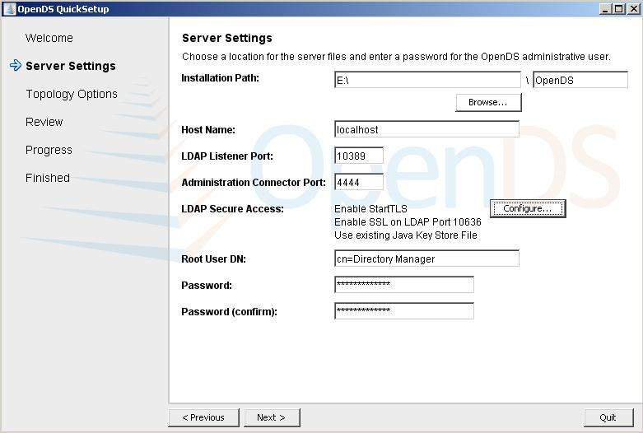

  - LDAP Secure Access:
    - Tick the SSL Access check box to indicate that the LDAPS listener should be enabled. Enter the port number on which the directory server listens for connections.
    - Tick the StartTLS Access to configure whether the LDAP connection handler will allow clients to use the StartTLS extended operation to initiate secure communication over an otherwise insecure connection.
    - Tick the “Use an Existing Certificate:” radio button to obtain the certificate that the server should use for secure access (SSL and TLS)
      - Type or Browse the path of the server key store in “the Key Store Path” field
      - Type the password of this key store in the “Key Store Pin” field: the password is secret
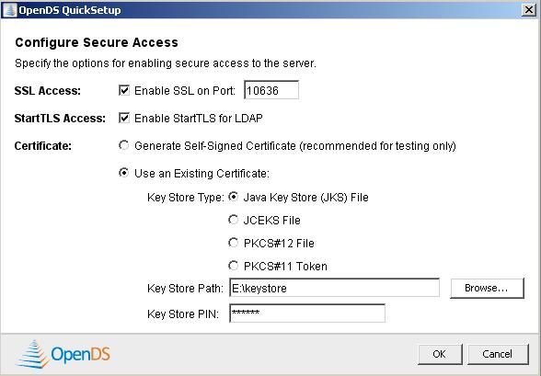

- Click on the “Next” button
- Tick “This will be a standalone server” radio button and click on the “Next” button

- Directory Data
  - Change the Directory Base DN to dc=bonita,dc=org
  - Tick “import Data from LDIF File” and type or browse the path to the bonitaDSTest.ldif file
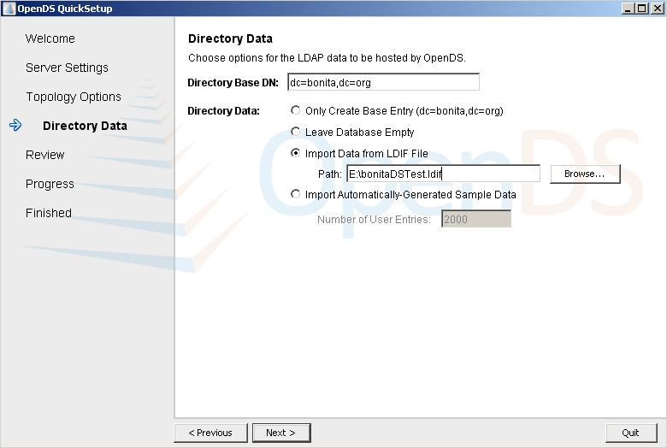
- Then click next, Have a look on the review window and click finish.
- Wait until the end of the installation progression and click on the “Launch Control Panel” button in order to check if the configuration is well set. Type the password bonita-secret and accept the self-signed certificate.

More details about this LDAP Directory Service can be found on the OpenDS website.

