Sensecanvas: Ultimate PC Hardware Sensor Monitoring Dashboard

Overview
Sensecanvas is a highly customizable, real-time PC hardware monitoring dashboard designed for tech enthusiasts and PC gamers. It combines futuristic, sci-ti aesthetics with powerful personalization tools, allowing users to create immersive, shareable dashboards tailored to their setups. The focus is on user experience: drag-and-drop editing, Al-generated layouts and widgets, stunning SVG-based visuals, and seamless real-time data streaming. Whether you're overclocking your GPU during a gaming session or monitoring temperatures in a professional rig, Sensecanvas provides an elegant, efficient interface that feels like a high-tech command center.
Built with a customization-first mindset, Sensecanvas empowers users to export/import JSON configurations for dashboards, themes, widgets, and layouts fostering a community where gamers share epic RGB-themed setups or enthusiasts collaborate on optimized monitoring presets.

Key Features
Real-Time Hardware Monitoring
Continuously polls and displays metrics for CPU (usage, temperature, frequency, power, per-core data), GPU (usage, temperature, VRAM, fan speed, power), memory (total, used, available, usage), storage (usage, temperature, read/write speeds, IOPS), network (bandwidth up/down, packets), fans, voltages, and motherboard sensors.
User-defined refresh rates and fallback to basic monitoring (e.g., psutil) on non Windows platforms.
Historical data viewing with charts and export options.

Customizable Dashboard

.. _. &. ... _

_. "T"----■•- •--"---------. _: : -----• --1:.L.: ... !.LI--·"---••--··"'" ----!.L.-1- ·---.L- .... -- _.

t.011 Mooe: 1 u :H::lle ueLweer1 v1ewir1g uriu eu1ur1g w1u1 u Luu1uur w1Lc;r1. r-euLure gr1u based layout with adjustable snap sizes, collision prevention (visual feedback: green for valid, red for invalid positions), interactive resizing via handles (continuous click and-hold), boundary protection, and minimum size enforcement.
Widget Library: Drag-and-drop from a palette. Types include: Gauges (arc, speedometer, radial) for single metrics like CPU usage. Charts (line, bar, area) for trends using LayerChart.
Meters (horizontal bars) for progress-style displays. Simple widgets for single-value readouts.
Multi-resource widgets (e.g., CPU Essentials: primary gauge+ core mini-gauges; GPU Essentials: usage+ VRAM + fans).
Al-Powered Customization: Use Google Genkit to generate:
Dashboard layouts based on user preferences (e.g., compact for gamers, spacious for pros).
Custom widgets or widget groups (e.g., multi-sensor aggregates).
New SVG UI components by extending Cosmic UI methods (e.g., Al prompts to create futuristic frames or gauges).
Themes and Aesthetics: Sci-ti inspired with Cosmic Ul's SVG-first components. Presets: Gaming (green/orange), RGB (hue-shifting gradients), Neon (cyan/magenta), Cyberpunk (purple/gold), Minimal (clean blue). Customize via css variables, gradients, glow/pulse animations, and theme builder.
Layout Management: Save/load presets, import/ export JSON for sharing, reset to defaults. Supports tabs for multiple dashboards.
Alerts and Notifications: Custom thresholds trigger desktop notifications (with permission handling). Alert history and configurator for conditions.
Data Management: Export metrics as csv/JSON, set custom thresholds, view historical data.
User Experience Enhancements: Onboarding tutorial, keyboard shortcuts (Esc to cancel drag, Delete to remove widget, arrows for fine-tuning), undo/redo, widget grouping.

Cross-Platform Compatibility
Full support on Windows with advanced sensors (ad min privileges recommended for detailed data).
Fallback monitoring on other OS via psutil.

Architecture
Sensecanvas follows a full-stack design emphasizing modularity, reactivity, and real time performance.

Data Flow
Backend Collection: PyHardwareMonitor (via pythonnet and LibreHardwareMonitorlib.dll) polls hardware sensors periodically.
Processing and Validation: Data normalized with Pydantic models, converted to builtin types for serialization.
Real-Time Streaming: Broadcast via WebSockets using FastAPI.
Frontend Reactivity: WebSocket client updates Svelte 5 runes-based stores ($state for data, $derived for computations).
Al Integration: Genkit endpoints for generating layouts/widgets/SVGs, with context aware prompts (e.g., "Generate a cyberpunk gauge for GPU temp using Cosmic UI frames").
Persistence: LocalStorage/lndexedDB for layouts/themes; JSON export/import for sharing.
Suggested Redesign for Optimal ux
To align with a customization-first mindset, I've redesigned the architecture slightly from the source documents:
Unified Frontend State: Use Svelte 5 runes exclusively for reactivity (no legacy stores), with compartments in NeoDrag for dynamic grid/ axis updates.
Widget System Overhaul: All widgets extend Cosmic Ul's SVG frames for consistent sci-fi aesthetic. LayerChart handles visualizations with theme-aware styling (e.g., pulse animations on high values).
Al as Core Feature: Expand Genkit beyond layouts to widget creation (e.g., prompt: "Create a multi-gauge widget for CPU cores with RGB theme") and SVG extension (using Cosmic Ul's programmatic SVG methods).
Backend Enhancements: Add HTTP endpoints for Al requests and config persistence, alongside WebSockets. Ensure DLL is bundled in deployment.
Performance Optimizations: Use Canvas fallback in LayerChart for complex dashboards; reactive bounds in NeoDrag to prevent off-screen drags.
Community Focus: JSON schemas validated with Zod for safe imports; potential future API for user-shared presets.
This redesign ensures seamless integration: Cosmic UI + LayerChart for visuals, NeoDrag for interactivity, Genkit for intelligence, all reactive via Svelte 5 runes.

Core Technologies
Frontend
SvelteKit 2 / Svelte 5: Full-stack framework with runes ($state, $derived, $effect) for reactive state. Breaking changes handled: no writable stores; use $state for component locals.
TailwindCSS 4: Utility-first css with breaking changes (e.g., new color palette syntax) implemented via config.js. Integrates with Cosmic UI themes.
Typescript 5: Type-safe code with interfaces for sensors, widgets, Al responses.
Cosmic UI: SVG-first sci-ti library for components (e.g., Frame for widget containers, Chart extensions). Install: npm i cosmic-ui. Customize via props/slots/css vars; extend SVGs programmatically.
LayerChart@next: Svelte 5-compatible charting for gauges/ charts. Install: npm i layerchart@next. Core: <chart>, <layer>, <arc> with data binding/animations.</arc>
</layer>< / chart>
NeoDrag@next: Draggable/resizable directives. Install: npm i @neodrag/svel te@next.
Use {@attach draggable()} with plugins (grid, bounds, events).
Zod: Schema validation for widget configs/forms.
WebSocket Client: For real-time data.

Backend
FastAPI: Python web framework with WebSockets for streaming.
Pydantic: Data models/validation (e.g., HardwareMetrics).
PyHardwareMonitor (HardwareMonitor 1.0.0): Wrapper for LibreHardwareMonitorlib. Install: pip install HardwareMonitor. Requires pythonnet, .NET 4.7+, admin privileges for full sensors. DLL must be in same dir or referenced via cir.AddReference.
LibreHardwareMonitorlib: .NET DLL for deep hardware access (fork of Open Hardware Monitor).
pythonnet: Enables Python-.NET interop; load DLLs with clr.AddReference.
psutil: Fallback for cross-platform basics.

Al and Other
Google Genkit: For Al generation. Integrate via API endpoints; prompts use dashboard context.
Notification API: Browser alerts.

Project Structure
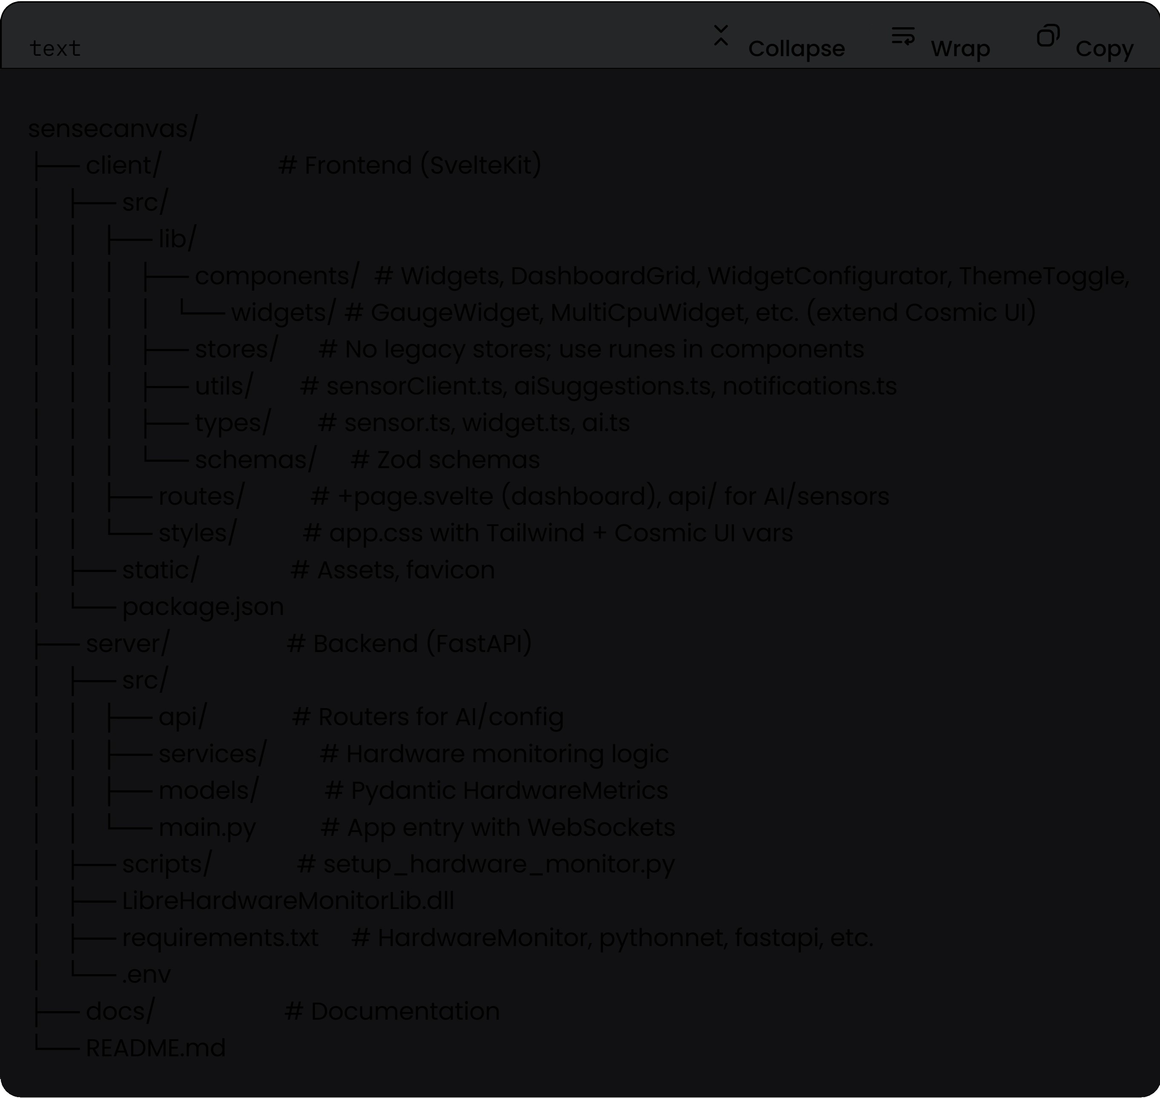

Getting Started
Prerequisites
Node.js 18+, Python 3.8+, pnpm, .NET Runtime 6+ (for DLL).

Installation
Clone repo: git clone <url> && cd sensecanvas
Frontend: cd client && pnpm install (includes layerchart@next, @neodrag/svelte@next, cosmic-ui, etc.)
Backend: cd .. /server && pip install -r requirements.txt && python scripts/ setup_hardware_monitor. py (place DLL here).
Config .env for ports/ CORS.

Running
Backend: uvicorn src. main: app - -reload - - host 0. 0. 0. 0 - - port 8000 (run as ad min for fu 11 sensors).
Frontend: cd client && pnpm dev .

Development Guide
Frontend
Use Svelte 5 runes: e.g., let data = $state( H); $effect(() => { I* WebSocket *I
});

Widgets: Extend Cosmic UI with LayerChart <arc> for gauges.</arc>
Edit Mode: NeoDrag with grid/bounds plugins; reactive compartments for dynamic snapping.
Al: Call / api/ai endpoint with Genkit; parse suggestions to update layout $state.

Backend
Monitoring: Use Computer() from HardwareMonitor; update() in interval, broadcast via WebSocket.
Al Endpoint: Integrate Genkit for prompts.

Testing
Vitest for units (widgets, stores).
Playwright for E2E (drag, Al apply, real-time updates).

Future Enhancements
Community marketplace for JSON presets. Mobile opp integration.
More Al: Auto-optimize layouts based on usage patterns.

This spec combines the best from sources: real-time from README/api_reference, edit features from dashboard_edit_mode, widgets/gauges from gauges_and_widgets, Al/architecture from sensecanvas-dashboard, with seamless tech integrations for a stellar UX.

