在第三题我们将比赛势头定义为了得分差。

我们在时间序列模型中，将时间定义为了小时：分钟，也就是我们每一次的发球时间为每一分钟，放宽了发球的具体时间，在一定程度上方便了时间序列模型的构造。

# 时间序列模型

## 时间序列图

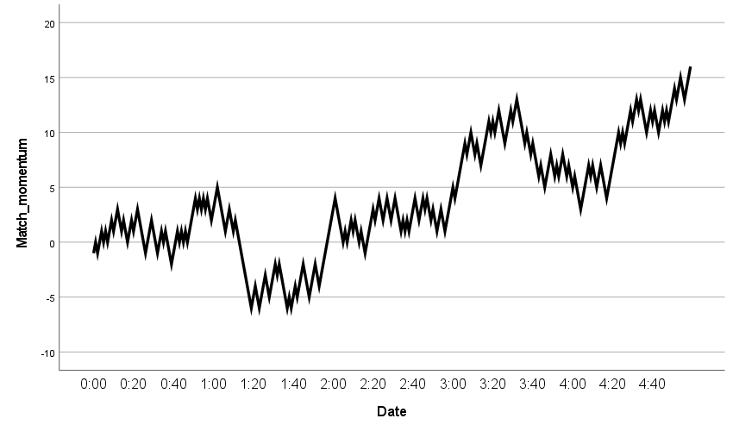

## 季节性分解（针对于本体要换个名字么？）

|  |  |  |
| --- | --- | --- |
| **Model Description** | | |
| Model Name | | MOD_9 |
| Model Type | | Multiplicative |
| Series Name | 1 | Match_momentum |
| Length of Seasonal Period | | 60 |
| Computing Method of Moving Averages | | Span equal to the periodicity plus one and endpoints weighted by 0.5 |
| Applying the model specifications from MOD_9 | | |

|  |  |
| --- | --- |
| **Seasonal Factors** | |
| Series Name: Match_momentum | |
| Period | Seasonal Factor (%) |
| 1 | 99.9 |
| 2 | -457.5 |
| 3 | -422.6 |
| 4 | -353.6 |
| 5 | -216.7 |
| 6 | 34.8 |
| 7 | -185.3 |
| 8 | 51.8 |
| 9 | 144.4 |
| 10 | 143.2 |
| 11 | 141.1 |
| 12 | 122.3 |
| 13 | 121.7 |
| 14 | 49.8 |
| 15 | 133.0 |
| 16 | 118.1 |
| 17 | 117.8 |
| 18 | 117.6 |
| 19 | 142.3 |
| 20 | 173.6 |
| 21 | 217.1 |
| 22 | 162.0 |
| 23 | 204.3 |
| 24 | 242.4 |
| 25 | 191.5 |
| 26 | 151.6 |
| 27 | 167.0 |
| 28 | 204.1 |
| 29 | 178.1 |
| 30 | 173.9 |
| 31 | 174.5 |
| 32 | 153.3 |
| 33 | 180.8 |
| 34 | 118.3 |
| 35 | 130.2 |
| 36 | 130.6 |
| 37 | 114.4 |
| 38 | 126.5 |
| 39 | 93.8 |
| 40 | 107.1 |
| 41 | 134.5 |
| 42 | 144.6 |
| 43 | 114.7 |
| 44 | 86.0 |
| 45 | 111.1 |
| 46 | 106.5 |
| 47 | 99.0 |
| 48 | 114.2 |
| 49 | 113.5 |
| 50 | 189.3 |
| 51 | 165.9 |
| 52 | 127.2 |
| 53 | 182.0 |
| 54 | 230.8 |
| 55 | 210.6 |
| 56 | 179.5 |
| 57 | 121.1 |
| 58 | 76.7 |
| 59 | 96.8 |
| 60 | 98.6 |

## 带有季节性因子的时间序列图

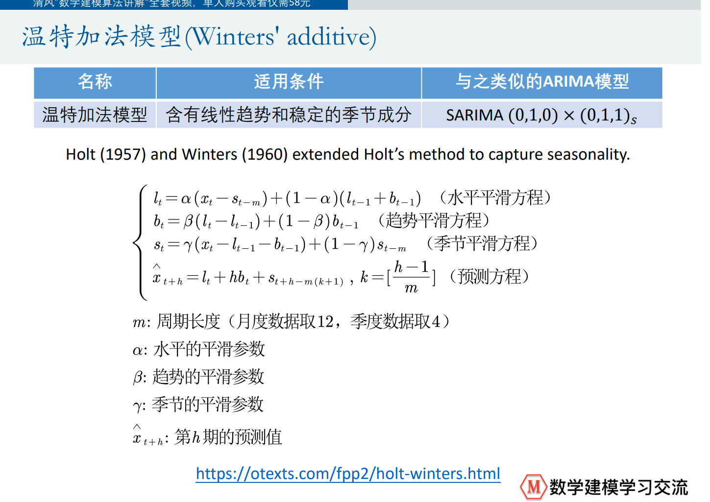

|  |  |  |
| --- | --- | --- |
| **该模型含有线性趋势和稳定的季节成分（相当于包含了比赛中得分周期性的变化，和比分连续的变化）——》从哪可以看出线性趋势和周期？是否有检验？**  **Model Description** | | |
| Model Name | | MOD_10 |
| Series or Sequence | 1 | Match_momentum |
| 2 | Error for Match_momentum from SEASON, MOD_9, MUL CEN 60 |
| 3 | Seasonal adjusted series for Match_momentum from SEASON, MOD_9, MUL CEN 60 |
| 4 | Seasonal factors for Match_momentum from SEASON, MOD_9, MUL CEN 60 |
| 5 | Trend-cycle for Match_momentum from SEASON, MOD_9, MUL CEN 60 |
| Transformation | | None |
| Non-Seasonal Differencing | | 0 |
| Seasonal Differencing | | 0 |
| Length of Seasonal Period | | 60 |
| Horizontal Axis Labels | | Date_ |
| Intervention Onsets | | None |
| For Each Observation | | Values not joined |
| Applying the model specifications from MOD_10 | | |

|  |  |  |  |  |  |  |
| --- | --- | --- | --- | --- | --- | --- |
| **Case Processing Summary** | | | | | | |
|  | | Match_momentum | Error for Match_momentum from SEASON, MOD_9, MUL CEN 60 | Seasonal adjusted series for Match_momentum from SEASON, MOD_9, MUL CEN 60 | Seasonal factors for Match_momentum from SEASON, MOD_9, MUL CEN 60 | Trend-cycle for Match_momentum from SEASON, MOD_9, MUL CEN 60 |
| Series or Sequence Length | | 300 | 300 | 300 | 300 | 300 |
| Number of Missing Values in the Plot | User-Missing | 0 | 0 | 0 | 0 | 0 |
| System-Missing | 0 | 0 | 0 | 0 | 0 |

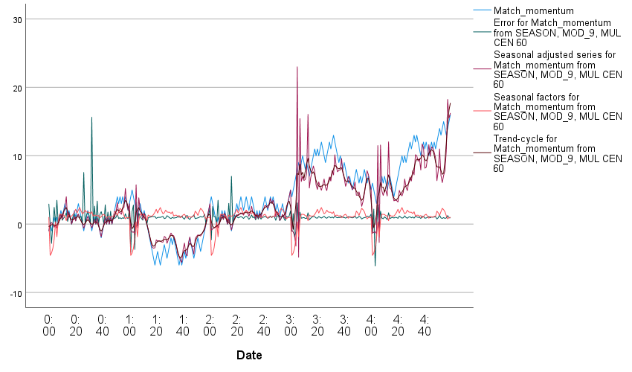

## 创建时间序列模型

|  |  |  |  |
| --- | --- | --- | --- |
| **Model Description** | | | |
|  | | | Model Type |
| Model ID | Match_momentum | 模型_1 | Winters' Additive |

|  |  |  |  |  |  |  |  |  |  |  |  |
| --- | --- | --- | --- | --- | --- | --- | --- | --- | --- | --- | --- |
| **Model Fit** | | | | | | | | | | | |
| Fit Statistic | Mean | SE | Minimum | Maximum | Percentile | | | | | | |
| 5 | 10 | 25 | 50 | 75 | 90 | 95 |
| Stationary R-squared | .607 | . | .607 | .607 | .607 | .607 | .607 | .607 | .607 | .607 | .607 |
| R-squared | .969 | . | .969 | .969 | .969 | .969 | .969 | .969 | .969 | .969 | .969 |
| RMSE | .892 | . | .892 | .892 | .892 | .892 | .892 | .892 | .892 | .892 | .892 |
| MAPE | 27.751 | . | 27.751 | 27.751 | 27.751 | 27.751 | 27.751 | 27.751 | 27.751 | 27.751 | 27.751 |
| MaxAPE | 168.572 | . | 168.572 | 168.572 | 168.572 | 168.572 | 168.572 | 168.572 | 168.572 | 168.572 | 168.572 |
| MAE | .786 | . | .786 | .786 | .786 | .786 | .786 | .786 | .786 | .786 | .786 |
| MaxAE | 1.711 | . | 1.711 | 1.711 | 1.711 | 1.711 | 1.711 | 1.711 | 1.711 | 1.711 | 1.711 |
| Normalized BIC | -.171 | . | -.171 | -.171 | -.171 | -.171 | -.171 | -.171 | -.171 | -.171 | -.171 |

|  |  |  |  |  |  |  |
| --- | --- | --- | --- | --- | --- | --- |
| **Model Statistics** | | | | | | |
| Model | Number of Predictors | Model Fit statistics | Ljung-Box Q(18) | | | Number of Outliers |
| Stationary R-squared | Statistics | DF | Sig. |
| Match_momentum-模型_1 | 0 | .607 | 26.922 | 15 | .029 | 0 |

|  |  |  |  |  |  |  |
| --- | --- | --- | --- | --- | --- | --- |
| **Exponential Smoothing Model Parameters** | | | | | | |
| Model | | | Estimate | SE | t | Sig. |
| Match_momentum-模型_1 | No Transformation | Alpha (Level) | .903 | .060 | 15.029 | .000 |
| Gamma (Trend) | 4.774E-5 | .012 | .004 | .997 |
| Delta (Season) | .001 | .387 | .003 | .998 |

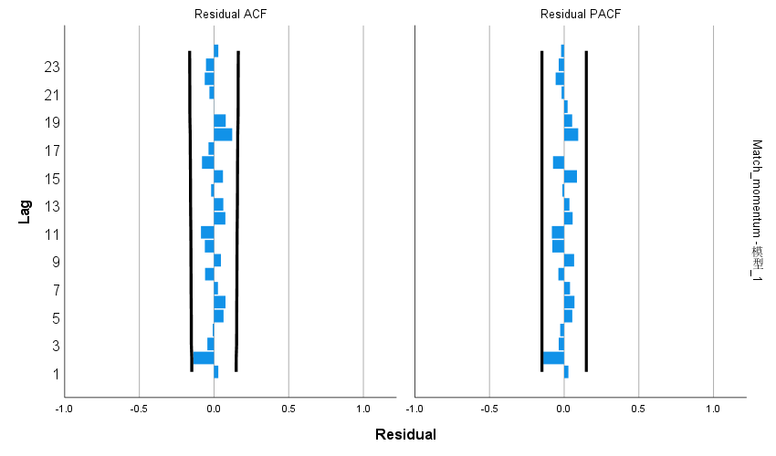

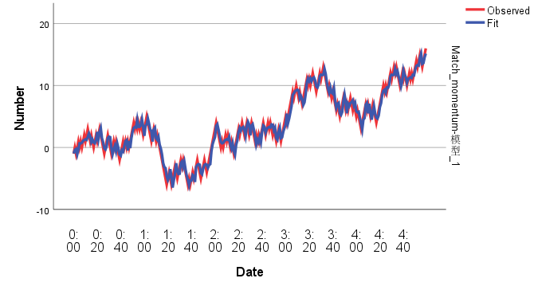

# 因素和上述指标“比赛势头match_momentum”相关

## ADF检验（没通过的差分）

ADF检验的p值:

match_momentum: 0.8581296800237611

double_fault: 0.0

winner_shot_type: 0.0

serve: 0.0

serve_no: 0.0

unf_err: 0.0

net_pt: 2.907750240594204e-29

break_pt: 0.0

y81: 2.9377683466895033e-29

y82: 2.4162146383200784e-08

y9: 5.0662073081573234e-11

y10: 2.1490681080551415e-23

ace: 3.1526046011816443e-06

score_rate: 3.0722156450910876e-17

M(t) player1: 2.709536634003313e-28

M(t) player2: 4.261906102146795e-29

Subtractive momentum: 3.0841757502686896e-18

differenced_data：2.689637184086286e-26

## Granger因果检验

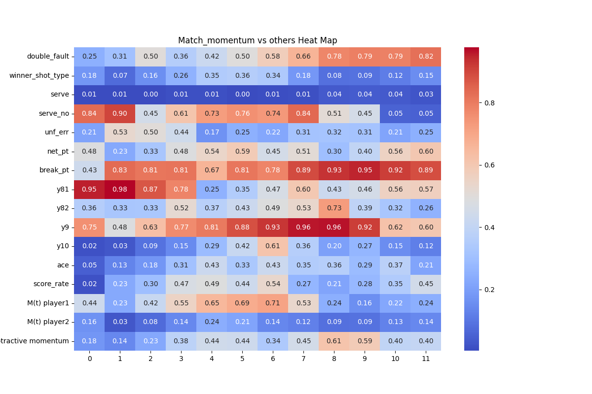

## 交叉性检验(差分后的数据分别和其他特征)

### Double_fault

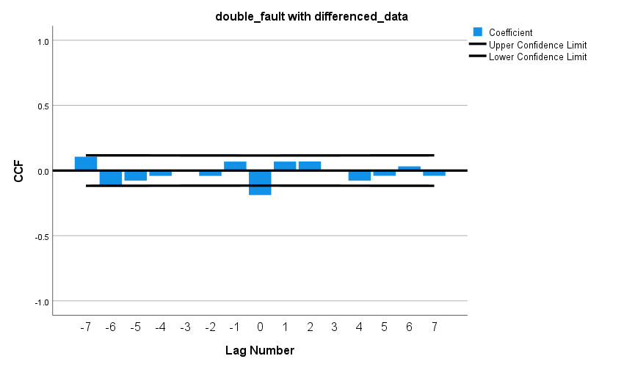

### Server

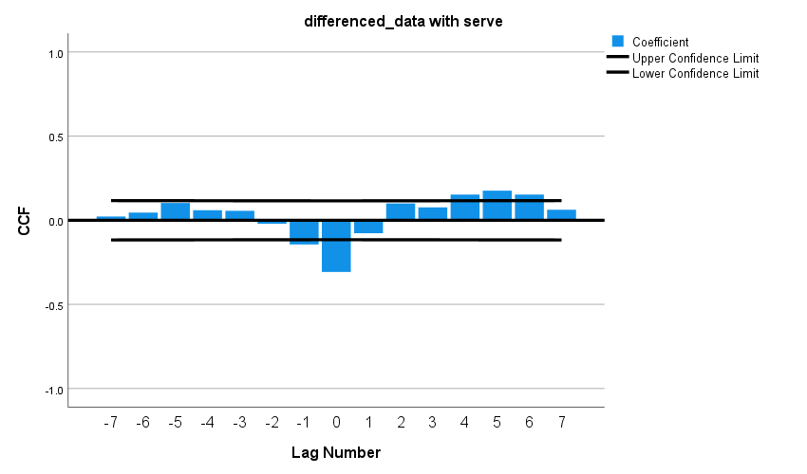

### Server_no

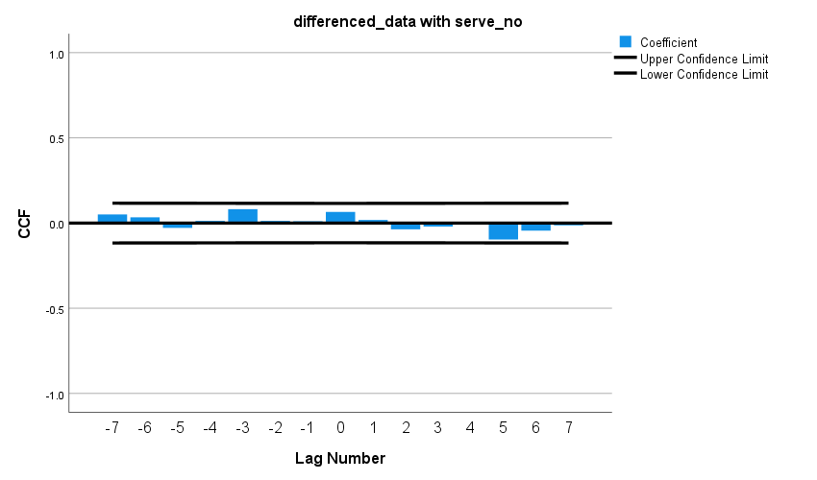

### Winner_shot_type

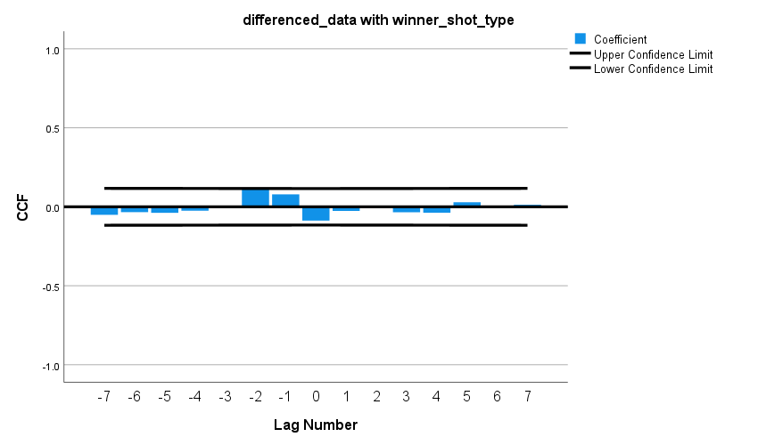

### Unf_err

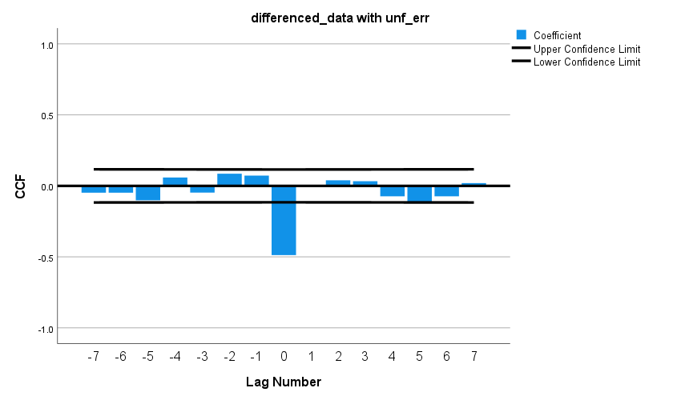

### Net_pt

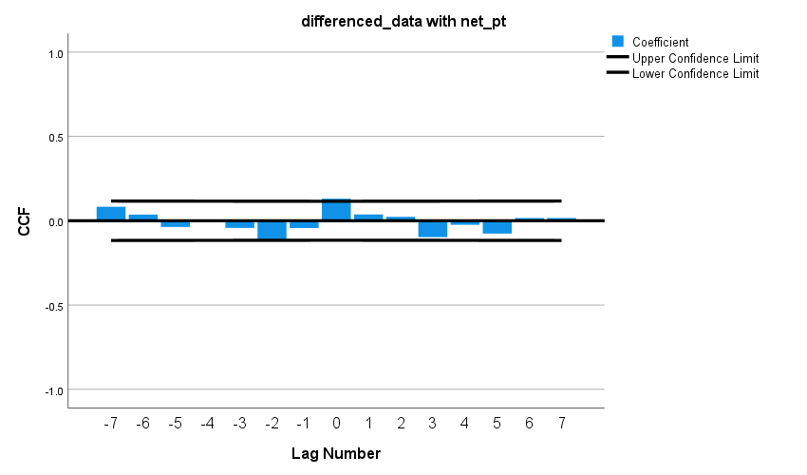

### Break_pt

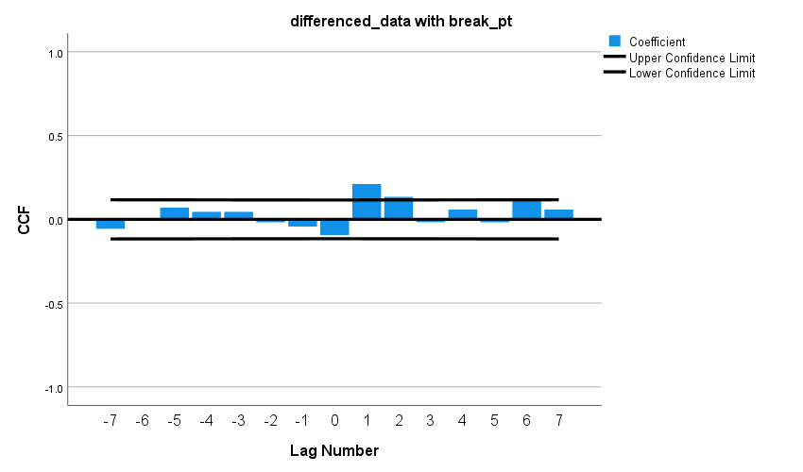

### Y81

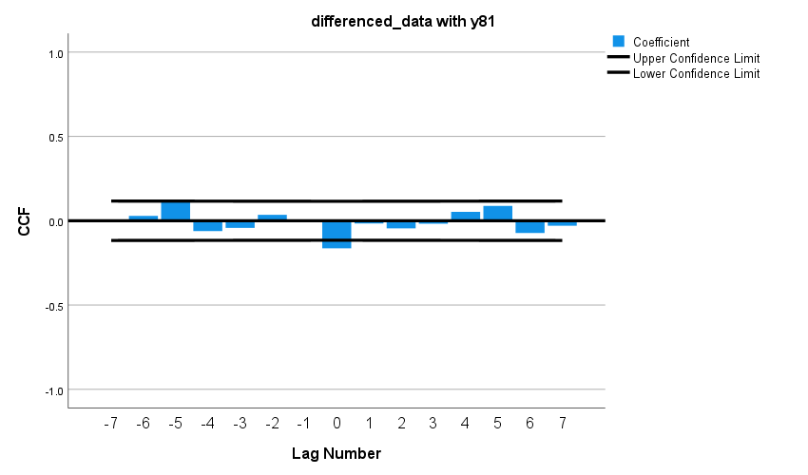

### Y82

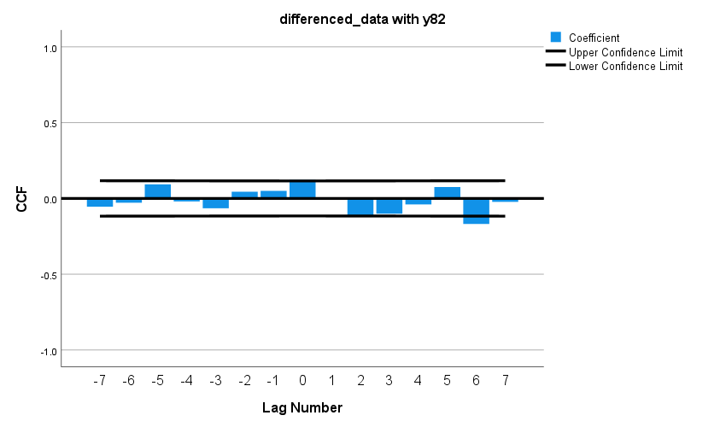

### Y9

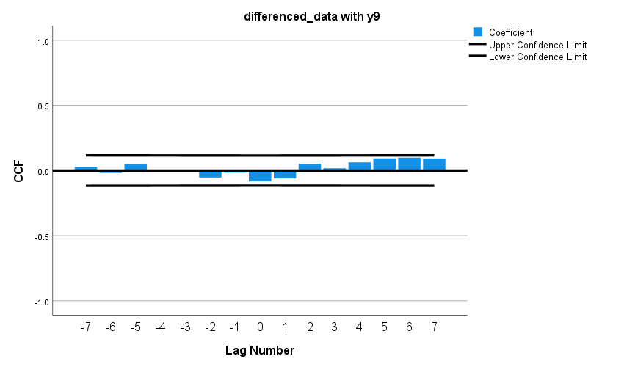

### Y10

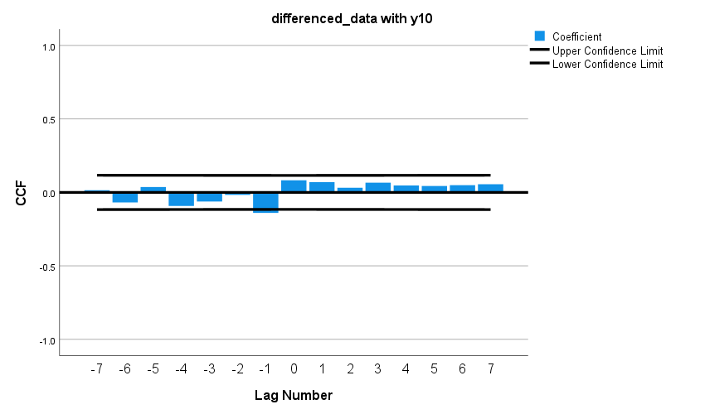

### Ace

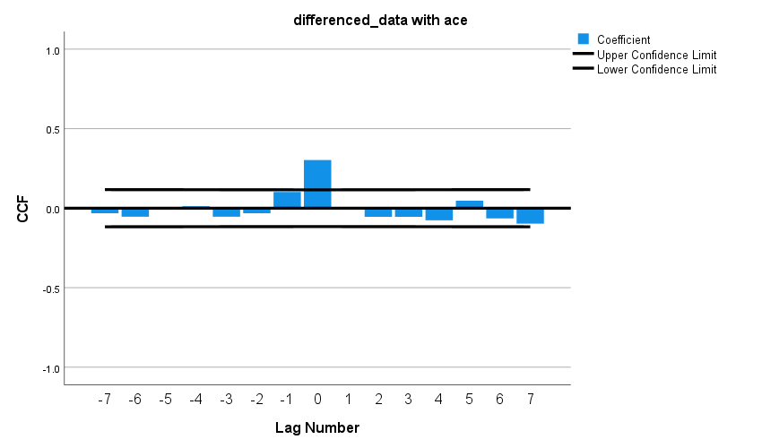

### Score_rate

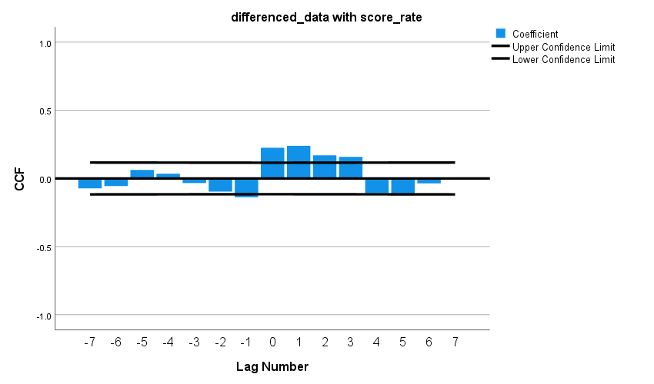

### M(t) player1

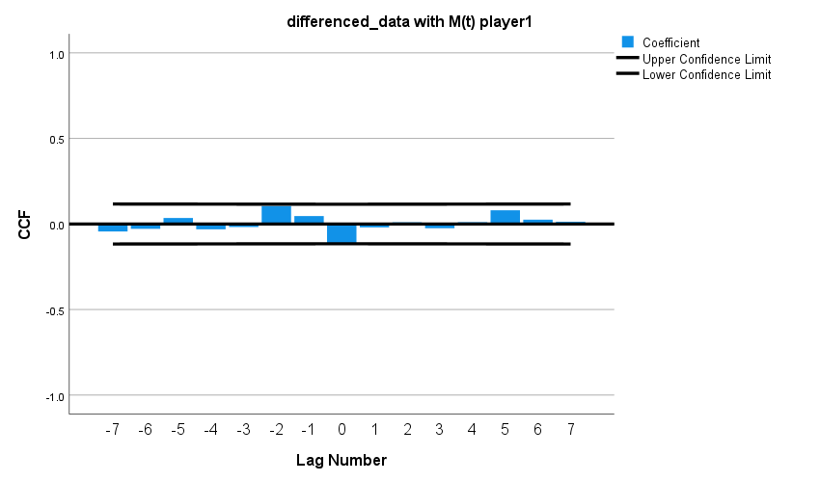

### M(t) player2

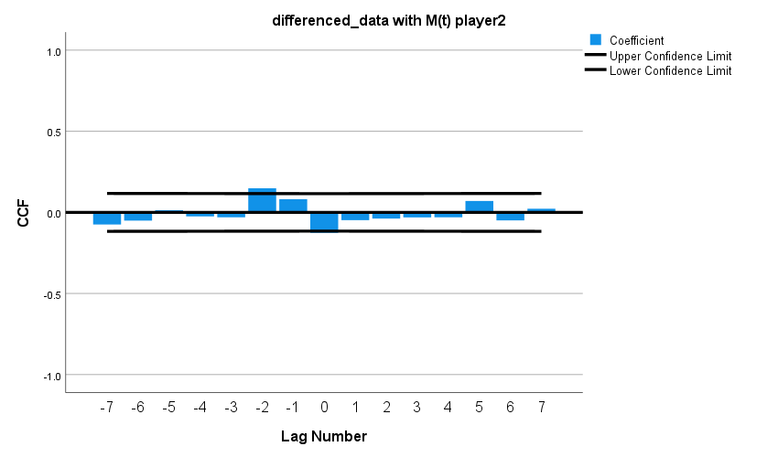

### Subtractive_momentum

