# 时间序列模型

## 时间序列图

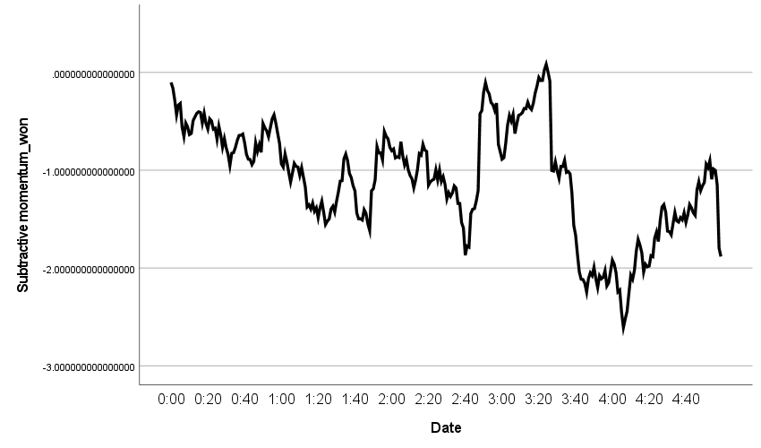

## 季节性分解（针对于本体要换个名字么？）

|  |  |  |
| --- | --- | --- |
| **Model Description** | | |
| Model Name | | MOD_2 |
| Model Type | | Multiplicative |
| Series Name | 1 | Subtractive momentum_won |
| Length of Seasonal Period | | 60 |
| Computing Method of Moving Averages | | Span equal to the periodicity plus one and endpoints weighted by 0.5 |
| Applying the model specifications from MOD_2 | | |

|  |  |
| --- | --- |
| **Seasonal Factors** | |
| Series Name: Subtractive momentum_won | |
| Period | Seasonal Factor (%) |
| 1 | 100.3 |
| 2 | 102.4 |
| 3 | 94.9 |
| 4 | 88.1 |
| 5 | 93.5 |
| 6 | 93.3 |
| 7 | 92.4 |
| 8 | 93.4 |
| 9 | 89.7 |
| 10 | 94.3 |
| 11 | 100.4 |
| 12 | 97.2 |
| 13 | 104.8 |
| 14 | 98.5 |
| 15 | 90.9 |
| 16 | 85.3 |
| 17 | 88.6 |
| 18 | 89.4 |
| 19 | 90.8 |
| 20 | 93.2 |
| 21 | 110.6 |
| 22 | 107.3 |
| 23 | 108.1 |
| 24 | 103.2 |
| 25 | 97.6 |
| 26 | 106.7 |
| 27 | 96.0 |
| 28 | 106.6 |
| 29 | 103.3 |
| 30 | 102.2 |
| 31 | 119.9 |
| 32 | 115.7 |
| 33 | 113.0 |
| 34 | 111.3 |
| 35 | 98.4 |
| 36 | 99.9 |
| 37 | 92.3 |
| 38 | 92.3 |
| 39 | 94.4 |
| 40 | 109.3 |
| 41 | 114.0 |
| 42 | 129.7 |
| 43 | 137.2 |
| 44 | 138.5 |
| 45 | 138.2 |
| 46 | 134.1 |
| 47 | 138.1 |
| 48 | 137.7 |
| 49 | 111.1 |
| 50 | 105.1 |
| 51 | 85.9 |
| 52 | 84.0 |
| 53 | 69.7 |
| 54 | 75.8 |
| 55 | 70.1 |
| 56 | 68.3 |
| 57 | 55.8 |
| 58 | 59.0 |
| 59 | 85.1 |
| 60 | 93.3 |

## 带有季节性因子的时间序列图

**该模型含有线性趋势和稳定的季节成分（相当于包含了比赛中得分周期性的变化，和比分连续的变化）——》从哪可以看出线性趋势和周期？是否有检验？**

|  |  |  |
| --- | --- | --- |
| **Model Description** | | |
| Model Name | | MOD_3 |
| Series or Sequence | 1 | Subtractive momentum_won |
| 2 | Error for Subtractivemomentum_won from SEASON, MOD_2, MUL CEN 60 |
| 3 | Seasonal adjusted series for Subtractivemomentum_won from SEASON, MOD_2, MUL CEN 60 |
| 4 | Seasonal factors for Subtractivemomentum_won from SEASON, MOD_2, MUL CEN 60 |
| 5 | Trend-cycle for Subtractivemomentum_won from SEASON, MOD_2, MUL CEN 60 |
| Transformation | | None |
| Non-Seasonal Differencing | | 0 |
| Seasonal Differencing | | 0 |
| Length of Seasonal Period | | 60 |
| Horizontal Axis Labels | | Date_ |
| Intervention Onsets | | None |
| For Each Observation | | Values not joined |
| Applying the model specifications from MOD_3 | | |

|  |  |  |  |  |  |  |
| --- | --- | --- | --- | --- | --- | --- |
| **Case Processing Summary** | | | | | | |
|  | | Subtractive momentum_won | Error for Subtractivemomentum_won from SEASON, MOD_2, MUL CEN 60 | Seasonal adjusted series for Subtractivemomentum_won from SEASON, MOD_2, MUL CEN 60 | Seasonal factors for Subtractivemomentum_won from SEASON, MOD_2, MUL CEN 60 | Trend-cycle for Subtractivemomentum_won from SEASON, MOD_2, MUL CEN 60 |
| Series or Sequence Length | | 300 | 300 | 300 | 300 | 300 |
| Number of Missing Values in the Plot | User-Missing | 0 | 0 | 0 | 0 | 0 |
| System-Missing | 0 | 0 | 0 | 0 | 0 |

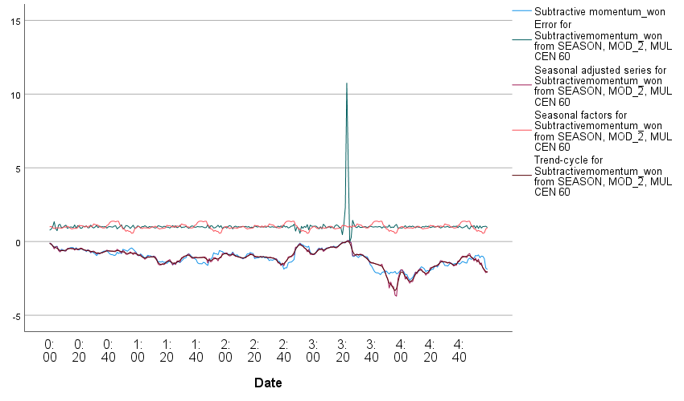

## 创建时间序列模型

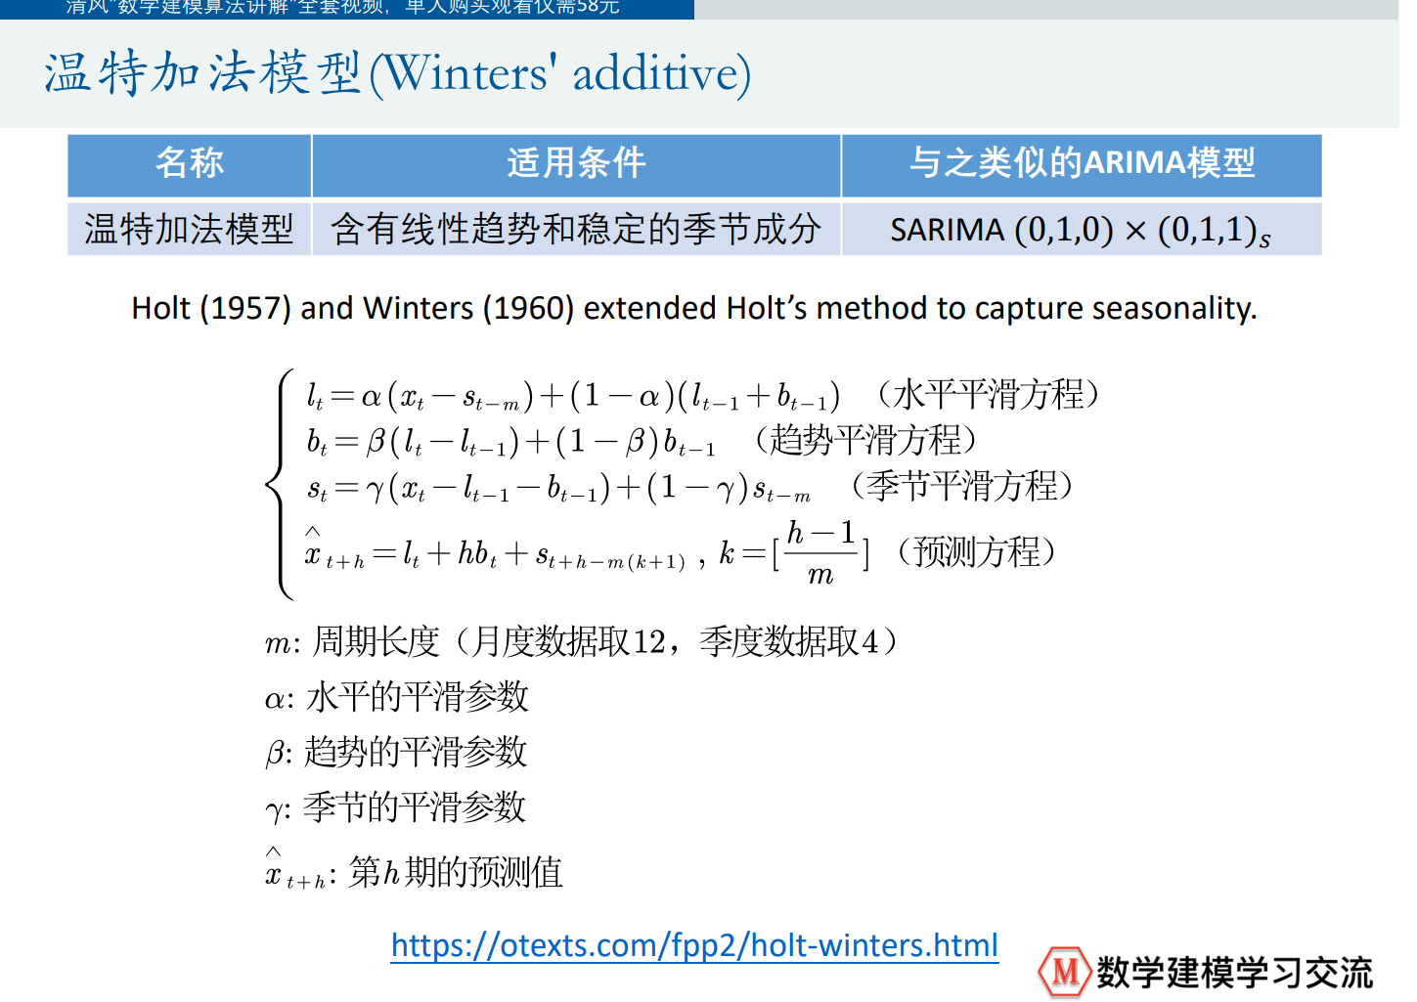

|  |  |  |  |
| --- | --- | --- | --- |
| **Model Description** | | | |
|  | | | Model Type |
| Model ID | Subtractive momentum_won | 模型_1 | Winters' Additive |

|  |  |  |  |  |  |  |  |  |  |  |  |
| --- | --- | --- | --- | --- | --- | --- | --- | --- | --- | --- | --- |
| **Model Fit** | | | | | | | | | | | |
| Fit Statistic | Mean | SE | Minimum | Maximum | Percentile | | | | | | |
| 5 | 10 | 25 | 50 | 75 | 90 | 95 |
| Stationary R-squared | .604 | . | .604 | .604 | .604 | .604 | .604 | .604 | .604 | .604 | .604 |
| R-squared | .954 | . | .954 | .954 | .954 | .954 | .954 | .954 | .954 | .954 | .954 |
| RMSE | .122 | . | .122 | .122 | .122 | .122 | .122 | .122 | .122 | .122 | .122 |
| MAPE | 14.066 | . | 14.066 | 14.066 | 14.066 | 14.066 | 14.066 | 14.066 | 14.066 | 14.066 | 14.066 |
| MaxAPE | 336.523 | . | 336.523 | 336.523 | 336.523 | 336.523 | 336.523 | 336.523 | 336.523 | 336.523 | 336.523 |
| MAE | .088 | . | .088 | .088 | .088 | .088 | .088 | .088 | .088 | .088 | .088 |
| MaxAE | .738 | . | .738 | .738 | .738 | .738 | .738 | .738 | .738 | .738 | .738 |
| Normalized BIC | -4.153 | . | -4.153 | -4.153 | -4.153 | -4.153 | -4.153 | -4.153 | -4.153 | -4.153 | -4.153 |

|  |  |  |  |  |  |  |
| --- | --- | --- | --- | --- | --- | --- |
| **Model Statistics** | | | | | | |
| Model | Number of Predictors | Model Fit statistics | Ljung-Box Q(18) | | | Number of Outliers |
| Stationary R-squared | Statistics | DF | Sig. |
| Subtractive momentum_won-模型_1 | 0 | .604 | 17.674 | 15 | .280 | 0 |

|  |  |  |  |  |  |  |
| --- | --- | --- | --- | --- | --- | --- |
| **Exponential Smoothing Model Parameters** | | | | | | |
| Model | | | Estimate | SE | t | Sig. |
| Subtractive momentum_won-模型_1 | No Transformation | Alpha (Level) | 1.000 | .060 | 16.613 | .000 |
| Gamma (Trend) | .001 | .008 | .116 | .908 |
| Delta (Season) | .001 | 677.079 | 1.477E-6 | 1.000 |

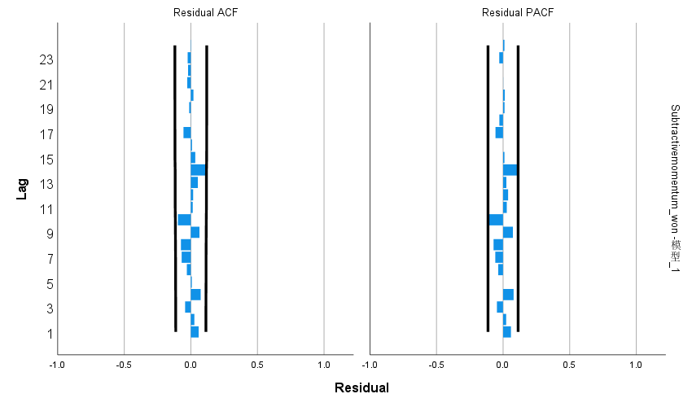

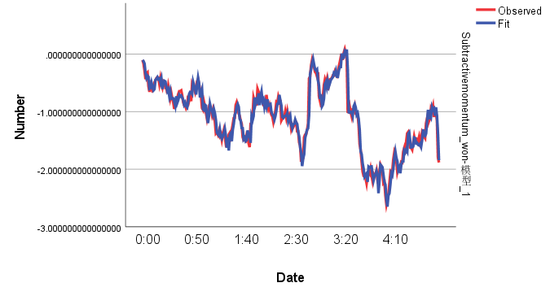

# 因素和上述指标“比赛势头match_momentum”相关

## ADF检验

{'Subtractive momentum_won': 0.10454635825609399,

'double_fault': 5.4409874938612814e-30,

'winner_shot_type': 2.1250827213002571e-29,

'serve': 3.901241706164559e-18,

'serve_no': 3.613295035172555e-25,

'unf_err': 4.038478880314803e-30,

'net_pt': 3.1825912705351784e-19,

'break_pt': 1.1448359372080317e-28,

'y81': 2.9377683466895033e-29,

'y82': 4.066626613130404e-09,

'y9': 1.4940462414648888e-19,

'y10': 0.026299536396391637,

'ace': 3.1526046011816443e-06,

'score_rate': 3.0722156450910876e-17,

'M(t) player1': 2.709536634003313e-28,

'M(t) player2': 4.261906102146795e-29}

Subtractive momentum_won第1次差分后的ADF检验P值：2.828883230169971e-18

## Granger因果检验

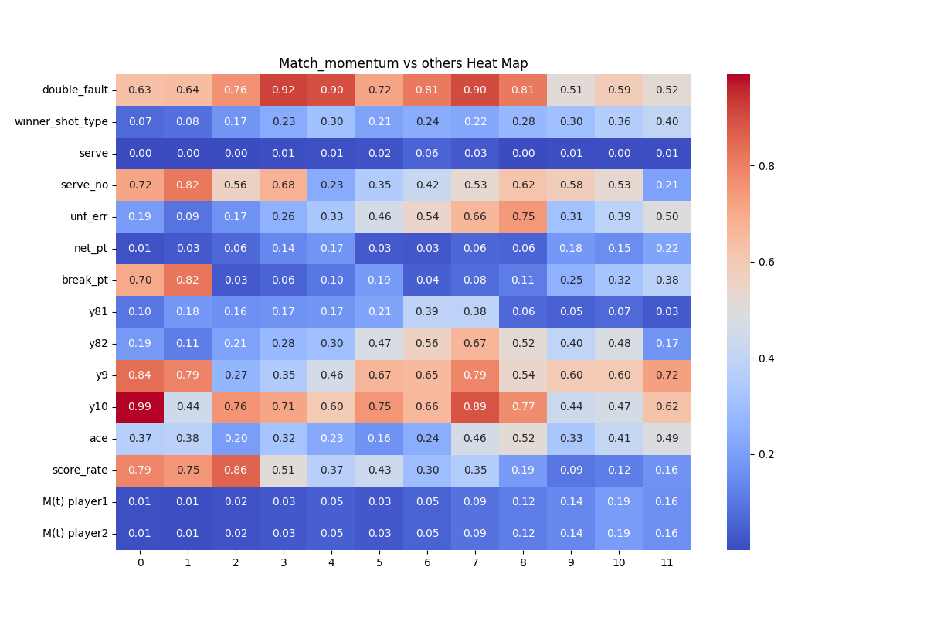

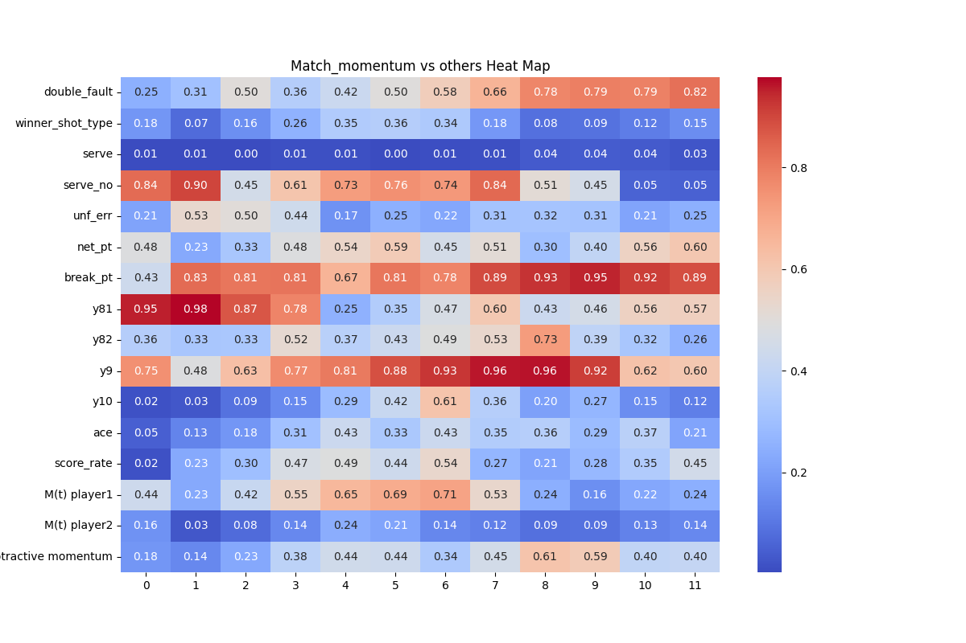

## 交叉性检验(差分后的数据分别和其他特征)

### Double_fault

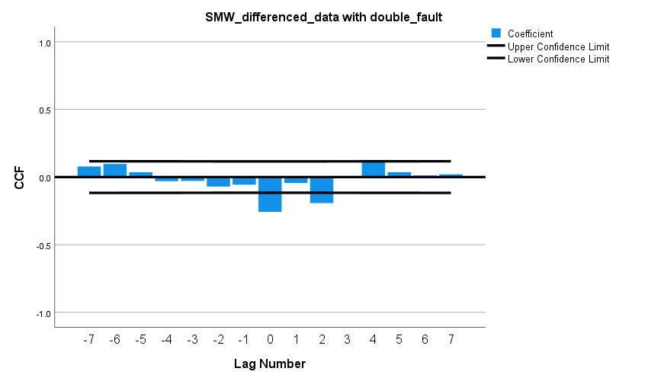

### Serve

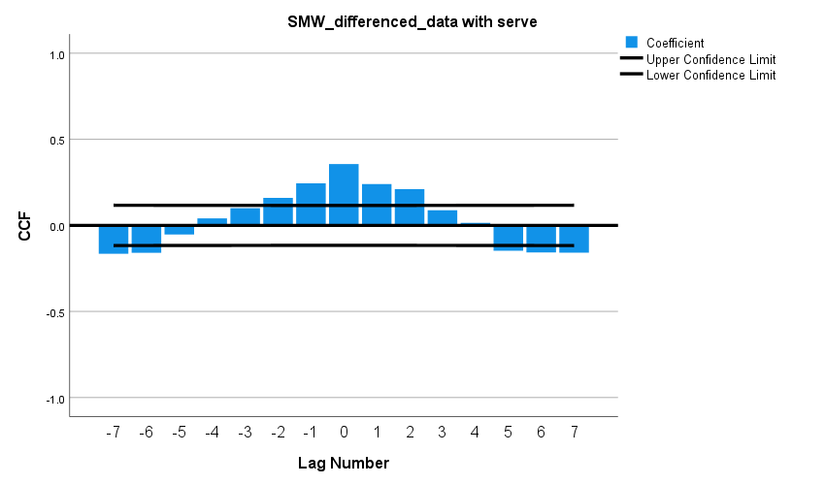

### Server_no

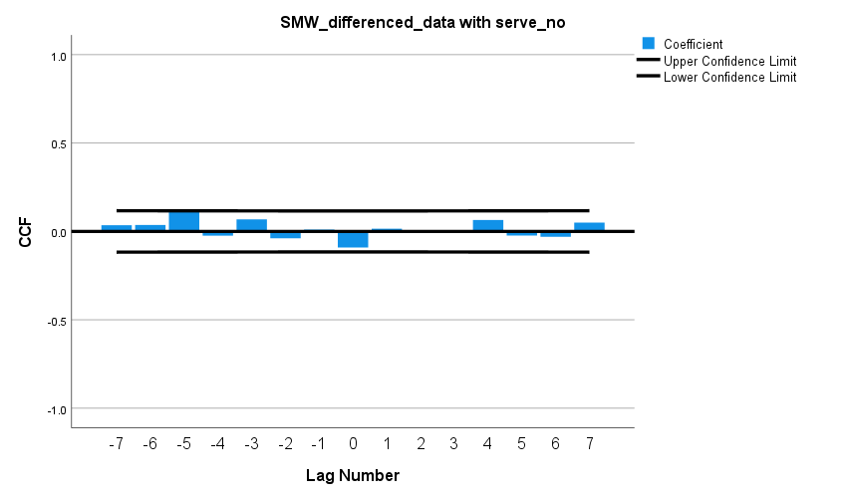

### Winner_shot_type

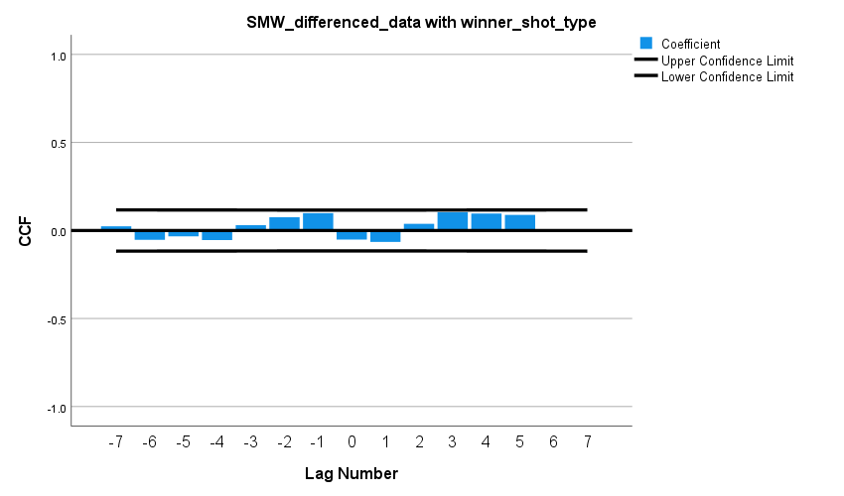

### Unf_err

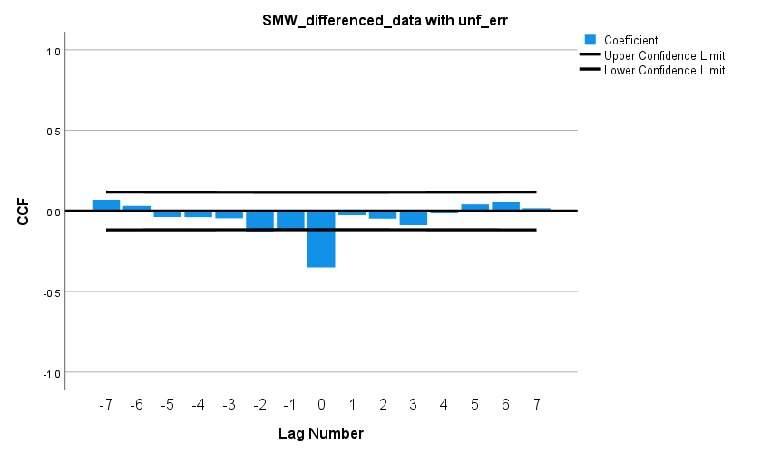

### Net_pt

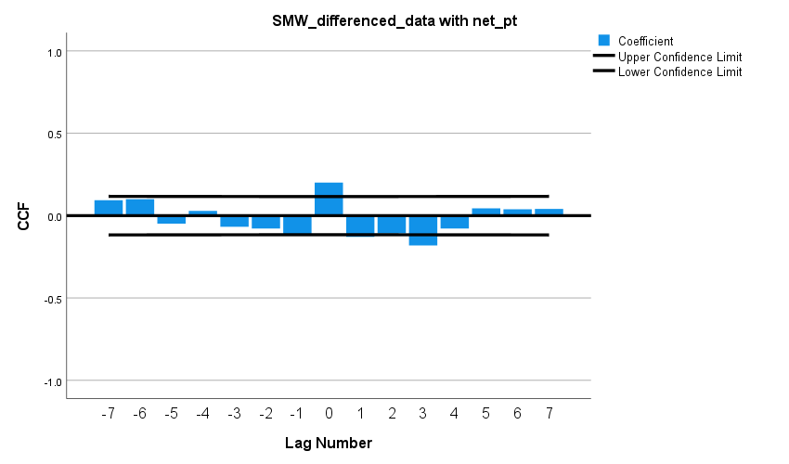

### Break_pt

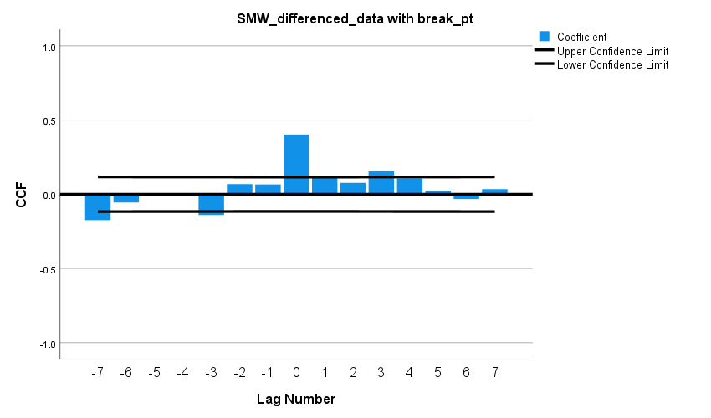

### Y81

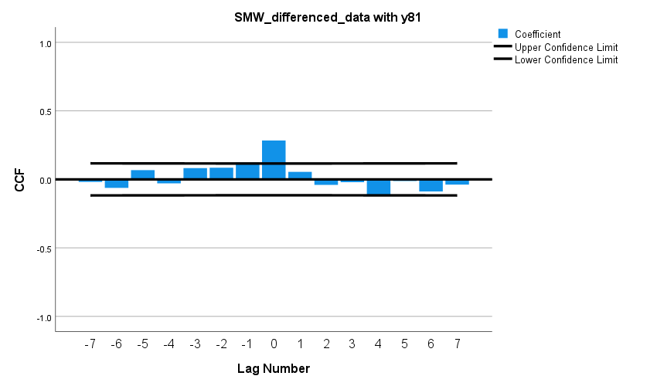

### Y82

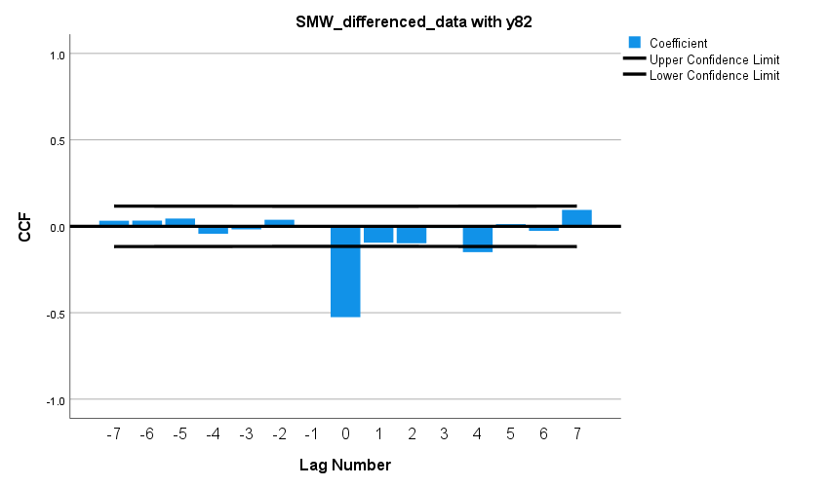

### Y9

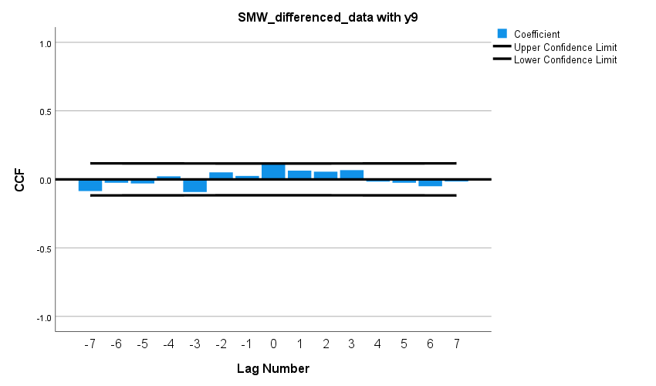

### Y10

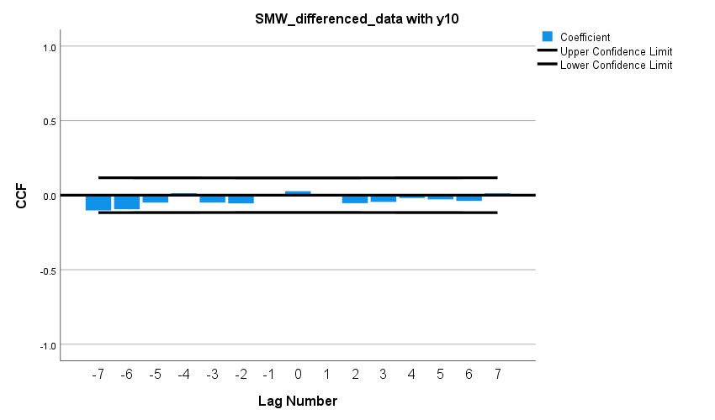

### Ace

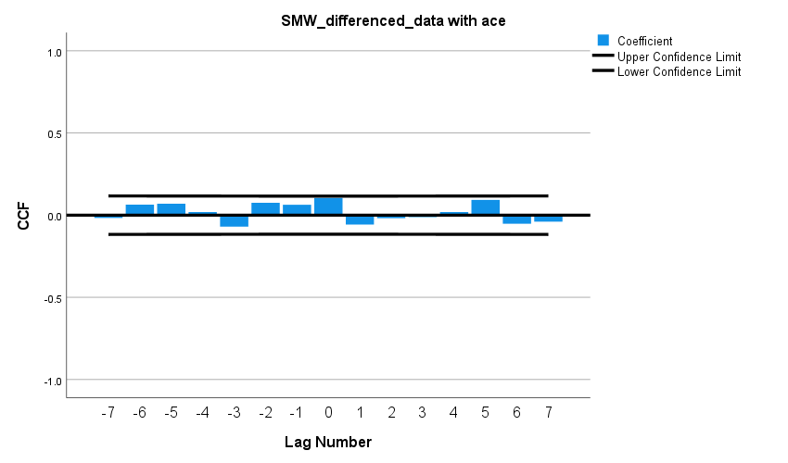

### Score_rate

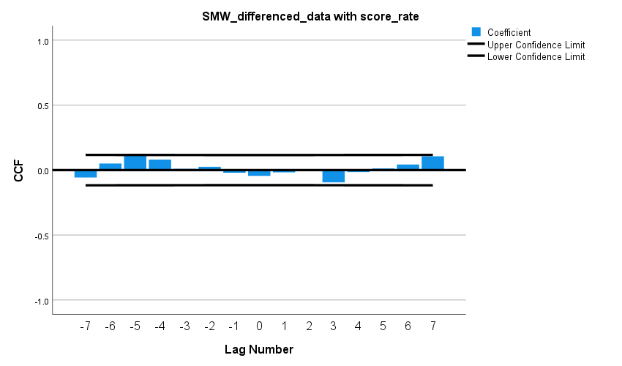

### M(t) player1

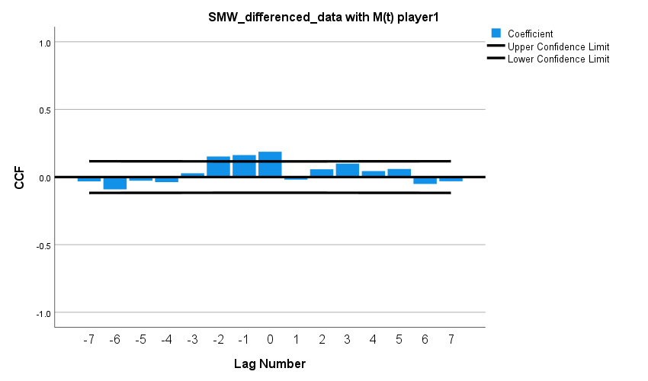

### M(t) player2

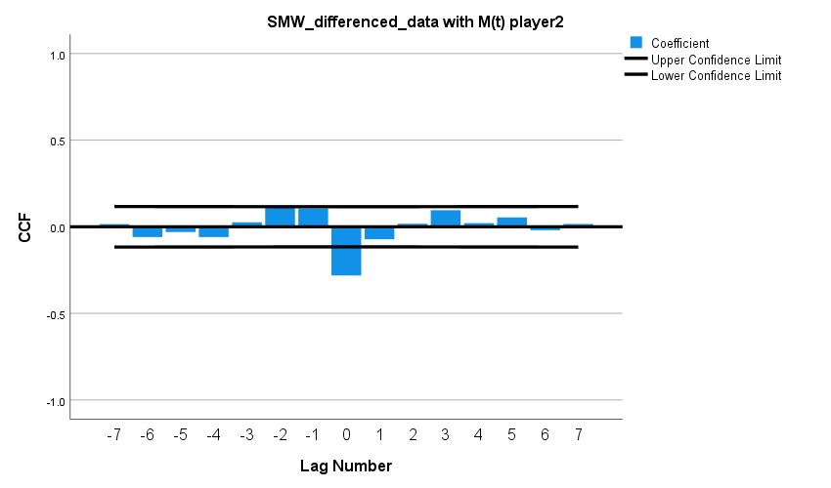

### Subtractive_momentum

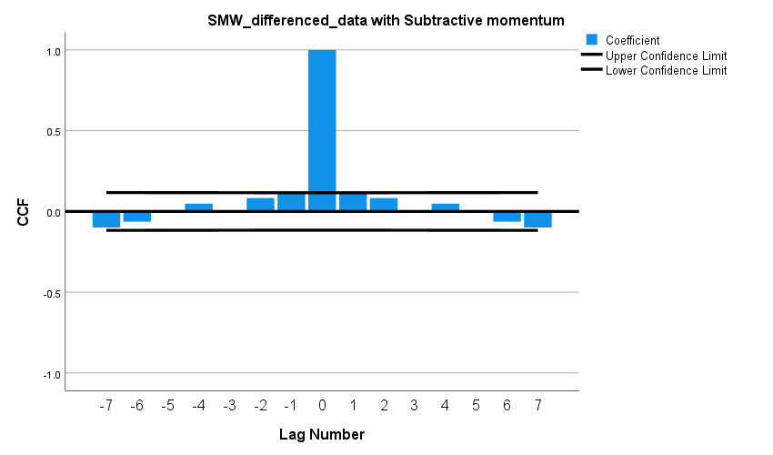

# 交叉检验（不同周期预测后五个比赛势头）

## 一个周期预测

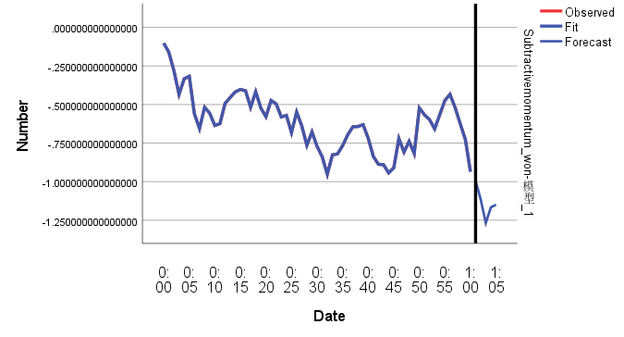

|  |  |
| --- | --- |
| 预测值 | 真实值 |
| -0.993493444562965 | -0.96777 |
| -1.114115308474957 | -0.83345 |
| -1.267348024204794 | -0.91548 |
| -1.165819062988786 | -1.0212 |
| -1.149270302412778 | -1.12083 |

并不能形成一个具体的时间序列模型，要构造出来的时间序列模型至少需要两个周期。

然后预测值和真实值是怎么样的？

## 两个周期（2个周期）

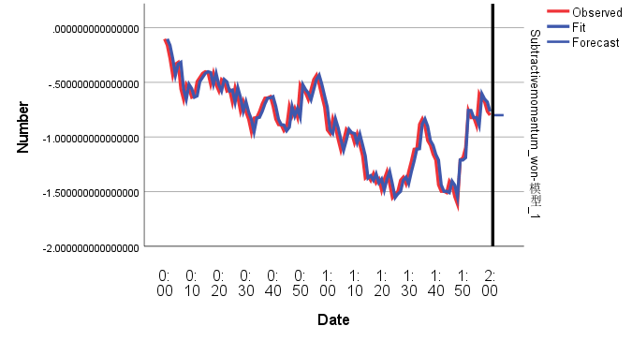

|  |  |
| --- | --- |
| 预测值 | 真实值 |
| -.799830534568948 | -0.78287 |
| -.799830534568948 | -0.87369 |
| -.799830534568948 | -0.8627 |
| -.799830534568948 | -0.87002 |
| -.799830534568948 | -0.70771 |

## 2个周期＋5（用来预测6-10）

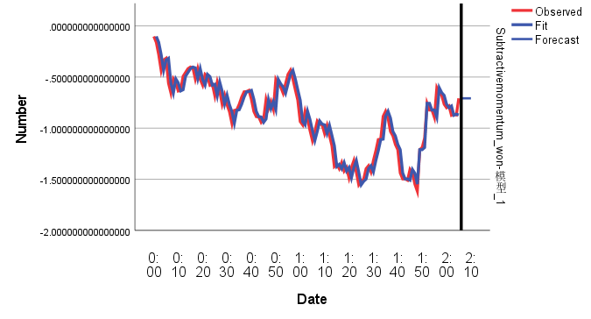

|  |  |
| --- | --- |
| 预测值 | 真实值 |
| -.707710660392948 | -0.85109 |
| -.707710660392948 | -0.94592 |
| -.707710660392948 | -0.89175 |
| -.707710660392948 | -0.9967 |
| -.707710660392948 | -1.0538 |

## 三个周期

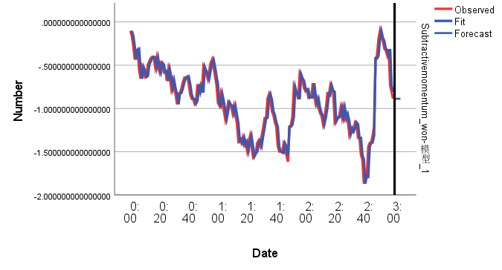

|  |  |
| --- | --- |
| 预测值 | 真实值 |
| -.887349248871446 | -0.87186 |
| -.887349248871446 | -0.72378 |
| -.887349248871446 | -0.53843 |
| -.887349248871446 | -0.4402 |
| -.887349248871446 | -0.49693 |

## 四个周期

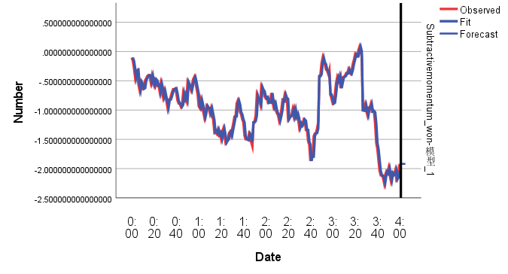

|  |  |
| --- | --- |
| 预测值 | 真实值 |
| -1.918763028591143 | -1.95971 |
| -1.918763028591143 | -2.04837 |
| -1.918763028591143 | -2.24412 |
| -1.918763028591143 | -2.22577 |
| -1.918763028591143 | -2.45243 |