# 1.随机挑选一轮数据进行预测

比如2023-wimbledon-1304场，然后针对该场的数据进行一个处理，转换成我们模型需要的形式。

# 2.计算得分率

# 3.处理短期势头需要的数据

# 4.求短期势头

# 5.其余值得处理（第四题相关分析的数据）

# 6交叉检验（不同周期预测后五个比赛势头）

## 一个周期预测

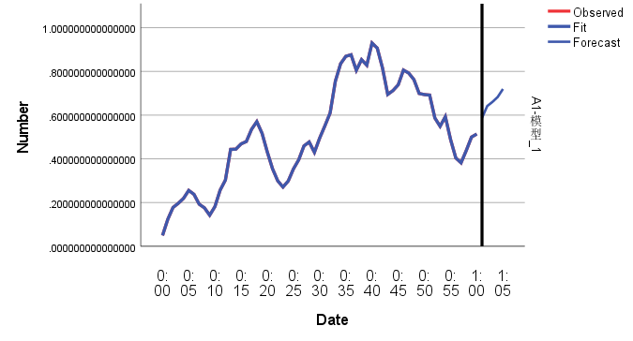

|  |  |
| --- | --- |
| 预测值 | 真实值 |
| .513757825656237 | 0.458309 |
| .587515115083950 | 0.153255 |
| .641760047676514 | 0.048935 |
| .660725127837512 | -0.01737 |
| .683239869375461 | 0.002389 |

## 2个周期预测

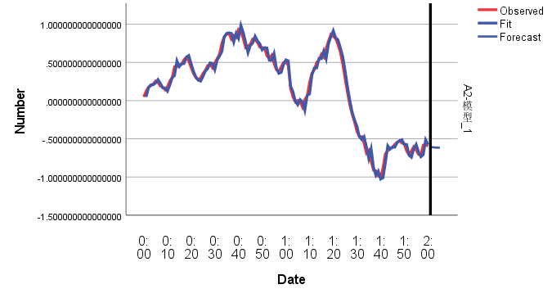

|  |  |
| --- | --- |
| 预测值 | 真实值 |
| -.574449479156421 | -0.5342 |
| -.604409901094939 | -0.56215 |
| -.609674906102714 | -0.53235 |
| -.612541521150675 | -0.53916 |
| -.614102294943114 | -0.52419 |

## 3个周期预测

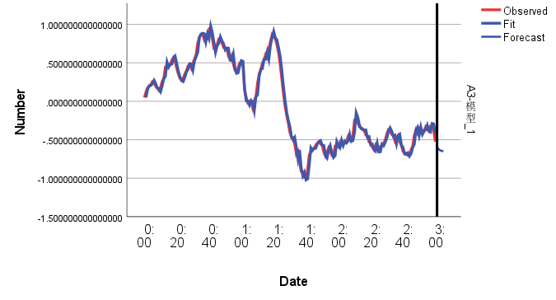

|  |  |
| --- | --- |
| 预测值 | 真实值 |
| -.574449479156421 | -.592266371042993 |
| -.604409901094939 | -.626636709051812 |
| -.609674906102714 | -.643712034270364 |
| -.612541521150675 | -.652195126035261 |
| -.614102294943114 | -.656409560897882 |

## 4个周期预测

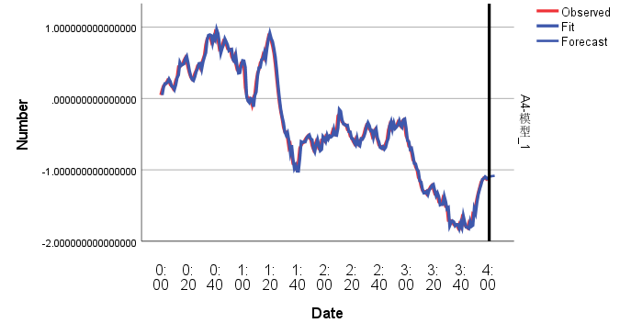

|  |  |
| --- | --- |
| 预测值 | 真实值 |
| -1.096993565197381 | -1.13804 |
| -1.090551792424377 | -1.2009 |
| -1.086968814893895 | -1.2232 |
| -1.084691771627331 | -1.17966 |
| -1.083313352925253 | -1.21913 |

## 5个周期预测

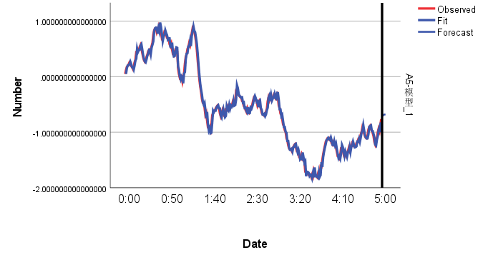

|  |  |
| --- | --- |
| 预测值 | 真实值 |
| -.715948945035333 | -0.683923989 |
| -.694331591886500 | -0.622527494 |
| -.684600898519227 | -0.665628601 |
| -.680220788116442 | -0.759913081 |
| -.678249153987561 | -0.870154347 |