# 乒乓球

## 预测2：01-2：05

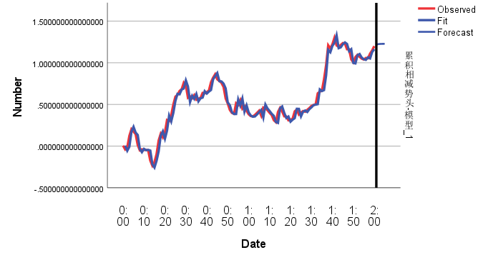

|  |  |
| --- | --- |
| 预测值 | 真实值 |
| 1.218476940637006 | 1.197586 |
| 1.224776908625942 | 1.198244 |
| 1.226991731010936 | 1.281959 |
| 1.227770375950987 | 1.370152 |
| 1.228044117063039 | 1.463526 |

## 2：11-2:15

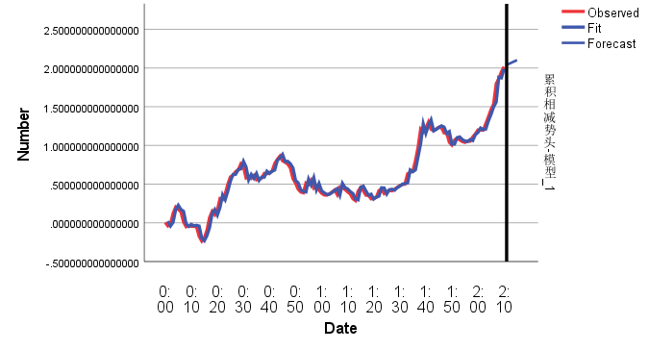

|  |  |
| --- | --- |
| 预测值 | 真实值 |
| 2.040818878841975 | 2.034412 |
| 2.056229395386097 | 2.036309 |
| 2.071639911930218 | 1.998856 |
| 2.087050428474340 | 1.927827 |
| 2.102460945018461 | 1.922787 |

## 2:31-2:35

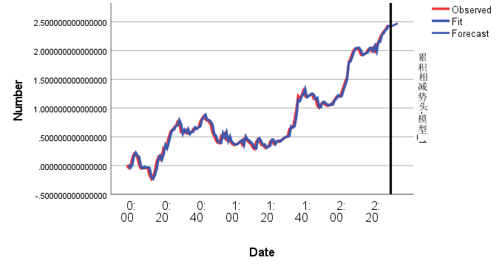

|  |  |
| --- | --- |
| 预测值 | 真实值 |
| 2.416861081126422 | 2.460653 |
| 2.431211873328655 | 2.431347 |
| 2.445562665530887 | 2.470472 |
| 2.459913457733120 | 2.523662 |
| 2.474264249935352 | 2.539327 |

## 2:41-2:45

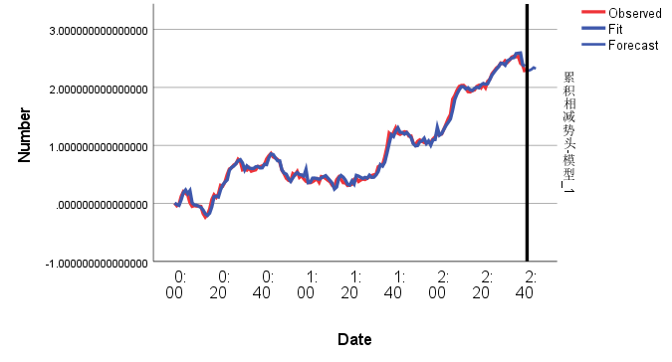

|  |  |
| --- | --- |
| 预测值 | 真实值 |
| 2.290548840467242 | 2.189271 |
| 2.293226079374180 | 2.092562 |
| 2.311675202732581 | 2.080282 |
| 2.343523138470249 | 2.0976 |
| 2.323980853146749 | 2.233889 |

# 大满贯

## 预测2：01-2：05

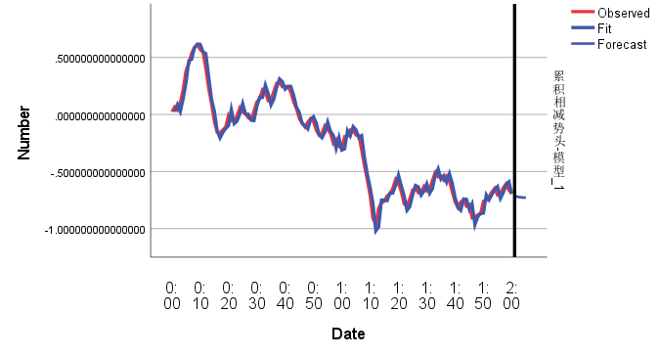

|  |  |
| --- | --- |
| 预测值 | 真实值 |
| -.711866266072480 | -0.75671 |
| -.720570976747037 | -0.80822 |
| -.725129228373372 | -0.76085 |
| -.727516172485106 | -0.7265 |
| -.728766103963137 | -0.75131 |

## 2:31-2:35

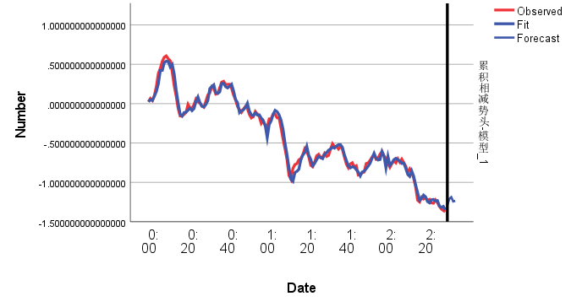

|  |  |
| --- | --- |
| 预测值 | 真实值 |
| -1.290472833026685 | -1.41533 |
| -1.209674773728652 | -1.42124 |
| -1.186925527619523 | -1.45 |
| -1.242006236437525 | -1.46515 |
| -1.233998961816290 | -1.43202 |

## 3:01-3:05

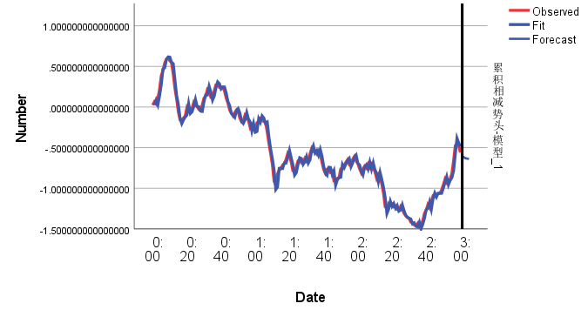

|  |  |
| --- | --- |
| 预测值 | 真实值 |
| -.598882407078915 | -0.598319956 |
| -.619269236171983 | -0.736664418 |
| -.629434238463224 | -0.723530098 |
| -.634502573078148 | -0.740815158 |
| -.637029676863553 | -0.718197707 |

## 3:16-3:20

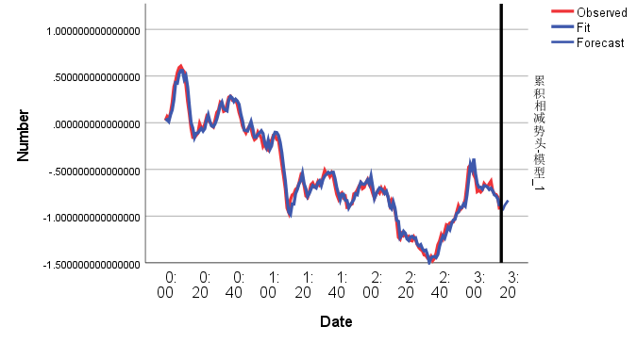

|  |  |
| --- | --- |
| 预测值 | 真实值 |
| -.926594774527342 | -0.94933 |
| -.928164853744309 | -1.01439 |
| -.884026502007981 | -1.08679 |
| -.858010766203618 | -1.19855 |
| -.830396346471420 | -1.29675 |

# 女子比赛

## 预测2：01-2：05

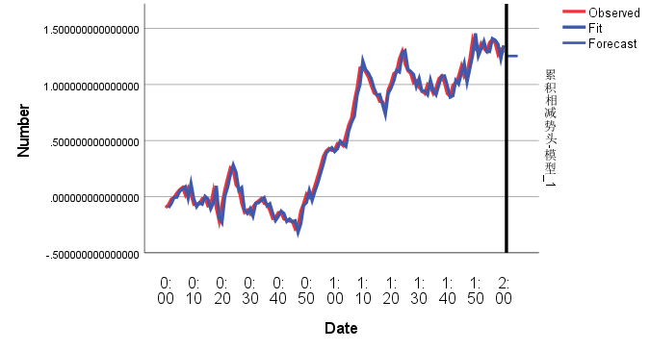

|  |  |
| --- | --- |
| 预测值 | 真实值 |
| 1.254577216314557 | 1.159474 |
| 1.254577216314557 | 1.150989 |
| 1.254577216314557 | 1.200077 |
| 1.254577216314557 | 1.217257 |
| 1.254577216314557 | 1.254419 |

## 2:31-2:35

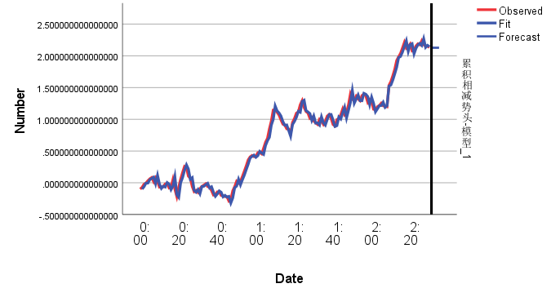

|  |  |
| --- | --- |
| 预测值 | 真实值 |
| 2.128393035213248 | 2.083179 |
| 2.128393035213248 | 2.094337 |
| 2.128393035213248 | 2.053284 |
| 2.128393035213248 | 2.098621 |
| 2.128393035213248 | 2.121354 |

## 3:01-3:05

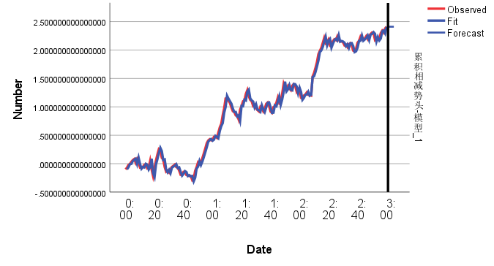

|  |  |
| --- | --- |
| 预测值 | 真实值 |
| 2.411072885561002 | 2.431109 |
| 2.411072885561002 | 2.501575 |
| 2.411072885561002 | 2.592253 |
| 2.411072885561002 | 2.655269 |
| 2.411072885561002 | 2.636439 |

## 3:16-3:20

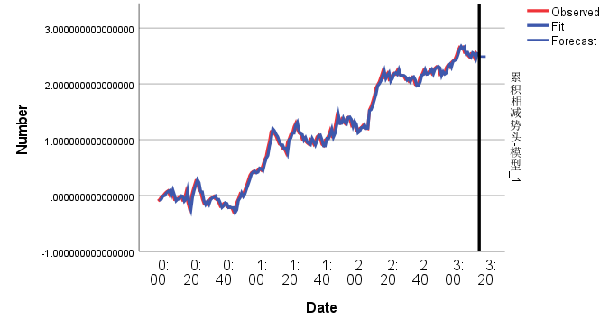

|  |  |
| --- | --- |
| 预测值 | 真实值 |
| 2.493248613746739 | 2.512052 |
| 2.489863254209436 | 2.558361 |
| 2.488917856295960 | 2.644051 |
| 2.488653843801879 | 2.718327 |
| 2.488580115484905 | 2.875943 |

# 锦标赛

## 预测2：01-2：05

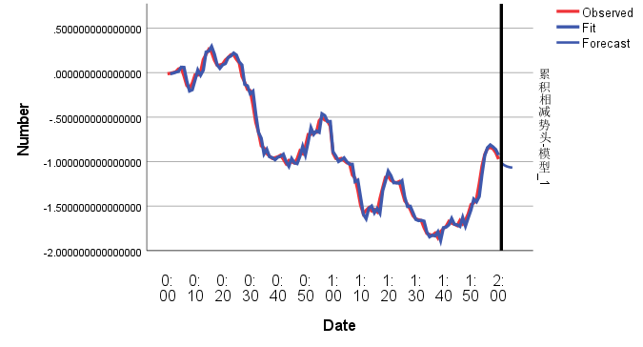

|  |  |
| --- | --- |
| 预测值 | 真实值 |
| -1.013329528975916 | -1.0355 |
| -1.038404609055375 | -1.09706 |
| -1.053266814678100 | -1.18025 |
| -1.062075765846840 | -1.25287 |
| -1.067296903453399 | -1.21915 |

## 2:31-2:35

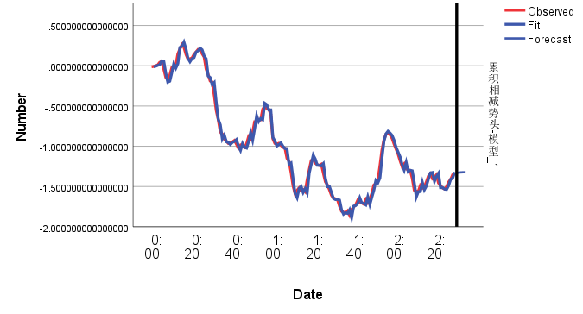

|  |  |
| --- | --- |
| 预测值 | 真实值 |
| -1.331248666694476 | -1.35946 |
| -1.326656656942673 | -1.33847 |
| -1.324057680830310 | -1.33439 |
| -1.322586717744924 | -1.30396 |
| -1.321754185122453 | -1.28539 |

## 3:01-3:05

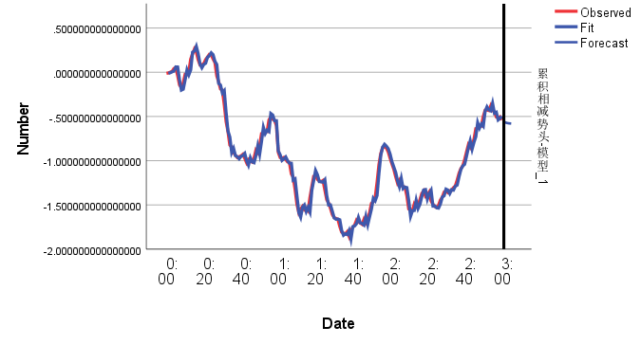

|  |  |
| --- | --- |
| 预测值 | 真实值 |
| -.557559578980102 | -0.54962 |
| -.568291504991722 | -0.49843 |
| -.574253298343546 | -0.55254 |
| -.577565190349824 | -0.61405 |
| -.579405010688094 | -0.71909 |

## 3:16-3:20

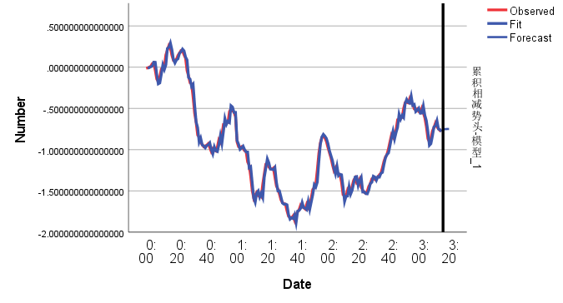

|  |  |
| --- | --- |
| 预测值 | 真实值 |
| -.753889231837417 | -0.70494 |
| -.751175554427092 | -0.61672 |
| -.749666543553153 | -0.61993 |
| -.748827418825577 | -0.56035 |
| -.748360801705323 | -0.53425 |