|  |  |  |
| --- | --- | --- |
| **Problem Chosen** C | **2024 MCM/ICM Summary Sheet** | **Team Control Number** 2410809 |

Tennis Match：Momentum Makes a Difference

summary

Tennis more than any other sport, is a game of momentum. Momentum intennis can swing wildly from point to point, game to game, set to set. However, sometimes they can beso small as to be imperceptible. Based on a dataset of tennis matches, we dig deeper into the impact of momentum on a match.

For Task 1, in order to capture the game flow at the moment of scoring, we developed an **EWMA model** for momentum. We then selected 12 technical indicators including the server, double faults, aces, etc., and used the Analytic Hierarchy Process (AHP) to determine the model's observations and smoothing coefficient, setting the smoothing coefficient to 0.65. Subsequently, we introduced "subtractive momentum" to compare players' performances and visualized the "2023-wimbledon-1301" match using the EWMA model.

For Task 2, our focus was on the role of momentum in the game. For ease of study, we represented momentum through "subtractive momentum" and match outcomes through "scores," then discussed the relationship between "subtractive momentum" and "scores," specifically examining their linear and causal relationships. We began with the time series of "subtractive momentum" and "scores," conducting **ADF tests** (to verify data stability for subsequent modeling), **cross-correlation analysis**, and **Granger causality tests**. The conclusion was that within the observed lag range, there was no significant linear relationship between momentum and the game; however, in the long run, momentum is a Granger cause of scoring, and the game outcome has a significant impact.

For Task 3, we were curious about how shifts in the game flow are influenced by momentum. Initially, we depicted in-game fluctuations with "cumulative subtractive momentum," capturing the game's macro changes. Considering the time correlation of "cumulative subtractive momentum," we opted for a time series model for prediction. Then, we used the Winters' additive model to forecast the game flow, further discovering the model's ability to distinguish between future fluctuations being cyclical or trend-based. Additionally, to identify factors most related to fluctuations, we employed **ADF tests**, **cross-correlation analysis**, and **Granger causality tests**, identifying Serve, Unf_err, M(t)player1, M(t)player2, Net_put as the most relevant factors. Considering the differences in past game "momentum" fluctuations, we proposed five scenarios with corresponding recommendations.。

For Task 4, we evaluated the model's predictive effectiveness from two aspects. One was assessing the model's accuracy; we selected different periods and used the same method as in Task 3 to predict data from tennis matches, finding the model to be highly accurate for short to mid-term data but deviating for long-term predictions. On the other hand, predicting other types of matches showed good results, indicating the model's strong generalizability.

For Task 5, we drafted a memorandum summarizing the research findings and offering valuable recommendations for coaches and players based on the role of "momentum."

**Keybord:** EWMA Model;ADF Test; Cross-correlation Analysis; Granger Causality Test

**Content**

summary 1

1 Introduction 3

1.1 Background of the Problem 3

1.2 Restatement of the Problem 3

1.3 Our Work 4

2 Assumptions and Notations 4

2.1 Assumptions 4

2.2 Natations 4

3 Data processing 5

3.1 Processing missing value 5

3.2 Handling of outliersm 6

4 Task 1 Capture game flow 6

4.1 Momentum modeling 7

4.2 Determined 7

4.3 Selection of the Smoothing Coefficient 9

4.4 Visualizing the Match Progress 10

5 Task 2 Exploring the Role of Momentum 11

5.1 Investigating the Randomness of the Subtracted Momentum Time Series 11

5.2 Discussing the Relationship Between Momentum and Match Outcomes 13

5.3 Summary 15

6 Task 3 Explore the transformation of the game flow 16

6.1 Predicting Fluctuations 16

6.2 Look for the factors most associated with volatility 18

6.3 Recommendations 20

7 Task 4 Evaluate the prediction effect 21

7.1 Anticipate fluctuations in the game 21

7.2 Apply to other sports 22

8 Memo 23

9 Sensitivity Analysis 24

10 Model Evaluation and Further Discussion 25

10.1 Strength 25

10.2 Weaknesses 25

References 25

# 1 Introduction

## 1.1 Background of the Problem

In the 2023 Wimbledon World Cup final, 20-year-old Spanish rising star Carlos Alcascaras defeated 36-year-old Novak Djokovic. Djokovic, one of the greatest players in Grand Slam history, lost for the first time.

Here's a recap of how they played. Djokovic won the first set 6-1, Alcalas won the second set 7-6, and the next set 6-1. But it was Djokovic who won the fourth set 6-3. So far, Alkaras has settled for a draw with Djokovic. In the early stages of the fifth set, Djokovic held a commanding 4-0 lead, but from the fifth game, Alkaras stormed back to take the fifth set 6-4. So the final winner of this game is Alcaras.

As can be seen from the above, there have been many "momentum" shifts in this game. The dictionary definition of momentum is " strength or force gained by motion or by a series of events. "; In sports, it means "strength." Often manifested as a phenomenon that is difficult to measure, a team or player may feel that they have momentum during a game . However, the influence of various events in the game on the "momentum" shift is not obvious.

## 1.2 Restatement of the Problem

Given the context as well as every point data after the first two rounds of the men's competition at Wimbledon 2023, the following questions need to be addressed in this paper:

* Task 1 required building a model that would allow it to identify the better performers at a particular time in the race, as well as reflect how well they performed. And show the flow of the game in a visual way.*Note: Players tend to perform better when serving, so this can be factored into the model.*
* Task 2 asks to evaluate a coach's view, based on a model, that game fluctuations are random and that "momentum" does not play a role in a game.
* Task 3 requires using data from at least one match to develop a model that enables it to predict turning points in a match, that is, which events will affect the direction of the outcome of the match, and analyze which factors are associated with it. And take into account the differences in the "momentum" fluctuations of the game, to provide suggestions for a new game.
* Task 4 requires testing the model to assess the accuracy of the model's predictions and its generalization to other sports or competitions (such as Women’s matches , tournaments, table tennis, etc.).
* Task 5 asked to write a memo, includes a summary of the results, suggestions for coach how to use "momentum", about players affect the process of incident response.

## 1.3 Our Work

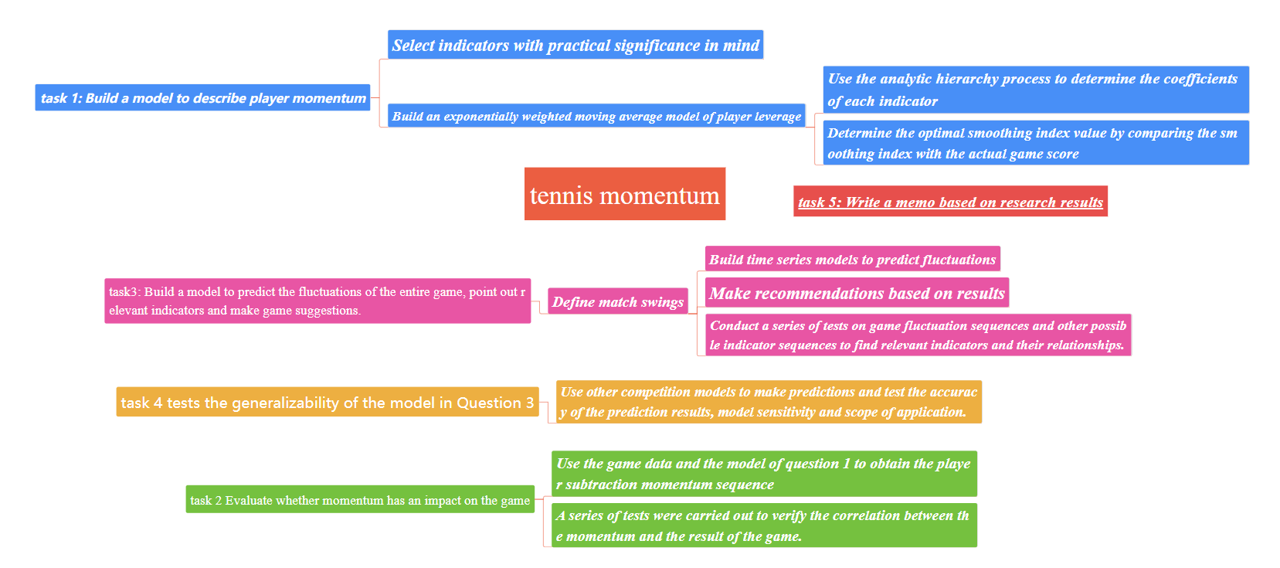

Figure 1: our work

**Data Processing:** Addressing missing and outlier values.

**Model Construction:** Developed an EWMA model for momentum to capture the game flow during scoring events.

**Exploring Effects:** Conducted ADF tests, cross-correlation analyses, and Granger causality tests on multiple time series to examine the relationships between different sets of time series and explore their effects.

**Forecasting Model:** Established a time series regression forecasting model, selecting predictions for different periods to test the predictive performance.

**Providing Recommendations:** Identified key indicators influencing the game and based on these, offered valuable strategic recommendations.

# 2 Assumptions and Notations

## 2.1 Assumptions

·**Assumption 1.** It is assumed that the impact of uncontrollable factors such as the venue on the game's trend is minimal and can be disregarded.

·**Assumption 2.** It is assumed that the serve point is a singular moment in time.

·**Assumption 3.** It is assumed that the momentum at the start of the match is zero.

·**Assumption 4.** It is assumed that fluctuations within the match can be depicted by cumulative subtractive momentum.

## 2.2 Natations

Table1: Nations

|  |  |
| --- | --- |
| Symbol | Definition |
|  | The momentum of player k at time t |
|  | Match momentum (cumulative subtracted momentum) |
|  | Subtractive momentum |
|  | The time point to start changing games or taking a break |
|  | Serve_no |
|  | serve |
|  | winner_shot_type |
|  | pk_double_fault |
|  | pk_unf_err |
|  | pk_net_pt |
|  | pk_break_pt |
|  | The distance traveled in one round |
|  | serve speed |
|  | player scoring differential ratio |
|  | pk_ace |
|  | scoring rate in the short term |
|  | p1_points_won |
|  | P2_points_won |

# 3 Data processing

## 3.1 Processing missing value

There may be missing values in the raw data, and a heat map can help us detect this, visualizing the distribution of missing values.A heatmap of the raw data is presented below.

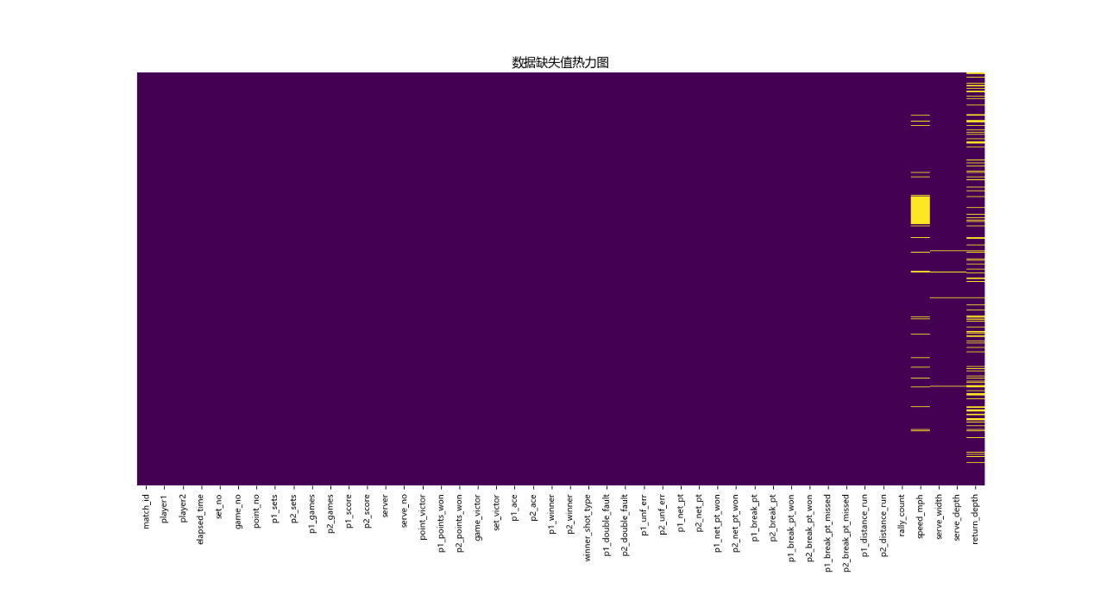

Figure 2: Heatmap of missing data

In the graph, purple represents non-missing values and yellow represents missing values. As can be seen from the figure, the data of most indicators are complete, but some indicators obviously have missing values. Further, we can see that a whole block of "speed_mph" is missing, "serve_width, serve_depth" has fewer missing values, and "return_dept" has more dense missing values.

In order to improve the quality of data and ensure that the model can make better use of information, we can fill the missing values with numerical time series forward or backward filling, average filling, mode filling and other methods.

## 3.2 Handling of outliersm

**(1) p1_score and p2_score**

There may also be outliers in the raw data. In a preliminary analysis of the raw data, we found that the p1_score and p2_score fields should contain only a few specific values (0, 15, 30, 40, AD).

Across all the data, we found outliers for the p1_score and p2_score fields ranging from 0 to 10.

However, considering that the data of these two features is of little significance to the following modeling, we choose to delete all the data of these two features

**(2) p1_points_won和p2_points_won**

In fact, the outliers in this part were discovered by accident in the subsequent problem solving process. In order to ensure the consistency of the structure of the paper and avoid the influence of the bad outliers, we choose to give corresponding treatment here.

Table2: Outliers of the original data

|  |  |  |
| --- | --- | --- |
| Line | p1_points_won | p2_points_won |
| 4055 | 12 | 8 |
| 4056 | 21 | 21 |

It can be seen from the table that the values of 12 and 21 and 8 and 21 in these two rows are not continuous, but mutated. Based on the two metrics "p1_points_won" and "p2_points_won" which mean "the cumulative score of the player", we know that there is an outlier.

Combining the actual meaning of the two indicators, as well as the actual meaning and data of other indicators in the original data, we can easily deduce the correct value.

# 4 Task 1 Capture game flow

In this section, we first built an EWMA model of momentum, which captures the flow of a game when a score occurs. Then, according to the model, the momentum of player 1 and player 2 changes with the flow of the game, and their performance is compared according to the subtraction momentum of the two players.

## 4.1 Momentum modeling

The EWMA model is a commonly used smoothing method in time series analysis to capture trends and changes in data.

In this problem, to better understand the changes in player performance during the game, we consider momentum as the dependent variable and define the momentum at a certain moment as the "technical performance at that moment" plus the "momentum from the previous moment". Specifically, "technical performance at that moment" is related to indicators such as double faults, service winners, unforced errors, and ace serves.

Based on the analysis above, the Exponentially Weighted Moving Average model we established is as follows: the momentum of player at time is

where is the smoothing coefficient, usually ranging from 0 to 1，indicating the weight of , with larger values indicating greater emphasis. is the "technical performance at the moment," calculated from the original scores based on match events.。is the momentum of player k at time .

Since is related to multiple technical indicators, it can be expressed as

Where are the technical indicators.

From the analysis above, it is easy to see that the key to determining the momentum at time is to determine and .The details are explained below.

## 4.2 Determined

4.2.1 Selection of Technical Indicators

In tennis matches, different technical performances are exhibited at different moments, playing a crucial role in affecting the game's momentum. In the provided match data, over a dozen technical statistical indicators for singles matches are listed. To create a balanced feature set covering various aspects of technical performance, we present the following 12 features:

indicates whether the first serve was a fault. A fault is marked as 1, no fault as 0. This feature captures the player's capability at the start of the match.

indicates whether acting as the server, since the server usually has a strategic advantage.

for the category of unreachable shots, providing insights into the player's skills and playing style.

for double faults. Double faults are significant errors, potentially leading to point losses, monitoring this helps assess the player's consistency.

for unforced errors, indicating the player's control and decision-making abilities.

for successful net approaches, showcasing the player's aggressiveness and ability to finish the game.

for break points, illustrating the player's opportunity to break the opponent's serve, a crucial element in tennis matches.

for the ratio of running distance to shots taken, reflecting the player's movement efficiency during the match.

for serve speed.

for the ratio of score difference, it captures the player's advantage in winning the game relative to the opponent, providing a relative measure.。

for Aces, showing the player's ability to easily score points.

for short-term scoring rate, a valuable measure of the player's current state and instant match performance. The specific mathematical expression is given as follows:

Defining the short-term as 5 rounds (considering rest and court change times), denoted as

Where represents“p1_points_won”， represents“p2_points_won”， denotes the time point for starting a changeover or rest.

By summing the 12 indicators with weights, the original score at time calculated based on match events can be obtained:

Where respectively represent the weights for. However, these weights are also unknown at this stage, hence we will address this issue below.

4.2.2 Determining the Weights

The AHP[1] is a multi-criteria decision-making method used to determine the relative importance of different factors or criteria.

For the technical performance , the 12 selected features have varying degrees of importance, hence the choice of AHP to quantify the significance of these features. Below are the specific steps of applying this method.

***Step1***:Establish the Hierarchical Structure of the System

Break down the decision-making problem into three levels: the top level is the goal layer M; the middle layer is the criteria layer, including five factors of importance C1, commonality C2, timeliness C3, stability C4, and relevance C5; the bottom layer is the alternative layer, which consists of the 12 features, as shown in the figure below.

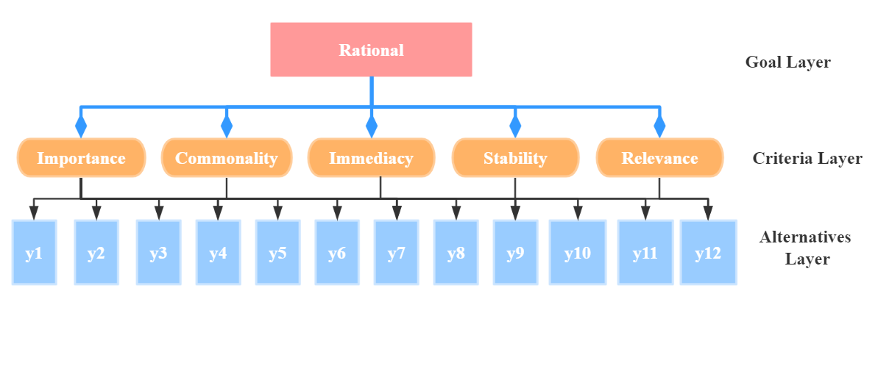

Figure 3: Hierarchy chart

***Step2***: Construct Pairwise Comparison Matrices

Compare the features in the decision layer C pairwise to obtain the judgment matrix .

For each factor, compare the 12 features pairwise to get 5 judgment matrices to .

***Step3***: Consistency Test

If the consistency ratio is less than 0.10, then the consistency of the judgment matrix is considered acceptable.

***Step4***: Calculation of Weights

Next, use the judgment matrix to calculate weights. To ensure the robustness of the results, we employed three methods: arithmetic mean, geometric mean, and eigenvalue method to derive the weights, then calculated the average of these results as the final weights.。

Considering that represent first serve faults, double faults, and unforced errors, respectively, which have a negative impact on momentum, it is considered that these three indicators are negatively correlated with momentum. The final weights obtained are shown in the table below.

Table3: Final weights of 12 features

|  |  |  |  |  |  |  |  |  |  |  |
| --- | --- | --- | --- | --- | --- | --- | --- | --- | --- | --- |
| Weights | value |  | Weights | value |  | Weights | value |  | Weights | value |
|  | -0.050 |  |  | -0.120 |  |  | 0.166 |  |  | 0.027 |
|  | 0.064 |  |  | -0.072 |  |  | 0.031 |  |  | 0.106 |
|  | 0.145 |  |  | 0.093 |  |  | 0.058 |  |  | 0.062 |

From the table, it can be observed that the absolute value of is the largest, indicating that （(break points) has the most significant impact on the original score ; the absolute value ofis the smallest, suggesting that (score difference ratio) has the weakest influence on the original score

## 4.3 Selection of the Smoothing Coefficient

Based on the aforementioned analysis and practical considerations, we believe that at time , if there is a rest period, the impact of on is minimal. Therefore, we preliminarily choose the coefficient before as 0.35, meaning the model's smoothing coefficient is set to 0.65. The resulting EWMA model for momentum is given by:

Subsequently, using formula (5), we calculate the momentum for Player 1 and Player 2, 。Further, we compare the data obtained with multiple aspects of the match, such as the actual win/loss outcome and player performances, to verify the appropriateness of our chosen coefficients.

Below is a demonstration of the momentum performance for the two players in the match “2023-wimbledon-1301”.

Figure 4: Player 1's Momentum

This line graph illustrates the changes in Player 1's momentum throughout the match under a smoothing coefficient of 0.65. After comparing this with the actual match outcomes, player performance metrics, and various other factors, we find that, within this model, the player's momentum aligns most closely with their real-world performance.

Figure 5: Player 2's Momentum

This line graph depicts the evolution of Player 2's momentum throughout the match with a smoothing coefficient set at 0.65. After comprehensive comparisons, it is observed that the player's momentum within this model most accurately reflects their actual performance.

Therefore, we select 0.65 as the smoothing coefficient for the final model.

## 4.4 Visualizing the Match Progress

4.4.1 Identifying the Better-Performing Player

To compare the performances of the two players, we introduce the concept of 'Subtracted Momentum':

If is greater than 0, then Player 1 performed better; if is less than 0, then Player 2 performed better. Below is a display of the 'Subtracted Momentum' for both players in the '2023-wimbledon-1301' match.

Figure 6: Subtracted Momentum Between the Two Players

The figure reveals significant fluctuations and frequent changes in the subtracted momentum between the two players, with an even distribution around the zero point. This indicates that the contest for each point within the match was intense, and the overall level of performance between the competitors was closely matched.

4.4.2 The specific performance of the players

As for how good the better player really is, you can use the formula (5) to find the player's momentum at time t to focus on the performance of the player himself. For example, Figure 4 and Figure 5 visualize the specific performance of two players in the game "2023-wimbledon-1301".

# 5 Task 2 Exploring the Role of Momentum

In this section, we primarily investigate the linear relationship and causality between momentum and match outcomes. For convenience in our study, we use 'Subtracted Momentum' to represent 'Momentum' and 'Score' to reflect 'Match Outcomes.' Initially, we conducted an ADF[2] test on both variables, followed by cross-correlation analysis and Granger causality tests to explore whether there exists a linear relationship or causality between them. Additionally, we performed an autocorrelation test on 'Subtracted Momentum.

## 5.1 Investigating the Randomness of the Subtracted Momentum Time Series

Before delving into the relationship between 'Subtracted Momentum' and match outcomes, we aim to first focus on the momentum itself, examining whether its time series is random. Prior to conducting an autocorrelation test, it is customary to assess the time series for stationarity.

5.1.1 Stationarity Test

1.Testing the Model

The ADF test is one of the most commonly used unit root tests, employed to examine whether a time series possesses a unit root, thereby assessing its stationarity. The specific model is as follows:

The null hypothesis posits the existence of a unit root, indicating the time series is non-stationary; the alternative hypothesis suggests the absence of a unit root, implying the time series is stationary, expressed as:

Assuming the time series is represented by:

Where is the difference operator, is the observed value of the time series, is the time trend term,， is the intercept, and is white noise error.

Calculate the p-value of the test statistic; if the p-value is greater than 0.05, then the null hypothesis cannot be rejected, indicating that the time series is non-stationary. If the p-value is less than 0.05, then the null hypothesis is rejected, suggesting that the time series is stationary.

2.Solving the Model

Using software, we obtained the ADF test results at the1%,5%,and 10% significance levels,

Table4: ADF Test Results for Subtracted Momentum

|  |  |
| --- | --- |
| Subtractive momentum | |
| ADF Statistic | p-value |
| -10.316684188792774 | 3.0841757502686896 |

It is readily apparent from the table that the p-value is significantly less than 0.05, indicating that at the 1%, 5%, and 10% significance levels, we can reject the null hypothesis of the existence of a unit root, thereby considering the data to be stationary.

5.1.2 Testing for Autocorrelation

1.Model Establishment

ACF (Autocorrelation Function) and PACF (Partial Autocorrelation Function) are two commonly used methods for testing autocorrelation in time series analysis, intended to examine the autocorrelation relationships between different lag orders within a time series. Below are the relevant formulas:

1. ACF

For lag order ,the autocorrelation coefficient between time series and is calculated as

1. PACF

For lag order ,the partial autocorrelation coefficient between and is,

Where is the predicted value obtained by regressing .

2.Solving the Model

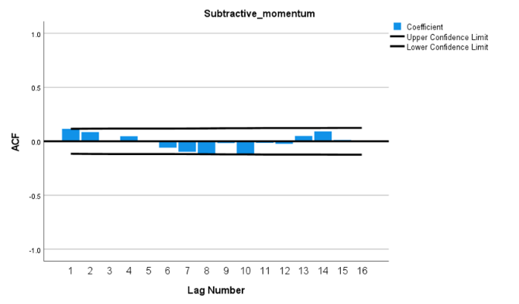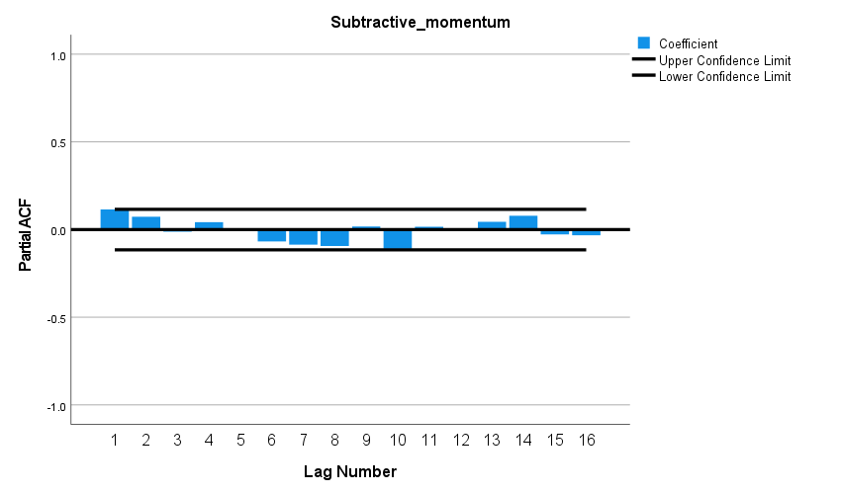

Figure 7: ACF and PACF Plots for Residuals

The figure reveals that the autocorrelation coefficients and partial autocorrelation coefficients for all lag orders do not show significant differences from zero, indicating that the residuals constitute a white noise series.

## 5.2 Discussing the Relationship Between Momentum and Match Outcomes

For match outcomes, we consider using 'Cumulative Score' or 'Score' to characterize them, thus transforming the issue into 'discussing the relationship between Subtracted Momentum and Cumulative Score or Score.' Furthermore, we aim to explore both the linear relationship and causality between the two. However, prior to this, it is typically required for the time series of both variables to be stationary, hence the need for stationarity tests.

5.2.1 Stationarity Tests for Cumulative Score and Score Time Series

Having already tested the stationarity of Subtracted Momentum, this section focuses solely on testing the Cumulative Score and Score. The results are presented below.

Table5: ADF Test Results for Cumulative Score and Score

|  |  |  |  |
| --- | --- | --- | --- |
| Cumulative Score | | Score | |
| ADF Statistic | p-value | ADF Statistic | p-value |
| 0.763834912212 | 0.991029388897 | -14.07951731660 | 2.84517110749 |

From the table, it is easy to discern that the p-value for Cumulative Score significantly exceeds 0.05, indicating that at the 1%, 5%, and 10% significance levels, we cannot reject the null hypothesis of the existence of a unit root, thereby considering the data as non-stationary. However, the p-value for Score is far below 0.05, indicating that at the 1%, 5%, and 10% significance levels, we can reject the null hypothesis, thus the data is stationary.

In summary, both the Subtracted Momentum and the point_victor columns are stationary and can be directly utilized for further modeling work.

5.2.2 Investigating the Linear Relationship Between Subtracted Momentum and Score

1.Model Establishment

Cross-Correlation Analysis is employed to measure the correlation between two time series at different time points. Its principle involves calculating correlation coefficients at various lag times to describe the relationship between the two series. Here are the fundamental principles and mathematical formula for cross-correlation analysis:

For time series and with the same sample length , using to represent the lag time, where a positive indicates lags behind ,and and a negative indicates lags behind .The cross-correlation coefficient at lag time is defined as:

Generally, if at a certain lag time, the correlation coefficient is significantly non-zero (i.e., the confidence interval does not include zero), it implies a significant correlation between the two time series at that lag time.

2．Model Solution

By calculating the correlation coefficients at different lag times, we can plot the cross-correlation function graph for Subtracted Momentum and Score.

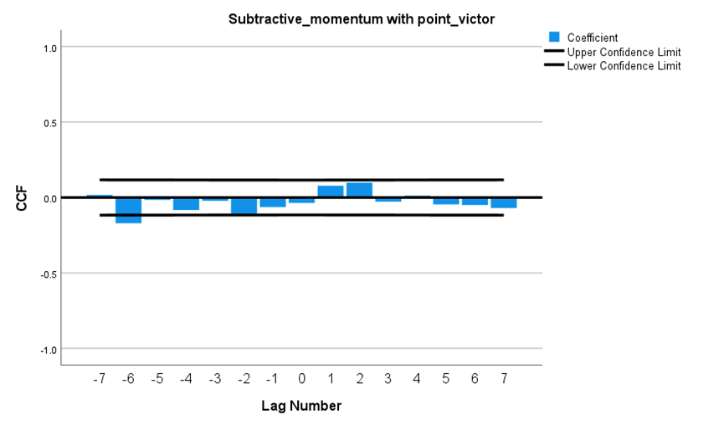

Figure 8: Cross-Correlation Function Graph Between Subtracted Momentum and Score

From the graph, we can observe that the confidence intervals for all lag points include zero, indicating no significant linear relationship between Subtracted Momentum and Score within the observed lag range.

Such a result might suggest that the two time series are independent, or their relationship could be non-linear, or the correlation may exist within higher-order dynamic relations

5.2.3 Testing the Causal Relationship Between Subtracted Momentum and Score

1.Model Establishment

The Granger causality test[3] is a statistical method used to examine the causal relationships between time series data, enabling the investigation of causality between variables. Below is the model for causality testing:

The null hypothesis posits that the time series variable X does not cause changes in the time series variable Y, while the alternative hypothesis suggests that X is the cause of changes in Y, expressed as:

The Null Model is:

The Alternative Model is:

Parameters for the above models are then estimated using the least squares method, and the test statistic and the p-valueare derived from the residual sum of squares and of these two regression models:

If the test statistic is significant or the p-value is less than 0.05, the null hypothesis is rejected, indicating the existence of a Granger causal relationship. Otherwise, the null hypothesis cannot be rejected, suggesting no significant causal relationship was found.

2.Model Solution

Upon solving, we obtained the causal test results between Subtracted Momentum and Score.For lags of 6 and beyond, the p-values are less than 0.05, leading to the rejection of the null hypothesis. This suggests that Subtracted Momentum is a Granger cause of the scoring conditions; furthermore, at longer lags, the p-values are very small, signifying even stronger statistical significance.

## 5.3 Summary

The figure reveals that the confidence intervals for all lag points include zero, indicating no significant linear relationship between Subtracted Momentum and Score within the observed lag range.

Such results may imply that the two time series are independent, or the relationship between them could be non-linear, or the correlation may exist within a higher-order dynamic structure.

It is inferred that Subtracted Momentum is a Granger cause of the scoring conditions; notably, at longer lags, the p-values are significantly small, signifying stronger statistical significance.

# 6 Task 3 Explore the transformation of the game flow

In this section, we first establish the time series model [4], is used to predict volatility, then has carried on the stationarity test, the cross correlation analysis and granger causality test, to find the most relevant factors and fluctuations.

## 6.1 Predicting Fluctuations

In the match, we characterize fluctuations using 'Cumulative Subtracted Momentum,' capturing the macroscopic changes of the contest. Due to the temporal interrelation of cumulative subtracted momentum, we opt for a time series model for predictions. Among them, the formula of "cumulative subtraction momentum" is

6.1.1 Constructing Time Series Plots

Within our time series model, we have defined time as 'hour:minute,' equating each serve to every minute. This abstraction of the specific serving time, to an extent, facilitates the construction of the time series model. Below is the time series plot for cumulative subtracted momentum.

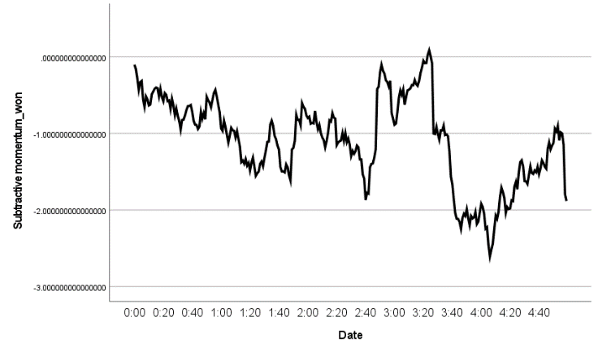

Figure 9: Time Series Plot of Cumulative Subtracted Momentum

The figure illustrates that the subtracted momentum exhibits significant overall fluctuations over time, yet during certain intervals, the fluctuations are smaller, suggesting the applicability of an additive decomposition model. Furthermore, it is observed that substantial changes generally occur on the hour, leading to the conjecture that there might be a 60-minute cycle.

6.1.2 Model Establishment, Solution, and Testing

Decomposing the time series reveals a 60-minute cycle. Next, Using the SPSS software for expert modeling, the identified model type is Winters' Additive, with the specific formula as follows,

Within this model, represents the current period, the forecast horizon,and the cycle length (taken as 60 here), the estimated level at time , as the smoothing parameter for the level, for the trend, and for the seasonality,and as the forecasted value for period .

Furthermore, the corresponding coefficients have been obtained: ，，,These can be substituted into formula (16) as necessary.

Subsequently, we conducted a test of the model. Since time series models typically assume residuals are white noise, we chose a white noise residual test.。

Specifically, we utilized the Ljung-Box[5] test, a common method for checking whether a series of residuals exhibits autocorrelation.

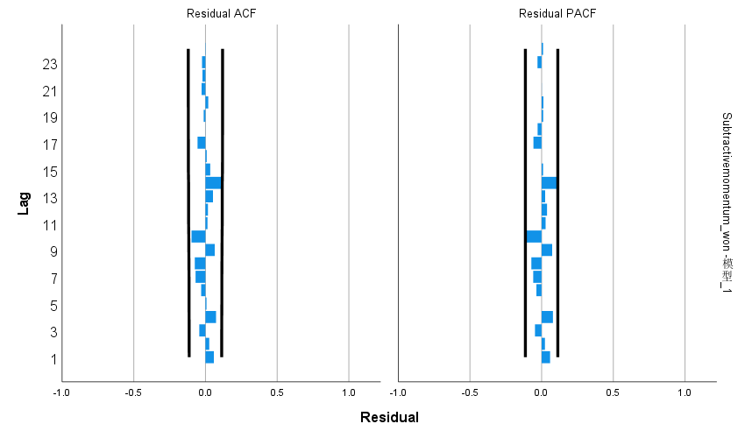

Figure 10: White noise residual test

Table6: Model data

|  |  |  |  |  |  |
| --- | --- | --- | --- | --- | --- |
| Number of Predictors | Stationary R-squared | Statistics | DF | Sig. | Number of Outliers |
| 0 | 0.604 | 17.674 | 15 | 0.280 | 0 |

From the ACF and PACF plots of the residuals, it is evident that the autocorrelation and partial autocorrelation coefficients for all lags do not differ significantly from zero; the table shows a stationary R-squared value of 0.604, which is quite high, indicating that the model adapts well to the stationarized time series. Moreover, the p-value obtained from the Q test on residuals is 0.280, greater than 0.05, leading us to accept the null hypothesis. Therefore, it is considered that the residual is a white noise sequence, indicating that the addition model can identify the cumulative subtraction momentum well.

6.1.3 Prediction

Given that the Winters' additive model effectively identifies cumulative subtracted momentum, it can be employed for future predictions.

Since predicting based on information from only one cycle does not yield satisfactory results, we preliminarily choose data from two cycles for the prediction. Below are our predictions for the momentum of the next five matches based on the first two cycles.

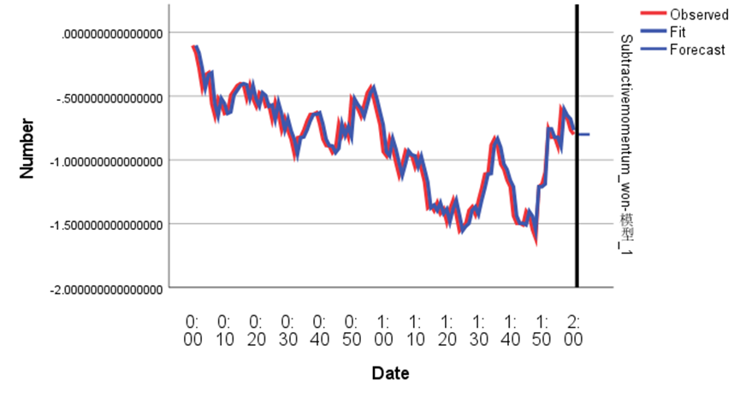

Figure 11: Forecast of last five cumulative subtraction momentum based on two cycles

Table7 Predicted and true values of the last five cumulative subtracted momentums

|  |  |  |  |  |  |
| --- | --- | --- | --- | --- | --- |
|  | 1 | 2 | 3 | 4 | 5 |
| forecast | -0.79983 | -0.79983 | -0.79983 | -0.79983 | -0.79983 |
| truth | -0.78287 | -0.87369 | -0.8627 | -0.87002 | -0.70771 |

It can be seen from the figure that the five cumulative subtraction momentum predicted based on the two cycles are all -0.79983, indicating that the momentum of the upcoming race exhibits sustained fluctuations rather than trend-based momentum. In addition, the model is particularly accurate in predicting the most recent cumulative loss of momentum. This shows that our model is not only able to predict match momentum, but also to distinguish whether upcoming fluctuations are cyclical or trend-based..

## 6.2 Look for the factors most associated with volatility

6.2.1 Stationarity test

The relevant methods have been described previously (see formula (7-8)), and only the results are shown below。The p-value of Subtractive momentum_won and the other 12 indicators after first-order difference are all less than 0.05, indicating that the data is stable at the significance level of 1%, 5% and 10%. So it can be used for the next step.

6.2.2 Cross correlation analysis

In order to explore the correlation between "cumulative subtraction momentum" and time series of other factors at different time points, we use cross-correlation analysis. It is important to note that the "cumulative subtracting momentum" time series data after first difference is chosen here because it is stationary.

The method of this analysis has already been introduced (see formula (11)). Several representative results are analyzed in detail below, and the rest are only conclusions.

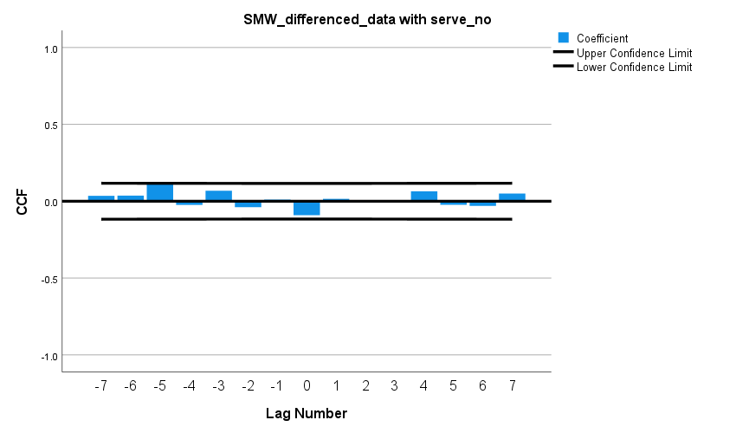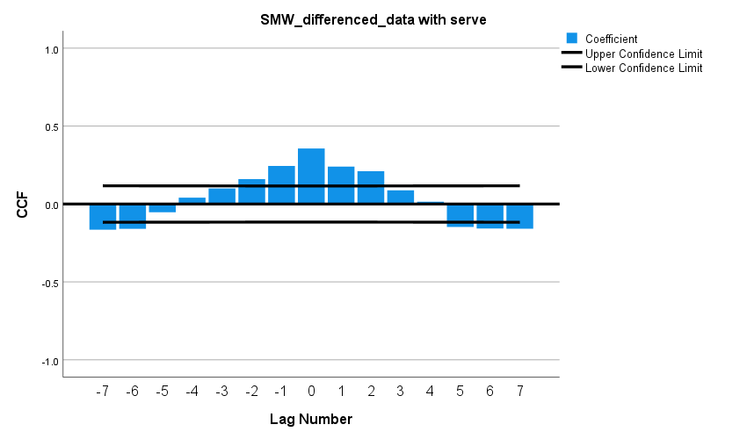1. .Individual analysis

Figure 12: serve Figure 13: miss service

The left graph shows that, across most lag periods, there is a relatively clear linear relationship between serve and the cumulative subtracted momentum of the match, exhibiting a periodic distribution. This may be influenced by the cyclical change in the serving player. Some periods do not show a clear linear relationship, possibly due to the effect of alternating serves, which neutralizes the serving advantage. A strong linear relationship at lag 0 could be indicative of a player's consistent serving advantage.

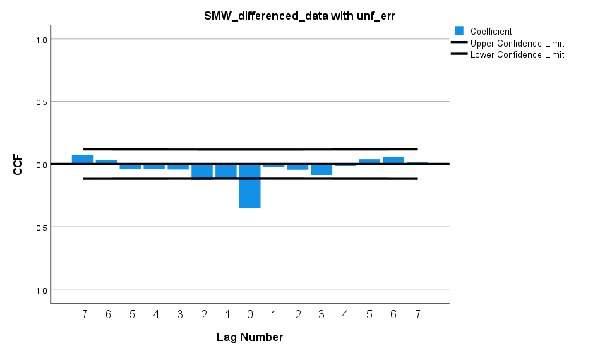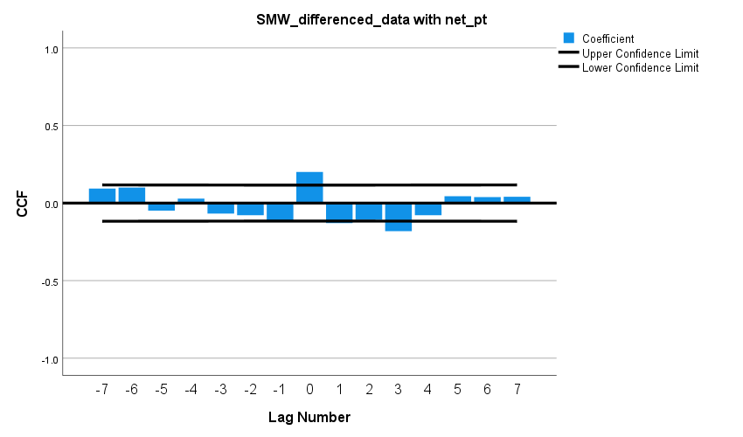 From the right graph, it is evident that service errors do not have a clear linear relationship with changes in cumulative momentum. This might be because the data on service errors were not combined with information on the serving player.

Figure 14: Unf_err Figure 15: Net put

The left graph reveals that at a lag of 0, there is a significant negative linear correlation between Unf_err and the cumulative subtracted momentum of the match, which may be influenced by the immediacy and rarity of unforced errors in professional matches.

From the right graph, it is observed that at lags of 0 and 3, there exists a certain linear relationship between Net put and the cumulative subtracted momentum of the match, with one being positively correlated and the other negatively correlated. This could be due to our selection of successful net approaches data without knowing which player made the successful approach.

Based on the results, we have categorized the indicators according to the strength of their relationship with the cumulative subtracted momentum:

* With significant linear relationship: Serve, Unf_err, Unf_err (at a lag of 0).
* With weaker or unclear relationship: Double_fault, service errors, Winner_shot_type, Net put, Break_pt, player's physical indicators.
* With no significant linear relationship: y9, y10, ace, scoring rate.

6.2.3 Granger Causality Test

Next, we sought to determine if there is a causal relationship between 'Cumulative Subtracted Momentum' and other factors, thus employing the Granger causality test. The methodology has already been described (see formula (12-14)), and below are the test results.：

* The p-values for winner-shot-type at lags 1~2 are less than 0.1, which is relatively significant, indicating a certain causal relationship with match fluctuations.
* The p-values for serve at all lags are less than 0.05, very significant, suggesting a clear causal relationship with match fluctuations.
* The p-values for M(t)player1 and M(t)player2 increase with the lag and are less than 0.05 for lags 0~6, significantly indicating a clear causal relationship with match fluctuations.
* The p-values for net-put at lags 01 and 56 are less than 0.05, very significant, indicating a clear causal relationship with match fluctuations.
* The p-values for Y81 (distance run per rally) at lags 8 and 10 are less than 0.1, relatively significant, indicating a certain causal relationship with match fluctuations; at lags 9 and 11, the p-values are less than 0.05, very significant, suggesting a clear causal relationship with match fluctuations.

6.2.4 Summary

Based on the analysis above, overall, Serve, Unf_err, M(t)player1, M(t)player2, and Net_put are the factors most related to match fluctuations, while the relationships of other factors are relatively weak or unclear.

## 6.3 Recommendations

Considering the differences in "momentum" fluctuations in past matches, we propose the following recommendations based on our model research:

* When the cumulative total momentum from the previous match is higher than the opponent's and continues to rise, players should accelerate the pace of the next match to further widen the score gap and consolidate their advantageous position.
* When the momentum from the previous match is even, special attention should be paid to the performance at every point, actively displaying spectacular maneuvers, such as aces. At the same time, it is crucial to avoid unforced errors, like serve faults, to strive for a more advantageous position.
* When the momentum from the previous match is at a disadvantage, it is advisable to slow down the pace of the game while waiting for opportunities to counterattack, aiming to reverse the disadvantage.
* In cases where the momentum from the previous match is advantageous but shows a downward trend, the next match requires vigilance to guard against possible counterattacks.
* When the momentum from the previous match is in a disadvantageous position but shows an upward trend, the next match should be more aggressive in contesting for momentum, making every effort to turn the situation around.

# 7 Task 4 Evaluate the prediction effect

In this part, we evaluate the prediction effect of the model from two aspects. On the one hand, we choose different periods to predict the data of tennis matches to evaluate the accuracy of the model. On the other hand, we repeat the inquiry process above and make predictions for other competitions to assess the generality of the model.

## 7.1 Anticipate fluctuations in the game

We select various periods (ranging from 2 to 5) and then, following the approach of Task 3, use the model to predict the cumulative subtractive momentum for the next five matches. Below are the results obtained.

Table8: Predicted values and actual values for different periods

|  |  |  |  |  |  |
| --- | --- | --- | --- | --- | --- |
|  | Predictive value | Actual value |  | Predictive value | Actual value |
|  | Two cycles | |  | Four cycles | |
| 1 | -0.5744 | -0.5342 |  | -1.0970 | -1.1380 |
| 2 | -0.6044 | -0.5622 |  | -1.0906 | -1.2009 |
| 3 | -0.6097 | -0.5324 |  | -1.0870 | -1.2232 |
| 4 | -0.6125 | -0.5392 |  | -1.0847 | -1.1797 |
| 5 | -0.6141 | -0.5242 |  | -1.0833 | -1.2191 |
|  | Three cycles | |  | Five cycles | |
| 1 | -0.5744 | -0.5923 |  | -0.7159 | -0.6839 |
| 2 | -0.6044 | -0.6266 |  | -0.6943 | -0.6225 |
| 3 | -0.6097 | -0.6437 |  | -0.6846 | -0.6656 |
| 4 | -0.6125 | -0.6522 |  | -0.6802 | -0.7599 |
| 5 | -0.6141 | -0.6564 |  | -0.6782 | -0.8702 |

From the tables, we can observe that predictions based on longer periods are closer to the actual values compared to those based on shorter periods, indicating that the more historical data the model has, the more accurate it becomes. The model exhibits strong predictive capabilities for short-term game situations when sufficient historical data is available. Furthermore, it can predict the trend of the game situation over the long term, including whether the match will be closely contested.

## 7.2 Apply to other sports

We used the above method to predict three other sports competitions. Due to the large number of results, we only display and analyze the prediction results for a certain period of each sport.

**1.Table Tennis Competition**

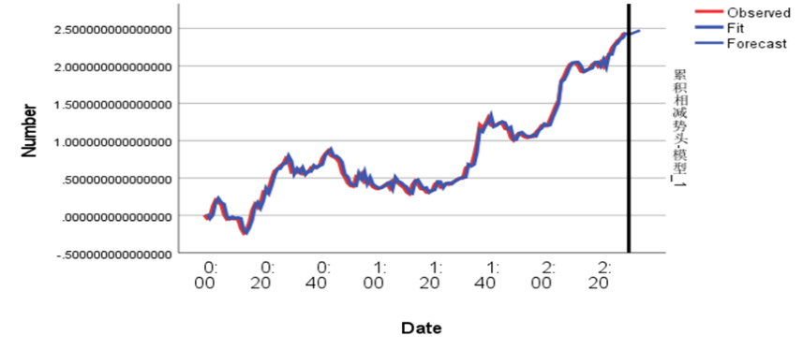Table 9 and Figure 16

|  |  |  |
| --- | --- | --- |
|  | Predictive value | Actual value |
| 1 | 2.0408 | 2.0344 |
| 2 | 2.0562 | 2.0363 |
| 3 | 2.0716 | 1.9989 |
| 4 | 2.0871 | 1.9278 |
| 5 | 2.1025 | 1.9228 |

The above figure presents predictions for points between 2:31-2:35 in a table tennis match. The results indicate that the predicted values are closely aligned with the actual values and follow the same trend, particularly for the point at 2:31, which is extremely precise. Furthermore, it reflects a one-sided score situation in the match, demonstrating the model's high accuracy and strong generalizability.

**2.Grand slam tournament**

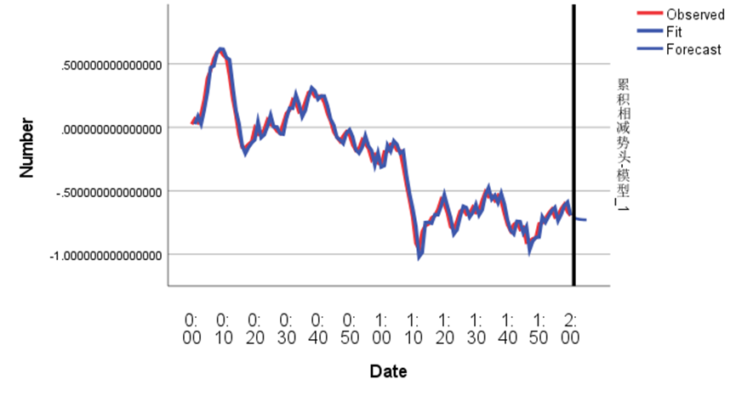Table 10 and Figure 17

|  |  |  |
| --- | --- | --- |
|  | Predictive value | Actual value |
| 1 | -0.7119 | -0.7567 |
| 2 | -0.7206 | -0.8082 |
| 3 | -0.7251 | -0.7609 |
| 4 | -0.7275 | -0.7265 |
| 5 | -0.7288 | -0.7513 |

The figure above forecasts points from 2:01 to 2:05 in a Grand Slam match. The results show that the predicted values closely match the actual values and share the same trend, indicating the model's high accuracy and strong generalizability.

3. Women's tennis match

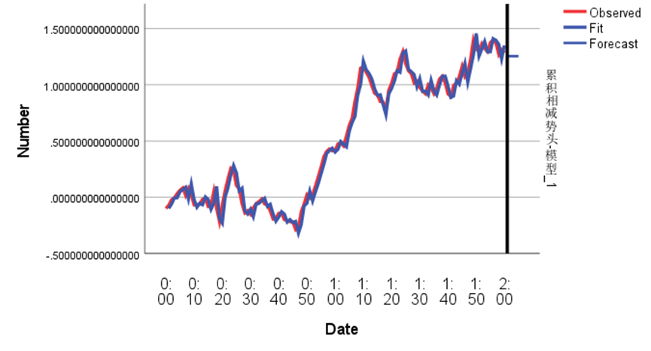Table 11 and Figure 18

|  |  |  |
| --- | --- | --- |
|  | Predictive value | Actual value |
| 1 | 1.2546 | 1.1595 |
| 2 | 1.2546 | 1.1510 |
| 3 | 1.2546 | 1.2001 |
| 4 | 1.2546 | 1.2173 |
| 5 | 1.2546 | 1.2544 |

The figure above provides predictions for points from 2:01 to 2:05 in a women's match. The results indicate that the predicted values are closely aligned with the actual values and follow the same trend, demonstrating the model's high accuracy, strong generalizability, and broad applicability.

# 8 Memo

Dear Coach,

To enhance our players' performance against varying game dynamics, I present to you the findings of our research along with some recommendations.

We began by developing an Exponential Weighted Moving Average model for players' momentum, accurately depicting changes during the match. This model precisely reflects short-term momentum shifts and predicts upcoming changes in the game situation. Our validations confirmed the significant impact of momentum on scoring.

For predicting overall game momentum fluctuations, we established a Winsted additive model based on cumulative subtractive momentum, characterized by high fit and reasonable predictive outcomes. We identified serve, Unf_err, and Break_pt as the most relevant indicators to momentum fluctuations. Their impacts are as follows: serve has a strong positive correlation with improving situations, indicating the advantage of serving; Unf_err, or unforced errors, typically signify worsening situations; while Break_pt usually indicates a shift towards a better situation.

Observing these indicators helps us predict momentum shifts, thereby adjusting tactics accordingly. For instance, during service, playing more aggressively is beneficial, whether to expand an advantage or to reverse the game's tide. When the opponent makes unforced errors, seizing the opportunity to build momentum is crucial; conversely, slowing the game's pace to adjust one's state is advisable upon making unforced errors oneself. Aggressively capitalizing on break points can either widen the lead or overturn a disadvantage; caution is advised when facing break points to avoid unfavorable momentum.

Upon testing our model, we found it generally performs well. The results indicate that with sufficient match data, the model accurately predicts short to medium-term game flow changes. However, with limited data within a match, long-term predictions may deviate, though it still performs well in predicting long-term trends. Overall, the model's predictive capability and applicability are commendable and valuable for reference.

Based on our research, I propose the following suggestions, focusing on leveraging momentum to expand the score or counteracting disadvantages to reverse situations:

1.In adverse situations, decelerate the pace, recalibrate your state,。

2.At pivotal momentum shifts, intensify the offense to aim for a turnaround.

3.Under neutral momentum, compete for control, optimizing serving and receiving strategies.

4.When advantageous, amplify the lead while avoiding overconfidence or a false sense of security.

Sincerely,

Team #2410809

# 9 Sensitivity Analysis

For the selection of the smoothing exponent in Model 1, we conducted a sensitivity analysis. Under different smoothing exponent metrics, we calculated the cumulative momentum of players, and the cumulative total of players' scoring rate, ，setting

Then, we computed the cumulative variance for and . Utilizing Monte Carlo simulation, we identified a more optimal solution where Sis minimized, with the smoothing constant at 0.65.

Additionally, line graphs depicting the players' winning rate and momentum at =1,0.65,0.35 were plotted.

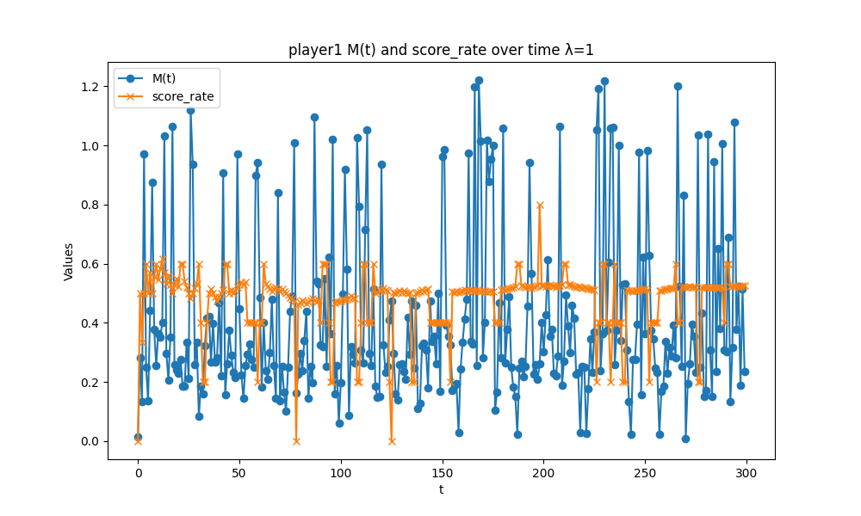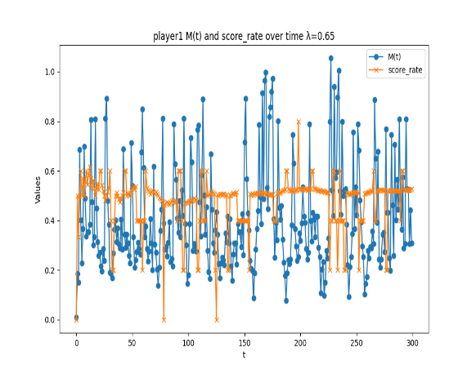

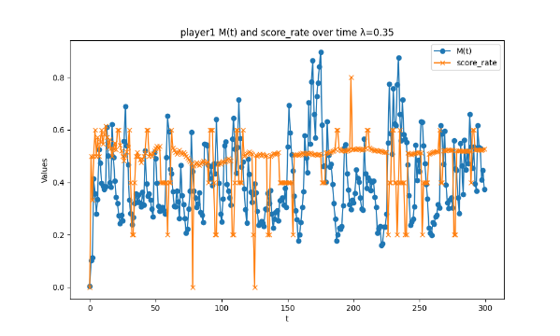

Figure 19 Line graphs of players' winning rates and momentum for =1,0.65, 0.35

As indicated by the graph, when =0.65 , the variations in players' winning rates and momentum more accurately reflect real-world scenarios.

# 10 Model Evaluation and Further Discussion

## 10.1 Strength

1. The application of an Exponential Weighted Moving Average model for the leverage rate attained by players is both simplistic and adaptable, effectively quantifying the momentum of players and providing a robust tool for the objective assessment of player performance. The model has a very wide range of applicability.

2. Through various tests comparing cumulative subtractive momentum with other metrics, not only have we identified key indicators affecting fluctuations, but we also understand how these indicators impact the overall game dynamics. This has significant reference value for adjusting game strategies.

## 10.2 Weaknesses

The model does not account for factors such as venue, audience influence, or the player's historical performance, focusing more on the athlete's performance within the match.

# References

[1] Saaty TL. *The Analytic Hierarchy Process*. 1980. New York: Mc-Graw-Hill.

[2] Kumar Naveen P., et al. "Estimation of price volatility of nifty 50 index using ADF and GARCH (1, 1)."*Indian Journal of Economics and Development* 17. 2 (2021):

[3] Joon S P .A re-examination of Granger causality between government expenditure and GDP[J].*International Journal of Economic Policy Studies*,2023,17(2):533-550.

[4] *Jurnal Matematika Integratif.p-ISSN*：1412-6184e-ISSN：2549-903 Volume 16, Issue 2, 2020, pp. 151-157.doi:10.24198/jmi.v16.n2.29293.151-157

[4] 格兰杰Joon S P .A re-examination of Granger causality between government expenditure and GDP[J].International Journal of Economic Policy Studies,2023,17(2):533-550.

[5] Lee T .Wild bootstrap Ljung–Box test for cross correlations of multivariate time series[J].*Economics Letters*,2016,14759-62.