销售量与充电桩数量

1. 差分
2. 英国检验的图

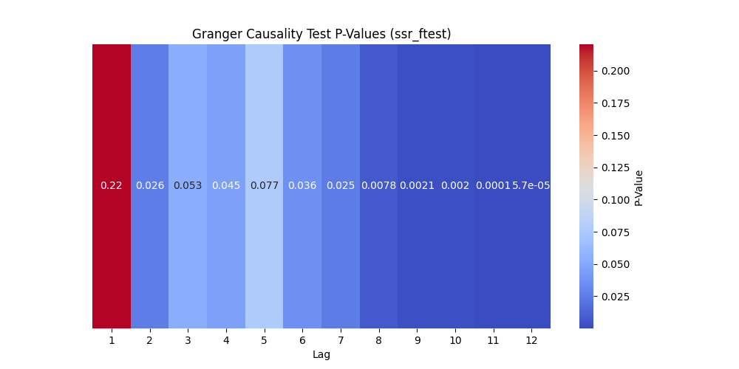

1. 交叉检验的图

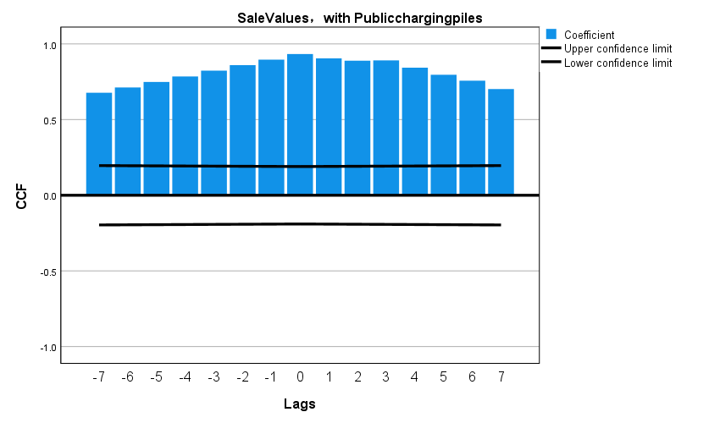

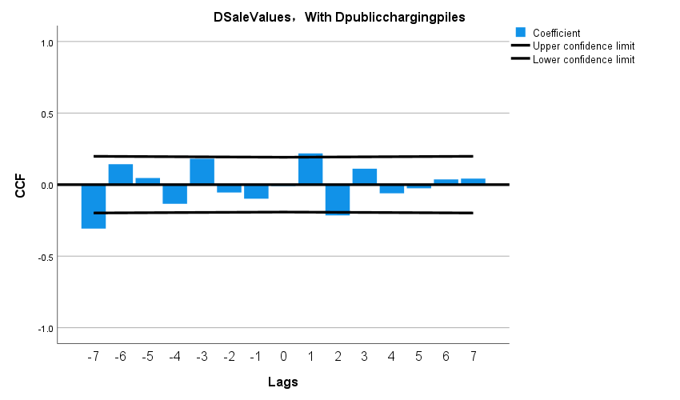

二

1.差分

销售量

ADF Statistic: -1.1846350541848096

p-value: 0.6801701554379541

ADF Statistic (1st diff): -1.310507873749686

p-value (1st diff): 0.6243513421125965

ADF Statistic (2nd diff): -7.99035218496282

p-value (2nd diff): 2.484075151112917e-12

GDP（月）

ADF Statistic: -1.8928035511434924

p-value: 0.33545408404252774

ADF Statistic (1st diff): -7.799268488409893

p-value (1st diff): 7.569757797148794e-12

2.英国检验

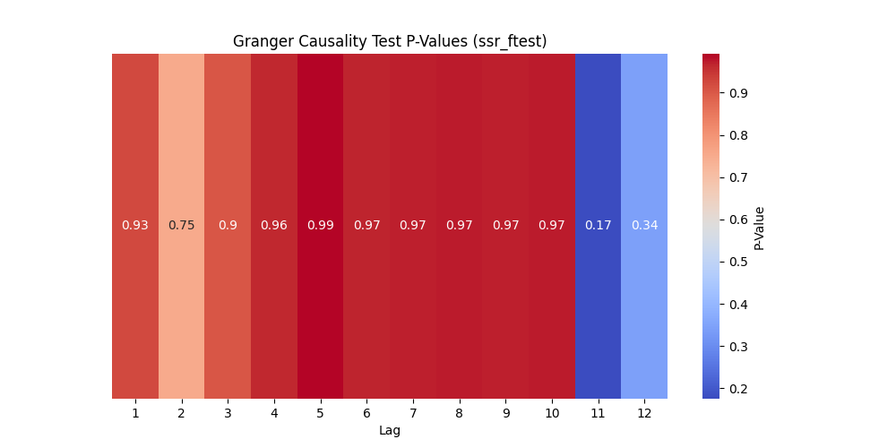

交叉检验图

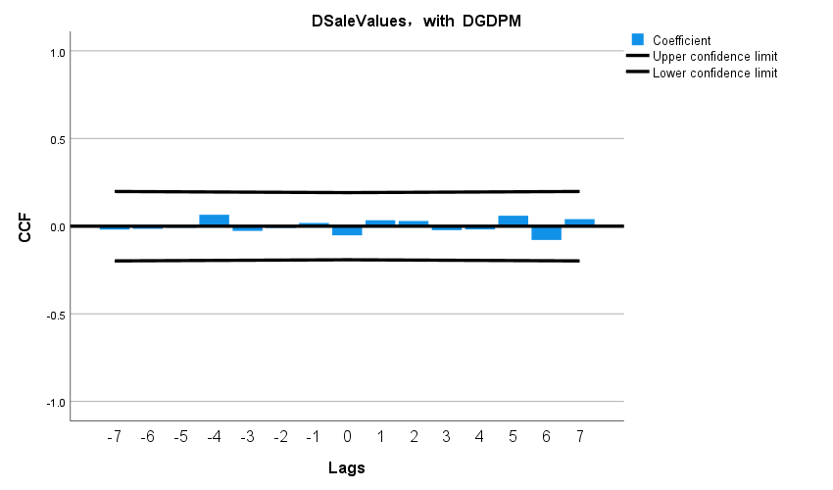

三．Battery capacity (km)

1.差分

ADF Statistic: -1.1846350541848096

p-value: 0.6801701554379541

ADF Statistic (1st diff): -1.310507873749686

p-value (1st diff): 0.6243513421125965

ADF Statistic (2nd diff): -7.99035218496282

p-value (2nd diff): 2.484075151112917e-12

电池

ADF Statistic: -2.674110578889385

p-value: 0.07862640883375338

ADF Statistic (1st diff): -10.463615543662018

p-value (1st diff): 1.3392184725027405e-18

2.英国检验

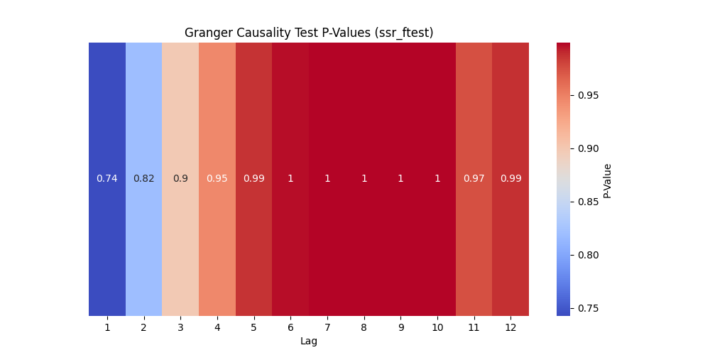

1. 交叉

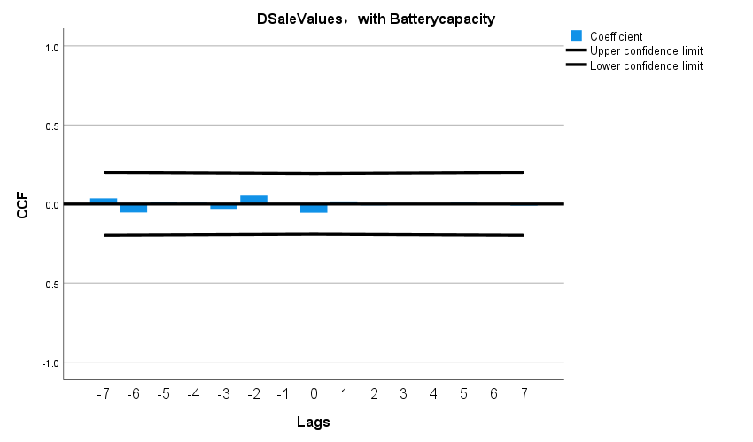

四．最大行驶速度

销售量

ADF Statistic: -1.1846350541848096

p-value: 0.6801701554379541

ADF Statistic (1st diff): -1.310507873749686

p-value (1st diff): 0.6243513421125965

ADF Statistic (2nd diff): -7.99035218496282

p-value (2nd diff): 2.484075151112917e-12

ADF Statistic: -1.1851468588562422

最大行驶速度

p-value: 0.679952301316203

ADF Statistic (1st diff): -10.498074925347614

p-value (1st diff): 1.1021633461942648e-18

2.英国

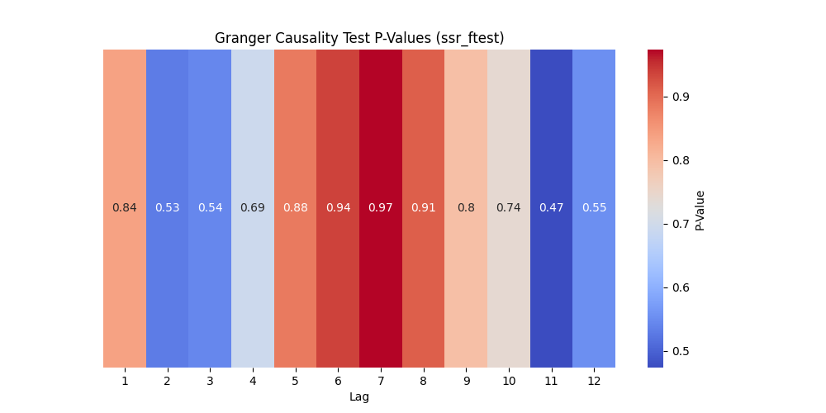

3．交叉检验

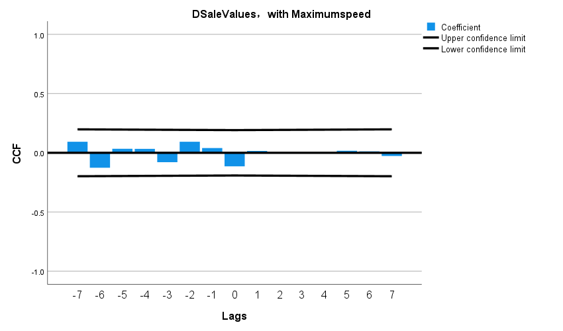

五．R&D expenses

1.ADF

ADF Statistic: -1.1846350541848096

p-value: 0.6801701554379541

ADF Statistic (1st diff): -1.310507873749686

p-value (1st diff): 0.6243513421125965

ADF Statistic (2nd diff): -7.99035218496282

p-value (2nd diff): 2.484075151112917e-12

ADF Statistic: 0.03992726367351919

p-value: 0.9617120963351141

ADF Statistic (1st diff): -10.48714919282083

p-value (1st diff): 1.1723459088350093e-18

2.因果

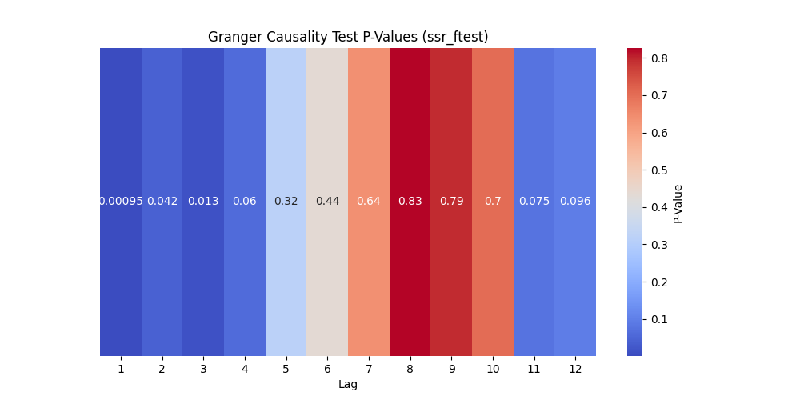

3.

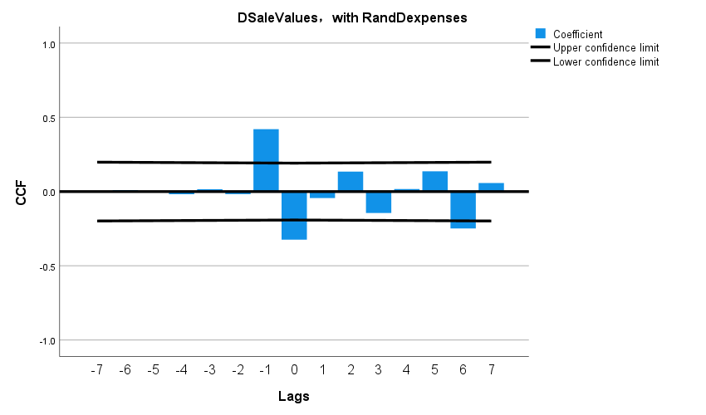

六．Amount involved (yuan)

1.ADF

ADF Statistic: -1.1846350541848096

p-value: 0.6801701554379541

ADF Statistic (1st diff): -1.310507873749686

p-value (1st diff): 0.6243513421125965

ADF Statistic (2nd diff): -7.99035218496282

p-value (2nd diff): 2.484075151112917e-12

ADF Statistic: -1.801226063597716

p-value: 0.37985315718599655

ADF Statistic (1st diff): -14.33537638419285

p-value (1st diff): 1.0823072669202748e-26

2.英国

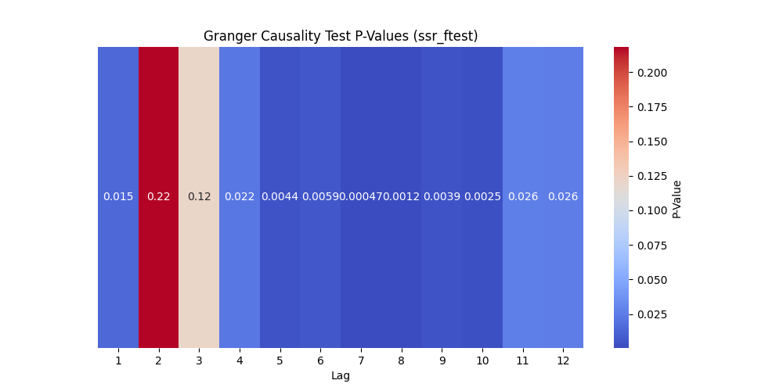

3.

