1. **Global traditional energy vehicle sales**与ZH Sales volume

ADF

ADF Statistic: -1.4527404013270449

p-value: 0.5567471582990045

ADF Statistic (1st diff): -10.344473235124338

p-value (1st diff): 2.6328983380939217e-18

ADF Statistic: -1.1846350541848094

p-value: 0.6801701554379542

ADF Statistic (1st diff): -1.3105078737497071

p-value (1st diff): 0.6243513421125867

ADF Statistic (2nd diff): -7.9903521849623305

p-value (2nd diff): 2.484075151120039e-12

2.

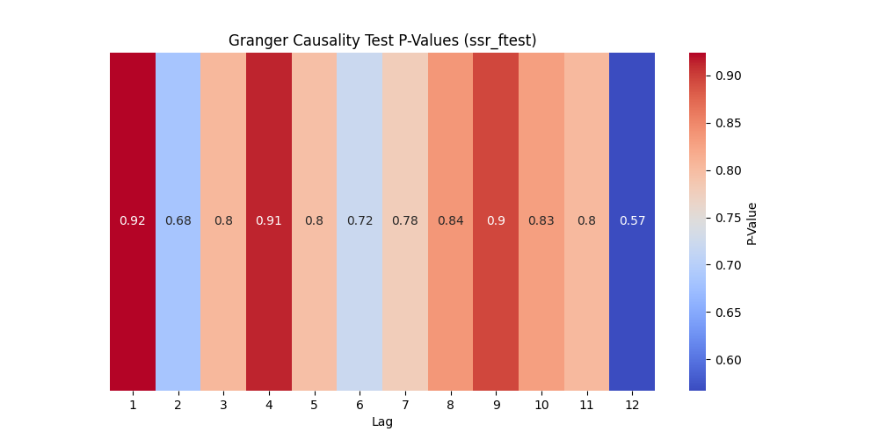

3.

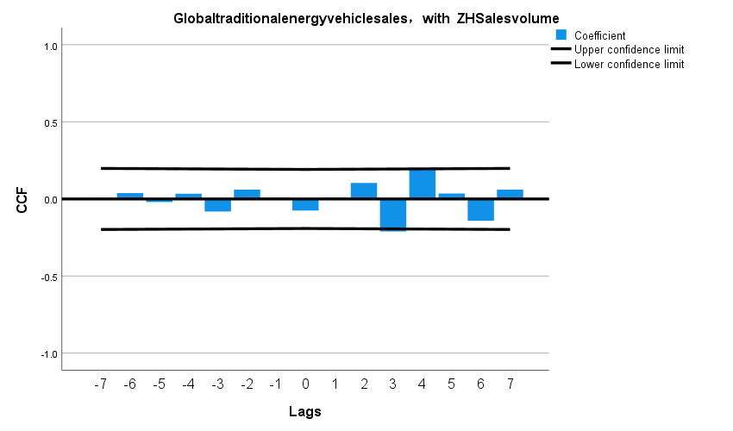

二．全球传统能源汽车销量与Market Share

1.ADF

ADF Statistic: -1.4527404013270449

p-value: 0.5567471582990045

ADF Statistic (1st diff): -10.344473235124338

p-value (1st diff): 2.6328983380939217e-18

ADF Statistic: -1.596420029517792

p-value: 0.4853915789383559

ADF Statistic (1st diff): -10.357073666560806

p-value (1st diff): 2.4508065958821646e-18

1. 因果检验

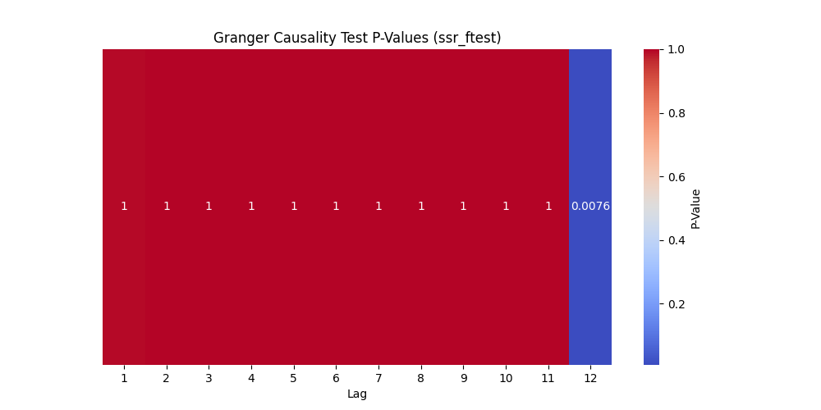

1. 交叉性检验
2. 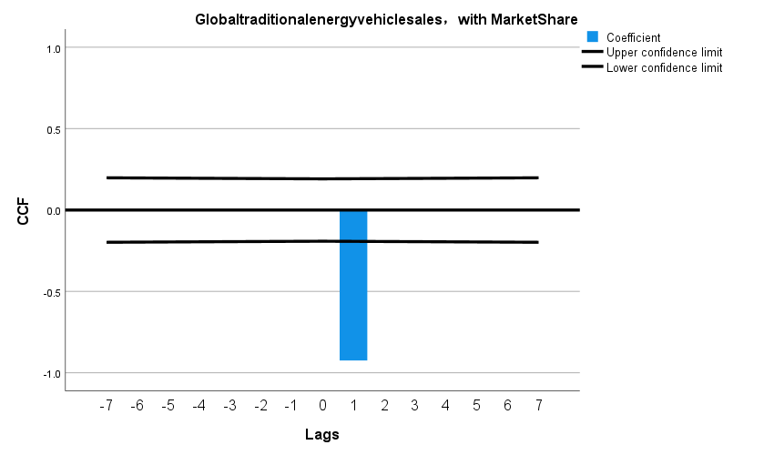

三Global Pure electric sales

ADF Statistic: -1.4527404013270449

p-value: 0.5567471582990045

ADF Statistic (1st diff): -10.344473235124338

p-value (1st diff): 2.6328983380939217e-18

ADF Statistic: -0.5481778985784644

p-value: 0.8822671282992339

ADF Statistic (1st diff): -2.297705762766523

p-value (1st diff): 0.1727089763808216

ADF Statistic (2nd diff): -63.46963874287046

p-value (2nd diff): 0.0

2.

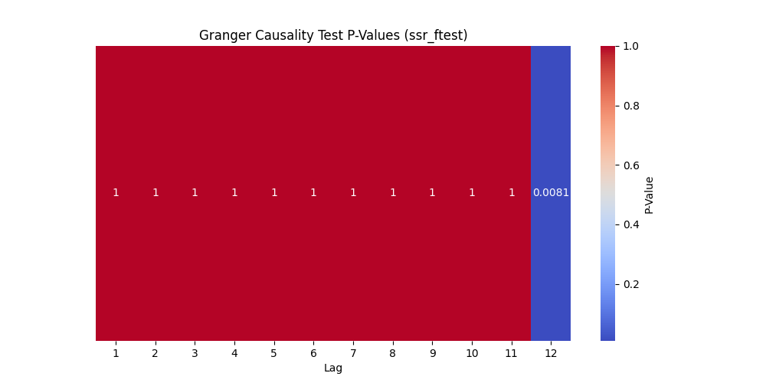

3.

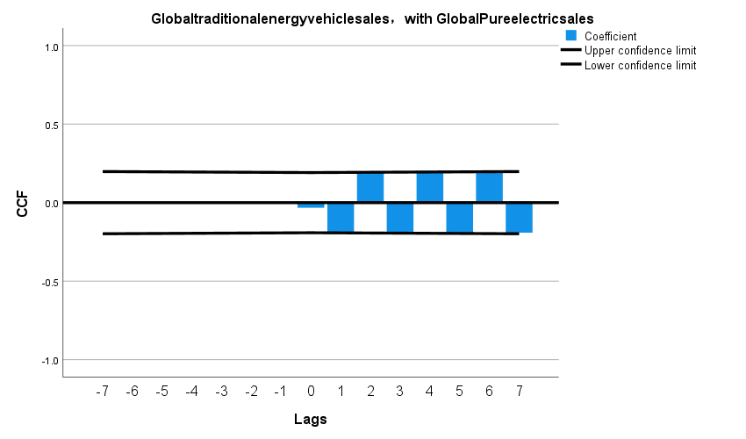

四．Plug-in sales

ADF Statistic: -1.4527404013270449

p-value: 0.5567471582990045

ADF Statistic (1st diff): -10.344473235124338

p-value (1st diff): 2.6328983380939217e-18

ADF Statistic: -0.9684235276169455

p-value: 0.7646062109154256

ADF Statistic (1st diff): -1.9245957439562615

p-value (1st diff): 0.3205804154345584

ADF Statistic (2nd diff): -65.77385273197817

p-value (2nd diff): 0.0

2.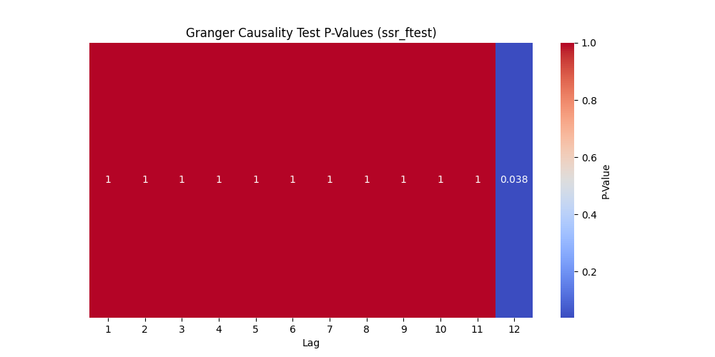

3.

