1.序列图

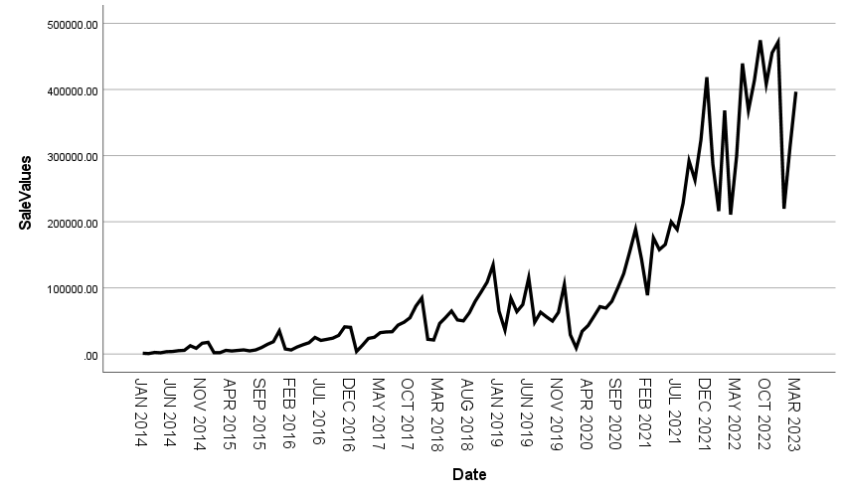

2.季节性分解

|  |  |  |
| --- | --- | --- |
| **模型描述** | | |
| 模型名称 | | MOD_2 |
| 模型类型 | | 乘性 |
| 序列名称 | 1 | SaleValues |
| 季节性周期长度 | | 12 |
| 移动平均值的计算方法 | | 跨度等于周期长度加 1，且端点按 0.5 加权 |
| 正在应用来自 MOD_2 的模型指定项 | | |

|  |  |
| --- | --- |
| **季节因子** | |
| 序列名称: SaleValues | |
| 周期 | 季节因子 (%) |
| 1 | 59.9 |
| 2 | 43.8 |
| 3 | 86.8 |
| 4 | 77.5 |
| 5 | 90.7 |
| 6 | 101.4 |
| 7 | 82.7 |
| 8 | 96.3 |
| 9 | 111.6 |
| 10 | 119.0 |
| 11 | 147.4 |
| 12 | 182.9 |

3.画出分解后的时序图

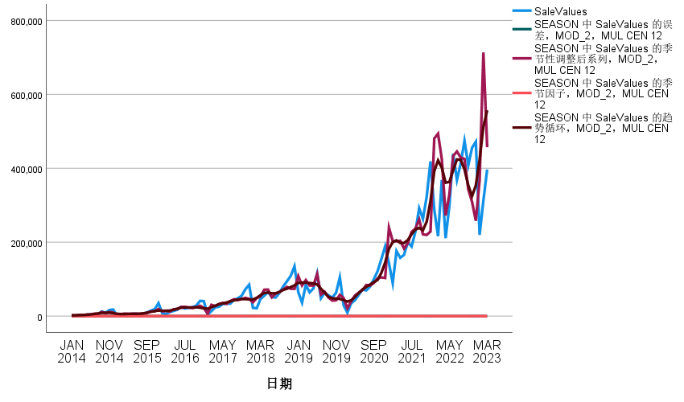

英文版

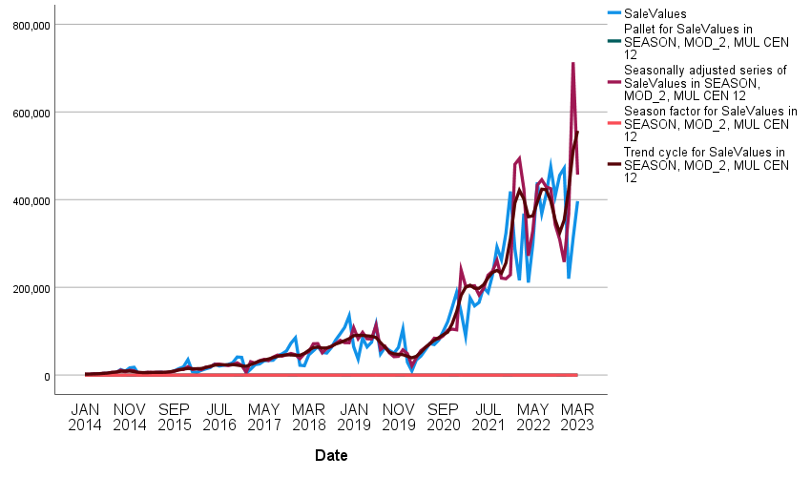

4.建立时间序列模型

|  |  |  |  |
| --- | --- | --- | --- |
| **模型描述** | | | |
|  | | | 模型类型 |
| 模型 ID | SaleValues | 模型_1 | 温特斯乘性 |

|  |  |  |  |  |  |  |  |  |  |  |  |
| --- | --- | --- | --- | --- | --- | --- | --- | --- | --- | --- | --- |
| **模型拟合度** | | | | | | | | | | | |
| 拟合统计 | 平均值 | 标准误差 | 最小值 | 最大值 | 百分位数 | | | | | | |
| 5 | 10 | 25 | 50 | 75 | 90 | 95 |
| 平稳 R 方 | .555 | . | .555 | .555 | .555 | .555 | .555 | .555 | .555 | .555 | .555 |
| R 方 | .963 | . | .963 | .963 | .963 | .963 | .963 | .963 | .963 | .963 | .963 |
| RMSE | 24602.568 | . | 24602.568 | 24602.568 | 24602.568 | 24602.568 | 24602.568 | 24602.568 | 24602.568 | 24602.568 | 24602.568 |
| MAPE | 49.275 | . | 49.275 | 49.275 | 49.275 | 49.275 | 49.275 | 49.275 | 49.275 | 49.275 | 49.275 |
| MaxAPE | 621.726 | . | 621.726 | 621.726 | 621.726 | 621.726 | 621.726 | 621.726 | 621.726 | 621.726 | 621.726 |
| MAE | 15755.795 | . | 15755.795 | 15755.795 | 15755.795 | 15755.795 | 15755.795 | 15755.795 | 15755.795 | 15755.795 | 15755.795 |
| MaxAE | 103272.759 | . | 103272.759 | 103272.759 | 103272.759 | 103272.759 | 103272.759 | 103272.759 | 103272.759 | 103272.759 | 103272.759 |
| 正态化 BIC | 20.348 | . | 20.348 | 20.348 | 20.348 | 20.348 | 20.348 | 20.348 | 20.348 | 20.348 | 20.348 |

|  |  |  |  |  |  |  |
| --- | --- | --- | --- | --- | --- | --- |
| **模型统计** | | | | | | |
| 模型 | 预测变量数 | 模型拟合度统计 | 杨-博克斯 Q(18) | | | 离群值数 |
| 平稳 R 方 | 统计 | DF | 显著性 |
| SaleValues-模型_1 | 0 | .555 | 18.149 | 15 | .255 | 0 |

|  |  |  |  |  |  |  |
| --- | --- | --- | --- | --- | --- | --- |
| **指数平滑法模型参数** | | | | | | |
| 模型 | | | 估算 | 标准误差 | t | 显著性 |
| SaleValues-模型_1 | 不转换 | Alpha（水平） | .734 | .057 | 12.957 | .000 |
| Gamma（趋势） | .000 | .013 | .012 | .991 |
| Delta（季节） | .091 | .036 | 2.539 | .013 |

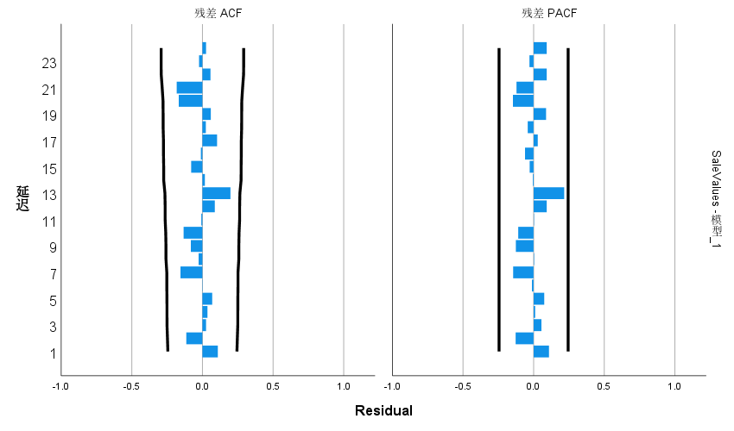

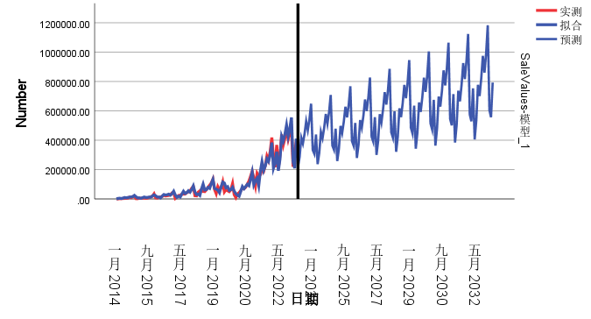

预测值从2023年4月开始至2033年3月

216157.56

285915.74

417609.27

377812.51

443106.58

529353.59

468728.63

542069.09

649249.37

333740.27

307533.31

439496.85

237199.16

313523.91

457611.95

413716.47

484884.65

578874.32

512238.74

592000.85

708598.28

364017.36

335223.55

478774.34

258240.77

341132.08

497614.62

449620.42

526662.72

628395.06

555748.85

641932.60

767947.19

394294.44

362913.79

518051.84

279282.37

368740.25

537617.30

485524.37

568440.79

677915.80

599258.96

691864.35

827296.10

424571.53

390604.03

557329.34

300323.97

396348.43

577619.98

521428.33

610218.87

727436.54

642769.08

741796.11

886645.02

454848.61

418294.27

596606.83

321365.57

423956.60

617622.65

557332.28

651996.94

776957.28

686279.19

791727.86

945993.93

485125.70

445984.50

635884.33

342407.17

451564.77

657625.33

593236.23

693775.01

826478.02

729789.30

841659.62

1005342.84

515402.78

473674.74

675161.82

363448.77

479172.94

697628.01

629140.19

735553.08

875998.76

773299.41

891591.37

1064691.75

545679.87

501364.98

714439.32

384490.37

506781.11

737630.68

665044.14

777331.15

925519.50

816809.53

941523.12

1124040.66

575956.95

529055.22

753716.82

405531.98

534389.28

777633.36

700948.10

819109.23

975040.24

860319.64

991454.88

1183389.57

606234.04

556745.46

792994.31