1.序列图

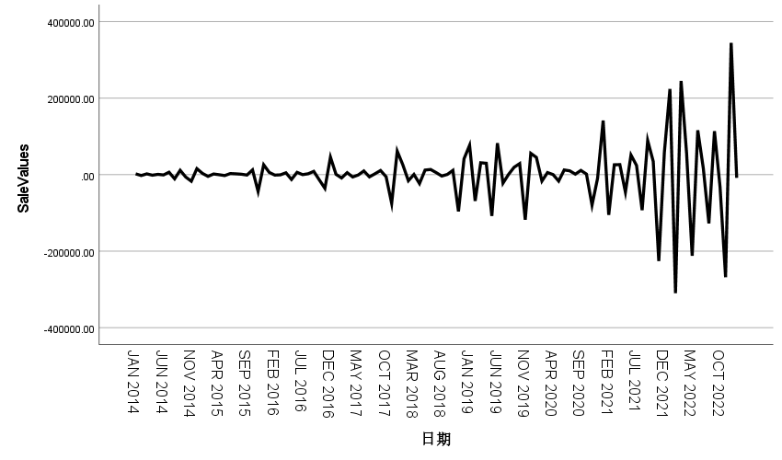

2.季节性分解·

|  |  |  |
| --- | --- | --- |
| **模型描述** | | |
| 模型名称 | | MOD_2 |
| 模型类型 | | 乘性 |
| 序列名称 | 1 | SaleValues |
| 季节性周期长度 | | 12 |
| 移动平均值的计算方法 | | 跨度等于周期长度加 1，且端点按 0.5 加权 |
| 正在应用来自 MOD_2 的模型指定项 | | |

|  |  |
| --- | --- |
| **季节因子** | |
| 序列名称: SaleValues | |
| 周期 | 季节因子 (%) |
| 1 | 50.0 |
| 2 | 500.0 |
| 3 | -127.1 |
| 4 | -77.6 |
| 5 | 129.5 |
| 6 | 301.1 |
| 7 | -7.3 |
| 8 | 106.6 |
| 9 | -20.2 |
| 10 | 448.8 |
| 11 | 310.2 |
| 12 | -414.0 |

3. 画出分解后的时序图

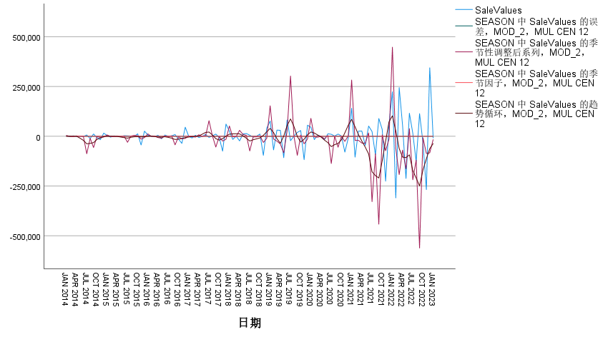

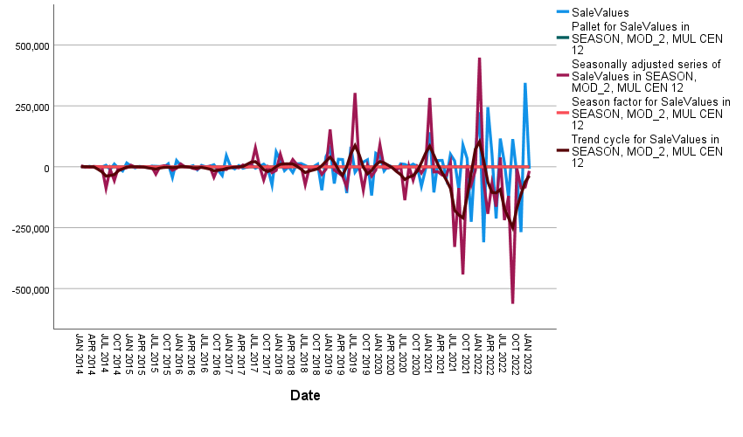

4.建立时间序列模型

|  |  |  |  |
| --- | --- | --- | --- |
| **模型描述** | | | |
|  | | | 模型类型 |
| 模型 ID | SaleValues | 模型_1 | ARIMA(3,0,0)(0,1,0) |

|  |  |  |  |  |  |  |  |  |  |  |  |
| --- | --- | --- | --- | --- | --- | --- | --- | --- | --- | --- | --- |
| **模型拟合度** | | | | | | | | | | | |
| 拟合统计 | 平均值 | 标准误差 | 最小值 | 最大值 | 百分位数 | | | | | | |
| 5 | 10 | 25 | 50 | 75 | 90 | 95 |
| 平稳 R 方 | .518 | . | .518 | .518 | .518 | .518 | .518 | .518 | .518 | .518 | .518 |
| R 方 | .720 | . | .720 | .720 | .720 | .720 | .720 | .720 | .720 | .720 | .720 |
| RMSE | 45034.424 | . | 45034.424 | 45034.424 | 45034.424 | 45034.424 | 45034.424 | 45034.424 | 45034.424 | 45034.424 | 45034.424 |
| MAPE | 451.767 | . | 451.767 | 451.767 | 451.767 | 451.767 | 451.767 | 451.767 | 451.767 | 451.767 | 451.767 |
| MaxAPE | 8871.524 | . | 8871.524 | 8871.524 | 8871.524 | 8871.524 | 8871.524 | 8871.524 | 8871.524 | 8871.524 | 8871.524 |
| MAE | 27763.782 | . | 27763.782 | 27763.782 | 27763.782 | 27763.782 | 27763.782 | 27763.782 | 27763.782 | 27763.782 | 27763.782 |
| MaxAE | 250948.679 | . | 250948.679 | 250948.679 | 250948.679 | 250948.679 | 250948.679 | 250948.679 | 250948.679 | 250948.679 | 250948.679 |
| 正态化 BIC | 21.525 | . | 21.525 | 21.525 | 21.525 | 21.525 | 21.525 | 21.525 | 21.525 | 21.525 | 21.525 |

|  |  |  |  |  |  |  |  |  |  |  |  |
| --- | --- | --- | --- | --- | --- | --- | --- | --- | --- | --- | --- |
| **残差 ACF 摘要** | | | | | | | | | | | |
| 延迟 | 平均值 | 标准误差 | 最小值 | 最大值 | 百分位数 | | | | | | |
| 5 | 10 | 25 | 50 | 75 | 90 | 95 |
| 延迟 1 | -.308 | . | -.308 | -.308 | -.308 | -.308 | -.308 | -.308 | -.308 | -.308 | -.308 |
| 延迟 2 | -.229 | . | -.229 | -.229 | -.229 | -.229 | -.229 | -.229 | -.229 | -.229 | -.229 |
| 延迟 3 | .008 | . | .008 | .008 | .008 | .008 | .008 | .008 | .008 | .008 | .008 |
| 延迟 4 | .150 | . | .150 | .150 | .150 | .150 | .150 | .150 | .150 | .150 | .150 |
| 延迟 5 | -.114 | . | -.114 | -.114 | -.114 | -.114 | -.114 | -.114 | -.114 | -.114 | -.114 |
| 延迟 6 | -.014 | . | -.014 | -.014 | -.014 | -.014 | -.014 | -.014 | -.014 | -.014 | -.014 |
| 延迟 7 | -.089 | . | -.089 | -.089 | -.089 | -.089 | -.089 | -.089 | -.089 | -.089 | -.089 |
| 延迟 8 | .054 | . | .054 | .054 | .054 | .054 | .054 | .054 | .054 | .054 | .054 |
| 延迟 9 | .114 | . | .114 | .114 | .114 | .114 | .114 | .114 | .114 | .114 | .114 |
| 延迟 10 | -.091 | . | -.091 | -.091 | -.091 | -.091 | -.091 | -.091 | -.091 | -.091 | -.091 |
| 延迟 11 | .162 | . | .162 | .162 | .162 | .162 | .162 | .162 | .162 | .162 | .162 |
| 延迟 12 | -.128 | . | -.128 | -.128 | -.128 | -.128 | -.128 | -.128 | -.128 | -.128 | -.128 |
| 延迟 13 | -.104 | . | -.104 | -.104 | -.104 | -.104 | -.104 | -.104 | -.104 | -.104 | -.104 |
| 延迟 14 | .135 | . | .135 | .135 | .135 | .135 | .135 | .135 | .135 | .135 | .135 |
| 延迟 15 | .043 | . | .043 | .043 | .043 | .043 | .043 | .043 | .043 | .043 | .043 |
| 延迟 16 | -.110 | . | -.110 | -.110 | -.110 | -.110 | -.110 | -.110 | -.110 | -.110 | -.110 |
| 延迟 17 | .014 | . | .014 | .014 | .014 | .014 | .014 | .014 | .014 | .014 | .014 |
| 延迟 18 | -.056 | . | -.056 | -.056 | -.056 | -.056 | -.056 | -.056 | -.056 | -.056 | -.056 |
| 延迟 19 | .083 | . | .083 | .083 | .083 | .083 | .083 | .083 | .083 | .083 | .083 |
| 延迟 20 | .025 | . | .025 | .025 | .025 | .025 | .025 | .025 | .025 | .025 | .025 |
| 延迟 21 | -.028 | . | -.028 | -.028 | -.028 | -.028 | -.028 | -.028 | -.028 | -.028 | -.028 |
| 延迟 22 | -.067 | . | -.067 | -.067 | -.067 | -.067 | -.067 | -.067 | -.067 | -.067 | -.067 |
| 延迟 23 | .156 | . | .156 | .156 | .156 | .156 | .156 | .156 | .156 | .156 | .156 |
| 延迟 24 | -.117 | . | -.117 | -.117 | -.117 | -.117 | -.117 | -.117 | -.117 | -.117 | -.117 |

|  |  |  |  |  |  |  |
| --- | --- | --- | --- | --- | --- | --- |
| **模型统计** | | | | | | |
| 模型 | 预测变量数 | 模型拟合度统计 | 杨-博克斯 Q(18) | | | 离群值数 |
| 平稳 R 方 | 统计 | DF | 显著性 |
| SaleValues-模型_1 | 0 | .518 | 32.171 | 16 | .009 | 0 |

|  |  |  |  |  |  |  |  |  |
| --- | --- | --- | --- | --- | --- | --- | --- | --- |
| **ARIMA 模型参数** | | | | | | | | |
|  | | | | | 估算 | 标准误差 | t | 显著性 |
| SaleValues-模型_1 | SaleValues | 不转换 | AR | 延迟 1 | -.543 | .079 | -6.915 | .000 |
| 延迟 3 | .485 | .090 | 5.374 | .000 |
| 季节性差异 | | 1 |  |  |  |

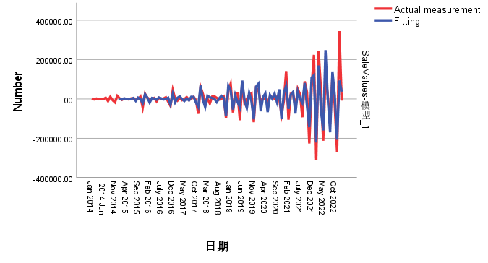

-203985.55

326110.86

-103195.38

-75684.69

81264.97

-41029.05

-30210.31

44108.86

-21215.83

-226490.79

288232.54

27226.29

-203149.19

298334.00

-70867.42

-92842.28

77119.17

-23103.07

-48267.66

51909.01

-16762.38

-237665.05

298085.05

24032.81

-206831.89

305111.55

-76097.81

-91786.21

79831.41

-27112.44

-45577.45

51762.46

-18626.64

-235347.93

296755.15

23851.46

-205609.95

303802.92

-75474.79

-91532.25

79058.98

-26390.73

-45846.41

51534.08

-18152.65

-235735.84

296855.17

24026.93

-205893.35

304005.37

-75499.70

-91656.12

79224.43

-26492.70

-45851.07

51616.82

-18247.04

-235686.82

296868.65

23973.84

-205840.74

303983.33

-75513.47

-91623.13

79195.82

-26483.83

-45839.89

51596.88

-18231.91

-235689.62

296860.51

23985.60

-205848.49

303983.59

-75507.91

-91629.91

79199.63

-26483.20

-45843.52

51600.70

-18233.68

-235690.42

296862.79

23983.50

-205847.74

303984.29

-75509.30

-91628.78

79199.36

-26483.73

-45842.69

51600.11

-18233.62

-235690.05

296862.31

23983.80

-205847.72

303984.04

-75509.03

-91628.92

79199.31

-26483.57

-45842.84

51600.18

-18233.58

-235690.14

296862.39

23983.77

-205847.75

303984.10

-75509.07

-91628.92

79199.34

-26483.61

-45842.82

51600.18

-18233.59

-235690.12

296862.38

23983.77

-205847.74

303984.09