1. 未差分

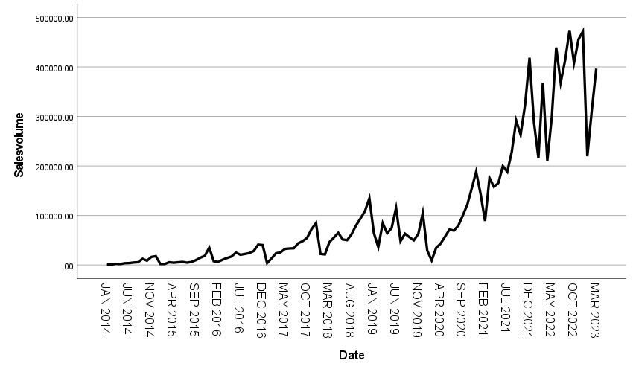

|  |  |  |
| --- | --- | --- |
| **Model Description** | | |
| Model Name | | MOD_2 |
| Model Type | | Multiplicative |
| Series Name | 1 | Salesvolume |
| Length of Seasonal Period | | 12 |
| Computing Method of Moving Averages | | Span equal to the periodicity plus one and endpoints weighted by 0.5 |
| Applying the model specifications from MOD_2 | | |

|  |  |
| --- | --- |
| **Seasonal Factors** | |
| Series Name: Salesvolume | |
| Period | Seasonal Factor (%) |
| 1 | 59.9 |
| 2 | 43.8 |
| 3 | 86.8 |
| 4 | 77.5 |
| 5 | 90.7 |
| 6 | 101.4 |
| 7 | 82.7 |
| 8 | 96.3 |
| 9 | 111.6 |
| 10 | 119.0 |
| 11 | 147.4 |
| 12 | 182.9 |

|  |  |  |
| --- | --- | --- |
| **Model Description** | | |
| Model Name | | MOD_3 |
| Series or Sequence | 1 | Salesvolume |
| 2 | Error for Salesvolume from SEASON, MOD_2, MUL CEN 12 |
| 3 | Seasonal adjusted series for Salesvolume from SEASON, MOD_2, MUL CEN 12 |
| 4 | Seasonal factors for Salesvolume from SEASON, MOD_2, MUL CEN 12 |
| 5 | Trend-cycle for Salesvolume from SEASON, MOD_2, MUL CEN 12 |
| Transformation | | None |
| Non-Seasonal Differencing | | 0 |
| Seasonal Differencing | | 0 |
| Length of Seasonal Period | | 12 |
| Horizontal Axis Labels | | Date_ |
| Intervention Onsets | | None |
| For Each Observation | | Values not joined |
| Applying the model specifications from MOD_3 | | |

|  |  |  |  |  |  |  |
| --- | --- | --- | --- | --- | --- | --- |
| **Case Processing Summary** | | | | | | |
|  | | Salesvolume | Error for Salesvolume from SEASON, MOD_2, MUL CEN 12 | Seasonal adjusted series for Salesvolume from SEASON, MOD_2, MUL CEN 12 | Seasonal factors for Salesvolume from SEASON, MOD_2, MUL CEN 12 | Trend-cycle for Salesvolume from SEASON, MOD_2, MUL CEN 12 |
| Series or Sequence Length | | 111 | 111 | 111 | 111 | 111 |
| Number of Missing Values in the Plot | User-Missing | 0 | 0 | 0 | 0 | 0 |
| System-Missing | 0 | 0 | 0 | 0 | 0 |

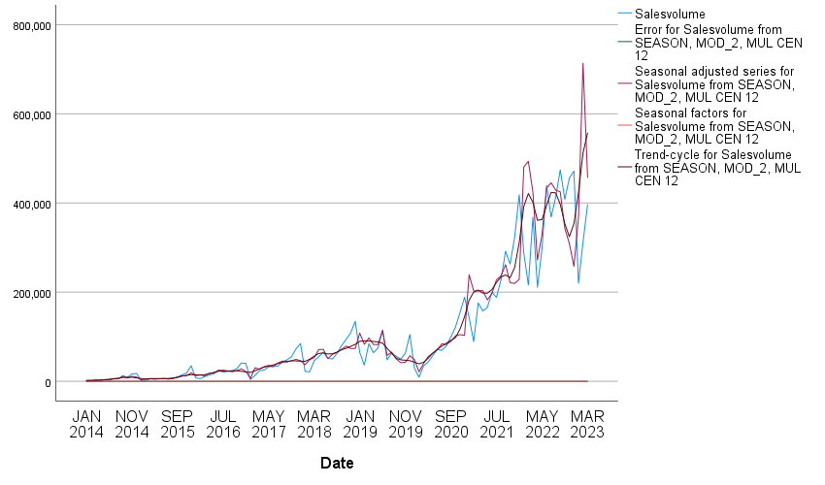

|  |  |  |  |
| --- | --- | --- | --- |
| **Model Description** | | | |
|  | | | Model Type |
| Model ID | Salesvolume | 模型_1 | Winters' Multiplicative |

|  |  |  |  |  |  |  |  |  |  |  |  |
| --- | --- | --- | --- | --- | --- | --- | --- | --- | --- | --- | --- |
| **Model Fit** | | | | | | | | | | | |
| Fit Statistic | Mean | SE | Minimum | Maximum | Percentile | | | | | | |
| 5 | 10 | 25 | 50 | 75 | 90 | 95 |
| Stationary R-squared | .555 | . | .555 | .555 | .555 | .555 | .555 | .555 | .555 | .555 | .555 |
| R-squared | .963 | . | .963 | .963 | .963 | .963 | .963 | .963 | .963 | .963 | .963 |
| RMSE | 24602.568 | . | 24602.568 | 24602.568 | 24602.568 | 24602.568 | 24602.568 | 24602.568 | 24602.568 | 24602.568 | 24602.568 |
| MAPE | 49.275 | . | 49.275 | 49.275 | 49.275 | 49.275 | 49.275 | 49.275 | 49.275 | 49.275 | 49.275 |
| MaxAPE | 621.726 | . | 621.726 | 621.726 | 621.726 | 621.726 | 621.726 | 621.726 | 621.726 | 621.726 | 621.726 |
| MAE | 15755.795 | . | 15755.795 | 15755.795 | 15755.795 | 15755.795 | 15755.795 | 15755.795 | 15755.795 | 15755.795 | 15755.795 |
| MaxAE | 103272.759 | . | 103272.759 | 103272.759 | 103272.759 | 103272.759 | 103272.759 | 103272.759 | 103272.759 | 103272.759 | 103272.759 |
| Normalized BIC | 20.348 | . | 20.348 | 20.348 | 20.348 | 20.348 | 20.348 | 20.348 | 20.348 | 20.348 | 20.348 |

|  |  |  |  |  |  |  |
| --- | --- | --- | --- | --- | --- | --- |
| **Model Statistics** | | | | | | |
| Model | Number of Predictors | Model Fit statistics | Ljung-Box Q(18) | | | Number of Outliers |
| Stationary R-squared | Statistics | DF | Sig. |
| Salesvolume-模型_1 | 0 | .555 | 18.149 | 15 | .255 | 0 |

|  |  |  |  |  |  |  |
| --- | --- | --- | --- | --- | --- | --- |
| **Exponential Smoothing Model Parameters** | | | | | | |
| Model | | | Estimate | SE | t | Sig. |
| Salesvolume-模型_1 | No Transformation | Alpha (Level) | .734 | .057 | 12.957 | .000 |
| Gamma (Trend) | .000 | .013 | .012 | .991 |
| Delta (Season) | .091 | .036 | 2.539 | .013 |

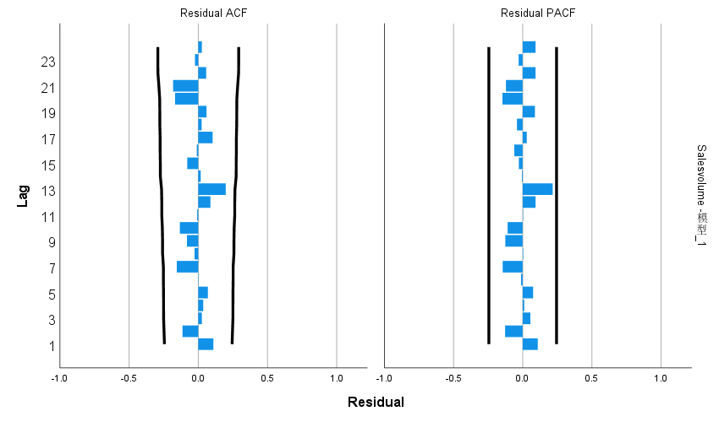

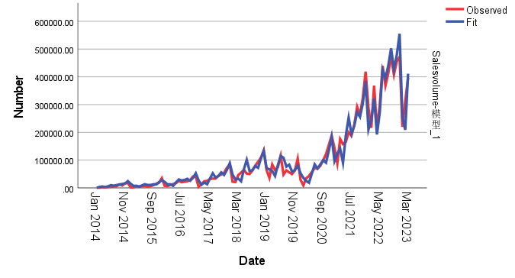

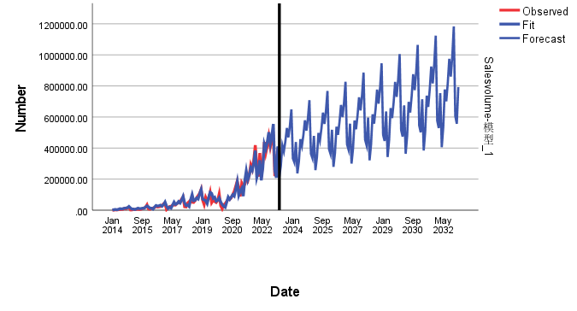

2.差分

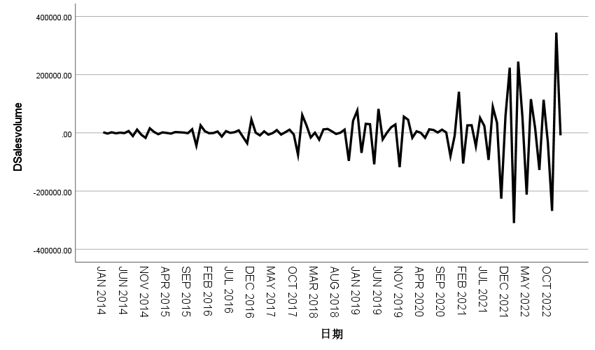

|  |  |  |
| --- | --- | --- |
| **模型描述** | | |
| 模型名称 | | MOD_2 |
| 模型类型 | | 加性 |
| 序列名称 | 1 | DSalesvolume |
| 季节性周期长度 | | 12 |
| 移动平均值的计算方法 | | 跨度等于周期长度加 1，且端点按 0.5 加权 |
| 正在应用来自 MOD_2 的模型指定项 | | |

|  |  |
| --- | --- |
| **季节因子** | |
| 序列名称: DSalesvolume | |
| 周期 | 季节因子 |
| 1 | 64421.22126 |
| 2 | -66757.92458 |
| 3 | 38952.18480 |
| 4 | 9880.35147 |
| 5 | -47613.32041 |
| 6 | 37046.85147 |
| 7 | 2686.33700 |
| 8 | -12882.26833 |
| 9 | 18686.51813 |
| 10 | 6210.27334 |
| 11 | -87227.09124 |
| 12 | 36596.86709 |

|  |  |  |
| --- | --- | --- |
| **模型描述** | | |
| 模型名称 | | MOD_3 |
| 系列或序列 | 1 | DSalesvolume |
| 2 | SEASON 中 DSalesvolume 的误差，MOD_2，ADD CEN 12 |
| 3 | SEASON 中 DSalesvolume 的季节性调整后系列，MOD_2，ADD CEN 12 |
| 4 | SEASON 中 DSalesvolume 的季节因子，MOD_2，ADD CEN 12 |
| 5 | SEASON 中 DSalesvolume 的趋势循环，MOD_2，ADD CEN 12 |
| 转换 | | 无 |
| 非季节性差分 | | 0 |
| 季节性差分 | | 0 |
| 季节性周期长度 | | 12 |
| 水平轴标 | | Date_ |
| 干预开始 | | 无 |
| 对于每个观测值 | | 未连接的值 |
| 正在应用来自 MOD_3 的模型指定项 | | |

|  |  |  |  |  |  |  |
| --- | --- | --- | --- | --- | --- | --- |
| **个案处理摘要** | | | | | | |
|  | | DSalesvolume | SEASON 中 DSalesvolume 的误差，MOD_2，ADD CEN 12 | SEASON 中 DSalesvolume 的季节性调整后系列，MOD_2，ADD CEN 12 | SEASON 中 DSalesvolume 的季节因子，MOD_2，ADD CEN 12 | SEASON 中 DSalesvolume 的趋势循环，MOD_2，ADD CEN 12 |
| 系列或序列长度 | | 109 | 109 | 109 | 109 | 109 |
| 图中的缺失值数目 | 用户缺失值 | 0 | 0 | 0 | 0 | 0 |
| 系统缺失值 | 0 | 0 | 0 | 0 | 0 |

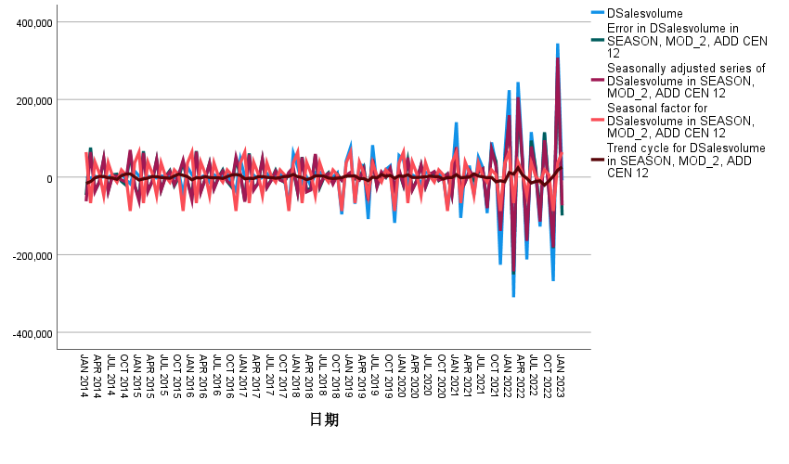

|  |  |  |  |
| --- | --- | --- | --- |
| **Model Description** | | | |
|  | | | Model Type |
| Model ID | DSalesvolume | 模型_1 | ARIMA(0,0,6)(0,1,0) |

|  |  |  |  |  |  |  |  |  |  |  |  |
| --- | --- | --- | --- | --- | --- | --- | --- | --- | --- | --- | --- |
| **Model Fit** | | | | | | | | | | | |
| Fit Statistic | Mean | SE | Minimum | Maximum | Percentile | | | | | | |
| 5 | 10 | 25 | 50 | 75 | 90 | 95 |
| Stationary R-squared | .886 | . | .886 | .886 | .886 | .886 | .886 | .886 | .886 | .886 | .886 |
| R-squared | .934 | . | .934 | .934 | .934 | .934 | .934 | .934 | .934 | .934 | .934 |
| RMSE | 22589.139 | . | 22589.139 | 22589.139 | 22589.139 | 22589.139 | 22589.139 | 22589.139 | 22589.139 | 22589.139 | 22589.139 |
| MAPE | 322.212 | . | 322.212 | 322.212 | 322.212 | 322.212 | 322.212 | 322.212 | 322.212 | 322.212 | 322.212 |
| MaxAPE | 11670.331 | . | 11670.331 | 11670.331 | 11670.331 | 11670.331 | 11670.331 | 11670.331 | 11670.331 | 11670.331 | 11670.331 |
| MAE | 15605.108 | . | 15605.108 | 15605.108 | 15605.108 | 15605.108 | 15605.108 | 15605.108 | 15605.108 | 15605.108 | 15605.108 |
| MaxAE | 55233.575 | . | 55233.575 | 55233.575 | 55233.575 | 55233.575 | 55233.575 | 55233.575 | 55233.575 | 55233.575 | 55233.575 |
| Normalized BIC | 20.428 | . | 20.428 | 20.428 | 20.428 | 20.428 | 20.428 | 20.428 | 20.428 | 20.428 | 20.428 |

|  |  |  |  |  |  |  |
| --- | --- | --- | --- | --- | --- | --- |
| **Model Statistics** | | | | | | |
| Model | Number of Predictors | Model Fit statistics | Ljung-Box Q(18) | | | Number of Outliers |
| Stationary R-squared | Statistics | DF | Sig. |
| DSalesvolume-模型_1 | 0 | .886 | 34.511 | 15 | .003 | 5 |

|  |  |  |  |  |  |  |  |  |
| --- | --- | --- | --- | --- | --- | --- | --- | --- |
| **ARIMA Model Parameters** | | | | | | | | |
|  | | | | | Estimate | SE | t | Sig. |
| DSalesvolume-模型_1 | DSalesvolume | No Transformation | MA | Lag 1 | .983 | .105 | 9.380 | .000 |
| Lag 3 | -.361 | .087 | -4.139 | .000 |
| Lag 6 | -.205 | .067 | -3.046 | .003 |
| Seasonal Difference | | 1 |  |  |  |

|  |  |  |  |  |  |  |
| --- | --- | --- | --- | --- | --- | --- |
| **Outliers** | | | | | | |
|  | | | Estimate | SE | t | Sig. |
| DSalesvolume-模型_1 | Nov 2021 | Innovational | -91348.782 | 22806.677 | -4.005 | .000 |
| Feb 2022 | Innovational | -144645.122 | 22914.192 | -6.312 | .000 |
| Mar 2022 | Additive | 99907.377 | 18255.509 | 5.473 | .000 |
| May 2022 | Innovational | -96956.667 | 28697.776 | -3.379 | .001 |
| Dec 2022 | Innovational | 234071.185 | 26850.791 | 8.717 | .000 |

