1. 提高传统汽车碳排放标准

利用2014年1月到2019年12月的数据预测2020年1月到2023年3月的值

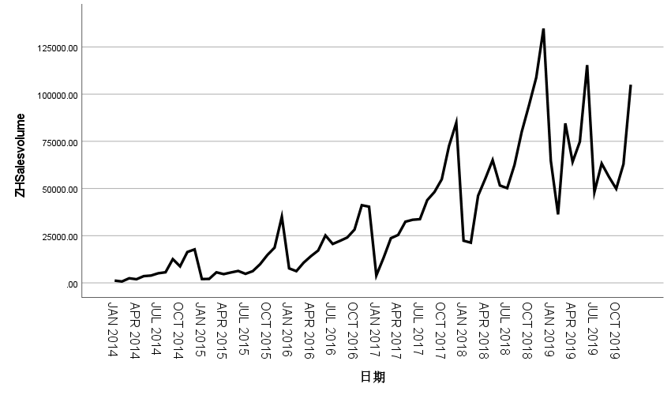

|  |  |  |
| --- | --- | --- |
| **模型描述** | | |
| 模型名称 | | MOD_2 |
| 模型类型 | | 乘性 |
| 序列名称 | 1 | ZHSalesvolume |
| 季节性周期长度 | | 12 |
| 移动平均值的计算方法 | | 跨度等于周期长度加 1，且端点按 0.5 加权 |
| 正在应用来自 MOD_2 的模型指定项 | | |

|  |  |
| --- | --- |
| **季节因子** | |
| 序列名称: ZHSalesvolume | |
| 周期 | 季节因子 (%) |
| 1 | 41.3 |
| 2 | 41.8 |
| 3 | 80.4 |
| 4 | 80.6 |
| 5 | 95.1 |
| 6 | 97.2 |
| 7 | 79.0 |
| 8 | 92.8 |
| 9 | 111.8 |
| 10 | 124.9 |
| 11 | 160.4 |
| 12 | 194.7 |

|  |  |  |  |  |  |  |
| --- | --- | --- | --- | --- | --- | --- |
| **个案处理摘要** | | | | | | |
|  | | ZHSalesvolume | SEASON 中 ZHSalesvolume 的误差，MOD_2，MUL CEN 12 | SEASON 中 ZHSalesvolume 的季节性调整后系列，MOD_2，MUL CEN 12 | SEASON 中 ZHSalesvolume 的趋势循环，MOD_2，MUL CEN 12 | SEASON 中 ZHSalesvolume 的季节因子，MOD_2，MUL CEN 12 |
| 系列或序列长度 | | 72 | 72 | 72 | 72 | 72 |
| 图中的缺失值数目 | 用户缺失值 | 0 | 0 | 0 | 0 | 0 |
| 系统缺失值 | 0 | 0 | 0 | 0 | 0 |

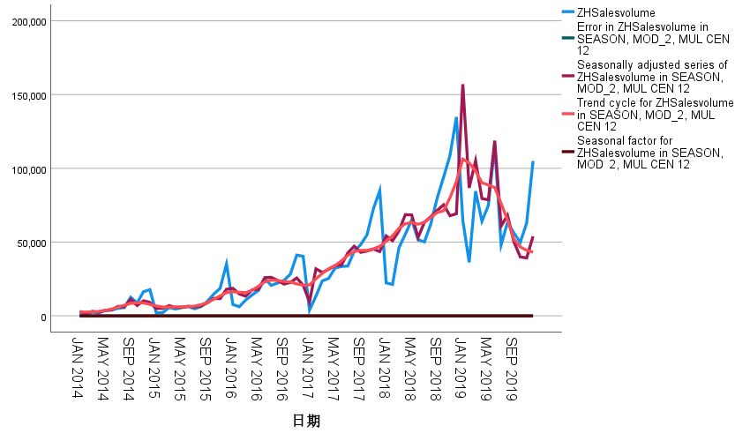

|  |  |  |  |
| --- | --- | --- | --- |
| **模型描述** | | | |
|  | | | 模型类型 |
| 模型 ID | ZHSalesvolume | 模型_1 | 简单季节性 |

|  |  |  |  |  |  |  |  |  |  |  |  |
| --- | --- | --- | --- | --- | --- | --- | --- | --- | --- | --- | --- |
| **模型拟合度** | | | | | | | | | | | |
| 拟合统计 | 平均值 | 标准误差 | 最小值 | 最大值 | 百分位数 | | | | | | |
| 5 | 10 | 25 | 50 | 75 | 90 | 95 |
| 平稳 R 方 | .322 | . | .322 | .322 | .322 | .322 | .322 | .322 | .322 | .322 | .322 |
| R 方 | .846 | . | .846 | .846 | .846 | .846 | .846 | .846 | .846 | .846 | .846 |
| RMSE | 12588.905 | . | 12588.905 | 12588.905 | 12588.905 | 12588.905 | 12588.905 | 12588.905 | 12588.905 | 12588.905 | 12588.905 |
| MAPE | 94.511 | . | 94.511 | 94.511 | 94.511 | 94.511 | 94.511 | 94.511 | 94.511 | 94.511 | 94.511 |
| MaxAPE | 1351.157 | . | 1351.157 | 1351.157 | 1351.157 | 1351.157 | 1351.157 | 1351.157 | 1351.157 | 1351.157 | 1351.157 |
| MAE | 9367.575 | . | 9367.575 | 9367.575 | 9367.575 | 9367.575 | 9367.575 | 9367.575 | 9367.575 | 9367.575 | 9367.575 |
| MaxAE | 37869.819 | . | 37869.819 | 37869.819 | 37869.819 | 37869.819 | 37869.819 | 37869.819 | 37869.819 | 37869.819 | 37869.819 |
| 正态化 BIC | 19.000 | . | 19.000 | 19.000 | 19.000 | 19.000 | 19.000 | 19.000 | 19.000 | 19.000 | 19.000 |

|  |  |  |  |  |  |  |
| --- | --- | --- | --- | --- | --- | --- |
| **模型统计** | | | | | | |
| 模型 | 预测变量数 | 模型拟合度统计 | 杨-博克斯 Q(18) | | | 离群值数 |
| 平稳 R 方 | 统计 | DF | 显著性 |
| ZHSalesvolume-模型_1 | 0 | .322 | 30.395 | 16 | .016 | 0 |

|  |  |  |  |  |  |  |
| --- | --- | --- | --- | --- | --- | --- |
| **指数平滑法模型参数** | | | | | | |
| 模型 | | | 估算 | 标准误差 | t | 显著性 |
| ZHSalesvolume-模型_1 | 不转换 | Alpha（水平） | .500 | .104 | 4.798 | .000 |
| Delta（季节） | 3.705E-5 | .067 | .001 | 1.000 |

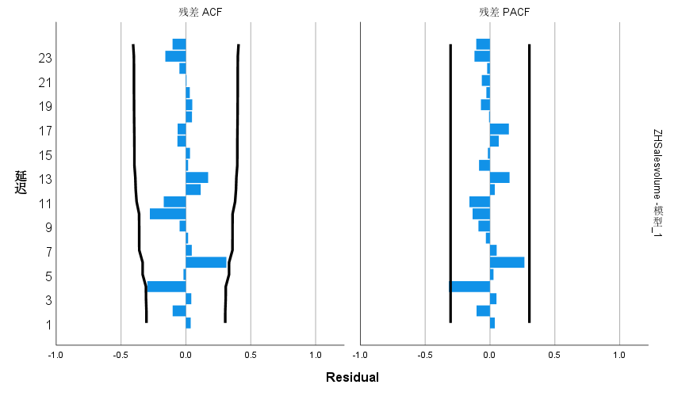

41364.99

37692.93

53221.40

51954.97

57459.08

63661.54

51460.00

58296.61

62841.34

66123.64

77785.57

94007.09

41364.99

37692.93

53221.40

51954.97

57459.08

63661.54

51460.00

58296.61

62841.34

66123.64

77785.57

94007.09

41364.99

37692.93

53221.40

51954.97

57459.08

63661.54

51460.00

58296.61

62841.34

66123.64

77785.57

94007.09

41364.99

37692.93

53221.40

2. 欧盟提高对新能源电动汽车的补贴

3. 美国提高对中国新能源汽车的进口关税27.5%

4. 欧盟反补贴调查

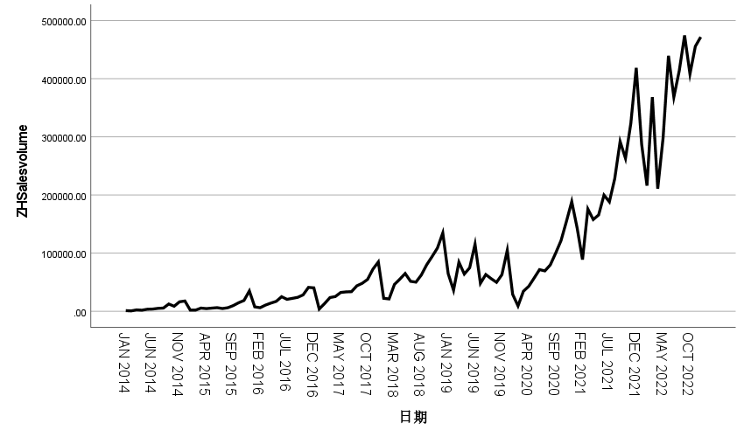

|  |  |  |
| --- | --- | --- |
| **模型描述** | | |
| 模型名称 | | MOD_3 |
| 模型类型 | | 乘性 |
| 序列名称 | 1 | ZHSalesvolume |
| 季节性周期长度 | | 12 |
| 移动平均值的计算方法 | | 跨度等于周期长度加 1，且端点按 0.5 加权 |
| 正在应用来自 MOD_3 的模型指定项 | | |

|  |  |
| --- | --- |
| **季节因子** | |
| 序列名称: ZHSalesvolume | |
| 周期 | 季节因子 (%) |
| 1 | 60.3 |
| 2 | 44.1 |
| 3 | 87.4 |
| 4 | 78.0 |
| 5 | 91.3 |
| 6 | 102.1 |
| 7 | 80.6 |
| 8 | 94.9 |
| 9 | 109.2 |
| 10 | 119.8 |
| 11 | 148.3 |
| 12 | 184.1 |

|  |  |  |  |  |  |  |
| --- | --- | --- | --- | --- | --- | --- |
| **个案处理摘要** | | | | | | |
|  | | ZHSalesvolume | SEASON 中 ZHSalesvolume 的误差，MOD_3，MUL CEN 12 | SEASON 中 ZHSalesvolume 的季节性调整后系列，MOD_3，MUL CEN 12 | SEASON 中 ZHSalesvolume 的季节因子，MOD_3，MUL CEN 12 | SEASON 中 ZHSalesvolume 的趋势循环，MOD_3，MUL CEN 12 |
| 系列或序列长度 | | 108 | 108 | 108 | 108 | 108 |
| 图中的缺失值数目 | 用户缺失值 | 0 | 0 | 0 | 0 | 0 |
| 系统缺失值 | 0 | 0 | 0 | 0 | 0 |

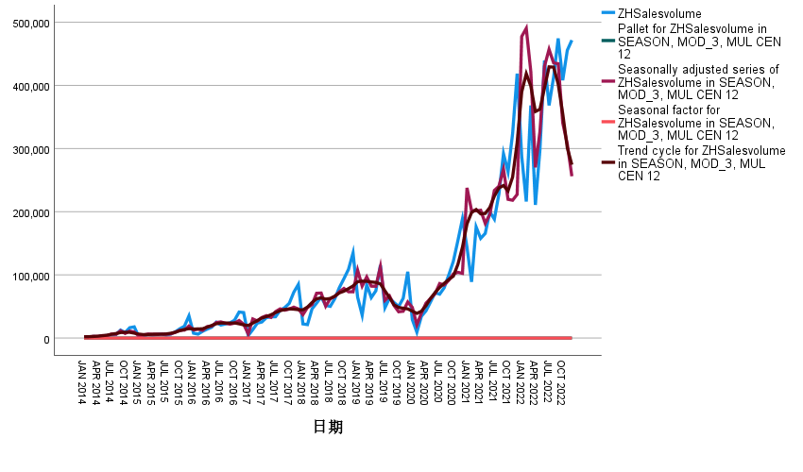

|  |  |  |  |
| --- | --- | --- | --- |
| **模型描述** | | | |
|  | | | 模型类型 |
| 模型 ID | ZHSalesvolume | 模型_1 | ARIMA(1,1,0)(0,1,1) |

|  |  |  |  |  |  |  |  |  |  |  |  |
| --- | --- | --- | --- | --- | --- | --- | --- | --- | --- | --- | --- |
| **模型拟合度** | | | | | | | | | | | |
| 拟合统计 | 平均值 | 标准误差 | 最小值 | 最大值 | 百分位数 | | | | | | |
| 5 | 10 | 25 | 50 | 75 | 90 | 95 |
| 平稳 R 方 | .648 | . | .648 | .648 | .648 | .648 | .648 | .648 | .648 | .648 | .648 |
| R 方 | .911 | . | .911 | .911 | .911 | .911 | .911 | .911 | .911 | .911 | .911 |
| RMSE | 38779.550 | . | 38779.550 | 38779.550 | 38779.550 | 38779.550 | 38779.550 | 38779.550 | 38779.550 | 38779.550 | 38779.550 |
| MAPE | 20.979 | . | 20.979 | 20.979 | 20.979 | 20.979 | 20.979 | 20.979 | 20.979 | 20.979 | 20.979 |
| MaxAPE | 84.104 | . | 84.104 | 84.104 | 84.104 | 84.104 | 84.104 | 84.104 | 84.104 | 84.104 | 84.104 |
| MAE | 20046.524 | . | 20046.524 | 20046.524 | 20046.524 | 20046.524 | 20046.524 | 20046.524 | 20046.524 | 20046.524 | 20046.524 |
| MaxAE | 177327.537 | . | 177327.537 | 177327.537 | 177327.537 | 177327.537 | 177327.537 | 177327.537 | 177327.537 | 177327.537 | 177327.537 |
| 正态化 BIC | 21.419 | . | 21.419 | 21.419 | 21.419 | 21.419 | 21.419 | 21.419 | 21.419 | 21.419 | 21.419 |

|  |  |  |  |  |  |  |
| --- | --- | --- | --- | --- | --- | --- |
| **模型统计** | | | | | | |
| 模型 | 预测变量数 | 模型拟合度统计 | 杨-博克斯 Q(18) | | | 离群值数 |
| 平稳 R 方 | 统计 | DF | 显著性 |
| ZHSalesvolume-模型_1 | 0 | .648 | 17.194 | 16 | .373 | 4 |

|  |  |  |  |  |  |  |  |  |
| --- | --- | --- | --- | --- | --- | --- | --- | --- |
| **ARIMA 模型参数** | | | | | | | | |
|  | | | | | 估算 | 标准误差 | t | 显著性 |
| ZHSalesvolume-模型_1 | ZHSalesvolume | 自然对数 | AR | 延迟 1 | -.319 | .087 | -3.688 | .000 |
| 差异 | | 1 |  |  |  |
| 季节性差异 | | 1 |  |  |  |
| MA，季节性 | 延迟 1 | .540 | .115 | 4.681 | .000 |

|  |  |  |  |  |  |  |
| --- | --- | --- | --- | --- | --- | --- |
| **离群值** | | | | | | |
|  | | | 估算 | 标准误差 | t | 显著性 |
| ZHSalesvolume-模型_1 | 一月 2015 | 革新 | -1.843 | .526 | -3.506 | .001 |
| 一月 2017 | 加性 | -1.333 | .180 | -7.413 | .000 |
| 六月 2019 | 加性 | .538 | .176 | 3.058 | .003 |
| 二月 2020 | 加性 | -.896 | .179 | -5.011 | .000 |

