1. 提高传统汽车碳排放标准

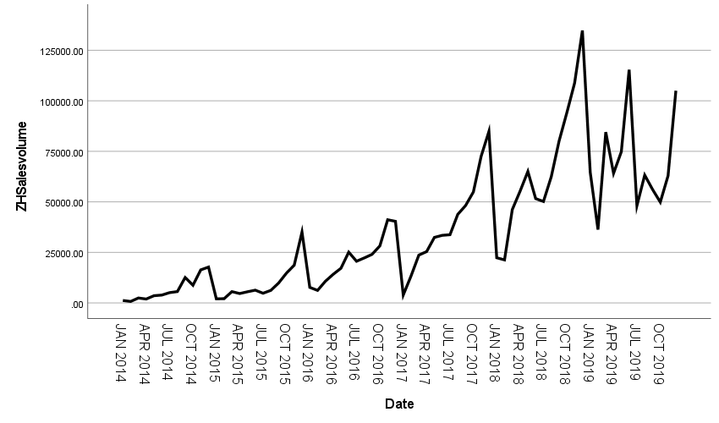

|  |  |  |
| --- | --- | --- |
| **Model Description** | | |
| Model Name | | MOD_2 |
| Model Type | | Multiplicative |
| Series Name | 1 | ZHSalesvolume |
| Length of Seasonal Period | | 12 |
| Computing Method of Moving Averages | | Span equal to the periodicity plus one and endpoints weighted by 0.5 |
| Applying the model specifications from MOD_2 | | |

|  |  |
| --- | --- |
| **Seasonal Factors** | |
| Series Name: ZHSalesvolume | |
| Period | Seasonal Factor (%) |
| 1 | 41.3 |
| 2 | 41.8 |
| 3 | 80.4 |
| 4 | 80.6 |
| 5 | 95.1 |
| 6 | 97.2 |
| 7 | 79.0 |
| 8 | 92.8 |
| 9 | 111.8 |
| 10 | 124.9 |
| 11 | 160.4 |
| 12 | 194.7 |

|  |  |  |
| --- | --- | --- |
| **Model Description** | | |
| Model Name | | MOD_3 |
| Series or Sequence | 1 | ZHSalesvolume |
| 2 | Error for ZHSalesvolume from SEASON, MOD_2, MUL CEN 12 |
| 3 | Seasonal adjusted series for ZHSalesvolume from SEASON, MOD_2, MUL CEN 12 |
| 4 | Seasonal factors for ZHSalesvolume from SEASON, MOD_2, MUL CEN 12 |
| 5 | Trend-cycle for ZHSalesvolume from SEASON, MOD_2, MUL CEN 12 |
| Transformation | | None |
| Non-Seasonal Differencing | | 0 |
| Seasonal Differencing | | 0 |
| Length of Seasonal Period | | 12 |
| Horizontal Axis Labels | | Date_ |
| Intervention Onsets | | None |
| For Each Observation | | Values not joined |
| Applying the model specifications from MOD_3 | | |

|  |  |  |  |  |  |  |
| --- | --- | --- | --- | --- | --- | --- |
| **Case Processing Summary** | | | | | | |
|  | | ZHSalesvolume | Error for ZHSalesvolume from SEASON, MOD_2, MUL CEN 12 | Seasonal adjusted series for ZHSalesvolume from SEASON, MOD_2, MUL CEN 12 | Seasonal factors for ZHSalesvolume from SEASON, MOD_2, MUL CEN 12 | Trend-cycle for ZHSalesvolume from SEASON, MOD_2, MUL CEN 12 |
| Series or Sequence Length | | 72 | 72 | 72 | 72 | 72 |
| Number of Missing Values in the Plot | User-Missing | 0 | 0 | 0 | 0 | 0 |
| System-Missing | 0 | 0 | 0 | 0 | 0 |

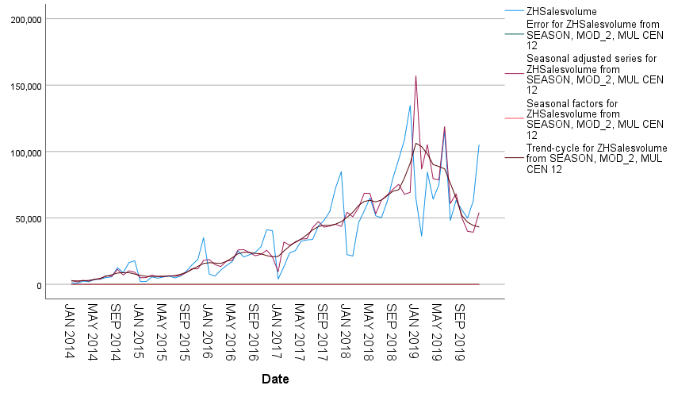

|  |  |  |  |
| --- | --- | --- | --- |
| **Model Description** | | | |
|  | | | Model Type |
| Model ID | ZHSalesvolume | 模型_1 | ARIMA(1,1,0)(0,1,0) |

|  |  |  |  |  |  |  |  |  |  |  |  |
| --- | --- | --- | --- | --- | --- | --- | --- | --- | --- | --- | --- |
| **Model Fit** | | | | | | | | | | | |
| Fit Statistic | Mean | SE | Minimum | Maximum | Percentile | | | | | | |
| 5 | 10 | 25 | 50 | 75 | 90 | 95 |
| Stationary R-squared | .487 | . | .487 | .487 | .487 | .487 | .487 | .487 | .487 | .487 | .487 |
| R-squared | .744 | . | .744 | .744 | .744 | .744 | .744 | .744 | .744 | .744 | .744 |
| RMSE | 16179.887 | . | 16179.887 | 16179.887 | 16179.887 | 16179.887 | 16179.887 | 16179.887 | 16179.887 | 16179.887 | 16179.887 |
| MAPE | 28.147 | . | 28.147 | 28.147 | 28.147 | 28.147 | 28.147 | 28.147 | 28.147 | 28.147 | 28.147 |
| MaxAPE | 98.438 | . | 98.438 | 98.438 | 98.438 | 98.438 | 98.438 | 98.438 | 98.438 | 98.438 | 98.438 |
| MAE | 10532.061 | . | 10532.061 | 10532.061 | 10532.061 | 10532.061 | 10532.061 | 10532.061 | 10532.061 | 10532.061 | 10532.061 |
| MaxAE | 52683.076 | . | 52683.076 | 52683.076 | 52683.076 | 52683.076 | 52683.076 | 52683.076 | 52683.076 | 52683.076 | 52683.076 |
| Normalized BIC | 19.521 | . | 19.521 | 19.521 | 19.521 | 19.521 | 19.521 | 19.521 | 19.521 | 19.521 | 19.521 |

|  |  |  |  |  |  |  |
| --- | --- | --- | --- | --- | --- | --- |
| **Model Statistics** | | | | | | |
| Model | Number of Predictors | Model Fit statistics | Ljung-Box Q(18) | | | Number of Outliers |
| Stationary R-squared | Statistics | DF | Sig. |
| ZHSalesvolume-模型_1 | 0 | .487 | 11.688 | 17 | .819 | 1 |

|  |  |  |  |  |  |  |  |  |
| --- | --- | --- | --- | --- | --- | --- | --- | --- |
| **ARIMA Model Parameters** | | | | | | | | |
|  | | | | | Estimate | SE | t | Sig. |
| ZHSalesvolume-模型_1 | ZHSalesvolume | Natural Logarithm | AR | Lag 1 | -.323 | .132 | -2.448 | .017 |
| Difference | | 1 |  |  |  |
| Seasonal Difference | | 1 |  |  |  |

|  |  |  |  |  |  |  |
| --- | --- | --- | --- | --- | --- | --- |
| **Outliers** | | | | | | |
|  | | | Estimate | SE | t | Sig. |
| ZHSalesvolume-模型_1 | Jan 2017 | Additive | -1.195 | .191 | -6.239 | .000 |

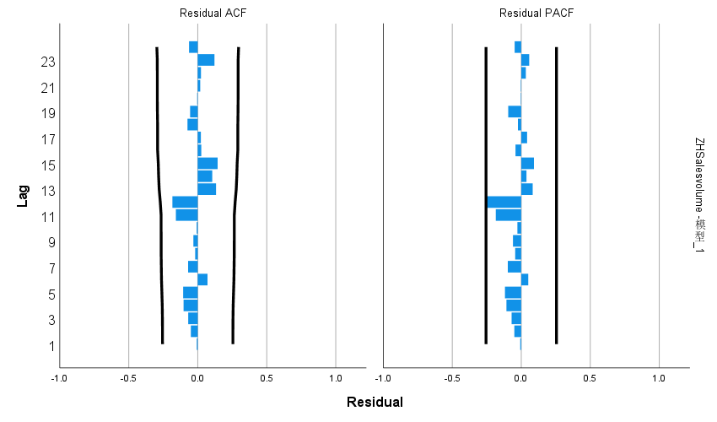

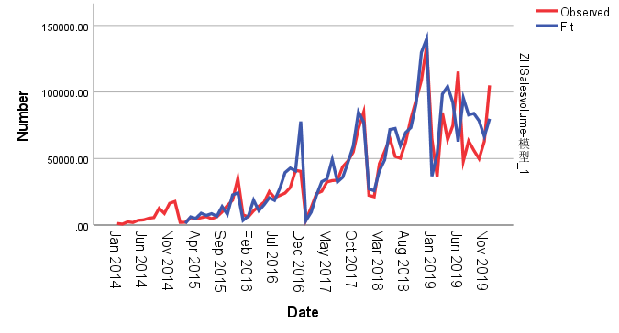

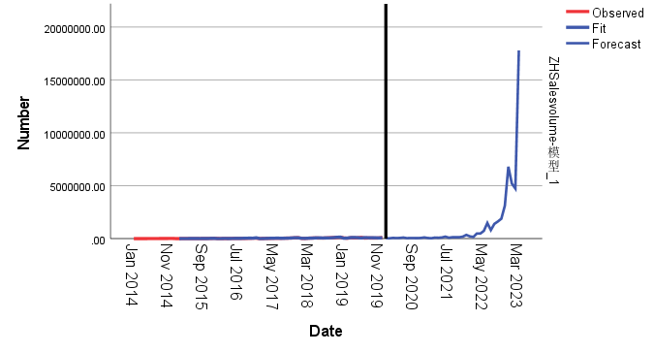

1. 欧盟提高对新能源电动汽车的补贴
2. 利用2014年1月至2019年12年预测2022年12月的过程和上面一致
3. 利用2020年1月至2022年12月的值预测 2023年3月的值

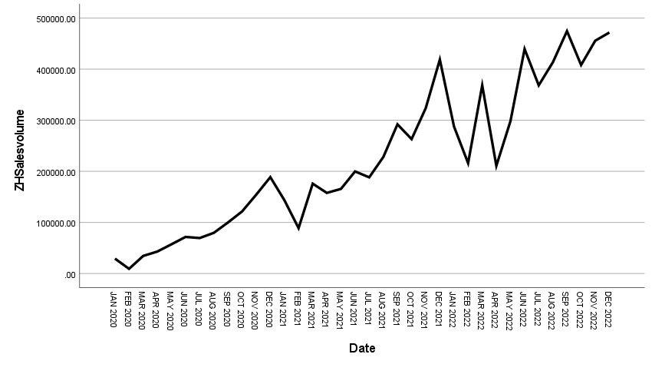

|  |  |  |  |
| --- | --- | --- | --- |
| **Model Description** | | | |
|  | | | Model Type |
| Model ID | ZHSalesvolume | 模型_1 | Winters' Additive |

|  |  |  |  |  |  |  |  |  |  |  |  |
| --- | --- | --- | --- | --- | --- | --- | --- | --- | --- | --- | --- |
| **Model Fit** | | | | | | | | | | | |
| Fit Statistic | Mean | SE | Minimum | Maximum | Percentile | | | | | | |
| 5 | 10 | 25 | 50 | 75 | 90 | 95 |
| Stationary R-squared | .698 | . | .698 | .698 | .698 | .698 | .698 | .698 | .698 | .698 | .698 |
| R-squared | .953 | . | .953 | .953 | .953 | .953 | .953 | .953 | .953 | .953 | .953 |
| RMSE | 31787.696 | . | 31787.696 | 31787.696 | 31787.696 | 31787.696 | 31787.696 | 31787.696 | 31787.696 | 31787.696 | 31787.696 |
| MAPE | 29.963 | . | 29.963 | 29.963 | 29.963 | 29.963 | 29.963 | 29.963 | 29.963 | 29.963 | 29.963 |
| MaxAPE | 453.808 | . | 453.808 | 453.808 | 453.808 | 453.808 | 453.808 | 453.808 | 453.808 | 453.808 | 453.808 |
| MAE | 24456.635 | . | 24456.635 | 24456.635 | 24456.635 | 24456.635 | 24456.635 | 24456.635 | 24456.635 | 24456.635 | 24456.635 |
| MaxAE | 70859.079 | . | 70859.079 | 70859.079 | 70859.079 | 70859.079 | 70859.079 | 70859.079 | 70859.079 | 70859.079 | 70859.079 |
| Normalized BIC | 21.032 | . | 21.032 | 21.032 | 21.032 | 21.032 | 21.032 | 21.032 | 21.032 | 21.032 | 21.032 |

|  |  |  |  |  |  |  |
| --- | --- | --- | --- | --- | --- | --- |
| **Model Statistics** | | | | | | |
| Model | Number of Predictors | Model Fit statistics | Ljung-Box Q(18) | | | Number of Outliers |
| Stationary R-squared | Statistics | DF | Sig. |
| ZHSalesvolume-模型_1 | 0 | .698 | 22.832 | 15 | .088 | 0 |

|  |  |  |  |  |  |  |
| --- | --- | --- | --- | --- | --- | --- |
| **Exponential Smoothing Model Parameters** | | | | | | |
| Model | | | Estimate | SE | t | Sig. |
| ZHSalesvolume-模型_1 | No Transformation | Alpha (Level) | .099 | .095 | 1.038 | .307 |
| Gamma (Trend) | 6.444E-6 | .047 | .000 | 1.000 |
| Delta (Season) | .000 | .203 | .002 | .998 |

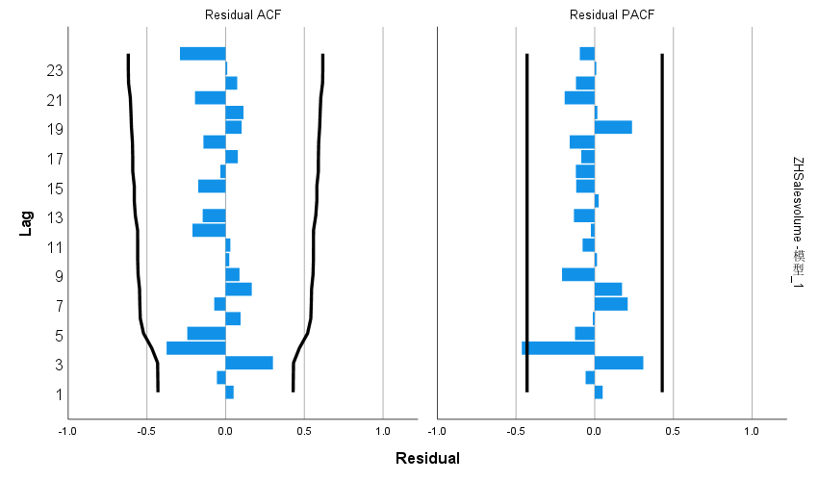

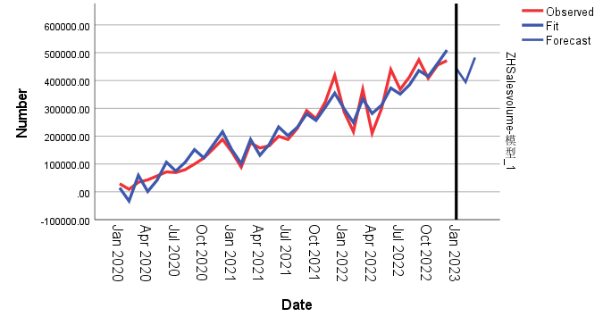

3. 美国提高对中国新能源汽车的进口关税27.5% 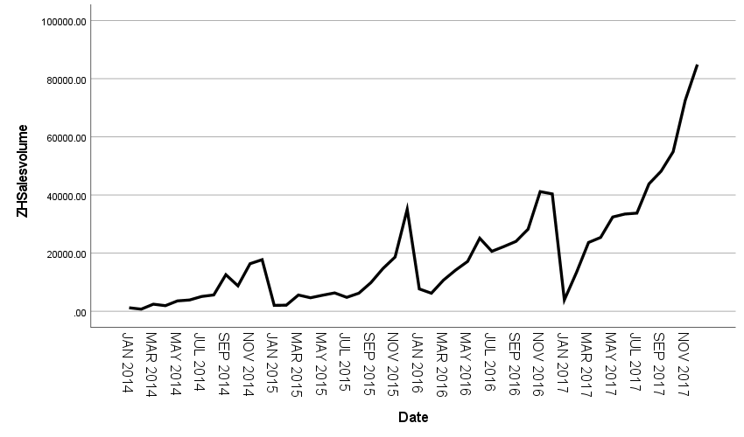

|  |  |  |
| --- | --- | --- |
| **Model Description** | | |
| Model Name | | MOD_2 |
| Model Type | | Multiplicative |
| Series Name | 1 | ZHSalesvolume |
| Length of Seasonal Period | | 12 |
| Computing Method of Moving Averages | | Span equal to the periodicity plus one and endpoints weighted by 0.5 |
| Applying the model specifications from MOD_2 | | |

|  |  |
| --- | --- |
| **Seasonal Factors** | |
| Series Name: ZHSalesvolume | |
| Period | Seasonal Factor (%) |
| 1 | 27.1 |
| 2 | 39.1 |
| 3 | 74.9 |
| 4 | 77.4 |
| 5 | 86.8 |
| 6 | 91.1 |
| 7 | 77.5 |
| 8 | 84.3 |
| 9 | 109.7 |
| 10 | 123.3 |
| 11 | 171.5 |
| 12 | 237.4 |

|  |  |  |
| --- | --- | --- |
| **Model Description** | | |
| Model Name | | MOD_3 |
| Series or Sequence | 1 | ZHSalesvolume |
| 2 | Error for ZHSalesvolume from SEASON, MOD_2, MUL CEN 12 |
| 3 | Seasonal adjusted series for ZHSalesvolume from SEASON, MOD_2, MUL CEN 12 |
| 4 | Seasonal factors for ZHSalesvolume from SEASON, MOD_2, MUL CEN 12 |
| 5 | Trend-cycle for ZHSalesvolume from SEASON, MOD_2, MUL CEN 12 |
| Transformation | | None |
| Non-Seasonal Differencing | | 0 |
| Seasonal Differencing | | 0 |
| Length of Seasonal Period | | 12 |
| Horizontal Axis Labels | | Date_ |
| Intervention Onsets | | None |
| For Each Observation | | Values not joined |
| Applying the model specifications from MOD_3 | | |

|  |  |  |  |  |  |  |
| --- | --- | --- | --- | --- | --- | --- |
| **Case Processing Summary** | | | | | | |
|  | | ZHSalesvolume | Error for ZHSalesvolume from SEASON, MOD_2, MUL CEN 12 | Seasonal adjusted series for ZHSalesvolume from SEASON, MOD_2, MUL CEN 12 | Seasonal factors for ZHSalesvolume from SEASON, MOD_2, MUL CEN 12 | Trend-cycle for ZHSalesvolume from SEASON, MOD_2, MUL CEN 12 |
| Series or Sequence Length | | 48 | 48 | 48 | 48 | 48 |
| Number of Missing Values in the Plot | User-Missing | 0 | 0 | 0 | 0 | 0 |
| System-Missing | 0 | 0 | 0 | 0 | 0 |

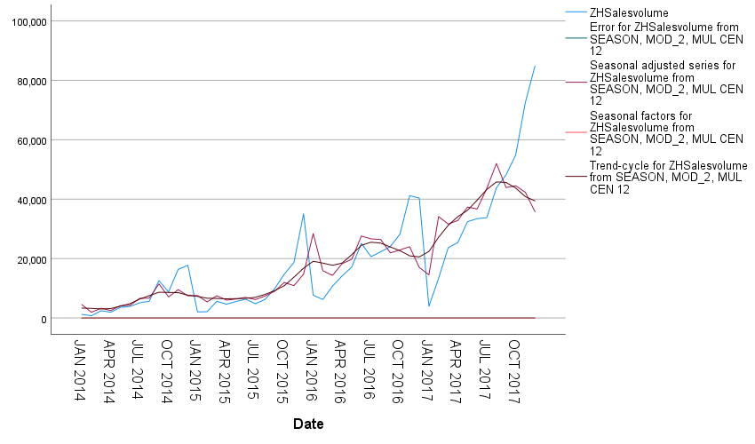

|  |  |  |  |
| --- | --- | --- | --- |
| **Model Description** | | | |
|  | | | Model Type |
| Model ID | ZHSalesvolume | 模型_1 | Winters' Additive |

|  |  |  |  |  |  |  |  |  |  |  |  |
| --- | --- | --- | --- | --- | --- | --- | --- | --- | --- | --- | --- |
| **Model Fit** | | | | | | | | | | | |
| Fit Statistic | Mean | SE | Minimum | Maximum | Percentile | | | | | | |
| 5 | 10 | 25 | 50 | 75 | 90 | 95 |
| Stationary R-squared | .609 | . | .609 | .609 | .609 | .609 | .609 | .609 | .609 | .609 | .609 |
| R-squared | .945 | . | .945 | .945 | .945 | .945 | .945 | .945 | .945 | .945 | .945 |
| RMSE | 4493.465 | . | 4493.465 | 4493.465 | 4493.465 | 4493.465 | 4493.465 | 4493.465 | 4493.465 | 4493.465 | 4493.465 |
| MAPE | 44.170 | . | 44.170 | 44.170 | 44.170 | 44.170 | 44.170 | 44.170 | 44.170 | 44.170 | 44.170 |
| MaxAPE | 744.553 | . | 744.553 | 744.553 | 744.553 | 744.553 | 744.553 | 744.553 | 744.553 | 744.553 | 744.553 |
| MAE | 3202.382 | . | 3202.382 | 3202.382 | 3202.382 | 3202.382 | 3202.382 | 3202.382 | 3202.382 | 3202.382 | 3202.382 |
| MaxAE | 15263.343 | . | 15263.343 | 15263.343 | 15263.343 | 15263.343 | 15263.343 | 15263.343 | 15263.343 | 15263.343 | 15263.343 |
| Normalized BIC | 17.063 | . | 17.063 | 17.063 | 17.063 | 17.063 | 17.063 | 17.063 | 17.063 | 17.063 | 17.063 |

|  |  |  |  |  |  |  |
| --- | --- | --- | --- | --- | --- | --- |
| **Model Statistics** | | | | | | |
| Model | Number of Predictors | Model Fit statistics | Ljung-Box Q(18) | | | Number of Outliers |
| Stationary R-squared | Statistics | DF | Sig. |
| ZHSalesvolume-模型_1 | 0 | .609 | 15.133 | 15 | .442 | 0 |

|  |  |  |  |  |  |  |
| --- | --- | --- | --- | --- | --- | --- |
| **Exponential Smoothing Model Parameters** | | | | | | |
| Model | | | Estimate | SE | t | Sig. |
| ZHSalesvolume-模型_1 | No Transformation | Alpha (Level) | .813 | .156 | 5.193 | .000 |
| Gamma (Trend) | .104 | .100 | 1.040 | .304 |
| Delta (Season) | .001 | .266 | .004 | .997 |

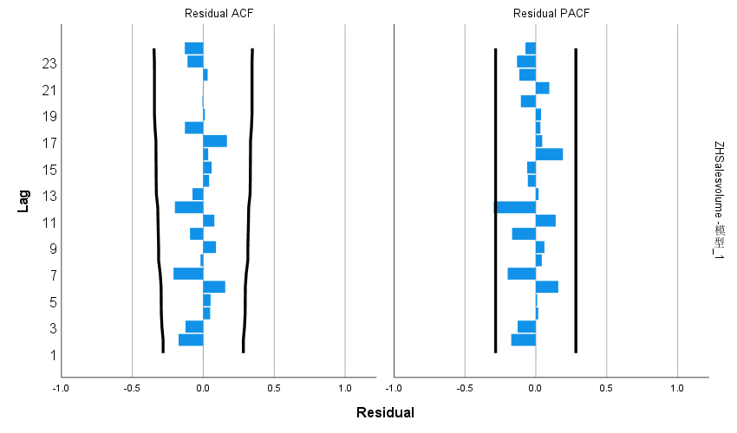

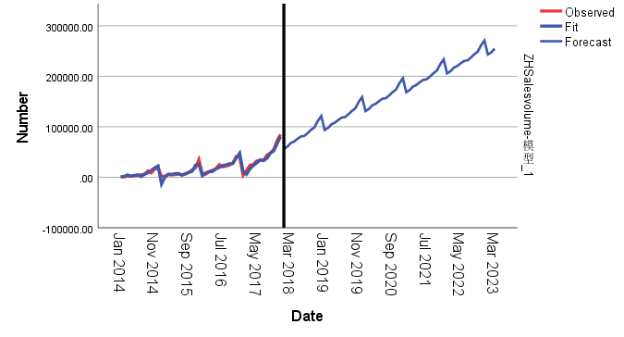

4. 欧盟反补贴调查

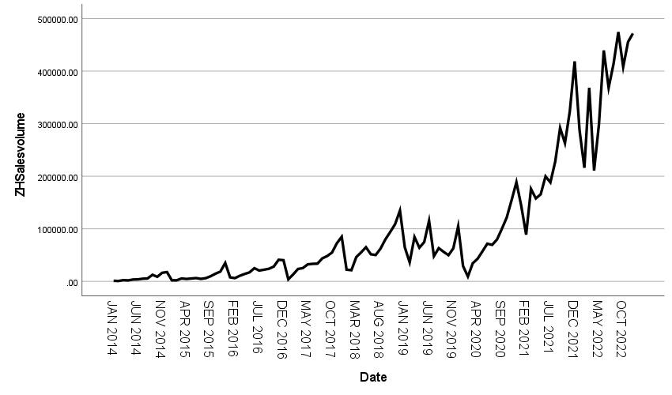

|  |  |  |
| --- | --- | --- |
| **Model Description** | | |
| Model Name | | MOD_2 |
| Model Type | | Multiplicative |
| Series Name | 1 | ZHSalesvolume |
| Length of Seasonal Period | | 12 |
| Computing Method of Moving Averages | | Span equal to the periodicity plus one and endpoints weighted by 0.5 |
| Applying the model specifications from MOD_2 | | |

|  |  |
| --- | --- |
| **Seasonal Factors** | |
| Series Name: ZHSalesvolume | |
| Period | Seasonal Factor (%) |
| 1 | 60.3 |
| 2 | 44.1 |
| 3 | 87.4 |
| 4 | 78.0 |
| 5 | 91.3 |
| 6 | 102.1 |
| 7 | 80.6 |
| 8 | 94.9 |
| 9 | 109.2 |
| 10 | 119.8 |
| 11 | 148.3 |
| 12 | 184.1 |

|  |  |  |
| --- | --- | --- |
| **Model Description** | | |
| Model Name | | MOD_3 |
| Series or Sequence | 1 | ZHSalesvolume |
| 2 | Error for ZHSalesvolume from SEASON, MOD_2, MUL CEN 12 |
| 3 | Seasonal adjusted series for ZHSalesvolume from SEASON, MOD_2, MUL CEN 12 |
| 4 | Seasonal factors for ZHSalesvolume from SEASON, MOD_2, MUL CEN 12 |
| 5 | Trend-cycle for ZHSalesvolume from SEASON, MOD_2, MUL CEN 12 |
| Transformation | | None |
| Non-Seasonal Differencing | | 0 |
| Seasonal Differencing | | 0 |
| Length of Seasonal Period | | 12 |
| Horizontal Axis Labels | | Date_ |
| Intervention Onsets | | None |
| For Each Observation | | Values not joined |
| Applying the model specifications from MOD_3 | | |

|  |  |  |  |  |  |  |
| --- | --- | --- | --- | --- | --- | --- |
| **Case Processing Summary** | | | | | | |
|  | | ZHSalesvolume | Error for ZHSalesvolume from SEASON, MOD_2, MUL CEN 12 | Seasonal adjusted series for ZHSalesvolume from SEASON, MOD_2, MUL CEN 12 | Seasonal factors for ZHSalesvolume from SEASON, MOD_2, MUL CEN 12 | Trend-cycle for ZHSalesvolume from SEASON, MOD_2, MUL CEN 12 |
| Series or Sequence Length | | 108 | 108 | 108 | 108 | 108 |
| Number of Missing Values in the Plot | User-Missing | 0 | 0 | 0 | 0 | 0 |
| System-Missing | 0 | 0 | 0 | 0 | 0 |

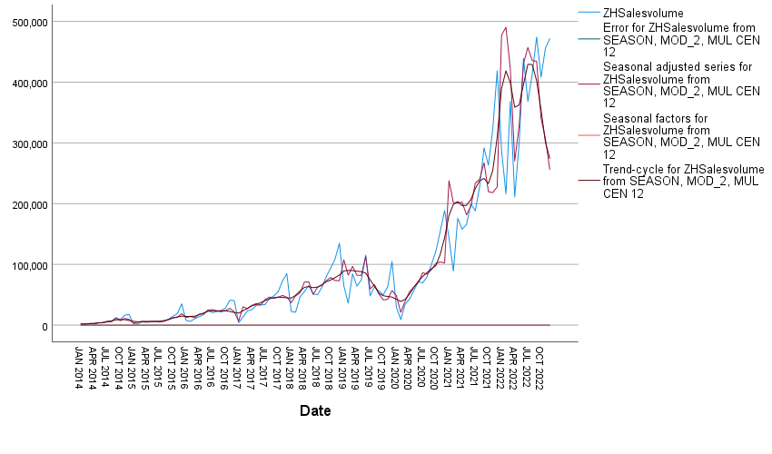

|  |  |  |  |
| --- | --- | --- | --- |
| **Model Description** | | | |
|  | | | Model Type |
| Model ID | ZHSalesvolume | 模型_1 | ARIMA(0,1,0)(0,1,1) |

|  |  |  |  |  |  |  |  |  |  |  |  |
| --- | --- | --- | --- | --- | --- | --- | --- | --- | --- | --- | --- |
| **Model Fit** | | | | | | | | | | | |
| Fit Statistic | Mean | SE | Minimum | Maximum | Percentile | | | | | | |
| 5 | 10 | 25 | 50 | 75 | 90 | 95 |
| Stationary R-squared | .679 | . | .679 | .679 | .679 | .679 | .679 | .679 | .679 | .679 | .679 |
| R-squared | .922 | . | .922 | .922 | .922 | .922 | .922 | .922 | .922 | .922 | .922 |
| RMSE | 36483.239 | . | 36483.239 | 36483.239 | 36483.239 | 36483.239 | 36483.239 | 36483.239 | 36483.239 | 36483.239 | 36483.239 |
| MAPE | 20.070 | . | 20.070 | 20.070 | 20.070 | 20.070 | 20.070 | 20.070 | 20.070 | 20.070 | 20.070 |
| MaxAPE | 79.338 | . | 79.338 | 79.338 | 79.338 | 79.338 | 79.338 | 79.338 | 79.338 | 79.338 | 79.338 |
| MAE | 19263.112 | . | 19263.112 | 19263.112 | 19263.112 | 19263.112 | 19263.112 | 19263.112 | 19263.112 | 19263.112 | 19263.112 |
| MaxAE | 165285.327 | . | 165285.327 | 165285.327 | 165285.327 | 165285.327 | 165285.327 | 165285.327 | 165285.327 | 165285.327 | 165285.327 |
| Normalized BIC | 21.345 | . | 21.345 | 21.345 | 21.345 | 21.345 | 21.345 | 21.345 | 21.345 | 21.345 | 21.345 |

|  |  |  |  |  |  |  |
| --- | --- | --- | --- | --- | --- | --- |
| **Model Statistics** | | | | | | |
| Model | Number of Predictors | Model Fit statistics | Ljung-Box Q(18) | | | Number of Outliers |
| Stationary R-squared | Statistics | DF | Sig. |
| ZHSalesvolume-模型_1 | 0 | .679 | 18.683 | 17 | .347 | 6 |

|  |  |  |  |  |  |  |  |  |
| --- | --- | --- | --- | --- | --- | --- | --- | --- |
| **ARIMA Model Parameters** | | | | | | | | |
|  | | | | | Estimate | SE | t | Sig. |
| ZHSalesvolume-模型_1 | ZHSalesvolume | Natural Logarithm | Difference | | 1 |  |  |  |
| Seasonal Difference | | 1 |  |  |  |
| MA, Seasonal | Lag 1 | .643 | .132 | 4.854 | .000 |

|  |  |  |  |  |  |  |
| --- | --- | --- | --- | --- | --- | --- |
| **Outliers** | | | | | | |
|  | | | Estimate | SE | t | Sig. |
| ZHSalesvolume-模型_1 | Sep 2014 | Additive | .571 | .166 | 3.433 | .001 |
| Jan 2015 | Level Shift | -1.211 | .247 | -4.908 | .000 |
| Dec 2015 | Additive | .544 | .164 | 3.321 | .001 |
| Jan 2017 | Additive | -1.430 | .157 | -9.121 | .000 |
| Jun 2019 | Additive | .560 | .153 | 3.652 | .000 |
| Feb 2020 | Additive | -.703 | .154 | -4.574 | .000 |

