|  |  |
| --- | --- |
| Team Number : | apmcm2305788 |
| Problem Chosen : | C |

The Development Trend of New Energy Electric Vehicles in China

2023 APMCM summary sheet

For Question One, the study first created time series graphs of the sales volume of China's new energy pure electric vehicles and various factors, initially describing the impact of these factors on sales volume based on the graphs. Then, taking the relationship between sales volume and infrastructure as an example, a time series model was established, sequentially conducting ADF tests, differencing adjustments, Granger causality tests, and cross-correlation tests, to further analyze the impact of infrastructure on sales volume. The results showed a strong immediate relationship but no significant linear relationship between the two, indicating that infrastructure has a considerable impact on China's new energy pure electric vehicle industry to a certain extent. Other factors such as GDP, battery endurance capacity, and the maximum driving speed of new energy pure electric vehicles basically have no significant impact on the sales volume of China's new energy pure electric vehicles. The R&D investment costs and the amounts involved in lawsuits against related vehicle companies have a certain degree of impact on the sales volume of China's new energy pure electric vehicles.

For Question Two, the study collected monthly sales data of China's new energy pure electric vehicles over the years. Using the collected data, time series graphs, seasonal decomposition analysis, and the construction of respective time series models for both differenced and non-differenced data were performed. It was found that the long-term sales volume trend before and after differencing is upward, with increasing cyclic variations over time. The seasonal decomposition analysis by month for both before and after differencing showed that the average sales in June, September, and December are above the annual average, while those in February, May, and August are below the annual average. A monthly-based time series model was then established, and seasonal decomposition for the sales volume before and after differencing was conducted, leading to the construction of Winters' multiplicative model and ARIMA model. After conducting residual tests on both models, the non-differenced time series model was found to be more accurate. Therefore, this model was used to predict the sales volume of China's new energy vehicles for the next 10 years. The results indicate that in April 2023, sales will be 216,157 units, in May 2023, 285,915 units, and by March 2033, 792,994 units.

For Question Three, the study collected related data such as the sales volume and market share of pure electric energy vehicles and traditional energy vehicles, and standardized the data. Then, taking ZH Sales Volume and Global Traditional Energy Vehicle Sales as examples, the time series model from Question One was applied, and ADF tests, differencing adjustments, Granger causality tests, and cross-correlation tests were conducted. It was found that there is neither a causal relationship nor a significant linear relationship between them. Similarly, it can be concluded that there is no significant linear relationship between Global Pure Electric Sales, Plug-in Sales, and Global Traditional Energy Vehicle Sales. However, the market share of pure electric vehicles has a great negative correlation with the sales volume of traditional fuel vehicles and shows a significant one-to-one corresponding relationship over time.

For Question Four, the study collected information on four policies from the United States and the European Union and their implementation times. Taking the policy of 'The United States raising the import tariff on Chinese new energy vehicles by 27.5%' as an example, a Winters' Additive model was established. The sales volume from January 2014 to December 2017 (the period with policy) was used to predict the sales volume from February 2018 to March 2023 (the period without policy). A comparison between the predicted values and the actual values revealed that the sales volume without the policy was always higher than with the policy, indicating that the policy had a suppressive effect on sales volume. However, looking at the long-term trend, the sales volume gradually increased, suggesting that it may have been influenced by other factors that drove the increase in sales. Similarly, it was concluded that the European Union's policy of 'increasing carbon emission standards for traditional vehicles' has a significant promotional effect on the development of China's new energy electric vehicles, while the other two policies have no significant suppressive effect on them.

For Question Five, the study considered factors such as the city's transportation demand, modes of transportation, degree of electrification, energy structure, and carbon emissions. An equation relating CO2 emissions to these factors was established. Reasonable assumptions were made for data such as the average number of trips per person per day, average length of each trip, proportion of travel by different types of vehicles, and the energy loss rate during charging and discharging. These assumptions were then substituted into the above equation, resulting in a calculated net reduction of CO2 emissions of 845,340 tons.

**Keybord:** Time Series Model; ADF Test; Granger Causality Test; Cross-Correlation Test

**Content**

The Development Trend of New Energy Electric Vehicles in China 1

1. Introduction 4

1.1 Background 4

1.2 Problem Conditions and Data 4

1.3 Work 5

2. Problem analysis 5

2.1 Analysis of question one 5

2.2 Analysis of question two 7

2.3 Analysis of question three 7

2.4 Analysis of question four 9

2.5 Analysis of question five 10

2.6 Analysis of question six 10

3. Symbol and Assumptions 10

3.2 Fundamental assumptions 11

4. Model Establishment and Solution 11

4.1 Question one 11

4.1.1Model Establishment 11

4.1.2 Model Solution and Results 14

4.2 Question two 17

4.2.1 Model Establishment 17

4.2.2 Model Solution and Results 18

4.3 Question three 24

4.3.1 Model Establishment 24

4.3.2 Model Solution and Results 25

4.4 Question Four 29

4.4.1 Model Establishment 29

4.4.2 Model Solution and Results 29

4.5 Question Five 33

4.5.1 Model Establishment 33

4.5.2 Model Solution and Results 34

4.6 Question Six 35

5.Evaluation of the Model 36

5.1 Advantages of the Model 36

5.2 Disadvantages of the Model 36

5.3 Extension of the Model 36

References 36

Appendix 38

1 Support Material 38

2 Appendix I 38

3 Appendix II 52

3.1 Question one 52

3.2 Question Three 62

3.3 Question Four 68

4 Appendix III 78

# 1. Introduction

1.1 Background

New energy vehicles refer to cars that use unconventional vehicle fuels as their power source. These vehicles combine advanced power control and driving technologies, featuring advanced technical principles, new technologies, and new structures, and are primarily categorized into four types. The advantages of new energy vehicles include being environmentally friendly and providing a smooth driving experience. In the field of new energy vehicles, Western countries began paying attention and exploring this area in the mid-19th century. Since 2011, China has implemented a series of preferential policies, leading to significant development in the new energy electric vehicle industry. China has achieved breakthroughs in enterprises, technology, and market areas. Under the pressure of energy and environmental concerns, new energy vehicles will undoubtedly become the main direction of future automotive development.

1.2 Problem Conditions and Data

1.Table 1 in DATA.excel presents the monthly sales volume of China's pure electric energy vehicles from January 2014 to March 2023, infrastructure (number of charging piles), GDP (monthly), battery endurance capacity (presented as maximum range), maximum driving speed, as well as the R&D expenses of vehicle companies and the amount involved in lawsuits against these companies, along with the implementation times of 6 policies.

2.Table 2 in DATA.excel provides the monthly sales volume of China's pure electric energy vehicles from January 2014 to March 2023, market share, global sales volume of traditional energy vehicles, global sales volume of pure electric energy vehicles, global sales volume of plug-in hybrid vehicles, and the specific implementation time intervals of four policies: EU subsidies, EU anti-subsidy investigations, U.S. tariffs on China, and EU anti-dumping investigations.

3.Table 3 in DATA.excel lists the monthly sales volume of China's pure electric energy vehicles from January 2014 to March 2023, market share, global sales volume of traditional energy vehicles, global sales volume of pure electric energy vehicles, and global sales volume of plug-in hybrid vehicles, all standardized.

4.Table 4 in DATA.excel provides the monthly sales volume of China's pure electric energy vehicles from January 2014 to March 2023 and the specific implementation time intervals of four policies: EU subsidies, EU anti-subsidy investigations, U.S. tariffs on China, and EU anti-dumping investigations.

5.Table 1 in YearDate.excel presents annual data from 2014 to 2015 on Sales volume, Number of public charging piles_Nationwide (cumulative), GDP, Battery capacity (km), Maximum speed (km/h), equity ratio, Net assets per share increased compared to the beginning of the year, return on invested capital, and R&D expenses.

1.3 Work

**Question 1**: Consider the main factors influencing the development of China's new energy electric vehicles, describe and analyze the impact of these factors on the development of China's new energy electric vehicles.

**Question 2**: Collect data on the development of China's new energy electric vehicle industry, describe and predict the development of China's new energy electric vehicles in the next 10 years.

**Question 3**: Collect relevant data to analyze the impact of global new energy electric vehicles on the traditional energy automotive industry.

**Question 4**: Research policies in some countries that resist the development of China's new energy electric vehicles, and analyze the impact of these policies on the development of China's new energy electric vehicles.

**Question 5**: Assuming a city population of 1 million, analyze the impact of urban new energy electric vehicle electrification on the ecological environment.

**Question 6**: Based on the conclusions of Question 5, write an open letter to the citizens, including the benefits of new energy electric vehicles and the contributions of the electric vehicle industry in various countries around the world.

# 2. Problem analysis

## 2.1 Analysis of question one

For Question One, the task requires considering the main factors affecting the development of China's new energy electric vehicles and to describe and analyze the impact of these factors on the development. This can include aspects such as policies, technology, economics, public environmental consciousness, and consumer attitudes towards electric vehicles. The development can be reflected by the sales volume of China's new energy electric vehicles. Policy-related factors may include subsidies for companies, personal vehicle purchase subsidies, financial support for technology development, and the improvement of related infrastructure such as the number of charging stations. Technological aspects may involve battery capacity, vehicle speed, etc.; and economic aspects may include societal economic development, R&D costs, etc. Therefore, it is first necessary to collect a sufficient amount of related data, such as the annual sales volume of pure electric vehicles, China's GDP development, and R&D expenditure by companies. Regarding model construction, multiple linear regression could be chosen to analyze the effects of various factors on the development of China's new energy electric vehicles, or ADF data stationarity tests could be conducted on the sales volume of China's new energy electric vehicles and other factors, followed by Granger causality tests and cross-correlation methods to examine their causal relationships and correlation levels, describing as much as possible how these factors impact the development of China's new energy sources. Alternatively, a multiple linear regression model could be used, relating the sales volume of China's new energy pure electric vehicles with infrastructure construction, policy support for technological development, and other related factors, as well as policies as dummy variables, and time as a dummy variable for multiple linear regression. Lasso regression could be employed to filter relevant variables, adjusting the model repeatedly, such as adding interaction terms for policy and time, and after repeated adjustments, conducting Wald tests on non-significant dummy variables (such as time) to test whether to remove related dummy variables. Finally, an optimal multiple linear regression model could be obtained. Using this multiple linear regression model, one could preliminarily explain the influence of related factors on the sales volume of China's new energy pure electric vehicles and make some predictions about the sales volume to a certain extent.

The main factor

Technology

economy

infrastructure

Battery life

The maximum travel speed of the car

The total number of charging stations

Battery capacity

R&D expenses

GDP

The amount involved

purchaser

Enterprises:

increase the difficulty

of subsidies and eliminate

backward enterprises

Policy

subsidies

Purchase subsidy

Business subsidies

Technology subsidies

The sales volume is tested with ADF for each factor

smooth

Unsteady

Granger causality test

Differential adjustment

Cross-relevance

conclusion

## 2.2 Analysis of question two

For Question Two, the task is to collect data on the development of China's new energy pure electric vehicle industry and to describe and predict the development of China's new energy pure electric vehicles over the next 10 years. The sales volume of China's new energy electric vehicles can still be used to reflect development, and then other main factors such as the number of infrastructure constructions can be incorporated along with the sales volume of China's new energy pure electric vehicles to forecast a more accurate value. Therefore, it is necessary to collect the monthly sales volume of China's new energy electric vehicles over the years, as well as related data on other major factors, such as the number of infrastructure constructions. For describing development, existing data can be used to draw a time series graph of sales volume, and then observe its long-term trend, cyclicality, seasonality, etc., from the graph. For forecasting development, further establish sales volume time series graphs by month, quarter, and year, and by observing and comparing their characteristics, choose an appropriate unit to establish a time series model, and then perform seasonal decomposition to establish a suitable specific model (such as Winters' multiplicative model, Winters' additive model, etc.). For verifying the reliability of the model, residual checks (ACF and PACF tests) can be conducted on the established model, and finally, choose the most accurate model to predict the development of China's new energy vehicles over the next 10 years. The multiple linear regression model from Question One can be used to some extent to make predictions about the sales volume of China's new energy pure electric vehicles.

Images related to sales volume (month, quarter, year)

(Differential adjustment)

Select the appropriate units to build a time series model

Whether it is cyclical or quarterly

Establish a suitable concrete model

(For example, the Winster multiplication model)

Seasonal decomposition

Residual test

Forecast for the next 10 years

## 2.3 Analysis of question three

For Question Three, the task requires the collection of relevant data to analyze the impact within the global new energy electric vehicle industry. Considering the competitive relationship between them, the development of new energy electric vehicles may squeeze the market share of the traditional energy vehicle industry, affect its sales volume, reduce the profits of related enterprises, and thus force traditional energy vehicle enterprises to undergo technological upgrades to enhance competitiveness. For this, as much relevant data as possible should be collected, such as the annual sales volume and market share of China's pure electric energy vehicles, the global sales volume of traditional energy vehicles, global pure electric energy vehicle sales, and global plug-in hybrid vehicle sales, etc. Then, appropriate time series models can be established for different factors and perform Granger causality tests and cross-correlation analysis as in Question One to explore the causal relationships and degrees of correlation between each factor and sales volume. Furthermore, it is possible to analyze whether there are causal relationships at different lag times between them, what type of relationship exists, and the degree of correlation, such as the presence of positive or negative correlations to some extent. Alternatively, a multiple linear regression model could be used, relating the sales volume of global traditional energy vehicles with the sales volumes of global pure electric energy vehicles, global plug-in hybrid vehicles, other main factors, and related policies as dummy variables, and time as a dummy variable for multiple linear regression. Lasso regression can be employed to filter relevant variables, adjusting the model repeatedly, such as adding interaction terms for policy and time, and after repeated adjustments, conducting Wald tests on non-significant dummy variables (such as time) to test whether to remove related dummy variables. Finally, an optimal multiple linear regression model could be obtained. Using this multiple linear regression model, one can preliminarily explain the influence of related factors on the sales volume of global traditional energy vehicles and make some predictions about the sales volume to a certain extent.

Global Pure electric Sales

Plug in sales

China Sales Volume

The sales volume is tested with ADF for each factor

smooth

Unsteady

Granger causality test

Differential adjustment

Cross-relevance

conclusion

Market Share

Influencing Factors

## 2.4 Analysis of question four

For Question Four, The task requires identifying some countries' policies that resist the development of China's new energy pure electric vehicles and analyzing the impact of these policies on the development of China's new energy electric vehicles. For this purpose, relevant policies such as import taxes, technological restrictions, market access limitations, etc., and the periods during which these policies were implemented should be collected, as well as specific data on the development of China's new energy electric vehicles around these time periods. Subsequently, different policies can be classified into different dimensions, and a multiple linear regression analysis can be performed to analyze their impact on China's new energy electric vehicles, or a time series analysis can be conducted separately for specific, more important policies. Specifically, the dataset can be segmented by time based on the start and end dates of specific policies, then appropriate prediction models can be used to forecast data for later periods based on data from earlier periods, and the forecasted data can be compared with actual data to analyze the specific impact of the policy on the sales volume of China's new energy electric vehicles. As with Question One, establish a multiple linear regression analysis model for the sales volume of China's new energy pure electric vehicles with policies and time, where policies and time can be treated as dummy variables or policy indicators can be quantified. Lasso regression can be used to filter relevant variables, and the model can be adjusted multiple times, such as by adding interaction terms between policy and time. After repeated adjustments, and ultimately performing Wald tests on non-significant dummy variables (such as time) to test whether to remove related dummy variables, an optimal multiple linear regression model can be obtained. Using this multiple linear regression model, one can preliminarily explain the influence of related factors on the sales volume of global traditional energy vehicles and make some predictions about the sales volume to a certain extent.

Estimate Later data

Compared

Get conclusion

ADF Inspection

Differential processing

Data set is

not stationary

re-insert

Data set is stationary

Divide the stationary data set

into two periods based on policy

implementation time

Later data

Previous data

Predict

## 2.5 Analysis of question five

For question five, The task assumes a population of 1 million in a city and analyzes the impact of the electrification of new energy electric vehicles in the city on the ecological environment. This requires establishing a reasonable model to simulate the reduction in carbon emissions from urban transport after electrification, to reflect the ecological benefits of the popularization of new energy electric vehicles. For the construction of the model, relevant factors to be considered include the city's transportation demand, modes of transportation, degree of electrification, energy structure, and carbon emissions. Specifically, the city's transportation demand includes urban population, per capita number of trips, and kilometers traveled per trip; modes of transportation include the proportion of total kilometers traveled by private cars and buses; the degree of electrification includes the proportion of new energy electric vehicles among all private cars and the proportion of electric buses among all buses; the energy structure includes the share of fuel and electricity in the total transportation energy; and carbon emissions include emissions per kilometer for fuel vehicles and electric vehicles (it can be assumed that the part of electricity from renewable sources has zero carbon emissions). By collecting these factors and establishing a reasonable model, it is possible to calculate the annual reduction in carbon emissions from the city after electrification and determine the impact of electrification on environmental protection.

## 2.6 Analysis of question six

For question six,Combine the results of question five to promote the benefits of new energy electric vehicles and the contribution of the electric vehicle industry in countries around the world.

# Symbol and Assumptions

|  |  |
| --- | --- |
| Symbol DescriptionSymbol | Meaning |
| *P* | Urban opulation |
| *T* | Average number of trips per person per day |
| *L* | Average trip length |
| *D* | Days in year |
|  | Proportion of private car trips |
|  | Proportion of electric private cars |
|  | Proportion of public transportation trips |
|  | Proportion of electric buses |
|  | CO2 emissions per kilometer of fuel vehicles |
|  | CO2 emissions per kWh of non-renewable energy |
|  | Proportion of renewable energy in electricity supply |
|  | Charge and discharge energy loss rate |

## 3.2 Fundamental assumptions

(1) Assume complete combustion of the vehicle's fuel, with only carbon dioxide being emitted in the exhaust.

(2) Assume an average of 3 trips per person per day.

(3) Assume an average trip length of 10 kilometers.

(4) Use a standard year of 365 days.

(5) Private car trips account for 50% of all trips.

(6) Electric private cars make up 50% of all private cars.

(7) Public transport trips account for 30% of all trips.

(8) Electric buses make up 50% of all public transport.

(9) CO2 emissions from fuel vehicles are 2.3 kilograms per kilometer; CO2 emissions from non-renewable energy are 0.475 kilograms per kilowatt-hour.

(10) Renewable energy accounts for 26% of the electricity supply.

(11) The energy loss rate during charging and discharging is 5%.

# Model Establishment and Solution

## 4.1 Question one

4.1.1Model Establishment

(One) Data Preprocessing

For Question 1, this study primarily explores the relationship between the sales volume of China's new energy electric vehicles and other variables over time, that is, investigating the impact of various factors on sales volume in a time series. Here, the sales volume is used to reflect the development of China's new energy electric vehicles.

To this end, this study establishes the following time series model.

(Two) Establishment of Time Series Model

(1) ADF Test[1]

Before establishing a time series model, it is necessary to perform a stationarity test on the data. In this study, the Augmented Dickey-Fuller (ADF) test is used. The model is as follows:

Assume the null hypothesis that there is a unit root, indicating the time series is non-stationary; assume the alternative hypothesis that there is no unit root, indicating the time series is stationary.

When the basic trend of a series exhibits irregular increases or decreases repeatedly, it is categorized as an autoregressive process without a drift term. The corresponding regression formula is:

When the basic trend of a series shows a clear increase or decrease over time and the trend is not too steep, it is categorized as an autoregressive process with a drift term. The corresponding regression formula is:

When the basic trend of a series shows a rapid increase over time, it is categorized as a regression process with a trend term. The corresponding test regression formula is:

In this model, is the constant term, is the time trend term, and is the random disturbance term.

If the p-value is greater than 0.05, the null hypothesis cannot be rejected, indicating that the time series is non-stationary. If the p-value is less than 0.05, the null hypothesis is rejected, indicating that the time series is stationary.

(2) Differencing Adjustment

If the time series is non-stationary, it is necessary to use first-order differencing to adjust the series. The formula for this is:

If the time series remains non-stationary after first-order differencing, it is necessary to use second-order differencing for further adjustment. The formula for this is:

In the same way, the d-order integral is

In addition, the seasonal difference is

Among them, m is the period.

(Two) Testing of time series models

(1) Granger Causality Test [2]

The Granger causality test is used to determine if one time series variable is a cause of changes in another time series variable. The null hypothesis posits that the time series variable X does not cause changes in the time series variable Y. The alternative hypothesis is that the time series variable X does cause changes in Y. The formula is represented as:

If "time series variable X is the cause of changes in time series variable Y", according to the p-order autoregressive model of Y

Among them, is a constant term, is the maximum number of lag periods of Y, and is white noise. At the same time, considering the influence of X on Y, the infinite regression model of Y can be obtained

Among them, is the maximum number of lag periods for X.

Then use the residual sum of squares and of these two regression models to obtain the statistics

Among them, n is the maximum sample size.

According to the above model, the previously proposed hypothesis "time series variable X is the cause of the change in time series variable Y" is equivalent to testing that β_i is significantly not equal to 0, that is

If , then the time series variable X is not the cause of the change in the time series variable Y.

(2) Cross-Check [3]

For the time series and with the same sample length N, let the cross-correlation function be

Then the correlation test statistic is

The correlation statistic obeys the chi-square distribution with m as the degree of freedom (the degree of freedom m is between 1-1000). If there is no cross-correlation between the two time series, the value of the correlation statistic is the same as the chi-square The distribution is consistent; on the contrary, as m increases, the correlation statistics exceed the standard chi-square distribution value, indicating that the cross-correlation between the two time series is significant.

4.1.2 Model Solution and Results

First, the data is processed to obtain the results of descriptive statistics, as shown in the table below.

Table1 Descriptive Statistics of Question 1 Data

|  |  |  |  |  |
| --- | --- | --- | --- | --- |
|  | **Sales volume** | **Number of public charging piles_Nationwide**  **(cumulative)** | **…** | **Battery capacity (km)** |
| **mean** | 103501.2072 | 490761.8874 | … | 494.5045045 |
| **min** | 750 | 518 | … | 320 |
| **25%** | 16772.5 | 74965 | … | 480 |
| **50%** | 50211 | 278736 | … | 480 |
| **75%** | 139121 | 751294.5 | … | 545 |
| **max** | 474475 | 1900386 | … | 545 |
| **std** | 127141.6221 | 523393.5695 | … | 64.42104031 |

Note: See Appendix 1 for complete data.

As can be seen from the table, the sales volume ranges from 750 to 474475, and the standard deviation is 127141.6221, which reflects the large difference between sales volumes; the number of charging piles ranges from 518 to 1900386, and the standard deviation is 523,393.5695, indicating that the number of charging piles varies in different There are large differences between time points; the range of battery capacity is 320~545km, and the standard deviation is 64.42104031, showing the relative stability of battery capacity between different data points.

In order to study the relationship between sales volume and other factors, this article successively conducted the ADF data stationarity test, Granger causality test, and cross-examination test. The specific solution results are as follows. The following takes the relationship between sales volume and infrastructure construction (number of charging piles) as an example. See Appendix 2 for other processes.

(One) ADF inspection and differential adjustment

1. The relationship between sales volume and infrastructure construction (number of charging piles)

Table2 Sales Volume ADF Test and Difference Adjustment Results

|  |  |  |  |  |  |
| --- | --- | --- | --- | --- | --- |
| Before differential  Statistics | *p value* | First difference  Statistics | *p value* | Second order difference  Statistics | *p value* |
| -1.1846 | 0.680 | -1.3105 | 0.624 | -7.990 | 2.484 |

As can be seen from the table, the p-value of sales volume before the difference is 0.680, which is greater than 0.05, indicating that there is a unit root and the data is non-stationary; the p-value after the first-order difference is 0.624, which is still greater than 0.05, indicating that the data is still non-stationary; second The p value after the first-order difference is 2.484, which is less than 0.05, indicating that the data is a stationary sequence.

Table3 Infrastructure (number of charging piles) ADF inspection and differential adjustment results

|  |  |  |  |  |  |
| --- | --- | --- | --- | --- | --- |
| Before differential  Statistics | *p value* | First difference  Statistics | *p value* | Second order difference  Statistics | *p value* |
| 3.9663 | 1.000 | -0.2420 | 0.933 | -5.1425 |  |

As can be seen from the table, the p-value of the sales volume before the difference is 1, which is greater than 0.05, indicating that there is a unit root and the data is non-stationary; the p-value after the first-order difference is 0.933, which is still greater than 0.05, indicating that the data is still non-stationary; second The p value after the first-order difference is , which is less than 0.05, indicating that the data is a stationary sequence.

(2) Differentially adjusted data

Table4: Difference data between sales volume and infrastructure construction (number of charging piles)

|  |  |
| --- | --- |
| Date | Number of public charging piles_Nationwide (cumulative) |
| 2014.3 | 0 |
| 2014.4 | 0.01 |
| 2014.5 | -0.01 |
| 2014.6 | 0 |
| 2014.7 | 0 |
| … | … |
| 2023.3 | 0 |

(Two) Results and analysis of Ganger causality test

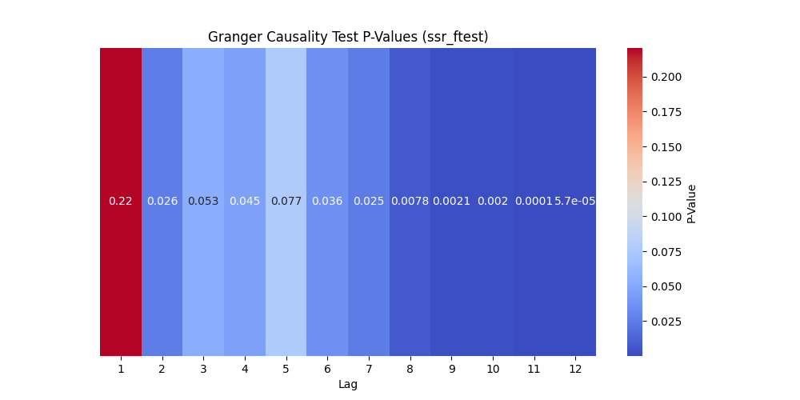

Picture1 Geanger Causality Test P-Values

As can be seen from the figure, if the lag period is 4 and the subsequent p-value is less than 0.05, the null hypothesis is rejected, indicating that infrastructure construction (the number of charging piles) is the Granger cause of sales; and during these lag periods, infrastructure has statistically significant predictive ability for sales volume. Especially when the lag period is long, the p value is very small, indicating that the significance is stronger.

(Three) Cross-examination[4] results and analysis

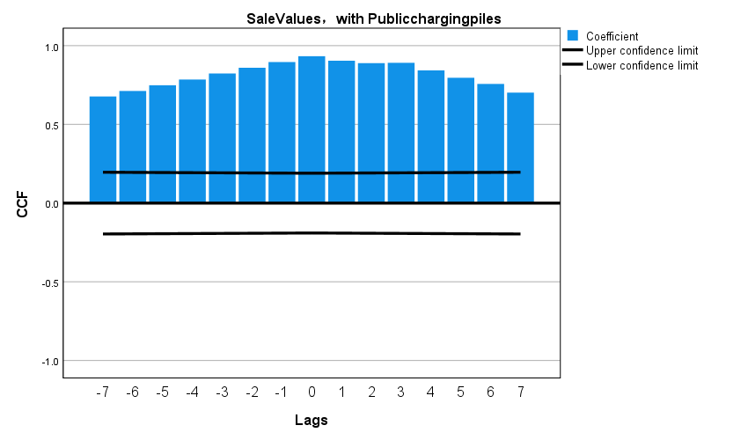

Figure2 Cross-validation results (before difference)

As can be seen from the figure, the correlation is high at each lag order. This may be due to the trend and seasonal components in the data, indicating that the time series of sales and infrastructure construction may share one or more unscheduled times. A common trend or cyclical structure that is eliminated by differencing.

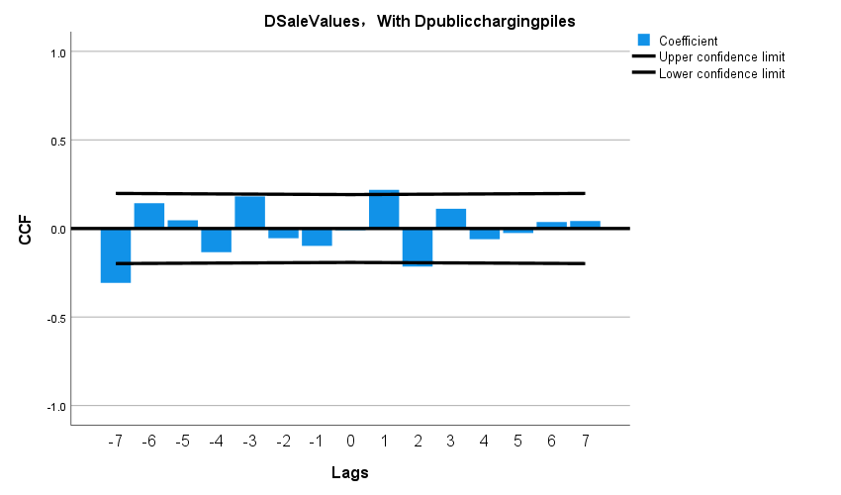

Figure3 Cross-validation results (after difference)

It can be seen from the figure that the correlation is close to zero in the number of lags, indicating that there is no obvious linear relationship between the time sequence after the difference. It also shows that the cross -test results before the difference may be affected by trends and seasonal components.

(Four) Comprehensive analysis and inference

The significant results of the Granger causal test[5] indicate that the changes in infrastructure construction have changed to the change of sales in time and may have an impact on it. However, the analysis of cross -correlation does not indicate that there is a strong instant relationship between the two. This shows that the relationship between sales volume and infrastructure construction may be adjusted by other variables, or there is a non -linear relationship between sales volume and infrastructure construction.

That is, China's new energy electric vehicle development and infrastructure construction have no obvious linear relationship, but statistically, the construction of infrastructure has a significant predictive ability for sales, that is, to a certain extent, infrastructure to a certain extent The construction is impact on the sales of new energy pure electric vehicles, but it is not a linear effect. The relationship between them may be related to the number function or secondary function.

## 4.2 Question two

4.2.1 Model Establishment

(One) Description of the development of China's new energy electric vehicle industry

Draw a time series visual depiction of China's new energy electric vehicle sales in units of months, quarters, and years, and analyze whether there is cyclicality and quarterliness.

(Two) Forecast the development of new energy electric vehicles in China in the next 10 years

Based on preliminary analysis of cyclicality and seasonality, it is necessary to select an appropriate unit to establish a time series model. To choose more scientific data, this study models the data before and after differencing separately, and finally compares the performance of the two models to select the better one for forecasting.

The time series forecasting model is as follows.

(1) Winters' Multiplicative Model[6]

Among them, m is the period length, is the horizontal smoothing parameter, is the trend smoothing parameter, is the seasonal smoothing parameter, and is the predicted value of period h.

(2) SARIMA(p,d,q) (P,D,Q)m Model

Seasonal ARIMA models are generated by including additional seasonal terms in the ARIMA model and are of the following form,

(3) White noise test model

After estimating the time series model, you need to conduct a white noise test on the residuals. If the residuals are white noise, it means that the selected model can fully identify the patterns of the time series data, that is, the model is acceptable; if the residuals are not white noise, This means that there is still some information that has not been recognized by the model, and the model needs to be modified to identify this part of the information. The Q test can be used to determine whether the residual is white noise. The model is shown below.

If

Under the condition that is established, the statistics

Among them, T represents the number of samples, n represents the number of unknown parameters in the model, and s can generally be 8, 16, 24, etc. depending on the size of the sample.

After calculating the p-value of the Q statistic, if the p-value is greater than 0.05, the null hypothesis cannot be rejected, indicating that the time series is a white noise sequence. If the p-value is less than 0.05, the null hypothesis is rejected, indicating that the time series is not a white noise sequence.

4.2.2 Model Solution and Results

(One) Description of the development of China's new energy electric vehicle industry

According to the collected data, the data before and after the difference are used in monthly time series visual depictions, as follows:

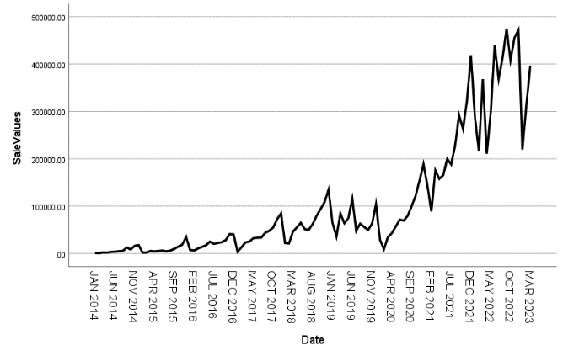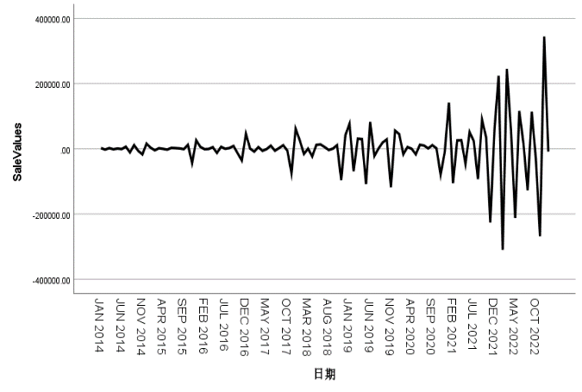

Figure4 Time series visual depiction (before difference) Figure5 Time series visual depiction (after difference)

It can be seen from the figure that the sales volume before the difference is generally upward, and the fluctuations of the season with the change of time are getting larger and larger; the sales volume after the differential oscillating is repeatedly oscillated near a certain value, which has weakened the impact of seasonality and trends to a certain extent. However, the overall trend becomes a horn -like mouth. Over time, his oscillation range is also increasing.

(Two) Forecast the development of new energy electric vehicles in China in the next 10 years

In order to establish a suitable time series model[7] to predict the data of the past ten years, the time series before and after the difference are analyzed separately. The specific steps are as follows.

**Step1**: Seasonal decomposition

From the above description of the time series visual depiction, it can be seen that the sales volume before difference fluctuates more and more with the seasons, so using the multiplicative model[8] will be more accurate. The specific decomposition is shown in the following table,

Table5 Seasonal factors obtained by multiplicative decomposition of sales volume (before differences)

|  |  |  |  |
| --- | --- | --- | --- |
| Cycle | Seasonal factor（%） | Cycle | Seasonal factor（%） |
| 1 | 59.9 | 7 | 82.7 |
| 2 | 43.8 | 8 | 96.3 |
| 3 | 86.8 | 9 | 111.6 |
| 4 | 77.5 | 10 | 119.0 |
| 5 | 90.7 | 11 | 147.4 |
| 6 | 101.4 | 12 | 182.9 |

It can be seen from the table that the seasonal factors in months 6 and 9-12 are greater than 1, and the seasonal factors in months 1-5 and 7-8 are less than 1, indicating that the average sales volume in months 6 and 9-12 before the difference is higher than that in months 1-5 and 7-8. From January to May and July to August, the average sales volume in the 12th month is 82.9% higher than the annual average, and the average sales volume in the second month is 46.2% lower than the annual average.

Table6 Seasonal factors obtained by additive decomposition of sales volume (after difference)

|  |  |  |  |
| --- | --- | --- | --- |
| Cycle | Seasonal factor（%） | Cycle | Seasonal factor（%） |
| 1 | 64421.22126 | 7 | 2686.33700 |
| 2 | -66757.92458 | 8 | -12882.26833 |
| 3 | 38952.18480 | 9 | 18686.51813 |
| 4 | 9880.35147 | 10 | 6210.27334 |
| 5 | -47613.32041 | 11 | -87227.09124 |
| 6 | 37046.85147 | 12 | 36596.86709 |

It can be seen from the table that the seasonal factors in months 1, 3, 4, 6, 7, 9, 10, and December are positive, and the seasonal factors in months 2, 5, 8, and November are negative, indicating that after the difference, the seasonal factors in months 1, 3, The average sales volume in 4, 6, 7, 9, 10, and December is higher than that in the 2nd, 5th, 8th, and 11th months, and the average sales volume in the first month is higher than the annual average of 64,421 units, and in the second month The average sales volume was lower than the annual average of 66,757 vehicles.

**Step2**: Decomposed timing diagram

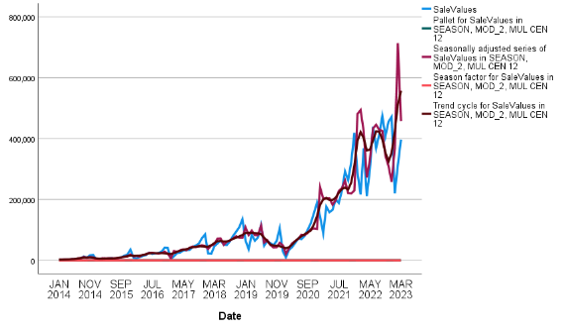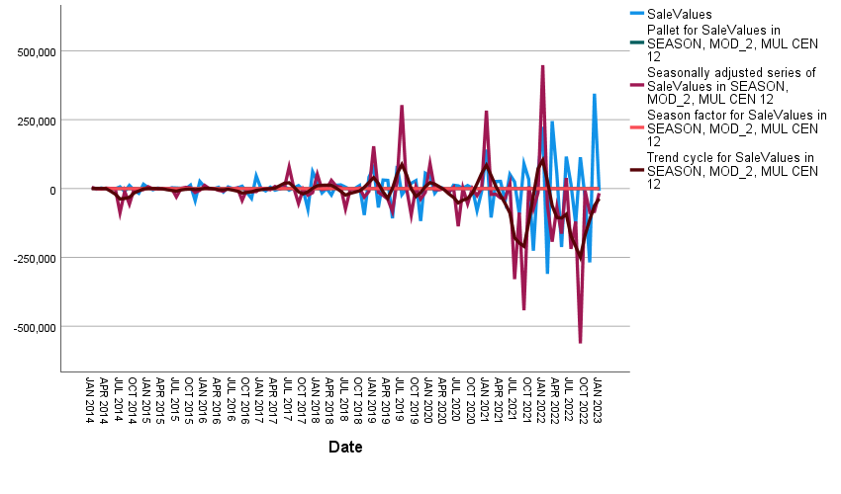

Figure6 The time (before difference) Figure7 The time (after difference)

It can be seen from the figure that the data before the differential shows the trend and periodic changes of the long -term rise in seasonal, and the data after differentiality shows a relatively stable trend; the data before and after the difference is basically the level of quantity. To a certain extent, the value of the residual is that the remaining factors are very small and can be regarded as 0, indicating that the model simulation results are good.

**Step3**: Establish a time series analysis model

(1) Before differential

Using SPSS software expert modeling, the model type is Winters multiplicative. Substitute the data into the formula (17) to get,

(2) After differential

Use SPSS software expert modeling to obtain the ARIMA(0,0,6)(0,1,0)12 model[9], and substitute the data into the formula (18) to get,

**Step4**: White noise residual test

(1) Before differential

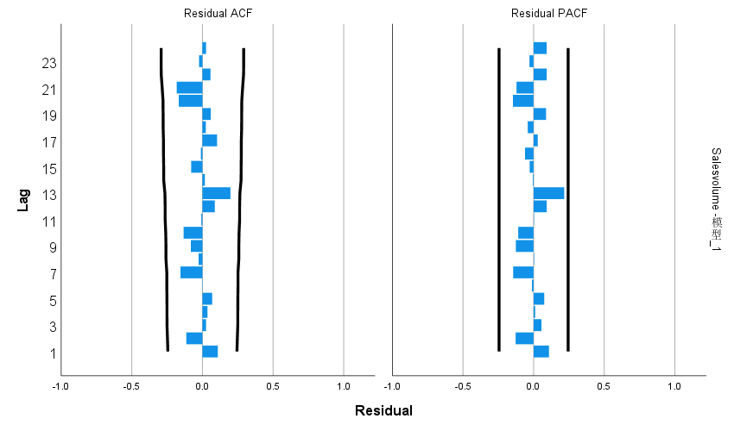

Figure8 Residual test visual depiction before difference

Table7 Winters multiplicative model statistical table

|  |  |  |  |  |  |
| --- | --- | --- | --- | --- | --- |
| Number of predictors | Model fit statistics: Stationary R-squared | Statistics | DF | Significance | Number of outliers |
| 0 | 0.555 | 18.149 | 15 | 0.255 | 0 |

As can be seen from the visual depiction, the autocorrelation coefficients and partial autocorrelation coefficients of all lag orders are not significantly different from 0; the p value obtained by Q test on the residuals is 0.255, which is greater than 0.05. The null hypothesis cannot be rejected, so the residuals are considered It is a white noise sequence, so the multiplicative model can well identify the sales data in this question.

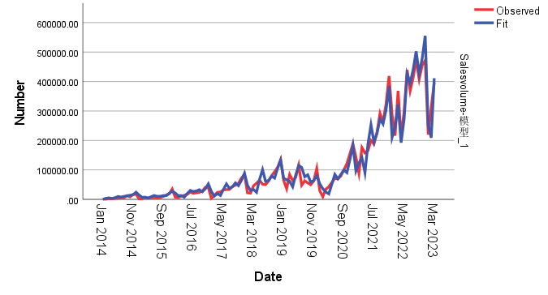

Figure9 Time fits the graph in series

It can be seen from the figure that the measured, fitted, and predicted curves basically overlap, indicating that the fitting and prediction effects are good and the results are credible.

(2) After differential

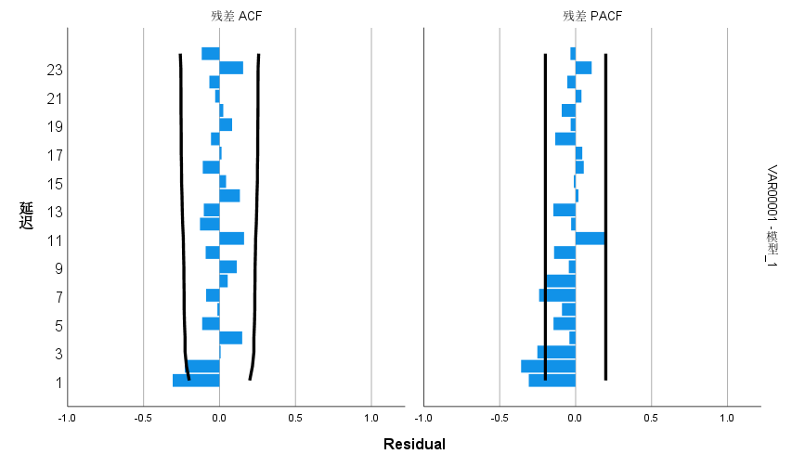

Figure10 Residual test visual depiction after difference

Table8 ARIMA(0,0,6)(0,1,0)12 model statistical table

|  |  |  |  |  |  |
| --- | --- | --- | --- | --- | --- |
| Number of predictors | Model fit statistics: Stationary R-squared | Statistics | DF | Significance | Number of outliers |
| 0 | .518 | 32.171 | 16 | .009 | 0 |

It can be seen from the visual depiction that the autocorrelation coefficient and partial autocorrelation coefficient of most lag orders are not significantly different from 0; the p value obtained by Q test on the residual is 0.009, which is less than 0.05, then the null hypothesis is rejected, indicating that the time series If it is not a white noise sequence, it means that there is still some information that has not been recognized by the model, and the model needs to be corrected to identify this part of the information.

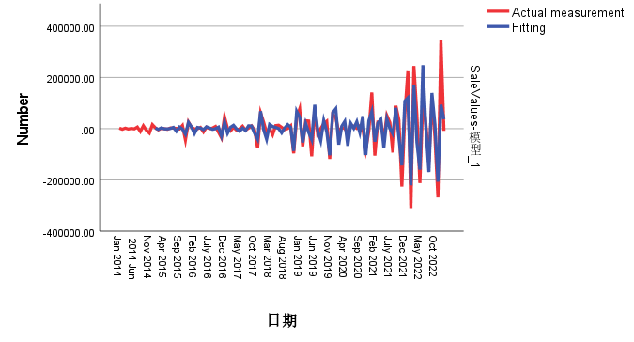

Figure11 Time fits the graph in series

It can be seen from the figure that the measured, fitted, and predicted curves basically overlap, indicating that the fitting and prediction effects are good and the results are credible.

According to the above analysis, we can know that the Worms' multiplication model before the split can identify the sales data in this question well, and the differential model fails to identify all information, that is, the model of the data before the difference is better. Therefore The model of the model is performed below. Based on the special situation of this article, the data before the difference may be that the original data shows a certain seasonality or trend characteristics. The expert model may choose the corresponding model to capture these features. When the data is different, these characteristics may be changed or disappeared, resulting in the model no longer applicable. The difference may cause the model to excessively fit the specific data set, especially when the amount of data is not large or the time span is not long. Excessive fitting models may perform poorly on new data or verification data.

**Step5**: Predict future indicator values

According to the formula (21), the prediction results obtained are as shown in the figure below,

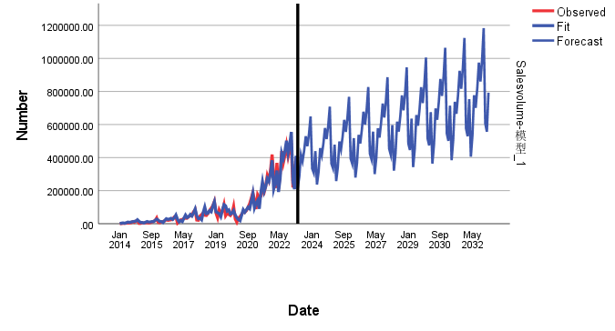

Figure12 Forecast graphs

The visual depiction demonstrates that beginning around 2024, the forecasted sales volume continues to grow, and as time progresses, the uncertainty of the forecast also increases, which is reflected in the widening of the columnar area. This widening may be due to the fact that as time advances, the uncertainty about the future also increases, leading to a broadening of the forecast confidence interval.

Table9: Forecasting results using sales volume before differences

|  |  |
| --- | --- |
| Date | Forecast sales |
| 2023.4 | 216157 |
| 2023.5 | 285915 |
| 2023.6 | 417609 |
| 2023.7 | 377812 |
| … | … |
| 2032.12 | 1183389 |
| 2033.1 | 606234 |
| 2033.2 | 556745 |
| 2033.3 | 792994 |

As can be seen from the table, the sales volume of new energy electric vehicles in China is expected to be 216,157 vehicles in April 2023, 285,915 vehicles in May 2023. and 792,994 vehicles in March 2033.

Overall, the visual depiction presents a positive growth trend in the sales volume of new energy pure electric vehicles, hinting at the potential prosperity of the new energy vehicle market. However, the visual depiction also shows a significant forecast uncertainty, especially towards the end of the prediction period. This may reflect the uncertainties related to long-term market dynamics, policy changes, and technological advancements.

## 4.3 Question three

4.3.1 Model Establishment

Question three requires an investigation into the impact of new energy electric vehicles on the global traditional energy automobile industry. Based on the available data, namely the known sales volume and market share of new energy electric vehicles and traditional energy automobiles in certain years, this study primarily explores the impact of new energy electric vehicles on the sales volume and market share of traditional energy automobiles in a time series. Here, sales volume and market share are used to reflect the development of the global traditional energy automobile industry

(One) Data Standardization

Considering the different dimensions of market share and sales volume, to more accurately study the important factors affecting the evaluation metrics, the data will be standardized.

There are n objects to be evaluated, with m evaluation indicators. Here, n represents the 111 months to be evaluated, and m represents the 5 indicators to be evaluated. The composition of the normalized matrix is as follows:

The standardized matrix is denoted as Z, where each element in Z is:

The resulting standardized matrix is

And define the maximum value as . The Euclidean weighted distance of the i-th object being evaluated from the maximum value is

Define the minimum value as . The Euclidean weighted distance of the i-th object being evaluated from the minimum value is

Thus, the unnormalized score of the i-th object being evaluated is

where represents the distance of the i-th object being evaluated from the maximum value, and represents the distance from the minimum value. , and the larger is, the smaller is, meaning it is closer to the maximum value.

(Two) The Relationship Between Global Traditional Energy Vehicle Sales and Other Variables

This question essentially mirrors Question One, as it also explores the relationship between one variable and other variables. For this purpose, this study utilizes the time series model from Question One, which will not be reiterated here.

4.3.2 Model Solution and Results

Firstly, the data is processed to obtain the results of descriptive statistics, as shown in the following table,

Table10 Descriptive Statistics of Question 3 Data

|  |  |  |  |  |  |
| --- | --- | --- | --- | --- | --- |
|  | ZH Sales volume | Market Share | Global traditional energy vehicle sales | Global Pure electric sales | Plug-in sales |
| **count** | 111 | 111 | 111 | 111 | 111 |
| **mean** | 103501.207 | 5.665387619 | 4945579.532 | 3187126.608 | 1359800.42 |
| **min** | 750 | 1.163045619 | 3801869.667 | 221050 | 166220 |
| **25%** | 16772.5 | 2.371947762 | 4928367.139 | 737440 | 483040 |
| **50%** | 50211 | 4.574263 | 5107792.5 | 2265166.667 | 991340 |
| **75%** | 139121 | 5.890674619 | 5368039.167 | 3839859.667 | 1767801.79 |
| **max** | 474475 | 15.50578757 | 5503195 | 9451747.75 | 3680794.33 |
| **std** | 127141.622 | 4.34934711 | 540872.8851 | 3080959.753 | 1165223.61 |

The table shows that the sales volume ranges from 750 to 474,475, indicating a significant variation in sales volume; the market share of ZH ranges from 1.16% to 15.51%, indicating relatively high volatility in market share; the sales volume of global traditional energy vehicles ranges from 3,801,869.667 to 5,503,195, the sales volume of global pure electric vehicles ranges from 221,050 to 9,451,747, and the sales volume of plug-in hybrid vehicles ranges from 166,220 to 3,680,794.33, showing significant differences in sales volumes among different types of vehicles.

Then, using formulas (23) to (28), the standardized data was obtained, as shown in the following table,

Table11: Standardization of Original Data for Question Three

|  |  |  |  |  |  |
| --- | --- | --- | --- | --- | --- |
| Date | ZH Sales volume | Market Share | Global traditional energy vehicle sales | Global Pure electric sales | Plug-in sales |
| 2014.1 | -0.81 | -1.04 | 0.16 | -0.97 | -1.03 |
| 2014.2 | -0.81 | -1.04 | 0.16 | -0.96 | -1.03 |
| 2014.3 | -0.80 | -1.04 | 0.16 | -0.96 | -1.03 |
| … | | | | | |
| 2018.1 | -0.64 | -0.25 | 0.78 | -0.52 | -0.46 |
| 2018.2 | -0.65 | -0.25 | 0.78 | -0.49 | -0.44 |
| 2018.3 | -0.45 | -0.25 | 0.78 | -0.46 | -0.42 |
| … | | | | | |
| 2023.1 | 0.92 | 0.00 | -0.03 | 2.04 | 2.00 |
| 2023.2 | 1.65 | 0.00 | -0.03 | 1.90 | 1.88 |
| 2023.3 | 2.32 | 0.00 | -0.03 | 2.04 | 2.00 |

To further study the relationship between global traditional energy vehicle sales and other factors, as in Question One, this study sequentially conducted ADF data stationarity tests, Granger causality tests, and cross-correlation tests, with specific solution results as follows. The relationship between Global traditional energy vehicle sales and ZH Sales volume is taken as an example, with other processes detailed in Appendix II.

(One) ADF nspection and Differential adjustment

1. The relationship between Global traditional energy vehicle sales and ZH Sales volume

Table12 Global traditional energy vehicle sales ADF test and difference adjustment results

|  |  |  |  |
| --- | --- | --- | --- |
| Before differential  Statistics | *p value* | First difference  Statistics | *p value* |
| -1.4527 | 0.556 | -10.3444 |  |

The table shows that before differencing, the p-value of the original sales volume is greater than 0.05, indicating the presence of a unit root and that the data is non-stationary; after first-order differencing, the p-value is less than 0.05, indicating that the data is a stationary series.

Table13: Results of ADF Test and Differencing Adjustment for ZH Sales Volume

|  |  |  |  |  |  |
| --- | --- | --- | --- | --- | --- |
| Before differential  Statistics | *p value* | First difference  Statistics | *p*值 | Second order difference  Statistics | *p value* |
| -1.1846 | 0.680 | -1.310 | 0.624 | -7.990 |  |

The table shows that before differencing, the p-value of sales volume is greater than 0.05, indicating the presence of a unit root and that the data is non-stationary; after first-order differencing, the p-value is still greater than 0.05, indicating that the data remains non-stationary; after second-order differencing, the p-value is less than 0.05, indicating that the data is a stationary series.

(2) Differentially adjusted data

Table14: Data after Differencing for Global Traditional Energy Vehicle Sales and ZH Sales Volume

|  |  |
| --- | --- |
| Date | Global traditional energy vehicle sales |
| 2014 | 0 |
| 2015 | 0.199257964 |
| 2016 | 0.573700861 |
| 2017 | 0.107475856 |
| 2018 | -0.251017923 |
| 2019 | -0.483342643 |
| 2020 | -1.696473152 |
| 2021 | -0.728949628 |
| 2022 | 2.092185358 |
| 2023 | 0 |

Note: See Appendix 1 for complete data.

(Two) Results and analysis of Ganger causality test

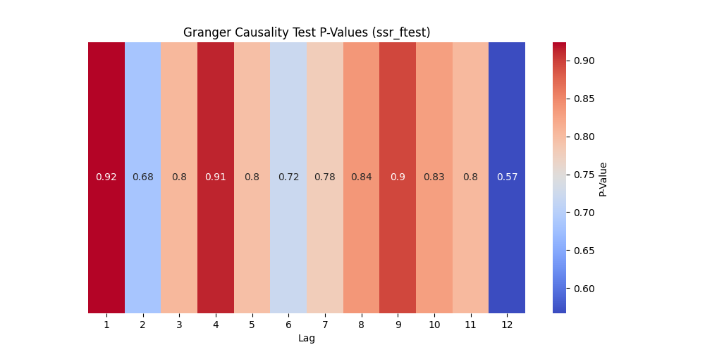

Figure13 Granger Test P-values

It is evident from the graph that the p-values for lags 1-12 are all greater than 0.05. Therefore, we cannot reject the null hypothesis, indicating that ZH Sales volume is not the Granger cause of Global traditional energy vehicle sales. This implies that there is no causal relationship between the two, and statistically, Sales-volume is not significant in relation to Global traditional energy vehicle sales. Consequently, Sales-volume cannot predict Global traditional energy vehicle sales, meaning that Sales-volume essentially does not impact Global traditional energy vehicle sales..

(Three) Cross-examination results and analysis

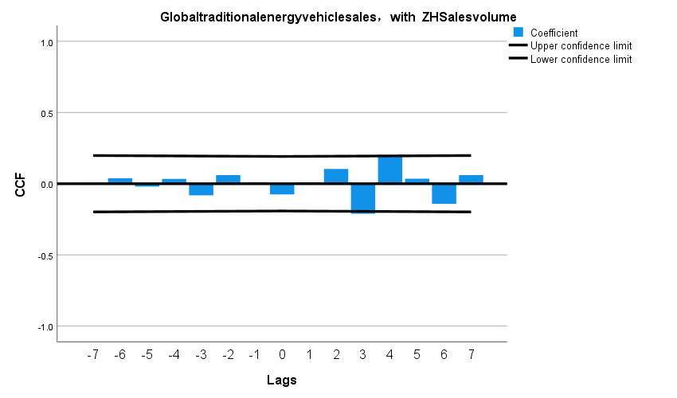

Figure14 Cross-validation results (after difference)

It can be seen from the figure that the correlation coefficients of all lag orders are almost close to zero and are within the confidence interval, which means that there is no obvious linear correlation between the two time series at these lag orders. This is consistent with the previous Granger causality test results, both indicating that there is no significant linear relationship or causal relationship between ZH Sales volume and Global traditional energy vehicle sales.

(Four) Comprehensive Analysis and Inference

From a statistical perspective, there is neither a causal relationship nor a significant linear relationship between ZH Sales Volume and Global Traditional Energy Vehicle Sales. This means that based on the current data and the statistical methods used, changes in ZH Sales Volume cannot effectively predict changes in Global Traditional Energy Vehicle Sales, and vice versa.

## 4.4 Question Four

4.4.1 Model Establishment

In order to explore the impact of other countries' policies on the development of new energy electric vehicles in China, we searched for relevant policies, analyzed the development of China's new energy electric vehicle sales before the implementation of the policy, and established a reasonable model to predict the development of new energy electric vehicles in the absence of this policy. Under the conditions of China's new energy electric vehicle sales, compare with real data to analyze the specific impact of this policy on China's new energy electric vehicle sales.

Among them, time series models can still be used for data prediction. At the same time, considering that it is difficult to obtain the actual value from the data after the difference, the data before the difference is selected.

Time series prediction models include the following:

(1) Winters' Multiplicative Model

See the formula (17) and (21) in Question two.

1. Winters' Additive Model

Here, m represents the length of the cycle, is the smoothing parameter for the level, is the smoothing parameter for the trend, is the smoothing parameter for the seasonality, and is the forecast value for period h.

(3) *SARIMA(p,d,q) (P,D,Q)m Model*

See the formula (18) and (22) in Question two.

4.4.2 Model Solution and Results

Taking the policy of 'The United States raising the import tariff on Chinese new energy vehicles by 27.5%' as an example, we analyze the impact of this policy on the development of China's new energy electric vehicles, where the sales volume of China's new energy electric vehicles is used to reflect the development situation. For the impact of other policies, see the detailed process in Appendix II.

**Step1**: Create a time series graph.

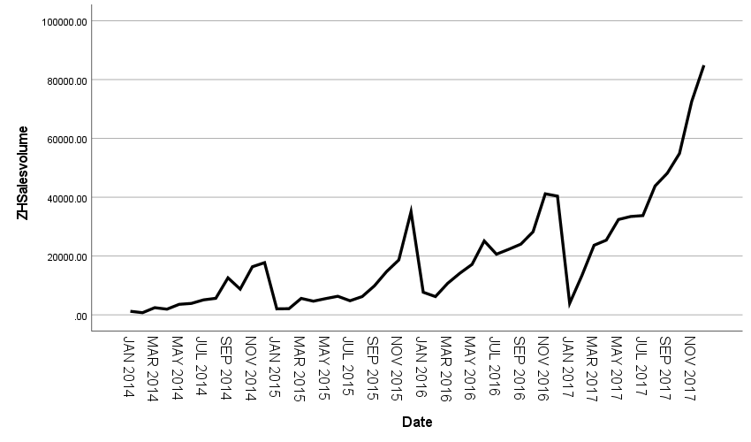

Figure15 A time series plot of sales under the influence of U.S. policy

The graph shows that, overall, the sales volume exhibits a clear upward trend, gradually increasing from a lower level in 2014 to a peak in 2017. From a cyclical perspective, the sales of China's new energy vehicles generally follow an annual cycle. In terms of seasonality, there are seasonal variations in sales volume, with the highest sales occurring at the end of the year, falling to the lowest at the beginning of the year, and then gradually increasing, forming another peak at the end of the next year.

**Step2:** Seasonal Decomposition

Based on the description of the time series graph above, since the sales volume shows a clear upward trend, using a multiplicative model would be more accurate. The specific decomposition is shown in the following table,

Table15 Seasonal factors obtained by multiplicative decomposition of sales volume (2014.1-2017.12)

|  |  |  |  |
| --- | --- | --- | --- |
| Cycle | Seasonal factor（%） | Cycle | Seasonal factor（%） |
| 1 | 27.1 | 7 | 77.5 |
| 2 | 39.1 | 8 | 84.3 |
| 3 | 74.9 | 9 | 109.7 |
| 4 | 77.4 | 10 | 123.3 |
| 5 | 86.8 | 11 | 171.5 |
| 6 | 91.1 | 12 | 237.4 |

The table shows that the seasonal factors for September to December are greater than 1, while those for January to August are less than 1. This indicates that the average sales volume before differencing from September to December is higher than from January to August. Specifically, the average sales volume in December is 237.4% higher than the annual average, while January's average sales are 27.1% below the annual average. The average sales in February are 39.1% below the annual average. In March, the average sales are 74.9% below the annual average. April's average sales are 77.4% below the annual average. May's average sales are 86.8% below the annual average. June's average sales are 91.1% below the annual average. July's average sales are 77.5% below the annual average. August's average sales are 84.3% below the annual average. December's average sales are 109.7% above the annual average. October's average sales are 123.3% above the annual average. November's average sales are 171.5% above the annual average.

**Step3:** Decomposed timing diagram

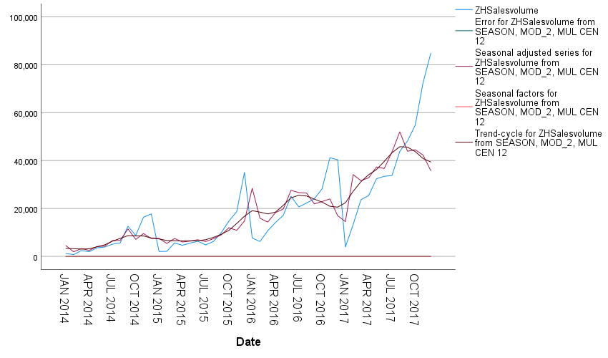

Figure16 A broken down time series diagram of sales volume under the influence of U.S. policy

The sales forecast value of the figure under the influence of the policy

The graph shows that the red line represents the seasonally adjusted sales volume, which eliminates the impact of seasonal factors, providing a clearer view of the long-term upward trend and cyclical fluctuations beyond seasonal factors. The purple line represents the seasonal factors, showing that sales volume increases with the months of the year. The dark blue line represents the trend-cycle component, also indicating a long-term upward trend and cyclical changes. The residual values are almost zero, suggesting that the model simulation results are good.

**Step 4:** Establish a Time Series Analysis Model

Using SPSS software for expert modeling, the model type obtained is Winters' Additive. The data is (29) then inputted into the model

**Step5:** White noise residual test

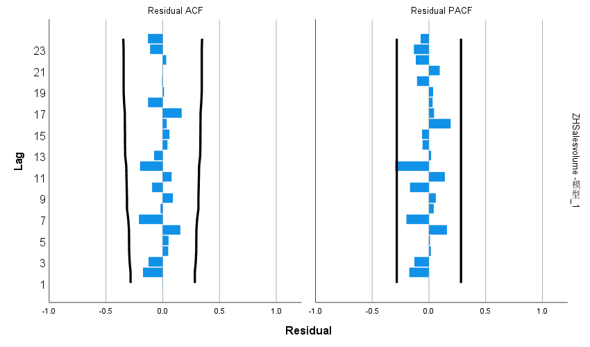

Figure17 Residual test plot

Table16 Winters' Additive model statistics table

|  |  |  |  |  |  |
| --- | --- | --- | --- | --- | --- |
| Number of predictors | Model fit statistics: Stationary R-squared | Statistics | DF | Significance | Number of outliers |
| 0 | 0.609 | 15.133 | 15 | 0.442 | 0 |

The graph and table show that the stationary R-squared is 0.609, indicating that the model has a relatively high degree of fit to the sales volume data, meaning the model can effectively explain the changes in sales volume. The number of outliers is 0, suggesting that there are no values with significant deviations from the model's predictions. The p-value obtained from the Q test for residuals is 0.442, which does not allow us to reject the null hypothesis. Therefore, it is considered that the residuals are a white noise series, indicating that the additive model can accurately identify the sales data in this problem.

**Step6:** Predict future indicator values

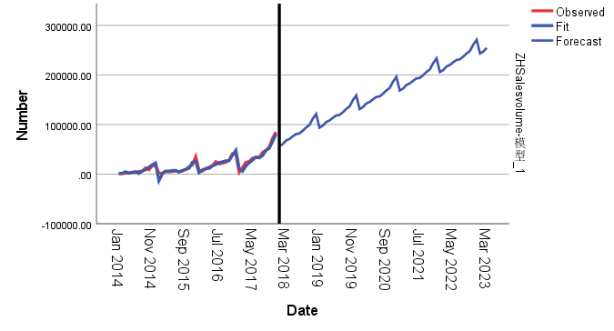

Figure18 Forecast graphs

The graph indicates that the upward trend of the forecast line depicts a pattern of sustained growth, suggesting that if current conditions or policies remain unchanged, the expected quantity metric will continue to rise. This implies that the policy may have a significant promotional effect on the development of China's new energy electric vehicles.

**Step7:** Compared with predicted data and actual values

Table17 The comparison of predictive values and actual values under the influence of US policy

|  |  |  |
| --- | --- | --- |
|  | Predictive value (unsuccessful) | Actual value (with policy) |
| Jan-18 | 56427.44 | 22367 |
| Feb-18 | 60510.48 | 21315 |
| Mar-18 | 67721.3 | 46217 |
| Apr-18 | 70853.11 | 55318 |
| … | … | … |
| Mar-23 | 254636.51 | 396672 |

It can be seen from the table that the sales volume of no policies is always higher than the volume of policy sales, indicating that the policy has inhibited the sales quantity; but from the perspective of long -term trends, the sales volume is gradually increasing, indicating that it may be affected by other factors. Promote the growth of sales.

## 4.5 Question Five

4.5.1 Model Establishment

For this question, the study primarily aims to demonstrate the ecological benefits of the popularization of new energy electric vehicles by establishing a reasonable model to simulate the reduction in carbon emissions due to electrification in urban transport.

To build the model, relevant factors that need to be considered include the city's transportation demand, which involves urban population, per capita trips, and kilometers traveled per trip; modes of transportation, which include the proportion of total kilometers traveled by private cars, the proportion of total kilometers traveled by buses, etc.; the degree of electrification, which includes the proportion of new energy electric vehicles in total private cars, the proportion of electric buses in all buses, the share of fuel in the total transportation energy, the share of electricity in the total transportation energy, carbon emission values, etc. Moreover, the above factors satisfy the following relationship,

The total kilometers traveled is

The number of kilometers traveled by private cars is

The number of kilometers traveled by public transportation is

The mileage traveled by a fuel vehicle is

The number of kilometers traveled by electric vehicles is

The adjusted power consumption of electric vehicles is

The carbon dioxide emissions of fuel vehicles are

The amount of carbon dioxide emitted by new energy vehicles due to charging losses is

The net emission reduction is

4.5.2 Model Solution and Results

It can be seen from the meaning of the question that the urban population is 1 million, recorded as P = 1,000,000. Based on the information reviewed, the following reasonable assumptions are made:

(1) Assume that the average number of trips per person per day is 3 times, recorded as T =3;

(2) Assume that the average trip length is 10 kilometers, recorded as L=10km;

(3) Using the conventional 365 days in a year, recorded as D = 365;

(4) Private car trips account for 50% of all trips, recorded as ;

(5) Electric private cars account for 50% of all private cars, recorded as ;

(6) Public transportation accounts for 30% of all trips, recorded as ;

(7) Electric buses account for 50% of all public transportation, recorded as ;

(8) The CO2 emissions per kilometer of fuel vehicles are 2.3 kilograms, recorded as ; the CO2 emissions per kWh of non-renewable energy sources are 0.475 kilograms, recorded as .

(9) Renewable energy accounts for 26% of the electricity supply, recorded as

(10) The energy loss rate during the charge and discharge process is 5%, recorded as .

Substituting the above data into the formula (31)-(39), the result is 845340 tons.

## Question Six

Dear citizens:

I am writing this letter to everyone to promote the benefits of new energy electric vehicles to our environmental protection and global economic development. As people's awareness of environmental protection gradually increases, environmental protection and sustainable development have increasingly become what people look forward to. The development and promotion of new energy electric vehicles in today's era is not only a symbol of technological progress, but also a driver of economic development and a key force in promoting environmental change. I firmly believe that we can make the most of this opportunity to create a greener and more sustainable future for our cities, our country, and the world.

According to our simulation studies, if our cities could electrify transportation in the short term, up to 845,340 tons of CO2 emissions could be reduced within a year. This number is not just a bunch of cold data, it represents our firm commitment to improving air quality, raising living standards, and protecting the natural environment. It is our concrete action to leave a better environment for future generations.。

In addition to environmental protection, the electric vehicle industry has created huge economic value globally. This industry not only directly creates millions of jobs, but also indirectly promotes the development of a series of related industries. From battery production to vehicle assembly to the construction of charging infrastructure, every aspect of the electric vehicle industry contributes considerable growth momentum to the global economy. For example, in many countries such as the United States, China, and Europe, governments are actively investing in this field to promote economic development and industrial upgrading. At the same time, the development of electric vehicles has also spawned new business models and innovative enterprises, providing traditional automobile manufacturers with opportunities for transformation and upgrading.

Of course, to realize the grand blueprint of making the new energy electric vehicle industry flourish and make the world a better place, we need your support and participation. Whether it's by buying an electric vehicle, supporting policy, providing industry advice, or spreading the word about the benefits of electric vehicles, every choice and action you make matters to our shared purpose. Every citizen who uses an electric vehicle is an important promoter of this change and is contributing to a cleaner and more sustainable future. Let us work together towards a fresher, greener and more dynamic future.

Thank you for taking the time out of your busy schedule to read this letter. I firmly believe that as long as we work together, there is no problem that we cannot solve. Let us move towards a brighter future together.

Sincerely

# 5.Evaluation of the Model

## 5.1 Advantages of the Model

The application of Granger causality tests and cross-correlation tests effectively detects whether there are causal or linear relationships between different time series.

The use of time series models takes into account long-term trends, seasonal factors, and cyclical elements, enabling effective prediction of the sales volume of new energy electric vehicles over the next 10 years.

## 5.2 Disadvantages of the Model

Cross-correlation tests cannot determine if there are relationships other than linear relationships, such as logarithmic relationships, between different time series.

When considering the impact of policies, the factors considered are relatively singular, which may amplify the impact of policy factors. Also, other variables may not fully control the outcome, possibly leading to biased results.

## 5.3 Extension of the Model

The model developed in this study can simulate and predict the future changes of an entity over a certain period.

It can analyze whether there is an impact between different entities and provide certain explanations.

# References

[1]SAID E. SAID, DAVID A. DICKEY, Testing for unit roots in autoregressive-moving average models of unknown order, Biometrika, Volume 71, Issue 3, December 1984, Pages 599–607, https://doi.org/10.1093/biomet/71.3.599

[2]Shojaie A, Fox EB. Granger Causality: A Review and Recent Advances. Annu Rev Stat Appl. 2022 Mar;9(1):289-319. doi: 10.1146/annurev-statistics-040120-010930. Epub 2021 Nov 17. PMID: 37840549; PMCID: PMC10571505.

[3]Natalia Bailey, George Kapetanios & M. Hashem Pesaran (2016): "Exponent of Cross‐Sectional Dependence: Estimation and Inference," Journal of Applied Econometrics, John Wiley & Sons, Ltd., vol. 31(6), pages 929-960, September

[4]潘慧峰,袁军. Granger因果检验的文献回顾[J]. 科学决策,2016(9):58-94. DOI:10.3773/j.issn.1006-4885.2016.09.058.

[5] M. Hashem Pesaran, 2021. "General diagnostic tests for cross-sectional dependence in panels," Empirical Economics, Springer, vol. 60(1), pages 13-50, January.

[6] 张树京, 齐立心. 时间序列分析简明教程[M]. 清华大学出版社有限公司, 2003.

[7] Greene, W. H. (2002). Econometric Analysis (Fifth ed.). New Jersey: Prentice Hall. ISBN 0-13-066189-9.[

[8] 孙靖, 程大章. 基于季节性时间序列模型的空调负荷预测[J]. 电工技术学报, 2004, 19(3): 88293.

[9] 张蔚, 张彦琦, 杨旭. 时间序列资料 ARIMA 季节乘积模型及其应用[J]. 第三军医大学学报, 2002, 24(8): 955-957.

# Appendix

## 1 Support Material

Problem1

Problem2

Problem3

Problem4

DATA

Descriptive Statistics

Differential data

YearDate

## 2 Appendix I

Table18 data after difference

|  |  |  |  |  |  |  |  |
| --- | --- | --- | --- | --- | --- | --- | --- |
| **Date** | **Sales volume** | **Number of public charging piles_Nationwide (cumulative)** | **GDP(month)** | **Battery capacity (km)** | **Maximum speed (km/h)** | **R&D expenses** | **Amount involved (yuan)** |
| **2014.3** | 2183 | 0 | 0 | 1 | 0 | 0 | 36060379 |
| **2014.4** | -2216 | 0.01 | 0 | 1 | 0 | 0 | 46206485 |
| **2014.5** | 2156 | -0.01 | 0 | 1 | 0 | 0 | -82266864 |
| **2014.6** | -1336 | 0 | 0 | 1 | 0 | 0 | 0 |
| **2014.7** | 898 | 0 | 0 | 1 | 0 | 0 | 58568793 |
| **2014.8** | -682 | 0 | 0 | 1 | 0 | 0 | 324923963 |
| **2014.9** | 6437 | 0 | 0 | 1 | 0 | 0 | -383492756 |
| **2014.10** | -10798 | 0.01 | 0 | 1 | 0 | 0 | 0 |
| **2014.11** | 11446 | -0.01 | 0 | 1 | 0 | 0 | 10000000 |
| **2014.12** | -6228 | 0 | 0 | 150 | 49 | 0 | -10000000 |
| **2015.1** | -17091 | -263.51 | -0.015210086 | 0 | 0 | 192795104.6 | 10155700 |
| **2015.2** | 15776 | -0.01 | 0 | 0 | 0 | 0 | 69810048 |
| **2015.3** | 3424 | 0.01 | 0 | 0 | 0 | 0 | 47159838 |
| **2015.4** | -4438 | 0 | 0 | 0 | 0 | 0 | -76886486 |
| **2015.5** | 1819 | -0.01 | 0 | 0 | 0 | 0 | -50239100 |
| **2015.6** | -77 | 0.01 | 0 | 0 | 0 | 0 | 0 |
| **2015.7** | -2320 | 0 | 0 | 0 | 0 | 0 | 231669228 |
| **2015.8** | 2950 | -0.01 | 0 | 0 | 0 | 0 | -42401993 |
| **2015.9** | 2218 | 0.01 | 0 | 0 | 0 | 0 | -189267235 |
| **2015.10** | 1221 | 0 | 0 | 0 | 0 | 0 | 0 |
| **2015.11** | -925 | -0.01 | 0 | 0 | 0 | 0 | 69580000 |
| **2015.12** | 12465 | 0.01 | 0 | 0 | 0 | 0 | -69580000 |
| **2016.1** | -43792 | -1905.17 | 0.005303971 | 0 | 0 | 34299061.59 | 533819707 |
| **2016.2** | 25910 | 0 | 0 | 0 | 0 | 0 | -434819707 |
| **2016.3** | 5979 | 4574.5 | 0 | 0 | 0 | 0 | 1000000 |
| **2016.4** | -1068 | 2101 | 0 | 0 | 0 | 0 | -16261500 |
| **2016.5** | -425 | -1849 | 0 | 0 | 0 | 0 | -83738500 |
| **2016.6** | 4966 | -1192 | 0 | 0 | 0 | 0 | 536800000 |
| **2016.7** | -12480 | -389 | 0 | 0 | 0 | 0 | -290809277 |
| **2016.8** | 6151 | 3206 | 0 | 0 | 0 | 0 | -46493446 |
| **2016.9** | 131 | 2912 | 0 | 0 | 0 | 0 | -148247277 |
| **2016.1** | 2424 | -5152 | 0 | 0 | 0 | 0 | -51250000 |
| **2016.11** | 8707 | 3971 | 0 | 0 | 0 | 0 | 262644524 |
| **2016.12** | -13697 | 16768 | 0 | 0 | 0 | 0 | -262644524 |
| **2017.1** | -35658 | -18480 | -0.004180212 | 0 | 0 | 203637954.4 | 0 |
| **2017.2** | 45857 | -4156 | 0 | 0 | 0 | 0 | 7480592 |
| **2017.3** | 921 | 2304 | 0 | 0 | 0 | 0 | -7480592 |
| **2017.4** | -8595 | -129 | 0 | 0 | 0 | 0 | 46742431 |
| **2017.5** | 5288 | 752 | 0 | 0 | 0 | 0 | -33349108 |
| **2017.6** | -6004 | -1090 | 0 | 0 | 0 | 0 | -13393323 |
| **2017.7** | -705 | 4412 | 0 | 0 | 0 | 0 | 11235500 |
| **2017.8** | 9760 | -3769 | 0 | 0 | 0 | 0 | 584720756 |
| **2017.9** | -5740 | -737 | 0 | 0 | 0 | 0 | -595956256 |
| **2017.1** | 2377 | -534 | 0 | 0 | 0 | 0 | 10306470.25 |
| **2017.11** | 10976 | 6100 | 0 | 0 | 0 | 0 | -10306470.25 |
| **2017.12** | -5383 | -961 | 0 | 0 | 0 | 0 | 61989705.37 |
| **2018.1** | -74825 | 1994 | -0.056365308 | 0 | 0 | 541676132.4 | -5469705.37 |
| **2018.2** | 61468 | 7784 | 0 | 0 | 0 | 0 | -56520000 |
| **2018.3** | 25954 | -9901 | 0 | 0 | 0 | 0 | 60200000 |
| **2018.4** | -15801 | -67 | 0 | 0 | 0 | 0 | -38226268.69 |
| **2018.5** | 652 | -4811 | 0 | 0 | 0 | 0 | -8313104.31 |
| **2018.6** | -23205 | 1347 | 0 | 0 | 0 | 0 | -13660627 |
| **2018.7** | 12044 | -2494 | 0 | 0 | 0 | 0 | 0 |
| **2018.8** | 13610 | 933 | 0 | 0 | 0 | 0 | 6869726 |
| **2018.9** | 5399 | 1957 | 0 | 0 | 0 | 0 | 106926649.7 |
| **2018.1** | -3523 | -5930 | 0 | 0 | 0 | 0 | 14152075.6 |
| **2018.11** | 664 | 5100 | 0 | 0 | 0 | 0 | -95698460.16 |
| **2018.12** | 11230 | 4942 | 0 | 0 | 0 | 0 | 389943571.1 |
| **2019.1** | -95978 | 31985 | -0.298313235 | 65 | 151 | 287350305.5 | -268361659.4 |
| **2019.2** | 41504 | -36154 | 0 | 0 | 0 | 0 | 297497463.3 |
| **2019.3** | 76741 | 30088 | 0 | 0 | 0 | 0 | -343621439 |
| **2019.4** | -68652 | -28483 | 0 | 0 | 0 | 0 | 813522033.2 |
| **2019.5** | 31133 | 2194 | 0 | 0 | 0 | 0 | -590017473.3 |
| **2019.6** | 29846 | 1268 | 0 | 0 | 0 | 0 | -16636462.88 |
| **2019.7** | -107861 | 24095 | 0 | 0 | 0 | 0 | 32547265.55 |
| **2019.8** | 82440 | -25853 | 0 | 0 | 0 | 0 | 2575909869 |
| **2019.9** | -22196 | 1125 | 0 | 0 | 0 | 0 | -2717382822 |
| **2019.1** | 725 | 1738 | 0 | 0 | 0 | 0 | -159765353.4 |
| **2019.11** | 19411 | 5339 | 0 | 0 | 0 | 0 | 1416302434 |
| **2019.12** | 28973 | 3524 | 0 | 0 | 0 | 0 | 1908219839 |
| **2020.1** | -117815 | -6172 | 0.529597639 | 0 | 0 | -78057283.65 | -1906332929 |
| **2020.2** | 55779 | -14527 | 0 | 0 | 0 | 0 | -1464074327 |
| **2020.3** | 45206 | 10164 | 0 | 0 | 0 | 0 | 180357421.4 |
| **2020.4** | -16653 | -5267 | 0 | 0 | 0 | 0 | 1267137616 |
| **2020.5** | 5579 | -1268 | 0 | 0 | 0 | 0 | -409093393 |
| **2020.6** | 317 | 4010 | 0 | 0 | 0 | 0 | -396984203 |
| **2020.7** | -16654 | -8 | 0 | 0 | 0 | 0 | -390051015.8 |
| **2020.8** | 12369 | 17905 | 0 | 0 | 0 | 0 | 55128846.04 |
| **2020.9** | 10037 | -11719 | 0 | 0 | 0 | 0 | -120051672.1 |
| **2020.1** | 1407 | 46540 | 0 | 0 | 0 | 0 | 280345826.6 |
| **2020.11** | 11148 | -31904 | 0 | 0 | 0 | 0 | -186388326 |
| **2020.12** | 1578 | 83559 | 0 | 0 | 0 | 0 | -115023609.3 |
| **2021.1** | -79629 | -108702 | -0.445536079 | 0 | 0 | 105624258.8 | -132035919 |
| **2021.2** | -9231 | 22941 | 0 | 0 | 0 | 0 | -13250209.8 |
| **2021.3** | 141518 | -13205 | 0 | 0 | 0 | 0 | 76033838.1 |
| **2021.4** | -105078 | 4390 | 0 | 0 | 0 | 0 | 608923709.6 |
| **2021.5** | 25904 | -1443 | 0 | 0 | 0 | 0 | -367670959.9 |
| **2021.6** | 26314 | 22784 | 0 | 0 | 0 | 0 | 109674331.9 |
| **2021.7** | -45702 | -11883 | 0 | 0 | 0 | 0 | -369518693.4 |
| **2021.8** | 51363 | 7296 | 0 | 0 | 0 | 0 | 1129379316 |
| **2021.9** | 24080 | 25097 | 0 | 0 | 0 | 0 | -1054345625 |
| **2021.1** | -92811 | -41482 | 0 | 0 | 0 | 0 | 589253429 |
| **2021.11** | 89452 | 11544 | 0 | 0 | 0 | 0 | -600609566.5 |
| **2021.12** | 34538 | 25531 | 0 | 0 | 0 | 0 | 380210841.3 |
| **2022.1** | -225825 | -24489 | 0.249994436 | 0 | 0 | -307909558 | -511821983.3 |
| **2022.2** | 58906 | 4965 | 0 | 0 | 0 | 0 | 176096657.3 |
| **2022.3** | 224086 | -16819 | 0 | 0 | 0 | 0 | 2235681620 |
| **2022.4** | -309776 | 81654 | 0 | 0 | 0 | 0 | -1380484040 |
| **2022.5** | 245077 | -28219 | 0 | 0 | 0 | 0 | -986460318.8 |
| **2022.6** | 53510 | 51322 | 0 | 0 | 0 | 0 | 768296784.8 |
| **2022.7** | -212110 | -76303 | 0 | 0 | 0 | 0 | -412107898.5 |
| **2022.8** | 116094 | 1075 | 0 | 0 | 0 | 0 | 525577534.7 |
| **2022.9** | 16025 | -35749 | 0 | 0 | 0 | 0 | -816355775.4 |
| **2022.1** | -127350 | 31473 | 0 | 0 | 0 | 0 | -40049580.71 |
| **2022.11** | 113769 | 7509 | 0 | 0 | 0 | 0 | 46436004.13 |
| **2022.12** | -31399 | 14689 | 0 | 0 | 0 | 0 | 1244753184 |
| **2023.1** | -268055 | -25155 | -0.058685833 | 0 | 0 | 4168388289 | -721261158.1 |
| **2023.2** | 344587 | -10093 | 0 | 0 | 0 | 0 | 1540000767 |
| **2023.3** | -8327 | 0 | 0 | 0 | 0 | 0 | -951559004.8 |

Table19 Forecast Sales Volume

|  |  |
| --- | --- |
| Date | Forecast sales |
| 2023.4 | 216157.6 |
| 2023.5 | 285915.7 |
| 2023.6 | 417609.3 |
| 2023.7 | 377812.5 |
| 2023.8 | 443106.6 |
| 2023.9 | 529353.6 |
| 2023.10 | 468728.6 |
| 2023.11 | 542069.1 |
| 2023.12 | 649249.4 |
| 2024.1 | 333740.3 |
| 2024.2 | 307533.3 |
| 2024.3 | 439496.9 |
| 2024.4 | 237199.2 |
| 2024.5 | 313523.9 |
| 2024.6 | 457612 |
| 2024.7 | 413716.5 |
| 2024.8 | 484884.7 |
| 2024.9 | 578874.3 |
| 2024.10 | 512238.7 |
| 2024.11 | 592000.9 |
| 2024.12 | 708598.3 |
| 2025.1 | 364017.4 |
| 2025.2 | 335223.6 |
| 2025.3 | 478774.3 |
| 2025.4 | 258240.8 |
| 2025.5 | 341132.1 |
| 2025.6 | 497614.6 |
| 2025.7 | 449620.4 |
| 2025.8 | 526662.7 |
| 2025.9 | 628395.1 |
| 2025.1 | 555748.9 |
| 2025.11 | 641932.6 |
| 2025.12 | 767947.2 |
| 2026.1 | 394294.4 |
| 2026.2 | 362913.8 |
| 2026.3 | 518051.8 |
| 2026.4 | 279282.4 |
| 2026.5 | 368740.3 |
| 2026.6 | 537617.3 |
| 2026.7 | 485524.4 |
| 2026.8 | 568440.8 |
| 2026.9 | 677915.8 |
| 2026.1 | 599259 |
| 2026.11 | 691864.4 |
| 2026.12 | 827296.1 |
| 2027.1 | 424571.5 |
| 2027.2 | 390604 |
| 2027.3 | 557329.3 |
| 2027.4 | 300324 |
| 2027.5 | 396348.4 |
| 2027.6 | 577620 |
| 2027.7 | 521428.3 |
| 2027.8 | 610218.9 |
| 2027.9 | 727436.5 |
| 2027.1 | 642769.1 |
| 2027.11 | 741796.1 |
| 2027.12 | 886645 |
| 2028.1 | 454848.6 |
| 2028.2 | 418294.3 |
| 2028.3 | 596606.8 |
| 2028.4 | 321365.6 |
| 2028.5 | 423956.6 |
| 2028.6 | 617622.7 |
| 2028.7 | 557332.3 |
| 2028.8 | 651996.9 |
| 2028.9 | 776957.3 |
| 2028.1 | 686279.2 |
| 2028.11 | 791727.9 |
| 2028.12 | 945993.9 |
| 2029.1 | 485125.7 |
| 2029.2 | 445984.5 |
| 2029.3 | 635884.3 |
| 2029.4 | 342407.2 |
| 2029.5 | 451564.8 |
| 2029.6 | 657625.3 |
| 2029.7 | 593236.2 |
| 2029.8 | 693775 |
| 2029.9 | 826478 |
| 2029.1 | 729789.3 |
| 2029.11 | 841659.6 |
| 2029.12 | 1005343 |
| 2030.1 | 515402.8 |
| 2030.2 | 473674.7 |
| 2030.3 | 675161.8 |
| 2030.4 | 363448.8 |
| 2030.5 | 479172.9 |
| 2030.6 | 697628 |
| 2030.7 | 629140.2 |
| 2030.8 | 735553.1 |
| 2030.9 | 875998.8 |
| 2030.1 | 773299.4 |
| 2030.11 | 891591.4 |
| 2030.12 | 1064692 |
| 2031.1 | 545679.9 |
| 2031.2 | 501365 |
| 2031.3 | 714439.3 |
| 2031.4 | 384490.4 |
| 2031.5 | 506781.1 |
| 2031.6 | 737630.7 |
| 2031.7 | 665044.1 |
| 2031.8 | 777331.2 |
| 2031.9 | 925519.5 |
| 2031.1 | 816809.5 |
| 2031.11 | 941523.1 |
| 2031.12 | 1124041 |
| 2032.1 | 575957 |
| 2032.2 | 529055.2 |
| 2032.3 | 753716.8 |
| 2032.4 | 405532 |
| 2032.5 | 534389.3 |
| 2032.6 | 777633.4 |
| 2032.7 | 700948.1 |
| 2032.8 | 819109.2 |
| 2032.9 | 975040.2 |
| 2032.1 | 860319.6 |
| 2032.11 | 991454.9 |
| 2032.12 | 1183390 |
| 2033.1 | 606234 |
| 2033.2 | 556745.5 |
| 2033.3 | 792994.3 |

Table20 Question 3 Standardization of original data

|  |  |  |  |  |  |
| --- | --- | --- | --- | --- | --- |
| **Date** | **ZH Sales volume** | **Market Share** | **Global traditional energy vehicle sales** | **Global Pure electric sales** | **Plug-in sales** |
| 2014.1 | -0.808059835 | -1.039871221 | 0.15519562 | -0.96707796 | -1.02898148 |
| 2014.2 | -0.811828572 | -1.039871221 | 0.15519562 | -0.962566073 | -1.027695389 |
| 2014.3 | -0.798349611 | -1.039871221 | 0.15519562 | -0.958054187 | -1.026409298 |
| 2014.4 | -0.802379077 | -1.039871221 | 0.15519562 | -0.953542301 | -1.025123207 |
| 2014.5 | -0.789374171 | -1.039871221 | 0.15519562 | -0.949030414 | -1.023837115 |
| 2014.6 | -0.786924887 | -1.039871221 | 0.15519562 | -0.944518528 | -1.022551024 |
| 2014.7 | -0.777380582 | -1.039871221 | 0.15519562 | -0.940006641 | -1.021264933 |
| 2014.8 | -0.7732247 | -1.039871221 | 0.15519562 | -0.935494755 | -1.019978842 |
| 2014.9 | -0.718210628 | -1.039871221 | 0.15519562 | -0.930982869 | -1.018692751 |
| 2014.1 | -0.748510638 | -1.039871221 | 0.15519562 | -0.926470982 | -1.017406659 |
| 2014.11 | -0.688376772 | -1.039871221 | 0.15519562 | -0.921959096 | -1.016120568 |
| 2014.12 | -0.677449807 | -1.039871221 | 0.15519562 | -0.91744721 | -1.014834477 |
| 2015.1 | -0.801557382 | -0.836292919 | 0.354453585 | -0.910413578 | -0.996601855 |
| 2015.2 | -0.80102012 | -0.836292919 | 0.354453585 | -0.903379947 | -0.978369233 |
| 2015.3 | -0.773430124 | -0.836292919 | 0.354453585 | -0.896346316 | -0.960136611 |
| 2015.4 | -0.78090439 | -0.836292919 | 0.354453585 | -0.889312684 | -0.941903989 |
| 2015.5 | -0.774006891 | -0.836292919 | 0.354453585 | -0.882279053 | -0.923671367 |
| 2015.6 | -0.767717762 | -0.836292919 | 0.354453585 | -0.875245422 | -0.905438744 |
| 2015.7 | -0.779758757 | -0.836292919 | 0.354453585 | -0.86821179 | -0.887206122 |
| 2015.8 | -0.768492052 | -0.836292919 | 0.354453585 | -0.861178159 | -0.8689735 |
| 2015.9 | -0.739701117 | -0.836292919 | 0.354453585 | -0.854144528 | -0.850740878 |
| 2015.1 | -0.701263165 | -0.836292919 | 0.354453585 | -0.847110896 | -0.832508256 |
| 2015.11 | -0.670133559 | -0.836292919 | 0.354453585 | -0.840077265 | -0.814275634 |
| 2015.12 | -0.540519046 | -0.836292919 | 0.354453585 | -0.833043634 | -0.796043012 |
| 2016.1 | -0.75690141 | -0.760660413 | 0.928154446 | -0.825414153 | -0.787111692 |
| 2016.2 | -0.768571061 | -0.760660413 | 0.928154446 | -0.817784672 | -0.778180373 |
| 2016.3 | -0.733001141 | -0.760660413 | 0.928154446 | -0.810155192 | -0.769249053 |
| 2016.4 | -0.705869399 | -0.760660413 | 0.928154446 | -0.802525711 | -0.760317734 |
| 2016.5 | -0.682095545 | -0.760660413 | 0.928154446 | -0.79489623 | -0.751386414 |
| 2016.6 | -0.619085746 | -0.760660413 | 0.928154446 | -0.78726675 | -0.742455095 |
| 2016.7 | -0.654679369 | -0.760660413 | 0.928154446 | -0.779637269 | -0.733523775 |
| 2016.8 | -0.641674463 | -0.760660413 | 0.928154446 | -0.772007788 | -0.724592456 |
| 2016.9 | -0.627634536 | -0.760660413 | 0.928154446 | -0.764378308 | -0.715661136 |
| 2016.1 | -0.594442792 | -0.760660413 | 0.928154446 | -0.756748827 | -0.706729817 |
| 2016.11 | -0.492457779 | -0.760660413 | 0.928154446 | -0.749119346 | -0.697798497 |
| 2016.12 | -0.498691601 | -0.760660413 | 0.928154446 | -0.741489865 | -0.688867178 |
| 2017.1 | -0.786656256 | -0.583990835 | 1.035630301 | -0.725926594 | -0.671612317 |
| 2017.2 | -0.712308644 | -0.583990835 | 1.035630301 | -0.710363323 | -0.654357456 |
| 2017.3 | -0.63068429 | -0.583990835 | 1.035630301 | -0.694800052 | -0.637102595 |
| 2017.4 | -0.616968301 | -0.583990835 | 1.035630301 | -0.679236781 | -0.619847734 |
| 2017.5 | -0.561472273 | -0.583990835 | 1.035630301 | -0.663673509 | -0.602592873 |
| 2017.6 | -0.553413339 | -0.583990835 | 1.035630301 | -0.648110238 | -0.585338012 |
| 2017.7 | -0.550924551 | -0.583990835 | 1.035630301 | -0.632546967 | -0.568083151 |
| 2017.8 | -0.471322831 | -0.583990835 | 1.035630301 | -0.616983696 | -0.55082829 |
| 2017.9 | -0.437072363 | -0.583990835 | 1.035630301 | -0.601420425 | -0.533573429 |
| 2017.1 | -0.384041421 | -0.583990835 | 1.035630301 | -0.585857154 | -0.516318568 |
| 2017.11 | -0.244290033 | -0.583990835 | 1.035630301 | -0.570293882 | -0.499063707 |
| 2017.12 | -0.147069272 | -0.583990835 | 1.035630301 | -0.554730611 | -0.481808846 |
| 2018.1 | -0.641034489 | -0.252008641 | 0.784612379 | -0.522964475 | -0.461288794 |
| 2018.2 | -0.649346251 | -0.252008641 | 0.784612379 | -0.491198339 | -0.440768743 |
| 2018.3 | -0.452597662 | -0.252008641 | 0.784612379 | -0.459432202 | -0.420248692 |
| 2018.4 | -0.380691433 | -0.252008641 | 0.784612379 | -0.427666066 | -0.39972864 |
| 2018.5 | -0.303633807 | -0.252008641 | 0.784612379 | -0.39589993 | -0.379208589 |
| 2018.6 | -0.409916918 | -0.252008641 | 0.784612379 | -0.364133793 | -0.358688537 |
| 2018.7 | -0.421041407 | -0.252008641 | 0.784612379 | -0.332367657 | -0.338168486 |
| 2018.8 | -0.32463444 | -0.252008641 | 0.784612379 | -0.300601521 | -0.317648434 |
| 2018.9 | -0.185570432 | -0.252008641 | 0.784612379 | -0.268835384 | -0.297128383 |
| 2018.1 | -0.074341348 | -0.252008641 | 0.784612379 | -0.237069248 | -0.276608332 |
| 2018.11 | 0.042133943 | -0.252008641 | 0.784612379 | -0.205303112 | -0.25608828 |
| 2018.12 | 0.247336512 | -0.252008641 | 0.784612379 | -0.173536976 | -0.235568229 |
| 2019.1 | -0.305774955 | 0.052032802 | 0.301269736 | -0.164196567 | -0.226545671 |
| 2019.2 | -0.530966839 | 0.052032802 | 0.301269736 | -0.154856159 | -0.217523113 |
| 2019.3 | -0.149834592 | 0.052032802 | 0.301269736 | -0.145515751 | -0.208500555 |
| 2019.4 | -0.311115974 | 0.052032802 | 0.301269736 | -0.136175343 | -0.199477997 |
| 2019.5 | -0.226418163 | 0.052032802 | 0.301269736 | -0.126834935 | -0.190455439 |
| 2019.6 | 0.094090362 | 0.052032802 | 0.301269736 | -0.117494527 | -0.181432881 |
| 2019.7 | -0.437601725 | 0.052032802 | 0.301269736 | -0.108154119 | -0.172410322 |
| 2019.8 | -0.317942365 | 0.052032802 | 0.301269736 | -0.098813711 | -0.163387764 |
| 2019.9 | -0.373651717 | 0.052032802 | 0.301269736 | -0.089473303 | -0.154365206 |
| 2019.1 | -0.423632907 | 0.052032802 | 0.301269736 | -0.080132895 | -0.145342648 |
| 2019.11 | -0.320249432 | 0.052032802 | 0.301269736 | -0.070792487 | -0.13632009 |
| 2019.12 | 0.012047259 | 0.052032802 | 0.301269736 | -0.061452079 | -0.127297532 |
| 2020.1 | -0.586502372 | 1.148029916 | -1.395203416 | -0.037602235 | -0.085642395 |
| 2020.2 | -0.744346855 | 1.148029916 | -1.395203416 | -0.013752392 | -0.043987259 |
| 2020.3 | -0.545022567 | 1.148029916 | -1.395203416 | 0.010097452 | -0.002332122 |
| 2020.4 | -0.47727222 | 1.148029916 | -1.395203416 | 0.033947296 | 0.039323015 |
| 2020.5 | -0.365442667 | 1.148029916 | -1.395203416 | 0.057797139 | 0.080978152 |
| 2020.6 | -0.251108523 | 1.148029916 | -1.395203416 | 0.081646983 | 0.122633289 |
| 2020.7 | -0.268356221 | 1.148029916 | -1.395203416 | 0.105496827 | 0.164288425 |
| 2020.8 | -0.187877499 | 1.148029916 | -1.395203416 | 0.12934667 | 0.205943562 |
| 2020.9 | -0.028097291 | 1.148029916 | -1.395203416 | 0.153196514 | 0.247598699 |
| 2020.1 | 0.142799504 | 1.148029916 | -1.395203416 | 0.177046357 | 0.289253836 |
| 2020.11 | 0.401775701 | 1.148029916 | -1.395203416 | 0.200896201 | 0.330908973 |
| 2020.12 | 0.673219543 | 1.148029916 | -1.395203416 | 0.224746045 | 0.37256411 |
| 2021.1 | 0.31552141 | 2.272761312 | -2.124153044 | 0.36457739 | 0.497821843 |
| 2021.2 | -0.11511007 | 2.272761312 | -2.124153044 | 0.504408736 | 0.623079576 |
| 2021.3 | 0.572380162 | 2.272761312 | -2.124153044 | 0.644240081 | 0.748337309 |
| 2021.4 | 0.429658031 | 2.272761312 | -2.124153044 | 0.784071427 | 0.873595042 |
| 2021.5 | 0.491601206 | 2.272761312 | -2.124153044 | 0.923902772 | 0.998852775 |
| 2021.6 | 0.761449062 | 2.272761312 | -2.124153044 | 1.063734117 | 1.124110508 |
| 2021.7 | 0.670209294 | 2.272761312 | -2.124153044 | 1.203565463 | 1.249368241 |
| 2021.8 | 0.984784232 | 2.272761312 | -2.124153044 | 1.343396808 | 1.374625974 |
| 2021.9 | 1.489613207 | 2.272761312 | -2.124153044 | 1.483228154 | 1.499883707 |
| 2021.1 | 1.261150343 | 2.272761312 | -2.124153044 | 1.623059499 | 1.62514144 |
| 2021.11 | 1.739440144 | 2.272761312 | -2.124153044 | 1.762890845 | 1.750399173 |
| 2021.12 | 2.490611753 | 2.272761312 | -2.124153044 | 1.90272219 | 1.875656906 |
| 2022.1 | 1.457559194 | 4.10271E-16 | -0.031967686 | 2.042553535 | 2.000914639 |
| 2022.2 | 0.889917943 | 4.10271E-16 | -0.031967686 | 1.902722516 | 1.875657768 |
| 2022.3 | 2.09276117 | 4.10271E-16 | -0.031967686 | 2.042553862 | 2.000915501 |
| 2022.4 | 0.848090498 | 4.10271E-16 | -0.031967686 | 1.902722842 | 1.87565863 |
| 2022.5 | 1.539752414 | 4.10271E-16 | -0.031967686 | 2.042554188 | 2.000916363 |
| 2022.6 | 2.654192301 | 4.10271E-16 | -0.031967686 | 1.902723168 | 1.875659492 |
| 2022.7 | 2.092769071 | 4.10271E-16 | -0.031967686 | 2.042554514 | 2.000917225 |
| 2022.8 | 2.448594686 | 4.10271E-16 | -0.031967686 | 1.902723494 | 1.875660354 |
| 2022.9 | 2.931032468 | 4.10271E-16 | -0.031967686 | 2.04255484 | 2.000918087 |
| 2022.1 | 2.407288702 | 4.10271E-16 | -0.031967686 | 1.90272382 | 1.875661216 |
| 2022.11 | 2.782424154 | 4.10271E-16 | -0.031967686 | 2.042555166 | 2.000918949 |
| 2022.12 | 2.909478771 | 4.10271E-16 | -0.031967686 | 1.902724146 | 1.875662078 |
| 2023.1 | 0.918653572 | 4.10271E-16 | -0.031967686 | 2.042555492 | 2.000919811 |
| 2023.2 | 1.650381028 | 4.10271E-16 | -0.031967686 | 1.902724472 | 1.87566294 |
| 2023.3 | 2.316317565 | 4.10271E-16 | -0.031967686 | 2.042555818 | 2.000920673 |

Table21: Differential data for question 3

|  |  |  |  |  |  |
| --- | --- | --- | --- | --- | --- |
| **Date** | **Global traditional energy vehicle sales** | **ZH Sales volume** | **Market Share** | **Global Pure electric sales** | **Plug-in sales** |
| **2014.3** | 0 | 0.017247698 | 0 | 1.11022E-16 | 2.22045E-16 |
| **2014.4** | 0 | -0.017508428 | 0 | -1.11022E-16 | 0 |
| **2014.5** | 0 | 0.017034373 | 0 | 1.11022E-16 | -2.22045E-16 |
| **2014.6** | 0 | -0.010555623 | 0 | -1.11022E-16 | 1.11022E-15 |
| **2014.7** | 0 | 0.007095022 | 0 | 0 | -8.88178E-16 |
| **2014.8** | 0 | -0.005388424 | 0 | 1.11022E-16 | -2.22045E-16 |
| **2014.9** | 0 | 0.050858191 | 0 | -1.11022E-16 | 2.22045E-16 |
| **2014.1** | 0 | -0.085314082 | 0 | 0 | 8.88178E-16 |
| **2014.11** | 0 | 0.090433875 | 0 | 1.11022E-16 | -8.88178E-16 |
| **2014.12** | 0 | -0.0492069 | 0 | -1.11022E-16 | -2.22045E-16 |
| **2015.1** | 0.199257964 | -0.135034541 | 0 | 0.002521745 | 0.016946531 |
| **2015.2** | 0 | 0.124644838 | 0.203578302 | -1.11022E-16 | -2.22045E-16 |
| **2015.3** | 0 | 0.027052734 | 0 | 1.11022E-16 | 2.22045E-16 |
| **2015.4** | 0 | -0.035064262 | 0 | -1.11022E-16 | 0 |
| **2015.5** | 0 | 0.014371765 | 0 | 1.11022E-16 | -2.22045E-16 |
| **2015.6** | 0 | -0.00060837 | 0 | 0 | 2.22045E-16 |
| **2015.7** | 0 | -0.018330123 | 0 | -1.11022E-16 | 0 |
| **2015.8** | 0 | 0.0233077 | 0 | 1.11022E-16 | -1.11022E-16 |
| **2015.9** | 0 | 0.01752423 | 0 | -1.11022E-16 | 1.11022E-16 |
| **2015.1** | 0 | 0.009647017 | 0 | 1.11022E-16 | 0 |
| **2015.11** | 0 | -0.007308347 | 0 | 0 | 0 |
| **2015.12** | 0 | 0.098484908 | 0 | -1.11022E-16 | -2.22045E-16 |
| **2016.1** | 0.573700861 | -0.345996877 | 0 | 0.000595849 | -0.009301303 |
| **2016.2** | 0 | 0.204712712 | 0.075632506 | 0 | 0 |
| **2016.3** | 0 | 0.047239572 | 0 | 0 | 1.11022E-16 |
| **2016.4** | 0 | -0.008438177 | 0 | 1.11022E-16 | -1.11022E-16 |
| **2016.5** | 0 | -0.003357889 | 0 | -1.11022E-16 | 0 |
| **2016.6** | 0 | 0.039235945 | 0 | 0 | 0 |
| **2016.7** | 0 | -0.098603421 | 0 | 0 | 1.11022E-16 |
| **2016.8** | 0 | 0.048598529 | 0 | 0 | -1.11022E-16 |
| **2016.9** | 0 | 0.00103502 | 0 | 0 | 0 |
| **2016.1** | 0 | 0.019151818 | 0 | 0 | 0 |
| **2016.11** | 0 | 0.068793268 | 0 | 0 | 1.11022E-16 |
| **2016.12** | 0 | -0.108218835 | 0 | 0 | -2.22045E-16 |
| **2017.1** | 0.107475856 | -0.281730833 | 0 | 0.00793379 | 0.008323541 |
| **2017.2** | 0 | 0.362312267 | 0.176669578 | -1.11022E-16 | 0 |
| **2017.3** | 0 | 0.007276743 | 0 | -1.11022E-16 | 0 |
| **2017.4** | 0 | -0.067908366 | 0 | 1.11022E-16 | 0 |
| **2017.5** | 0 | 0.041780039 | 0 | 0 | 0 |
| **2017.6** | 0 | -0.047437095 | 0 | -1.11022E-16 | -1.11022E-16 |
| **2017.7** | 0 | -0.005570145 | 0 | 1.11022E-16 | 1.11022E-16 |
| **2017.8** | 0 | 0.077112932 | 0 | -1.11022E-16 | 0 |
| **2017.9** | 0 | -0.045351253 | 0 | 1.11022E-16 | 0 |
| **2017.1** | 0 | 0.018780475 | 0 | -1.11022E-16 | 0 |
| **2017.11** | 0 | 0.086720445 | 0 | 1.11022E-16 | 0 |
| **2017.12** | 0 | -0.042530626 | 0 | 1.11022E-16 | 1.66533E-16 |
| **2018.1** | -0.251017923 | -0.591185978 | 0 | 0.016202865 | 0.00326519 |
| **2018.2** | 0 | 0.485653454 | 0.331982194 | 1.11022E-16 | -1.11022E-16 |
| **2018.3** | 0 | 0.205060352 | 0 | -5.55112E-17 | -5.55112E-17 |
| **2018.4** | 0 | -0.124842361 | 0 | 0 | 5.55112E-17 |
| **2018.5** | 0 | 0.005151397 | 0 | 0 | 0 |
| **2018.6** | 0 | -0.183340737 | 0 | 0 | -5.55112E-17 |
| **2018.7** | 0 | 0.095158622 | 0 | 0 | 1.66533E-16 |
| **2018.8** | 0 | 0.107531455 | 0 | 1.11022E-16 | -1.11022E-16 |
| **2018.9** | 0 | 0.042657041 | 0 | -1.11022E-16 | -5.55112E-17 |
| **2018.1** | 0 | -0.027834924 | 0 | -2.77556E-17 | 5.55112E-17 |
| **2018.11** | 0 | 0.005246208 | 0 | 2.77556E-17 | 0 |
| **2018.12** | 0 | 0.088727277 | 0 | -4.996E-16 | -2.77556E-17 |
| **2019.1** | -0.483342643 | -0.758314036 | 0 | -0.022425728 | -0.011497493 |
| **2019.2** | 0 | 0.327919583 | 0.304041443 | 1.11022E-16 | 1.11022E-16 |
| **2019.3** | 0 | 0.606324131 | 0 | -1.11022E-16 | -1.11022E-16 |
| **2019.4** | 0 | -0.542413628 | 0 | 0 | 1.11022E-16 |
| **2019.5** | 0 | 0.245979192 | 0 | 0 | 0 |
| **2019.6** | 0 | 0.235810714 | 0 | -1.38778E-17 | -1.11022E-16 |
| **2019.7** | 0 | -0.852200611 | 0 | 1.38778E-17 | 1.11022E-16 |
| **2019.8** | 0 | 0.651351447 | 0 | 4.16334E-17 | 0 |
| **2019.9** | 0 | -0.175368713 | 0 | -2.77556E-17 | -1.11022E-16 |
| **2019.1** | 0 | 0.005728163 | 0 | 0 | 1.11022E-16 |
| **2019.11** | 0 | 0.153364664 | 0 | 0 | 0 |
| **2019.12** | 0 | 0.228913215 | 0 | 1.59595E-16 | 4.996E-16 |
| **2020.1** | -1.696473152 | -0.930846321 | 0 | 0.014509436 | 0.032632579 |
| **2020.2** | 0 | 0.440705147 | 1.095997114 | 6.93889E-18 | -4.85723E-17 |
| **2020.3** | 0 | 0.357168771 | 0 | 0 | 1.38778E-17 |
| **2020.4** | 0 | -0.13157394 | 0 | -1.38778E-17 | 0 |
| **2020.5** | 0 | 0.044079206 | 0 | 1.38778E-17 | -1.38778E-17 |
| **2020.6** | 0 | 0.00250459 | 0 | 0 | -3.46945E-17 |
| **2020.7** | 0 | -0.131581841 | 0 | 3.46945E-17 | 8.32667E-17 |
| **2020.8** | 0 | 0.09772642 | 0 | -9.71445E-17 | -8.32667E-17 |
| **2020.9** | 0 | 0.079301486 | 0 | 1.11022E-16 | 8.32667E-17 |
| **2020.1** | 0 | 0.011116588 | 0 | -1.11022E-16 | 2.77556E-17 |
| **2020.11** | 0 | 0.088079402 | 0 | 1.11022E-16 | -1.38778E-16 |
| **2020.12** | 0 | 0.012467644 | 0 | 4.71845E-16 | -5.55112E-16 |
| **2021.1** | -0.728949628 | -0.629141974 | 0 | 0.115981502 | 0.083602596 |
| **2021.2** | 0 | -0.072933348 | 1.124731397 | -2.77556E-17 | -5.55112E-17 |
| **2021.3** | 0 | 1.118121713 | 0 | -5.55112E-17 | -5.55112E-17 |
| **2021.4** | 0 | -0.830212364 | 0 | 1.11022E-16 | 0 |
| **2021.5** | 0 | 0.204665307 | 0 | -1.11022E-16 | 1.11022E-16 |
| **2021.6** | 0 | 0.207904682 | 0 | 0 | -4.44089E-16 |
| **2021.7** | 0 | -0.361087625 | 0 | 2.22045E-16 | 7.77156E-16 |
| **2021.8** | 0 | 0.405814706 | 0 | 2.22045E-16 | -8.88178E-16 |
| **2021.9** | 0 | 0.190254037 | 0 | -1.33227E-15 | 8.88178E-16 |
| **2021.1** | 0 | -0.733291838 | 0 | 1.33227E-15 | -8.88178E-16 |
| **2021.11** | 0 | 0.706752664 | 0 | -2.22045E-16 | 8.88178E-16 |
| **2021.12** | 0 | 0.272881808 | 0 | -8.88178E-16 | -8.88178E-16 |
| **2022.1** | 2.092185358 | -1.784224169 | 0 | 8.88178E-16 | 0 |
| **2022.2** | 0 | 0.465411309 | -2.272761312 | -0.279662365 | -0.250514604 |
| **2022.3** | 0 | 1.770484477 | 0 | 0.279662365 | 0.250514604 |
| **2022.4** | 0 | -2.447513898 | 0 | -0.279662365 | -0.250514604 |
| **2022.5** | 0 | 1.936332587 | 0 | 0.279662365 | 0.250514604 |
| **2022.6** | 0 | 0.422777971 | 0 | -0.279662365 | -0.250514604 |
| **2022.7** | 0 | -1.675863117 | 0 | 0.279662365 | 0.250514604 |
| **2022.8** | 0 | 0.917248846 | 0 | -0.279662365 | -0.250514604 |
| **2022.9** | 0 | 0.126612166 | 0 | 0.279662365 | 0.250514604 |
| **2022.1** | 0 | -1.006181547 | 0 | -0.279662365 | -0.250514604 |
| **2022.11** | 0 | 0.898879218 | 0 | 0.279662365 | 0.250514604 |
| **2022.12** | 0 | -0.248080835 | 0 | -0.279662365 | -0.250514604 |
| **2023.1** | 0 | -2.117879816 | 0 | 0.279662365 | 0.250514604 |
| **2023.2** | 0 | 2.722552656 | 0 | -0.279662365 | -0.250514604 |
| **2023.3** | 0 | -0.065790921 | 0 | 0.279662365 | 0.250514604 |

Table22 predicted and actual values under different policies

|  |  |  |  |  |
| --- | --- | --- | --- | --- |
|  | Raise carbon emission standards for traditional cars | | EU increases subsidies for new energy electric vehicles | |
| Date | Predicted value (no policy) | Actual value (with policy) | Predicted value (no policy) | Actual value (with policy) |
| Jan-20 | 48334.95 | 29269 | 48334.95 | 29269 |
| Feb-20 | 28606.88 | 9291 | 28606.88 | 9291 |
| Mar-20 | 68110.14 | 34519 | 68110.14 | 34519 |
| Apr-20 | 53373.94 | 43094 | 53373.94 | 43094 |
| May-20 | 64140.28 | 57248 | 64140.28 | 57248 |
| Jun-20 | 101943.32 | 71719 | 101943.3 | 71719 |
| Jul-20 | 43790.87 | 69536 | 43790.87 | 69536 |
| Aug-20 | 59329.36 | 79722 | 59329.36 | 79722 |
| Sep-20 | 54320.99 | 99945 | 54320.99 | 99945 |
| Oct-20 | 49675.35 | 121575 | 49675.35 | 121575 |
| Nov-20 | 64614.97 | 154353 | 64614.97 | 154353 |
| Dec-20 | 111054.32 | 188709 | 111054.3 | 188709 |
| Jan-21 | 57013.59 | 143436 | 57013.59 | 143436 |
| Feb-21 | 36690.45 | 88932 | 36690.45 | 88932 |
| Mar-21 | 95773.3 | 175946 | 95773.3 | 175946 |
| Apr-21 | 82064.58 | 157882 | 82064.58 | 157882 |
| May-21 | 107925.49 | 165722 | 107925.5 | 165722 |
| Jun-21 | 187671.55 | 199876 | 187671.6 | 199876 |
| Jul-21 | 88208.12 | 188328 | 88208.12 | 188328 |
| Aug-21 | 130757.73 | 228143 | 130757.7 | 228143 |
| Sep-21 | 130991.22 | 292038 | 130991.2 | 292038 |
| Oct-21 | 131066.26 | 263122 | 131066.3 | 263122 |
| Nov-21 | 186534.43 | 323658 | 186534.4 | 323658 |
| Dec-21 | 350781.84 | 418732 | 350781.8 | 418732 |
| Jan-22 | 213308.97 | 287981 | 213309 | 287981 |
| Feb-22 | 158489.23 | 216136 | 158489.2 | 216136 |
| Mar-22 | 481605.84 | 368377 | 481605.8 | 368377 |
| Apr-22 | 479123.4 | 210842 | 479123.4 | 210842 |
| May-22 | 732205.5 | 298384 | 732205.5 | 298384 |
| Jun-22 | 1479123.36 | 439436 | 1479123 | 439436 |
| Jul-22 | 807700.41 | 368378 | 807700.4 | 368378 |
| Aug-22 | 1391016.88 | 413414 | 1391017 | 413414 |
| Sep-22 | 1618954.16 | 474475 | 1618954 | 474475 |
| Oct-22 | 1881955.26 | 408186 | 1881955 | 408186 |
| Nov-22 | 3111743.85 | 455666 | 3111744 | 455666 |
| Dec-22 | 6798423.95 | 471747 | 6798424 | 471747 |
| Jan-23 | 5199479.64 | 219773 | 219773 | 443471.4 |
| Feb-23 | 4736058.27 | 312386 | 312386 | 394695.6 |
| Mar-23 | 17789352.43 | 396672 | 396672 | 482856.4 |

Continuation table

|  |  |  |  |  |  |
| --- | --- | --- | --- | --- | --- |
| The United States raises import tariffs on Chinese new energy vehicles to 27.5% | | | EU Countervailing Investigation | | |
| Date | Predicted value (no policy) | Actual value (with policy) | Date | Predicted value (no policy) | Actual value (with policy) |
| Jan-18 | 56427.44 | 22367 | Jan-23 | 256029.18 | 219773 |
| Feb-18 | 60510.48 | 21315 | Feb-23 | 183799.29 | 312386 |
| Mar-18 | 67721.3 | 46217 | Mar-23 | 360456.34 | 396672 |
| Apr-18 | 70853.11 | 55318 |  |  |  |
| May-18 | 76194.47 | 65071 |  |  |  |
| Jun-18 | 80923.1 | 51619 |  |  |  |
| Jul-18 | 82000.01 | 50211 |  |  |  |
| Aug-18 | 87621.67 | 62413 |  |  |  |
| Sep-18 | 94004.81 | 80014 |  |  |  |
| Oct-18 | 99193.79 | 94092 |  |  |  |
| Nov-18 | 111932.93 | 108834 |  |  |  |
| Dec-18 | 121457.29 | 134806 |  |  |  |
| Jan-19 | 93810.48 | 64800 |  |  |  |
| Feb-19 | 97893.52 | 36298 |  |  |  |
| Mar-19 | 105104.35 | 84537 |  |  |  |
| Apr-19 | 108236.15 | 64124 |  |  |  |
| May-19 | 113577.51 | 74844 |  |  |  |
| Jun-19 | 118306.14 | 115410 |  |  |  |
| Jul-19 | 119383.05 | 48115 |  |  |  |
| Aug-19 | 125004.71 | 63260 |  |  |  |
| Sep-19 | 131387.85 | 56209 |  |  |  |
| Oct-19 | 136576.83 | 49883 |  |  |  |
| Nov-19 | 149315.97 | 62968 |  |  |  |
| Dec-19 | 158840.33 | 105026 |  |  |  |
| Jan-20 | 131193.52 | 29269 |  |  |  |
| Feb-20 | 135276.57 | 9291 |  |  |  |
| Mar-20 | 142487.39 | 34519 |  |  |  |
| Apr-20 | 145619.19 | 43094 |  |  |  |
| May-20 | 150960.55 | 57248 |  |  |  |
| Jun-20 | 155689.19 | 71719 |  |  |  |
| Jul-20 | 156766.09 | 69536 |  |  |  |
| Aug-20 | 162387.75 | 79722 |  |  |  |
| Sep-20 | 168770.89 | 99945 |  |  |  |
| Oct-20 | 173959.87 | 121575 |  |  |  |
| Nov-20 | 186699.02 | 154353 |  |  |  |
| Dec-20 | 196223.37 | 188709 |  |  |  |
| Jan-21 | 168576.57 | 143436 |  |  |  |
| Feb-21 | 172659.61 | 88932 |  |  |  |
| Mar-21 | 179870.43 | 175946 |  |  |  |
| Apr-21 | 183002.23 | 157882 |  |  |  |
| May-21 | 188343.59 | 165722 |  |  |  |
| Jun-21 | 193072.23 | 199876 |  |  |  |
| Jul-21 | 194149.13 | 188328 |  |  |  |
| Aug-21 | 199770.79 | 228143 |  |  |  |
| Sep-21 | 206153.93 | 292038 |  |  |  |
| Oct-21 | 211342.91 | 263122 |  |  |  |
| Nov-21 | 224082.06 | 323658 |  |  |  |
| Dec-21 | 233606.41 | 418732 |  |  |  |
| Jan-22 | 205959.61 | 287981 |  |  |  |
| Feb-22 | 210042.65 | 216136 |  |  |  |
| Mar-22 | 217253.47 | 368377 |  |  |  |
| Apr-22 | 220385.27 | 210842 |  |  |  |
| May-22 | 225726.63 | 298384 |  |  |  |
| Jun-22 | 230455.27 | 439436 |  |  |  |
| Jul-22 | 231532.17 | 368378 |  |  |  |
| Aug-22 | 237153.83 | 413414 |  |  |  |
| Sep-22 | 243536.97 | 474475 |  |  |  |
| Oct-22 | 248725.95 | 408186 |  |  |  |
| Nov-22 | 261465.1 | 455666 |  |  |  |
| Dec-22 | 270989.45 | 471747 |  |  |  |
| Jan-23 | 243342.65 | 219773 |  |  |  |
| Feb-23 | 247425.69 | 312386 |  |  |  |
| Mar-23 | 254636.51 | 396672 |  |  |  |

## 3 Appendix II

### 3.1 Question one

#### 3.1.1 Pure electric sales volume and GDP

(One) ADF nspection and Differential adjustment

1. The relationship between Pure electric sales volume and GDP

Table23 GDP ADF test and difference adjustment results

|  |  |  |  |  |  |
| --- | --- | --- | --- | --- | --- |
| Before differential  Statistics | *p value* | First difference  Statistics | *p value* | Second order difference  Statistics | *p value* |
| -1.8928 | 0.3354 | -7.7992 | 2.484 |  |  |

As can be seen from the table, the p-value of sales volume before difference is 0.3354, which is greater than 0.05, indicating that there is a unit root and the data is non-stationary; the p-value after first-order difference is 2.484, which is less than 0.05, indicating that the data is a stationary sequence.

1. Differentially adjusted data

Table24 GDP data after difference

|  |  |
| --- | --- |
| Date | Number of public charging piles_Nationwide (cumulative) |
| 2015.1 | -0.01521 |
| 2016.1 | 0.005303 |
| 2017.1 | -0.004180 |
| 2018.1 | -0.05636 |
| 2019.1 | -0.2983 |
| … | … |
| 2023.1 | -0.05868 |

Note: See Appendix 1 for complete data.

(Two) Results and analysis of Ganger causality test

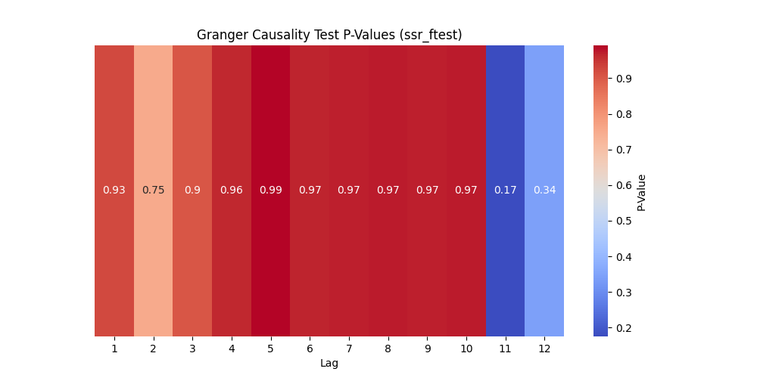

Picture19 Granger Causality Test P-Values

As can be seen from the figure, the p-values ​​in the lag period are all greater than 0.05, which means the original hypothesis is accepted, indicating that the historical value of GDP growth rate has no impact on pure electric vehicle sales.

(Three) Cross-examination results and analysis

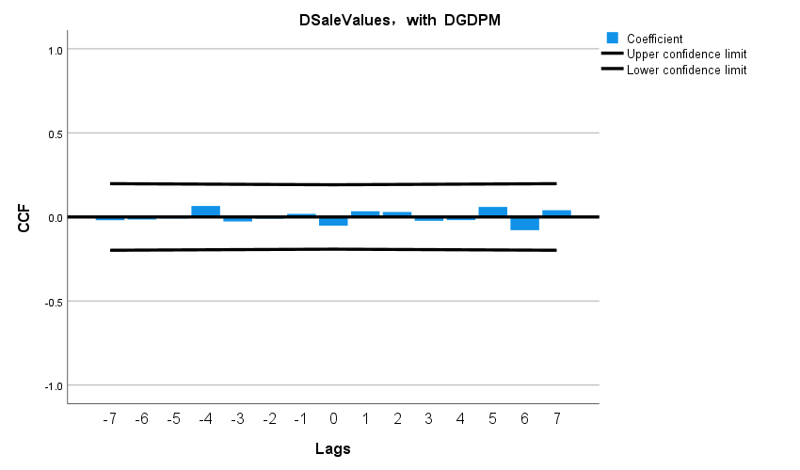

Figure20 Cross-validation results (after difference)

The graph shows that the correlation is close to zero at each lag order, indicating that there is no significant linear relationship between the differenced time series.

(Four) Comprehensive Analysis and Inference

The significant results of the Granger causality test suggest that changes in the GDP growth rate have little impact on the sales of pure electric vehicles. Cross-correlation analysis does not show a strong immediate relationship between the two, indicating that there is no significant linear relationship between the development of China's new energy electric vehicles and the GDP growth rate.

#### 3.1.2 Pure electric sales volume and Battery capacity (km)

(One) ADF nspection and Differential adjustment

1. The relationship between Pure electric sales volume and Battery capacity (km)

|  |  |  |  |  |  |
| --- | --- | --- | --- | --- | --- |
| Before differential  Statistics | *p value* | First difference  Statistics | *p value* | Second order difference  Statistics | *p value* |
| -2.6741 | 0.0786 | -10.4636 |  |  |  |

1. Differentially adjusted data

Table Battery capacity (km) data after difference

|  |  |
| --- | --- |
| Date | Number of public charging piles_Nationwide (cumulative) |
| 2014.3 | 1 |
| 2014.4 | 1 |
| 2014.5 | 1 |
| 2014.6 | 1 |
| 2014.7 | 1 |
| … | … |
| 2023.3 | 0 |

Note: See Appendix 1 for complete data.

(Two) Results and analysis of Ganger causality test

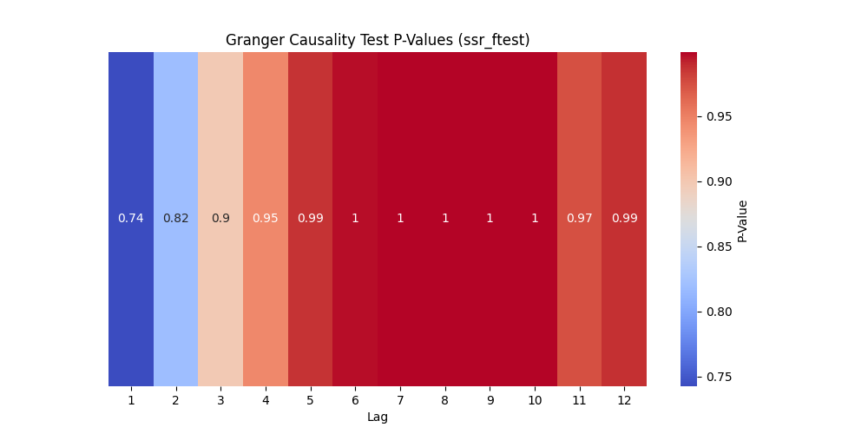

Picture21 Granger Causality Test P-Values

As can be seen from the figure, the p value for any lag period is much greater than 0.05, indicating that there is no causal relationship between Battery capacity (km) and pure electric vehicle sales.

(Three) Cross-examination results and analysis

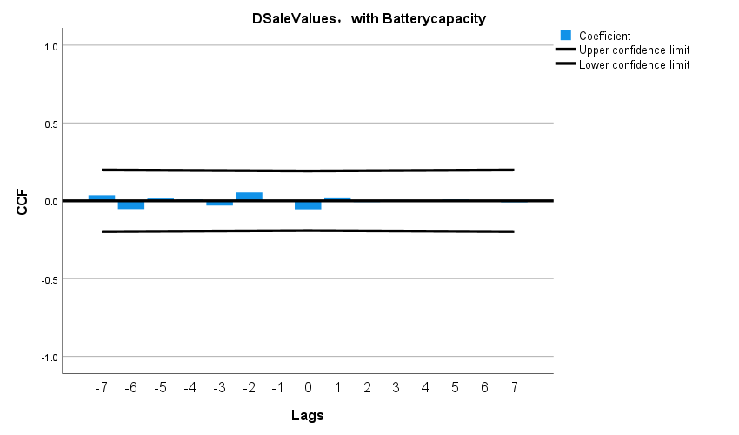

It can be seen from the figure that the correlation is close to zero at each lag order, indicating that there is no obvious linear relationship between the differentiated time series.

(Four) Comprehensive Analysis and Inference

The significant results of the Granger causality test show that there is no obvious causal relationship between Battery capacity (km) and pure electric vehicle sales. Cross-correlation analysis shows that there is no strong immediate relationship between the two, indicating that the development of new energy electric vehicles in China is closely related to Battery capacity ( km) has no obvious linear relationship.

#### 3.1.3 Pure electric sales volume and Maximum speed (km/h)

(One) ADF nspection and Differential adjustment

1. The relationship between Pure electric sales volume and Maximum speed (km/h)

Table Maximum speed (km/h) ADF test and difference adjustment results

|  |  |  |  |  |  |
| --- | --- | --- | --- | --- | --- |
| Before differential  Statistics | *p value* | First difference  Statistics | *p value* | Second order difference  Statistics | *p value* |
| -1.1851 | 0.6799 | -10.4980 |  |  |  |

As can be seen from the table, the p-value of sales volume before difference is 0.6799, which is greater than 0.05, indicating that there is a unit root and the data is non-stationary; the p-value after first-order difference is , which is less than 0.05, indicating that the data is a stationary sequence.

1. Differentially adjusted data

Table Maximum speed (km/h) data after difference

|  |  |
| --- | --- |
| Date | Number of public charging piles_Nationwide (cumulative) |
| 2014.3 | 0 |
| 2014.12 | 49 |
| 2019.1 | 151 |
| 2020.6 | 0 |
| 2021.7 | 0 |
| … | … |
| 2023.3 | 0 |

Note: See Appendix 1 for complete data.

(Two) Results and analysis of Ganger causality test

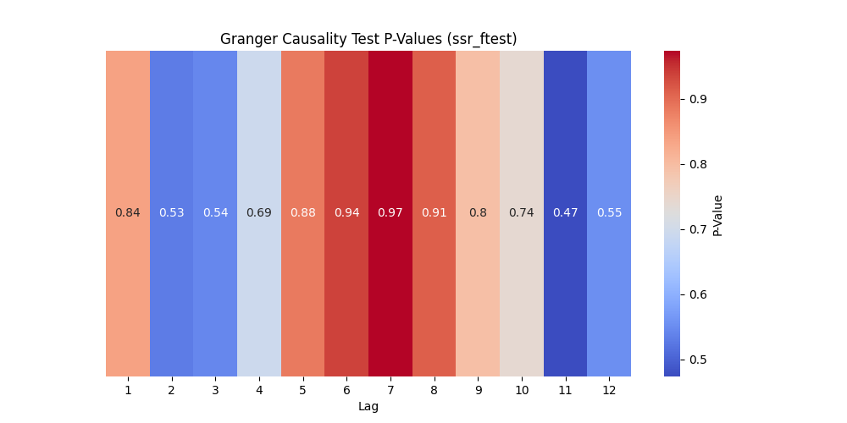

Picture Granger Causality Test P-Value

As can be seen from the figure, the p value for any lag period is much greater than 0.05, indicating that there is no causal relationship between Maximum speed (km/h) and pure electric vehicle sales.

(Three) Cross-examination results and analysis

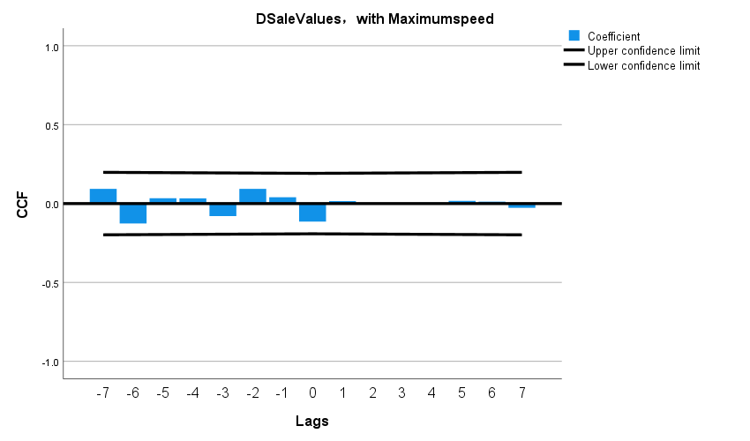

Figure Cross-validation results (after difference)

It can be seen from the figure that the correlation is close to zero at each lag order, indicating that there is no obvious linear relationship between the differentiated time series.

(Four) Comprehensive Analysis and Inference

The significant result of the Granger causality test shows that there is no obvious causal relationship between Maximum speed (km/h) and pure electric vehicle sales. Cross-correlation analysis shows that there is no strong immediate relationship between the two, indicating that the development of new energy electric vehicles in China is closely related to Maximum speed. There is no obvious linear relationship between speed (km/h).

#### 3.1.4 Pure electric sales volume and R&D expenses

(One) ADF nspection and Differential adjustment

1. The relationship between Pure electric sales volume and R&D expenses

Table R&D expenses ADF test and difference adjustment results

|  |  |  |  |  |  |
| --- | --- | --- | --- | --- | --- |
| Before differential  Statistics | *p value* | First difference  Statistics | *p value* | Second order difference  Statistics | *p value* |
| 0.0399 | 0.9617 | -10.4871 |  |  |  |

As can be seen from the table, the p-value of sales volume before difference is 0.96171, which is greater than 0.05, indicating that there is a unit root and the data is non-stationary; the p-value after first-order difference is , which is less than 0.05, indicating that the data is a stationary sequence.

1. Differentially adjusted data

Table R&D expenses data after difference

|  |  |
| --- | --- |
| Date | Number of public charging piles_Nationwide (cumulative) |
| 2015.3 | 192795104.57 |
| 2016.1 | 34299061.5 |
| 2017.1 | 203637954.3 |
| 2018.1 | 541676132.4 |
| 2019.7 | 287350305.5 |
| … | … |
| 2023.1 | 4168388289.3 |

Note: See Appendix 1 for complete data.

(Two) Results and analysis of Ganger causality test

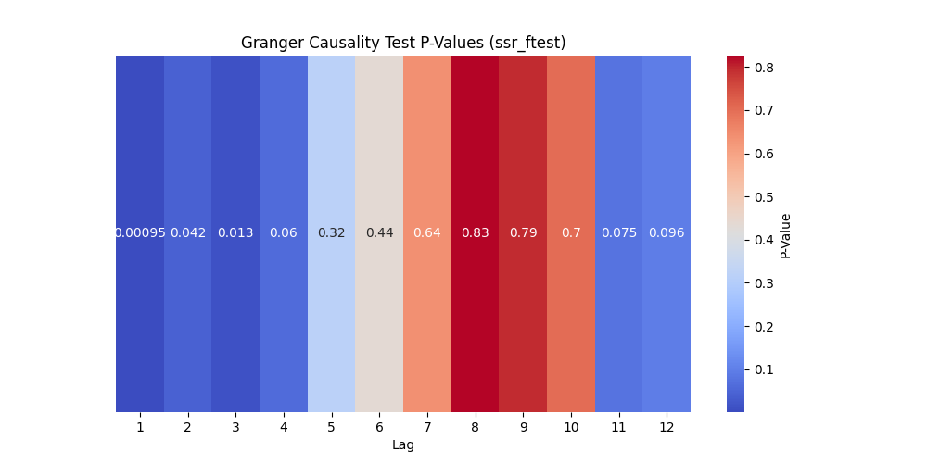

Picture Granger Causality Test P-Value

As can be seen from the figure, when the lag period is 1 to 3, the p value is less than 0.05, and when the lag period is 4, the p value is close to 0.05, indicating that R&D expenses are the Granger cause of sales. In this lag period, technology investment funds have an important impact on pure electric vehicle sales. The impact is significant; in the lag period of 11 and 12, the value is small but greater than 0.05, indicating that the technical investment in this lag period has a certain impact on the sales volume of pure electric vehicles, but the impact is small. Therefore, we can conclude that the impact of R&D expenses on pure electric vehicles has an immediate effect, the short-term impact is very significant, the impact is not significant in the mid-term, but it still has a certain impact in the long term.

(Three) Cross-examination results and analysis

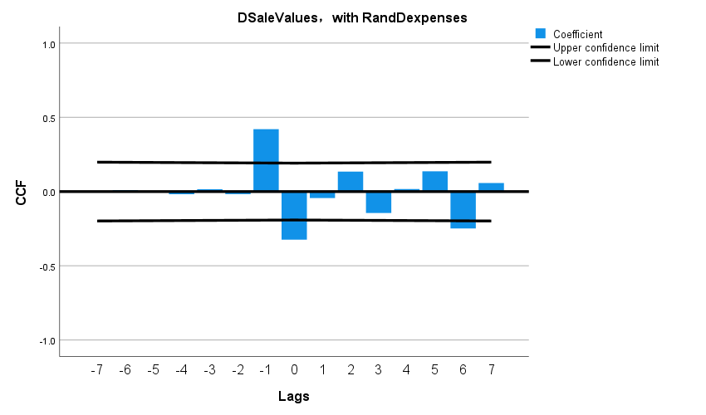

Figure Cross-validation results (after difference)

It can be seen from the figure that there is a weak positive correlation between the sales volume of pure electric vehicles and R&D expenses only when the lag order is -1, and the correlation is not significant under other conditions.

(Four) Comprehensive Analysis and Inference

The significant results of the Granger causality test indicate that changes in R&D expenses precede changes in sales volume in time and have a greater immediate impact on them. The results of the cross-correlation analysis show that except for R&D expenses, which have a weak linear relationship within a short period of time, it shows that R&D expenses mainly have a short-term impact on the sales of pure electric vehicles.

#### 3.1.5 Pure electric sales volume and Amount involved (yuan)

(One) ADF nspection and Differential adjustment

1. The relationship between Pure electric sales volume and Amount involved (yuan)

Table Amount involved (yuan) ADF test and difference adjustment results

|  |  |  |  |  |  |
| --- | --- | --- | --- | --- | --- |
| Before differential  Statistics | *p value* | First difference  Statistics | *p value* | Second order difference  Statistics | *p value* |
| -1.801 | 0.3798 | -14.335 |  |  |  |

As can be seen from the table, the p-value of sales volume before difference is 0.3798, which is greater than 0.05, indicating that there is a unit root and the data is non-stationary; the p-value after first-order difference is , which is less than 0.05, indicating that the data is a stationary sequence.

1. Differentially adjusted data

Table Amount involved (yuan) data after difference

|  |  |
| --- | --- |
| Date | Number of public charging piles_Nationwide (cumulative) |
| 2014.3 | 36060379 |
| 2014.4 | 46206485 |
| 2014.5 | -82266864 |
| 2014.6 | 0 |
| 2014.7 | 58568793 |
| … | … |
| 2023.3 | -951559004.83 |

Note: See Appendix 1 for complete data.

(Two) Results and analysis of Ganger causality test

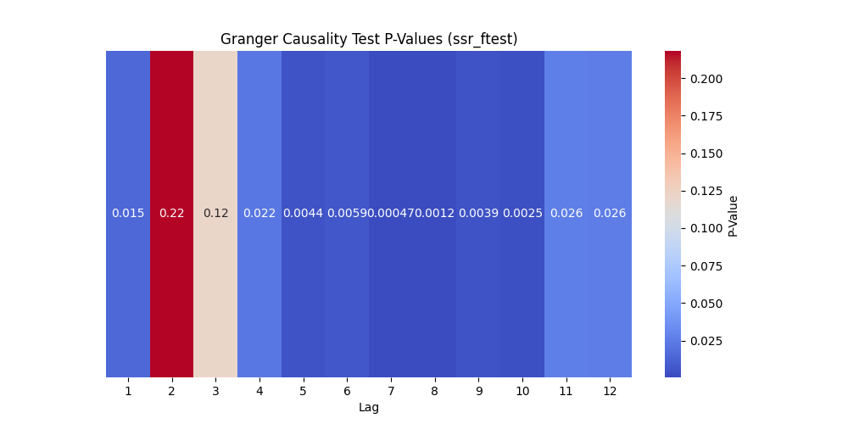

Picture Granger Causality Test P-Value

As can be seen from the figure, except when the lag period is 2 and 3, the p value is greater than 0.05, and the other periods are less than 0.05, indicating that there is a great causal relationship between Amount involved and pure electric vehicle sales, especially when the lag period is 4 to 10. The relationship is statistically more significant.

(Three) Cross-examination results and analysis

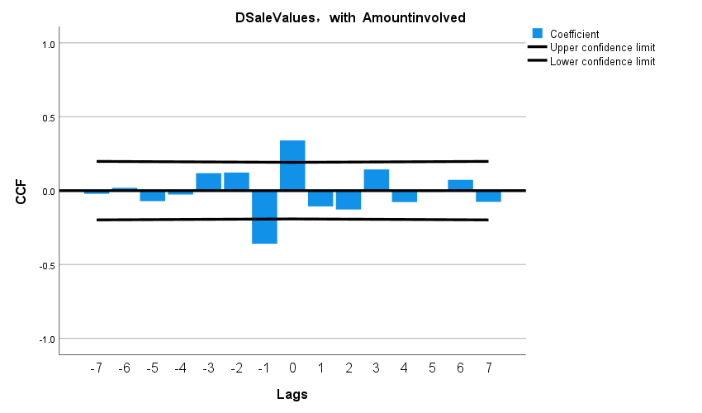

Figure Cross-validation results (after difference)

As can be seen from the figure, most of the bars are within the confidence limits, indicating that there is no significant correlation between pure electric vehicle sales and the Amount involved at most lag values. But at lags -1 and 1, the bars of the correlation coefficient slightly exceed the lower confidence limit, suggesting that there may be a slight negative correlation at these two lag points. However, none of these correlations are very strong, meaning there may not be an obvious direct relationship between the two sequences.

(Four) Comprehensive Analysis and Inference

The significant results of the Granger causality test indicate that the change in Amount involved precedes the change in sales volume in time and may have an impact on it. However, cross-correlation analysis did not indicate a strong immediate relationship between the two. That is, there is no obvious linear relationship between the development of new energy electric vehicles in China and the amount involved.

### 3.2 Question Three

#### 3.2.1 Global traditional energy vehicle sales and Market Share

(One) ADF nspection and Differential adjustment

1. The relationship between Global traditional energy vehicle sales and Market Share

Table Market Share ADF test and difference adjustment results

|  |  |  |  |  |  |
| --- | --- | --- | --- | --- | --- |
| Before differential  Statistics | *p value* | First difference  Statistics | *p value* | Second order difference  Statistics | *p value* |
| -1.5964 | 0.4853 | -10.3570 |  | -1.5964 | 0.4853 |

As can be seen from the table, the p-value of sales volume before difference is 0.4853, which is greater than 0.05, indicating that there is a unit root and the data is non-stationary; the p-value after first-order difference is , which is less than 0.05, indicating that the data is a stationary sequence.

1. Differentially adjusted data

Table Market Share data after difference

|  |  |
| --- | --- |
| Date | Number of public charging piles_Nationwide (cumulative) |
| 2014.3 | 0 |
| 2015.02 | 0.2035 |
| 2016.02 | 0.0756 |
| 2017.2 | 0.1766 |
| 2019.2 | 0.3040 |
| … | … |
| 2023.3 | -2.272 |

Note: See Appendix 1 for complete data.

(Two) Results and analysis of Ganger causality test

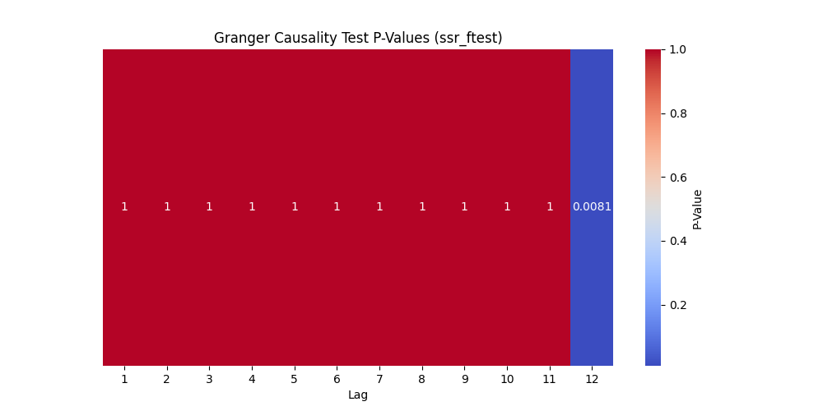

Picture Granger Causality Test P-Value

As can be seen from the figure, the p value suddenly becomes smaller only when the lag value is 12, and is much less than 0.05. The causal relationship is very significant. This shows that Global Pure electric sales has a significant impact on Global traditional energy vehicle sales only when the lag value is 12. The two A time series has a great causal relationship at a specific time difference.

(Three) Cross-examination results and analysis

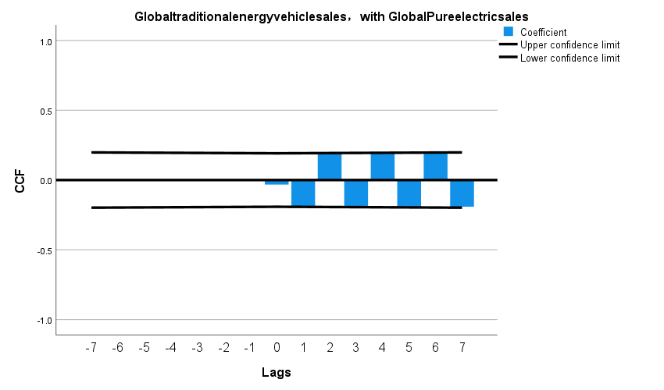

Figure Cross-validation results (after difference)

As can be seen from the figure, the correlation is close to zero at each lag order, indicating that there is no obvious linear relationship between the differentiated time series.

(Four) Comprehensive Analysis and Inference

The significant results of the Granger causality test indicate that only in the special lag period, the total sales of pure electric vehicles have a great causal effect on the sales of traditional fuel vehicles. However, cross-correlation analysis did not indicate a strong immediate relationship between the two. And there is no obvious linear relationship between Global Pure electric sales and Global traditional energy vehicle sales.

#### 3.2.2 Global traditional energy vehicle sales and Plug-in sales

(One) ADF nspection and Differential adjustment

1. The relationship between Global traditional energy vehicle sales and Plug-in sales

Table Plug-in sales ADF test and difference adjustment results

|  |  |  |  |  |  |
| --- | --- | --- | --- | --- | --- |
| Before differential  Statistics | *p value* | First difference  Statistics | *p value* | Second order difference  Statistics | *p value* |
| -0.9684 | 0.7646 | -1.9245 | 0.3205 | -65.7738 | 0.0 |

It can be seen from the table that the p-value of sales volume before difference is 0.7646, which is greater than 0.05, indicating that there is a unit root and the data is non-stationary; the p-value after first-order difference is 0.3205, which is still greater than 0.05, indicating that The data is still non-stationary; the p value after second-order difference is 0, which is 0.05, indicating that the data is a stationary sequence.

1. Differentially adjusted data

Table Plug-in sales data after difference

|  |  |
| --- | --- |
| Date | Number of public charging piles_Nationwide (cumulative) |
| 2014.3 |  |
| 2014.4 |  |
| 2014.5 |  |
| 2014.6 |  |
| 2014.7 |  |
| … | … |
| 2023.3 |  |

Note: See Appendix 1 for complete data.

(Two) Results and analysis of Ganger causality test

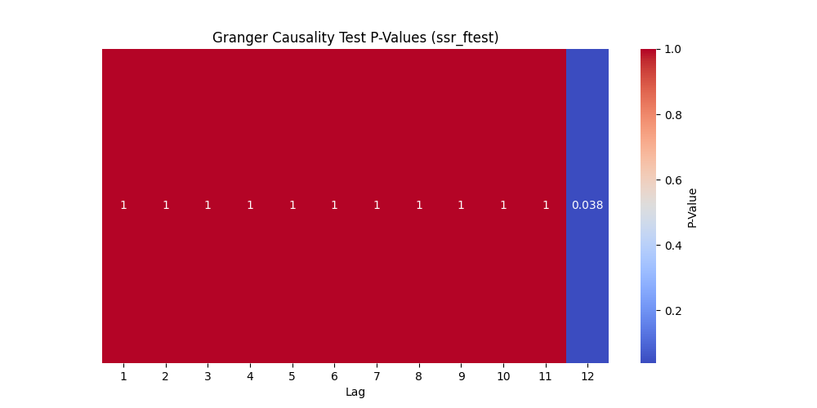

Picture Granger Causality Test P-Value

As can be seen from the figure, the p value suddenly becomes smaller only when the lag value is 12, and is much less than 0.05. The causal relationship is very significant. This shows that Plug-in sales has a significant impact on Global traditional energy vehicle sales only when the lag value is 12. The two A time series has a great causal relationship at a specific time difference.

(Three) Cross-examination results and analysis

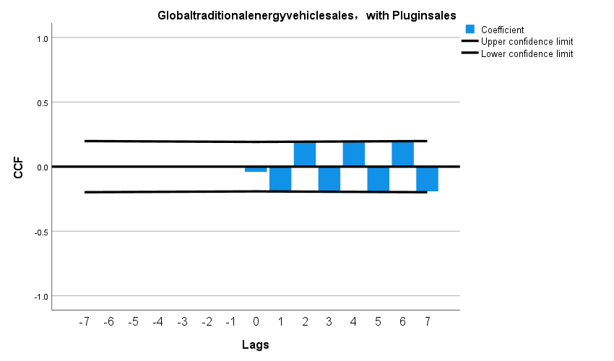

Figure Cross-validation results (after difference)

It can be seen from the figure that the correlation is close to zero at each lag order, indicating that there is no obvious linear relationship between the differentiated time series.

(Four) Comprehensive Analysis and Inference

The significant results of the Granger causality test indicate that only in the special lag period, the total sales of pure electric vehicles have a great causal effect on the sales of traditional fuel vehicles. However, cross-correlation analysis did not indicate a strong immediate relationship between the two. And there is no obvious linear relationship between Plug-in sales and Global traditional energy vehicle sales.

#### 3.2.3 Global traditional energy vehicle sales and Global Pure electric sales

(One) ADF nspection and Differential adjustment

1. The relationship between Global traditional energy vehicle sales and Global Pure electric sales

Table Global Pure electric sales ADF test and difference adjustment results

|  |  |  |  |  |  |
| --- | --- | --- | --- | --- | --- |
| Before differential  Statistics | *p value* | First difference  Statistics | *p value* | Second order difference  Statistics | *p value* |
| -0.5481 | 0.8822 | -2.297 |  | -63.4696 | 0.0 |

As can be seen from the table, the p-value of sales volume before difference is 0.8822, which is greater than 0.05, indicating that there is a unit root, and the data is non-stationary; the p-value after first-order difference is 0.1727, which is still greater than 0.05, indicating that the data is still non-stationary. Stationary; the p value after the second difference is 0, which is 0.05, indicating that the data is a stationary sequence.

1. Differentially adjusted data

Table Global Pure electric sales data after difference

|  |  |
| --- | --- |
| Date | Number of public charging piles_Nationwide (cumulative) |
| 2014.3 |  |
| 2014.4 |  |
| 2014.5 |  |
| 2014.6 |  |
| 2014.7 |  |
| … | … |
| 2023.3 |  |

Note: See Appendix 1 for complete data.

(Two) Results and analysis of Ganger causality test



Picture Granger Causality Test P-Value

As can be seen from the figure, the p value suddenly becomes smaller only when the lag value is 12, and is much less than 0.05. The causal relationship is very significant. This shows that Global Pure electric sales has a significant impact on Global traditional energy vehicle sales only when the lag value is 12. The two A time series has a great causal relationship at a specific time difference.

(Three) Cross-examination results and analysis



Figure Cross-validation results (after difference)

As can be seen from the figure, the correlation is close to zero at each lag order, indicating that there is no obvious linear relationship between the differentiated time series.

(Four) Comprehensive Analysis and Inference

The significant results of the Granger causality test indicate that only in the special lag period, the total sales of pure electric vehicles have a great causal effect on the sales of traditional fuel vehicles. However, cross-correlation analysis did not indicate a strong immediate relationship between the two. And there is no obvious linear relationship between Global Pure electric sales and Global traditional energy vehicle sales.

### 3.3 Question Four

#### 3.3.1 EU's policy of "improving traditional car carbon emissions"

**Step1**: Create a time series graph.

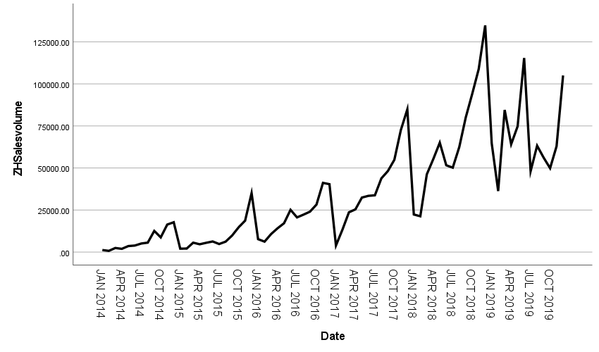

It can be seen from the figure that in general, the sales volume first showed a significant upward trend, and then tended to slowly, and reached its peak in 2018; from the period of cyclicality, the sales of China's new energy vehicles basically took one year as the cycle as the cycle. From seasonal perspective, seasonal fluctuations are obvious.

**Step2:** Seasonal Decomposition

From the description of the time sequence diagram above, the sales volume shows a significant upward trend. Therefore, the use of the multiplication model will be more accurate. The specific decomposition is shown in the following table,

Table Seasonal factors obtained by multiplicative decomposition of sales volume (2014.1-2017.12)

|  |  |  |  |
| --- | --- | --- | --- |
| Cycle | Seasonal factor（%） | Cycle | Seasonal factor（%） |
| 1 | 41.3 | 7 | 79.0 |
| 2 | 41.8 | 8 | 92.8 |
| 3 | 80.4 | 9 | 111.8 |
| 4 | 80.6 | 10 | 124.9 |
| 5 | 95.1 | 11 | 160.4 |
| 6 | 97.2 | 12 | 194.7 |

It can be seen from the table that the seasons of the September to December are greater than 1, and the seasons of the first to August are less than 1, indicating that the average sales volume of the 9th to December before the difference is higher than the first to August, and the 12th is 12th, and the 12th is 12th. The average sales of a month were 94.7%higher than the average annual level, and the average sales of the first month were less than 58.7%of the annual average. The average sales in February are 41.8% below the annual average. In March, the average sales are80.4% below the annual average. April's average sales are 80.6% below the annual average. May's average sales are 95.1% below the annual average. June's average sales are97.2% below the annual average. July's average sales are 79.0% below the annual average. August's average sales are 92.8% below the annual average. December's average sales are 194.7% above the annual average. October's average sales are 124.9% above the annual average. November's average sales are 160.4% above the annual average.

**Step3:** Decomposed timing diagram

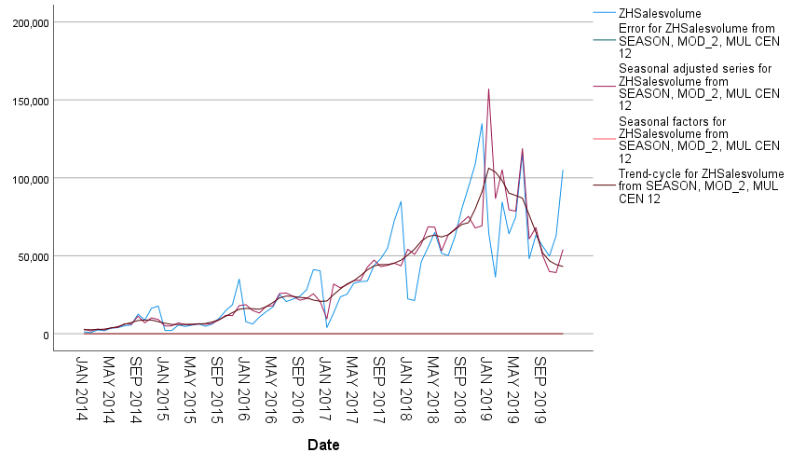

The sales forecast value of the figure under the influence of the policy

The graph shows that the red line represents the seasonally adjusted sales volume, which eliminates the impact of seasonal factors, providing a clearer view of the long-term upward trend and cyclical fluctuations beyond seasonal factors. The purple line represents the seasonal factors, showing that sales volume increases with the months of the year. The dark blue line represents the trend-cycle component, also indicating a long-term upward trend and cyclical changes. The residual values are almost zero, suggesting that the model simulation results are good.

**Step 4:** Establish a Time Series Analysis Model

Use the SPSS software expert to model the model type as Arima (1,1,0) (0,1,0), and the data is available for formulas (18)

**Step5:** White noise residual test

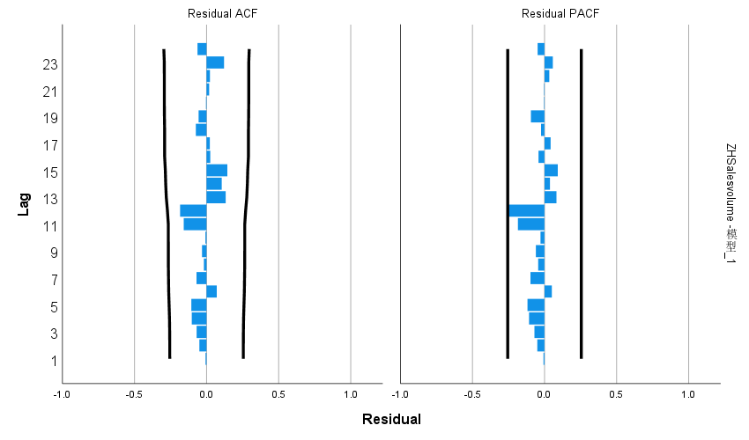

Figure Residual test plot

Table ARIMA(1,1,0)(0,1,0)12 model statistics table

|  |  |  |  |  |  |
| --- | --- | --- | --- | --- | --- |
| Number of predictors | Model fit statistics: Stationary R-squared | Statistics | DF | Significance | Number of outliers |
| 0 | 0.487 | 11.688 | 17 | 0.819 | 1 |

It can be seen from the visual depiction that the P value obtained by Q testing of the residue is 0.819, which is greater than 0.05. It cannot reject the original assumption. Therefore, the residual is considered to be the white noise sequence, so ARIMA(1,1,0)(0,1,0)12 The model can well identify the sales data in this question.

**Step6:** Predict future indicator values

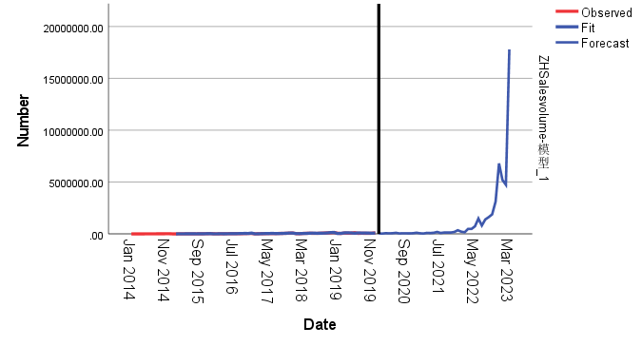

It can be seen from the figure that the upward trend of the forecast line shows a continuous growth model, indicating that if the current conditions or policies remain unchanged, the expected number indicator will continue to grow, indicating that the policy may be obvious to the development of China's new energy electric vehicles in China. enhancement.

**Step7:** Compared with predicted data and actual values

The comparison of predictive values and actual values under the influence of US policy

|  |  |  |
| --- | --- | --- |
|  | Predictive value (unsuccessful) | Actual value (with policy) |
| Jan-20 | 48334.95 | 29269 |
| Feb-20 | 28606.88 | 9291 |
| Mar-20 | 68110.14 | 34519 |
| Apr-20 | 53373.94 | 43094 |
| … | … | … |
| Mar-23 | 17789352.43 | 396672 |

Note: For details, see Appendix I

It can be seen from the table that from January 2020 to March 2023, the sales volume showed a significant fluctuation and growth trend, especially in November and December 2022, the sales volume increased sharply and reached a high level. For a period of time after the implementation of the policy, the sales volume rebounded significantly and continued to grow, and even reached a new peak, indicating that the policy has significantly promoted the development of China's new energy electric vehicles.

#### 3.3.2 The European Union's policy of "improving new energy electric vehicles"

**Step1：**Same as above, first use data from 2014.1 ~ 2019.12 to predict data from 2022.12. Use the data of 2020.1 ~ 2022.12 to predict the data of 2023.3.

**Step2**: Create a time series graph.

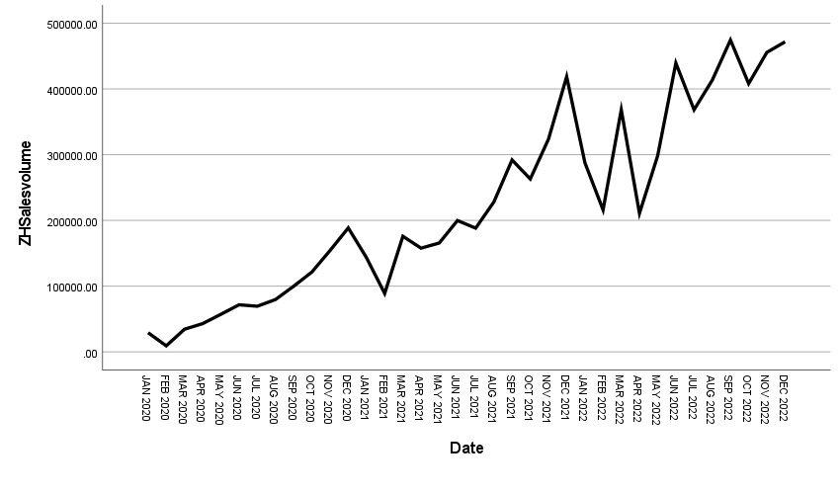

T It can be seen from the figure that in general, the sales volume first shows a significant upward trend; from a seasonal perspective, seasonal fluctuations have changed from relatively smooth to larger, and then become gentle.

**Step3:** Seasonal Decomposition

From the description of the time sequence diagram above, the seasonal fluctuations of the sales volume are generally slower, so the use of the addition model will be more accurate. However, after the operation of the SPSS program, the corresponding seasonal decomposition factor cannot be found, whether it is an additional model or a multiplication model.

Step 4: Establish a Time Series Analysis Model

Using SPSS software for expert modeling, the model type obtained is Winters' Additive. The data is (29) then inputted into the model

Step5: White noise residual test

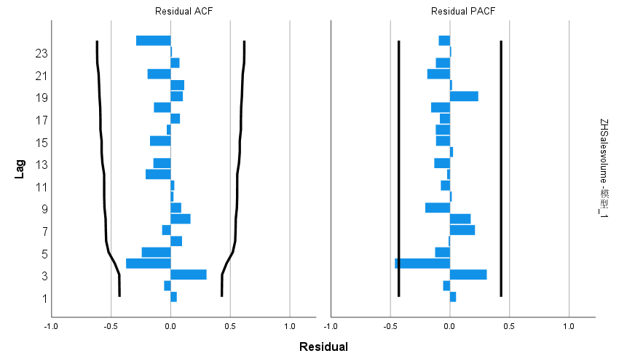

Figure Residual test plot

Table Winters' Additive model statistics table

|  |  |  |  |  |  |
| --- | --- | --- | --- | --- | --- |
| Number of predictors | Model fit statistics: Stationary R-squared | Statistics | DF | Significance | Number of outliers |
| 0 | 0.698 | 22.832 | 15 | 0.088 | 0 |

It can be seen from the visual depiction that the smooth R square is 0.698, indicating that the degree of fitting of the sales volume data is relatively high, indicating that the model can well explain the changes in the sales volume. The number of group values is 0, indicating that the model does not have a large value with the model prediction. The P value obtained by the Q test of the residue is 0.088, which is greater than 0.05. It cannot refuse the original assumption. Therefore, the residual is considered to be the white noise sequence. Therefore, the Winters' Additive model can well identify the sales data in this question.

Step6: Predict future indicator values

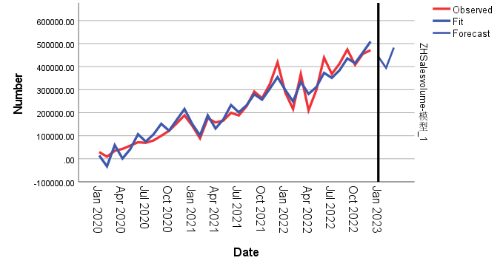

The sales forecast value of the figure under the influence of the policy

It can be seen from the figure that the policy has generally promoted the development of China's new energy electric vehicles, and there is a small -scale inhibitory effect, indicating that the European Union's "subsidy for new energy electric vehicles" may not restrict the Chinese new energy electric vehicles that China New Energy Electric Vehicles. develop..

Step7: Compared with predicted data and actual values

The comparison of predictive values and actual values under the influence of US policy

|  |  |  |
| --- | --- | --- |
|  | Predictive value (unsuccessful) | Actual value (with policy) |
| Jan-20 | 48334.95 | 29269 |
| Feb-20 | 28606.88 | 9291 |
| Mar-20 | 68110.14 | 34519 |
| … | … | … |
| Mar-23 | 396672 | 482856.4 |
| Jan-20 | 48334.95 | 29269 |

As can be seen from the table, from January 2020 to March 2023, sales volume fluctuated greatly during the policy implementation period, indicating that sales volume may be suppressed to a certain extent in the early stages of policy implementation, but will gradually recover in subsequent months and reach the level at the end of 2022 A new peak; from January to March 2023, sales continued to grow, and there was no obvious policy impact that led to a downward trend in sales, indicating that the initial policy implementation may have a certain negative impact on sales, but as time goes by, sales Volume gradually adapted and rebounded, eventually showing an obvious growth trend. At the beginning of 2023, sales continued to grow, which may indicate that the market demand for products or services continues, and the policy has no obvious inhibitory effect.

#### 3.3.3 EU anti -subsidy survey

**Step1**: Create a time series graph.

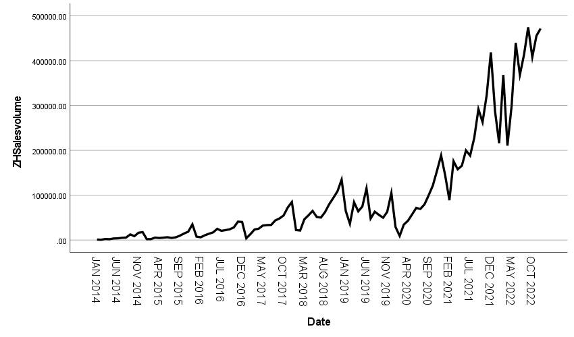

The graph shows that, overall, the sales volume exhibits a clear upward trend, gradually increasing from a lower level in 2014 to a peak in 2022. From a cyclical perspective, the sales of China's new energy vehicles generally follow an annual cycle. In terms of seasonality, there are seasonal variations in sales volume, with the highest sales occurring at the end of the year, falling to the lowest at the beginning of the year, and then gradually increasing, forming another peak at the end of the next year.

**Step2:** Seasonal Decomposition

Based on the description of the time series graph above, since the sales volume shows a clear upward trend, using a multiplicative model would be more accurate. The specific decomposition is shown in the following table,

Table Seasonal factors obtained by multiplicative decomposition of sales volume (2014.1-2017.12)

|  |  |  |  |
| --- | --- | --- | --- |
| Cycle | Seasonal factor（%） | Cycle | Seasonal factor（%） |
| 1 | 60.3 | 7 | 80.6 |
| 2 | 44.1 | 8 | 94.9 |
| 3 | 87.4 | 9 | 109.2 |
| 4 | 78.0 | 10 | 119.8 |
| 5 | 91.3 | 11 | 148.3 |
| 6 | 102.1 | 12 | 184.1 |

It can be seen from the table that the seasonal factors in the 6th, 9th to 12th months are greater than 1, and the seasonal factors in the 1st to 5th, 7th and 8th months are less than 1, indicating that the average sales volume in the 6th, 9th to 12th months before the difference is higher than the first. From January to May and July to August, the average sales volume in the 12th month is 84.1% higher than the annual average. The average sales in February are 44.1% below the annual average. In March, the average sales are 87.4% below the annual average. April's average sales are 78.0% below the annual average. May's average sales are 91.3% below the annual average. June's average sales are 102.1% above the annual average. July's average sales are 80.6% below the annual average. August's average sales are 94.9% below the annual average. December's average sales are 184.1% above the annual average. October's average sales are 119.8% above the annual average. November's average sales are148.3% above the annual average.

**Step3:** Decomposed timing diagram

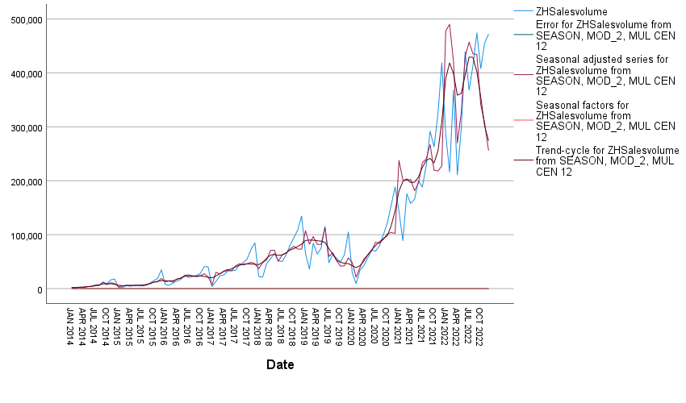

The sales forecast value of the figure under the influence of the policy

The graph shows that the red line represents the seasonally adjusted sales volume, which eliminates the impact of seasonal factors, providing a clearer view of the long-term upward trend and cyclical fluctuations beyond seasonal factors. The purple line represents the seasonal factors, showing that sales volume increases with the months of the year. The dark blue line represents the trend-cycle component, also indicating a long-term upward trend and cyclical changes. The residual values are almost zero, suggesting that the model simulation results are good.

**Step 4:** Establish a Time Series Analysis Model

Use the SPSS software expert to model the model type as Arima (1,1,0) (0,1,0), and the data is available for formulas (18)

**Step5:** White noise residual test

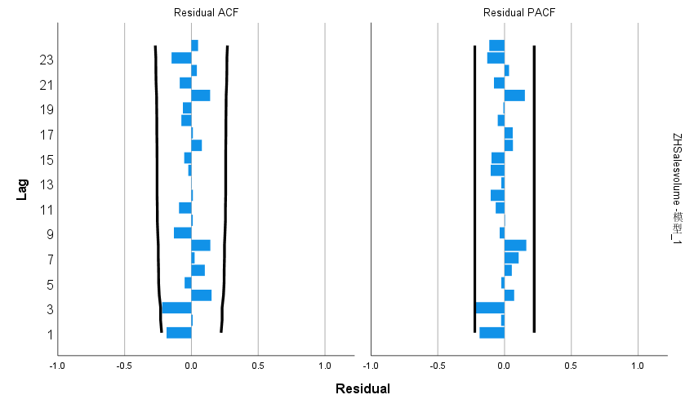

Figure Residual test plot

Table ARIMA(0,1,0)(0,1,1)12 model statistics table

|  |  |  |  |  |  |
| --- | --- | --- | --- | --- | --- |
| Number of predictors | Model fit statistics: Stationary R-squared | Statistics | DF | Significance | Number of outliers |
| 0 | 0.679 | 18.683 | 17 | 0.347 | 6 |

As can be seen from the visual depiction, the stationary R-square is 0.679, which means that the model fits the sales volume data relatively well, indicating that the model can well explain the changes in sales volume; the p-value obtained by performing the Q test on the residuals is 0.347, which is greater than 0.05, the null hypothesis cannot be rejected, so the residual is considered to be a white noise sequence, so the ARIMA(0,1,0)(0,1,1)12 model can well identify the sales data in this question.

**Step6:** Predict future indicator values



As can be seen from the figure, the upward trend of the forecast line shows a pattern of fluctuating growth, indicating that if the current conditions or policies remain unchanged, the expected sales volume growth indicates that this policy may have a significant promoting effect on the development of new energy electric vehicles in China.

**Step7:** Compared with predicted data and actual values

The comparison of predictive values and actual values under the influence of US policy

|  |  |  |
| --- | --- | --- |
|  | Predictive value (unsuccessful) | Actual value (with policy) |
| Jan-23 | 256029.18 | 219773 |
| Feb-23 | 183799.29 | 312386 |
| Mar-23 | 360456.34 | 396672 |

As can be seen from the table, between January and March 2023, sales volume showed a steady growth trend, reflected in a continuously rising sales level; between January and March 2023, sales volume continued to grow without obvious policy impact This has led to a downward trend in sales, and the data is relatively stable without obvious fluctuations, indicating that this policy has no obvious inhibitory effect on the development of new energy electric vehicles in China.

## 4 Appendix III

|  |
| --- |
| **code1** |
| Python：Perform descriptive statistics on the data |
| 1. import pandas as pd 2. from matplotlib.dates import DateFormatter 3. from adjustText import adjust_text 4. *# Load the data* 5. file_path = 'E:/科研程序/代码/vscode/亚太杯/DATA.xlsx' *#Change the worksheet order in excel#The visualization below is for the first question* 6. data = pd.read_excel(file_path) 7. *# Descriptive statistics* 8. desc_stats = data.describe() 9. *# Print the descriptive statistics* 10. print(desc_stats) 11. desc_stats.to_excel('E:/科研程序/代码/vscode/亚太杯/output_file.xlsx') 12. import matplotlib.pyplot as plt 13. import seaborn as sns 14. *# Visualization: Sales Quantity over Time (Years and Months)* 15. plt.figure(figsize=(15, 6)) 16. sns.lineplot(x="Date", y="Sales volume", data=data, marker='o') 17. plt.title("Sales volume changes by Data") 18. plt.xlabel("Date") 19. plt.ylabel("Sales volume") 20. plt.xticks(rotation=45) 21. plt.grid(True) 22. plt.rcParams['font.sans-serif'] = ['SimHei']  *# SimHei* 23. plt.rcParams['axes.unicode_minus'] = False  *#* 24. plt.tight_layout() 25. *# Visualization: Sales vs. Charging Piles* 26. plt.figure(figsize=(15, 6)) 27. sns.scatterplot(x="Number of public charging piles_Nationwide (cumulative)", y="Sales volume", data=data) 28. plt.title("The relationship between sales volume and the number of public charging piles") 29. plt.xlabel("Number of public charging piles_Nationwide (cumulative)") 30. plt.ylabel("Sales volume") 31. plt.grid(True) 32. plt.rcParams['font.sans-serif'] = ['SimHei']  *#  SimHei* 33. plt.rcParams['axes.unicode_minus'] = False  *#* 34. plt.tight_layout() 35. *# Visualization: Sales vs. Battery Capacity* 36. plt.figure(figsize=(15, 6)) 37. sns.scatterplot(x="Battery capacity (km)", y="Sales volume", data=data) 38. plt.title("Relationship between sales quantity and battery capacity") 39. plt.xlabel("Battery capacity (km)") 40. plt.ylabel("Sales volume") 41. plt.grid(True) 42. plt.tight_layout() 43. plt.rcParams['font.sans-serif'] = ['SimHei']  *# SimHei* 44. plt.rcParams['axes.unicode_minus'] = False  *# '-'* 45. plt.show() 46. *# Prepare the figure* 47. plt.figure(figsize=(20, 10)) 48. *# Plotting Sales Quantity over Time* 49. sns.lineplot(x="Date", y="Sales volume", data=data, marker='o', color="black", label="Sales volume") 50. *# Define the policy columns and corresponding colors and markers* 51. policy_info = { 52. "Subsidy Standards for Private Purchase of New Energy Vehicle": ("red", "X"), 53. "Notice on further development of pilot projects for the promotion of energy saving and New Energy Vehicles (NEVs)": ("green", "P"), 54. "Subsidy on New Energy Vehicle 2023": ("blue", "D"), 55. "Financial Subsidy Policy for the Promotion and Application of New Energy Vehicles": ("cyan", "s"),  *# 's' for square* 56. "2016-2020:Ministry of Finance,No.958[2016],Subsidy scheme and product technology requirement for promotion of new energy vehicles": ("magenta", "^"),  *# '^' for triangle_up* 57. "Adjustments and improvements to Subsidy Policies for New Energy Vehicles": ("yellow", "o"),  *# 'o' for circle* 58. "Notice on vehicle and vessel tax reduction for energy saving and new energy automobiles": ("orange", "v"),  *# 'v' for triangle_down* 59. *# Add more policies as needed...* 60. } 61. *# Create an empty list to collect all text objects* 62. texts = [] 63. *# Draw policy points and text* 64. for policy, (color, marker) in policy_info.items(): 65. policy_data = data[data[policy] == 1] 66. if not policy_data.empty: 67. sns.scatterplot(x="Date", y="Sales volume", data=policy_data, 68. color=color, label=policy, marker=marker, s=100) 69. *# Add text to the first point of each policy* 70. first_policy_date = policy_data['Date'].min() 71. text = plt.text(first_policy_date, 72. data.loc[data['Date'] == first_policy_date, 'Sales volume'].iloc[0], 73. policy, 74. ha='center', va='bottom') 75. texts.append(text) 76. *# Use adjust_text to improve the position of text annotations and reduce overlap* 77. adjust_text(texts, arrowprops=dict(arrowstyle="->", color='r', lw=0.5)) 78. *# Enhancing the plot* 79. plt.title("Changes in sales volume over time and policy time periods") 80. plt.xlabel("Date") 81. plt.ylabel("Sales volume") 82. plt.gca().xaxis.set_major_formatter(DateFormatter("%Y-%m")) 83. plt.xticks(rotation=45) 84. plt.legend() 85. plt.grid(True) 86. plt.tight_layout() 87. plt.rcParams['font.sans-serif'] = ['SimHei']  *# SimHei* 88. plt.rcParams['axes.unicode_minus'] = False  *# '-'* 89. *# Show the plot* 90. plt.show() |

|  |
| --- |
| **Code2** |
| Python：Conduct ADF test, difference test and Granger test on the sales volume and main factors of the first question.Conduct ADF test, difference test and Granger test on the traditional car sales volume and main factors in the third question. |
| 1. import pandas as pd 2. from statsmodels.tsa.statespace.sarimax import SARIMAX 3. from statsmodels.tsa.stattools import adfuller, grangercausalitytests 4. from statsmodels.graphics.tsaplots import plot_acf, plot_pacf 5. import matplotlib.pyplot as plt 6. *# Download Data* 7. data = pd.read_excel('E:/科研程序/代码/vscode/亚太杯/亚太杯/第一题/DATA.xlsx')  *#Excel can be changed* 8. *# Data preprocessing* 9. data['Date'] = pd.to_datetime(data['Date']) 10. data.set_index('Date', inplace=True) 11. *# Extract key columns* 12. sales_volume = data['Sales volume']          *#Changing column names that require Granger causality testing* 13. infrastructure = data['Amount involved (yuan)']*#Changing column names that require Granger causality testing* 14. *# Functions: Check stationarity and differencing* 15. def make_stationary(series): 16. adf_test = adfuller(series.dropna()) 17. print(f'ADF Statistic: {adf_test[0]}') 18. print(f'p-value: {adf_test[1]}') 19. if adf_test[1] > 0.05: 20. *# Try first differences* 21. series_diff = series.diff().dropna() 22. adf_test_diff = adfuller(series_diff) 23. print(f'ADF Statistic (1st diff): {adf_test_diff[0]}') 24. print(f'p-value (1st diff): {adf_test_diff[1]}') 25. if adf_test_diff[1] > 0.05: 26. *# Try second difference* 27. series_diff = series_diff.diff().dropna() 28. adf_test_diff = adfuller(series_diff) 29. print(f'ADF Statistic (2nd diff): {adf_test_diff[0]}') 30. print(f'p-value (2nd diff): {adf_test_diff[1]}') 31. return series_diff 32. else: 33. return series_diff 34. else: 35. return series 36. *# Check stationarity and make necessary differences* 37. sales_volume_stationary = make_stationary(sales_volume) 38. infrastructure_stationary = make_stationary(infrastructure) 39. *# Combine the data again for Granger causality testing* 40. combined_data_stationary = pd.concat([sales_volume_stationary, infrastructure_stationary], axis=1).dropna() 41. *# Export smoothed data to Excel* 42. combined_data_stationary.to_excel('E:/科研程序/代码/vscode/亚太杯/亚太杯/第一题/TimeStationaryData.xlsx') 43. *# Perform Granger causality test* 44. granger_test_result = grangercausalitytests(combined_data_stationary, maxlag=12, verbose=False) 45. *# Extract P-value for Granger causality test* 46. p_values = {lag: min(test[1] for test in result[0].values()) for lag, result in granger_test_result.items()} 47. *# Plot a P-value bar chart* 48. plt.figure(figsize=(8, 4)) 49. plt.bar(p_values.keys(), p_values.values(), color='skyblue') 50. plt.xlabel('Lags') 51. plt.ylabel('P-Value') 52. plt.title('Granger Causality Test Results (P-Values)') 53. plt.axhline(y=0.05, color='red', linestyle='--')  *# Significance level line* 54. plt.show() 55. import seaborn as sns 56. import seaborn as sns 57. import matplotlib.pyplot as plt 58. import numpy as np 59. *# Perform Granger causality test and obtain P value* 60. maxlag = 12 61. test_results = grangercausalitytests(combined_data_stationary, maxlag=maxlag, verbose=False) 62. *# Extract the P-value for a specific test (e.g. ssr_ftest)* 63. p_values = np.zeros(maxlag) 64. for i in range(maxlag): 65. p_values[i] = test_results[i+1][0]['ssr_ftest'][1]  *# Here the p value of ssr based on F test is used* 67. *# Draw heat map* 68. plt.figure(figsize=(10, 5)) 69. sns.heatmap([p_values], annot=True, cmap='coolwarm', cbar_kws={'label': 'P-Value'}) 70. plt.title('Granger Causality Test P-Values (ssr_ftest)') 71. plt.xlabel('Lag') 72. plt.xticks(np.arange(0.5, maxlag + 0.5), np.arange(1, maxlag + 1)) 73. plt.yticks([]) 74. plt.show() 75. print(p_values) |

|  |
| --- |
| **Code3** |
| Python：Perform descriptive statistics on the data |
| 1. import pandas as pd 2. from matplotlib.dates import DateFormatter 3. from adjustText import adjust_text 4. *# Load the data* 5. file_path = 'E:/科研程序/代码/vscode/亚太杯/Before Standardization.xlsx' *#Change the worksheet order in excel#The visualization below is for the first question* 6. data = pd.read_excel(file_path) 7. *# Descriptive statistics* 8. desc_stats = data.describe() 9. *# Print the descriptive statistics* 10. print(desc_stats) 11. desc_stats.to_excel('E:/科研程序/代码/vscode/亚太杯/output_file.xlsx') 12. import matplotlib.pyplot as plt 13. import seaborn as sns 14. *# Visualization: Sales Quantity over Time (Years and Months)* 15. plt.figure(figsize=(15, 6)) 16. sns.lineplot(x="Date", y="Sales volume", data=data, marker='o') 17. plt.title("Sales volume changes by Data") 18. plt.xlabel("Date") 19. plt.ylabel("Sales volume") 20. plt.xticks(rotation=45) 21. plt.grid(True) 22. plt.rcParams['font.sans-serif'] = ['SimHei']  *# SimHei* 23. plt.rcParams['axes.unicode_minus'] = False  *#* 24. plt.tight_layout() 25. *# Visualization: Sales vs. Charging Piles* 26. plt.figure(figsize=(15, 6)) 27. sns.scatterplot(x="Number of public charging piles_Nationwide (cumulative)", y="Sales volume", data=data) 28. plt.title("The relationship between sales volume and the number of public charging piles") 29. plt.xlabel("Number of public charging piles_Nationwide (cumulative)") 30. plt.ylabel("Sales volume") 31. plt.grid(True) 32. plt.rcParams['font.sans-serif'] = ['SimHei']  *#  SimHei* 33. plt.rcParams['axes.unicode_minus'] = False  *#* 34. plt.tight_layout() 35. *# Visualization: Sales vs. Battery Capacity* 36. plt.figure(figsize=(15, 6)) 37. sns.scatterplot(x="Battery capacity (km)", y="Sales volume", data=data) 38. plt.title("Relationship between sales quantity and battery capacity") 39. plt.xlabel("Battery capacity (km)") 40. plt.ylabel("Sales volume") 41. plt.grid(True) 42. plt.tight_layout() 43. plt.rcParams['font.sans-serif'] = ['SimHei']  *# SimHei* 44. plt.rcParams['axes.unicode_minus'] = False  *# '-'* 45. plt.show() 46. *# Prepare the figure* 47. plt.figure(figsize=(20, 10)) 48. *# Plotting Sales Quantity over Time* 49. sns.lineplot(x="Date", y="Sales volume", data=data, marker='o', color="black", label="Sales volume") 50. *# Define the policy columns and corresponding colors and markers* 51. policy_info = { 52. "Subsidy Standards for Private Purchase of New Energy Vehicle": ("red", "X"), 53. "Notice on further development of pilot projects for the promotion of energy saving and New Energy Vehicles (NEVs)": ("green", "P"), 54. "Subsidy on New Energy Vehicle 2023": ("blue", "D"), 55. "Financial Subsidy Policy for the Promotion and Application of New Energy Vehicles": ("cyan", "s"),  *# 's' for square* 56. "2016-2020:Ministry of Finance,No.958[2016],Subsidy scheme and product technology requirement for promotion of new energy vehicles": ("magenta", "^"),  *# '^' for triangle_up* 57. "Adjustments and improvements to Subsidy Policies for New Energy Vehicles": ("yellow", "o"),  *# 'o' for circle* 58. "Notice on vehicle and vessel tax reduction for energy saving and new energy automobiles": ("orange", "v"),  *# 'v' for triangle_down* 59. *# Add more policies as needed...* 60. } 61. *# Create an empty list to collect all text objects* 62. texts = [] 63. *# Draw policy points and text* 64. for policy, (color, marker) in policy_info.items(): 65. policy_data = data[data[policy] == 1] 66. if not policy_data.empty: 67. sns.scatterplot(x="Date", y="Sales volume", data=policy_data, 68. color=color, label=policy, marker=marker, s=100) 69. *# Add text to the first point of each policy* 70. first_policy_date = policy_data['Date'].min() 71. text = plt.text(first_policy_date, 72. data.loc[data['Date'] == first_policy_date, 'Sales volume'].iloc[0], 73. policy, 74. ha='center', va='bottom') 75. texts.append(text) 76. *# Use adjust_text to improve the position of text annotations and reduce overlap* 77. adjust_text(texts, arrowprops=dict(arrowstyle="->", color='r', lw=0.5)) 78. *# Enhancing the plot* 79. plt.title("Changes in sales volume over time and policy time periods") 80. plt.xlabel("Date") 81. plt.ylabel("Sales volume") 82. plt.gca().xaxis.set_major_formatter(DateFormatter("%Y-%m")) 83. plt.xticks(rotation=45) 84. plt.legend() 85. plt.grid(True) 86. plt.tight_layout() 87. plt.rcParams['font.sans-serif'] = ['SimHei']  *# SimHei* 88. plt.rcParams['axes.unicode_minus'] = False  *# '-'* 89. *# Show the plot* 90. plt.show() |

|  |
| --- |
| **Code4** |
| Python：Standardize the required data |
| 1. import pandas as pd 2. from sklearn.preprocessing import StandardScaler 3. *# Load Excel file* 4. file_path = 'E:/科研程序/代码/vscode/亚太杯/亚太杯/第三题/Before Standardization.xlsx'  *# Replace with your file path "E:\Scientific Research Program\Code\vscode\Asia Pacific Cup\Asia Pacific Cup\Question 3\DATA New.xlsx"* 5. *# Load the first worksheet* 6. df_sheet1 = pd.read_excel(file_path, sheet_name=0) 7. *# Columns that need to be standardized* 8. columns_to_standardize = ['ZH Sales volume', 'Market Share', 'Global traditional energy vehicle sales', 'Global Pure electric sales', 'Plug-in sales'] 9. *# Standardize using StandardScaler* 10. scaler = StandardScaler() 11. df_sheet1_standardized = df_sheet1.copy() 12. df_sheet1_standardized[columns_to_standardize] = scaler.fit_transform(df_sheet1[columns_to_standardize]) 13. *# Save standardized data to a new worksheet* 14. with pd.ExcelWriter(file_path, engine='openpyxl', mode='a') as writer: 15. df_sheet1_standardized.to_excel(writer, sheet_name='Sheet3', index=False) |

|  |
| --- |
| **Code5** |
| Python：Conduct ADF test, difference test and Granger test on the sales volume and main factors of the first question.Conduct ADF test, difference test and Granger test on the traditional car sales volume and main factors in the third question. |
| 1. import pandas as pd 2. from statsmodels.tsa.statespace.sarimax import SARIMAX 3. from statsmodels.tsa.stattools import adfuller, grangercausalitytests 4. from statsmodels.graphics.tsaplots import plot_acf, plot_pacf 5. import matplotlib.pyplot as plt 6. *# Download Data* 7. data = pd.read_excel('E:/科研程序/代码/vscode/亚太杯/亚太杯/第一题/Standardized.xlsx')  *#Excel can be changed* 8. *# Data preprocessing* 9. data['Date'] = pd.to_datetime(data['Date']) 10. data.set_index('Date', inplace=True) 11. *# Extract key columns* 12. sales_volume = data['Global traditional energy vehicle sales']          *#Changing column names that require Granger causality testing* 13. infrastructure = data['ZH Sales volume']*#Changing column names that require Granger causality testing* 14. *# Functions: Check stationarity and differencing* 15. def make_stationary(series): 16. adf_test = adfuller(series.dropna()) 17. print(f'ADF Statistic: {adf_test[0]}') 18. print(f'p-value: {adf_test[1]}') 19. if adf_test[1] > 0.05: 20. *# Try first differences* 21. series_diff = series.diff().dropna() 22. adf_test_diff = adfuller(series_diff) 23. print(f'ADF Statistic (1st diff): {adf_test_diff[0]}') 24. print(f'p-value (1st diff): {adf_test_diff[1]}') 25. if adf_test_diff[1] > 0.05: 26. *# Try second difference* 27. series_diff = series_diff.diff().dropna() 28. adf_test_diff = adfuller(series_diff) 29. print(f'ADF Statistic (2nd diff): {adf_test_diff[0]}') 30. print(f'p-value (2nd diff): {adf_test_diff[1]}') 31. return series_diff 32. else: 33. return series_diff 34. else: 35. return series 36. *# Check stationarity and make necessary differences* 37. sales_volume_stationary = make_stationary(sales_volume) 38. infrastructure_stationary = make_stationary(infrastructure) 39. *# Combine the data again for Granger causality testing* 40. combined_data_stationary = pd.concat([sales_volume_stationary, infrastructure_stationary], axis=1).dropna() 41. *# Export smoothed data to Excel* 42. combined_data_stationary.to_excel('E:/科研程序/代码/vscode/亚太杯/亚太杯/第一题/TimeStationaryData.xlsx') 43. *# Perform Granger causality test* 44. granger_test_result = grangercausalitytests(combined_data_stationary, maxlag=12, verbose=False) 45. *# Extract P-value for Granger causality test* 46. p_values = {lag: min(test[1] for test in result[0].values()) for lag, result in granger_test_result.items()} 47. *# Plot a P-value bar chart* 48. plt.figure(figsize=(8, 4)) 49. plt.bar(p_values.keys(), p_values.values(), color='skyblue') 50. plt.xlabel('Lags') 51. plt.ylabel('P-Value') 52. plt.title('Granger Causality Test Results (P-Values)') 53. plt.axhline(y=0.05, color='red', linestyle='--')  *# Significance level line* 54. plt.show() 55. import seaborn as sns 56. import seaborn as sns 57. import matplotlib.pyplot as plt 58. import numpy as np 59. *# Perform Granger causality test and obtain P value* 60. maxlag = 12 61. test_results = grangercausalitytests(combined_data_stationary, maxlag=maxlag, verbose=False) 62. *# Extract the P-value for a specific test (e.g. ssr_ftest)* 63. p_values = np.zeros(maxlag) 64. for i in range(maxlag): 65. p_values[i] = test_results[i+1][0]['ssr_ftest'][1]  *# Here the p value of ssr based on F test is used* 67. *# Draw heat map* 68. plt.figure(figsize=(10, 5)) 69. sns.heatmap([p_values], annot=True, cmap='coolwarm', cbar_kws={'label': 'P-Value'}) 70. plt.title('Granger Causality Test P-Values (ssr_ftest)') 71. plt.xlabel('Lag') 72. plt.xticks(np.arange(0.5, maxlag + 0.5), np.arange(1, maxlag + 1)) 73. plt.yticks([]) 74. plt.show() 75. print(p_values) |