|  |  |  |
| --- | --- | --- |
| **Problem Chosen** D | **2023 ShuWei Cup Summary Sheet** | **Team Control Number** 2023111121187 |

The Mathematics of Laundry Cleaning

Summary

Optimizing Cleaning Solutions Given Dirt Quantity, Available Water, and ${ a}_{1}$ = 0.8: This paper establishes a nonlinear integer programming model with the objective of minimizing residual dirt. The optimal cleaning plan found involves washing twice, each with 50L of water. To explore the influence of the ${ a}_{k}$ parameter, the Monte Carlo algorithm was used. The minimum solubility required for cleaning in just two washes is 0.6667. It was found that when ${ a}_{k}$ is greater than 0.6667, two washes are optimal. For ${ a}_{k}$ between 0.58 and 0.6667, three washes are optimal, and around 0.5, six washes are required. Changing the initial dirt quantity and solving the model showed that different initial dirt amounts do not affect the washing method when ${ a}_{k}$ is fixed. Regarding the available water quantity, varying this parameter showed that with ample water, dirt can be cleaned effectively when ${ a}_{k}$ is greater than 0.5, but not when ${ a}_{k}$ is much less than 0.5. The cleanliness levels for different ${ a}_{k}$ values with a fixed water quantity of 500L were also calculated.

In addressing the issue of providing the most time-efficient cleaning solution without water limitations, this paper establishes a nonlinear integer programming model. Since the duration of each wash is equal, the objective function is to minimize the number of washes, with the constraint that the final dirt residue does not exceed one-thousandth of the initial dirt quantity. Using the Monte Carlo algorithm, it is found that the most time-efficient cleaning plan, with unlimited water and ${ a}_{1}$ =0.8, involves washing twice. To discuss the impact of ${ a}_{k}$, further exploration based on Problem 1 is conducted. The Monte Carlo algorithm is used to find the ${ a}_{k}$ value that exactly meets the cleaning standard, which is determined to be 0.4995. As for the impact of the initial dirt quantity, the results are consistent with those of Problem 1.

Cost-Efficient Cleaning Solutions Considering Dirt Quantity and Solubility: A nonlinear integer programming model was developed with the goal of minimizing cleaning costs. The constraints included cleaning clothes or reducing eight types of dirt residues to less than one-thousandth. Different types of detergents and their ${ a}_{k}$ values for each dirt type were considered, and the Particle Swarm algorithm was used to simulate the lowest approximate cleaning cost. The optimal solution involved using detergents 1, 4, 6, 7, 8, 9, 10 once, and detergents 2, 3, 5 twice, with a total cost of 19.77 yuan.

Cost-Efficient Cleaning Solutions for Non-Mixable Materials: Materials were categorized into four groups based on mixability principles: [13456, 34568, 28, 678]. Clothes were randomly assigned to these groups, ensuring no more than 36 items per group. A nonlinear integer programming model was then established to minimize cleaning costs, with the constraint of reducing each dirt type to less than one-thousandth. The Particle Swarm algorithm was used to find the most cost-effective solution for each group, and the Monte Carlo algorithm iterated 1000 times to identify the optimal solution: group one should use detergents 1, 8, 9, 10 once, and 2, 3, 5, 6, 7 twice, with a total cost of 79.87 yuan.

**Keybord:** Nonlinear Integer Programming;Monte Carlo;Particle Swarm Algorithm

**Content**

The Mathematics of Laundry Cleaning 1

Summary 1

1.1 Background 3

1.2 Problem Data 3

1.3 Work 3

2. Problem analysis 4

2.1 Analysis of question One 4

2.2 Analysis of question Two 5

2.3 Analysis of question Three 5

2.4 Analysis of question Four 6

3. Symbol and Assumptions 6

3.1 Symbol Description 6

3.2 Fundamental assumptions 7

4. Model establishment and solution 7

4.1 Problem 1 7

4.1.1 Model Building 7

4.1.2 Model Solution and Results 10

4.2 Problem 2 13

4.2.1 Model Building 13

4.2.2 Model Solution and Results 14

4.3 Problem 3 16

4.3.1 Model Building 16

4.3.2 Model Solution and Results 19

4.4 Problem 4 21

4.4.1 Model Building 21

4.4.2 Model Solution and Results 23

5. Model Evaluation 26

5.1 Advantages of the Model 26

5.2 Disadvantages of the Model 26

References 26

Appendix 27

1 Support material 27

2 Appendix I 27

3 Appendix II 27

**1. Introduction**

1.1 Background

Laundry cleaning is a routine activity, where people commonly use laundry detergent or other cleaning agents. The surfactants on the surface of laundry detergent possess dirt-removing capabilities. They weaken the intermolecular forces that maintain the cohesion of water molecules, allowing individual molecules to penetrate the surface of the object being cleaned and between dirt particles. This effectively reduces the surface tension of water, enhancing its permeability. The chemical principle involves surfactant molecules having one lipophilic end, which attracts dirt and repels water, and one hydrophilic end, which attracts water molecules.

When washing clothes with a liquid containing laundry detergent, the lipophilic part of the surfactant molecules adheres to the dirt on the clothes, and the hydrophilic part repels these dirt particles. Through the mechanical action of a washing machine or hand rubbing, the dirt particles surrounded by surfactant molecules dislodge and are removed during the rinsing stage.

1.2 Problem Data

Table 1 presents the relationship between 36 pieces of clothing and the quantity of 8 types of contaminants found on each piece of clothing.

Table 2 details the unit prices of 10 types of detergents and their solubility with respect to the 8 types of contaminants.

Table 3 shows the relationship between 132 pieces of clothing and 8 types of materials, along with the quantity of 8 types of contaminants on each piece of clothing.

Table 4 outlines the compatibility of 8 types of clothing materials with 8 types of detergents, indicating whether they can be mixed and washed together.

1.3 Work

Problem 1:Given the quantity of dirt and available water, with the solubility of dirt in the k-th wash as ${ a}_{k}$ (where $a_{1}=0.80,a_{k}=0.5a_{k-1},k=2,3,…$), the first requirement is to propose an optimal cleaning plan detailing the quantity of washing and water used per wash, without considering other factors. The second requirement is to analyze and discuss the impact of ${ a}_{k}$, initial dirt quantity, and available water on the optimal plan.

Problem 2: Assuming each washing cycle takes the same amount of time and water is unlimited, other conditions similar to Problem 1. The first requirement is to provide the most time-efficient cleaning plan, ensuring that the final dirt residue does not exceed one-thousandth of the initial amount. The second requirement is to consider ${ a}_{k}$ and initial dirt quantity, analyzing and discussing their impact on the optimal solution.

Problem 3: Assuming the water cost is 3.8 yuan/ton. The requirement is to propose the most cost-effective cleaning plan based on data from Tables 1 and 2, considering water cost, type of clothing, quantity of dirt, types of detergents, unit price of detergents, and the solubility of various detergents on dirt.

Problem 4: Based on data from Tables 3 and 4, considering the impact of non-mixable materials, types and quantities of dirt, and other conditions similar to Problem 2, the requirement is to provide a cost-effective and efficient cleaning plan.

# 2. Problem analysis

## 2.1 Analysis of question One

Problem 1: This problem is set with given initial dirt quantities and available water, allowing us to first assume constant values for both and consider each washing cycle to use equal amounts of water. Additionally, knowing the solubility of dirt in the k-th wash and the initial value of ${ a}_{k}$, it is feasible to consider the use of only one type of detergent, assuming equal amounts of detergent are used in each wash. To determine the optimal number of washes and the water quantity per wash, we can transform the problem into finding the best number of washing cycles. A nonlinear integer programming mathematical model is established, aiming to minimize the residual dirt quantity. The constraints include the total water used in k washes not exceeding the available quantity, meeting the dirt solubility requirements set in the problem, and the number of washes being more than one. To solve this model, algorithms such as Monte Carlo, Particle Swarm Optimization, or Simulated Annealing could be utilized.

For discussing the impact of ${ a}_{k}$, initial dirt quantity, and available water, we can use the control variable method to analyze these factors one by one, all solvable through the Monte Carlo algorithm applied to the aforementioned nonlinear integer programming model. Specifically, to discuss the impact of ${ a}_{k}$, considering the efficiency of ${ a}_{k}$, if ${ a}_{k}$ is large, the focus is on finding the minimum number of washes required to clean the clothes; if ${ a}_{k}$ is small, the goal is to determine the minimum number of washes needed to meet the standard. When discussing the influence of the initial dirt quantity, to simplify the problem, an upper limit of the dirt quantity can be set first, and then the impact of varying dirt quantities within this range on the number of washes can be discussed. As for the influence of available water, scenarios of both abundant water and fixed water quantity can be considered, and solutions can be derived for cleaning or reaching a certain standard of cleanliness given a fixed initial dirt quantity and ${ a}_{k}$.

## 2.2 Analysis of question Two

Problem 2: This problem assumes that each washing cycle takes the same amount of time and requires the most time-efficient cleaning plan. Essentially, this translates to finding the solution with the least number of washes, similar in essence to Problem 1. Additionally, there is no restriction on the available water for this problem, and the termination condition is that the dirt residue does not exceed one-thousandth of the initial dirt quantity. Therefore, a nonlinear programming model can be established with the objective of minimizing the number of washes. The constraints include ensuring that the dirt residue does not exceed one-thousandth of the initial dirt quantity, meeting the dirt solubility requirements, and having more than one wash. The Monte Carlo algorithm can be used to solve this model.

In discussing the impact of ${ a}_{k}$ and the initial dirt quantity, the control variable method can be applied for individual analysis of these factors, and the Monte Carlo algorithm can be employed to solve the above nonlinear integer programming model. Firstly, in discussing the impact of a_k, the aim is to find the minimum solubility a_min required for meeting the cleaning standard. Then, ${ a}_{k}$ is categorized for further discussion: when ${ a}_{k}$ > ${ a}_{min}$, the focus is on finding the number of washes needed for cleaning; when ${ a}_{k}$ ≤ ${ a}_{min}$, the goal is to determine the number of washes required to reduce the dirt residue to less than one-thousandth of the initial quantity. Secondly, the influence of the initial dirt quantity is analyzed using a similar approach and solution method as in Problem 1.

## 2.3 Analysis of question Three

Problem 3: This problem requires a comprehensive consideration of the ${ a}_{k}$ values (cleaning efficiency) of 10 detergents for 8 types of dirt, the unit price of each detergent, and the impact of water consumption (total number of washes) on cost to provide the most cost-effective cleaning solution. As every piece of clothing must be cleaned thoroughly, it's not sufficient to just meet a general standard for the total amount of dirt; instead, all 8 types of dirt must individually meet the cleaning standard, with their residual amounts being less than one-thousandth. Additionally, considering the varying ${ a}_{k}$ values of different detergents for different types of dirt, it's necessary to account for the residual amount of the same dirt type after being treated with different detergents for varying numbers of washes. An important consideration is whether the order of using different detergents affects the cleaning outcome, which can also be a direction for discussion.

Based on the above considerations, this problem can still be formulated as a nonlinear integer programming model. The objective is to minimize the washing cost, with the constraint that the residual amounts of all 8 types of dirt are less than one-thousandth. The Particle Swarm Optimization algorithm is used to solve this model, iterating multiple times to simulate the lowest approximate solution for cleaning costs.

## 2.4 Analysis of question Four

Problem 4: This problem requires considering the issue of non-mixable materials and providing the most cost-effective cleaning solution. Due to the large number of clothes, the approach involves grouping the clothes, similar to Problem 3, with the stipulation that each group contains no more than 36 items. Since the primary basis for grouping is material, grouping can be guided by information about special materials from Table 4 (such as Material 2 only being mixable with Material 8). On this basis, clothes are randomly assigned to groups, ensuring that each group does not exceed the limit of 36 items.

A nonlinear integer programming model is then established with the objective of minimizing cleaning costs. The constraints include ensuring that the residual amount of each type of dirt is less than one-thousandth. The Particle Swarm Optimization algorithm is utilized to compute the most cost-effective solution for each group. Then, the Monte Carlo algorithm is employed for multiple iterations to find the optimal solution.

# Symbol and Assumptions

## 3.1 Symbol Description

|  |  |
| --- | --- |
| symbol | meaning |
| $$D$$ | Initial amount of dirt |
| $$D_{k}$$ | The amount of dirt remaining in the kth time |
| $$W$$ | Water availability |
| $$i$$ | Type i detergent |
| $$j$$ | Dirt of the jth type |
| $$n_{i}$$ | The number of times the ith detergent was used |
| $$m_{i}$$ | The unit price of the ith detergent |
| $$D_{jN}$$ | The amount of residue of the j-th type of dirt after washing N times |
| $$a_{ij}$$ | Solubility of type j-type dirt in type i detergent |
| $$b_{1c_{i}}$$ | Contains the $c_{i}$ th piece of clothing in Material 1 |
| $$d_{1c_{i}}$$ | The amount of dirt corresponding to the $c_{i}$ piece of clothing containing material 1 |

## 3.2 Fundamental assumptions

(1) It is assumed that the detergent used in each cleaning has fully reacted;

(2) It is assumed that at least 1g of detergent is required to completely dissolve 1g of dirt;

(3) Assuming that the upper limit of the initial amount of dirt is 10g;

(4) It is assumed that the water consumption adopts the rule of rounding down;

(5) Suppose 50 liters of water are used for each wash;

(6) Suppose that for the same amount of detergent, the solubility of the dirt in the k-th wash is 0.5 of the k-1 wash, that is, $a_{k}=0.5a_{k-1}$ is constant;

# Model establishment and solution

## 4.1 Problem 1

4.1.1 Model Building

1. Optimal Cleaning Solution
2. Analysis of Conditions

The problem provides initial dirt quantity and available water volume. For the initial dirt quantity, let's assume a fixed value, say 10g. As for the available water volume, let's denote it as W and assume that the water volume used in each washing cycle is equal. According to the researched data, the traditional water washing method uses 40-60L per cycle, so we take the average value of 50L as the water volume for each washing cycle.

Furthermore, the problem specifies the solubility of dirt in the k-th washing cycle and the initial value of a_k, which is a_1=0.8. Therefore, in this paper, we only consider using the same type of detergent and assume equal amounts of detergent in each wash. Thus, for a unit of detergent, the solubility of dirt is 0.8 in the first wash, 0.4 in the second wash, 0.2 in the third wash, and so on.

1. Establishment of the Model

This question requires determining the optimal number of washes and the water volume per wash. Based on the above analysis and the assumption that the water volume per wash is equal, the problem is transformed into finding the best number of washing cycles. We now establish a nonlinear integer programming model:

The objective function aims to minimize the residual dirt quantity, which is $$\begin{aligned}\min{D_{k}}\#\left(1\right)\end{aligned}$$

Given the specified amount of available water and the assumption that the water volume used in each wash is equal, the maximum number of washing cycles is fixed. Therefore, the constraint condition is that the number of washes must be greater than or equal to 1 and not exceed the maximum number of washes, which is

$$\begin{aligned}1≤k≤\frac{W}{50}\#\left(2\right)\end{aligned}$$

Given the provided solubility of dirt in the k-th wash and the initial value of a_k, the residual quantity of dirt follows the relationship

$$\begin{aligned}D_{k}=D-\sum_{k=1}^{k}{a_{1}⋅D}×{0.5}^{k-1}\#\left(3\right)\end{aligned}$$

$$\begin{aligned}a_{1}=0.8\#\left(4\right)\end{aligned}$$

$$\begin{aligned}a_{k}=0.5a_{k-1}\#\left(5\right)\end{aligned}$$

well organized

$$\begin{aligned}\min{D_{k}}\#\left(6\right)\end{aligned}$$

$$\begin{aligned}s.t.\left\{\begin{aligned}1≤k≤\frac{W}{50} \\ D_{k}=D-\sum_{k=1}^{k}{a_{1}⋅D}×{0.5}^{k-1} \\ a_{1}=0.8 \\ a_{k}=0.5a_{k-1}\end{aligned}\right.\#\left(7\right)\end{aligned}$$

1. Discuss the impact of $a_{k}$

In discussing the impact of $a_{k}$, we consider the efficiency of $a_{k}$. To define this efficiency, we use the number of washes obtained earlier as the standard number p. Simultaneously, we solve for the smallest solubility that allows all dirt to be removed in no more than p washes, denoted as ${a^{p}}_{min}$. Then, $a_{k}$ is categorized for discussion:

When $a_{k}>{a^{p}}_{min}$, the number of washes needed to clean the dirt is consistently p.

When $a_{k}≤{a^{p}}_{min}$, the Monte Carlo algorithm is used to solve formulas (6) - (7) with p=2, determining the minimum number of washes to completely remove the dirt.

Another consideration is the scenario where the solubility of dirt under a certain detergent is too low, implying that infinite washing cycles might not remove all dirt. Hence, this paper introduces a cleaning standard: the final dirt residue should not exceed a certain proportion of the initial dirt quantity, denoted as r.

Given that the available water quantity in this problem is fixed, another scenario to consider is the possibility of having sufficient washes to remove all dirt or meet the cleaning standard, but the number of washes is too high, resulting in insufficient water. Thus, we assume W as the upper limit of water volume.

Next, we consider the reasonable value of available water volume:

(1) Determining the value of W

Since we have already assumed that each wash uses an equal amount of water, 50L, to determine the reasonable value of W, we need to establish a reasonable number of washes. Here, the Monte Carlo algorithm is applied to solve formulas (6) - (7), with the results shown as follows,

Table 1 The number of washing times corresponding to different $a_{k}$ (part)

|  |  |
| --- | --- |
| $$a_{k}$$ | $$k-th$$ |
| 1 | 1 |
| 0.67,0.99 | 2 |
| 0.58-0.67 | 3 |
| 0.54-0.58 | 4 |
| 0.52-0.54 | 5 |
| 0.50-0.52 | 6 |
| 0-0.50 | ∞ |

From the table, it is evident that when $a_{k}≥0.50$, the number of washes required to completely remove dirt is finite. However, when $a_{k}<0.50$, the number of washes required becomes infinite, indicating that using a single detergent is ineffective for completely removing dirt when $a_{k}$ is below a certain threshold.

To further determine a reasonable value for W, this paper re-applies the Monte Carlo algorithm with $a_{k}$ in the range of 0.50 to 0.51. The results obtained are as follows,

Table 2 The corresponding washing times when a_k is between 0.50-0.51

|  |  |
| --- | --- |
| $$a_{k}$$ | $$k-th$$ |
| 0.5 | 20 |
| 0.51 | 6 |

From the table, it is clear that when $a_{k}=0.50$, the number of washes required to clean the dirt is 20, and when $a_{k}=0.51$, the number of washes required is 6. Therefore, choosing 10 as the maximum number of washes, which falls within the range of 6 to 20, the maximum available water volume is determined to be 500L.

(2) Discussing the Impact When $a_{k}≤{a^{p}}_{min}$ under the Condition of W=500

Based on the above analysis, we need to discuss the following two scenarios: inability to completely remove dirt and the ability to completely remove dirt but constrained by water volume. Here, we introduce the solubility required to just completely remove dirt, denoted as $a_{min}$.

(i) Inability to Completely Remove Dirt

The cleaning standard mentioned above is such that the final dirt residue should not exceed a certain proportion of the initial dirt quantity, denoted as r. This satisfies the following relationship:

$$\begin{aligned}D_{k}<r⋅D\#\left(8\right)\end{aligned}$$

In this context, $D_{k}$ represents the final dirt residue, and $D$ denotes the initial dirt quantity.

Therefore, it is necessary to modify the existing nonlinear integer programming model by incorporating formula (8) as a constraint. The specific modification is as follows:

$$\begin{aligned}\min{D_{k}}\#\left(9\right)\end{aligned}$$

$$\begin{aligned}s.t.\left\{\begin{aligned}D_{k}<r⋅D \\ 1≤k≤10 \\ D_{k}=D-\sum_{k=1}^{k}{a_{1}⋅D}×{0.5}^{k-1} \\ a_{k}=0.5a_{k-1}\end{aligned}\right.\#\left(10\right)\end{aligned}$$

Furthermore, considering the scenario where the cleanliness standard is not met even after 10 washes, the residual dirt quantity after 10 washes under different values of $a_{k}$ can be calculated using the following formula:

$$\begin{aligned}D_{k}=D-\sum_{k=1}^{k}{a_{1}⋅D}×{0.5}^{k-1},k=10,a_{k}<a_{min}\#\left(11\right)\end{aligned}$$

(ii) Ability to Completely Remove Dirt but Constrained by Water Volume

For this scenario, the solution involves calculating the residual dirt quantity after 10 washes under different $a_{k}$ values. The formula for this calculation is:

$$\begin{aligned}D_{k}=D-\sum_{k=1}^{k}{a_{1}⋅D}×{0.5}^{k-1},k=10,a_{min}≤a_{k}≤{a^{p}}_{min}.\#\left(12\right)\end{aligned}$$

1. Discussing the Impact of Initial Dirt Quantity

In determining the optimal solution, the upper limit of the dirt quantity has been set at 10g. Hence, the effect of the dirt quantity varying between 0-10g on the number of washes is discussed. To simplify the problem, the upper limit of water available for 10 washes is used, and the Monte Carlo algorithm is applied to solve formulas (9) - (10).

1. Discussing the Impact of Available Water Volume

The discussion of available water volume in this paper is divided into two scenarios: abundant water and fixed water volume.

(1) When Water is Abundant

Given the initial dirt quantity, with $a_{k}$ fixed, the Monte Carlo algorithm is used to solve formula (8) to determine the number of washes required to completely remove the dirt or meet the cleanliness standard for different values of $a_{k}$.

(2) When Water Volume is Fixed

Following the analysis above, the upper limit of available water is first set at 500L, which is sufficient for 10 washes. Then, given the initial dirt quantity and with $a_{k}$ fixed, the Monte Carlo algorithm is used to solve formulas (9) - (10). In this case, $a_{k}$'s efficiency needs to be categorized for discussion, with the solution method similar to the "Discussion of the Impact of $a_{k}$".

4.1.2 Model Solution and Results

（One）Optimal Cleaning Solution

Based on $a_{1}=0.8$ and $a_{k}=0.5a_{k-1}$, it can be determined that for a unit of dirt, the quantity of dirt removed in the first wash is 0.8. Theoretically, the quantity of dirt removed in the second wash would be

$$\begin{aligned}a_{2}=0.5a_{1}=0.4\#\left(13\right)\end{aligned}$$

From the above results, it can be theoretically determined that the amount of dirtremoved in two washes is

$$\begin{aligned}0.8+0.4=1.2>1\#\left(14\right)\end{aligned}$$

This indicates that for a detergent with $a_{1}=0.8$, only two washes are needed to completely remove the dirt, which means $$\begin{aligned}k=2\#\left(15\right)\end{aligned}$$

Therefore, the optimal cleaning solution for this question is to wash twice, using 50L of water each time.

（Two）Discussing the Impact of $a_{k}$

Referring to the solution results from the previous problem, this paper takes 2 washes as the standard number of washes. By substituting $k=2$ into formulas (9) - (10), the results obtained are as shown in the following figure,

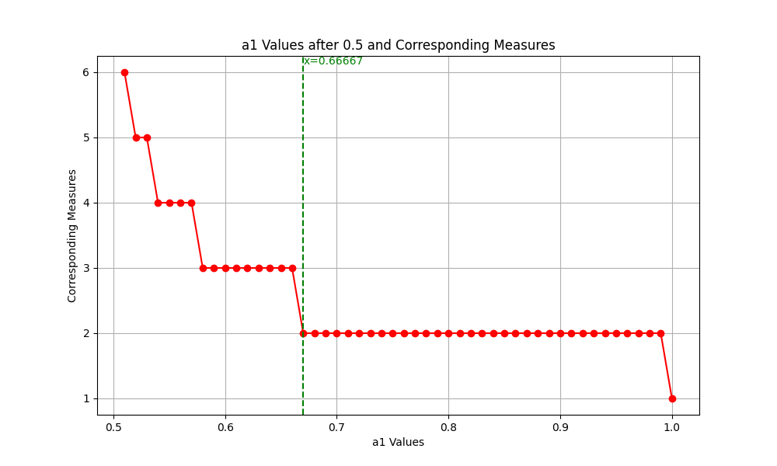

Figure 1 The number of washing times corresponding to different $a_{k}$ (part)

The graph indicates that when ${a^{p}}_{min}=0.6667$, which corresponds to exactly 2 washes, the minimum solubility is 0.6667. It is also evident that when $a_{k}$ is between 0.58 and 0.6667, the number of washes required to completely remove the dirt is 3; when $a_{k}$ ​ is between 0.54 and 0.58, it takes 4 washes; when ${ a}_{k}$ is between 0.52 and 0.54, it takes 5 washes; and when $a_{k}$ is around 0.5, it takes 6 washes.

Next, under the premise that W = 500L, we discuss the impact when $a_{k}≤0.6667$, specifically solving for the following two scenarios,

(i) Can't completely remove dirt

Using the Monte Carlo algorithm, formulas (9) - (11) are solved, where for ${0.50<a}_{k}<0.6667$, the results are as shown in Figure 1. The following table shows the dirt residue after 10 washes when $a_{k}<0.50$

Table 3: Dirt Residue After 10 Washes When $a_{k}<0.50$ (Partial)

|  |  |  |  |  |  |
| --- | --- | --- | --- | --- | --- |
| $$a_{k}$$ | 0.1 | 0.2 | 0.3 | 0.4 | 0.49 |
| Dirt residue | 8.00195 | 6.00390 | 4.00586 | 2.00781 | 0.20957 |

Note: For complete data, refer to the supplementary materials.

The table shows that the smaller the value of $a_{k}=0.50$, the greater the amount of dirt residue. With an initial dirt quantity of 10g, when $a_{k}=0.1$, the dirt residue is 8.00195g; when $a_{k}=0.2$, the residue is 6.00390g; when $a_{k}=0.3$ it is 4.00586g; when $a_{k}=0.4$ it is 2.00781g; and when $a_{k}=0.49$, the residue is 0.20957g.

(ii) Ability to Completely Remove Dirt but Constrained by Water Volume

For this scenario, the residual dirt quantity after 10 washes is calculated using formula (12). The results are as shown in the following table,

Table **4: Dirt Residue After 10 Washes When $a_{k}>0.50$ (Partial)**

|  |  |  |
| --- | --- | --- |
| $$a_{k}$$ | 0.50 | 0.51 |
| Dirt residue | 0.00977 | 0 |

Note: See supporting materials for complete data

The table indicates that with an initial dirt quantity of 10g, when $a_{k}=0.50$ the dirt residue is 0.00977g, and when $a_{k}=0.51$, the dirt residue is 0g.

(Three)Discussing the Impact of Initial Dirt Quantity

Based on the above analysis, this paper sets an upper limit of 10g for the dirt quantity and 500L for the available water quantity. The Monte Carlo algorithm is applied to solve formulas (9) - (10), and the results obtained are as shown in the following figure,

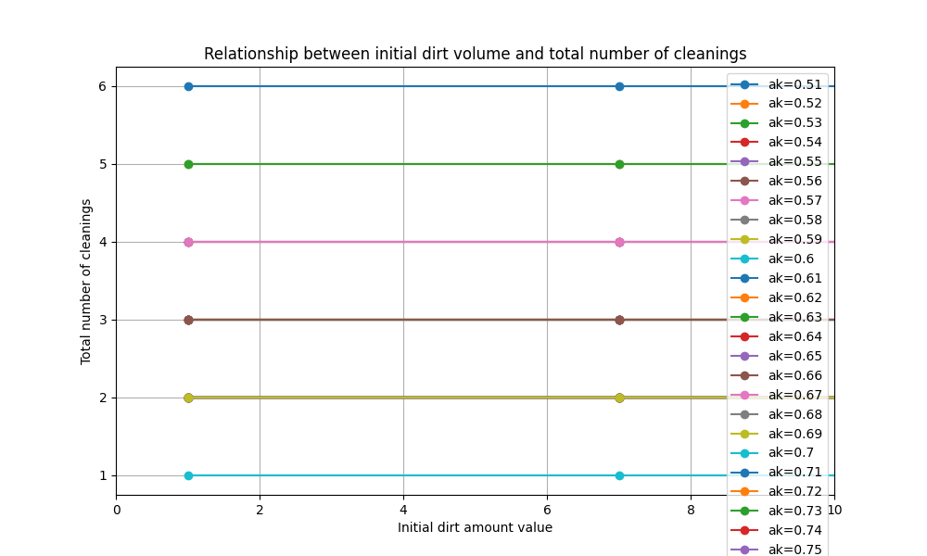

Figure 2 Relationship between initial dirt vilume and total number of cleanings

The graph shows that when $a_{k}$ is fixed, the number of washes required to completely clean different masses of initial dirt is the same. Therefore, varying initial dirt quantities do not influence the washing method.

(Four)Discussion on the Impact of Available Water

(1) When Water is Abundant

Given an initial amount of dirt, under the condition of a fixed $a_{k}$, the Monte Carlo algorithm is used to solve equation (8). This process determines the number of washes needed to completely remove the dirt or to meet the cleaning standard for different values of $a_{k}$. The results are shown in Figure 1 above.

(2) When Water Quantity is Fixed

With a limit of 500L of available water and an initial dirt amount of 10g, we analyze the impact of different $a_{k}$ values on the cleaning effectiveness. The results are shown in the figure below,

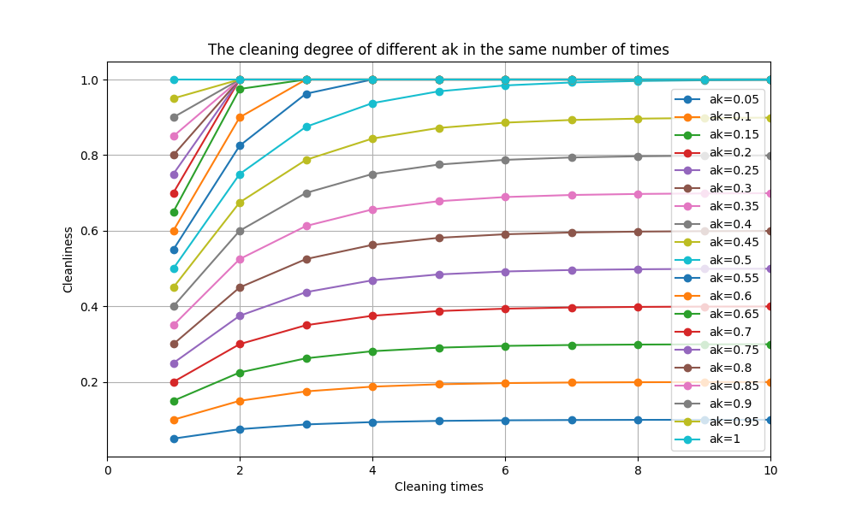

Figure 3 The cleaning degree of different ak in the same number of times

The graph shows that under the condition of a fixed water quantity, when $a_{k}$ is greater than 0.5, multiple cleaning cycles can achieve the required cleaning standard. However, when $a_{k}$ is less than 0.5, as $a_{k}$ decreases, the final cleaning effectiveness also diminishes, and the amount of dirt removed in each cleaning cycle is reduced.

## 4.2 Problem 2

4.2.1 Model Building

(One) The most time-saving cleaning solution

The problem assumes that each washing takes the same amount of time and requires the identification of the most time-efficient cleaning strategy. Therefore, this is essentially a problem of finding the solution with the minimum number of washes, similar to problem one. Additionally, there are no limitations on the availability of water for this problem, and the termination condition is defined as the dirt residue not exceeding one-thousandth of the initial amount of dirt. Hence, a nonlinear integer programming model can be established. The objective function is to minimize the number of washes, which is expressed as

$$\begin{aligned}\min{k}\#\left(16\right)\end{aligned}$$

With the constraint that the dirt residue does not exceed one-thousandth of the initial amount of dirt, which is expressed as

$$\begin{aligned}D_{k}<\frac{D}{1000}\#\left(17\right)\end{aligned}$$

Other conditions are the same as in problem one, leading to the following formulation:

$$\begin{aligned}s.t.\left\{\begin{aligned}D_{k}<\frac{D}{1000} \\ D_{k}=D-\sum_{k=1}^{k}{a_{1}⋅D}×{0.5}^{k-1} \\ a_{1}=0.8 \\ a_{k}=0.5a_{k-1} \\ k≥1\end{aligned}\right.\#\left(19\right)\end{aligned}$$

(Two) Discuss the impact of $a_{k}$

Removing the previously mentioned constraint of $a_{1}=0.8$, results in the following:

$$\begin{aligned}\left\{\begin{aligned}D_{k}<\frac{D}{1000} \\ D_{k}=D-\sum_{k=1}^{k}{a_{1}⋅D}×{0.5}^{k-1} \\ a_{k}=0.5a_{k-1} \\ k≥1\end{aligned}\right.\#\left(20\right)\end{aligned}$$

Solve for the minimum solubility $a_{min}$ that just meets the cleaning standard. Additionally, determine the number of washes required to meet the cleaning standard when $a_{k}>a_{min}$.

(Three) Discuss the influence of initial dirt amount

The model is the same as in problem one. Furthermore, it is known from the results of problem one that, when $a_{k}$ is fixed, the number of washes required to clean different initial dirt masses is the same. Therefore, varying initial dirt masses do not influence the washing method.

4.2.2 Model Solution and Results

(One) The most time-saving cleaning solution

From Problem 1, it is known that when a_k equals 0.8, only two washes are required to completely clean. Since the time required for each wash is the same, the most time-efficient cleaning plan remains two washes.

(Two) Discuss the impact of $a_{k}$

The Monte Carlo algorithm is used to solve equation (20) to find the minimum solubility $a_{min}$, and the results are presented in the following figure,

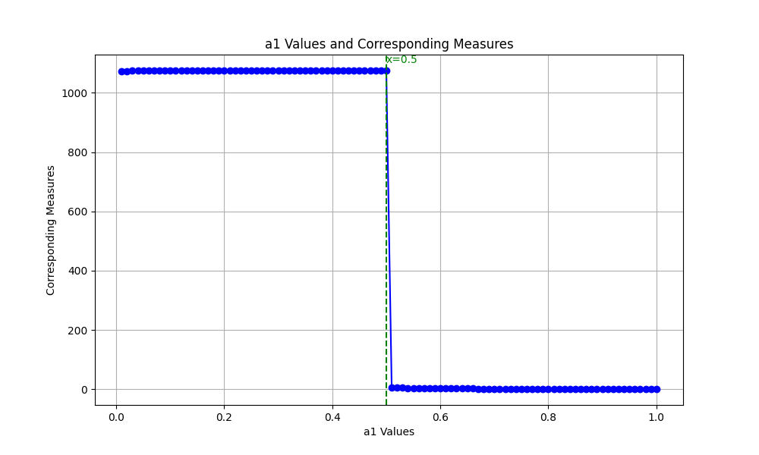

Figure 4 a1 Values and Corresponding Measures

As shown in the graph, under the condition of sufficient water, when $a_{k}$ is approximately equal to 0.5, the cleaning process is just sufficient. To determine a more precise value, the range of 0.44-0.50 is selected for further calculation. The results are presented in the following figure,

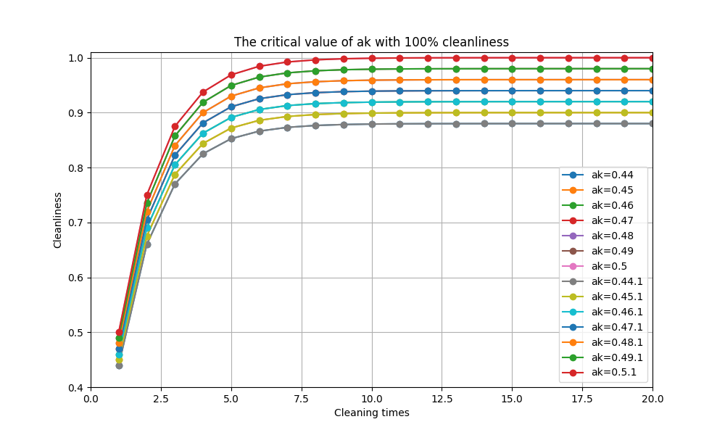

Figure 5 The critical value of ak with 100%cleanliness

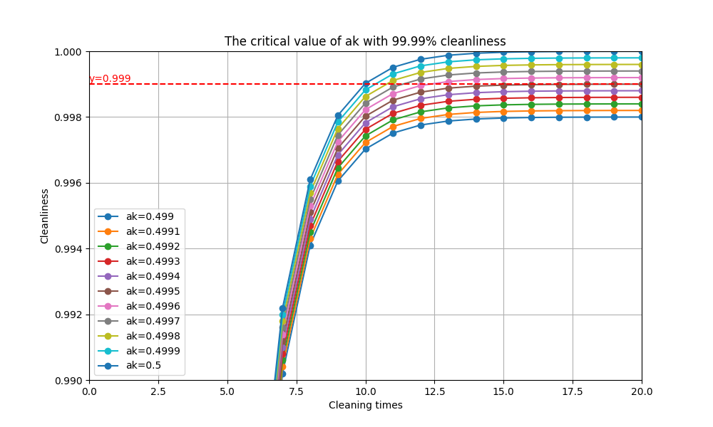

Figure 6 The critical value of ak with 99.99%cleanliness

According to the graph, when using only a single detergent, the solubility $a_{k}$ that just achieves a one-thousandth concentration is 0.4995. It is also observed that when $a_{k}$ is between 4.4 and 4.9995, the cleaning effectiveness increases with an increase in $a_{k}$, but it does not reach 99.9%, which means it cannot meet the one-thousandth standard. This indicates that using a single detergent alone is insufficient for cleaning.

The following discussion further addresses $a_{k}$ in two scenarios:

(i)when $a_{k}≥0.4995$

Solving equation (11) yields the number of washes required to meet the cleaning standards for different values of $a_{k}$. The results are shown in the table below:

Table 5: Number of Washes Required to Meet Cleaning Standards for $a_{k}≥0.4995$

|  |  |  |  |  |  |
| --- | --- | --- | --- | --- | --- |
| $$a_{k}$$ | 0.4995 | 0.4996 | 0.4997 | 0.4998 | 0.4999 |
| k-th | 21 | 13 | 12 | 11 | 11 |

According to the table, when $a_{k}=0.4995$, the number of washes required to meet the cleaning standard is 21. When $a_{k}=0.4996$, it takes 13 washes to meet the standard; for $a_{k}=0.4997$, it takes 12 washes; when $a_{k}=0.4998$, the required number of washes is 11; and similarly, for $a_{k}=0.4999$, it also takes 11 washes to reach the cleaning standard.

## 4.3 Problem 3

4.3.1 Model Building

To simplify the problem, this paper assumes that the 36 pieces of clothing given in the problem can all be washed together, treating the 36 items as a single entity. Suppose the total number of washes is N, and an equal amount of detergent is used in each wash, denoted as A. We further assume A=10g.

The problem requires providing the most cost-effective cleaning solution. Therefore, this paper establishes a nonlinear integer programming model with the objective of minimizing the costs of detergent and water, which is

$$\begin{aligned}\min{\sum_{i=1}^{8}{A⋅m_{i}n_{i}}}+3.8M\#\left(21\right)\end{aligned}$$

In this model, i represents the i-th type of detergent, j represents the j-th type of dirt, and $n_{i}$ represents the number of times the i-th type of detergent is used, which must satisfy

$$\begin{aligned}N=\sum_{i=1}^{10}{n_{i}}\#\left(22\right)\end{aligned}$$

$$\begin{aligned}n_{i}≥0,n_{i}∈Z^{+}\#\left(23\right)\end{aligned}$$

In the model, $M$ represents the unit price of the i-th type of detergent, and M represents the total water usage in tons. Given the assumption that each wash uses 50L of water, it follows that

$$\begin{aligned}M=\frac{50N}{1000}\#\left(24\right)\end{aligned}$$

In order to define a standard for cleanliness, this paper refers to Problem 2, adopting the criterion that the dirt residue should be less than one-thousandth of the initial dirt quantity. Consequently, the constraint is that after N washes, the residue of the j-th type of dirt should be less than the initial residue of that type of dirt, which is

$$\begin{aligned}D_{jN}≤\frac{D_{j}}{1000}\#\left(25\right)\end{aligned}$$

Since different types of dirt have different solubilities in various detergents, this paper denotes the solubility of the j-th type of dirt in the i-th type of detergent as $a_{ij}$ Thus, after N washes, the relationship satisfied by the residue of the j-th type of dirt is

$$\begin{aligned}D_{jN}=D_{j}\left(1-\sum_{n=1}^{n_{1}}{a_{1j}⋅{0.5}^{n-1}}\right)\left(1-\sum_{n=1}^{n_{2}}{a_{2j}⋅{0.5}^{n-1}}\right)…\left(1-\sum_{n=1}^{n_{10}}{a_{10j}⋅{0.5}^{n-1}}\right)\#\left(26\right)\end{aligned}$$

Regarding the above equation, it is apparent that the order of adding multiple detergents does not affect the final outcome of the washing. To prove this conclusion, the paper briefly provides the following proof:

Taking two types of detergents as an example, suppose the solubility of detergent 1 is $a_{1}$ ​, and it is used for $n_{1}$ times, while the solubility of detergent 2 is $a_{2}$, and it is used for $n_{2}$ times. Since the types of detergents used are different, their effects can be likened to cleaning directions in two different dimensions, as shown in the following figure,

Figure 7 Explores the impact of different addition orders of detergents on the final results

In one direction, the remaining quantity is given by

$$\begin{aligned} 1-\sum_{n=1}^{n_{1}}{a_{1}⋅{0.5}^{n-1}}\#\left(27\right)\end{aligned}$$

In the other direction, the remaining quantity is

$$\begin{aligned}1-\sum_{n=1}^{n_{2}}{a_{2}⋅{0.5}^{n-1}}\#\left(28\right)\end{aligned}$$

So then the remaining dirt amount is

$$\begin{aligned}D\left(1-\sum_{n=1}^{n_{1}}{m⋅{0.5}^{n-1}}\right)\left(1-\sum_{n=1}^{n_{2}}{n⋅{0.5}^{n-1}}\right)\#\left(29\right)\end{aligned}$$

Here's the English translation of the section from your mathematical modeling paper for the international competition:

The results are the same as those achieved by washing in sequence, conforming to the original equation (26).

When there are three types of detergents, this can be analogized to cleaning directions in three dimensions, and the proportion of dirt removed in each direction is the same for the final result. When there are n types of detergents, it can be viewed as having n dimensions of cleaning directions, with each cleaning direction removing a proportion of dirt as when these n detergents are used a fixed number of times, the final result still holds. Therefore, in this model, it can be concluded that the order of adding detergents does not affect the final outcome of the washing.

In summary, for solving the problem of finding the most cost-effective cleaning solution, the formula is as follows,

$$\begin{aligned}\min{\sum_{i=1}^{8}{A⋅m_{i}n_{i}}}+3.8M\#\left(30\right)\end{aligned}$$

$$\begin{aligned}s.t.\left\{\begin{aligned}N=\sum_{i=1}^{10}{n_{i}} \\ n_{i}≥0,n_{i}∈Z^{+} \\ M=\frac{50N}{1000} \\ D_{jN}≤\frac{D_{j}}{1000} \\ D_{jN}=D_{j}\left(1-\sum_{n=1}^{n_{1}}{a_{1j}⋅{0.5}^{n-1}}\right)\left(1-\sum_{n=1}^{n_{2}}{a_{2j}⋅{0.5}^{n-1}}\right)…\left(1-\sum_{n=1}^{n_{10}}{a_{10j}⋅{0.5}^{n-1}}\right)\end{aligned}\right.\#\left(31\right)\end{aligned}$$

4.3.2 Model Solution and Results

To solve the above nonlinear integer programming model, this paper employs the Particle Swarm Optimization algorithm [3]. The core idea of this algorithm is to use the sharing of information among individuals in a group, allowing the group's motion in the problem-solving space to evolve from disorder to order, thereby obtaining feasible solutions for the problem.

To prevent the Particle Swarm Optimization algorithm from getting trapped in local optima in this paper, we have employed an adaptive neighborhood model of Particle Swarm Optimization. This model allows the swarm to be divided into several different subgroups, facilitating search in multiple areas and avoiding local optima, thus aiming to find a globally optimal solution [4].

（One）Solution Steps and Flowchart

$$\begin{aligned}v_{i}^{d}=wv_{i}^{d-1}+c_{1}r_{1}\left(p_{i}^{d}-x_{i}^{d}\right)+c_{2}r_{2}\left(g_{i}^{d}-x_{i}^{d}\right)\#\left(32\right)\end{aligned}$$

Where $r_{1},r_{2}$ are random numbers between [0,1].

***Step1***: Selection of default parameters

（1）Number of particles：min{100,10*nvars}, where nvars is the number of variables.

（2）Inertia weight：[0.1,1.1]，Note that the inertia weight will adaptively adjust during the iteration process.

（3）Cognitive learning factor：1.49

（4）Social learning factor：1.49

（5）Proportion of particles within the neighborhood：0.25

(6) Minimum number of particles in the neighborhood： minNeighborhoodSize =max{2, The integer part of (number of particles * proportion of particles in the neighborhood) }，At the start of the iteration, each particle has a neighborhood, initially set to the "minimum neighborhood particle number," which adaptively adjusts during subsequent iterations.

***Step2***: Variable Initialization and Fitness Calculation

（1）Velocity initialization: vmax =ub – lb； v=‐vmax +2*vmax .*rand(n,narvs);

（2）Position initialization: Each particle's position is uniformly distributed within the upper and lower bound constraints.

（3）Calculate each particle's fitness: Fitness is still set as the target function we want to optimize.

（4）Initialize the personal best position: The position after initialization.

（5）Initialize the global best position for all particles: The particle with the lowest fitness becomes the best position for all particles.

Step3: Update Particle Velocity and Position

Update each particle's information in each iteration.

（1）Randomly generate a neighborhood for particle i, containing Q particles (including particle i), and find the best-positioned particle among them; this particle has the minimum objective function value, denoted as lbest.

（2）Update the velocity for particle i using the formula: v = w*v + c1*u1*(pbest‐x) + c2*u2*(lbest‐x)

（3）Update the velocity for particle i using the formula: x=x+v，similar to the basic Particle Swarm Optimization algorithm.

（4）Correct the position and velocity: If particle i's position exceeds the constraints, adjust it to the boundary; additionally, if the particle's position is at the boundary, ensure its velocity does not exceed the maximum allowed, otherwise set the velocity to zero.

（5）Calculate the fitness for particle i; if it is less than its historical best fitness, update its historical best position to its current position. Also, determine if particle i's fitness is less than the smallest fitness found by all particles so far, and if so, update the best position for all particles to particle i's position.

***Step4***: Adaptive Parameter Adjustment

Assuming that after the d-th iteration, all particles' information has been updated, it's necessary to update the model parameters before starting the next iteration, which reflects the adaptive process.

The rules are as follows: Let the current minimum fitness of all particles be a, and the minimum fitness of all particles after the previous iteration be b. Compare the relative size of a and b; if a < b, then set flag = 1; otherwise, set flag = 0. If flag = 0, perform the following operations:

（1）Update c=c+1 ；here, c represents the "stagnation counter," initially set to 0 at the beginning of the iteration.

（2）Update Q = min{Q+ minNeighborhoodSize, SwarmSize} ；Q: number of particles in the neighborhood; minNeighborhoodSize: minimum number of particles in the neighborhood; SwarmSize: total number of particles.

If flag = 1, perform the following operations：

（1）Update Q = minNeighborhoodSize

（2）Update c = max{c‐1, 0}

（3）Consider the value of c，ifc<2，then update w = 2*w； ifc>5，thenupdate w = w/2；Here, w is the inertia weight, and if the calculated result exceeds the upper or lower bounds of the inertia weight, it should be adjusted to the boundary.

Step5: Automatic Termination of the Iteration Loop

## 4.4 Problem 4

4.4.1 Model Building

（One）Grouping of Clothing

Referring to problem three, assuming a maximum of 36 garments can be washed at once, it is considered to divide the 132 garments given in this problem into four groups. Due to the different materials of the clothing, some materials cannot be mixed in the wash, hence the first step is to group the garments by material.

（1）Grouping by Material

Table 7 Restrictions on washing mixed laundry of different materials

|  |  |  |  |  |  |  |  |  |
| --- | --- | --- | --- | --- | --- | --- | --- | --- |
| material | 1 | 2 | 3 | 4 | 5 | 6 | 7 | 8 |
| 1 |  | × | √ | √ | √ | √ | × | × |
| 2 |  |  | × | × | × | × | × | √ |
| 3 |  |  |  | × | × | √ | √ | √ |
| 4 |  |  |  |  | × | √ | √ | √ |
| 5 |  |  |  |  |  | × | √ | √ |
| 6 |  |  |  |  |  |  | √ | √ |
| 7 |  |  |  |  |  |  |  | √ |
| 8 |  |  |  |  |  |  |  |  |

The table indicates that Material 2 can only be mixed with Material 8 for washing, and Material 7 can be mixed with Materials 6 and 8. The remaining Materials 1, 3, 4, 5, and 6 can all be washed together. Therefore, in grouping, priority is given to Materials 2 and 7 to cover as many grouping possibilities as possible. The proposed grouping method is as follows, with the results shown in the table below:

Table 8 Grouping of materials

|  |  |
| --- | --- |
| Constituencies | material |
| First | 1、3、4、5、6 |
| Second | 3、4、5、6、8 |
| Third | 2、8 |
| fourth | 6、7、8 |

From the above table, it is evident that the same material can be distributed into different groups. However, there are also cases where a material is allocated to only one group. For instance, Material 1 is only assigned to the first group, Material 2 to the third group, and Material 7 to the fourth group.

(2) Grouping Clothing by Material

Based on the grouping of materials, priority is given to grouping the garments made of Materials 1, 2, and 7. Then, the rest of the clothes are grouped randomly.

Random Allocation: Initialize four empty arrays, named group1, group2, group3, and group4. The original data, where each row represents a garment, is randomly reordered. After completely assigning the fixed materials 1, 2, and 7, each row is checked in sequence. If a garment meets the conditions for a group, it is assigned to that group; if not, it is checked against the next group’s conditions until all 83 flexibly allocatable garments out of the 132 are assigned.

(Two) For a Given Scenario, Calculate the Amount of Dirt for Each Group

Assuming a specific scenario as shown in the table below,

Table 9 A certain situation of clothing grouping

|  |  |  |  |  |  |
| --- | --- | --- | --- | --- | --- |
| Constituencies | The material and the corresponding amount of clothing | | | | |
| First | material1 | material3 | material4 | material5 | material6 |
| $$C_{11}$$ | $$C_{12}$$ | $$C_{13}$$ | $$C_{14}$$ | $$C_{15}$$ |
| Second | material3 | material4 | material5 | material6 | material8 |
| $$C_{21}$$ | $$C_{22}$$ | $$C_{23}$$ | $$C_{24}$$ | $$C_{25}$$ |
| Third | material2 | material8 | \ | \ | \ |
| $$C_{31}$$ | $$C_{32}$$ | \ | \ | \ |
| fourth | material6 | material7 | material8 | \ | \ |
| $$C_{41}$$ | $$C_{42}$$ | $$C_{43}$$ | \ | \ |

The table shows that the amount of dirt for the first group is the sum of the dirt amounts from Materials 1, 3, 4, 5, and 6. Specifically, the dirt amount for Material 1 in the first group corresponds to the dirt amount for $C_{11}$ pieces of clothing, which is expressed as

$$\begin{aligned}\sum_{c_{i}=1}^{C_{11}}{b_{1c_{i}}⋅d_{1c_{i}}}\#\left(33\right)\end{aligned}$$

Similarly, the dirt amount for Material 2 in the first group satisfies the following formula:

$$\begin{aligned}\sum_{c_{i}=1}^{C_{12}}{b_{1c_{i}}⋅d_{1c_{i}}}\#\left(34\right)\end{aligned}$$

It is evident that the total amount of dirt for the first group satisfies the formula:

$$\begin{aligned}D_{1j}=\sum_{c_{i}=1}^{C_{11}}{b_{1c_{i}}⋅d_{1c_{i}}}+\sum_{c_{i}=1}^{C_{12}}{b_{1c_{i}}⋅d_{1c_{i}}}+\sum_{c_{i}=1}^{C_{13}}{b_{1c_{i}}⋅d_{1c_{i}}}+\sum_{c_{i}=1}^{C_{14}}{b_{1c_{i}}⋅d_{1c_{i}}}+\sum_{c_{i}=1}^{C_{15}}{b_{1c_{i}}⋅d_{1c_{i}}} \\ =\sum_{s=1}^{5}{\sum_{c_{i}=1}^{C_{1s}}{b_{1c_{i}}⋅d_{1c_{i}}}}\#\left(35\right)\end{aligned}$$

Similarly, the amount of dirt for the second group is calculated as follows:

$$\begin{aligned}D_{2j}=\sum_{s=1}^{5}{\sum_{c_{i}=1}^{C_{2s}}{b_{1c_{i}}⋅d_{1c_{i}}}}\#\left(36\right)\end{aligned}$$

The third group is

$$\begin{aligned}D_{3j}=\sum_{c_{i}=1}^{C_{31}}{b_{1c_{i}}⋅d_{1c_{i}}}+\sum_{c_{i}=1}^{C_{32}}{b_{1c_{i}}⋅d_{1c_{i}}}=\sum_{s=1}^{2}{\sum_{c_{i}=1}^{C_{3s}}{b_{1c_{i}}⋅d_{1c_{i}}}}\#\left(37\right)\end{aligned}$$

The thourth group is

$$\begin{aligned}D_{4j}=\sum_{s=1}^{3}{\sum_{c_{i}=1}^{C_{4s}}{b_{1c_{i}}⋅d_{1c_{i}}}}\#\left(38\right)\end{aligned}$$

(Three) Determining the Washing Cost for Different Scenarios and Selecting the Optimal Solution

Calculate for each group using the method described in problem three.

$$\begin{aligned}\min{\sum_{i=1}^{8}{A⋅m_{i}n_{i}}}+3.8M\#\left(39\right)\end{aligned}$$

$$\begin{aligned}s.t.\left\{\begin{aligned}N=\sum_{i=1}^{10}{n_{i}} \\ n_{i}≥0,n_{i}∈Z^{+} \\ M=\frac{50N}{1000} \\ D_{jN}≤\frac{D_{j}}{1000} \\ D_{qjN}=D_{qj}\left(1-\sum_{n=1}^{n_{1}}{a_{1j}⋅{0.5}^{n-1}}\right)\left(1-\sum_{n=1}^{n_{2}}{a_{2j}⋅{0.5}^{n-1}}\right)…\left(1-\sum_{n=1}^{n_{10}}{a_{10j}⋅{0.5}^{n-1}}\right)\end{aligned}\right.\#\left(40\right)\end{aligned}$$

4.4.2 Model Solution and Results

Utilize the Particle Swarm Optimization algorithm to solve equation (40) and calculate the cost-effective suboptimal solution for each group. Then, employ the Monte Carlo [5] algorithm for 1000 iterations to determine the optimal solution. The results of the iterations are shown in the following figure:

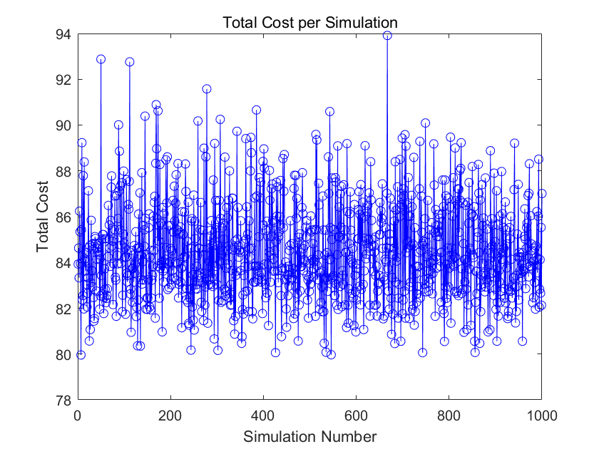

The graph shows that over 1000 iterations, the average cost is primarily around 84 Yuan, with the lowest cost reaching below 80 Yuan. Due to the large number of iterations and the multitude of scenarios, this paper will not enumerate each one. Below, only the results of the optimal scenario are presented.

1. Grouping Clothing by Material

Table 10 Clothing grouping results (optimal situation)

|  |  |  |  |
| --- | --- | --- | --- |
| Group1 | Group2 | Group3 | Group4 |
| 19、20、11、  12、36、124、  123、103、49、  104、99、70、  80、100、53、  56、50、125、  57、27、32、  25、7、67、  106、54、1、  9、23、29、  4、96、72、  47、118、102 | 111、115、22、  119、31、64、  116、65、112、  24、89、84、  108、120、55、  94、130、113、  83、15、2、  39、37、126、  105、48、28、  87、93、42、  107、60、63、  73、3、58 | 44、110、43、  129、40、17、  52、10、61、  90、109、92、  45、16、21、  88、122、8、  77、82 | 75、34、26  33、81、114、  59、78、71、  68、62、95、  46、18、97、  35、98、79、  69、5、132 |

(二) Amount of dirt in each group

According to equations (35) to (38), the amount of dirt for each material in each group is calculated, as shown in the table below:

Table 11 Amount of dirt in each group (optimal situation)

|  |  |  |  |
| --- | --- | --- | --- |
| Group1 | Group2 | Group3 | Group4 |
| 120 | 144 | 62 | 86 |
| 125 | 144 | 51 | 77 |
| 116 | 104 | 48 | 57 |
| 104 | 111 | 69 | 60 |
| 138 | 109 | 60 | 83 |
| 123 | 130 | 71 | 66 |
| 123 | 109 | 51 | 67 |
| 116 | 109 | 68 | 64 |

The table indicates that the amount of dirt for each material in each group is approximately equal, suggesting that the grouping in this scenario is reasonably balanced.

(Three)Washing costs

Substituting the above results into equations (39) and (40), and using the Particle Swarm Optimization algorithm as in problem three, the results of the solution are as follows：

Table 12 Washing scheme (optimal situation)

|  |  |  |  |
| --- | --- | --- | --- |
| Group1 | Group2 | Group3 | Group4 |
| 1 | 1 | 1 | 1 |
| 2 | 1 | 2 | 2 |
| 2 | 3 | 1 | 2 |
| 0 | 1 | 1 | 1 |
| 2 | 3 | 2 | 1 |
| 2 | 2 | 2 | 2 |
| 2 | 2 | 1 | 2 |
| 1 | 1 | 1 | 0 |
| 1 | 0 | 1 | 1 |
| 1 | 1 | 1 | 1 |

The table reveals that in the first group, the first to tenth types of detergents were used for washing 1, 2, 2, 0, 2, 2, 2, 1, 1, and 1 times, respectively. In the second group, they were used 1, 1, 3, 1, 3, 2, 2, 1, 0, and 1 times, respectively. In the third group, the usage was 1, 2, 1, 1, 2, 2, 1, 1, 1, and 1 times, respectively. For the fourth group, the detergents were used 1, 2, 2, 1, 1, 2, 2, 0, 1, and 1 times, respectively.

Table 13 Laundry cost results

|  |  |  |  |  |
| --- | --- | --- | --- | --- |
| Group1 | Group2 | Group3 | Group4 | Total Cost |
| 19.77 | 20.07 | 20.36 | 16.67 | 79.87 |

The table shows that the cost for the first group is 19.77 Yuan, the second group is 20.07 Yuan, the third group is 20.36 Yuan, and the fourth group is 16.67 Yuan, with a total cost of 79.87 Yuan.

# 5. Model Evaluation

## 5.1 Advantages of the Model

(1) This paper applies the Monte Carlo algorithm and Particle Swarm Optimization algorithm, among others, dealing with a large volume of data, which makes the results more realistic and reliable

(2) The model established in this paper can be applied to a wide range of specific laundry scenarios, demonstrating its broad applicability.

## 5.2 Disadvantages of the Model

(1) The response to the initial amount of dirt is not significant, and there may be substantial deviations in extreme cases.

(2) The model may produce deviations when a large variety of detergents are used.

# References

[1] nqi Li, Feng Yang, Reha Uzsoy, Jie Xu,A metamodel-based Monte Carlo simulation approach for responsive production planning of manufacturing systems,Journal of Manufacturing Systems,Volume 38,2016,Pages 114-133,ISSN 0278-6125,

[2] Kabiri, N.N., Emami, S. & Safaei, A.S. Simulation–optimization approach for the multi-objective production and distribution planning problem in the supply chain: using NSGA-II and Monte Carlo simulation. Soft Comput 26, 8661–8687 (2022).

[3]KennedyJ,Eberhart R .Particle swarm optimization[C]//Proceedings of ICNN'95 - International Conference on Neural Networks. IEEE, 1995

[4] 钱锋《粒子群算法及其工业应用 》科学出版社，2013，P34

[5] Vaidya, O.B., DSouza, R.T., Dhavala, S., Saha, S., Das, S. (2023). HMC-PSO: A Hamiltonian Monte Carlo and Particle Swarm Optimization-Based Optimizer. In: Tanveer, M., Agarwal, S., Ozawa, S., Ekbal, A., Jatowt, A. (eds) Neural Information Processing. ICONIP 2022. Lecture Notes in Computer Science, vol 13623. Springer, Cham.

# Appendix

## 1 Support material

Code

Picture

Data

The result of the fourth question

The result of the third question

## 2 Appendix I

|  |  |  |  |  |  |  |  |  |  |  |  |
| --- | --- | --- | --- | --- | --- | --- | --- | --- | --- | --- | --- |
|  | The first | The second | The third | The fourth | The fifth | The sixth | The seventh | The eighth | The ninth | The tenth | Total cost |
| 1 | 1 | 2 | 2 | 1 | 1 | 2 | 2 | 0 | 1 | 1 | 20.07 |
| 2 | 0 | 3 | 1 | 1 | 2 | 2 | 2 | 1 | 1 | 2 | 21.85 |
| 3 | 2 | 2 | 1 | 1 | 4 | 2 | 1 | 1 | 0 | 1 | 22.35 |
| 4 | 1 | 2 | 2 | 1 | 1 | 2 | 1 | 1 | 1 | 1 | 19.97 |
| 5 | 0 | 2 | 3 | 2 | 2 | 2 | 1 | 1 | 1 | 1 | 21.65 |
| 6 | 1 | 2 | 2 | 1 | 2 | 2 | 2 | 1 | 0 | 1 | 20.36 |
| 7 | 1 | 2 | 2 | 1 | 2 | 2 | 1 | 1 | 0 | 2 | 21.36 |
| 8 | 1 | 2 | 2 | 1 | 2 | 1 | 1 | 1 | 1 | 1 | 19.77 |
| 9 | 1 | 2 | 2 | 1 | 1 | 1 | 2 | 0 | 1 | 2 | 21.27 |
| 10 | 1 | 1 | 3 | 1 | 2 | 3 | 1 | 0 | 1 | 1 | 21.06 |
| 11 | 0 | 2 | 3 | 1 | 2 | 1 | 2 | 1 | 2 | 1 | 21.75 |
| 12 | 1 | 2 | 2 | 1 | 2 | 2 | 2 | 1 | 0 | 1 | 20.36 |
| 13 | 1 | 1 | 3 | 0 | 2 | 3 | 2 | 1 | 1 | 1 | 21.65 |
| 14 | 1 | 1 | 2 | 2 | 1 | 2 | 2 | 0 | 1 | 1 | 21.07 |
| 15 | 1 | 2 | 3 | 1 | 2 | 2 | 1 | 0 | 1 | 1 | 20.96 |
| 16 | 1 | 2 | 2 | 2 | 3 | 1 | 1 | 2 | 0 | 1 | 22.15 |
| 17 | 1 | 3 | 1 | 1 | 1 | 1 | 2 | 1 | 1 | 1 | 19.97 |
| 18 | 1 | 1 | 2 | 1 | 1 | 1 | 2 | 1 | 2 | 1 | 21.07 |
| 19 | 1 | 2 | 2 | 0 | 1 | 2 | 2 | 1 | 1 | 2 | 21.66 |
| 20 | 0 | 2 | 1 | 2 | 2 | 2 | 2 | 2 | 1 | 1 | 21.75 |

## 3 Appendix II

|  |
| --- |
| **code1** |
| matlab：Applying Monte Carlo simulation to solve integer nonlinear programming models |
| 1. function [bestStrategy, cleanedAmounts] = findOptimalCleaningStrategy(D_parts, X, W, a1) 2. % Parameter initialization 3. maxCleans = W / 50; 5. numParts = length(D_parts); 6. cleansUsed = 0; 7. Dk = D_parts; 8. bestStrategy = zeros(1, maxCleans); 9. cleanedAmounts = zeros(1, maxCleans); % Stores the amount of dirt removed by each cleaning 10. cleansCount = zeros(1, numParts); % Store the number of washes for each part 11. % Simulating different cleaning strategies under water constraints 12. while cleansUsed < maxCleans 13. maxClean = 0; 14. selectedPart = 0; 15. % Select the part to clean that removes the most dirt 16. for i = 1:numParts 17. if Dk(i) > 0 18. cleanPower = X; 19. if i == numParts  %For the last part, use the actual amount of dirt 20. cleanPower = D_parts(i); 21. end 22. potentialClean = cleanPower * a1 * 0.5^cleansCount(i); % Calculate the amount of dirt that may be removed 23. currentClean = min(Dk(i), potentialClean); % Make sure the amount of remaining dirt is not exceeded 24. if currentClean > maxClean 25. maxClean = currentClean; 27. selectedPart = i; 28. end 29. end 30. end 31. % If there are no parts to clean, terminate the cycle 32. if selectedPart == 0 33. break; 34. end 35. % Update cleaning strategy, dirt volume and dirt removal volume 36. bestStrategy(cleansUsed + 1) = selectedPart; 37. cleanedAmounts(cleansUsed + 1) = maxClean; 38. Dk(selectedPart) = Dk(selectedPart) - maxClean; 39. cleansCount(selectedPart) = cleansCount(selectedPart) + 1; 40. cleansUsed = cleansUsed + 1; 41. end 42. end 43. %%%%%%%%%dividing line%%%%%%%%% 44. % parameter settings 45. D_parts = 10; % initial dirt amount 46. X = 1000; % Detergent amount 47. W = 500; % Amount of water available 48. W= fix(W/50) * 50; 49. a1 = 0.8; % cleaning efficiency factor 50. % Find the optimal cleaning strategy 51. [optimalStrategy, cleanedAmounts] = findOptimalCleaningStrategy(D_parts, X, W, a1); 52. % Output results 53. %disp('Optimal Cleaning Strategy (Part Chosen per Step):'); 54. %disp(optimalStrategy); 55. disp('Cleaned Amounts per Step:'); 56. disp(cleanedAmounts); 57. nonZeroCount = nnz(cleanedAmounts); 58. disp('Number of non-zero cleaned amounts:'); 59. disp(nonZeroCount); |

|  |
| --- |
| **code2** |
| matlab：Change the value of ak based on Monte Carlo |
| 1. % parameter settings 2. D_parts = 10; % initial dirt amount 3. X = 1000; % Detergent amount 4. W = 1100*50; % Amount of water available 5. W = fix(W/50) * 50; % Ensure that W is a multiple of 50 6. a1_values = 0:0.01:1; % Assume that a1 ranges from 0 to 1 with a step size of 0.1 7. % Initialize variables 8. nonZeroCounts = zeros(size(a1_values)); % Used to store the nonZeroCount corresponding to each a1 value 9. cleanedAmountsMatrix = []; % Used to store Cleaned Amounts per Step under each a1 value 10. % Loop through different a1 values 11. for i = 1:length(a1_values) 12. a1 = a1_values(i); 13. % Find the optimal cleaning strategy 14. [optimalStrategy, cleanedAmounts] = findOptimalCleaningStrategy(D_parts, X, W, a1); 15. % Calculate the number of non-zero cleaning quantities and store the results 16. nonZeroCounts(i) = nnz(cleanedAmounts); 17. cleanedAmountsMatrix = [cleanedAmountsMatrix; cleanedAmounts]; % Add the results to the matrix 18. end 19. % Output table with non-zero degree 20. nonZeroCountsTable = table(a1_values', nonZeroCounts', 'VariableNames', {'a1', 'NonZeroCounts'}); 21. disp('Table of Non-Zero Counts for Different a1 Values:'); 22. disp(nonZeroCountsTable); 23. % Output the results of Cleaned Amounts per Step 24. disp('Cleaned Amounts per Step for Different a1 Values:'); 25. for i = 1:length(a1_values) 26. disp(['a1 = ', num2str(a1_values(i)), ':']); 27. disp(cleanedAmountsMatrix(i, :)); |

|  |
| --- |
| **code3** |
| matlab：Change the value of w based on Monte Carlo |
| 1. % parameter settings 2. D_parts = 10; % initial dirt amount 3. X = 1000; % Detergent amount 4. a1 = 0.8; % cleaning efficiency factor 5. % Initialize variables 6. W_values = 0:10:1000; 7. nonZeroCounts = zeros(size(W_values)); % Used to store the nonZeroCount corresponding to each W value 8. % Loop through different W values 9. for i = 1:length(W_values) 10. W = W_values(i); 11. W = fix(W/50) * 50; 12. % Find the optimal cleaning strategy 13. [optimalStrategy, cleanedAmounts] = findOptimalCleaningStrategy(D_parts, X, W, a1); 14. % Calculate the number of non-zero cleaning quantities 15. nonZeroCounts(i) = nnz(cleanedAmounts); 16. end 17. % Visualization 18. plot(W_values, nonZeroCounts, 'b-o'); % Draw a line chart 19. hold on; % Keep the current diagram so you can add more layers 20. % Mark the locations W = 50 and W = 100 21. w50_index = find(W_values == 50); 22. w100_index = find(W_values == 100); 23. plot(W_values(w50_index), nonZeroCounts(w50_index), 'ro', 'MarkerSize', 10, 'MarkerFaceColor', 'r'); 24. plot(W_values(w100_index), nonZeroCounts(w100_index), 'go', 'MarkerSize', 10, 'MarkerFaceColor', 'g'); 25. xlabel('Water Volume (W)'); 26. ylabel('Number of  Cleaned Amounts'); 27. title(' Cleaned Amounts vs Water Volume'); 28. grid on; 29. legend('Counts', 'W = 50', 'W = 100'); 30. hold off; % End layer addition |

|  |
| --- |
| **code4** |
| python：(ak-times)Import excel with different ak values ​​obtained in Program 2, and obtain visual images through python |
| 1. *###python* 2. *###(ak-times)Import excel with different ak values ​​obtained in Program 2, and obtain visual images through python* 3. import pandas as pd 4. import matplotlib.pyplot as plt 5. *# Load data* 6. file_path = 'C:/Users/35274/Desktop/数维杯/第一题/Data.xlsx' 7. df = pd.read_excel(file_path) 8. *# Extract data* 9. a1_values = df.iloc[:, 0]  *#  first column is the value of a1* 10. corresponding_values = df.iloc[:, 1]  *#  the second column is the corresponding quantity* 11. *# Plot complete data* 12. plt.figure(figsize=(10, 6)) 13. plt.plot(a1_values, corresponding_values, marker='o', color='blue') 14. plt.axvline(x=0.5, color='green', linestyle='--')  *# Add a vertical line with a1=0.66667* 15. *# Add text label* 16. plt.text(0.5, plt.ylim()[1], 'x=0.5', color='green', verticalalignment='top') 17. plt.title('a1 Values and Corresponding Measures') 18. plt.xlabel('a1 Values') 19. plt.ylabel('Corresponding Measures') 20. plt.grid(True) 21. plt.show() 22. *# Make sure the data is sorted by the value of a1* 23. df.sort_values(by=df.columns[0], inplace=True) 24. *# Extract data* 25. a1_values = df.iloc[:, 0]  *# Assume the first column is the value of a1* 26. corresponding_values = df.iloc[:, 1]  *#Assume that the second column is the corresponding quantity* 27. *# Split data* 28. *#a1=0 to 0.5 data* 29. mask1 = a1_values <= 0.5 30. a1_values_0_to_05 = a1_values[mask1] 31. corresponding_values_0_to_05 = corresponding_values[mask1] 32. *# Data after a1=0.5* 33. mask2 = a1_values > 0.5 34. a1_values_after_05 = a1_values[mask2] 35. corresponding_values_after_05 = corresponding_values[mask2] 36. *# Plot the data for a1=0 to 0.5* 37. plt.figure(figsize=(10, 6)) 38. plt.plot(a1_values_0_to_05, corresponding_values_0_to_05, marker='o', color='blue') 39. plt.title('a1 Values from 0 to 0.5 and Corresponding Measures') 40. plt.xlabel('a1 Values') 41. plt.ylabel('Corresponding Measures') 42. plt.grid(True) 43. plt.show() 44. *# Plot the data after a1=0.5* 45. plt.figure(figsize=(10, 6)) 46. plt.plot(a1_values_after_05, corresponding_values_after_05, marker='o', color='red') 47. plt.axvline(x=0.67, color='green', linestyle='--')  *# add a1=0.66667* 48. *# Add text label* 49. plt.text(0.67, plt.ylim()[1], 'x=0.66667', color='green', verticalalignment='top') 50. plt.title('a1 Values after 0.5 and Corresponding Measures') 51. plt.xlabel('a1 Values') 52. plt.ylabel('Corresponding Measures') 53. plt.grid(True) 54. plt.show() |

|  |
| --- |
| **code5** |
| python：(cleanliness,Dirt amount)Import excel with different ak values ​​obtained in Program 2 and Program 3, and obtain visual images through python |
| 1. import pandas as pd 2. import matplotlib.pyplot as plt 3. file_path = 'C:/Users/35274/Desktop/数维杯/第一题/Data.xlsx' 4. data = pd.read_excel(file_path, sheet_name=4)  *# Change the requirements worksheet according to the desired requirements* 5. *# Extract data* 6. cleaning_steps = data.iloc[1:, 0].tolist() 7. ak_values = data.columns[1:]  *# Skip the first column and extract all ak values* 8. selected_ak_values = ak_values[::1]  *# Every few ak values ​​can be selected upon request* 9. *# Create an empty DataFrame* 10. df = pd.DataFrame({'Cleaning Step': cleaning_steps}) 11. *# Traverse the selected ak value and extract the corresponding data* 12. for ak in selected_ak_values: 13. df[f'Dirt Removed (ak={ak})'] = data[ak].iloc[1:].tolist() 14. *# Draw a graph* 15. plt.figure(figsize=(10, 6)) 16. for ak in selected_ak_values: 17. plt.plot( 18. 'Cleaning Step', 19. f'Dirt Removed (ak={ak})', 20. data=df, 21. marker='o', 22. label=f'ak={ak}' 23. ) 24. plt.title('Amount of Dirt Removed for Different D Values') *#Change the title according to the desired requirements* 25. plt.xlabel('D Values')  *#Change the name of the x-axis according to your desired requirements* 26. plt.ylabel('Counts')  *#Change the name of the y-axis according to your desired requirements* 27. plt.xlim(0, 7)  *# Set x-axis range* 28. plt.legend() 29. plt.grid(True) 30. plt.show() |

|  |
| --- |
| **code6** |
| matlab：The objective function of particle swarm algorithm |
| 1. function cost = objectiveFunction(n) 2. % Parameter definition 3. m = [0.25, 0.09, 0.11, 0.19, 0.08, 0.1, 0.12, 0.11, 0.18, 0.22]; % Detergent unit price array 4. m=m*10; 5. A = 1;   % Detergent dosage factor 6. D_j = [116, 91, 96, 106, 99, 71, 86, 76]; % Initial dirt amount array 7. a_ij = [0.54, 0.75, 0.78, 0.69, 0.8, 0.66, 0.55, 0.73; 8. 0.77, 0.67, 0.59, 0.58, 0.71, 0.48, 0.45, 0.66; 9. 0.7, 0.64, 0.62, 0.71, 0.63, 0.78, 0.5, 0.8; 10. 0.51, 0.54, 0.66, 0.82, 0.7, 0.6, 0.46, 0.55; 11. 0.39, 0.72, 0.43, 0.57, 0.46, 0.53, 0.4, 0.6; 12. 0.45, 0.6, 0.53, 0.48, 0.55, 0.45, 0.49, 0.77; 13. 0.69, 0.55, 0.62, 0.56, 0.47, 0.38, 0.44, 0.64; 14. 0.52, 0.44, 0.63, 0.71, 0.56, 0.68, 0.36, 0.66; 15. 0.8, 0.65, 0.56, 0.49, 0.73, 0.55, 0.47, 0.61; 16. 0.47, 0.81, 0.77, 0.53, 0.64, 0.59, 0.53, 0.42]; % Solubility matrix of soil in detergents 17. % Calculate the total number of washes N 18. N = sum(n); 19. % Calculate the total water volume M 20. M = 50 * N / 1000; 21. % Computing costs 22. cost = A * sum(m .* n) + 3.8 * M; 23. large_penalty = 10000; % or other sufficiently large values 24. % Calculate the remaining amount for each dirt 25. for j = 1:length(D_j) 26. D_jN = D_j(j); 27. for i = 1:10 28. for k = 1:n(i) 29. D_jN = D_jN * (1 - a_ij(i, j) * 0.5^(k-1)); 30. end 31. end 32. % Add penalties to satisfy constraints 33. if D_jN > D_j(j)/1000 34. cost = cost + large_penalty; 35. end 36. end 37. end |

|  |
| --- |
| **code7** |
| matlab：Run the particle swarm algorithm and parameters |
| 1. nVars = 10;  % Number of variables, corresponding to 10 types of detergents 2. lb = zeros(1, nVars);  % Nether 3. ub = [15,15,15,15,15,15,15,15,15,15];  % Upper bound 4. % Particle swarm parameters 5. %options = optimoptions('particleswarm', 'SwarmSize', 50, 'HybridFcn', @fmincon); 6. %options = optimoptions('particleswarm','Display','iter'); 7. % Plot the optimal function value as a function of the number of iterations 8. options = optimoptions('particleswarm','PlotFcn','pswplotbestf'); 9. [optimal_n, optimal_cost] = particleswarm(@objectiveFunction, nVars, lb, ub, options); 10. optimal_n 11. optimal_cost |

|  |
| --- |
| **code8** |
| matlab |
| 1. % Import Data 2. [~,~,rawData] = xlsread('garments.xlsx'); 3. garmentsData = rawData(2:end, :); % Assume the second line is the title 4. % Set the number of Monte Carlo simulations 5. numSimulations = 1000; 6. % Set a maximum number of items per group 7. maxPerGroup = 36; 8. % Parameter settings of particle swarm algorithm 9. nVars = 10; % Number of variables, corresponding to 10 types of detergents 10. lb = zeros(1, nVars); % lower bound of variable 11. ub = ones(1, nVars) * 15; % upper bound of variable 12. options = optimoptions('particleswarm','MaxIterations',10000); 13. % Initialize storage variables for best simulation results 14. bestSimulation = struct(); 15. bestTotalCost = inf; % Initialize optimal total cost to infinity 16. % Initialize an array storing total costs for visualization 17. totalCosts = zeros(numSimulations, 1); 18. % Perform a Monte Carlo simulation 19. for sim = 1:numSimulations 20. % Initialize four groups 21. group1 = []; group2 = []; group3 = []; group4 = []; 22. % Shuffle the order of garmentsData to achieve random distribution 23. shuffledIndices = randperm(size(garmentsData, 1)); 24. shuffledData = garmentsData(shuffledIndices, :); 25. % Assign fixed material to clothing 26. for i = 1:size(shuffledData, 1) 27. garment = shuffledData(i, :); 28. material = garment{2}; % Use curly braces to extract data from cells 29. % allocation logic 30. if material == 1 && size(group1, 1) < maxPerGroup 31. group1 = [group1; garment]; 32. elseif material == 7 && size(group3, 1) < maxPerGroup 33. group3 = [group3; garment]; 34. elseif material == 2 && size(group4, 1) < maxPerGroup 35. group4 = [group4; garment]; 36. end 37. end 38. % Assign clothing with optional materials 39. for i = 1:size(shuffledData, 1) 40. garment = shuffledData(i, :); 41. material = garment{2}; 42. %Check if this item of clothing has been assigned 43. if any(cellfun(@(x) isequal(x, garment), [group1; group2; group3; group4])) 44. continue; 45. end 46. % Try randomly assigning items of clothing into a qualifying group 47. if ismember(material, [3,4,5,6]) && size(group1, 1) < maxPerGroup 48. group1 = [group1; garment]; 49. elseif ismember(material, [3,4,5,6,8]) && size(group2, 1) < maxPerGroup 50. group2 = [group2; garment]; 51. elseif ismember(material, [6,8]) && size(group3, 1) < maxPerGroup 52. group3 = [group3; garment]; 53. elseif material == 8 && size(group4, 1) < maxPerGroup 54. group4 = [group4; garment]; 55. end 56. end 57. % Assume contaminantsData starts at column 3 and ends at column 10 58. contaminantColumns = 3:10; 59. % Calculate the total amount of dirt in each group 60. totalContaminantsGroup1 = sum(cell2mat(group1(:, contaminantColumns)), 1); 61. totalContaminantsGroup2 = sum(cell2mat(group2(:, contaminantColumns)), 1); 62. totalContaminantsGroup3 = sum(cell2mat(group3(:, contaminantColumns)), 1); 63. totalContaminantsGroup4 = sum(cell2mat(group4(:, contaminantColumns)), 1); 64. % Perform particle swarm optimization on each group 65. [optimal_n1, optimal_cost1] = particleswarm(@(n) objectiveFunction(n, totalContaminantsGroup1), nVars, lb, ub, options); 66. [optimal_n2, optimal_cost2] = particleswarm(@(n) objectiveFunction(n, totalContaminantsGroup2), nVars, lb, ub, options); 67. [optimal_n3, optimal_cost3] = particleswarm(@(n) objectiveFunction(n, totalContaminantsGroup3), nVars, lb, ub, options); 68. [optimal_n4, optimal_cost4] = particleswarm(@(n) objectiveFunction(n, totalContaminantsGroup4), nVars, lb, ub, options); 69. % Calculate the total cost of the current simulation and store it 70. currentTotalCost = optimal_cost1 + optimal_cost2 + optimal_cost3 + optimal_cost4; 71. totalCosts(sim) = currentTotalCost; 72. % Check if it is the best simulation 73. if currentTotalCost < bestTotalCost 74. bestTotalCost = currentTotalCost; 75. bestSimulation.Group1 = group1; 76. bestSimulation.Group2 = group2; 77. bestSimulation.Group3 = group3; 78. bestSimulation.Group4 = group4; 79. bestSimulation.OptimalCosts = [optimal_cost1, optimal_cost2, optimal_cost3, optimal_cost4]; 80. bestSimulation.OptimalSolutions = [optimal_n1; optimal_n2; optimal_n3; optimal_n4]; 81. bestSimulation.SimulationNumber = sim; 82. end 83. % Visualize the total cost of the current simulation 84. figure(1); % Make sure you draw in the same window every time 85. plot(1:sim, totalCosts(1:sim), 'b-o'); 86. title('Total Cost per Simulation'); 87. xlabel('Simulation Number'); 88. ylabel('Total Cost'); 89. drawnow; % Update charts in real time 90. end 91. % Show best simulation results 92. disp('Best Simulation Result:'); 93. disp(['Simulation Number: ', num2str(bestSimulation.SimulationNumber)]); 94. disp('Group 1:'); 95. disp(bestSimulation.Group1); 96. disp('Group 2:'); 97. disp(bestSimulation.Group2); 98. disp('Group 3:'); 99. disp(bestSimulation.Group3); 100. disp('Group 4:'); 101. disp(bestSimulation.Group4); 102. disp('Optimal Costs:'); 103. disp(bestSimulation.OptimalCosts); 104. disp('Optimal Solutions:'); 105. disp(bestSimulation.OptimalSolutions); |

|  |
| --- |
| **Code9** |
| matlab |
| 1. function cost = objectiveFunction(n, D_j) 2. % Parameter definition 3. m = 10*[0.25, 0.09, 0.11, 0.19, 0.08, 0.1, 0.12, 0.11, 0.18, 0.22]; % Detergent unit price array 4. A = 1;   % Detergent dosage coefficient 5. a_ij = [0.54, 0.75, 0.78, 0.69, 0.8, 0.66, 0.55, 0.73; 6. 0.77, 0.67, 0.59, 0.58, 0.71, 0.48, 0.45, 0.66; 7. 0.7, 0.64, 0.62, 0.71, 0.63, 0.78, 0.5, 0.8; 8. 0.51, 0.54, 0.66, 0.82, 0.7, 0.6, 0.46, 0.55; 9. 0.39, 0.72, 0.43, 0.57, 0.46, 0.53, 0.4, 0.6; 10. 0.45, 0.6, 0.53, 0.48, 0.55, 0.45, 0.49, 0.77; 11. 0.69, 0.55, 0.62, 0.56, 0.47, 0.38, 0.44, 0.64; 12. 0.52, 0.44, 0.63, 0.71, 0.56, 0.68, 0.36, 0.66; 13. 0.8, 0.65, 0.56, 0.49, 0.73, 0.55, 0.47, 0.61; 14. 0.47, 0.81, 0.77, 0.53, 0.64, 0.59, 0.53, 0.42]; % foul solubility matrix 15. % Calculate the total number of washes N 16. N = sum(n); 17. % Calculate the total water volume M 18. M = 50 * N / 1000; 19. % Computing costs 20. cost = A * sum(m .* n) + 3.8 * M; 21. large_penalty = 10000; % Penalty value 22. % Calculate the remaining amount for each dirt 23. for j = 1:length(D_j) 24. D_jN = D_j(j); 25. for i = 1:10 26. for k = 1:n(i) 27. D_jN = D_jN * (1 - a_ij(i, j) * 0.5^(k-1)); 28. end 29. end 30. % Add penalties to satisfy constraints 31. if D_jN > D_j(j)/1000 32. cost = cost + large_penalty; 33. end 34. end 35. end |