This application is React exercise to demonstrate finnish vehicle open data information which was downloaded from Finnish Transport and Communication Agency (TRAFI). Finnish vehicle open dataset is in csv format and includes over 5 million rows. In exercise Elasticsearch is used as a backend server and Elasticsearch index was created to Bonsai Elasticsearch cloud service. Bonsai ES free plan has limitations and due to this, data was first extracted from the original csv file so that the new csv file contains less than 10000 rows (eg extract all home town vehicles to new csv file by awk command in Linux). After the new csv file contained the desired data it was loaded to Bonsai Elasticseach index by Logstash (see ELK stack for more information). (Bonsai Elasticsearch index URL is not included in the code shown in my Github since the URL contains credentials.)

After the data had been loaded to Elasticsearch index I started to create React application in which I used Reactivesearch module which offers UI components for Elasticsearch. Application has few pages and therefore I used react-router to handle page navigation.

Dashboard 1 and 2 visualizations have been made by Kibana and theirs urls were embedded to React code.

Reactivesearch UI components used for analyzing data saved to Elasticsearch index:

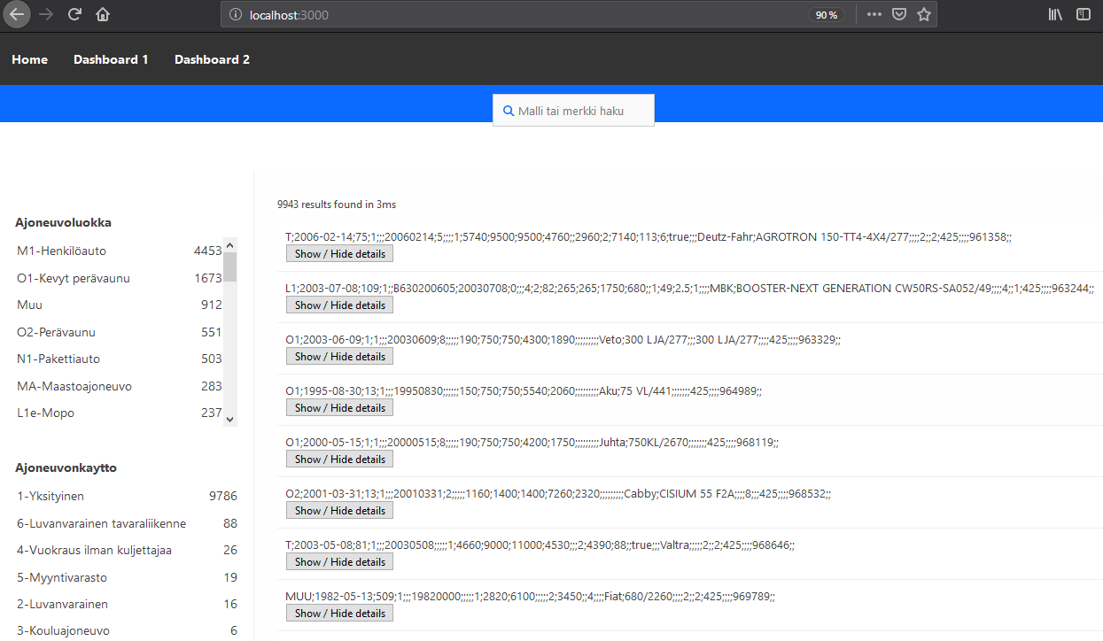

Dashboard 1 made in Kibana and embedded to React code: (Here visulations show the most common car models in specific town and how their registrations have developed during years. All Kibana graphs are clickable (work as filter) and other visulations on page change according to selections.)

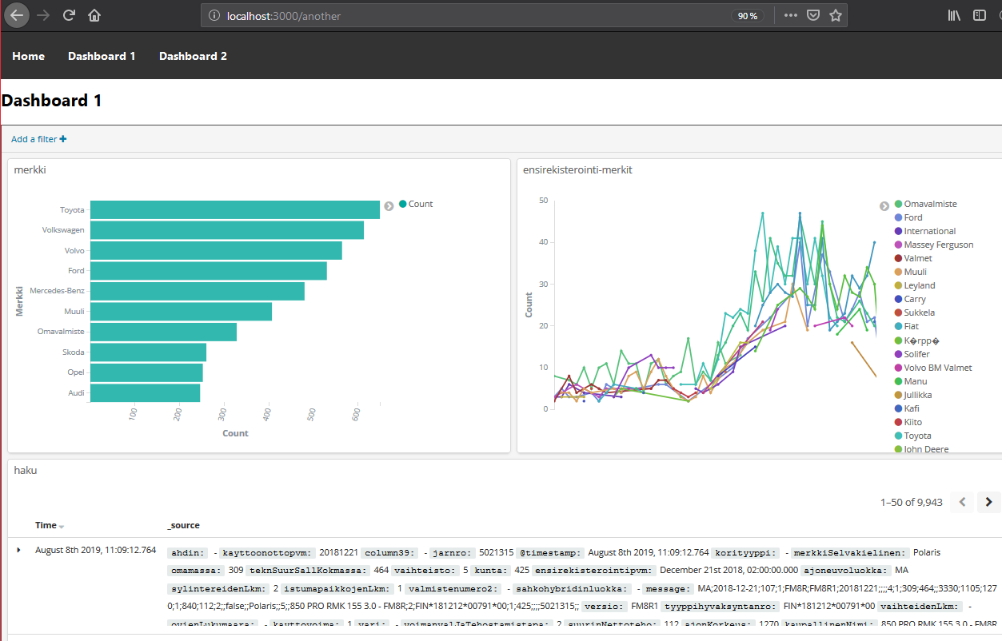

Dashboard 2 made in Kibana and embedded to React code: The first pie chart shows vehicle distribution by Co2 emission in specific town. The second pie chart shows vehicle distribution by number of kilometers driven by vehicle.

