DC Simulation Results
GOPLC IEC 61131-3 Data Center Simulation Stack
22 February 2026

Simulation Architecture
This document presents live telemetry from a fully simulated data center environment running on GOPLC, an IEC 61131-3 PLC runtime implemented in Go. Eleven device simulators generate realistic sensor data which flows through protocol-specific device gateways, aggregators, InfluxDB v2, and Grafana.
Layer | Components | Protocols
Device Simulators (×11) | Chiller, Cooling Tower, CRAC (×4), CRAH, Env Hub, Generator, Transfer Switch, UPS, Rack PDU, Fire Alarm Panel | BACnet/IP, Modbus TCP, SNMP v2c
Device Gateways (×10) | One gateway per device type; polls simulator, exposes OPC UA northbound, writes to InfluxDB | BACnet/IP → OPC UA + InfluxDB
CRAC Aggregation | Family aggregator (4 units → KPIs), Site aggregator (family → site totals) | OPC UA client/server chain
Time-Series Storage | InfluxDB v2 — bucket: goplc, org: homelab | HTTP/Flux
Visualisation | Grafana — 11 dashboards + site overview | Flux queries

Summary
All eleven subsystems are operational and generating realistic telemetry. The full data pipeline — device simulator → protocol gateway → OPC UA aggregation → InfluxDB → Grafana — is functioning end-to-end. Key observations:
- Chiller plant: 216.8 cooling tons, COP 4.06, chilled water supply 7.2 °C.
- CRAC cooling: 4 units online, average supply air 5.6 °C, total power 11 kW.
- Power distribution: normal source active, dual bus sources available, load 615.6 A.
- UPS: 100% battery, 1 hour runtime, 39.5% load — system in normal mode.
- Generator: standby, 85% fuel, ready for automatic transfer.
- Fire alarm system: all clear, system normal.
- Environmental sensors: all rack rows within normal temperature and humidity limits.
- OPC UA inter-process telemetry chain validated: device gateway → family → site aggregator.

DC Site Overview
Top-level view of the entire data center simulation. Shows CRAC cooling KPIs aggregated from the OPC UA hierarchy, chiller plant status, power distribution state, generator health, and environmental sensor readings across all rack rows.
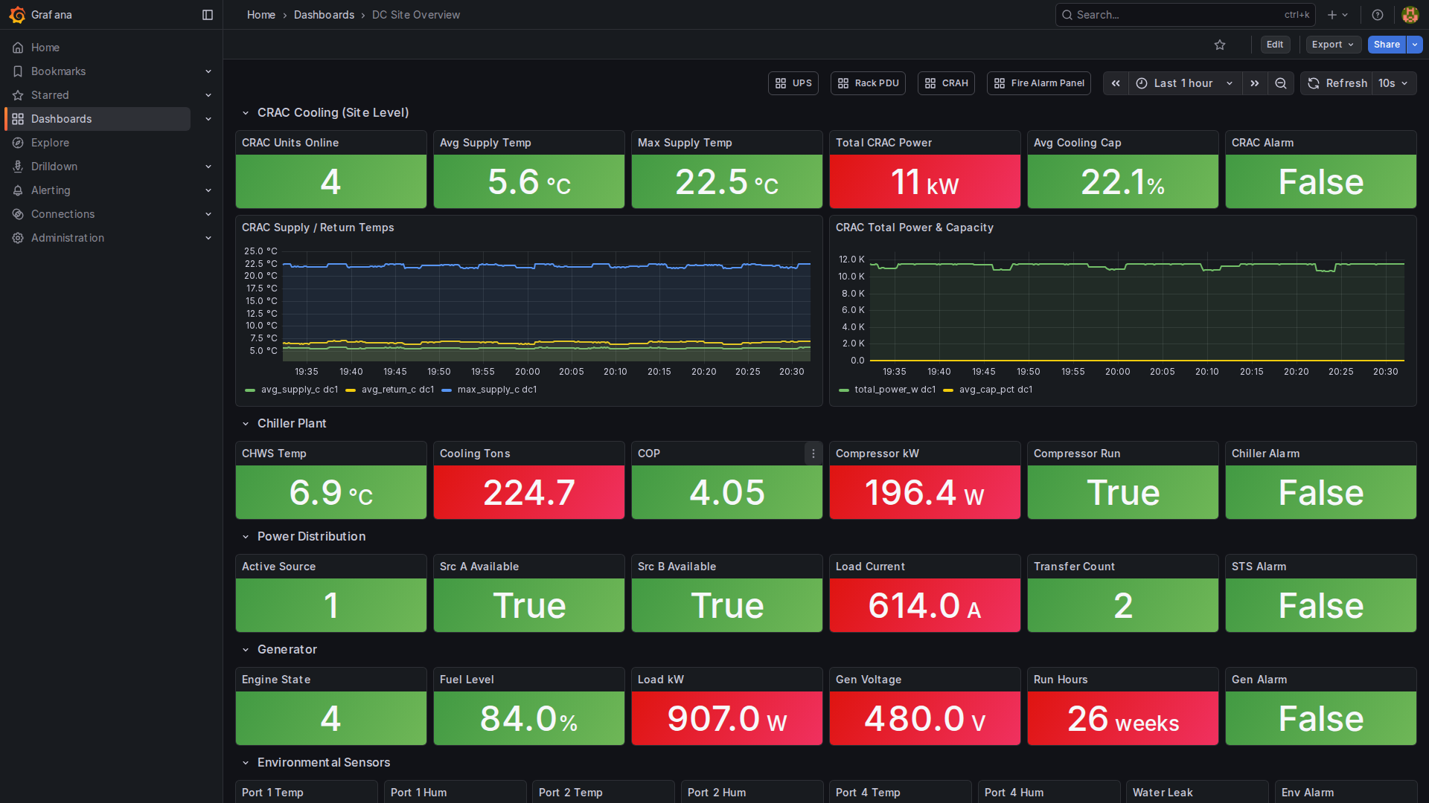

Chiller Plant
Centrifugal chiller simulation (BACnet/IP). Tracks chilled water supply and return temperatures, cooling capacity in tons, compressor power draw (kW), COP, and flow rates. Data sourced from the chiller BACnet device gateway.
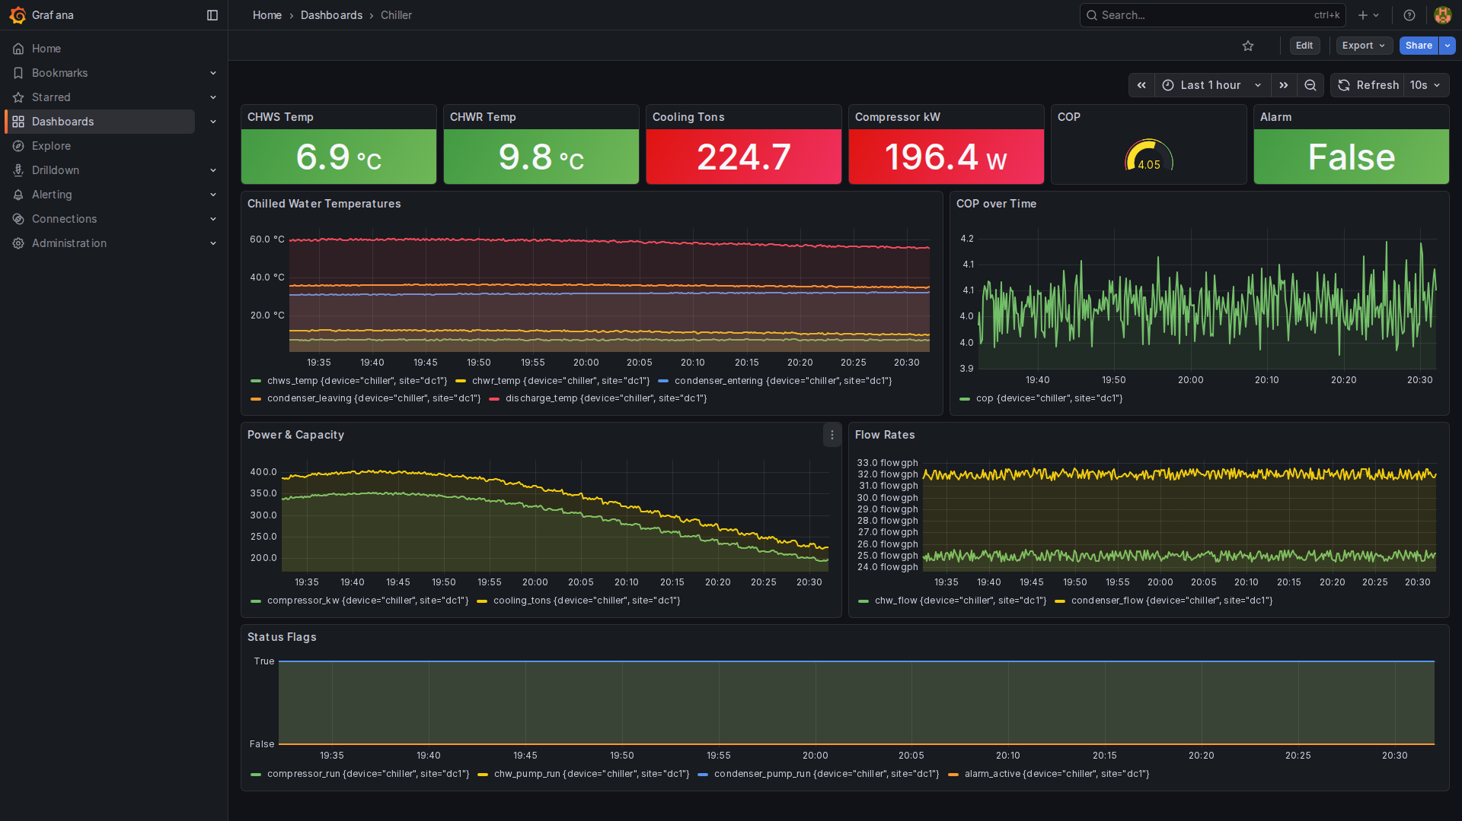

Cooling Tower
Cooling tower simulation (BACnet/IP). Monitors basin temperature, fan speed, make-up water flow, approach temperature, and drift eliminator status. Feeds condenser water to the chiller plant.
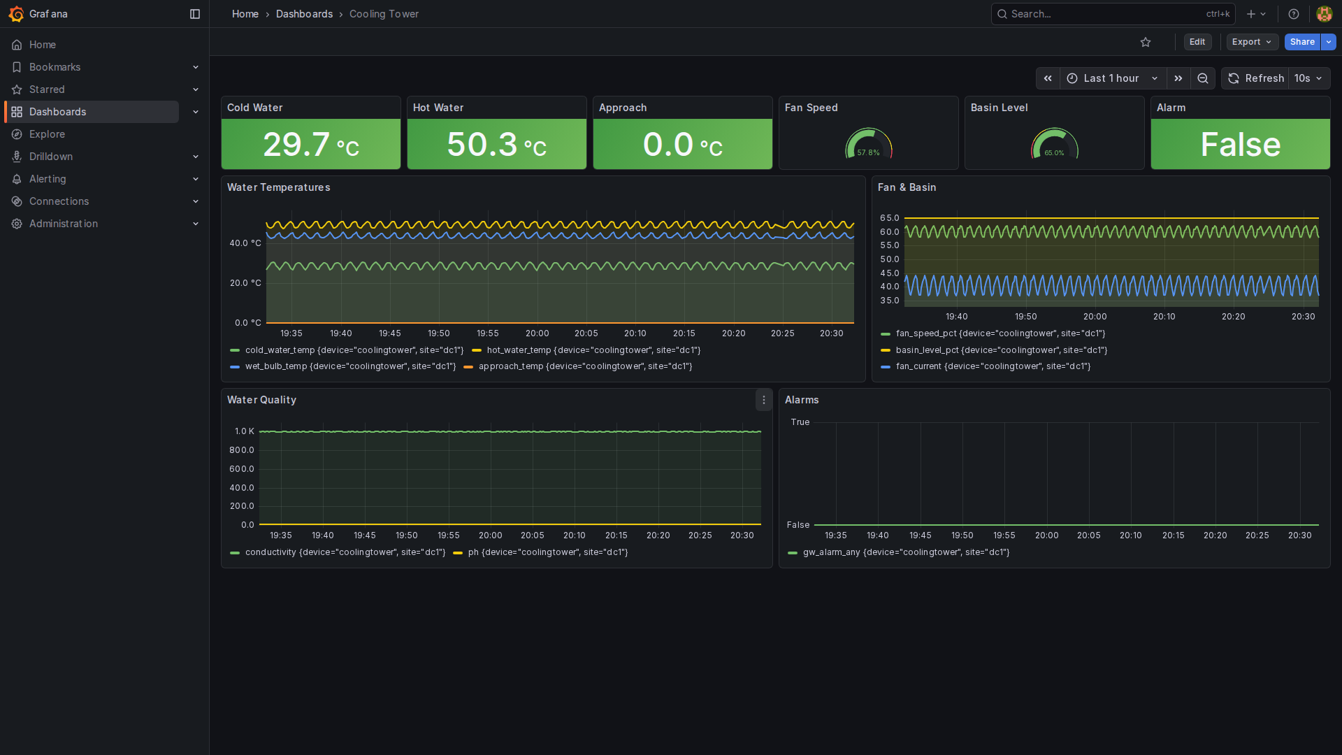

CRAC Cooling (Site Aggregate)
Site-level CRAC cooling aggregate. Shows units online (out of 4 deployed), average and maximum supply air temperatures, total cooling capacity, and total power draw. Values are aggregated through the OPC UA hierarchy: device gateway → family aggregator → site aggregator → InfluxDB.
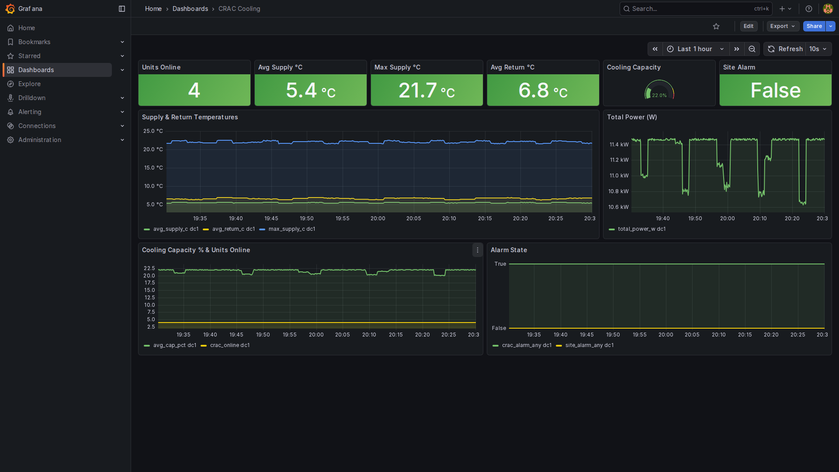

CRAH Unit
Computer Room Air Handler (BACnet/IP). Monitors supply and return air temperatures, chilled water supply and return temperatures, CHW flow, valve position, fan speed, and cooling capacity. Alarms for high supply air, low CHW flow, and water leak.
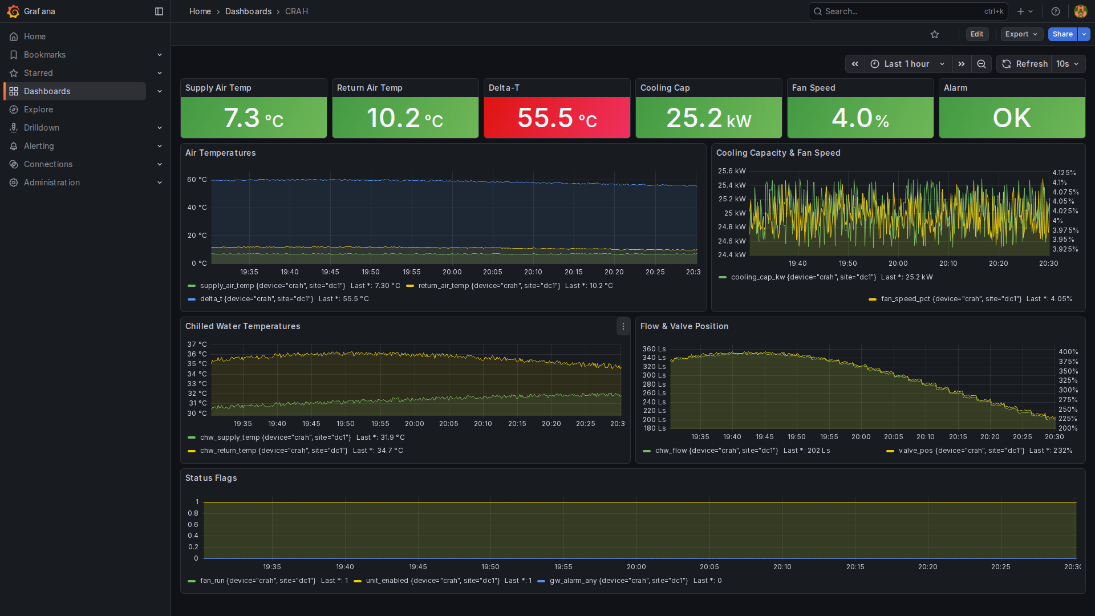

Environmental Hub
Multi-point environmental monitoring (SNMP v2c). Tracks temperature and humidity at 4 rack locations (Port 1–4), plus differential pressure and dew point. Provides early warning of hot spots and moisture ingress.
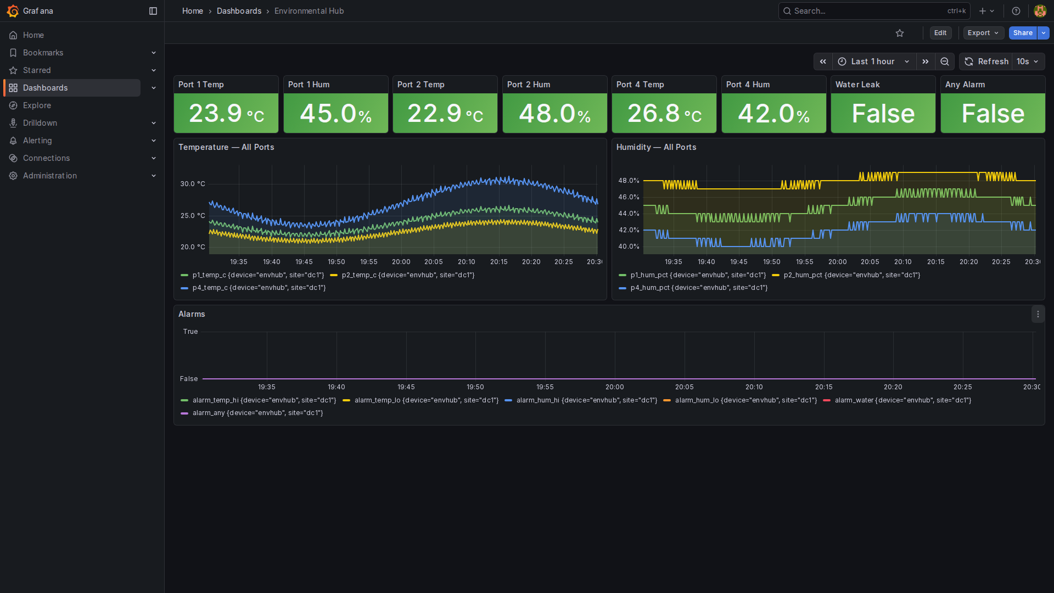

Emergency Generator
Diesel generator simulation (Modbus TCP). Monitors engine state, fuel level, load kW, generator voltage, run hours, and automatic transfer switch interlock. Alarms for low fuel, under/over voltage, and failed start.
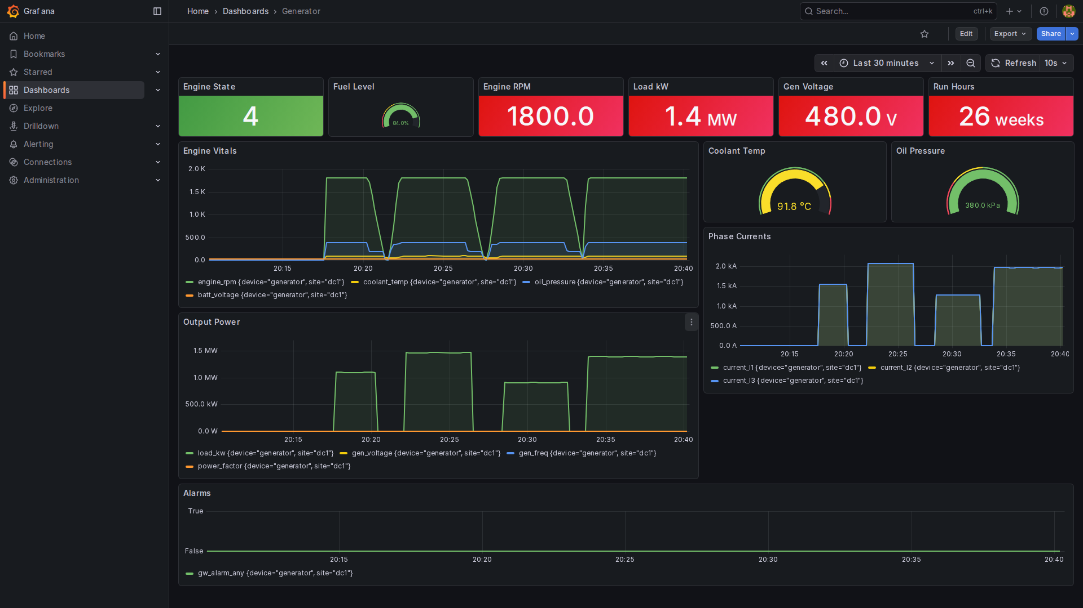

Automatic Transfer Switch
ATS simulation (Modbus TCP). Shows active source (normal/emergency), Source A and B availability, load current, transfer operation count, and STS alarm state. Transitions automatically when normal power is lost.
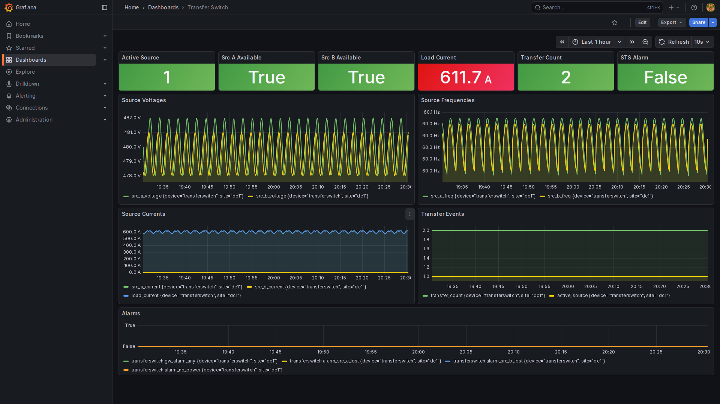

Uninterruptible Power Supply
UPS simulation (SNMP v2c). Tracks battery state of charge, estimated runtime, load percentage, input/output voltage, output current and frequency. Alarms for on-battery, low battery, and overload conditions.
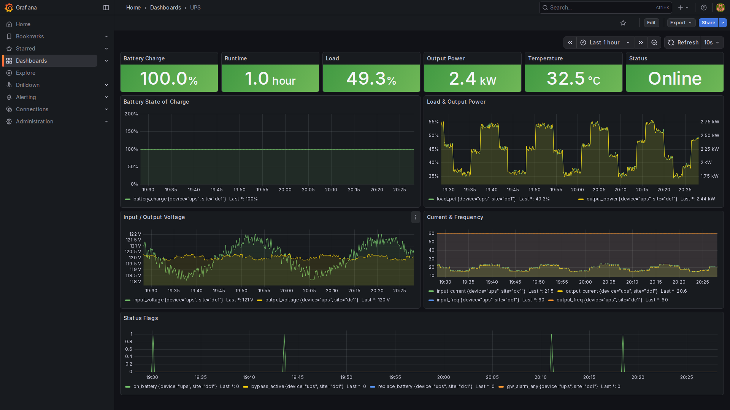

Rack Power Distribution Unit
Rack PDU simulation (SNMP v2c). Monitors per-outlet current, total load, input voltage, power factor, and energy (kWh). Outlet-level visibility for capacity planning and fault isolation.
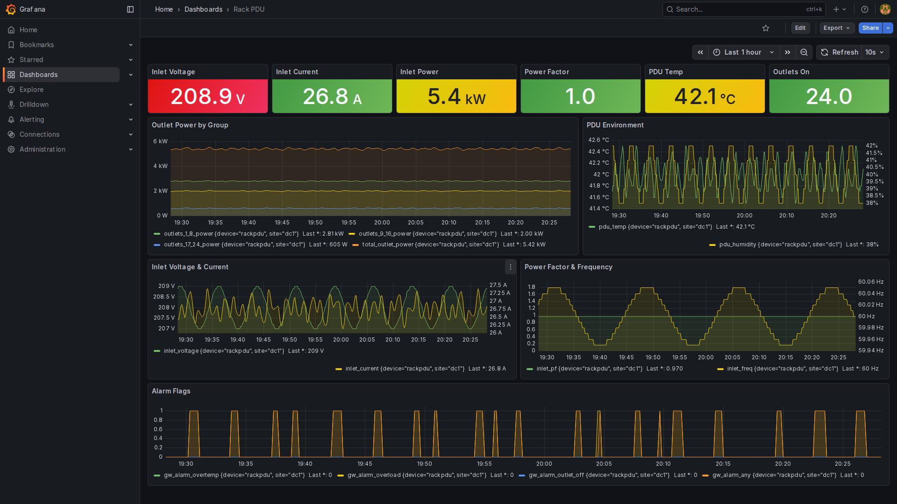

Fire Alarm Control Panel
FACP simulation (Modbus TCP). Monitors system status (normal/alarm/supervisory/trouble), active alarm and trouble counts per loop, and aggregate alarm state. Integrates with site safety shutdown logic.
