PROJECT PROPOSAL
Duty Desk & Gatehouse
Digital Operations Platforms for Resident Officer & Security Departments
Prepared for: The Destination — Smart Residences Limited
Prepared by: Philip Isaac Atabo, IT Support
August 6, 2026

1. Executive Summary
This proposal is submitted on my own initiative as IT Support staff. While reviewing how the Resident Officer department currently operates, I identified a gap I believed was worth solving proactively rather than waiting for it to be assigned — the findings and the solution below are the result of that initiative.
The Resident Officer and Security departments currently rely on manual, paper-based processes to manage daily operations — most critically, a 73-item paper checklist used to confirm an apartment is ready before a guest checks in. This process is inconsistently followed, leaves no reliable record, and provides no way to establish accountability when something goes wrong.
This proposal recommends building two purpose-built digital platforms — one per department, fully independent of each other — to replace these manual processes:
- Duty Desk — for the Resident Officer department: apartment readiness checklists, guest/resident complaints, maintenance tickets, shift handover, and daily duty reporting.
- Gatehouse — for the Security department: incident logging, vehicle access control, patrols, key management, and emergency alerts.
A design phase is complete: a full blueprint and a clickable UI prototype of both platforms have already been built and reviewed. This document requests approval to proceed to the production build phase.

2. The Problem

2.1 No enforcement
The apartment readiness checklist is currently a paper form. Resident Officers are supposed to complete it before every check-in, but completion is inconsistent — sometimes skipped entirely under time pressure, with no way to enforce it.

2.2 No accountability
When an incident is traced back to a specific apartment, there is currently no reliable way to determine who last inspected that unit, what condition it was in, or who signed off on it. Paper forms are easily lost, unfiled, or left incomplete.

2.3 Disconnected departments
Resident Officer and Security functions are organizationally distinct, but no current system reflects that separation — informal processes blur responsibility between the two.

3. Proposed Solution
Two independent, department-owned web applications — accessible from any browser on a desktop, front-desk PC, tablet, or phone, with no app-store installation required.

3.1 Duty Desk (Resident Officer Department)
Module | What it does
Apartment Readiness Checklist | Digital version of the 73-item paper form. Must be submitted before an apartment is marked ready — check-in is hard-blocked otherwise.
Complaints & Requests | Log and track guest/resident complaints by category and priority through to resolution.
Maintenance Tickets | Manual reports and tickets auto-created from failed checklist items, routed to Engineering or Housekeeping.
Duty Log & Handover | Shift notes, with handover flagging so the next officer sees what happened before them.
Resident Records | Stay dates, preferences, and notes for longer-term residents.
Tasks & Reports | Cross-department task assignment and daily/weekly operational reporting.

3.2 Gatehouse (Security Department)
Module | What it does
Incident Logging | Category, severity, location, and resolution tracking for all security incidents.
Vehicle Access Log | A numbered card is issued to every car at entry, with its plate number recorded against that card. The card is returned and logged at exit — any card not yet returned is visible at a glance.
Patrols | Route, timing, and findings for every patrol shift.
Access & Key Management | Issue/return/lost tracking for keys and secure-area access.
Alerts | Property-wide emergency alerts (fire, medical, breach, lockdown) with acknowledgment tracking.
Reports | Incident trends, patrol coverage, and key turnaround analytics.

3.3 Why two separate platforms
Resident Officer and Security are different departments with different responsibilities. Keeping the platforms fully independent — separate logins, separate data, separate hosting — mirrors that organizational reality and avoids one department depending on the other's system to function.

3.4 Accountability by design
Every checklist, incident, and ticket is tied to a real staff login and timestamped permanently. This directly answers the question that paper records could never reliably answer: who was responsible, and when.

4. Product Screens
A working, clickable prototype of both platforms has already been built. Below are screens from that prototype, shown as they actually appear — not concept art.

4.1 Shared entry point
Staff reach either platform from one shared landing page. It holds no data of its own — purely a signpost to each department's own login.
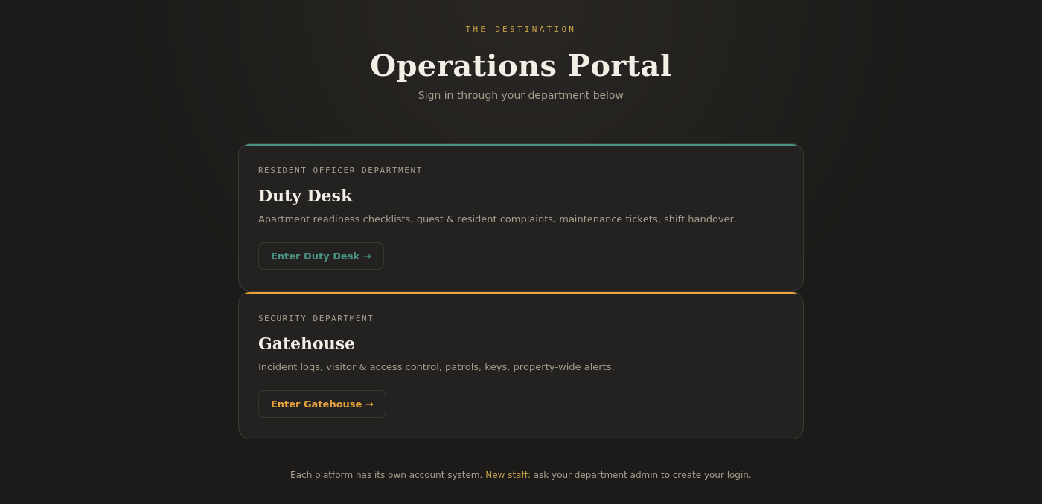
The Destination Operations Portal — shared landing page

4.2 Duty Desk (Resident Officer Department)
The dashboard shows apartments not ready for check-in, open complaints and maintenance tickets, and the last shift's handover note — all in one view.
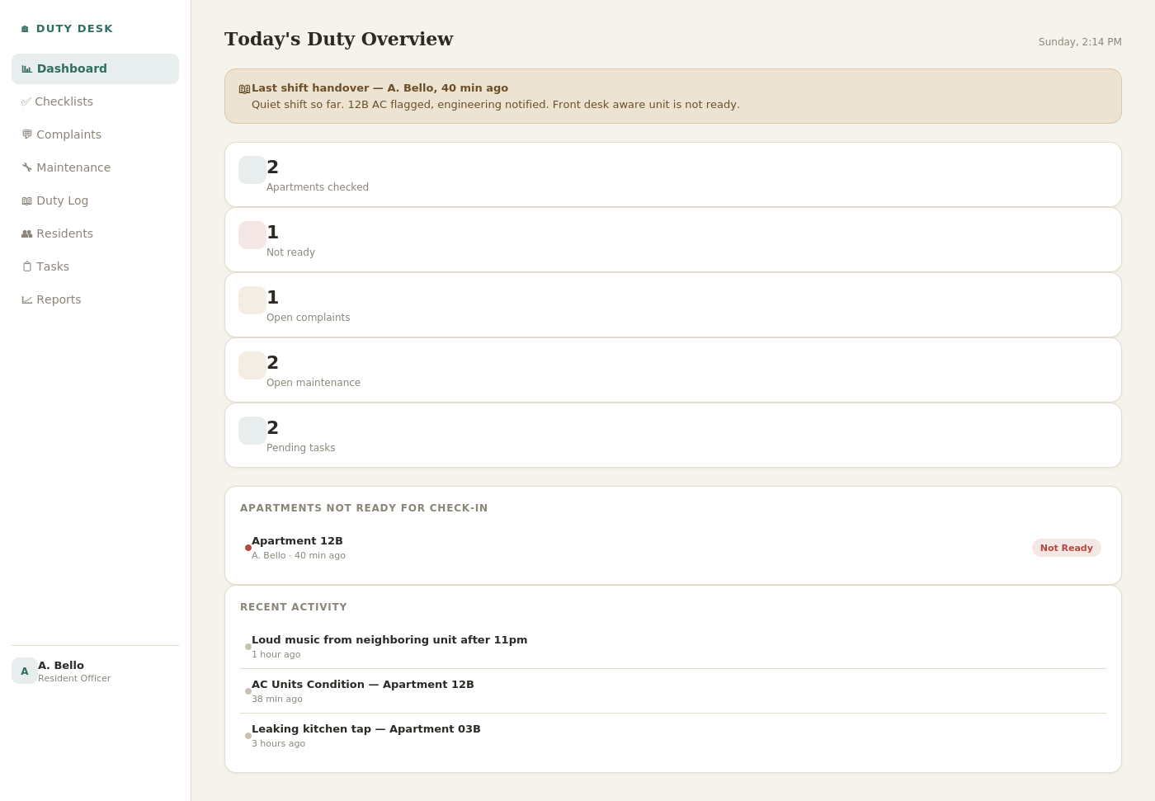
Duty Desk — Today's Duty Overview

4.3 Gatehouse (Security Department)
The Security dashboard surfaces unresolved incidents and alerts first, with shift activity underneath.
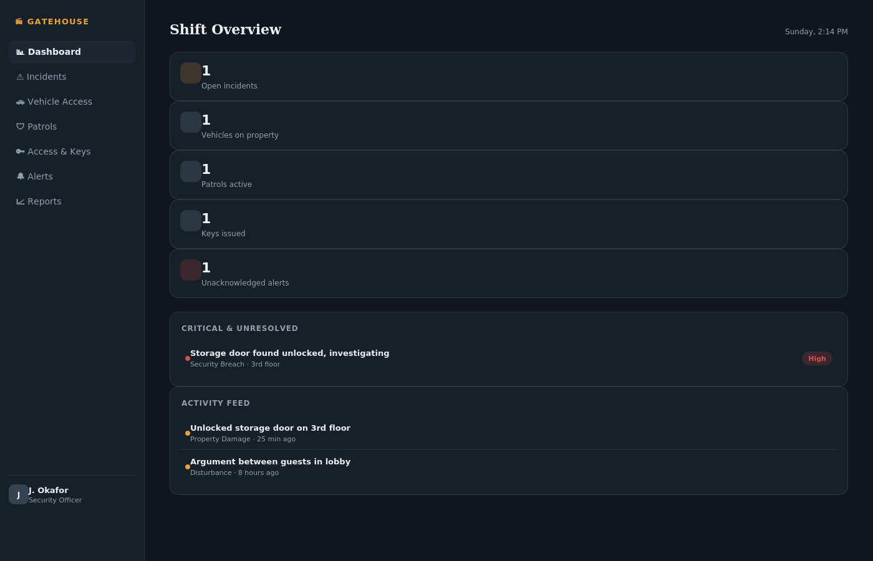
Gatehouse — Shift Overview

5. Staff Accounts & Access
Confirmed headcount: 16 Resident Officer accounts (Duty Desk) and 5 Security accounts (Gatehouse) — 21 staff accounts total, plus one Super Admin account per platform held by IT (myself), for 23 accounts overall.
- Login is username + usercode, not email + password — many staff do not have a company email address, so this removes that dependency entirely.
- Super Admin (IT) sits above both platforms — can create or reissue any account's login, including a department admin's own. This is a fallback role for technical issues, not part of daily operations.
- Day-to-day accounts are created only by each department's admin (General Manager for Duty Desk, Security Supervisor for Gatehouse) — no self sign-up.
- Role-based permissions per department (see attached blueprint, Section 4, for the full permissions matrix in the standalone blueprint document).
- Accounts can be disabled instantly when staff leave, without losing their historical records.
- A single shared landing page — a static signpost with no data of its own — lets staff reach either platform's login from one bookmarked link.

6. Current Status
Phase | Status
Phase 1 — Blueprint | Complete
Phase 2 — UI design (clickable prototype, both platforms) | Complete
Phase 3 — Production build (real database, hosting, accounts) | Pending approval
Phase 4 — Internal testing | Not started
Phase 5 — Rollout | Not started

7. Technical Approach & Cost
The production build will be carried out by myself (Philip Isaac Atabo, IT Support), using AI-assisted development tooling to build and deploy both platforms without requiring an external development agency or additional hires.

7.1 Infrastructure
- Hosting: Vercel Pro plan. Vercel's free Hobby tier is restricted to personal, non-commercial use under its terms of service — an internal company system does not qualify, so Pro is required for compliant commercial use.
- Database: Supabase Pro plan — recommended over the free tier for a production system serving real staff and guest data, since the free tier pauses inactive projects and has no backup guarantee. Pro includes daily backups and no forced pause.
- Optional: a company domain for a professional address (e.g. operations.thedestination.com).

7.2 Why AI-assisted development
This project is being built using Claude, Anthropic's AI development platform, rather than through a hired development agency or a new full-time developer role. This is a deliberate cost and speed decision, not a shortcut: it is what makes an in-house build realistic on this timeline and budget. AI-assisted development is now standard practice across the software industry — including at large enterprises — for exactly this reason: it lets a small team ship production software without the overhead of a traditional development team.

7.3 Estimated cost
Costs below use an approximate exchange rate of ₦1,400 = $1 (rates fluctuate; treat Naira figures as indicative, not fixed).
These fall into two different kinds of cost, worth keeping separate:
- Always-on infrastructure — domain, hosting, and database run the live app every day for staff, so these are genuine year-round costs regardless of whether anyone is actively developing.
- Claude (development tool) — only needed while actively building or making changes. Budgeted here at 3 months, covering the realistic build timeline for both platforms end to end (see Section 7.4) with a small buffer. It is not a fixed annual commitment; the monthly plan can be paused after launch and resumed only when new features or fixes are needed.
Item | USD | Naira (approx.) | Type
Domain (e.g. operations.thedestination.com) | $15 / year | ~₦21,000 / year | Always-on
Hosting (Vercel Pro) | $20 / month ($240/yr) | ~₦28,000 / month (~₦336,000/yr) | Always-on
Database (Supabase Pro) | $25 / month ($300/yr) | ~₦35,000 / month (~₦420,000/yr) | Always-on
Claude subscription (3 months, build + launch, both platforms) | $20 × 3 = $60 | ~₦84,000 | One-time
Always-on total, first year (domain + hosting + database): ~$555 / year (~₦777,000/year).
Plus one-time Claude build cost: ~$60 (~₦84,000).
Grand total, first year: ~$615 (~₦861,000)
No external development agency is required — the build is done in-house using Claude, which is the main reason this stays inexpensive relative to a typical custom software project quoted by an agency (commonly ₦3–5 million+ for comparable custom systems in the local market).

7.4 Timeline
This build is being carried out by one person (myself) alongside my regular IT support duties, not as a dedicated full-time project — the estimate below reflects that, in calendar weeks rather than a compressed sprint.
Stage | Estimated duration
Duty Desk: production build (database, accounts, all modules) | 3–4 weeks
Duty Desk: testing with a real Resident Officer, fixes | 1 week
Duty Desk: live rollout | Week 5
Gatehouse: production build (including Vehicle Access Log) | 2–3 weeks
Gatehouse: testing with a real Security Officer, fixes | 1 week
Gatehouse: live rollout | Week 8–9
Gatehouse's build is estimated shorter than Duty Desk's because the underlying accounts/login system, hosting, and database setup will already exist from the Duty Desk build — only the second platform's own modules need to be built fresh. This is a calendar-time estimate, not hours of continuous work; actual pace will depend on how much time is available around regular support duties in a given week.

8. Risks & Mitigations
Risk | Mitigation
Staff resistance to changing from paper | Keep the checklist structure familiar; run a short training session before rollout.
Data loss if hosting/database misconfigured | Use managed providers with automatic backups; IT retains admin access.
Incomplete adoption if check-in isn't enforced | Hard-block design ensures check-in cannot proceed without a submitted, Ready checklist.

9. Recommendation & Next Steps
I recommend approving progression to Phase 3 (production build). No new software spend is required to begin — only my time and, if approved, the infrastructure costs outlined in Section 7.
- Approve production build of Duty Desk and Gatehouse.
- Confirm whether both platforms launch together or Duty Desk first, given it addresses the most urgent operational gap.
- Identify a department admin for each platform (General Manager for Duty Desk, Security Supervisor for Gatehouse) to manage staff accounts once live.
I am glad to walk through the working prototype in person, answer any technical questions, and take this forward personally once approved.
Submitted by: Philip Isaac Atabo, IT Support
Attachments: Platform Blueprint (hotel-platforms-blueprint.md), UI Prototype (hotel-platforms-ui-prototype.jsx)

