**Report**

**KNeighborsClassifier() performance vs. K**

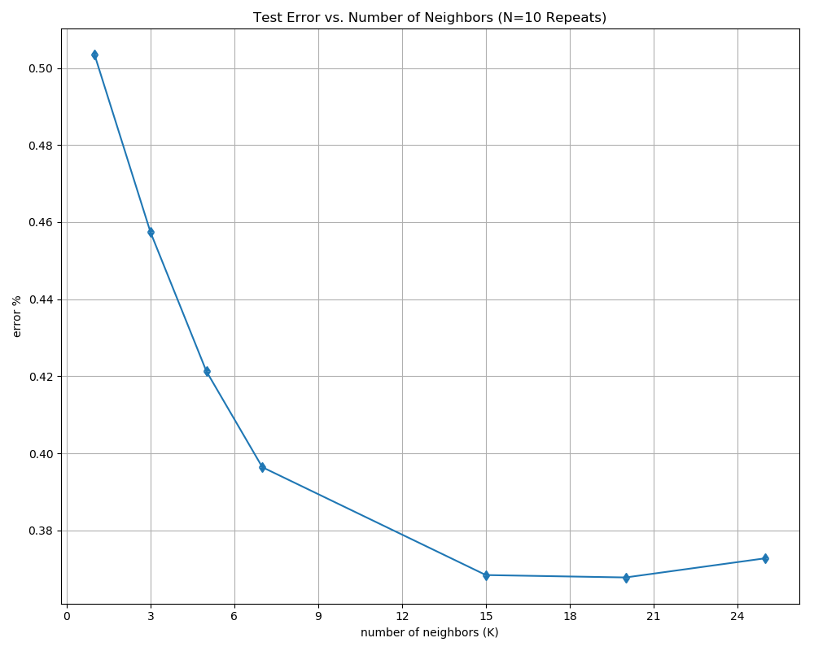

So, the conclusion is the best k for us is: 15!