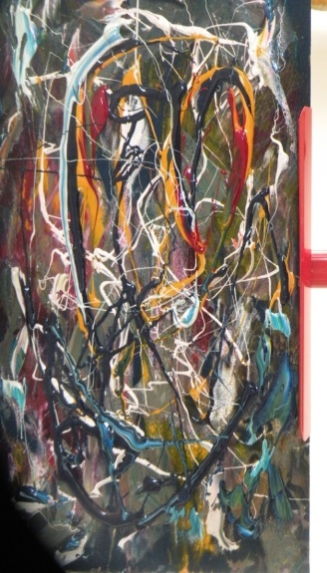

The Last Memory (Deja Vu), Synthetic Monoprint on Velvet Paper , Ayo Elebute

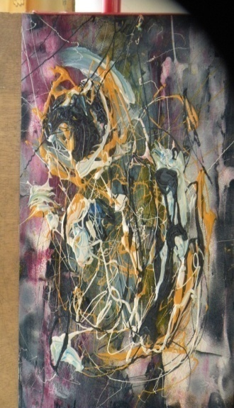 *There is no Escape,* Synthetic Monoprint on Velvet Paper, Ayo Elebute

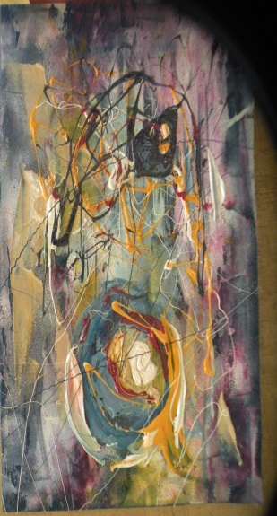

*Before the Day Break*, Synthetic Monoprint on Water Paper, Ayo Elebute

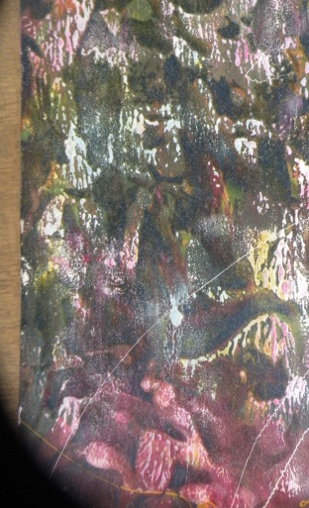

*Nocturnal Path,* Synthetic Monoprint on Velvet Paper, Ayo Elebute

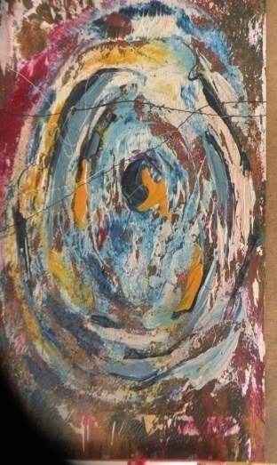

*Wheel of Fortune,* Monoprint on Water colour Paper, Ayo Elebute

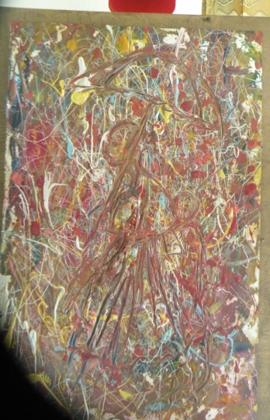

*Mother and Child,* Synthetic Monoprint on Water Colour Paper, Ayo Elebute

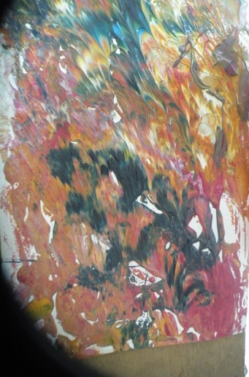

*The Interactiveness,* Monoprint on water Colour Paper, Ayo Elebute

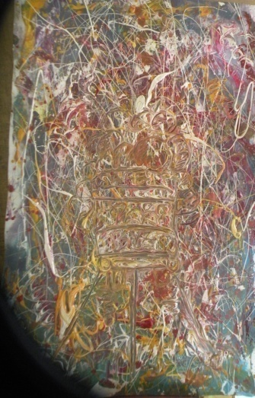 *Safe Journey*, Synthetic Monoprint on Water Colour Paper, Ayo Elebute

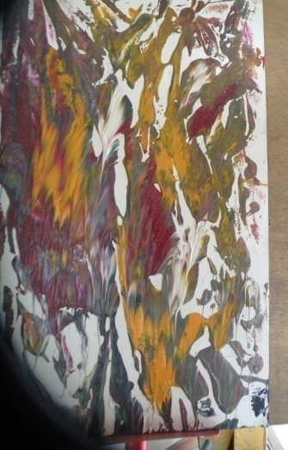 *The Famished Land*, Monoprint on Water Colour Paper, Ayo Elebute

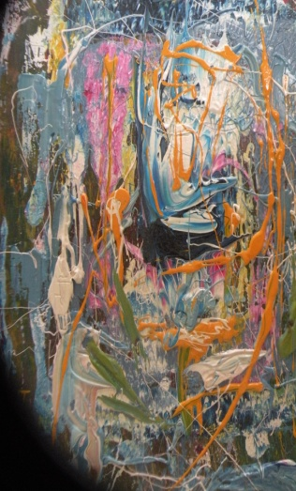 *Destiny*, Synthetic Monoprint on Water Colour Paper, Ayo Elebute

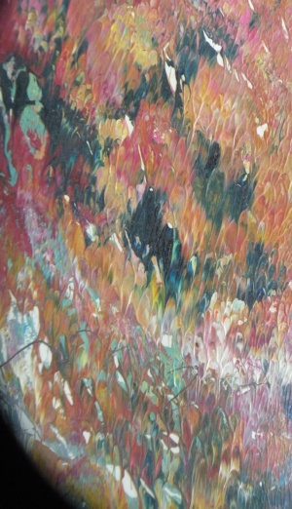*Land Scape at Imesi-Ile*, Monoprint on Water Colour Paper, Ayo Elebute

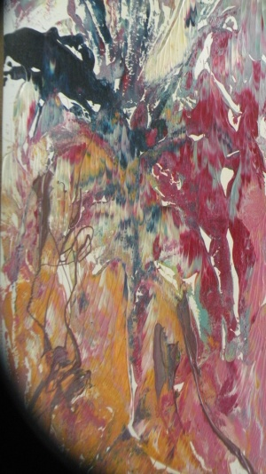 *Tree of life*, Monoprint on water Colour Paper, Ayo Elebute