# WEB APPLICATION FOR RENTAL SERVICES OF AGRICULTURAL TOOLS

### A PROJECT REPORT

***Submitted by***

**Ms. Fiza Javeed 20201CSE0633**

**Mr. Varun Chandrappa 20201CSE0602**

**Ms. Ritika Panchal 20201CSE0617**

**Mr. Rohit B M 20201CSE0627**

***Under the guidance of,***

**Mr. Md Zia Ur Rahman**

***in partial fulfillment for the award of the degree of***

## BACHELOR OF TECHNOLOGY

### IN

**COMPUTER SCIENCE AND ENGINEERING**

**At**



**PRESIDENCY UNIVERSITY BENGALURU JANUARY 2024**

**SCHOOL OF COMPUTER SCIENCE ENGINEERING**

**CERTIFICATE**

This is to certify that the Project report **“WEB APPLICATION FOR RENTAL SERVICES OF AGRICULTURAL TOOLS”** being submitted by “FIZA JAVEED”, “VARUN CHANDRAPPA”,

“RITIKA PANCHAL”, “ROHIT B M” bearing roll numbers “20201CSE0633”, “20201CSE0602”, “20201CSE0617”,

“20201CSE0627” in partial fulfilment of requirement for the award of degree of Bachelor of Technology in Computer Science and Engineering is a bonafide work carried out under my supervision.

|  |  |
| --- | --- |
| **Mr. Md Zia Ur Rahman** Assistant Professor School of CSE&IS  Presidency University | **Dr. Pallavi R**  Associate Professor & HoD School of CSE&IS Presidency University |

|  |  |  |
| --- | --- | --- |
| **Dr. C. KALAIARASAN**  Associate Dean  School of CSE&IS Presidency University | **Dr. SHAKKEERA L**  Associate Dean  School of CSE&IS Presidency University | **Dr. SAMEERUDDIN KHAN**  Dean  School of CSE&IS Presidency University |

## SCHOOL OF COMPUTER SCIENCE ENGINEERING

**DECLARATION**

We hereby declare that the work, which is being presented in the project report entitled **WEB APPLICATION FOR RENTAL SERVICES OF AGRICULTURAL TOOLS** in partial fulfilment for the award of Degree of **Bachelor of Technology** in **Computer Science and Engineering**, is a record of our own investigations carried under the guidance of **Mr. Md Zia Ur Rahman, Assistant Professor, School of Computer Science Engineering, Presidency University, Bengaluru.**

We have not submitted the matter presented in this report anywhere for the award of any other Degree.

|  |  |  |  |
| --- | --- | --- | --- |
| **Sl No** | Name | Roll No | Signature |
| 1. | Fiza Javeed | 20201CSE0633 |  |
| 2. | Varun Chandrappa | 20201CSE0602 |  |
| 3. | Ritika Panchal | 20201CSE0617 |  |
| 4. | Rohit B M | 20201CSE0627 |  |

The "Web Application for Rental Services of Agricultural Tools" is a user- friendly platform facilitating efficient and transparent interactions between farmers and tool owners. With a comprehensive catalog featuring diverse agricultural tools, the application streamlines the rental process, allowing farmers to easily access the equipment they need. Key features include secure user authentication, an intuitive booking system with integrated payment gateways, and a robust review system for accountability. Geolocation services ensure convenient tool pickup and return, while analytics tools enable tool owners to optimize their inventory. By fostering collaboration and resource-sharing, this web application contributes to improved agricultural practices, cost-effective utilization of equipment, and economic sustainability within the farming community.

First of all, we indebted to the GOD ALMIGHTY for giving me an opportunity to excel in our efforts to complete this project on time.

We express our sincere thanks to our respected dean Dr. Md. Sameeruddin Khan, Dean, School of Computer Science Engineering, Presidency University for getting us permission to undergo the project.

We record our heartfelt gratitude to our beloved Associate Deans Dr. Kalaiarasan C and Dr. Shakkeera L, School of Computer Science Engineering, Presidency University and Dr. Pallavi, Head of the Department, School of Computer Science Engineering, Presidency University for rendering timely help for the successful completion of this project.

We are greatly indebted to our guide Mr. Zia Ur Rahman, Assistant Professor, School of Computer Science Engineering, Presidency University for his inspirational guidance, and valuable suggestions and for providing us a chance to express our technical capabilities in every respect for the completion of the project work.

We would like to convey our gratitude and heartfelt thanks to the University Project-II Coordinators Dr. Sanjeev P Kaulgud, Dr. Mrutyunjaya MS and also the department Project Coordinators Mr. Zia Ur Rahman.

We thank our family and friends for the strong support and inspiration they have provided us in bringing out this project.

**Fiza Javeed Varun Chandrappa Ritika Panchal Rohit B M**

|  |  |  |  |
| --- | --- | --- | --- |
| **Sl. No.** | **Table Name** | **Table Caption** | **Page No.** |
| 1 | Table 3.1 | Literature Survey Observations | 12 |

|  |  |  |  |
| --- | --- | --- | --- |
| **Sl. No.** | **Figure**  **Name** | **Caption** | **Page No.** |
| 1  2  3  4  5  6  7  8  9  10  11  12  13  14  15  16  17  18 | Figure 2.1  Figure 2.2  Figure 2.3  Figure 2.4  Figure 2.5  Figure 2.6  Figure 2.7  Figure 2.8  Figure 7.1  Figure 7.3  Figure 8.1  Figure 8.3.1  Figure 8.3.2  Figure 8.3.3  Figure 8.3.4  Figure 8.3.5  Figure 9.1 | HTML, CSS, JS  React JS Node JS SQLite  Visual Studio Code Bootstrap MongoDB  JSON  Architecture Website Workflow  Development Process Login Page  Home Page About Us Page Services Page Contact Us Page Gantt Chart Appendix – B  Screenshots | 4  5  6  7  8  9  9  10  17  20  21  25  26  27  28  29  30  40 |

**CHAPTER NO. TITLE PAGE NO.**

|  |
| --- |
| 1. **INTRODUCTION 1**    1. Features    2. Scope and Purpose |
| **2. REQUIREMENT ANALYSIS 3** |
| 2.1 Hardware requirements |
| 2.2 Software requirements   1. **LITERATURE SURVEY 11**    1. Literature Survey Observations    2. Drawbacks 2. **RESEARCH GAPS OF EXISTING METHODS 14** 3. **PROPOSED METHODOLOGY 15** 4. **OBJECTIVES 16** 5. **SYSTEM DESIGN 17**    1. Architecture    2. Algorithm    3. Flowchart 6. **IMPLEMENTATION 21**    1. Development Process    2. Libraries    3. Modules 7. **TIMELINE FOR EXECUTION OF PROJECT 30**   **(Gantt Chart)**   1. **OUTCOMES 31** 2. **RESULTS AND DISCUSSIONS 32**    1. Results    2. Discussions |

**12. CONCLUSION 34**

REFERENCES APPENDIX - A APPENDIX - B

**Chapter-1**

## INTRODUCTION

A web application that the farmers can use to hire tractors as well as other mechanizations at a nominal amount all using their mobile phones. This would not only help them avoid manual labor but can be also be considered as an important step to encourage this profession. By promoting efficient tool utilization, transparent transactions, and community collaboration, the project seeks to enhance productivity, reduce costs, and contribute to the sustainable development of agriculture. Through innovative features like secure authentication, a comprehensive tool catalog, and integrated payment solutions, the application aims to empower farmers and tool owners alike.

#### Features

The "Web Application for Rental Services of Agricultural Tools" encompasses a range of features to facilitate efficient and transparent interactions between farmers and tool owners. Key features include:

* + - **User Authentication:**

o Secure registration and authentication for farmers and tool owners.

* + - **Tool Catalog:**

o Comprehensive catalog with detailed descriptions and images of agricultural tools**.**

* + - **Booking System:**

o Intuitive booking system for farmers to check tool availability and schedule rentals**.**

* + - **Payment Gateway:**

o Integrated payment gateway for secure and seamless financial transactions**.**

* + - **Feedback:**

o Farmer feedback and ratings for tools and tool owners to ensure accountability.

* 1. **Scope and Purpose**

The purpose of the "Web Application for Rental Services of Agricultural Tools" is to create a digital platform that connects farmers with tool owners, streamlining the rental process for essential agricultural equipment. This project aims to address challenges related to tool ownership costs and provide a cost-effective solution for farmers. The scope includes a user-friendly interface, secure authentication, a comprehensive tool catalog, integrated payment gateways, and features such as reviews, messaging, and geolocation. By fostering collaboration and resource-sharing, the project intends to enhance agricultural productivity, reduce financial burdens on farmers, and contribute to the overall sustainability and efficiency of farming practices.

**Chapter - 2**

## REQUIREMENT ANALYSIS

### HARDWARE REQUIREMENTS

The hardware requirements for a city information website can vary depending on factors. However, here are some general hardware requirements to consider:

#### Storage:

The website will need storage space for a variety of items, including databases, web pages, photos, and videos. The quantity of storage needed is determined by the website's size, complexity, anticipated growth, and frequency of content updates.

#### Network:

A stable and reliable internet connection is crucial for the website to function properly. A minimum of 10 Mbps of bandwidth is recommended to ensure speedy website loading times and a smooth user experience.

#### Environment:

The PC should have a minimum of 4GB of RAM and a multi-core processor to handle the load from multiple users accessing the website simultaneously. You can also access website through mobiles as well which has consistent network.

#### Database Server:

You will need a database server to store and manage any dynamic content or user- generated data on your website. For the database server to handle database queries effectively, it should have enough storage and processing power.

#### Security:

Putting security measures into place is essential to shield your website's data and the data of its users from hacker attacks and unauthorized access.

#### Backup and Recovery:

The website will need storage space for a variety of items, including databases, web pages, photos, and videos. The quantity of storage needed is determined by the website's size, complexity, anticipated growth, and frequency of content updates.

### SOFTWARE REQUIREMENTS

To build and operate a city information website, you will need various software components and tools. Here are some essential software requirements for a city information

website:HTML, CSS and JS



Fig 2.1 - HTML, CSS & JS

#### HTML (Hypertext Markup Language):

The structure and content of web pages are created using HTML, a standard markup language. It describes the components and tags used to arrange and display the data on a webpage. The Document Object Model (DOM), a hierarchical structure used by HTML, is used to specify the relationships between the various components of a webpage. It has components for headlines, sentences, pictures, links, tables, forms, and more. The building blocks for displaying material on the web are provided by HTML.

#### CSS (Cascading Style Sheets):

HTML documents' appearance and visual design are described using the stylesheet language CSS. You can manage the design, presentation, and formatting of web pages. With CSS, you may provide styles for HTML components such font styles, colors, sizes, margins, padding, and borders. To target particular HTML components and apply stylistic rules to them, CSS uses selectors. By separating the presentation (CSS) and the content (HTML), it offers flexibility and separation of concerns and enables developers to quickly update and change a website's aesthetic elements.

#### JS (JavaScript):

Web sites may now be interactive and dynamic thanks to JavaScript, a potent scripting language. It operates in the user's web browser because it is mostly client-side usage. JavaScript enables you to dynamically update and change the appearance and behaviour of web elements, handle user interactions (such form validation and button clicks), manipulate and modify a webpage's content, and make asynchronous connections to servers (AJAX). JavaScript is a powerful language that is frequently used to build dynamic online applications, implement sophisticated features, and integrate with external services and APIs.

The three primary technologies for creating and designing websites are HTML, CSS, and JavaScript. Structure and content are provided by HTML, style and presentation are added by

CSS, and dynamic behaviour and interactivity are made possible by JavaScript. Together, these three technologies may produce interesting and interactive web experiences.

#### React JS



Fig 2.2 – React js

React.js often referred to as React, is an open-source JavaScript library for building user interfaces (Uls). It was developed by Facebook and released in 2013. React.js allows developers to create reusable UI components and efficiently update and render them when the underlying data changes. It has gained widespread popularity in the web development community for its simplicity, performance, and scalability.

Here are some key features and concepts of React.js:

Component-Based Architecture: React follows a component-based architecture, where UIs are divided into reusable and self-contained components. These components can be combined to build complex Uls, making the code more modular and maintainable.

**Virtual DOM:** React uses a virtual DOM (Document Object Model) to efficiently update and render Ul components. The virtual DOM is a lightweight copy of the actual DOM and allows React to optimize the rendering process by minimizing direct manipulations to the real DOM.

**JSX (JavaScript XML):** JSX is a syntax extension used in React that allows developers to write HTML-like code within JavaScript. It enables the mixing of HTML and JavaScript, making it easier to define component structures and their rendering logic.

**Unidirectional Data Flow:** React follows a unidirectional data flow pattern, where data flows in a single direction from parent components to child components. This helps maintain a predictable state and simplifies debugging and understanding of the application's behavior. **State and Props:** React components have two primary ways to manage data: state and props. The state represents the internal data of a component and can be updated using the

setState) method. Props (short for properties) are immutable data passed from parent components to child components.

#### Node JS



Fig 2.3 Node js

Node js is an open-source, cross-platform runtime environment that allows you to execute JavaScript code outside of a web browser. It uses an event-driven, non-blocking 1/0 model, making it efficient and well-suited for building scalable network applications. Here's some key information about Node.js:

Server-side JavaScript: Traditionally, JavaScript was primarily used for client-side scripting in web browsers. However, Node.js extends JavaScript to the server side, enabling developers to build full-stack applications using a single programming language.

**V8 JavaScript engine:** Node.js is built on top of the V8 JavaScript engine, which is developed by Google and also powers the Chrome browser. V8 compiles JavaScript into machine code, making it highly performant and efficient.

**Asynchronous and event-driven:** Nodejs uses an asynchronous, non-blocking 1/0 model, which means it can handle many concurrent connections without getting blocked. This architecture is well-suited for applications that require high scalability and responsiveness, such as real-time web applications, chat servers, and streaming services.

**NPM (Node Package Manager):** NPM is the default package manager for Node.js, providing a vast ecosystem of open-source libraries and modules. It allows developers to easily manage dependencies, share code, and reuse existing components, speeding up development.

**Single-threaded, event loop:** Nodejs runs on a single thread but can handle many concurrent operations through the event loop mechanism. The event loop allows Node.js to efficiently manage 1/0 operations by delegating them to the operating system, freeing up the main thread to process other tasks.

#### Sql Lite



Fig 2.4 SQLite

SQLite is a self-contained, serverless, and zero-configuration relational database management system (RDBMS). It is a lightweight and compact database engine that is often embedded within applications to provide local data storage. SQLite is known for its simplicity, portability, and ease of integration into various programming languages. Unlike traditional client-server databases, SQLite operates as a file-based database, making it suitable for scenarios where a dedicated database server is unnecessary.

Key features of SQLite include:

Self-contained: The entire database is a single disk file. Serverless: No separate database server process is needed. Zero-configuration: No setup or administration required. Cross-platform: Works on various operating systems.

SQL compatibility: Supports a subset of SQL for querying and manipulating data.

SQLite is commonly used in mobile applications, embedded systems, and scenarios where a lightweight and local database solution is sufficient. It is widely supported and has become one of the most deployed database engines in the world.

#### Visual Studio Code

XICODE



Fig 2.5 VS Code

**Visual Studio Code (VS Code)** is a popular source code editor developed by Microsoft. It is known for its lightweight and versatile nature, making it suitable for various programming languages and development tasks. Here is some information about VS Code:

**Features:** VS Code offers a wide range of features to enhance coding productivity, including syntax highlighting, code completion, debugging capabilities, version control integration, and intelligent code refactoring. It supports multiple programming languages out of the box and can be extended with numerous plugins and extensions.

**Platform Compatibility**: VS Code is designed to be a cross-platform editor and is available for Windows, macOS, and Linux operating systems. This allows developers to use it seamlessly across different platforms.

**User Interface:** The user interface of VS Code is clean and intuitive, providing a pleasant coding experience. It offers a sidebar for easy navigation, a built-in terminal for executing commands, and a customizable layout that allows users to tailor the editor to their preferences. **Extensions and Marketplace:** One of the standout features of VS Code is its vast extension ecosystem. Developers can enhance the functionality of the editor by installing extensions from the Visual Studio Code Marketplace. These extensions provide additional language support, productivity tools, themes, and much more.

**Integrated Development Environment (IDE) Features:** While VS Code is primarily a code editor, it provides many IDE-like features through extensions. Users can set up debugging for different programming languages, manage Git repositories, run build tasks, and perform other development-related tasks without leaving the editor.

#### Bootstrap



Fig 2.6 bootstrap

Bootstrap is a widely-used open-source front-end framework, originally developed by Twitter. It simplifies responsive web development with a mobile-first approach, offering a versatile grid system and pre-styled CSS components for buttons, forms, and navigation. Bootstrap includes JavaScript components like modals and carousels, enhancing interactivity. Its extensive documentation and large community support facilitate quick learning and problem-solving. The framework is highly customizable, allowing developers to modify styles and use Sass for advanced customization. Bootstrap ensures cross-browser compatibility and integrates seamlessly with other front-end technologies like jQuery.

Overall, it streamlines development, provides a consistent look and feel, and accelerates the creation of modern, responsive websites and applications.

#### MongoDB



Fig 2.7 MongoDB

MongoDB is a popular NoSQL database that stores data in flexible, JSON-like documents using a binary representation called BSON. It is designed for scalability and high performance,

supporting horizontal scaling through sharding. MongoDB is schema-less, allowing dynamic and easy modifications to data structures without a predefined schema. It provides powerful querying capabilities, indexing, and aggregation frameworks for efficient data retrieval and analysis. MongoDB is commonly used in web applications, handling large volumes of unstructured or semi-structured data. It supports complex transactions and offers features like automatic sharding, replication for fault tolerance, and geospatial indexing for location-based queries. MongoDB's flexible data model suits a variety of use cases, from content management to real-time analytics. With a vibrant community and strong documentation, MongoDB has become a popular choice for developers seeking scalability and flexibility in managing diverse data sets.

### JSON



Fig 2.8 Json

JSON (JavaScript Object Notation) is a lightweight data interchange format widely used in web development. It represents data in a human-readable format using key-value pairs and supports nested structures. JSON is language-agnostic and easy for both humans and machines to understand. It is often used to transmit data between a server and a web application. JSON data is composed of objects, arrays, strings, numbers, Booleans, and null values. Objects are enclosed in curly braces, while arrays use square brackets. The key-value pairs within objects enable structured data organization. JSON's simplicity facilitates easy parsing and generation in various programming languages. Its widespread adoption is due to its simplicity, readability, and compatibility with modern web technologies. JSON is commonly used for configuration files, APIs, and data exchange between different systems.

**Chapter-3**

## LITERATURE REVIEW

* 1. **Following are some findings from our survey**

|  |  |  |  |
| --- | --- | --- | --- |
| **Sl No** | **PAPER**  **TITLE** | **AUTHORS** | **OBSERVATION** |
| **1.** | A Mobile Based Farm Machinery Hiring System | Sanjay Misra , JohnBosco Agbaegbu, Adio Akinwale , Ravin Ahuja | The aim of this research work is to design a mobile application for distributing or leasing agricultural machineries to farmers using locations-based services. The design also took into consideration the configuration of the various topologies and other factors that could enhance the flexibility of a  mobile application of this nature. |
| **2.** | Design and Development of Mobile App for Farmers | Krunal Bagaitkar, Khoshant, Anklesha Welekar, Aman Yadav | This work explores how Mobile Apps of agricultural services have impacted the farmers in their farming activities and which more innovative agriculture services will provide through  Mobile App. |
| **3.** | Tractor Hiring Application for Farmers | Ashok Gulati and Ritika Juneja | For a tractor hiring application for farmers, consider incorporating features like user- friendly interface, real-time availability tracking, transparent pricing, secure payment options, and a reliable rating system for  both farmers and tractor owners. |

|  |  |  |  |
| --- | --- | --- | --- |
|  |  |  | Ensure the app addresses the specific needs of farmers and provides a seamless and efficient way for them to connect with tractor owners. Regular user feedback and updates will be essential for continuous  improvement. |
| **4.** | Farm | Ms. Shubhangi G. | Farm mechanization in India, |
|  | Mechanization in | Mane, Dr. Kulkarni R. | particularly tractors, has made |
|  | Indian Agriculture | V | significant progress, increasing |
|  | with Focus on |  | farm power and replacing human |
|  | Tractors |  | and draught power. India has |
|  |  |  | become a major tractor producer, |
|  |  |  | exporting around 900,000 units |
|  |  |  | in 2019. Inclusiveness is |
|  |  |  | improving, with about 44% of |
|  |  |  | small and marginal farmers using |
|  |  |  | farm machinery. |

Table 3.1: Literature Survey Observation

* 1. **Drawbacks of Existing Systems**
     + Does not include complete and accurate information
     + Not so User-friendly (farmer-friendly)
     + Poor design and implementation
     + Illiterate background of farming culture

**Chapter-4**

# RESEARCH GAPS OF EXISTING METHODS

##### Limited Focus on Agricultural Rental Systems:

Most existing literature may focus on general rental systems or agricultural technology in broader terms, with limited attention to the specific requirements and challenges of a rental system for agricultural tools and tractors.

##### Integration of Modern Technologies:

There might be a gap in research regarding the integration of modern technologies such as IoT (Internet of Things), AI (Artificial Intelligence), or blockchain in the web application for tracking and managing agricultural tools and tractors in rental systems.

##### User Experience and Interface Design:

The literature might lack in-depth exploration of user experience (UX) and interface design considerations tailored specifically to the target users of the web application, which could include farmers, rental service providers, and maintenance personnel.

##### Data Security and Privacy Concerns:

Research gaps may exist concerning data security and privacy issues in the context of collecting and managing sensitive information related to agricultural operations and machinery through a web application.

##### Adoption and Acceptance Factors:

Limited research might address the factors influencing the adoption and acceptance of web- based rental systems for agricultural tools and tractors, including cultural, economic, and social aspects specific to the agricultural community.

##### Sustainability and Environmental Impact:

There may be a gap in understanding and evaluating the sustainability and environmental impact of the agricultural tool and tractor rental system, considering factors such as fuel consumption, emissions, and overall ecological footprint.

##### Interoperability with Existing Agricultural Systems:

Research may not adequately explore the interoperability of the web application with existing agricultural management systems, creating potential challenges for seamless integration into farmers' existing workflows.

##### Business Models and Economic Viability:

Limited studies might delve into the development of viable business models for the web-based rental system, including pricing strategies, revenue models, and economic feasibility for both the service providers and farmers.

##### Educational and Training Needs:

There might be a gap in research regarding the educational and training needs of users, particularly farmers and service providers, to effectively utilize and benefit from the web application for agricultural tool and tractor rentals.

##### Cross-cultural Considerations:

Research may not adequately address cross-cultural considerations and variations in the adoption and utilization of the web application in different geographical regions or agricultural communities.

**Chapter-5**

# PROPOSED METHODOLOGY

The MERN, the proposed work, which focuses on creates is, React, and Node is, is the foundation of the proposed work, which focuses on creating a cityscape information website.

A dynamic and interactive portal that provides comprehensive information on a targeted city, including hotels, attractions, police stations, transportation, and educational institutions, will be created thanks to this cutting-edge and potent technology stack.

MongoDB will be used as the website's backend database to store and handle the city-related data. MongoDB's document-oriented and adaptable data model will enable effective data storage and retrieval, accommodating the variety of information found in city data.

The server-side functionality and API development will be managed by the backend framework, Express.js, a web application framework for Nodejs. In order to manage many endpoints and communicate with the MongoDB database, it will offer routing features.

React, a well-liked JavaScript toolkit for creating user interfaces, will be used to create the Website's frontend. Users will be able to browse and explore various local information categories, such as hotels, attractions, police stations, transit, and educational institutions, thanks to Reacts ability to create dynamic and interactive components.

By utilizing the MERN stack, the proposed effort seeks to provide a user-friendly and comprehensive cityscape information website that will enable visitors to obtain crucial data about a city's lodgings, attractions, police stations, transportation alternatives, and educational institutions. Users will be able to explore and navigate a preferred city with ease while making informed judgements about their vacation or exploration plans thanks to this platform's immersive experience.

**Chapter - 6**

## OBJECTIVES

#### Objectives of the Mobile Application for Farm Mechanization:

1. **Facilitate Mechanization Access:** Enable farmers to easily access and hire tractors and machinery through a user-friendly mobile app.
2. **Reduce Manual Labor:** Alleviate the physical burden on farmers by providing efficient access to mechanized equipment for various agricultural tasks.
3. **Promote Agricultural Profession:** Encourage and sustain the farming profession by making it more efficient and attractive to new generations.
4. **Enhance Affordability:** Ensure that the hiring costs are nominal, making mechanization services financially accessible to a wide range of farmers.

**Chapter - 7**

#### Architecture

## SYSTEM DESIGN

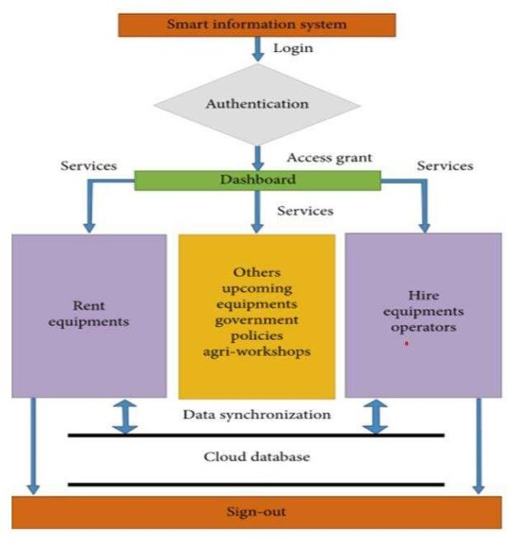

Fig 7.1 Architecture

The architecture of a city information guide website consists of a number of parts that operate in concert to deliver a thorough and user-friendly platform.

1. **Front-end:** This element is responsible for the website's user-facing interface, including its look and feel. In order to build an appealing and user-friendly interface, contemporary web technologies like responsive web design and interactive features are used.
2. **Back-end:** This part of the website represents the server-side and database technologies that make up its foundation. It includes choosing the right databases to store and manage data, as well as hosting alternatives like cloud-based systems.

**Data sources:** In order to deliver accurate and current information, this component

identifies and integrates numerous data sources, including public records, government databases, and user-generated material.

1. **Application programming interfaces (APIs):** are used in this component to simplify data interchange across various systems, including transport services, hotel booking websites, and social media networks. After gathering the necessary information, we manually entered it into our database. primarily used Flickr to obtain photos and integrating maps, we used OpenStreetMap.

#### Algorithm

The choice of algorithms in developing a tractor hiring rental system web application depends on the specific requirements and functionalities you want to implement. Here are some key components and areas where algorithms might be applied:

##### User Authentication and Authorization:

* + Algorithms for secure password hashing (e.g., bcrypt) to store user passwords securely.
  + Authorization algorithms to control access to different parts of the application based on user roles.

##### Search and Recommendation:

* + For searching tractors based on user preferences, you might use algorithms like binary search or more advanced search algorithms depending on the data structure used.
  + Recommendation algorithms (e.g., collaborative filtering, content-based filtering) can be employed to suggest tractors based on user history and preferences.

##### Booking and Scheduling:

* + Algorithms for scheduling and booking tractors efficiently, considering factors such as availability, location, and user preferences.
  + Time-based algorithms to manage rental durations and calculate costs.

##### Routing and Location-Based Services:

* + Algorithms for determining the optimal routes for delivering rented tractors to customers or for customers to pick up the tractors.
  + Location-based algorithms to track the real-time location of tractors or to find the nearest available tractor.

##### Notification System:

* + Algorithms to manage and schedule notifications for users, such as rental confirmations, reminders, and alerts.

##### Data Storage and Retrieval:

* + Algorithms related to database operations, especially if using complex queries or optimizing data retrieval based on specific criteria.

##### Review and Feedback System:

* + Algorithms to aggregate and analyze user reviews, possibly including sentiment analysis or rating aggregation.

##### Security Algorithms:

* + Encryption algorithms to secure data transmission and storage.
  + Algorithms for detecting and preventing common web application security vulnerabilities (e.g., SQL injection, cross-site scripting).

##### Performance Optimization:

* + Algorithms to optimize the performance of the application, such as caching strategies or load balancing algorithms.
  1. **Flowchart**

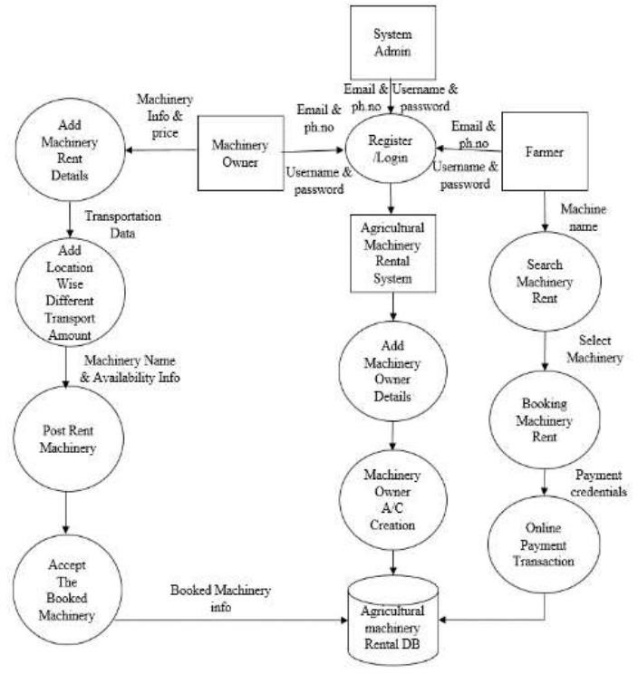

Fig 7.3 Website workflow

**Chapter – 8**

## IMPLEMENTATION

#### Development Process

There are various processes involved in putting a cityscape website together using the MERN stack. An outline of the implementation procedure is provided below:

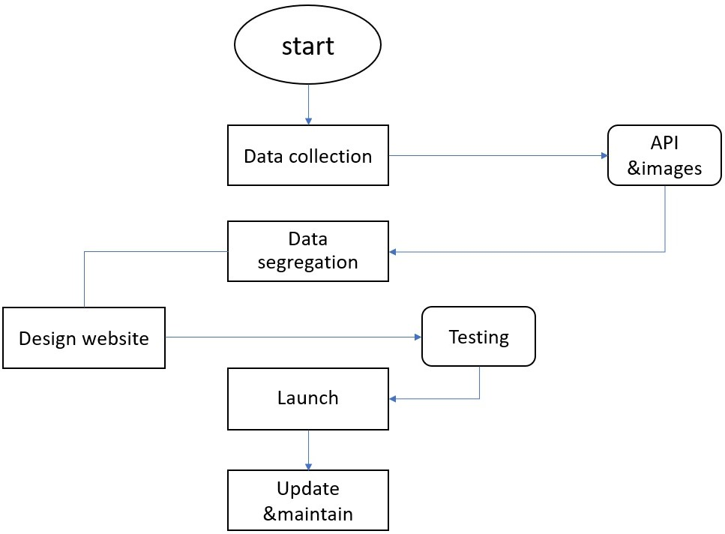

Fig 8.1 Development Process

Gathering all the requisite APIs, Images, Libraries, Designs and Themes, and Information needed to be incorporated in website was the first step in the process. To scrape the data obtained, data segregation is afterwards performed. After creating a suitable environment for the database and connecting it with the front end, the code for the front end was implemented into an interactive webpage. Once the coding was complete, we developed a number of test cases to make sure there were no flaws that would lead to issues when users interacted with the system and handled requests.

##### I. Set up the Development Environment:

* Install MongoDB and Nodejs on machine.
* Your project should be started as a Node.js project by creating a new directory and using pm or yarn to initialise it.
* Configure the connection in your Node.js application and set up a MongoDB database.

##### Il. Backend Development:

* Node.js and Express.js are used to create the server-side code.
* Create routes and controllers to handle API requests for various city information categories, including accommodations, points of interest, police stations, transit, and educational institutions.
* Use a MongoDB ORM or ODM (Object-Relational Mapping or Object-Document Mapping) library like Mongoose to implement data models and schemas.
* Use CRUD operations (Create, Read, Update, Delete) to communicate with the MongoDB database.
* Implement user authentication and authorization features by utilising JSON Web Tokens (JWT) or Passport.js libraries.

##### Frontend Development:

* + Utilize Create React App or a similar tool to set up a React application.
  + Create React components for the homepage, category listings, detailed information pages, and search capabilities of the cityscape website.
  + To manage client-side routing and navigation between several pages, use React Router.
  + To get city data from the server, integrate APIs and send HTTP queries from the frontend to the backend.
  + Create user interface elements for showing data, such as cards for lodging or tourist destinations, interactive maps made with map libraries like OpenStreetMaps or the Google Maps API, and search forms or filters.

##### Connect Backend and Frontend:

* + To send API queries from the frontend to the backend endpoints, use Axios or a comparable library.
  + On the front end, take care of data retrieval and display, making sure to refresh the user interface with the retrieved city data.

#### Libraries

1. **Regex:** Regular expression, or regex, is a potent tool for pattern matching and string manipulation. It offers a clear and adaptable vocabulary for finding, extracting, and replacing particular text patterns. JavaScript is only one of the many text editors and programming languages that support regular expressions. They are especially helpful for activities like text processing, data parsing, and form validation.
2. **React:** A well-liked JavaScript library for creating user interfaces is React. Widely used in web development, it was created by Facebook. Component-based architecture is used by React to create complex user interfaces by combining reusable components. It makes use of a virtual DOM (Document Object Model) to generate and update the user interface quickly. React is a potent tool for creating interactive and responsive web applications because to its declarative vocabulary and effective rendering.
3. **Decrypt JS:** A JavaScript package called Decrypts offers functions for data encryption and decryption using several encryption techniques. It is frequently employed for safe data transfer and storage. By offering a simple API for encrypting data with a given key and algorithm, Decrypts streamlines the encryption process. It supports well-known encryption techniques like RSA (Rivest-Shamir-Adleman) and AES (Advanced Encryption Standard).
4. **Axios:** Popular JavaScript library Axios is used by Node.js and web browsers to send HTTP requests. It offers a straightforward and understandable API for processing asynchronous HTTP requests and answers. Request and response interception, automatic JSON data parsing, progress monitoring, and error handling are just a few of the functionalities that Axios enables. Due to its simplicity of usage and adaptability, it is extensively used in web development.
5. **Sweetalert2:** A JavaScript module called Sweetalert improves the alert and confirmation dialogue boxes that web browsers by default provide. It provides an attractive, adaptable, and responsive replacement for the typical alert and confirm dialogues in JavaScript. Developers can show visually beautiful pop-up modals with editable content, buttons, and animations using Sweetalert2. It offers a straightforward

API for managing user interactions and is simple to incorporate into web applications.

1. **Express:** Express is a Node.js web application framework that is quick and simple. By offering a number of reliable features and an easy-to-use API, it makes the process of developing web servers and APIs simpler. Express gives programmers the ability to build routes, manage requests and answers, and use middleware functions to carry out operations like authentication, logging, and error handling. The Node.js ecosystem makes extensive use of it due to its performance, flexibility, and simplicity.
2. **Jsonwebtoken:** Working with JSON Web Tokens (JWTs) requires the JavaScript library Jsonwebtoken. As a JSON object, JWTs are a convenient and self-contained mechanism to securely send data between parties. Jsonwebtoken offers tools for producing, signing, checking, and decoding JWTs. Additionally, it provides a number of settings for altering token validity, issuing claims, and expiration. Web applications frequently integrate authentication and authorization techniques using Jsonwebtoken.
3. **Mongoose:** An easy and effective method of interacting with MongoDB databases is provided by the Object Data Modelling (ODM) framework for Node.js called Mongoose. It offers a more complex abstraction over the MongoDB driver, enabling programmers to specify data models, schemas, and relationships. Data management, querying, and validation are made easier by Mongoose. Additionally, it has capabilities like population, migrations depending on schema, and middleware.

#### Modules

* + 1. **Login page**

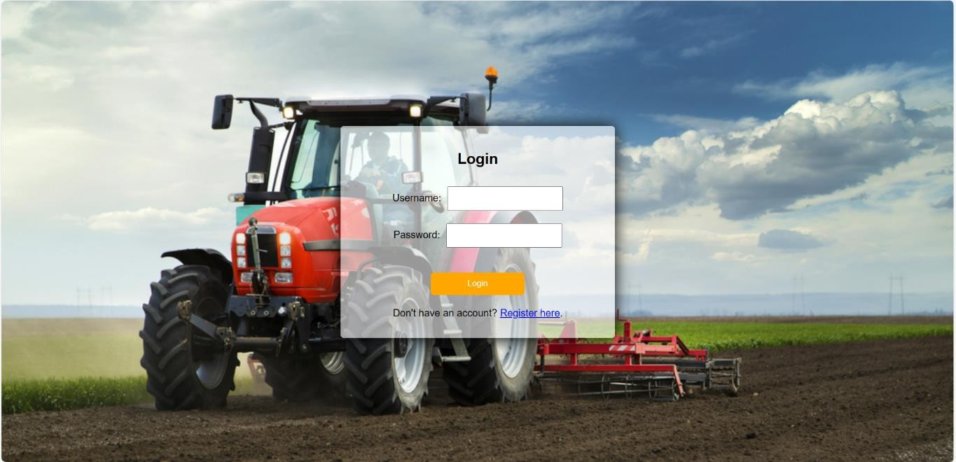

Fig 8.3.1 Login page

Welcome to our secure portal! Access your account by entering your credentials on our streamlined login page. Input your registered email or username, followed by your confidential password, ensuring a seamless and protected entry. For added security, our system employs advanced encryption measures to safeguard your data. Forgot your password? No worries – easily reset it with our user-friendly recovery options. Experience hassle-free navigation and swift access to your personalized dashboard, where you can manage your profile, explore services, and stay updated on the latest offerings. Trust us for a smooth, protected, and user-centric login experience. Welcome back to a world of convenience!

#### Home Page

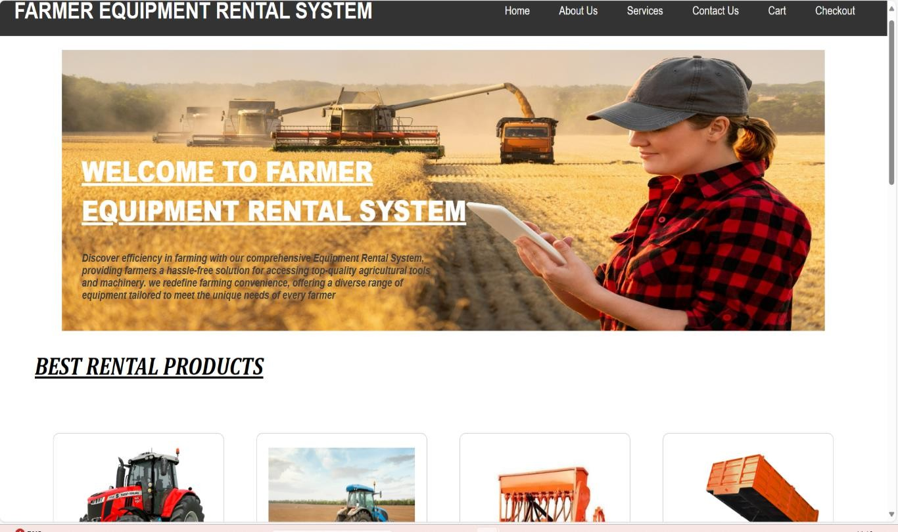

Fig 8.3.2 Home Page

Welcome to our Agricultural Rental System, where farming meets efficiency. Explore a vast network connecting farmers and resources for seamless equipment and land rentals. Empower your agricultural venture by easily accessing a diverse range of offerings—tractors, fields, and more. Our intuitive platform ensures a hassle-free experience, fostering collaboration within the farming community. Boost productivity, conserve resources, and strengthen agricultural sustainability through smart renting. Join us in cultivating a future where farmers effortlessly share and access the tools they need, creating a resilient and connected ecosystem. Your thriving farm begins with the right partnerships on our Agricultural Rental System.

#### About us

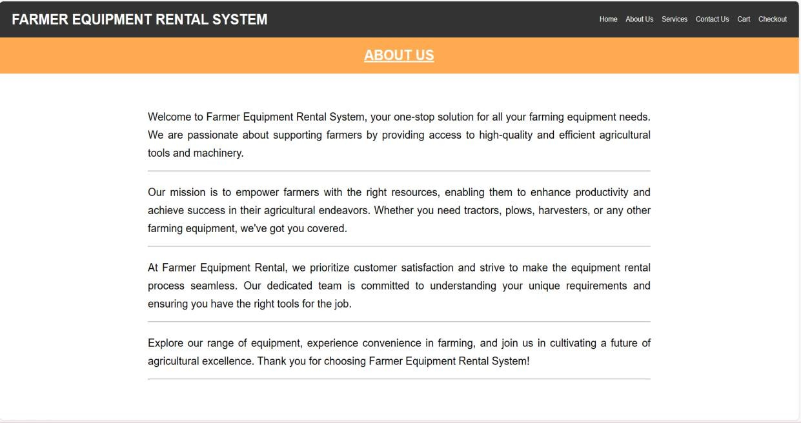

Fig 8.3.3 About us

Our Agricultural Rental System, where innovation meets cultivation. We are dedicated to revolutionizing the farming landscape by providing a seamless platform connecting farmers with state-of-the-art equipment. Our mission is to empower agricultural communities by facilitating easy access to modern machinery, fostering efficiency, and optimizing resource utilization. Committed to sustainable farming practices, we aim to bridge the gap between technology and traditional agriculture. With a focus on reliability and affordability, our platform ensures farmers have the tools they need to thrive. Join us in cultivating a future where technology transforms the fields, ensuring a bountiful harvest for generations to come.

#### Services

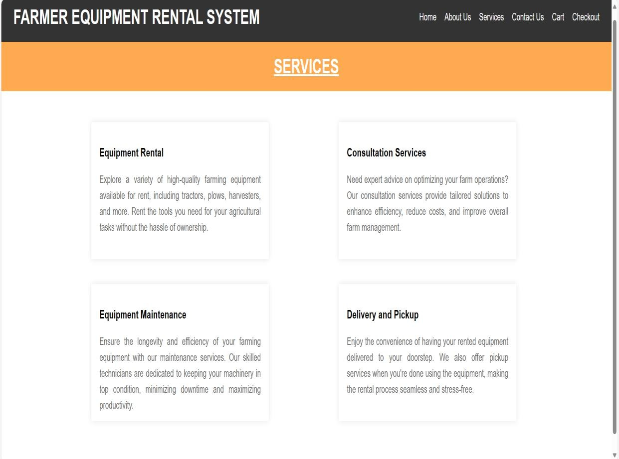

Fig 8.3.4 Services Page

Our Agricultural Rental System offers a comprehensive suite of services tailored to empower farmers with the latest and most advanced agricultural machinery. From tractors and plows to harvesters and precision equipment, we provide a diverse range of cutting-edge tools to meet the evolving needs of modern farming.

Our platform simplifies the equipment rental process, offering a user-friendly interface that allows farmers to browse, select, and book machinery with ease. We prioritize efficiency, ensuring timely delivery and pickup, minimizing downtime for farmers. Our fleet comprises well-maintained, high-quality equipment, guaranteeing optimal performance in every agricultural task.

To support farmers in maximizing productivity, we offer training and assistance programs, ensuring they harness the full potential of the rented machinery. Our experienced team is dedicated to providing guidance on equipment operation, maintenance, and troubleshooting. Transparency and affordability are at the core of our services. We strive to make advanced agricultural technology accessible to all farmers, promoting sustainable practices and fostering agricultural growth. With flexible rental plans and competitive pricing, our platform aims to contribute to the success and prosperity of agricultural communities, ushering in a new era of smart and efficient farming practices. Join us in cultivating a future where technology transforms agriculture for the better.

#### Contact Us

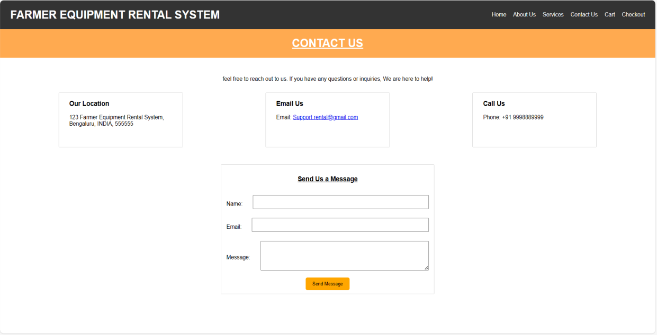

Fig 8.3.5 Contact Us

Feel free to reach out! For inquiries, collaborations, or assistance, contact our team at Farmer Equipment Rental System. We value your feedback and look forward to connecting with you. Email us at [support.rental@gmail.com](mailto:support.rental@gmail.com) or call 987654310.

**Chapter - 9**

## TIMELINE FOR EXECUTION OF PROJECT (GANTT CHART)

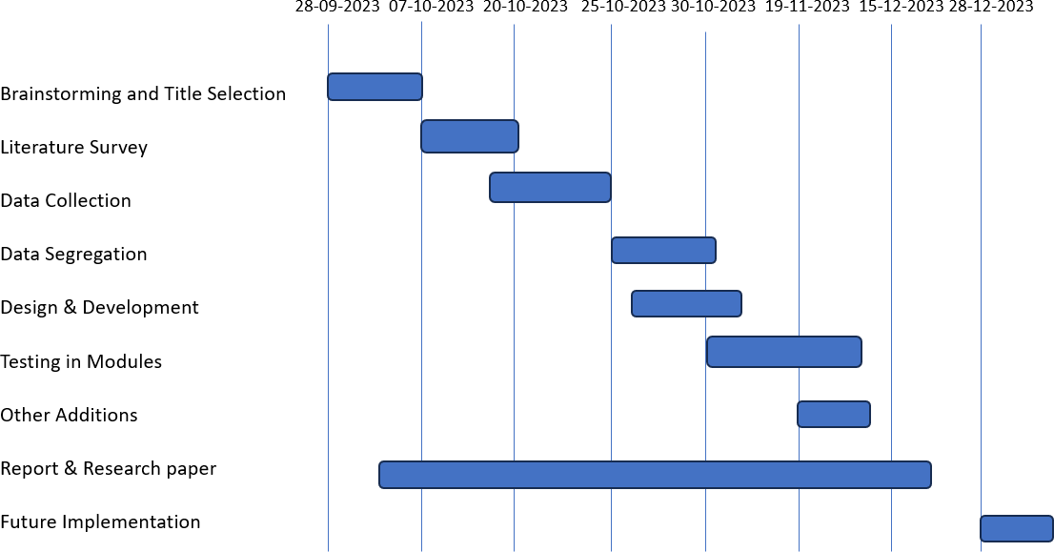

**Chapter - 10**

## OUTCOMES

##### Expected Outcomes of the Mobile Application for Farm Mechanization:

**Increased Mechanization:** More farmers will access and utilize mechanized equipment, reducing their reliance on manual labor.

**Higher Agricultural Efficiency:** Improved access to tractors and machinery will lead to increased efficiency, resulting in higher crop yields and reduced labor costs.

**Economic Empowerment:** Farmers' income is likely to rise as mechanization helps optimize resources and increase agricultural productivity.

**Sustainable Agriculture:** The project's success will contribute to more sustainable and modernized agricultural practices, ultimately benefitting the entire agricultural ecosystem.

## CHAPTER-11 RESULTS AND DISCUSSIONS

* 1. **Results:**

##### User Registration and Authentication:

* + Describe the implementation and success of user registration and authentication features.
  + Highlight any issues encountered and how they were resolved.

##### Tool and Tractor Listings:

* + Present the number of tools and tractors listed on the platform.
  + Discuss any challenges faced in managing the inventory and ensuring accuracy.

##### Booking and Reservation System:

* + Report on the functionality of the booking system.
  + Discuss any feedback or issues raised by users during the reservation process.

##### Payment Gateway Integration:

* + Evaluate the success of integrating a payment gateway for transactions.
  + Provide any statistics on completed transactions and payment-related issues.

##### User Feedback and Ratings:

* + Share feedback received from users through the platform.
  + Discuss any patterns or trends in user ratings and comments.

##### Website Performance:

* + Discuss the website's response time and overall performance.
  + Address any bottlenecks or areas for improvement identified during testing.
  1. **Discussions:**

##### User Experience (UX):

* + Analyze user feedback to assess the overall user experience.
  + Discuss any improvements or modifications based on user suggestions.

##### Challenges and Lessons Learned:

* + Detail challenges faced during development and deployment.
  + Discuss how these challenges were overcome and the lessons learned.

##### Security Measures:

* + Discuss the security features implemented to protect user data.
  + Address any potential vulnerabilities identified and the steps taken to mitigate them.

##### Future Enhancements:

* + Outline potential improvements and features for future versions.
  + Consider user suggestions and technological advancements that could be incorporated.

##### Impact on Agricultural Practices:

* + Discuss the practical impact of the web application on farmers and the agricultural community.
  + If possible, include testimonials or case studies highlighting success stories.

##### Sustainability and Scalability:

* + Address the sustainability of the platform in the long term.
  + Discuss scalability considerations and plans for handling increased user load.

##### Community Engagement:

* + Discuss any community engagement initiatives related to the platform.
  + Highlight partnerships, outreach efforts, or collaborations with agricultural organizations.

## CHAPTER-12 CONCLUSION

Our web application is a transformative tool poised to revolutionize the landscape of modern agriculture. Designed with a keen focus on user-friendly functionality, it stands as a testament to our commitment to bringing technological advancements to the forefront of farming practices.

At the heart of this innovation is the drive to minimize manual labor in agriculture. Through intuitive interfaces and streamlined processes, our web application significantly reduces the physical burden on farmers, boosting efficiency and productivity. Users can access a range of features that simplify tasks, optimize resource management, and contribute to overall farm management.

An integral aspect of our web application is its role in revitalizing the farming profession. As traditional practices face challenges in attracting younger generations, our application introduces a tech-savvy approach, making farming more accessible and appealing. It bridges generational gaps by seamlessly integrating technology into agriculture, creating an environment where both seasoned farmers and new enthusiasts can thrive.

Agricultural sustainability is a core principle embedded in our web application. By facilitating informed decision-making through data analytics and providing tools for resource optimization, the application contributes to sustainable farming practices. This, in turn, empowers farming communities economically, creating a resilient foundation for the future. In essence, our web application is more than a digital platform; it is a catalyst for positive change in agriculture. It provides a comprehensive solution to modernize farming practices, minimize manual labor, encourage the younger generation to embrace agriculture, and contribute to the sustainability of this essential industry. Through the fusion of technology and agricultural wisdom, our web application stands as a beacon for the future, where innovation and tradition harmonize to shape a thriving and sustainable agricultural landscape.

## APPENDIX-A PSUEDOCODE

from django.shortcuts import render from django.http import JsonResponse import json

import datetime

from .models import *

from .utils import cookieCart, cartData, guestOrder # Create your views here.

def store(request):

data = cartData(request) cartItems = data['cartItems']

products = Product.objects.all()

context = {'products':products, 'cartItems':cartItems} return render(request, 'store/store.html', context)

def cart(request):

data = cartData(request) cartItems = data['cartItems'] order = data['order']

items = data['items']

context = {'items':items , 'order':order, 'cartItems':cartItems} return render(request, 'store/cart.html', context)

def checkout(request):

data = cartData(request) cartItems = data['cartItems'] order = data['order']

items = data['items']

context = {'items':items , 'order':order, 'cartItems':cartItems} return render(request, 'store/checkout.html', context )

def updateItem(request):

data = json.loads(request.body) productId = data['productId'] action = data['action']

print('Action:', action) print('productId:', productId)

customer = request.user.customer

product = Product.objects.get(id=productId)

order, created = Order.objects.get_or_create(customer=customer, complete=False) orderItem, created = OrderItem.objects.get_or_create(order=order, product=product)

if action == 'add':

orderItem.quantity = (orderItem.quantity + 1) elif action == 'remove':

orderItem.quantity = (orderItem.quantity - 1) orderItem.save()

if orderItem.quantity <= 0: orderItem.delete()

return JsonResponse('Item was added', safe=False)

# from django.views.decorators.csrf import csrf_exempt # @csrf_exempt

def processOrder(request):

transaction_id = datetime.datetime.now().timestamp() data = json.loads(request.body)

if request.user.is_authenticated: customer = request.user.customer

order, created = Order.objects.get_or_create(customer=customer, complete=False) else:

customer, order = guestOrder(request, data)

total = float(data['form']['total']) order.transaction_id = transaction_id

if total == float(order.get_cart_total): order.complete = True

order.save()

if order.shipping == True: ShippingAddress.objects.create(

customer=customer, order=order,

address=data['shipping']['address'], city=data['shipping']['city'], state=data['shipping']['state'], zipcode=data['shipping']['zipcode'],

)

return JsonResponse('Payment complete!', safe=False) def Aboutus(request):

return render(request,'store/aboutus.html', {})

def Services(request):

return render(request,'store/services.html', {})

def Contactus(request):

if request.method == 'POST':

name = request.POST.get('name') email = request.POST.get('email') message = request.POST.get('message')

ins = Contact(name=name, email=email, message=message) ins.save()

print("ok")

return render(request,'store/contactus.html', {})

def Feedback(request):

if request.method == 'POST':

name = request.POST.get('name') number = request.POST.get('number')

question1 = request.POST.get('question1') question2 = request.POST.get('question2') question3 = request.POST.get('question3') question4 = request.POST.get('question4') question5 = request.POST.get('question5') feedback = request.POST.get('feedback')

ins = Feed(name=name, number=number, question1=question1, question2=question2, question3=question3, question4=question4, question5=question5, feedback=feedback)

ins.save() print("ok")

return render(request,'store/feedback.html', {})

## APPENDIX-B SCREENSHOTS



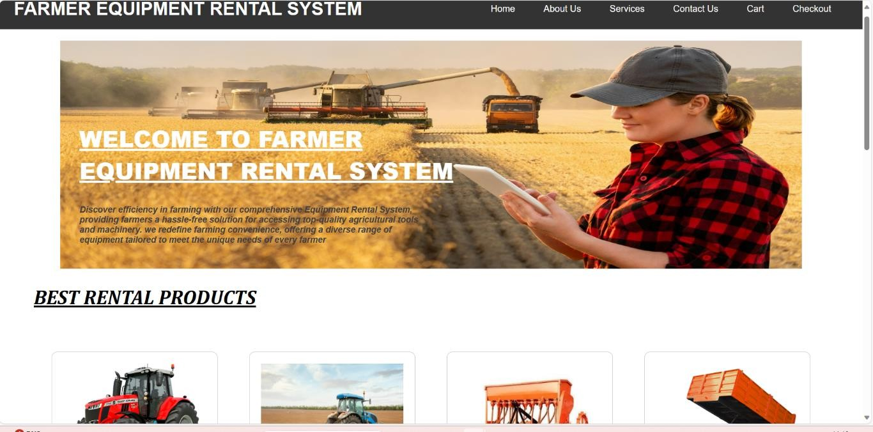







**APPENDIX-C ENCLOSURES**

**Conference paper certificates**

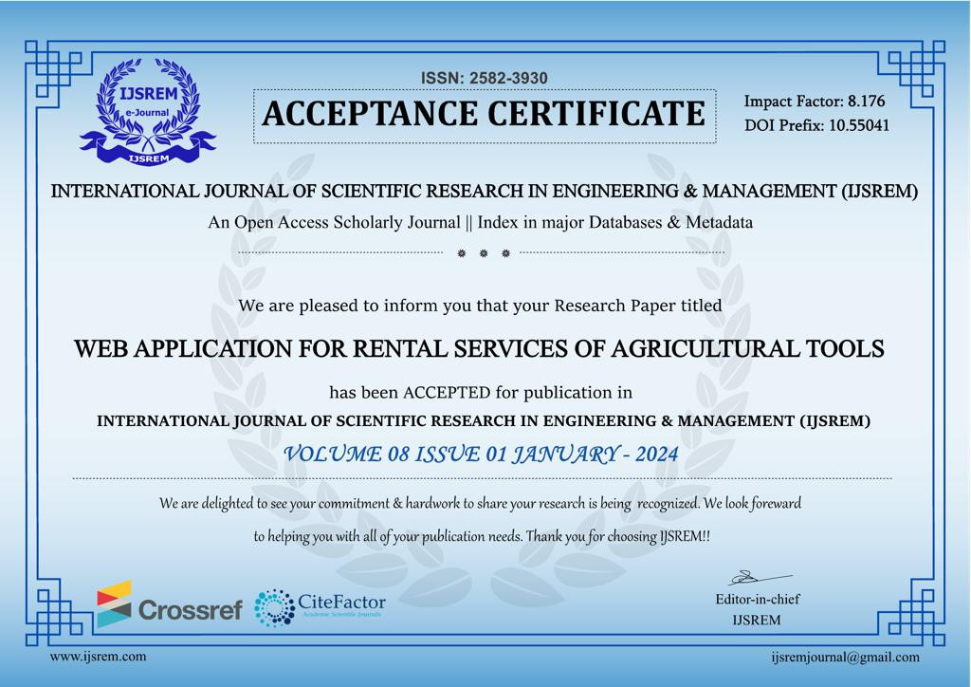

**Plagiarism Report**

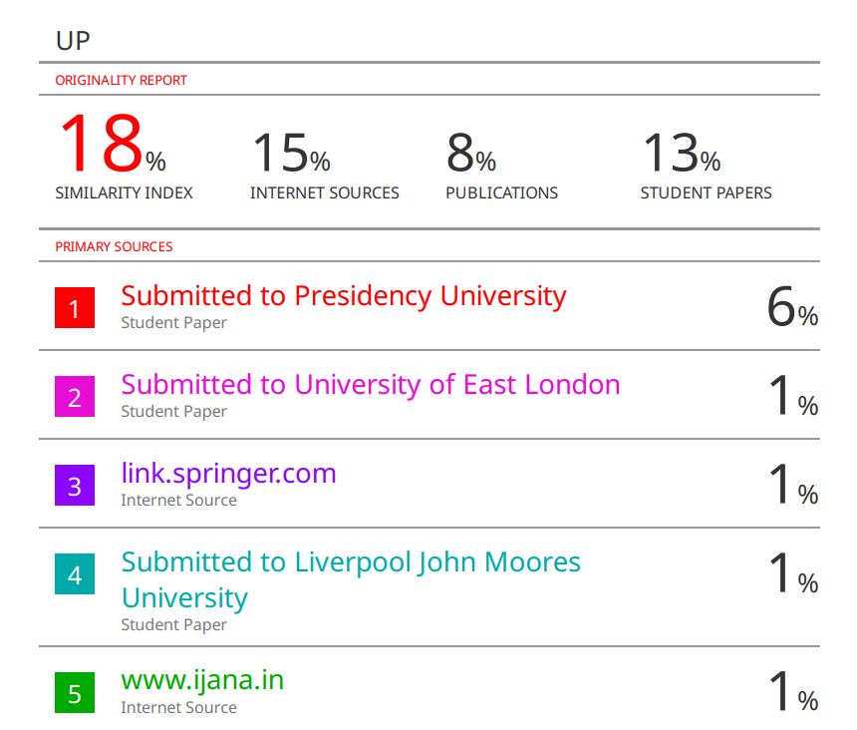

**Sustainable Development Goals**



**The Project work carried out here is mapped to SDG-9 Industry, Innovation and Infrastructure.**

Implementing an agricultural tool renting system aligns with Sustainable Development Goal-9: Industry, Innovation, and Infrastructure. By fostering technological advancements and enhancing infrastructure for sustainable agriculture, this project contributes to increased productivity, resource efficiency, and economic growth in rural communities, promoting a more sustainable and inclusive agricultural sector.