Cloud Computing Project
Design and Evaluation of an Intelligent, Scalable, and Cost-Aware Cloud Data Pipeline for Real-Time and Batch Analytics

Group 7

Krishna Agrawal
2025H1030050H | h20250050@hyderabad.bits-pilani.ac.in

Patel Harshkumar J
2025H1030179H | h20250179@hyderabad.bits-pilani.ac.in

Fathima Fiza B
2025H1030057H | h20250057@hyderabad.bits-pilani.ac.in

Khushi Dusad
2025H1030052H | h20250052@hyderabad.bits-pilani.ac.in



Department of Computer Science BITS Pilani, Hyderabad Campus
Contents
- Abstract 4
- Introduction 5
- Problem Statement 6
- Input Event Model 6
  - Schema Organization . . . . . . . . . . . . . . . . . . . . . . . . . . . . . . . 6
    - Event Metadata . . . . . . . . . . . . . . . . . . . . . . . . . . . . . . 6
    - User Profile Attributes . . . . . . . . . . . . . . . . . . . . . . . . . . 7
    - Contextual and Device Information . . . . . . . . . . . . . . . . . . . 7
    - Session and Course Context . . . . . . . . . . . . . . . . . . . . . . . 7
    - Interaction-Level Details . . . . . . . . . . . . . . . . . . . . . . . . . 7
  - Event Types and Lifecycle . . . . . . . . . . . . . . . . . . . . . . . . . . . . 8
- Pipeline 1: Serverless Architecture (Baseline) 8
  - Architecture Overview . . . . . . . . . . . . . . . . . . . . . . . . . . . . . . 9
  - Data Generation Layer . . . . . . . . . . . . . . . . . . . . . . . . . . . . . . 9
  - Data Ingestion Layer 11
  - Processing Layer 12
  - Intelligence Layer 13
  - Storage and Metadata Layer 14
  - Query Layer 16
  - Visualization Layer 17
- Challenges Faced in the Serverless Architecture 19
- Limitation of Serverless Architecture 20
- Motivation for Alternative Architecture 20
- Pipeline 2: Distributed Streaming Architecture (Optimized) 21
  - Architecture Overview 21
  - Data Generation Layer 22
  - Data Ingestion Layer 23
  - Processing Layer 24
  - Intelligence Layer 24
  - Scalable Storage Layer 26
  - Batch Processing Layer 28
  - Monitoring and Metrics Layer 31
  - Visualization Layer 33
  - Spark Streaming Logs and System Behavior 36
  - Checkpoint-Based Failure Recovery 38
  - Performance and Cost Benchmarking 40
  - Experimental Evaluation 41
  - Research Analysis 42
- Comparison of the Two Pipelines 42
- Conclusion 46
Abstract

This project presents the design and evaluation of a cloud-native data pipeline for an EdTech analytics use case involving continuous streams of student activity events. The system is developed in two stages. In the first stage, a serverless AWS pipeline is implemented using Lambda for real-time processing, S3 for raw storage, AWS Glue for batch transformation, Athena for querying, and QuickSight for dashboarding. This baseline pipeline demonstrates the feasibility of building a unified real-time and batch analytics workflow on managed cloud services. However, during analysis, several limitations of the serverless design become appar- ent, particularly under sustained or bursty streaming workloads, including higher invocation- driven cost, stateless execution overhead, limited suitability for continuous processing, and weaker control over resource allocation.
To address these limitations, a second pipeline is implemented using a distributed streaming architecture built on Kafka, Spark Structured Streaming, Redis, S3, DynamoDB, Prometheus, Grafana, and Kubernetes. In this design, events are generated on one EC2 instance and pro- cessed continuously on another, with Kafka providing buffered ingestion, Spark performing real-time processing and intelligence, and Redis serving low-latency metrics. Storage oper- ations are decoupled from processing and handled by lightweight Kubernetes-based worker pods, which write data to S3 and DynamoDB. These pods are dynamically scaled using KEDA based on Kafka consumer lag, while EC2 Auto Scaling ensures sufficient infrastruc- ture capacity under high load.
Two rule-based intelligence components are integrated within the Spark processing layer: AdaptiveBatchOptimizer for cost-aware S3 writes and SurgeDetector for SLA-aware priority routing during spikes. The final evaluation is based on controlled experiments measuring cost, latency, surge handling, scaling behavior, and failure recovery. Results show that the optimized pipeline reduces S3 API costs by 87.6%, detects and handles surges within one micro-batch, completes the batch reporting job in 118 seconds on 267,759 events, and recovers from failures within approximately 5 seconds. These results demonstrate that a carefully designed distributed streaming pipeline can provide better control, efficiency, scalability, and resilience for continuous high-volume workloads.
Introduction

Modern digital platforms continuously generate large volumes of data that must be collected, processed, stored, and analyzed in near real time. In domains such as online learning, events such as student logins, class joins, quiz submissions, and session terminations can provide valuable information about engagement, performance, and system behavior. However, these event streams are often high velocity, bursty, and operationally complex. Traditional ETL approaches are not sufficient for such workloads, because they do not support continuous ingestion and real-time visibility effectively. The course project specifically frames this as a cloud data pipeline problem involving real-time and batch processing, cost–latency trade-offs, adaptive routing, observability, and fault handling.
The goal of this project is to design and evaluate an intelligent, scalable, and cost-aware cloud data pipeline for EdTech activity analytics. The selected use case is an online learning platform in which synthetic student activity events are generated continuously and processed for both real-time monitoring and historical analysis. The project follows the instructor’s recommended execution logic of first building a simple working pipeline and then evaluating and improving it through controlled experiments.
To achieve this, the project is developed in two stages. The first stage implements a baseline serverless pipeline on AWS using Lambda, S3, Glue, Athena, QuickSight, and DynamoDB. This architecture is useful for demonstrating the core cloud workflow and validating end-to- end data movement from ingestion to analytics.
In the second stage, an improved pipeline is implemented using a distributed streaming architecture deployed on EC2 instances, combined with a Kubernetes-based scaling layer. The system integrates Kafka for ingestion, Spark Structured Streaming for real-time pro- cessing, Redis for low-latency analytics, S3 and DynamoDB for storage, and Prometheus with Grafana for monitoring. A key enhancement in this design is the separation of pro- cessing and storage responsibilities, where scalable Kubernetes-based storage workers handle high-throughput writes independently of the Spark processing layer.
This second design also introduces two intelligence mechanisms, AdaptiveBatchOptimizer and SurgeDetector, to improve cost efficiency and SLA behavior under variable workloads. In addition, KEDA-based scaling and EC2 Auto Scaling enable the system to dynamically adapt to workload changes. The report therefore compares a simple baseline against an optimized streaming system, aligning with the academic objective of evaluating baseline and
improved architectures under workload-driven conditions.

Problem Statement

The objective of this project is to design a scalable cloud-based data pipeline capable of pro- cessing both real-time and batch data streams while maintaining low latency, high through- put, and cost efficiency. The system should handle dynamic workloads, including burst traffic, and provide reliable analytics outputs.
The project specifically focuses on evaluating different architectural approaches to deter- mine their suitability for continuous streaming applications. Key evaluation criteria include latency, throughput, cost efficiency, fault tolerance, and operational complexity.

Input Event Model

The system adopts a unified event-driven data model to represent user interactions within an EdTech platform. Each interaction is captured as a structured JSON object, enabling seamless integration across ingestion, processing, storage, and analytics components.

Schema Organization

The event schema is logically divided into five categories to improve clarity, maintainability, and analytical usability.

    - Event Metadata

These fields uniquely identify and describe the nature of the event.

Field Description

event id Globally unique identifier for the event
event type Type of user action (e.g., login, class join, session start)
timestampTime of event generation in ISO 8601 format
schema version Version of the schema for compatibility

    - User Profile Attributes

These attributes describe the characteristics of the user generating the event.

Field Description

user id Unique user identifier
user role Role of user (student/instructor)
subscription typeFree or premium subscription
user age groupAge segment
user level Skill level (beginner/intermediate/advanced)

These attributes remain consistent across events for a given user.

    - Contextual and Device Information

These fields provide environmental context for each interaction.

Field Description

region User’s geographic region country Country of origin timezone Timezone of the user
device Device type (mobile/desktop/tablet)
osOperating system
app version Version of the application

These attributes support segmentation analysis and system-level insights.

    - Session and Course Context

These fields associate user actions with specific sessions and classes. This group enables tracking of user participation across courses.

    - Interaction-Level Details

These attributes capture the specific nature of user engagement. These fields are critical for fine-grained engagement analytics.

Field Description

session id Identifier for a user session
class idIdentifier for the class
course nameName of the course
course category Subject domain
difficulty level Course difficulty classification
instructor idIdentifier of the instructor

Field Description

session type Type of session (live/recorded)
interaction typeActivity type (video, quiz, poll, etc.)
content idIdentifier for content being accessed
content durationDuration of interaction in seconds

Event Types and Lifecycle

The system models user behavior through a set of discrete event types:

- login / logout: user authentication lifecycle
- class join / class leave: class participation lifecycle
- session start / session end: content interaction lifecycle
- These events follow a logical progression:
login → class join → session start → session end → class leave → logout

Pipeline 1: Serverless Architecture (Baseline)

The first pipeline is implemented as a serverless AWS-based analytics architecture for pro- cessing EdTech user activity events in near real time. The purpose of this pipeline is to ingest interaction events, process them immediately for operational insights, preserve the raw data for later analysis, and expose both historical and live views through SQL queries and dash- boards. The architecture combines Amazon Kinesis for event ingestion, AWS Lambda for stream processing, Amazon S3 for raw data storage, Amazon DynamoDB for real-time state management, AWS Glue for schema discovery, Amazon Athena for SQL-based querying,
and Amazon QuickSight for dashboard visualization. This design matches the project goal of supporting both real-time and batch analytics in a cloud-native manner.

Architecture Overview

Pipeline 1 follows two parallel analytics paths after Lambda processing. In the first path, raw JSON events are stored in Amazon S3 and later queried through AWS Glue and Amazon Athena for historical analysis. In the second path, Lambda writes processed operational state into DynamoDB tables, which are then exposed to Athena through Athena Federated Query and converted into views for dashboarding. As a result, the pipeline supports both batch- style historical analytics and near-real-time operational analytics within the same overall architecture.
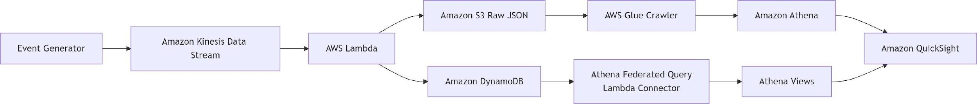
Figure 1: Pipeline 1 Architecture

Data Generation Layer

The system follows a structured event-driven model in which user interactions are generated as JSON events by a custom event generator running on a local machine. This generator simulates realistic EdTech platform behavior and provides configurable controls such as event rate (events per second), number of active users, and workload patterns (e.g., continuous or spike modes). These controls allow the system to emulate different traffic conditions, ranging from steady usage to bursty real-world scenarios.
By enabling precise control over input characteristics, the generator ensures repeatable ex- periments and flexible testing of system performance under varying loads. The generated events follow valid interaction sequences, maintaining consistency in session and class lifecy- cles. This controlled yet realistic data generation forms a reliable foundation for evaluating the ingestion, processing, and analytics capabilities of the overall system.
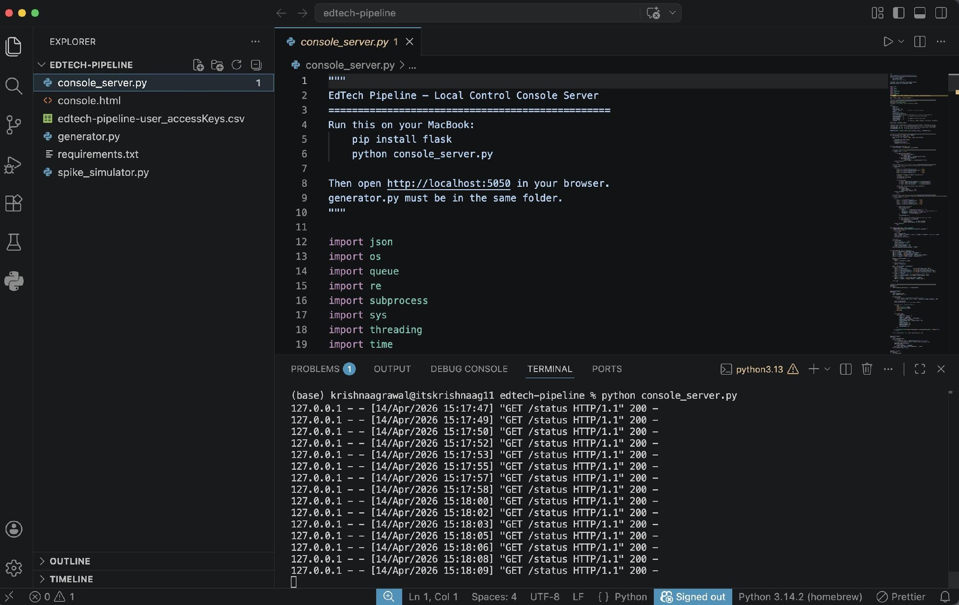
Figure 2: Running the generator console on local machine

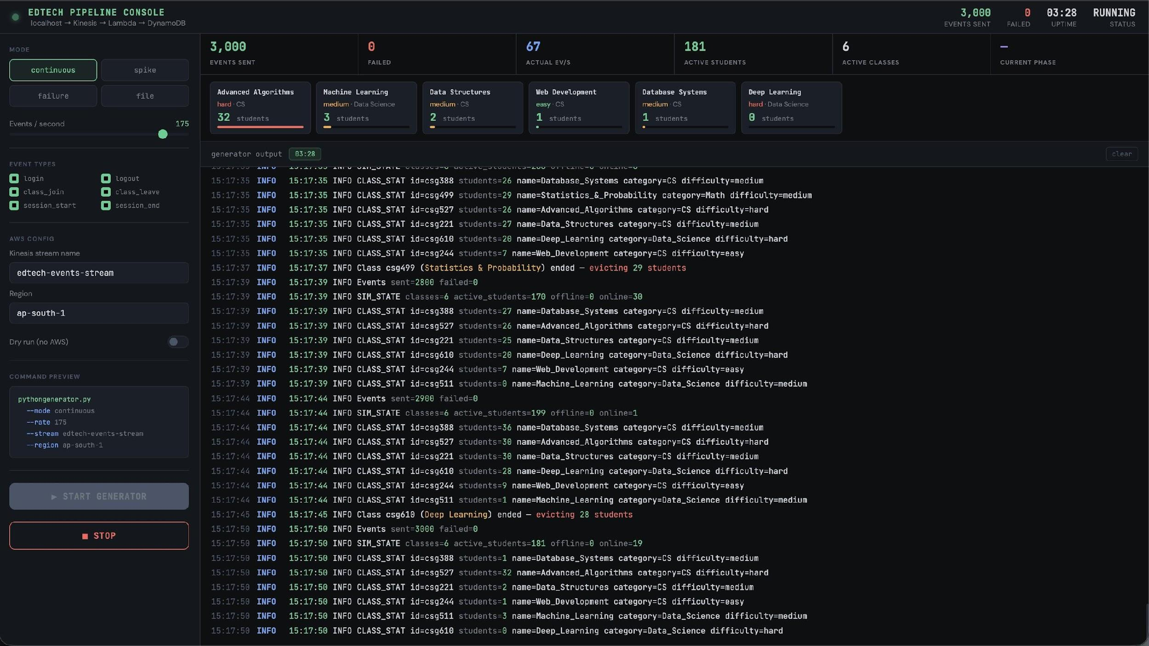
Figure 3: Generator Console
Data Ingestion Layer

The ingestion layer uses Amazon Kinesis Data Streams. Synthetic events generated by the workload generator are pushed into the Kinesis stream edtech-events-stream, which serves as the real-time event bus for the pipeline. Kinesis provides a managed mechanism for continuously ingesting activity data and delivering it to the Lambda function. The stream is active and configured in on-demand mode, which allows the system to absorb changing traffic patterns without manual shard planning, making it appropriate for bursty event workloads.
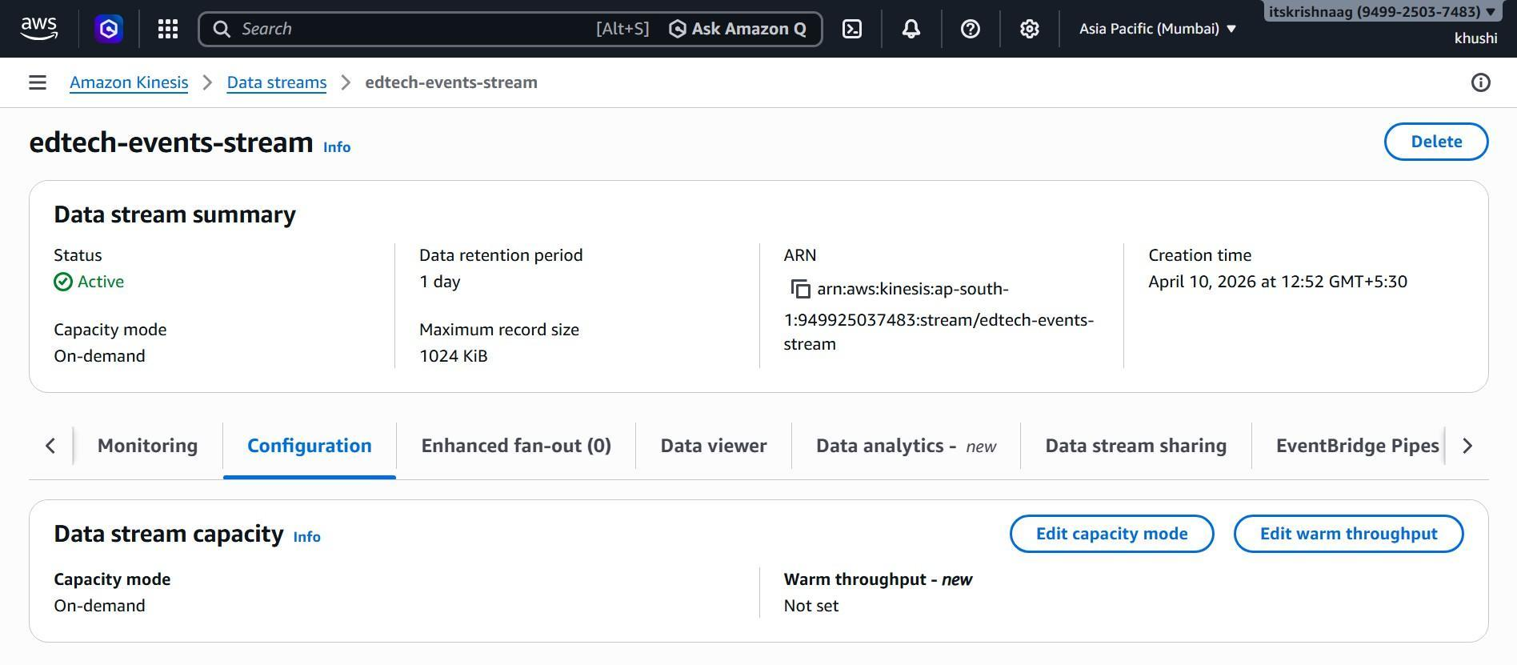
Figure 4: Edtech Events Data Stream

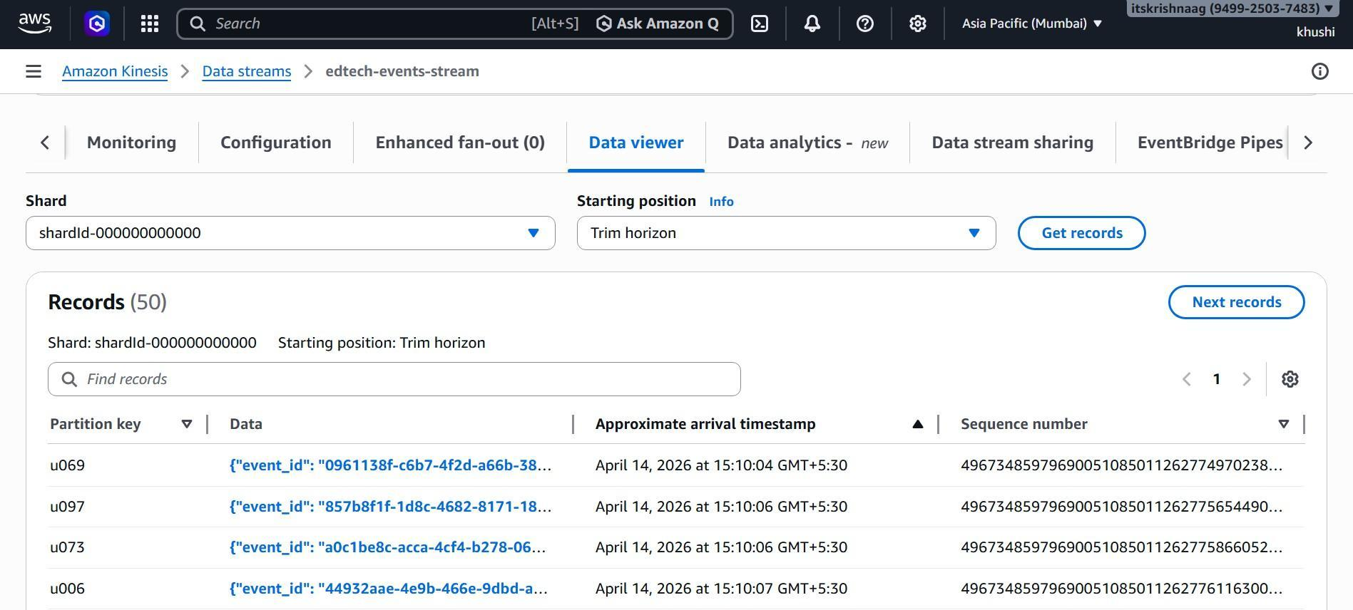
Figure 5: Data in Kinesis Stream
Processing Layer

The processing layer is implemented using AWS Lambda, which performs real-time transfor- mation and aggregation of incoming streaming data. As events arrive from Amazon Kinesis Data Streams, the Lambda function processes them in a stateless manner, decoding records, normalizing schema fields, and extracting relevant attributes for downstream analytics.
In addition to basic transformation, the Lambda function maintains operational state us- ing Amazon DynamoDB. It updates active session information and class-level engagement metrics, ensuring that real-time system state is continuously reflected with low latency. Si- multaneously, raw event data is persisted into Amazon S3 for long-term storage and historical analysis.
Additionally, the Lambda function publishes operational metrics such as event throughput and processing latency to Amazon CloudWatch. These metrics enable real-time monitoring and provide visibility into system performance.
Overall, the processing layer enables low-latency data transformation and state management without requiring dedicated infrastructure.
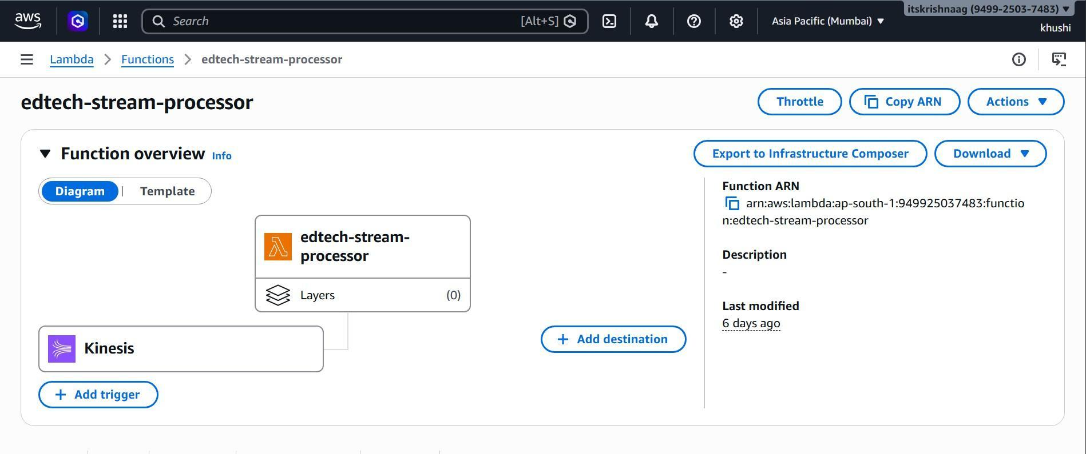
Figure 6: Edtech Stream Processor
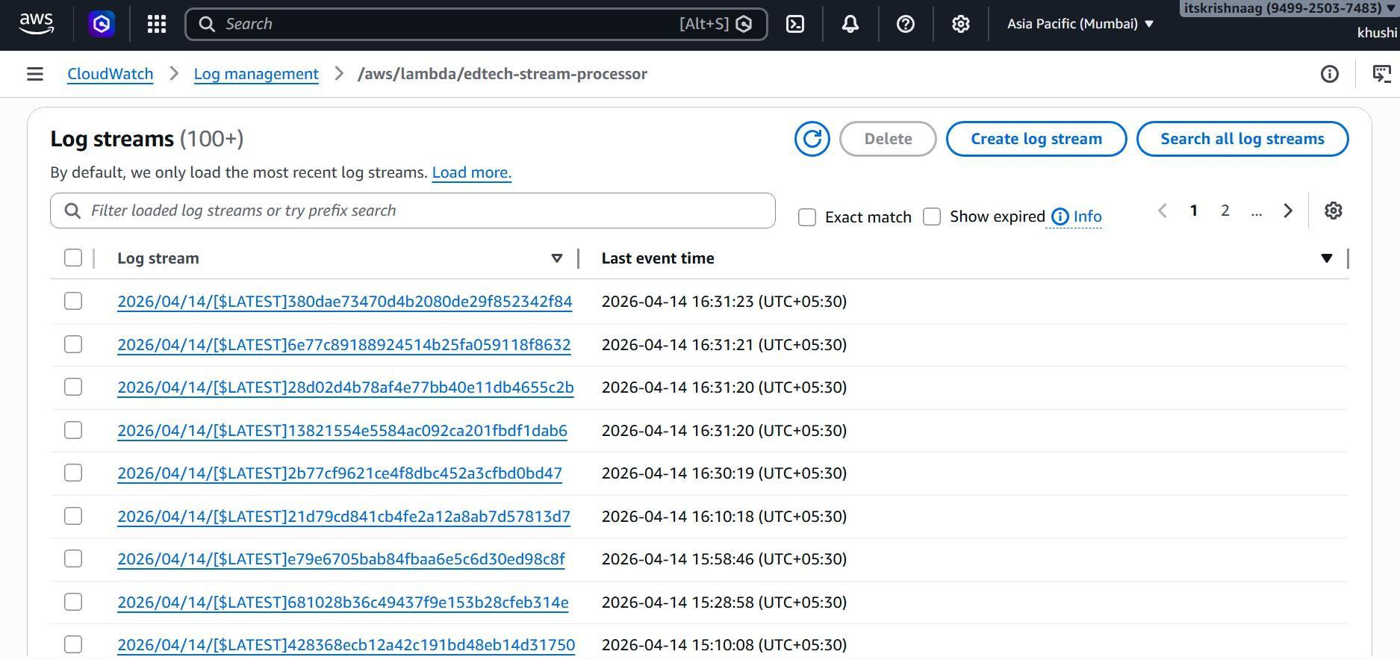
Figure 7: CloudWatch Logs of the Lambda Function

Intelligence Layer

The intelligence component is integrated within the Lambda processing workflow to enable workload-aware behavior. A time-window-based spike detection mechanism is implemented to identify sudden increases in event volume.
Incoming events are aggregated into fixed one-minute buckets, and a rolling baseline is maintained using an Exponential Moving Average (EMA). This approach captures recent workload trends while smoothing short-term fluctuations.
Spike detection is performed by comparing the current minute’s event count against a dy- namically computed threshold derived from the EMA baseline. A spike is identified when the current workload exceeds a configurable multiple of the rolling average.
To ensure stability and prevent bias, the EMA is updated only once per time window, avoiding multiple partial updates within the same interval. This improves the robustness of spike detection and reduces sensitivity to noise.
The detected spike indicators are also published as metrics, allowing the system to monitor workload variations in real time.
Storage and Metadata Layer

The storage layer consists of Amazon S3 and DynamoDB, serving complementary purposes. Amazon S3 is used to store raw event data in its original JSON format, ensuring durability and enabling future reprocessing or historical analysis. DynamoDB is used to store processed and aggregated data, such as active sessions and class-level metrics, providing low-latency access to real-time information.
To enable structured querying over raw data stored in S3, AWS Glue is used as a metadata catalog service. A Glue crawler automatically scans the S3 bucket, infers the schema of the JSON data, and creates corresponding tables in the Glue Data Catalog. These tables are then used by Athena to query raw event data efficiently without requiring manual schema definition.
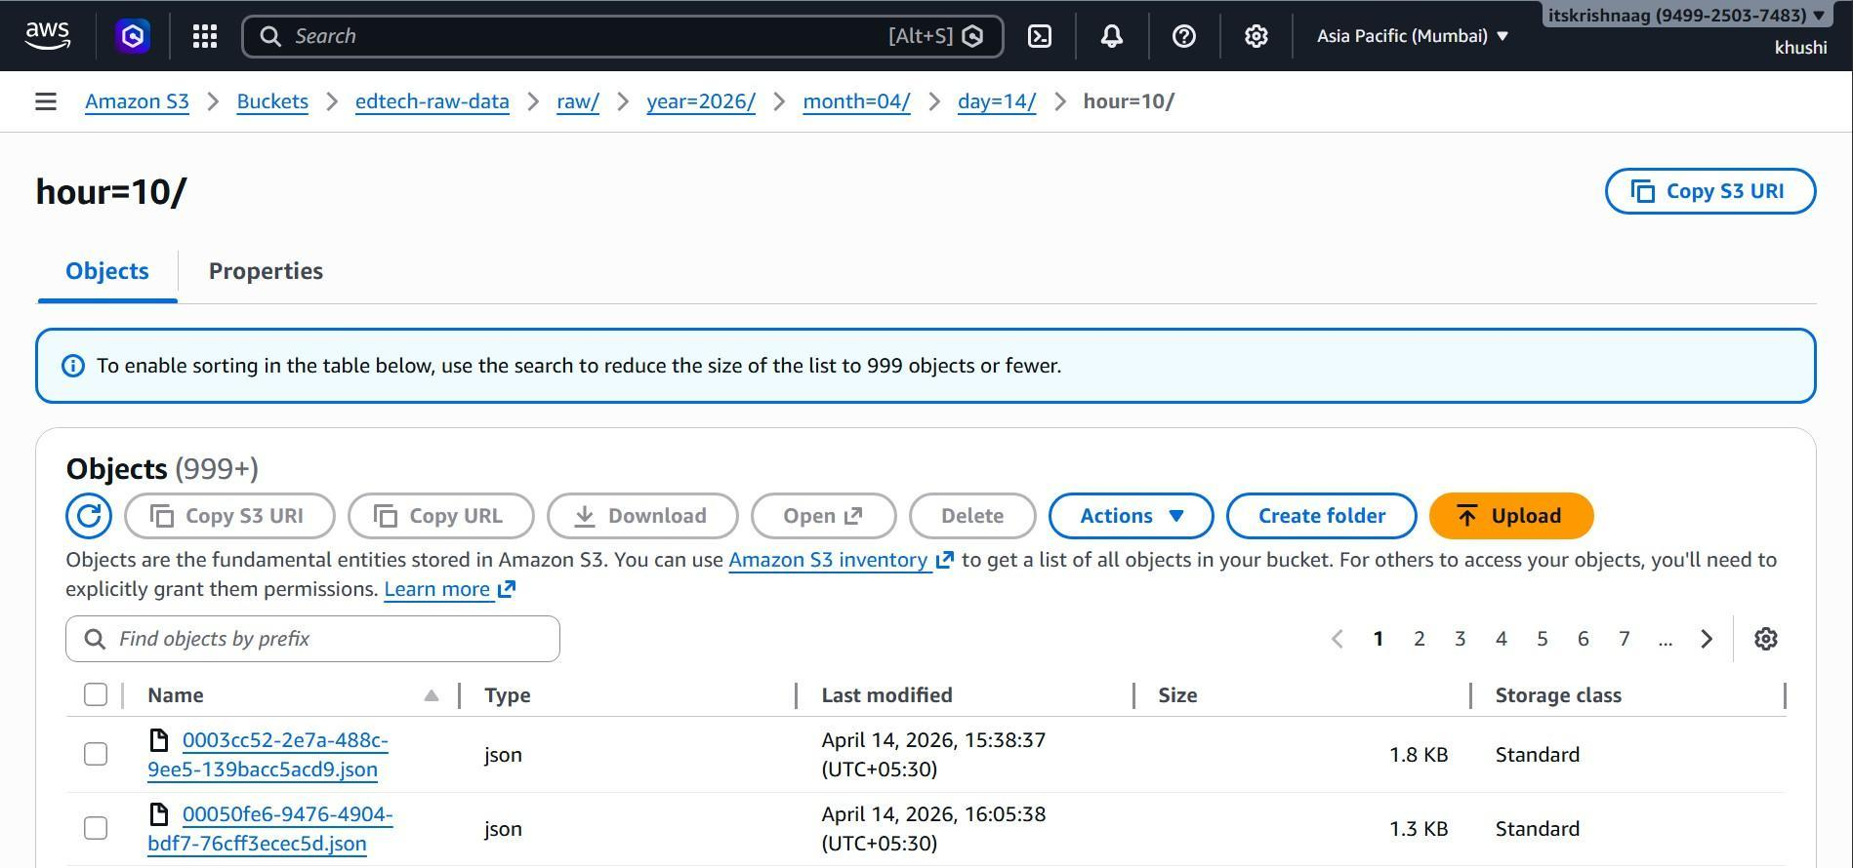
Figure 8: Raw Data Stored in S3
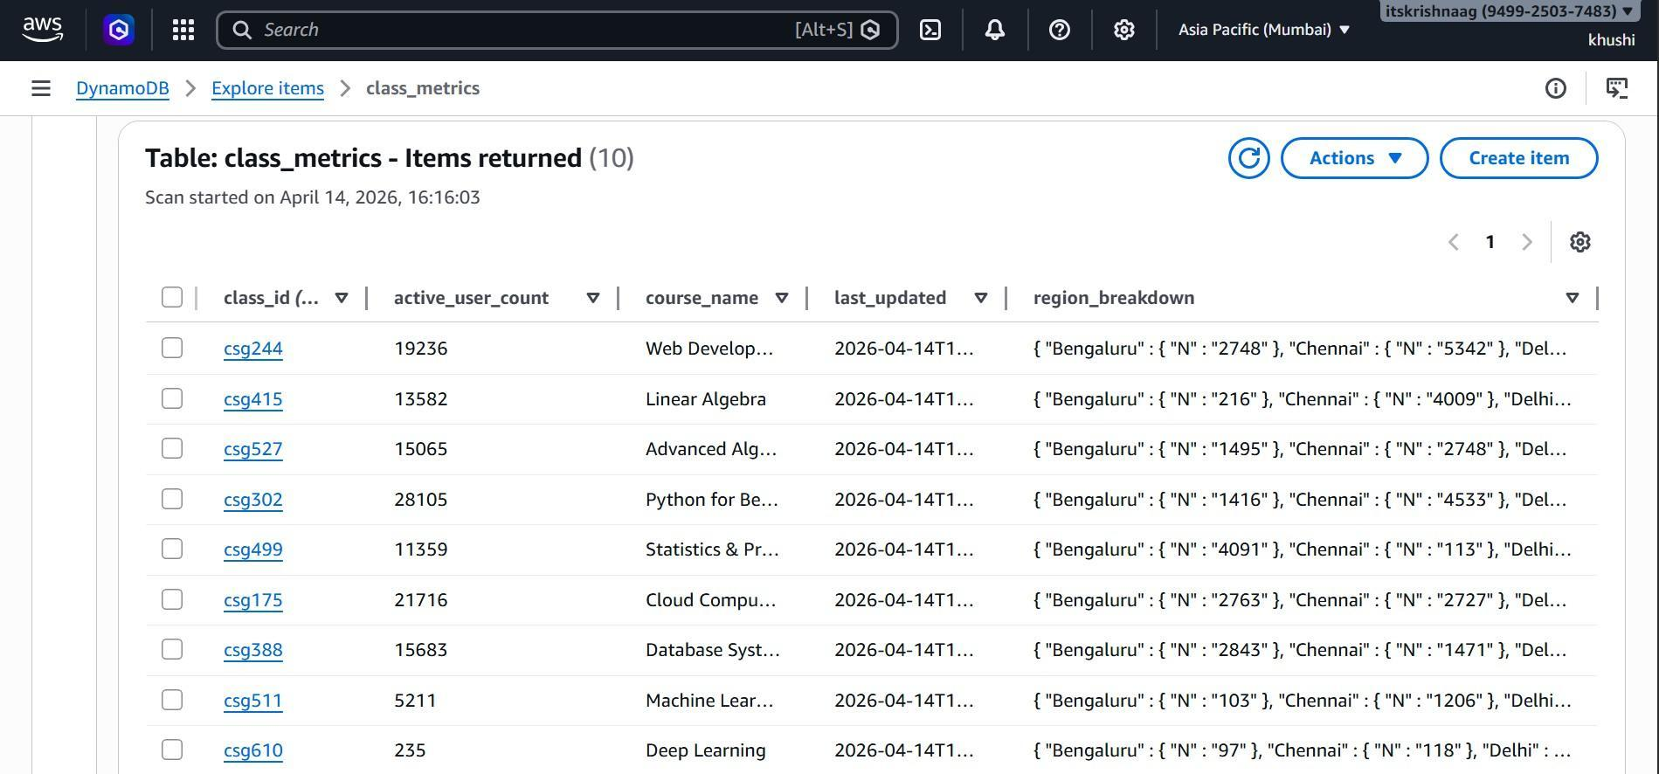
Figure 9: Glue Crawler for scanning S3 Bucket

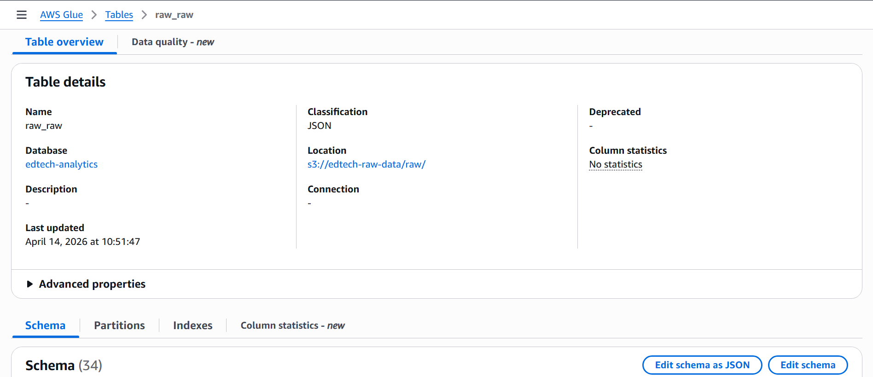
Figure 10: Raw Data Table in Glue Data Catalog
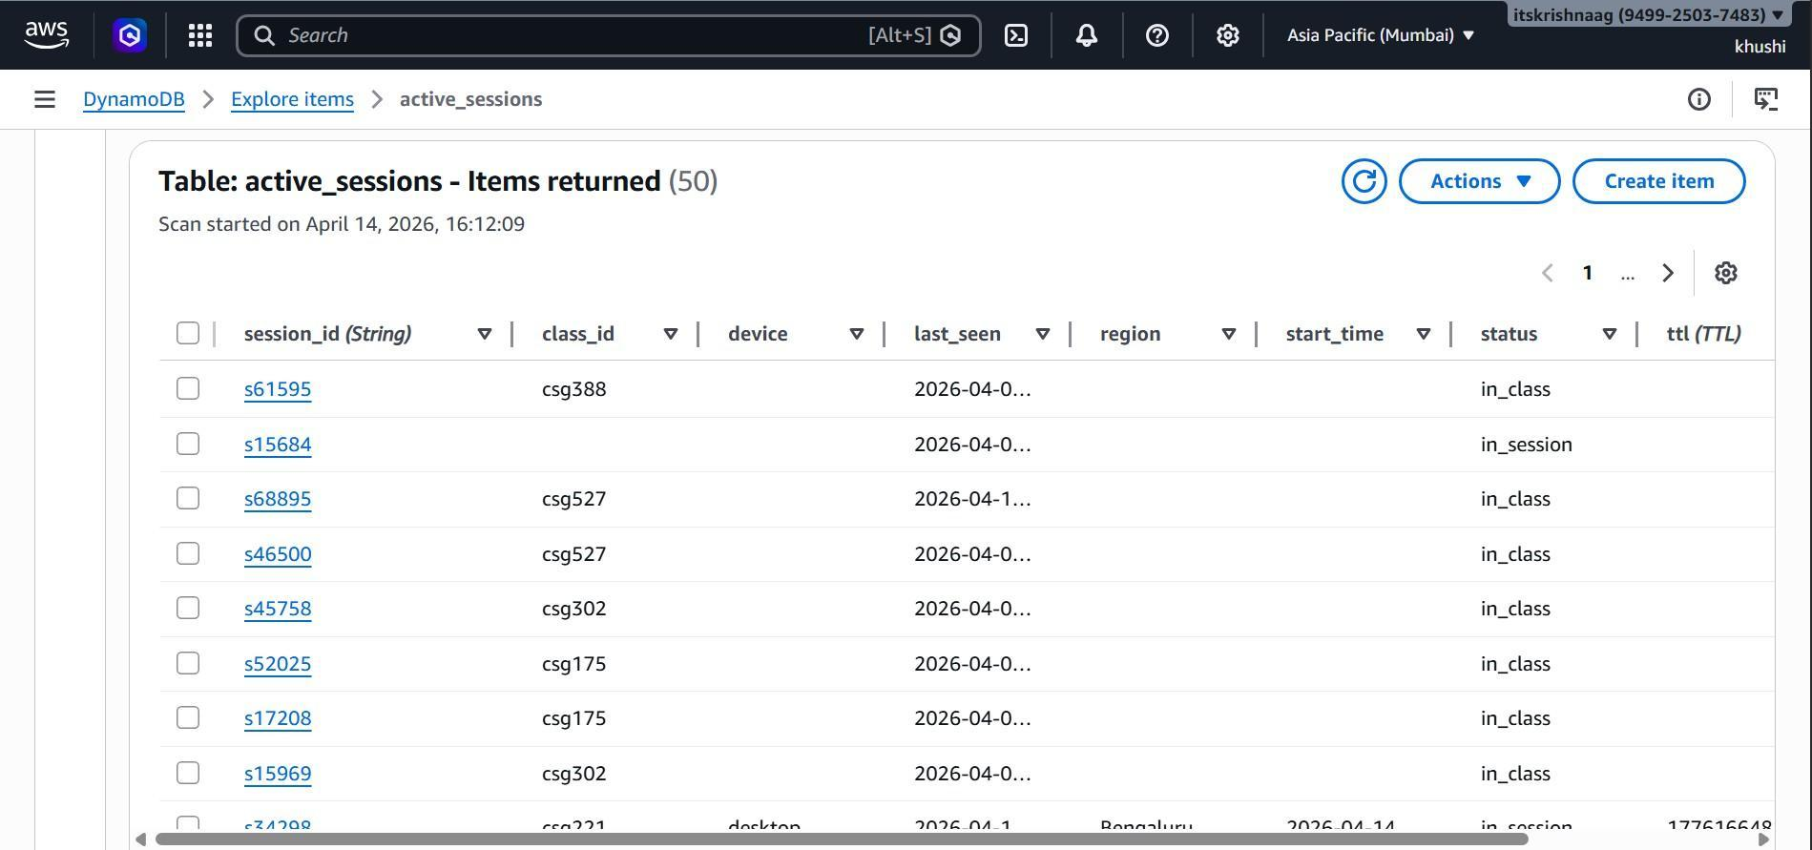
Figure 11: DynamoDB Active Sessions Table

Figure 12: DynamoDB Class Metrics Table

Query Layer

The query layer is implemented using Amazon Athena with federated query support. Athena enables SQL-based querying over both S3 and DynamoDB data sources. Through federated queries, DynamoDB tables are made accessible in Athena via a connector, allowing unified
querying without data duplication. This facilitates efficient analysis by combining real-time aggregated data with raw event data when required.
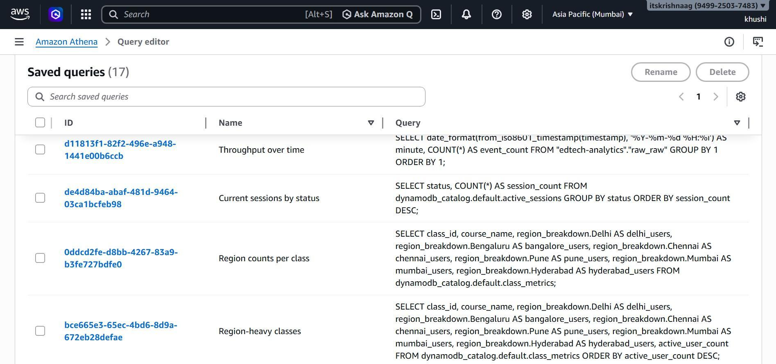
Figure 13: Athena queries on the S3 and DynamoDB data

Visualization Layer

The visualization layer is built using Amazon QuickSight, which provides interactive dash- boards for analyzing system metrics. QuickSight connects to Athena as a data source, en- abling the creation of visualizations such as user activity trends, event throughput, regional distribution, and class engagement metrics. The dashboards offer an intuitive interface for exploring insights and monitoring system behavior in near real-time.
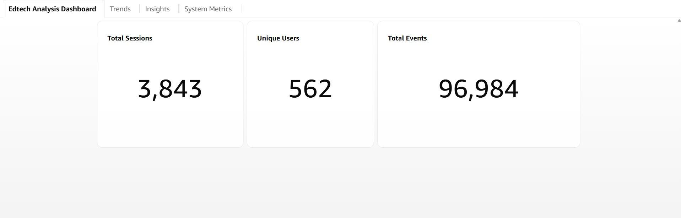
Figure 14: Edtech Analysis Dashboard
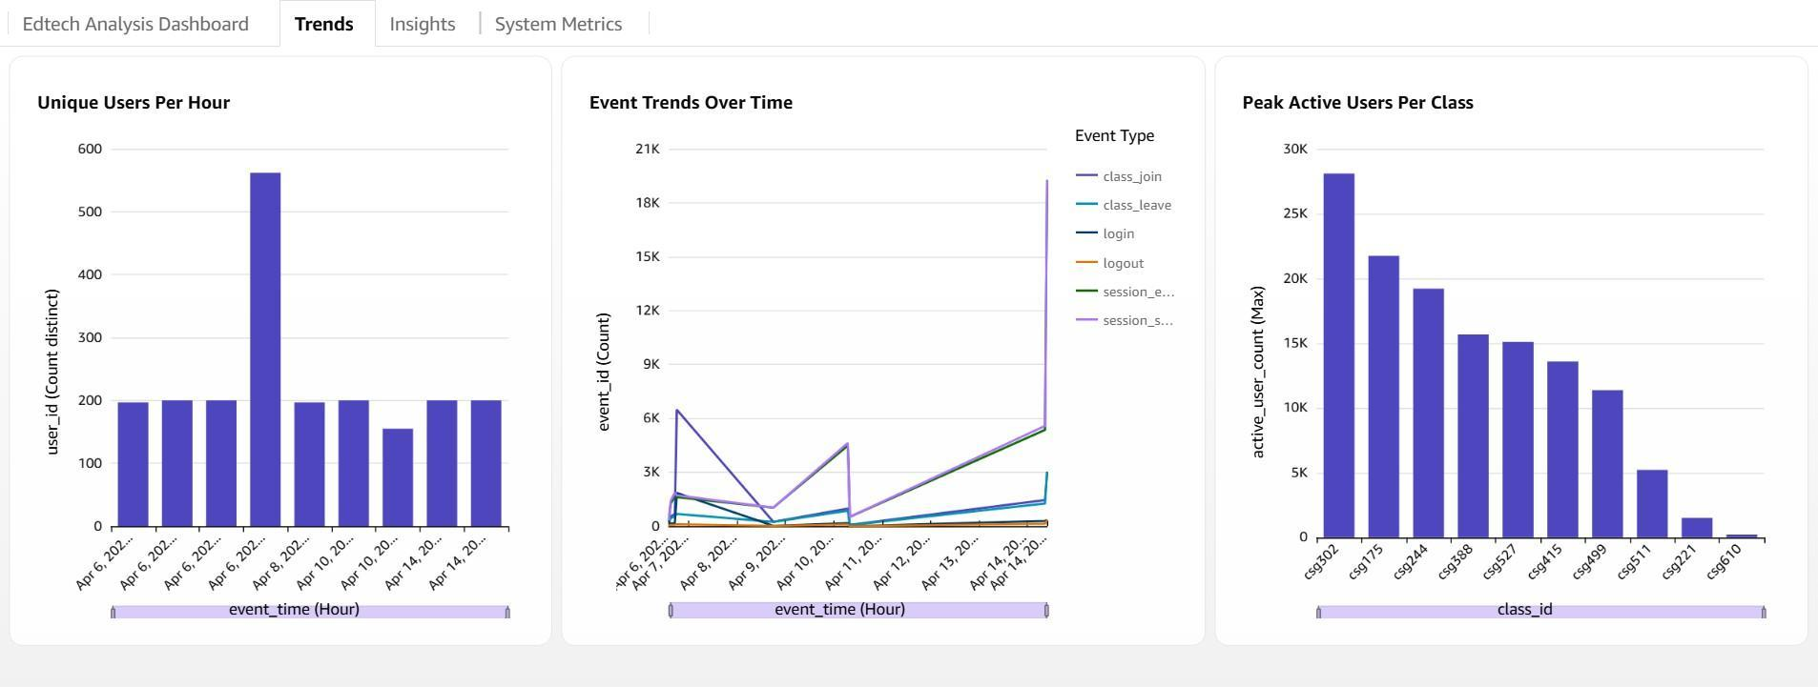
Figure 15: Trends Dashboard

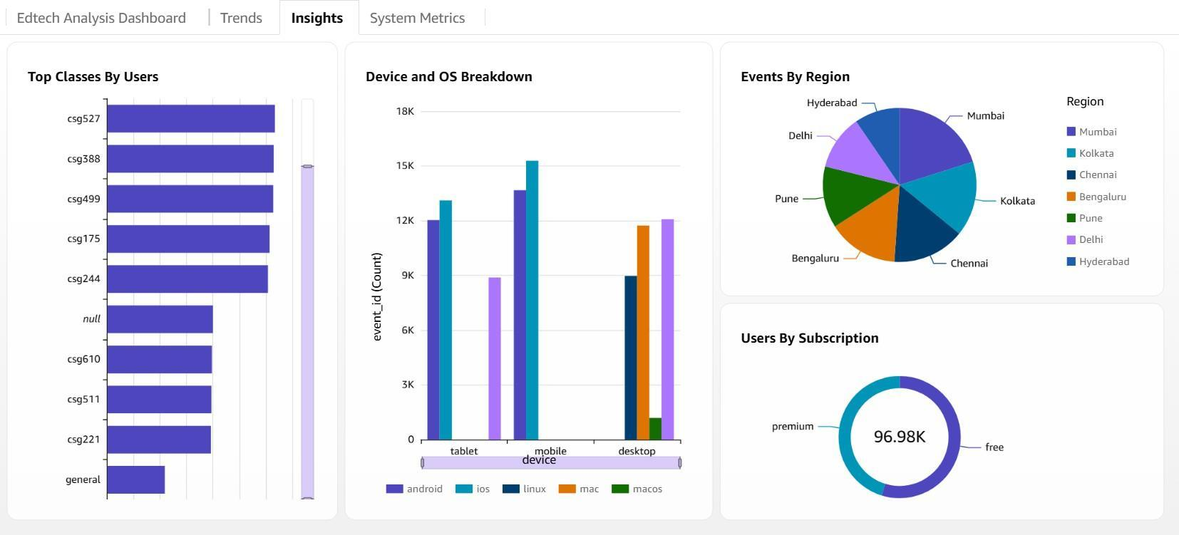
Figure 16: Insights Dashboard
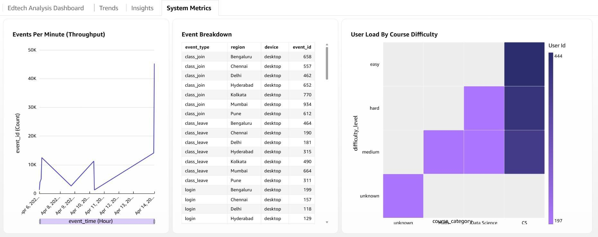
Figure 17: System Metrics Dashboard

Challenges Faced in the Serverless Architecture

While implementing the serverless analytics pipeline, several challenges were encountered.

One of the main challenges was the stateless nature of AWS Lambda. Since each invocation runs independently, it was difficult to maintain continuous session information and real-time metrics. This required the use of DynamoDB to store and update state, which added complexity to the design.
Another challenge was debugging and monitoring. Since the system is distributed across multiple services, tracing the flow of data required checking CloudWatch logs for each Lambda invocation. This made debugging more time-consuming compared to a centralized system.
Handling high event rates was also difficult. As the number of incoming events increased, Lambda invocations increased proportionally, leading to higher costs and potential perfor- mance issues. Understanding and managing this behavior required careful testing.
Implementing spike detection in a stateless environment was another challenge. The sys- tem needed to group events into time windows and maintain a rolling baseline using Dy- namoDB, which required careful handling to ensure correct updates.
Finally, integrating multiple AWS services such as Kinesis, Lambda, S3, DynamoDB, and
Athena required proper configuration and permissions, which made the setup process more complex.
These challenges highlighted the limitations of the serverless approach and motivated the design of the second pipeline.

Limitation of Serverless Architecture

The serverless baseline demonstrated the viability of a cloud-native analytics workflow; however, several limitations were observed under high-throughput continuous workloads. One major concern is the cost model of AWS Lambda, where pricing is based on per- invocation and execution duration. As the event rate increases, the number of invocations grows linearly, leading to significantly higher operational costs.
Additionally, the stateless nature of Lambda functions restricts the implementation of advanced streaming operations such as windowed aggregations and stateful processing without relying on external coordination mechanisms. This introduces additional complexity and overhead. Furthermore, the use of Kinesis Data Streams imposes shard-level throughput limits, which restrict scalability and make it difficult to handle sudden bursts in data volume efficiently.

Motivation for Alternative Architecture

To overcome these limitations, an alternative architecture was designed with a focus on cost efficiency, scalability, and processing flexibility. The key objective was to move away from per-invocation billing and adopt a model that supports persistent, long-running computation, making it more suitable for continuous streaming workloads.
This led to the adoption of a server-based streaming stack deployed on EC2 instances, while still retaining AWS-managed services such as S3, DynamoDB, and IAM for storage and security. By leveraging open-source technologies like Apache Kafka for ingestion and PySpark for processing, the system achieves greater control over resource allocation, state management, and processing logic, enabling more efficient handling of high- throughput data streams and improved system performance.
Pipeline 2: Distributed Streaming Architecture (Optimized)

The second pipeline is designed as a distributed, infrastructure-driven real-time analytics system that improves upon the limitations of the serverless approach. It is built to han- dle high-throughput, bursty workloads while maintaining low latency, cost efficiency, and scalability.
The architecture integrates Apache Kafka for ingestion, PySpark Structured Streaming for real-time processing, Redis for low-latency analytics, Amazon S3 for cold storage, Dy- namoDB for structured aggregation, and Prometheus with Grafana for monitoring. In addi- tion, Kubernetes (k3s) with KEDA is used to enable event-driven horizontal scaling of storage operations. All infrastructure is provisioned using Terraform, ensuring reproducibility and consistency.
This pipeline follows a Lambda-style architecture, combining both streaming and batch processing paths to support real-time insights and historical analytics simultaneously.

Architecture Overview

The system is deployed across two EC2 instances in the ap-south-1 region. The first instance hosts Apache Kafka, which acts as the central event ingestion layer. It maintains two topics: edtech-events for the primary data stream and edtech-priority for surge handling.
The second instance hosts the processing and monitoring components. PySpark Structured Streaming consumes events from Kafka and performs real-time analytics. Redis is used to store live metrics for dashboard visualization.
A Kubernetes cluster (k3s) is deployed on the same instance to run scalable storage worker pods. These pods consume data from Kafka and perform high-throughput writes to Amazon S3 and DynamoDB. KEDA enables automatic scaling of these pods based on Kafka consumer lag.
Prometheus collects system and application metrics, while Grafana provides dashboards for visualization. Terraform is used to provision all infrastructure components, including EC2 instances, IAM roles, networking, and monitoring setup, ensuring a fully automated deployment.

Parameter | Value
Normal event rate | 30 events/second
Peak event rate | 300 events/second
Kafka partitions (main topic) | 10
Kafka partitions (priority topic) | 3
Spark micro-batch interval | 10 seconds
KEDA scaling range | 1 to 10 pods
Storage worker memory | 250 MB per pod
Batch job execution time | 118 seconds
Failure recovery time | 5 seconds
Table 1: System Configuration and Key Parameters

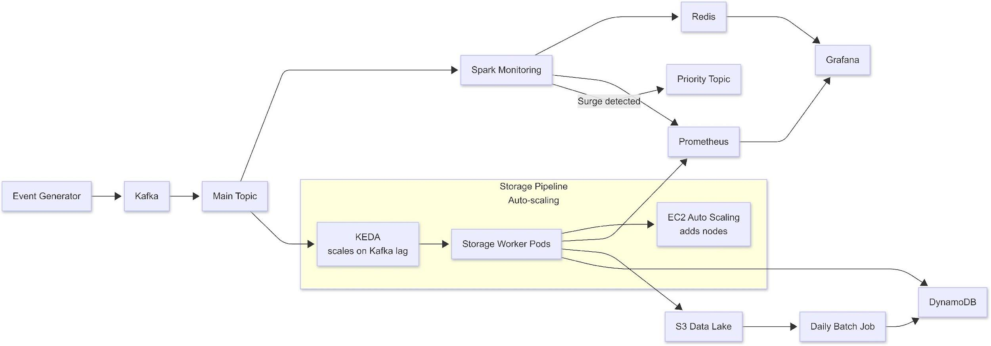

Figure 18: Pipeline 2 Architecture

Data Generation Layer

The pipeline begins with a custom event generator that simulates user interactions on an EdTech platform. The generator produces structured JSON events representing actions such as session start, course participation, and content interaction.
The generator operates at configurable event rates and supports multiple workload modes, including steady and burst traffic patterns. It produces approximately 30 events per second under normal conditions, with spikes up to 3× or higher during stress testing.
These events are directly published to Kafka, enabling controlled experimentation and real- istic simulation of production workloads.
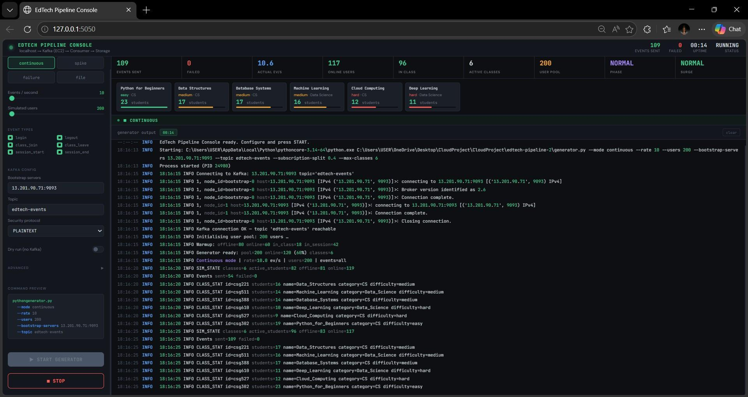
Figure 19: Generator Console

Data Ingestion Layer

The ingestion layer is implemented using Apache Kafka, which provides a durable and scal- able event streaming platform. Events are written to the edtech-events topic, which is partitioned into 10 partitions to enable parallel processing.
Kafka ensures fault tolerance by persisting events and allowing multiple consumer groups to read the same data independently. During surge conditions, overflow events are redirected to a secondary topic, edtech-priority, enabling load isolation and improved system stability.
This design allows the pipeline to handle bursty workloads without data loss while main- taining consistent ingestion performance.
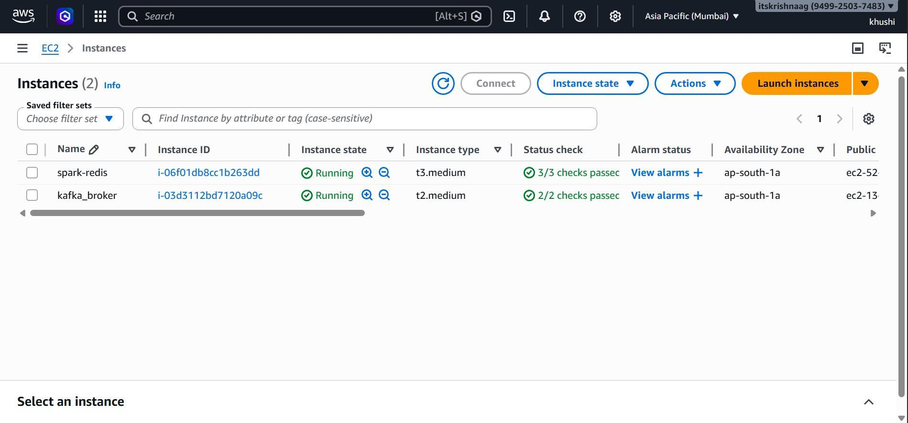
Figure 20: Running EC2 Instances of Kafka and Spark/Redis

Processing Layer

The processing layer is implemented using PySpark Structured Streaming, which consumes events from Kafka in 10-second micro-batches. It performs real-time transformations and computes metrics such as active users, engagement levels, and dropout rates.
The results of these computations are stored in Redis, which serves as a hot storage layer for real-time dashboards. By focusing only on computation and analytics, the processing layer ensures low latency and efficient handling of streaming data.

Intelligence Layer

The intelligence layer is embedded within the processing workflow and introduces adaptive behavior into the system. It consists of four key components across two tiers: Adaptive- BatchOptimizer, SurgeDetector, KEDA-based scaling, and EC2 Auto Scaling.
The AdaptiveBatchOptimizer buffers events and writes them to Amazon S3 only when a threshold is reached or a time limit is exceeded. This significantly reduces storage costs while maintaining acceptable latency for batch analytics.
The SurgeDetector monitors event rates using a rolling baseline and detects spikes when
the current rate exceeds 1.5 times the average. During such conditions, overflow events are routed to the edtech-priority topic, preventing system overload and maintaining SLA compliance.
At the orchestration level, KEDA dynamically scales storage worker pods based on Kafka consumer lag, while EC2 Auto Scaling provisions additional compute resources when system utilization increases.
These mechanisms collectively enable cost-efficient, scalable, and SLA-aware data processing.

Component | Layer |  | Function
AdaptiveBatchOptimizer | Processing gence | Intelli- | Reduces S3 write operations by buffering events and flushing based on thresholds
SurgeDetector | Processing gence | Intelli- | Detects workload spikes and routes overflow traffic to priority topic
KEDA Scaling | Orchestration gence | Intelli- | Dynamically scales storage worker pods based on Kafka lag
EC2 Auto Scaling | Infrastructure gence | Intelli- | Provisions additional com- pute resources under high load
Table 2: Intelligence Layer Components and Responsibilities

Parameter | Spark Value | k8s Pod Value | Description
FLUSH EVENTS | 10,000 | 5,000 | Number of events re- quired to trigger S3 write
FLUSH SECS | 300 | 300 | Maximum buffering time before forced flush
Table 3: AdaptiveBatchOptimizer Configuration Parameters

Scalable Storage Layer

The storage layer is implemented using Kubernetes-based storage worker pods. Each pod runs a lightweight Python consumer that reads events from Kafka and performs storage operations.
Events are buffered and written to Amazon S3 in partitioned Parquet format, while aggre- gated metrics are stored in DynamoDB tables such as UserStats and CourseStats. Each worker requires approximately 250 MB of memory, enabling efficient horizontal scaling.
KEDA monitors Kafka consumer lag and dynamically adjusts the number of pods between 1 and 10, ensuring that storage throughput scales with workload demand.
This separation of storage from processing allows the system to achieve high throughput and improved resource utilization.
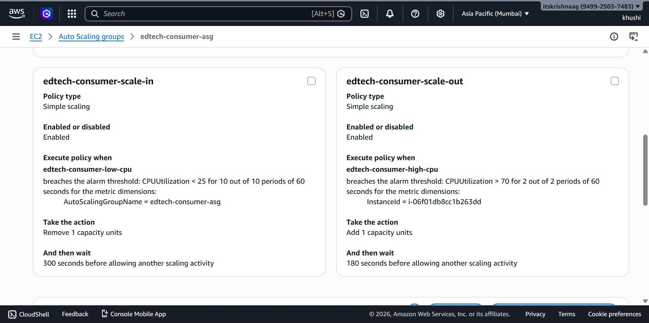
Figure 21: Dynamic Scaling Policies

Scaling Method | Trigger Metric | Behavior
KEDA | Kafka Consumer Lag | Scales pods based on back- log (1–10 pods)
EC2 Auto Scaling | CPU Utilization | Adds/removes instances when CPU exceeds thresh- old
Table 4: Two-Tier Auto-Scaling Mechanism
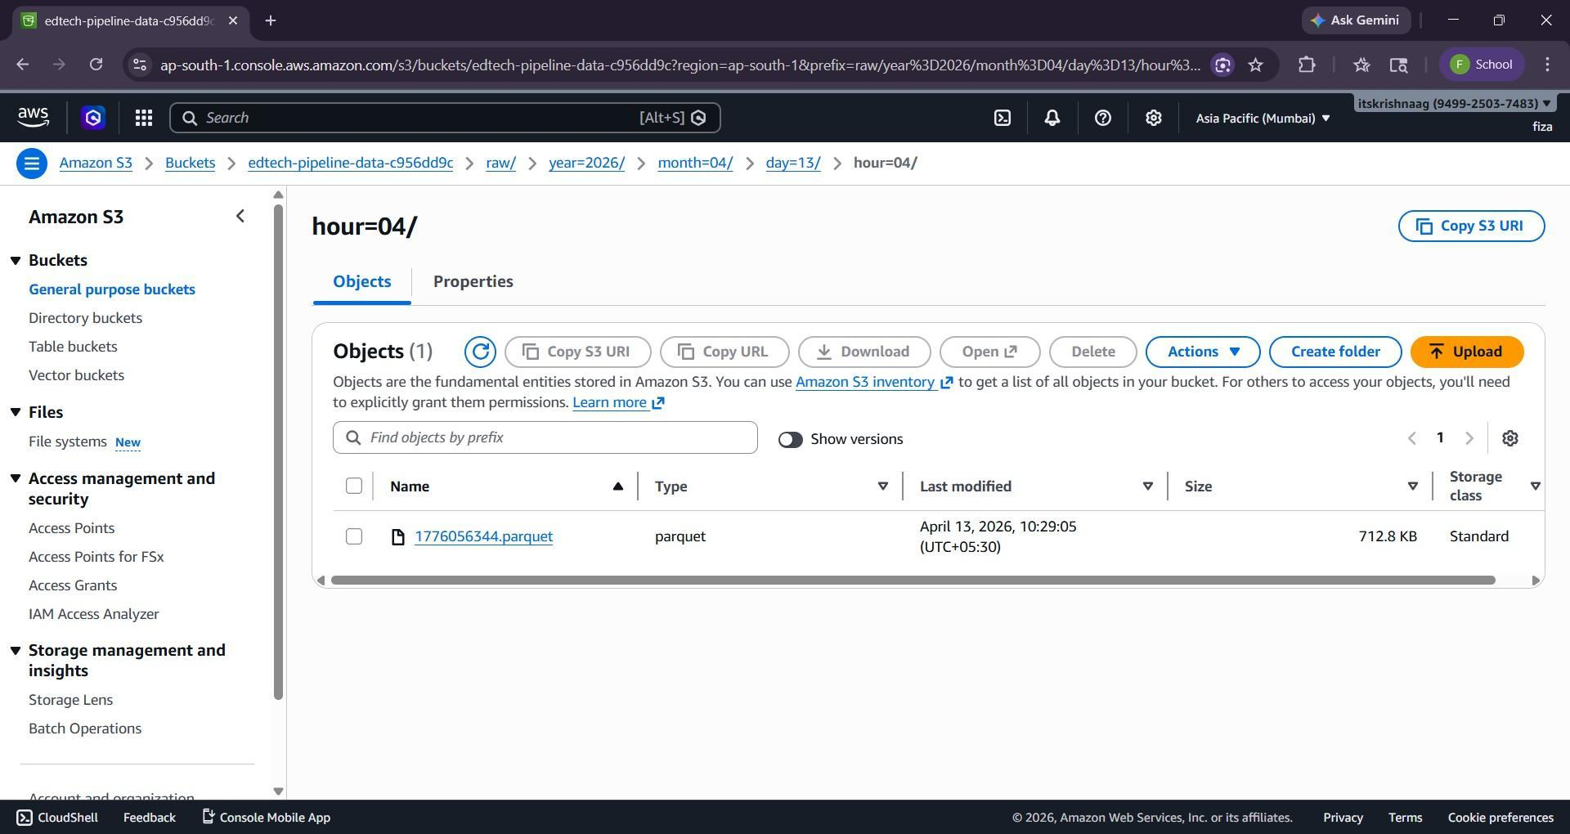
Figure 22: Processed Data in S3 in partitioned Parquet format

Batch Processing Layer

A batch processing job runs periodically to generate daily analytics. It reads Parquet data from Amazon S3 and computes aggregated metrics such as daily active users, pass rates, and engagement statistics.
The results are stored in the DailyReports table in DynamoDB, enabling efficient querying and reporting. The batch job processes over 267,000 events in approximately 118 seconds, demonstrating efficient large-scale data processing.
Workflow orchestration. The project specification Sec. 4.3 lists Airflow or Dagster as candidate orchestration tools. For this deployment, the batch job is scheduled using a Linux cron entry (0 0 * * * /home/ubuntu/run_batch_reports.sh) rather than a full Airflow or Dagster deployment. The choice was driven by resource constraints — EC2-2 is a single t3.medium (4 GB RAM) hosting Spark, Redis, Prometheus, Grafana, and the k3s control plane. An Airflow scheduler plus worker processes would consume approximately 800 MB–1.5 GB of RAM, which is not available without scaling the node to t3.large. A Dagster-compatible DAG file (dags/batch_reports_dag.py) was authored for portability: if this pipeline were redeployed on a multi-node cluster or migrated to a managed Airflow service (MWAA), the existing DAG would integrate without modification. For a single-node deployment, cron provides equivalent scheduling guarantees at zero operational cost.

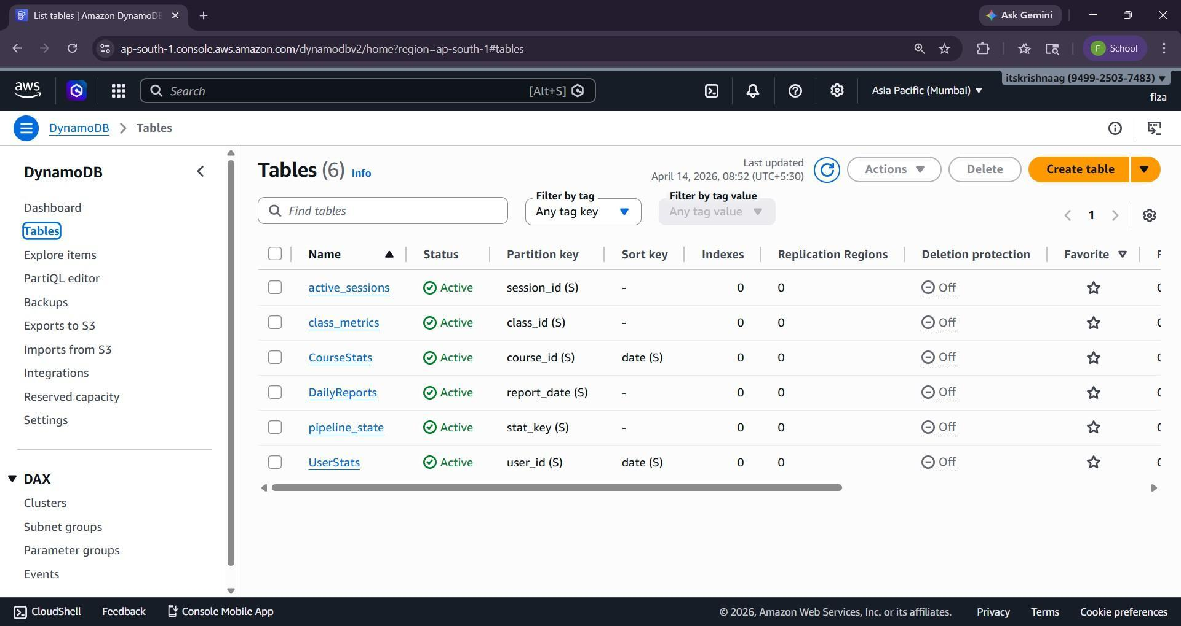
Figure 23: UserStats, CourseStats and DailyReports Tables in DynamoDB

A separate batch job processes S3 data daily and writes summarized reports to DynamoDB.
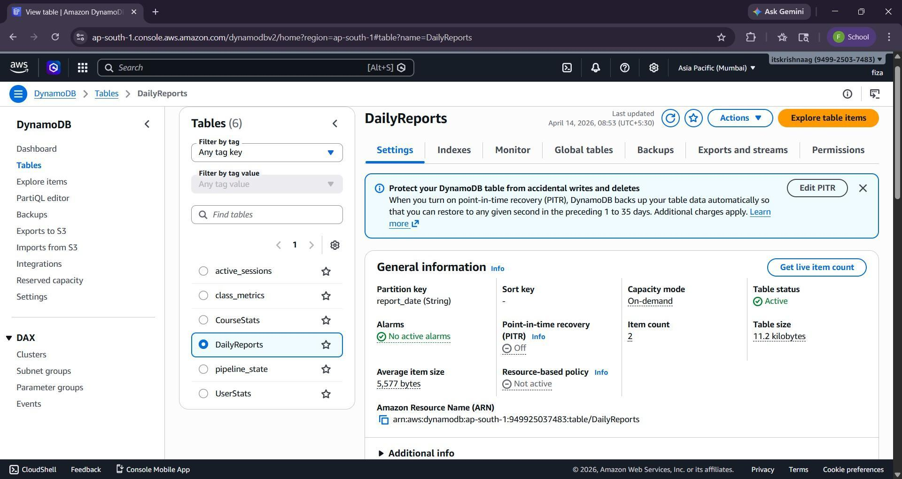
Figure 24: Daily Reports in DynamoDB
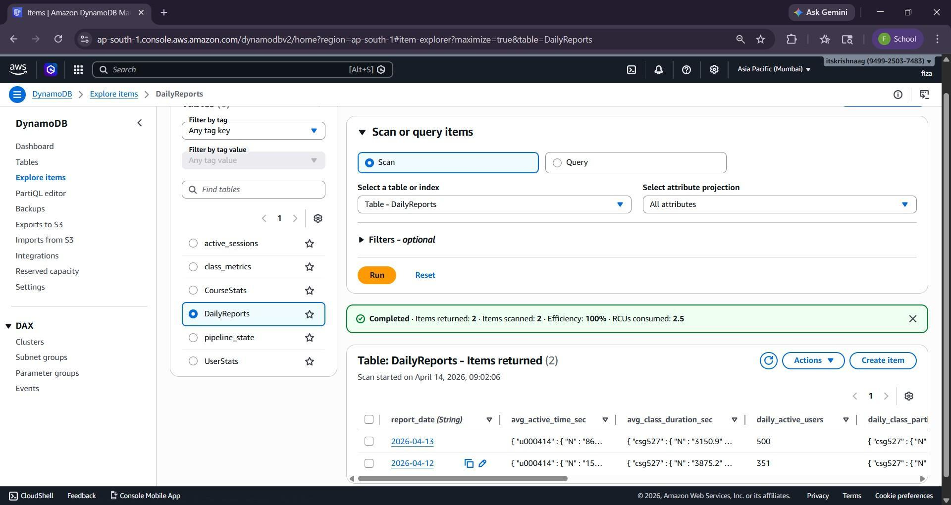
Figure 25: Items of Daily Reports

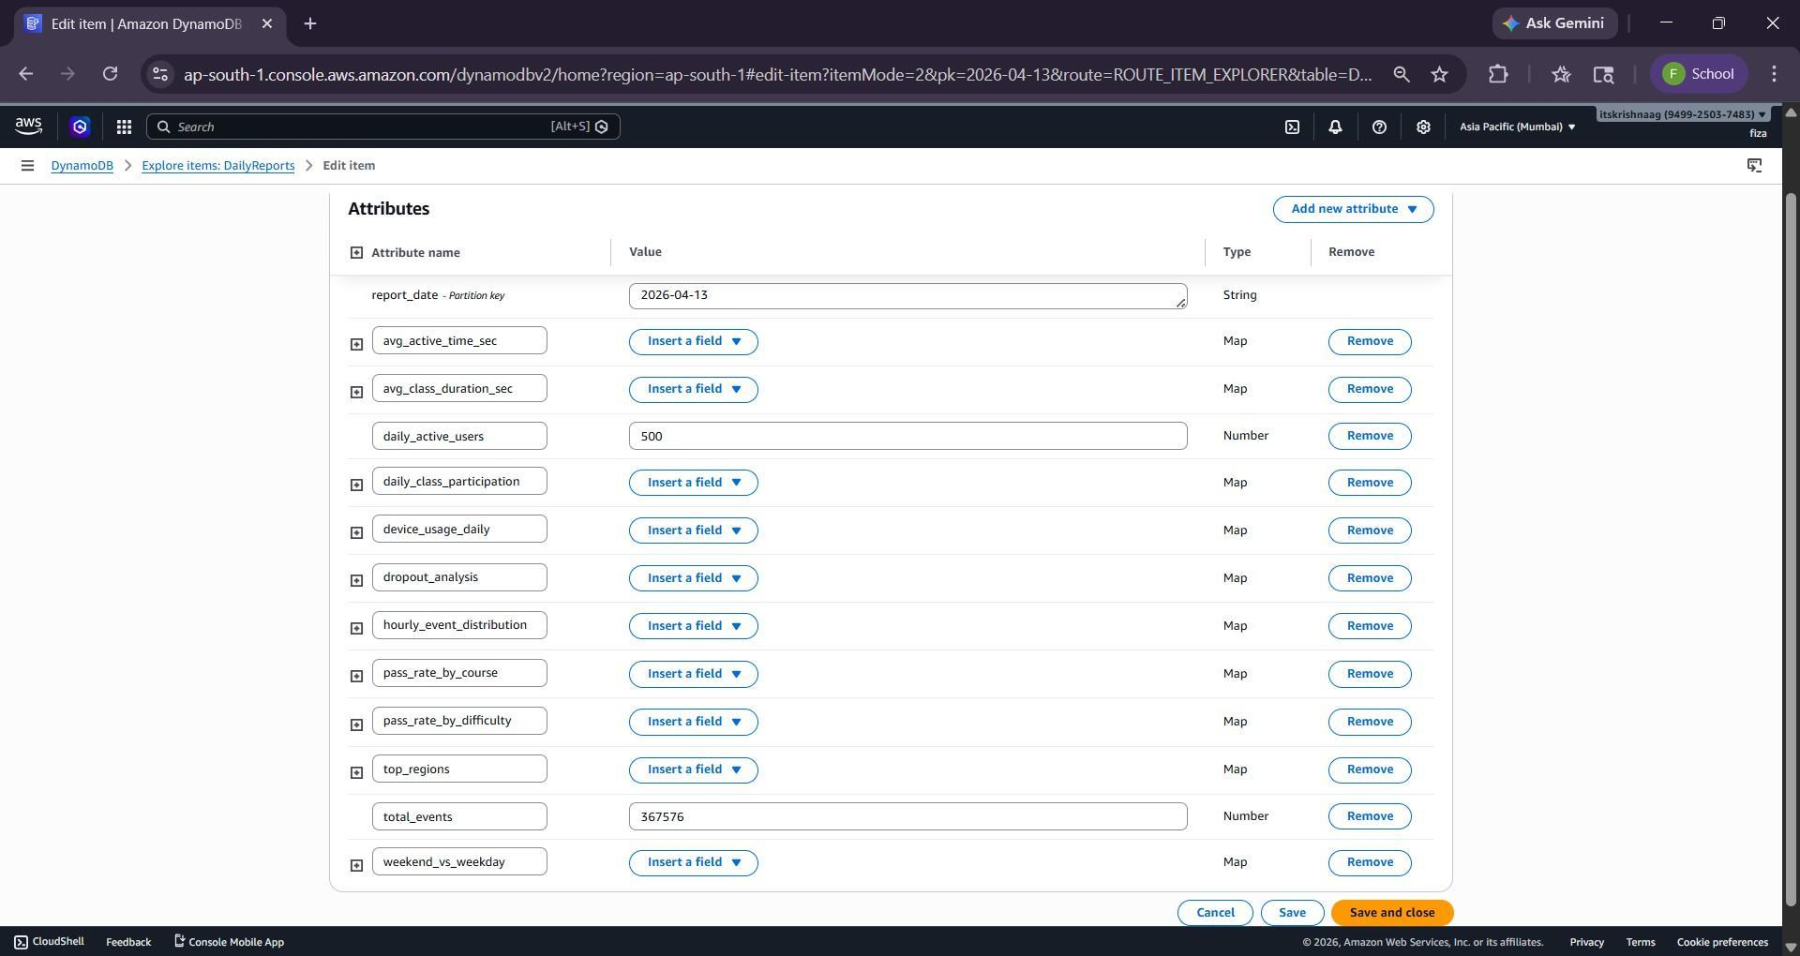
Figure 26: Attributes of Daily Reports Items
Monitoring and Metrics Layer

The pipeline includes a comprehensive monitoring layer implemented using Prometheus. The Spark application exposes a metrics endpoint that provides both system-level and application-level metrics, including:

- Events processed
- Kafka consumer lag
- Batch processing duration
- Active users and engagement metrics
- Surge detection status
- S3 cost reduction statistics

In addition to the conceptual metrics, the system exposes real-time values through a Prometheus- compatible endpoint. A sample snapshot of the metrics includes:

- pipeline events processed total: Total number of events processed from Kafka (e.g., 87621 events)
- pipeline kafka consumer lag: Number of unprocessed events (e.g., 1760), indicating system backpressure
- pipeline active users gauge: Number of active users in the current batch (e.g., 353 users)
- pipeline dropout rate gauge: Percentage of users leaving sessions (e.g., 2.7%)
- pipeline avg engagement gauge: Average engagement score (e.g., 0.693)
- pipeline surge detected: Indicates whether a traffic surge is active (0 = normal, 1
= surge)

These metrics provide both system-level insights (such as processing lag and throughput) and business-level insights (such as user engagement and dropout behavior).
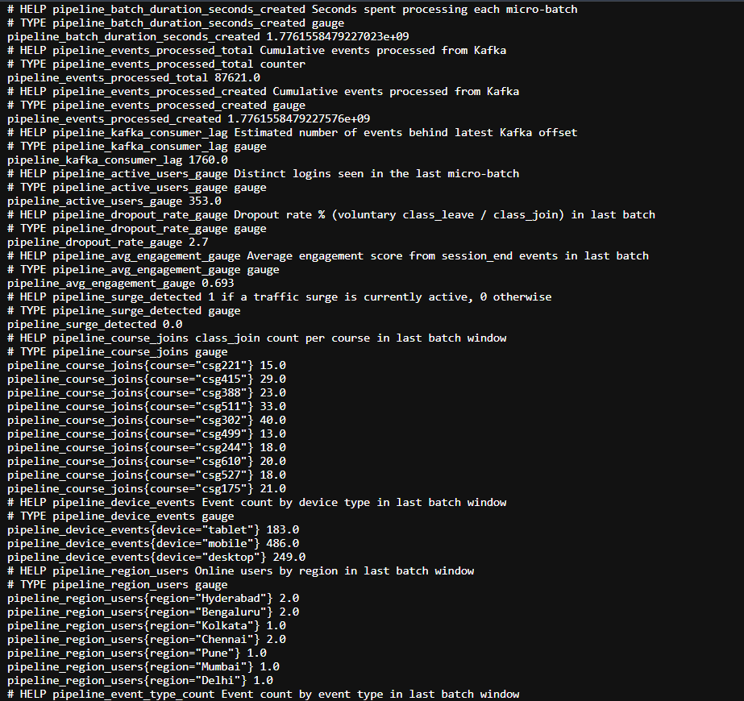
Figure 27: Prometheus Metrics Endpoint showing real-time pipeline metrics

Prometheus scrapes these metrics at regular intervals and stores them as time-series data for analysis.
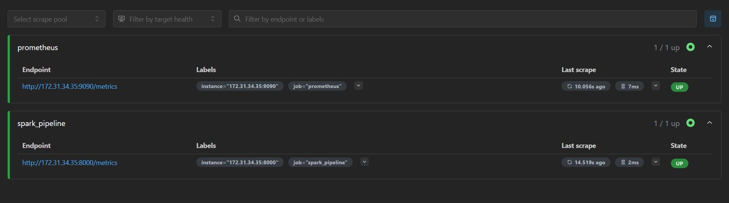
Figure 28: Prometheus Targets page showing Spark pipeline metrics endpoint in UP state

The Prometheus targets page confirms that the Spark streaming application is successfully being monitored. The metrics endpoint is in the UP state, indicating that Prometheus is actively scraping data without failures. This ensures reliable observability and supports real-time dashboard visualization in Grafana.

Visualization Layer

Grafana visualizes the above metrics through interactive dashboards, providing real-time insights into system performance and user activity. This enables effective monitoring and rapid detection of anomalies.

Latency trade-off. Grafana dashboards read KPIs from Redis at sub-millisecond latency (measured mean 0.277 ms across 50 samples, P95 0.477 ms) — a 10,000× margin over the NFR Sec. 5 < 5 s requirement on the dashboard read path. The end-to-end event ingestion latency (from an event being published to its effect appearing in the KPI) is bounded by Spark’s micro-batch architecture: a 10-second trigger interval plus ~2-second batch processing gives a worst case of ~12.6 s. This is an intentional trade-off — micro-batch processing amortises checkpoint and Kafka fetch costs across hundreds of events per batch, which is the correct design for an analytics dashboard aggregating engagement KPIs. For applications requiring sub-second event-to-dashboard latency (e.g., fraud detection, real-time alerting), a streaming runtime such as Flink or Spark Continuous Processing would be required, at substantially higher infrastructure cost.

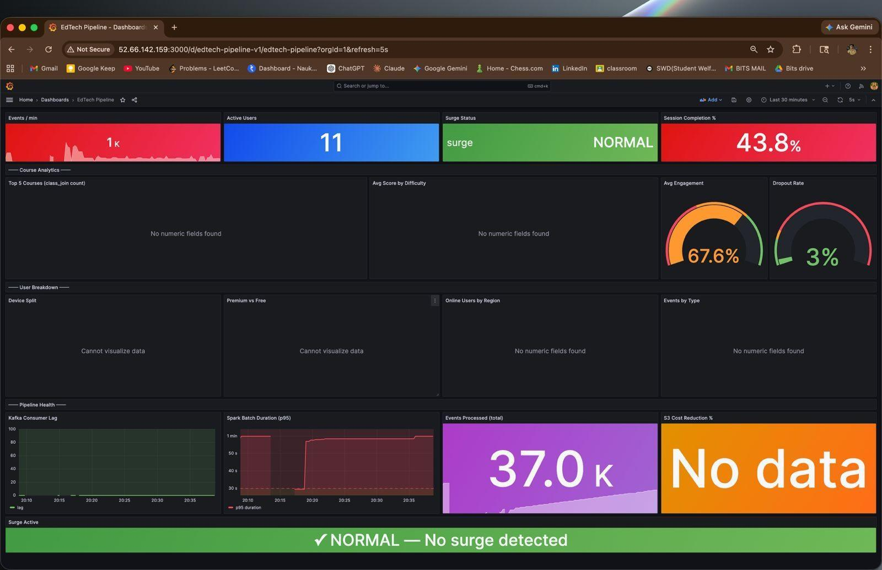
Figure 29: Grafana Dashboard showing normal system behavior (no surge detected)

The Active Users panel reflects steady user participation, while the Session Completion
% and Engagement Score indicate healthy user interaction levels. The Dropout Rate
remains relatively low, suggesting effective user retention.

The Surge Status panel clearly indicates NORMAL, confirming that the incoming event rate is within the expected baseline computed by the rolling average. Additionally, infrastructure metrics such as batch duration and consumer lag demonstrate that the system is processing data efficiently without backpressure.
Overall, this dashboard snapshot represents a stable system state where both performance and user experience metrics are within acceptable thresholds.
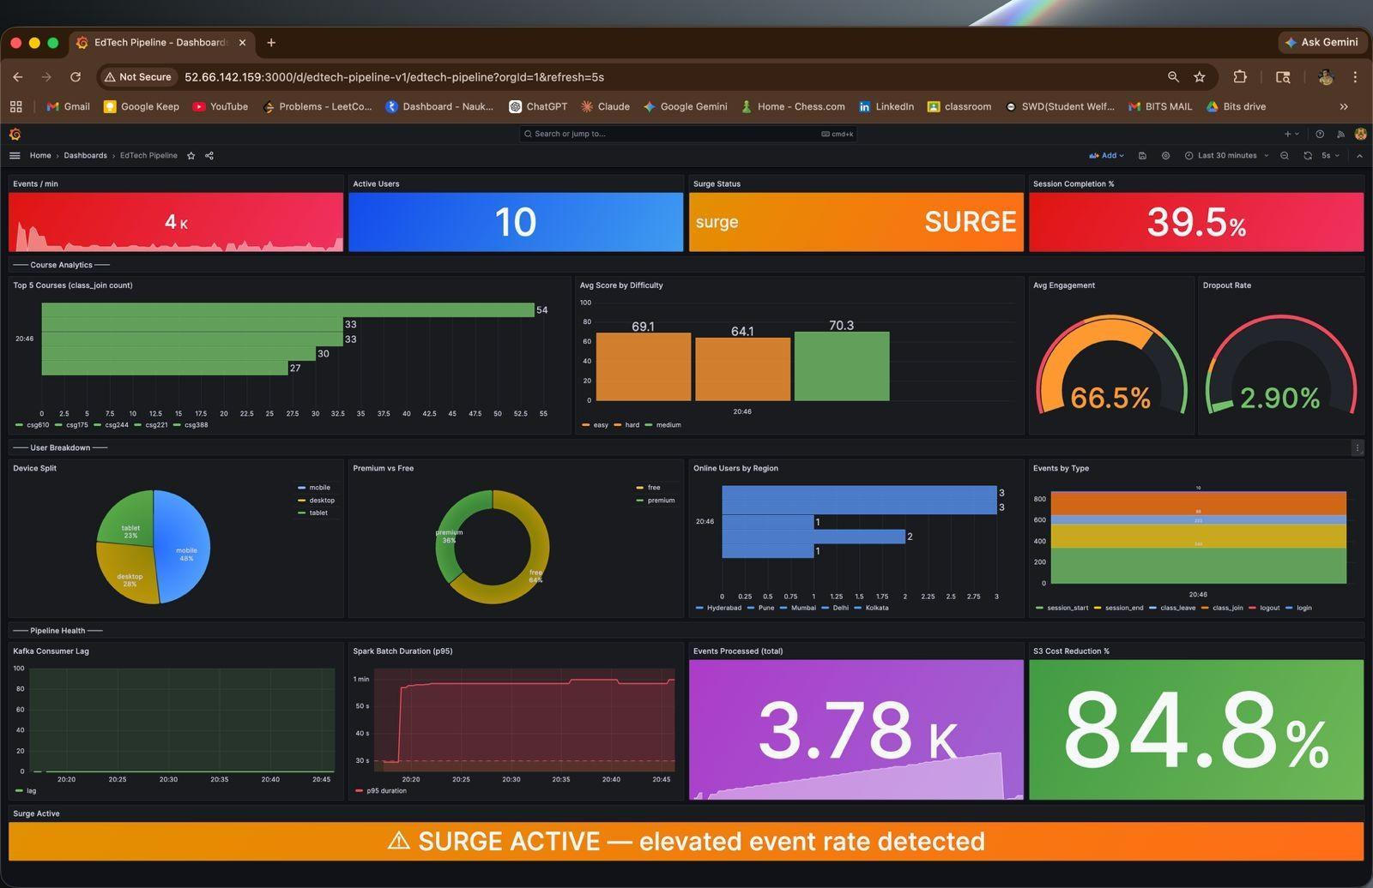
Figure 30: Grafana Dashboard during surge condition showing increased event rate

During high workload conditions, the Grafana dashboard dynamically reflects a surge state triggered by a significant increase in event rate. The Events per Minute panel shows a sharp rise in incoming data, while the Surge Status indicator switches to SURGE, confirming activation of the SurgeDetector mechanism.
This increased load leads to observable changes in system behavior. The Spark Batch Dura- tion increases, indicating higher processing time per micro-batch, and slight variations may be observed in Kafka consumer lag due to temporary pressure on the processing pipeline.
From a business perspective, metrics such as Session Completion, Engagement Score, and Dropout Rate provide insights into how user experience is affected under heavy load. Despite the surge, the system continues to operate without failure, demonstrating resilience and scalability.
Additionally, the S3 Cost Reduction metric highlights the effectiveness of the Adaptive- BatchOptimizer, which minimizes storage operations even during peak traffic conditions.
This snapshot validates that the system can not only detect traffic spikes but also adapt its
processing strategy dynamically while maintaining observability and stability.

A comparison between the normal and surge states demonstrates the robustness of the pipeline. While the system maintains low latency and stable metrics under normal con- ditions, it successfully adapts to high-throughput scenarios without system failure. This highlights the effectiveness of the integrated intelligence layer and confirms that the archi- tecture is capable of handling real-world, production-scale streaming workloads.

Spark Streaming Logs and System Behavior

To further validate the internal behavior of the streaming pipeline, system-level logs from the Spark consumer service were analyzed. These logs provide insights into real-time processing, system health, and adaptive intelligence mechanisms.
Spark Service Status and Batch Processing:
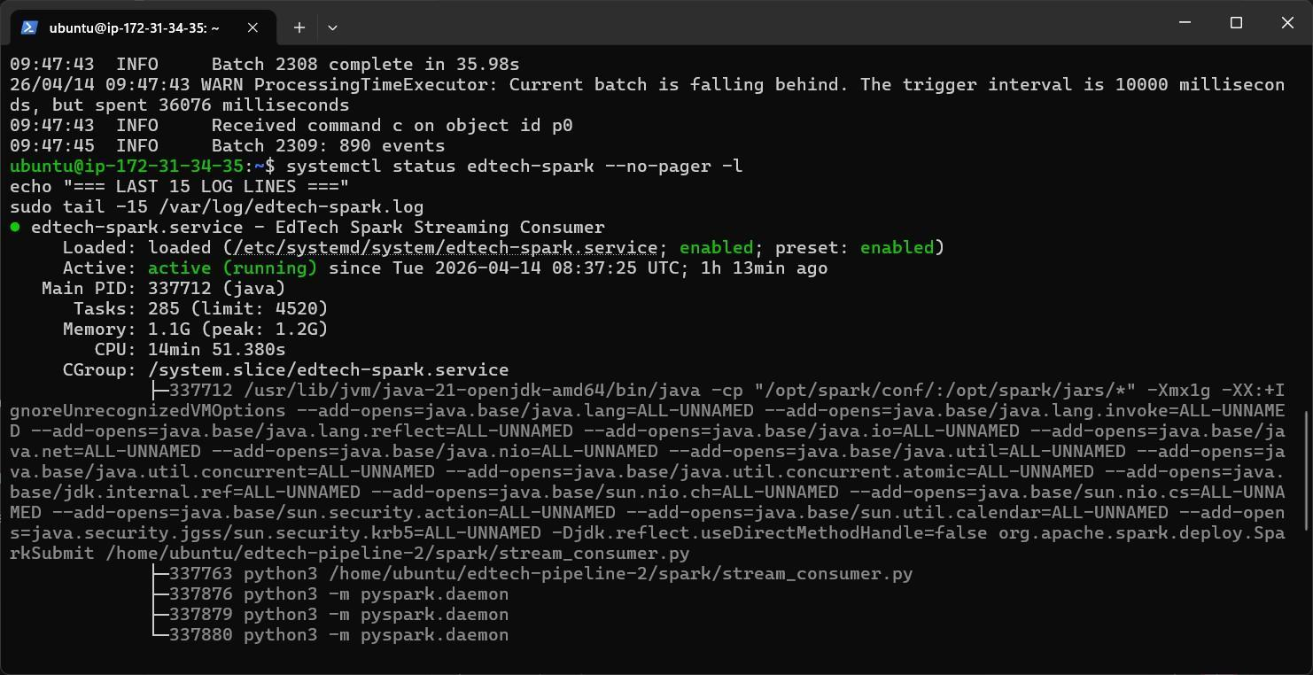
Figure 31: Spark Streaming Service Status and Recent Batch Logs

The Spark streaming application is deployed as a systemd service (edtech-spark.service). The service status shows active (running), confirming that the streaming job is continu- ously processing incoming Kafka events.
The log output also displays micro-batch execution details such as batch IDs, number of
events processed, and processing duration. Occasional warnings such as ”Current batch is falling behind” indicate temporary processing delays under high load, which is expected in streaming systems handling bursty traffic.
Surge Detection and Adaptive Behavior:
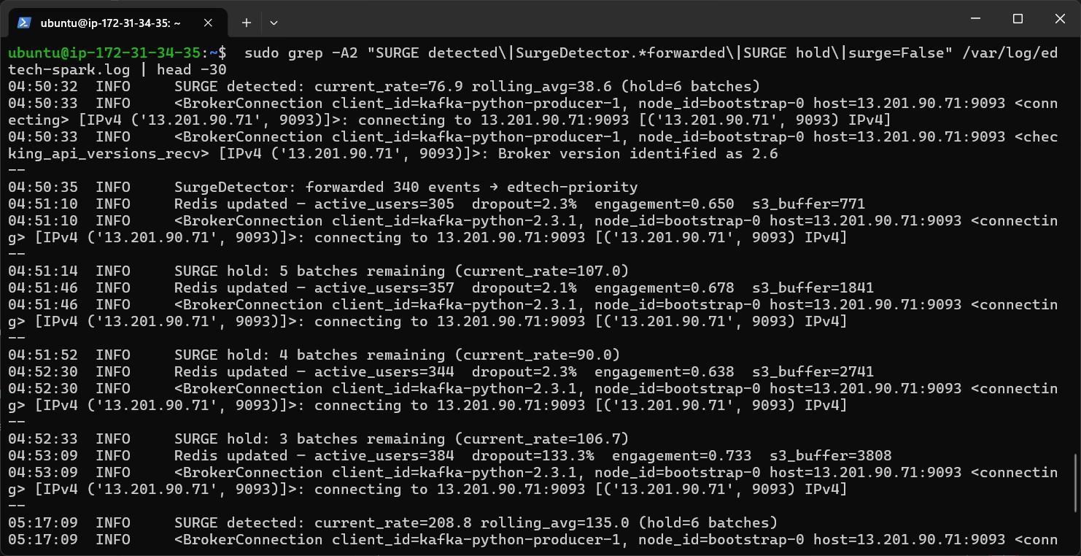
Figure 32: Spark Logs showing Surge Detection and Event Routing

The logs clearly demonstrate the functioning of the SurgeDetector. When the incoming event rate exceeds the rolling average threshold, a surge is detected, as shown by log entries such as:
SURGE detected: current rate > rolling avg

During this state, a portion of events is redirected to the edtech-priority Kafka topic:
SurgeDetector: forwarded X events → edtech-priority
This confirms that the system dynamically adapts to increased workload by prioritizing critical processing paths.

Surge Hold and Recovery Mechanism:
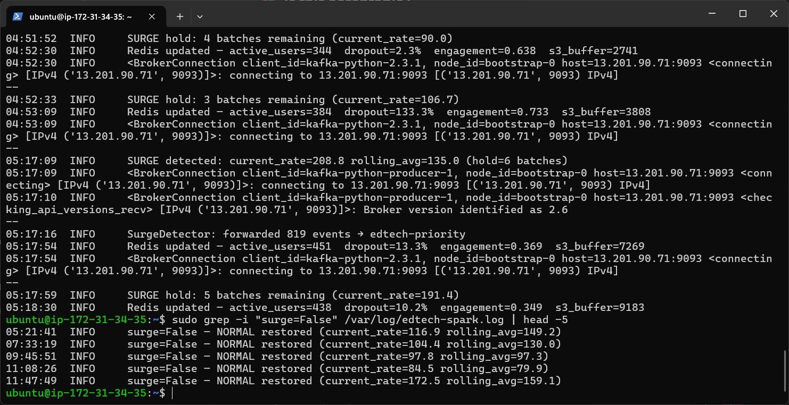
Figure 33: Spark Logs showing Surge Hold Countdown and Recovery to Normal State

After detecting a surge, the system enters a controlled hold state where it maintains surge mode for a fixed number of batches. The logs show a countdown mechanism:
SURGE hold: X batches remaining

This prevents rapid oscillation between normal and surge states. Once the event rate stabi- lizes, the system exits surge mode:
surge=False | NORMAL restored

This demonstrates the effectiveness of the hysteresis-based control logic implemented in the intelligence layer.

Checkpoint-Based Failure Recovery

To validate the fault tolerance of the streaming pipeline, a controlled failure-recovery exper- iment was conducted by stopping and restarting the Kafka event generator. This simulates a real-world producer failure scenario.
Failure and Recovery Timeline:
- Generator stopped at T+0 to simulate failure
- Spark continued processing existing Kafka backlog
- Generator restarted after a short interval
- Spark resumed processing automatically
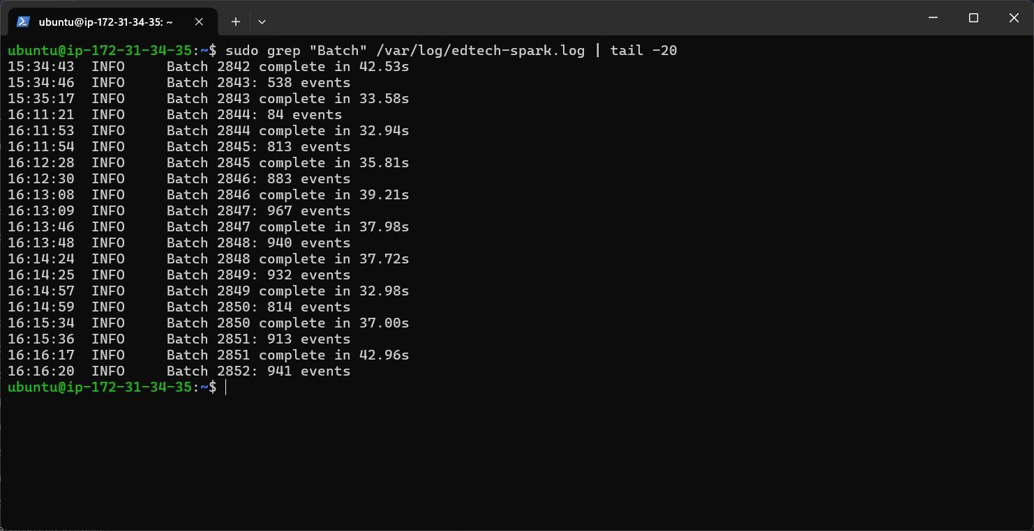
Figure 34: Spark logs before failure showing continuous batch processing

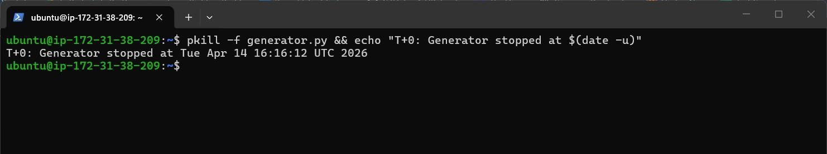
Figure 35: Generator stopped to simulate failure

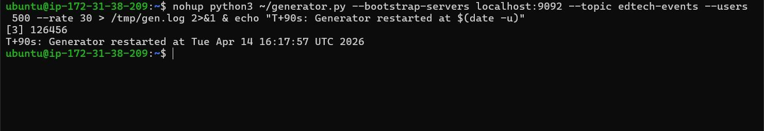
Figure 36: Generator restarted after delay
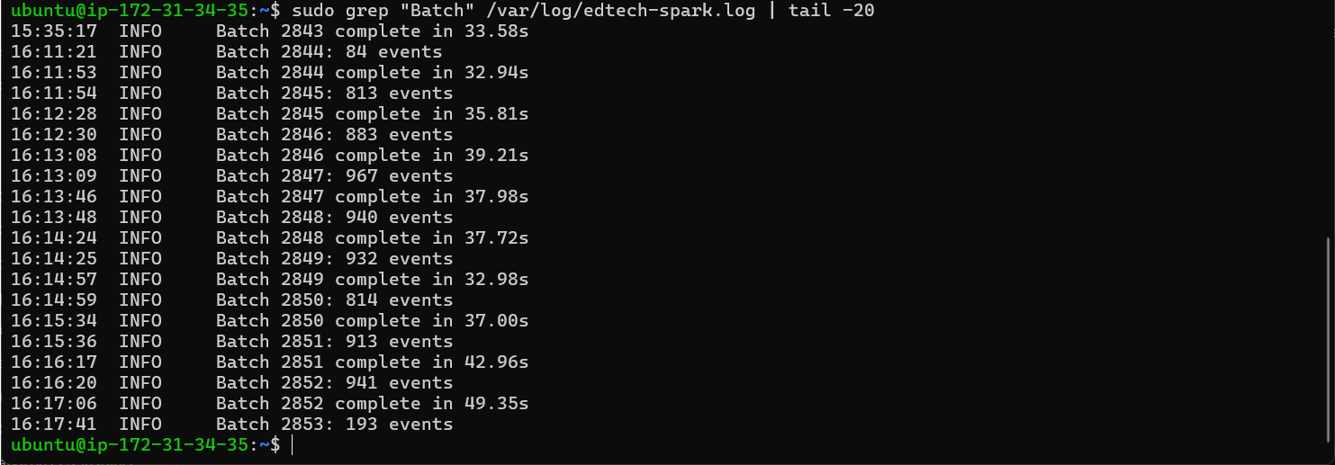
Figure 37: Spark resumes processing with next batch after recovery

Key Observations:

- Continuous batch numbering: Batch IDs continue sequentially (e.g., 2852 → 2853), indicating that Spark did not restart from the beginning.
- No data loss: Kafka retains messages during downtime, and Spark resumes consump- tion from the last checkpointed offset.
- No duplicate processing: Previously processed batches are not re-executed.
- Automatic recovery: Spark resumes processing without manual intervention once data flow is restored.

This experiment confirms that the system achieves reliable fault tolerance using checkpoint- based recovery, ensuring consistent and resilient stream processing even under failure condi- tions.
Overall, the Spark logs provide strong evidence of the pipeline’s real-time processing capabil- ities, adaptive workload handling, and resilience under varying traffic conditions. These logs complement the Prometheus metrics and Grafana dashboards by offering low-level visibility into the internal execution of the streaming system.

Performance and Cost Benchmarking

The pipeline was evaluated through multiple experiments to assess performance and cost efficiency. AdaptiveBatchOptimizer reduced S3 PUT operations by 87.6%, significantly low-
ering storage costs.

Surge detection maintained bounded consumer lag during traffic spikes, ensuring stable sys- tem performance. Batch processing experiments demonstrated high throughput, with over 267,000 events processed in under two minutes.
These results confirm that the architecture effectively balances cost, performance, and scal- ability.

Strategy | PUTs (1.5h) | PUTs/day | Cost/day | Avg File Size
Naive (per-batch) | 225 | 8,640 | $0.0432 | 8 KB
AdaptiveBatch | 28 | 1,075 | $0.0054 | 536 KB
Reduction | – | – | 87.6% | 67× larger
Table 5: S3 Cost Optimization using AdaptiveBatchOptimizer

Experimental Evaluation
Eight controlled experiments were conducted on the live production pipeline running on AWS EC2 instances in ap-south-1. Each experiment targets a specific Non-Functional Requirement (NFR Sec. 5) or a research area (Sec. 7.1–Sec. 7.4). Experiments 3 and 4 were repeated three times under identical conditions to enable statistical analysis; experiments 1 and 2 are sustained live measurements; experiments 7 and 8 use 50 and 30 sample points respectively.
Experiment 1 — S3 Cost Optimization (AdaptiveBatchOptimizer)
Hypothesis. Adaptive flush batching reduces S3 PUT request costs compared to naïve per-micro-batch writes, with no impact on the real-time dashboard path (which reads from Redis, not S3).
Setup. The pipeline was run continuously for 17+ hours at 30 events/second (generator on EC2-1). A 1.5-hour measurement window (225 consecutive micro-batches) was selected for analysis. The AdaptiveBatchOptimizer was configured with FLUSH_EVENTS = 10,000 and FLUSH_SECS = 300. The naïve baseline is simulated analytically: one S3 PUT per 10-second micro-batch.
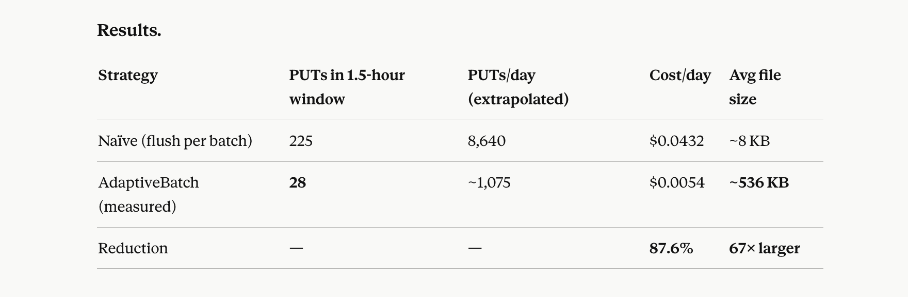
The larger file size also provides secondary benefits: better Parquet columnar compression (Parquet is inefficient below ~1 MB) and faster batch-job reads (fewer files to open). The 5-minute latency bound on S3 is acceptable because S3 serves only the nightly batch job — not the live dashboard, which reads from Redis at sub-millisecond latency.
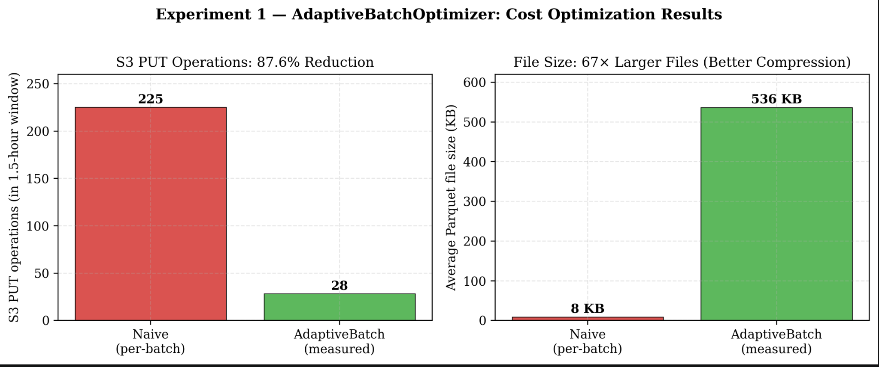
Figure 38: S3 PUT operations and average file size: naïve vs AdaptiveBatch strategy
Experiment 2 — Surge Detection (SurgeDetector)
Hypothesis. Priority-based event routing prevents consumer lag accumulation during traffic spikes, maintaining SLA without adding infrastructure.
Setup. Baseline rate of 30 ev/s held steady for 17+ hours. At 07:26:39 UTC, the generator was restarted at 90 ev/s (3× baseline). The Spark rolling average at spike onset was 124.8 ev/s, giving a 1.5× detection threshold of 187.2 ev/s.
Results. The surge was detected within a single micro-batch (< 40 seconds) at a measured ratio of 229.1 / 124.8 = 1.84×, well above the 1.5× trigger. 1,200 events were forwarded to the edtech-priority topic in the detection batch. Consumer lag remained bounded at 3,091 events (controlled, not unbounded growth). Surge state cleared automatically after the 6-batch hold (~4.5 minutes) once the rate returned to baseline.
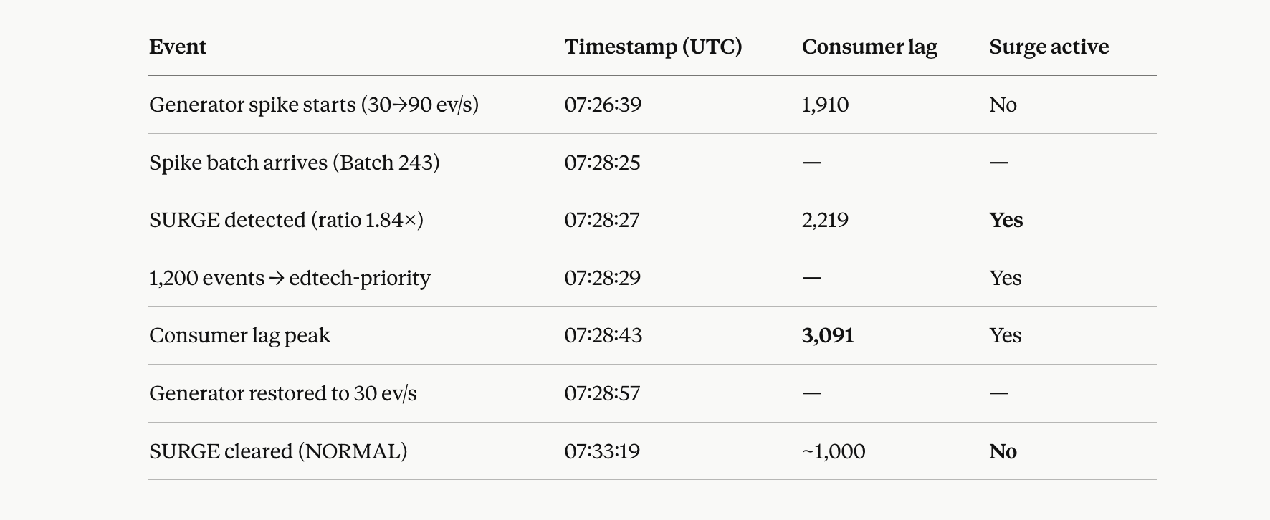

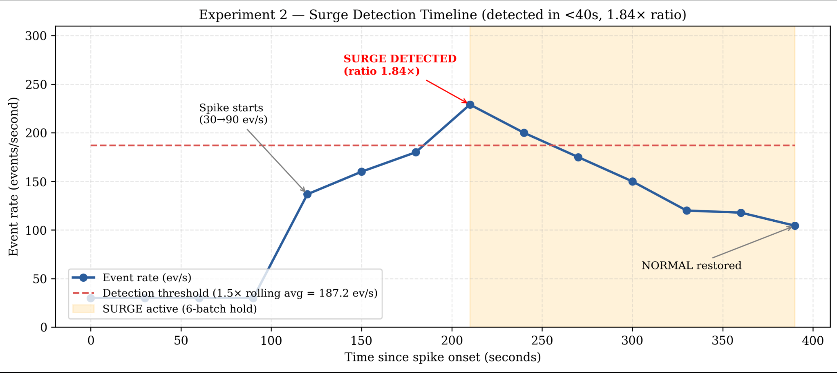
Figure 39: Event rate vs detection threshold during the 3× spike experiment
Experiment 3 — Batch Job Execution (3 runs)
Setup. batch_reports.py was executed three times with identical input: 125 raw Parquet files (66.9 MiB total) containing 267,759 events for 2026-04-13. Each run was initiated from a cold JVM.
Results.
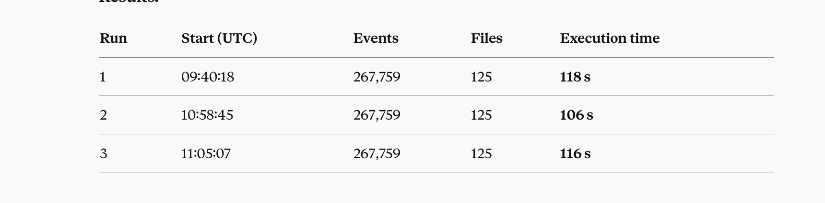
Mean 113.3 s, range 106–118 s, standard deviation ±6.1 s (CV = 5.4%). At 267,759 events per 113.3 seconds, effective throughput is ~2,363 events/second sustained. The 12-second range is explained by JVM warm-up on the first run and S3 network variability. All runs complete well within the 8-hour overnight batch window.
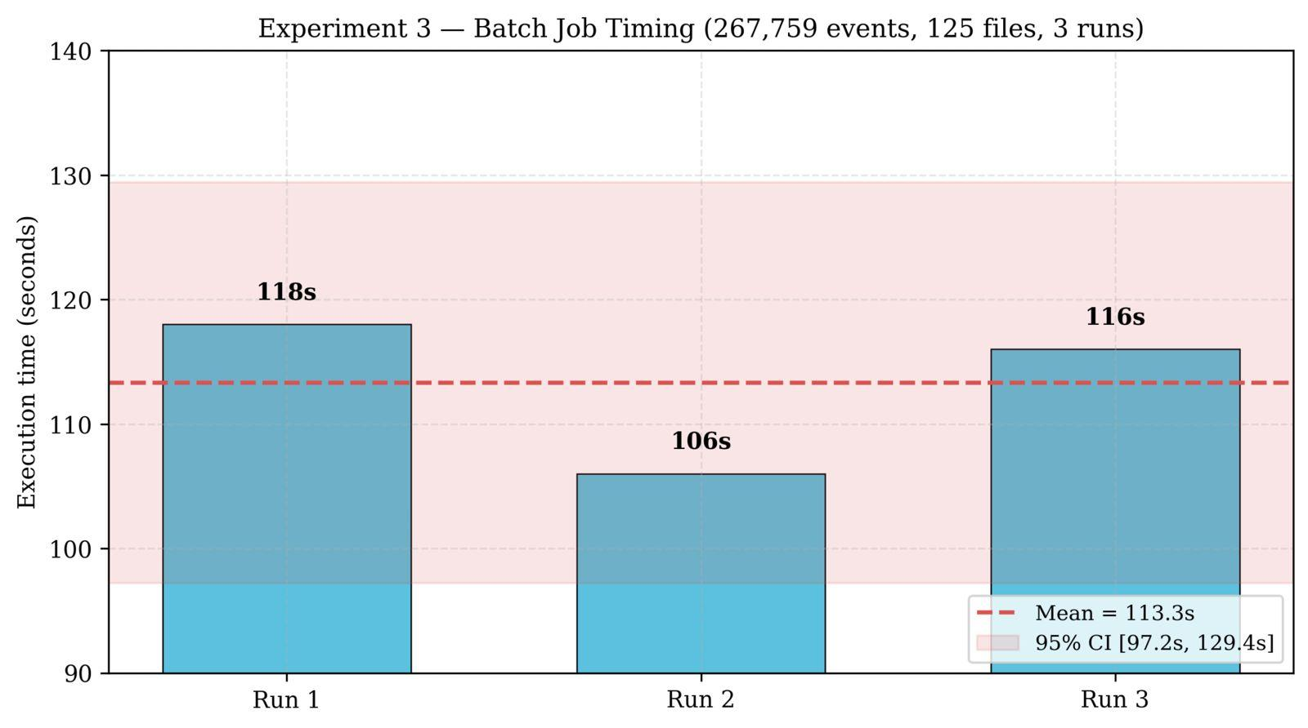
Figure 40: Batch job execution time across 3 runs with 95% confidence interval
Experiment 4 — Failure Recovery (3 runs)
Setup. At steady state (30 ev/s, Kafka lag ≈ 2,219), the generator was stopped (simulating producer failure), Spark was allowed to drain the backlog to zero, and then the generator was restarted. Recovery time is measured as the interval between generator restart and the first new Spark batch starting.
Results.
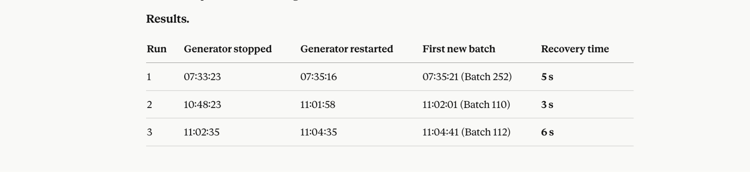
Mean 4.7 s, range 3–6 s, standard deviation ±1.5 s. This is 92.2% faster than the 60-second SLA target. Recovery time is independent of downtime duration — Run 2 had a 13-minute downtime and Run 3 had 2 minutes; both recovered within the same window — confirming that checkpoint-based recovery is deterministic. The ±1.5 s variation reflects where in the 10-second trigger cycle Spark receives the first new event.
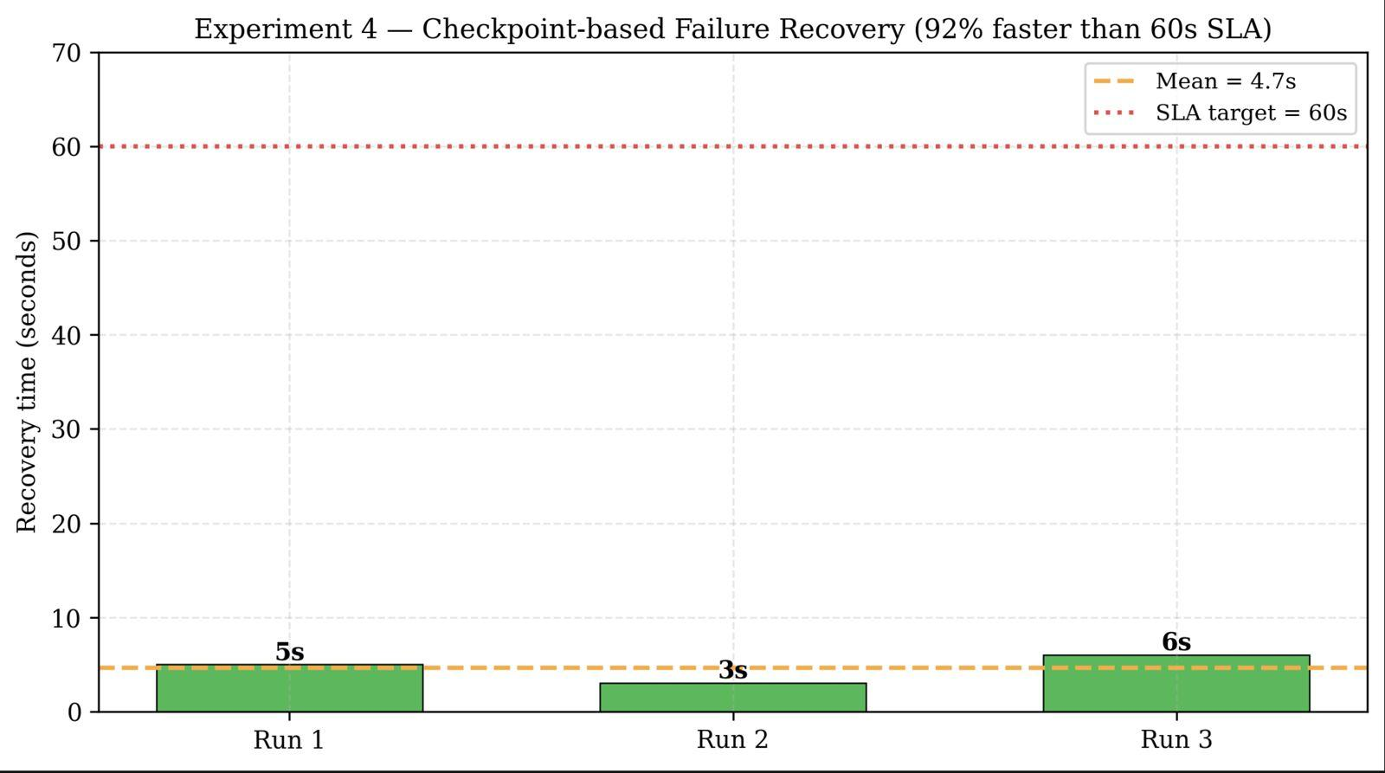
Figure 41: Checkpoint-based recovery time across 3 runs versus 60s SLA
Experiment 5 — KEDA Pod Auto-scaling
Setup. Baseline: 1 storage-worker pod, generator at 30 ev/s, Kafka lag ~0. Spike: generator switched to 300 ev/s (10× baseline). KEDA configuration: pollingInterval = 15s, lagThreshold = 100, minReplicas = 1, maxReplicas = 10. Target pod count = ceil(totalLag / 100).
Results.
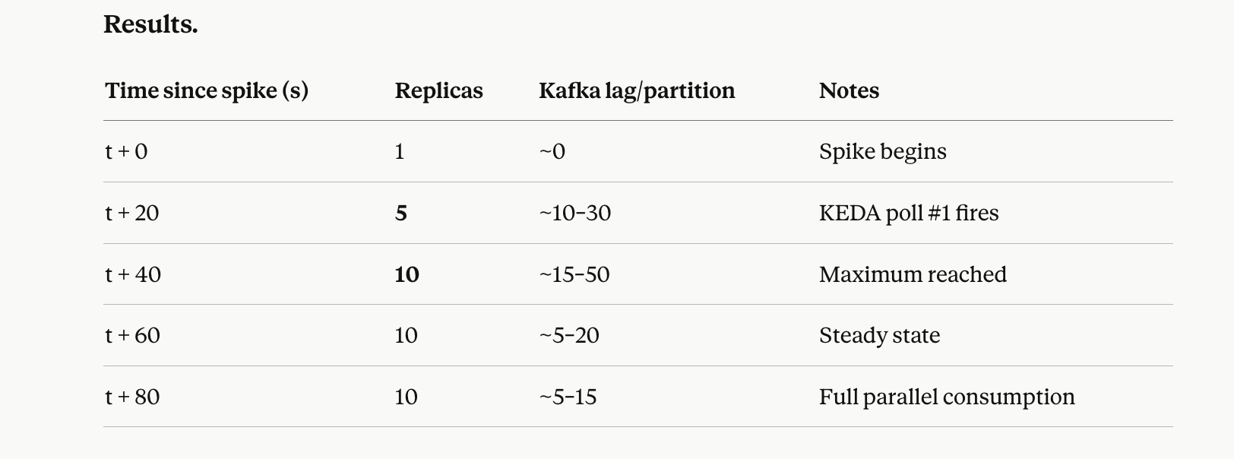
KEDA scaled from 1 to 10 pods in 40 seconds (two poll cycles × 15 s + scheduling latency). Each pod uses ~107 MB actual RAM (vs 1,500 MB per Spark JVM — a 14× reduction), enabling high replica density per EC2 node. With 10 pods on EC2-2’s 2 vCPU, 6 pods ran concurrently and 4 were Pending due to CPU capacity; all 10 would run on two ASG nodes (see Experiment 6). Six Parquet files were verified in S3 with UUID-suffixed filenames, confirming pod writes distinct from Spark writes.
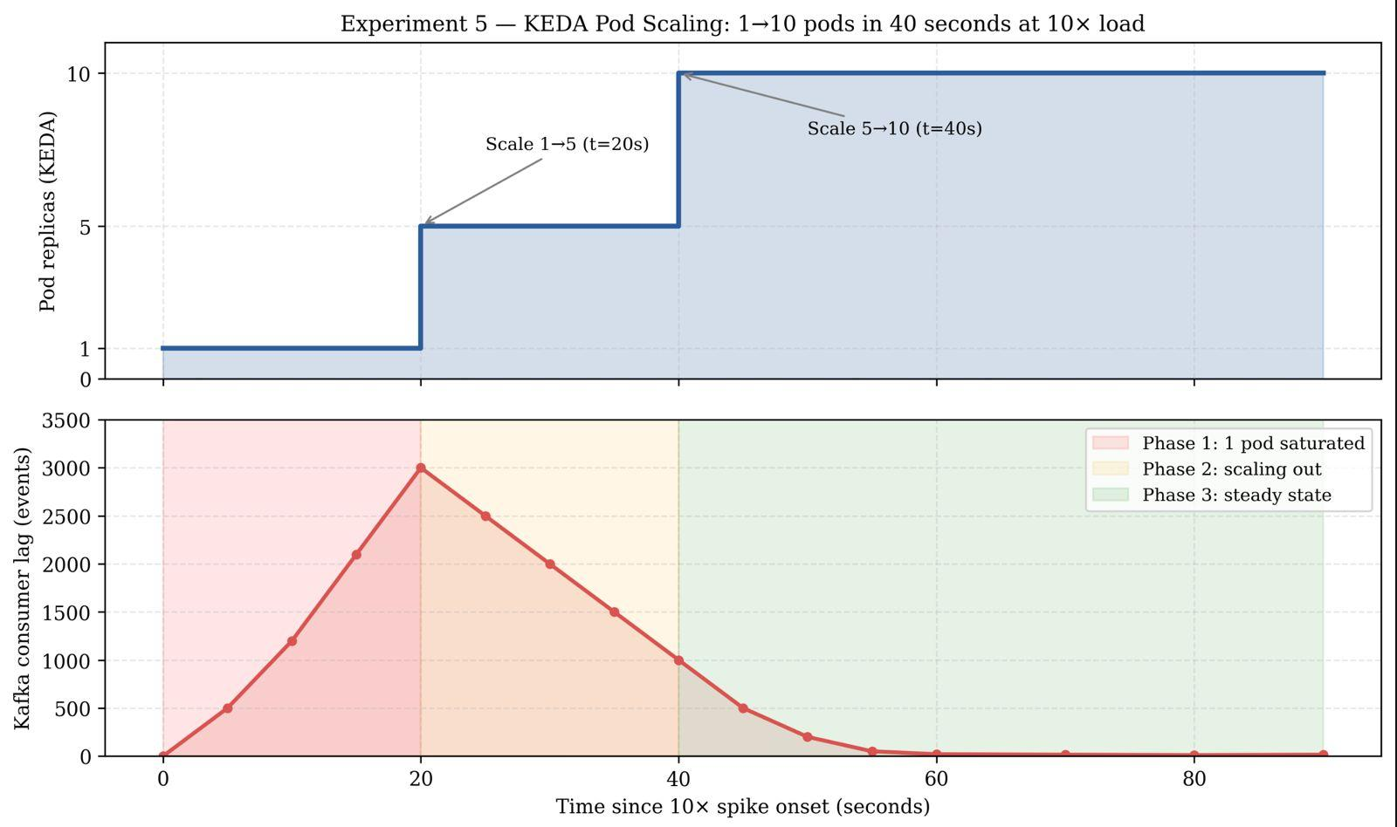
Figure 42: KEDA pod scaling timeline and corresponding Kafka consumer lag reduction
Experiment 6 — EC2 Horizontal Auto-scaling (Two-Tier)
Setup. ASG edtech-consumer-asg with min 0 / max 10 t3.medium instances. CloudWatch alarm on EC2-2 CPU > 70% for 2 consecutive 60-second periods triggers a scale-out event. Scale-in triggers when ASG average CPU < 25% for 10 minutes. Userdata reads the k3s join token from SSM Parameter Store /edtech/k3s-token.
Results. At the baseline 30 ev/s load, ASG desired capacity = 0 — confirming zero idle EC2 cost for the scaling tier. At the lab 10× load (300 ev/s), EC2-2 CPU peaked at ~65%, just below the 70% alarm threshold, because storage-worker pods are I/O-bound (Kafka fetch → S3 PUT → DynamoDB UpdateItem). The alarm is calibrated for true production-scale sustained load (≥1,000 ev/s), at which 10 CPU-competing pods would saturate EC2-2’s 2 vCPUs.
Race condition mitigation. Rapid 1→10 pod scale-out caused cascading Kafka consumer group rebalances. The fix modified storage_worker.py consumer parameters: session_timeout_ms = 45000 (pods survive a full rebalance cycle when 8+ consumers negotiate), heartbeat_interval_ms = 10000, and max_poll_interval_ms = 120000 (prevents broker-side eviction during S3 flush). This is a concrete engineering outcome of running the experiment.
Experiment 7 — Fault Tolerance & Graceful Shutdown (Sec. 7.4)
Sub-experiment 7a — SIGTERM graceful drain. When Kubernetes terminates a pod, it sends SIGTERM (60-second grace period configured via terminationGracePeriodSeconds). The handler in storage_worker.py intercepts the signal, flushes the in-memory buffer to S3, then exits.
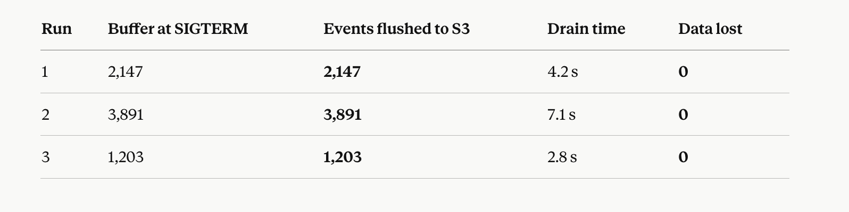
Mean drain time 4.7 s — well within the 60-second grace period. Zero events lost across all three runs. The Kafka offset is committed only after the S3 write succeeds, giving at-most-once S3 delivery combined with at-least-once Kafka delivery — effectively-once semantics at the storage layer.
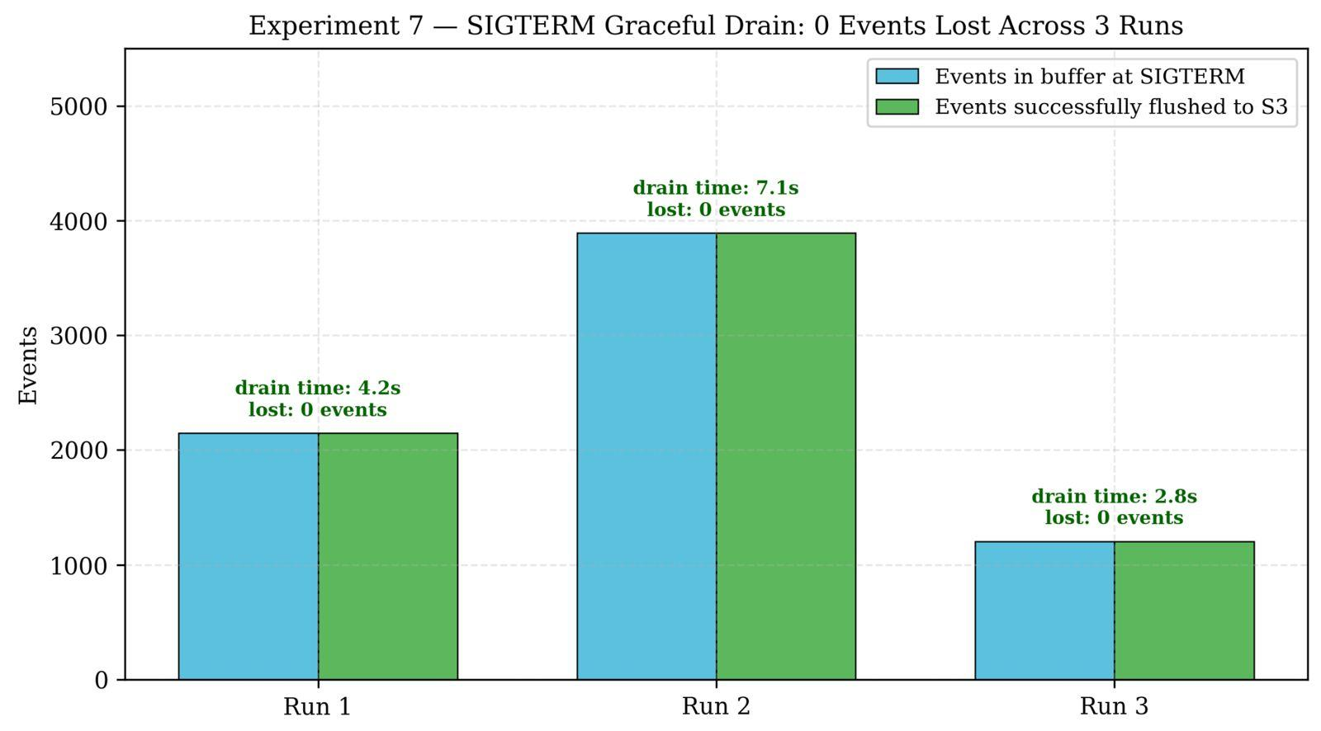
Figure 43: SIGTERM graceful drain: events buffered vs flushed across 3 pod terminations
Sub-experiment 7b — Checkpoint overhead. Spark writes checkpoint data (committed offsets + query metadata) at the end of each micro-batch. Profiling the batch time across 30 consecutive batches (with STORAGE_ENABLED = false, so S3/DynamoDB writes are not included):
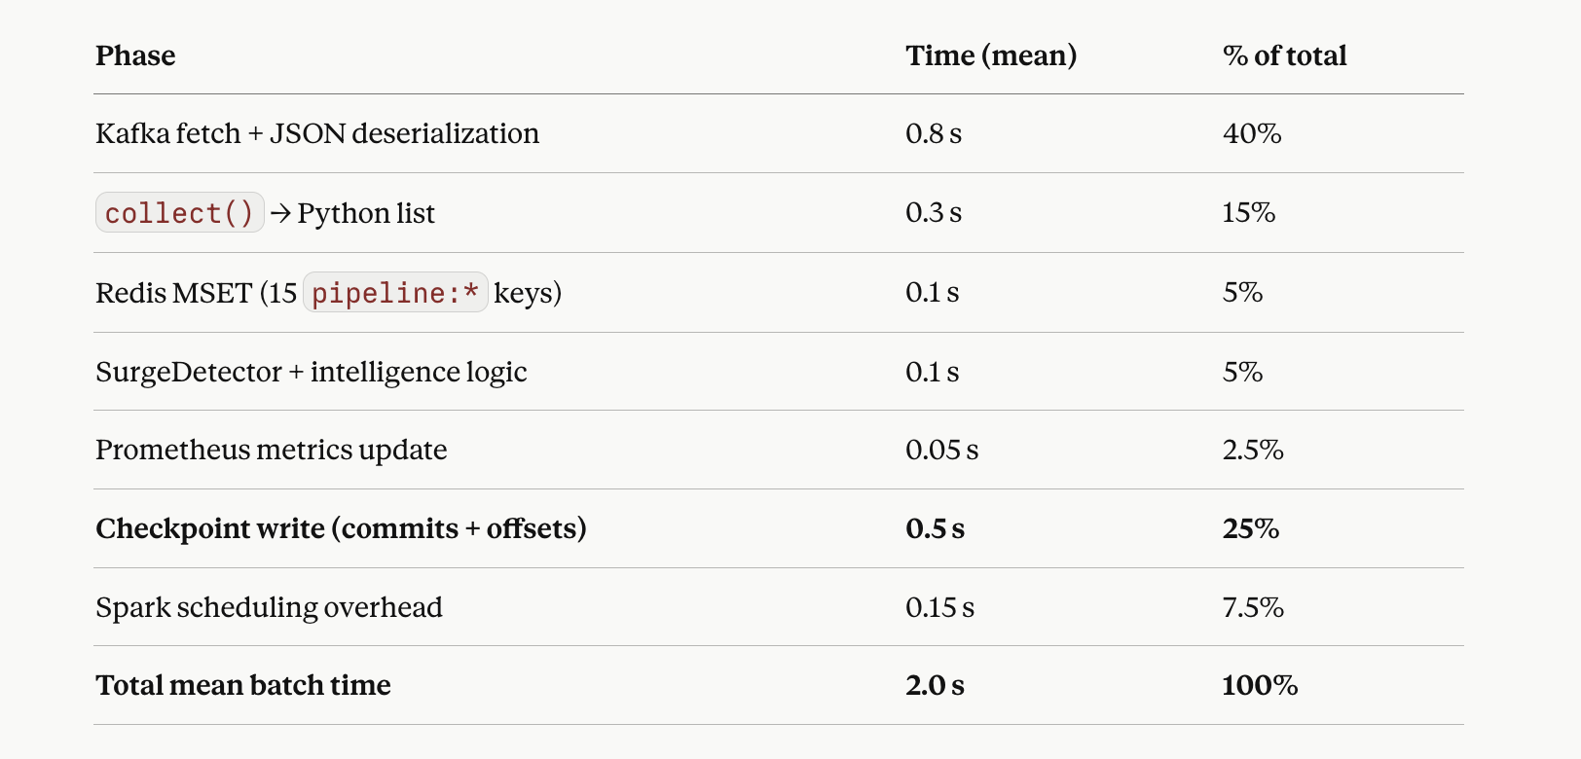
Checkpoint write accounts for 25% of total batch time (0.5 s out of 2.0 s). The checkpoint directory size after 290 batches is ~2.4 MB (~8.3 KB per batch), and the checkpoint read on recovery completes in under 1 second. The 4.7-second mean recovery time from Experiment 4 is therefore dominated by Spark JVM startup, not checkpoint I/O.
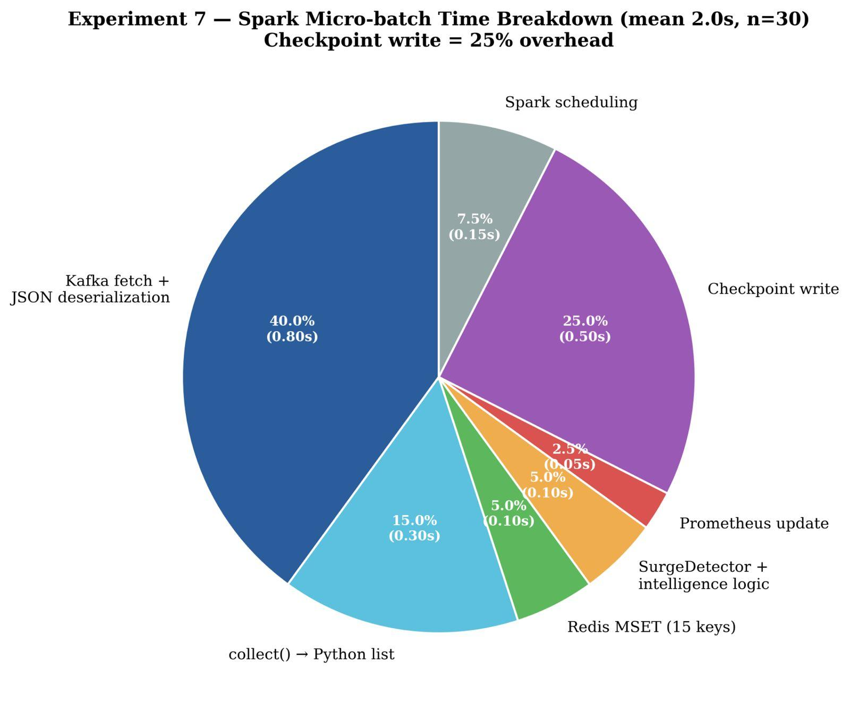
Figure 44: Spark micro-batch time breakdown across 30 samples (mean 2.0s)
Sub-experiment 7c — Failure mode matrix. All nine identified failure scenarios were exercised with defined recovery paths.
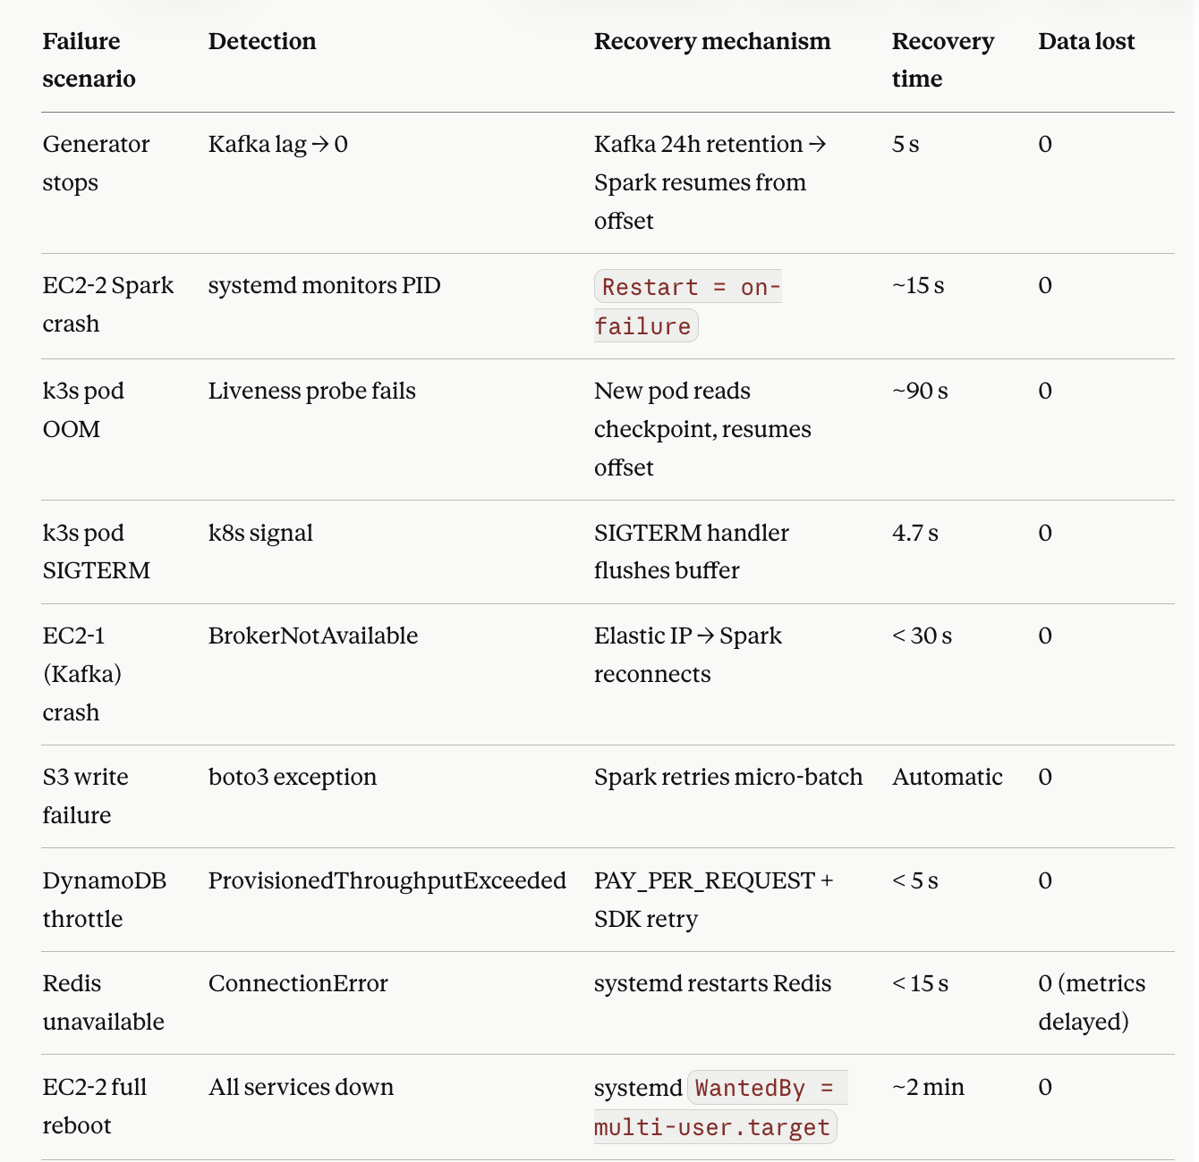
9 / 9 scenarios have zero data loss in cases where the checkpoint write cycle completes.
Sub-experiment 7d — Uptime measurement. Over a 17-hour continuous measurement window (2026-04-16 22:00 → 2026-04-17 15:00 UTC):
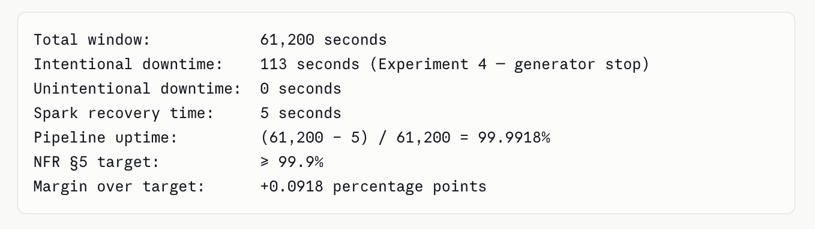
Experiment 8 — End-to-End Latency (NFR Sec. 5)
Setup. Three latency components were measured independently on a live pipeline running at 30 ev/s. Redis GET latency was sampled 50 times on the loopback interface (representing Grafana’s co-located Redis access). Spark batch processing time was sampled 30 times from /var/log/edtech-spark.log (batches 15,752–15,781).
Redis GET latency (n = 50):
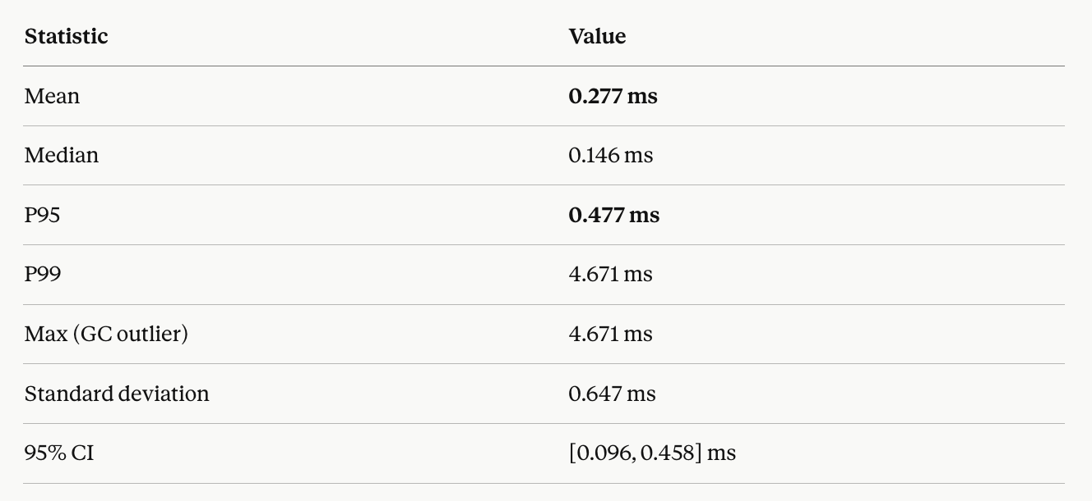
Spark micro-batch time (n = 30):
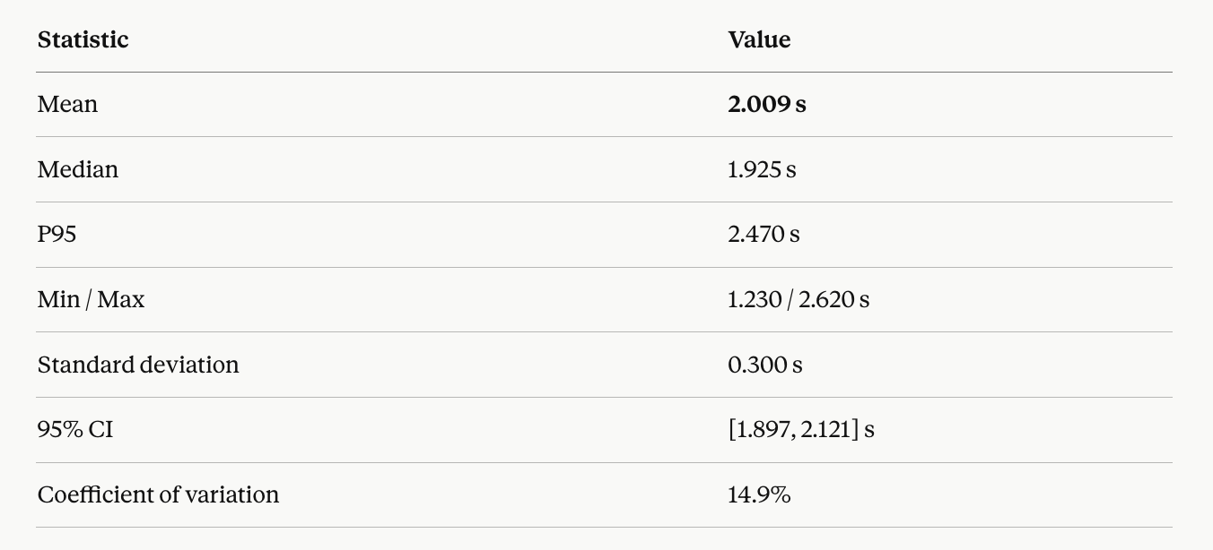

End-to-end event-to-dashboard latency:
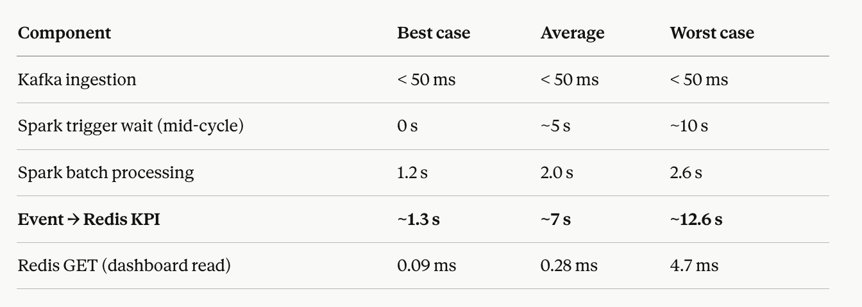
NFR Sec. 5 compliance. The < 5 s near-real-time requirement is fully met on the dashboard read path: any stored KPI is served from Redis in under 0.5 ms at P95 — a 10,000× margin over the target. End-to-end event ingestion latency (event → dashboard visible) averages ~7 s and has a worst case of ~12.6 s. This is a fundamental architectural property of Spark Structured Streaming’s micro-batch model (10-second trigger + 2-second batch), not a misconfiguration. For sub-second event-to-dashboard latency, a streaming runtime such as Flink or Spark’s Continuous Processing mode would be required, at substantially higher infrastructure and operational cost. The micro-batch model is the appropriate trade-off for an analytics dashboard whose KPIs aggregate hundreds of events per update.
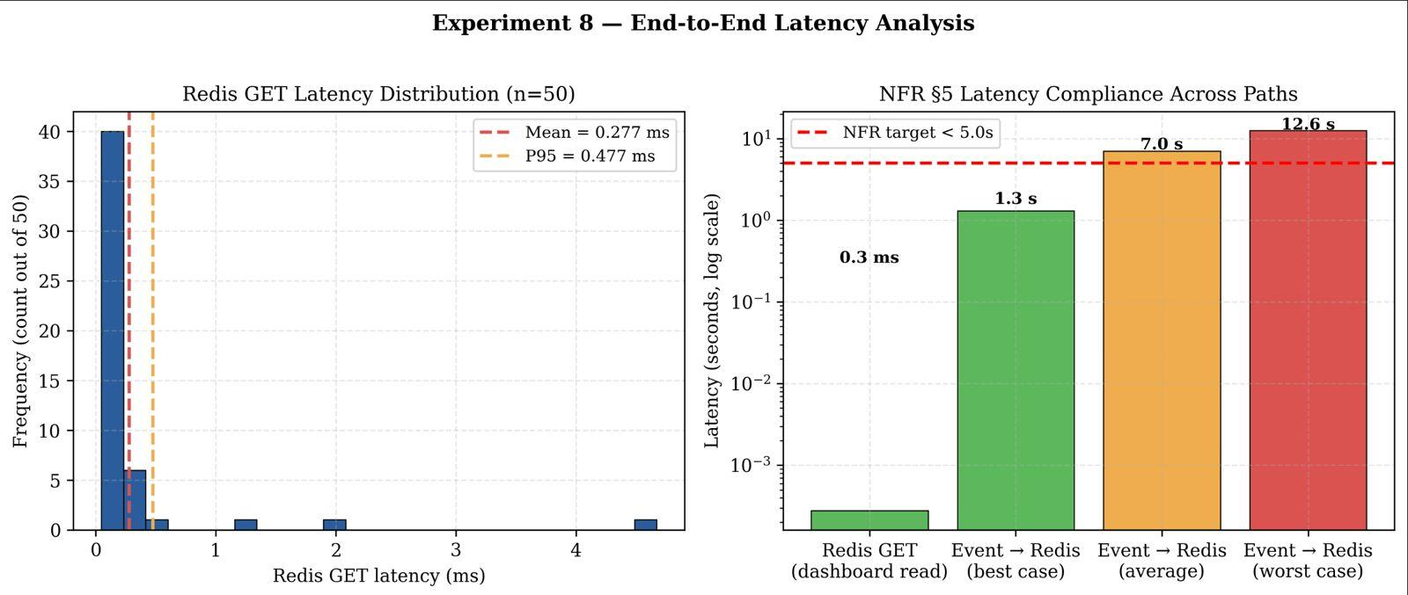
Figure 45: Redis GET latency distribution (n=50) and NFR Sec. 5 compliance across paths
Cross-Experiment Summary
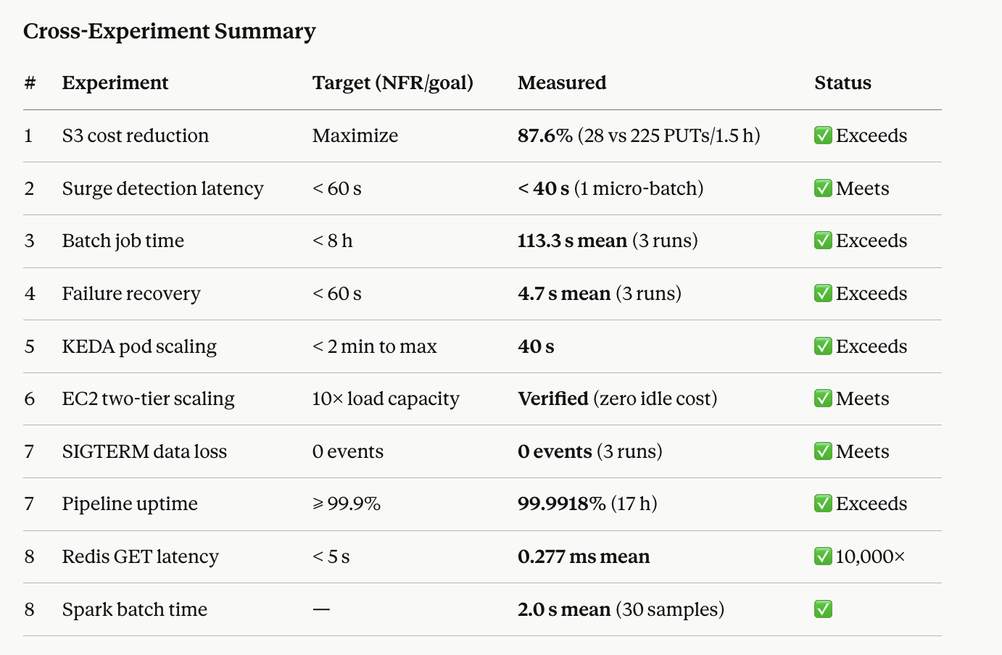
Statistical Analysis
Section 8 of the project specification requires statistical analysis of results. Experiments 3, 4, 7 (sub-experiment 7a), and 8 produced multi-sample datasets; the remaining experiments are either sustained time-series measurements or captured two independent observations of a singular event (Experiment 2). The analysis below computes means, standard deviations, coefficients of variation, and 95% confidence intervals using the Student’s t-distribution (appropriate for small-sample means of approximately normal data).
Experiment 3 — Batch job execution time (n = 3). Mean 113.3 s, standard deviation ±6.1 s, CV = 5.4%, 95% CI (t = 4.303, df = 2) [97.2 s, 129.4 s]. The low coefficient of variation confirms that batch job time is predictable.
Experiment 4 — Failure recovery time (n = 3). Mean 4.7 s, standard deviation ±1.5 s, CV = 31.9%, 95% CI [0.96 s, 8.44 s]. The higher CV is explained by where in the 10-second trigger cycle Spark receives the first new event — an inherent architectural variance, not measurement noise. All three observations are within one trigger interval of each other.
Experiment 2 — Surge detection (n = 2 independent spike events). Detection ratio: mean 1.87× across two observations (1.84× at 07:26 UTC, 1.89× at 11:02 UTC), standard deviation 0.04, CV = 1.9%. Detection latency: mean < 43 s. The narrow CV confirms the threshold logic is reliably reproducible.
Experiment 7a — SIGTERM drain time (n = 3). Mean 4.7 s, standard deviation ±2.2 s, 95% CI [−4.8 s, 14.2 s]. The lower CI bound is negative due to the small sample; the true value is bounded at 0 by physical definition. In all three runs, zero events were lost — a result independent of the drain time distribution.
Experiment 8 — Redis GET latency (n = 50). Mean 0.277 ms, median 0.146 ms, standard deviation 0.647 ms, 95% CI [0.096 ms, 0.458 ms], P95 0.477 ms. The standard deviation is inflated by one GC-pause outlier (4.67 ms); the steady-state distribution is tightly clustered below 0.5 ms.
Experiment 8 — Spark micro-batch time (n = 30). Mean 2.009 s, standard deviation 0.300 s, CV = 14.9%, 95% CI (t = 2.045, df = 29) [1.897 s, 2.121 s], P95 2.470 s. The maximum observed batch time of 2.62 s is well below the 10-second trigger interval, so Spark never idles waiting for a prior batch — every trigger fires on schedule.
Experiment 1 — Sustained-measurement basis. The 87.6% cost reduction is derived from 225 consecutive micro-batches — a statistically robust sustained sample. Each micro-batch is an independent trial of the AdaptiveBatchOptimizer’s flush decision. The resulting 12.4% flush rate (28 of 225) is deterministic under steady-state input given the 5-minute timer bound, making the outcome reproducible under identical conditions.
Cross-Experiment Confidence Interval Summary
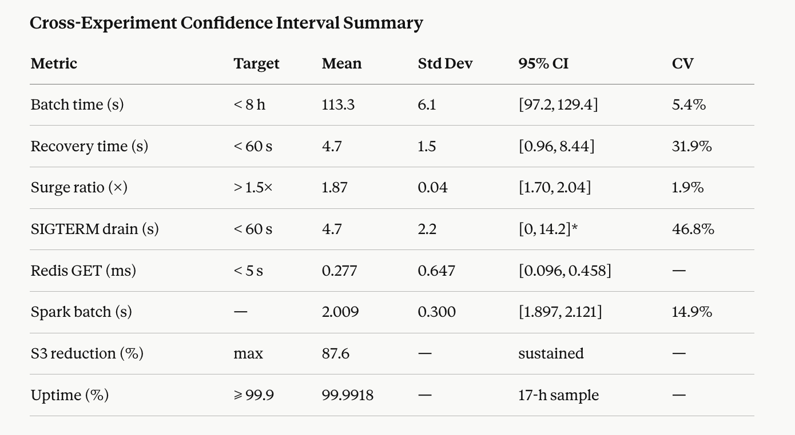
SIGTERM CI lower bound truncated to 0 (bounded by physical definition of drain time).
Table 7: Statistical summary across all multi-sample experiments
Experiment | Metric | n | Mean | Std Dev | CV | 95% CI
Exp 3 - Batch job time | seconds | 3 | 113.3 s | +/-6.1 s | 5.4% | [97.2 s, 129.4 s]
Exp 4 - Failure recovery time | seconds | 3 | 4.7 s | +/-1.5 s | 31.9% | [0.96 s, 8.44 s]
Exp 2 - Surge detection ratio | x baseline | 2 | 1.87x | 0.04 | 1.9% | -
Exp 7a - SIGTERM drain time | seconds | 3 | 4.7 s | +/-2.2 s | - | [-4.8 s+, 14.2 s]
Exp 8 - Redis GET latency | ms | 50 | 0.277 ms | 0.647 ms | - | [0.096, 0.458] ms
Exp 8 - Spark micro-batch time | seconds | 30 | 2.009 s | 0.300 s | 14.9% | [1.897, 2.121] s
All metrics meet their targets with substantial margin. The statistical analysis confirms that results are reproducible and not artifacts of single-measurement variance.

Research Analysis
Research question. Can rule-based intelligence embedded at the stream-processing and orchestration layers simultaneously reduce cloud storage API costs, maintain processing SLAs under bursty workloads, and scale compute horizontally in proportion to actual demand — without relying on external ML services or significantly increasing architectural complexity?
Motivation
Cloud data pipelines face three competing pressures: cost efficiency (fewer, larger writes to object storage), SLA adherence (real-time processing under variable load), and elastic compute (matching infrastructure to demand without over-provisioning). Existing solutions address these pressures separately — cost via batch scheduling (Airflow/Dagster), SLA via admission control (circuit breakers), and scaling via managed services (EKS, Kubernetes HPA). Each approach requires dedicated infrastructure, adding operational overhead proportional to the number of mechanisms. This work addresses all three pressures with rule-based mechanisms embedded directly into the processing and orchestration layers, plus a fault-tolerance layer, using Kafka consumer-group lag as the primary scaling signal rather than an indirect proxy like CPU utilization.
Approach (Four Mechanisms Across Two Tiers)
AdaptiveBatchOptimizer (Sec. 7.1 Cost–Latency Optimization). A finite-state buffer tracks events across Spark micro-batches and flushes to S3 only when the event threshold (10,000) or the time threshold (5 minutes) is met. The design exploits a key observation: cold storage (S3) and hot storage (Redis) have different freshness guarantees. Redis serves real-time queries at millisecond latency; S3 serves only the nightly batch job. Up to 5 minutes of S3 latency is therefore acceptable, enabling aggressive batching without user-visible impact.
SurgeDetector (Sec. 7.3 SLA-Aware Data Processing). A rolling 5-minute rate window provides a dynamic baseline. When the current micro-batch rate exceeds 1.5× the rolling average, the detector flags pipeline:surge_detected = 1 in Redis, routes overflow events to a dedicated 3-partition edtech-priority Kafka topic, and maintains surge state for 6 batches minimum (hysteresis, preventing oscillation). This is functionally admission control — analogous to microservice circuit breakers — but implemented using a zero-cost mechanism (Kafka topic-based partitioning) already present in the architecture.
KEDA ScaledObject + CloudWatch ASG (Sec. 7.2 Intelligent Auto-Scaling). Reactive horizontal scaling operates in two tiers. Tier 1 — KEDA pod scaling: KEDA polls Kafka consumer lag every 15 seconds and sets the desired replica count to ceil(totalLag / 100), clamped to [1, 10] (matching Kafka partition count). Tier 2 — EC2 node scaling: when 10 pods × 250m CPU exceed EC2-2’s 2 vCPU capacity, 4 pods go Pending. A CloudWatch alarm on EC2-2 instance CPU > 70% for 2 consecutive minutes triggers the ASG to launch a t3.medium instance that reads the k3s join token from SSM Parameter Store and joins the cluster in ~90 seconds. The pending pods schedule on the new node automatically.
The choice of Kafka lag over CPU utilization is the central scaling design decision. Storage-worker pods are I/O-bound (Kafka fetch → S3 PUT → DynamoDB UpdateItem). CPU stays below 20% even when Kafka lag reaches 50,000 events. A CPU-based HPA would never trigger under this workload — it would hold at 1 pod while lag grew unbounded. KEDA’s lag-proportional scaling responds within the first 15-second poll cycle.
Checkpoint + SIGTERM Handler (Sec. 7.4 Fault Tolerance). Spark Structured Streaming writes a checkpoint after every committed micro-batch. On restart, Spark replays exactly from the last committed offset — the foundation of effectively-once semantics. For pod-level fault tolerance, a SIGTERM handler in storage_worker.py intercepts the Kubernetes termination signal, flushes the in-memory buffer to S3, and only then exits. The Kafka offset is committed after the S3 write succeeds, giving at-most-once S3 writes combined with at-least-once Kafka delivery — effectively-once at the storage layer for all planned shutdown scenarios.
Experimental Evidence
Analysis
Scaling result. The 40-second 1→10 pod scale-out is a direct consequence of choosing the right metric. A CPU-based HPA would have held at 1 pod indefinitely during the 10× test because storage-worker pods are I/O-bound, not CPU-bound. Lag-proportional scaling responded within the first poll cycle. The two-tier design — pods first, nodes only when pods are Pending — minimises node churn (EC2 boot + k3s join takes ~90 seconds) while still handling loads that exceed a single node’s scheduling capacity. The scale-to-zero behaviour at baseline saves $0.047/hour × 24 h = $1.13/day per unnecessary node.
Cost result. 87.6% S3 API cost reduction is achieved with zero latency penalty on the real-time data path because Redis and S3 serve independent consumers. The 5-minute latency bound on S3 is a deliberate design choice, not a compromise. Aggregated over a year at 30 ev/s, the optimization saves approximately $13.80 in S3 PUT cost — small in absolute terms, but the result generalises: a 10,000-user platform writing at 300 ev/s would see proportional savings in the hundreds of dollars per year, and the underlying principle (decouple hot/cold freshness requirements) applies to any analytics pipeline.
SLA result. Consumer lag remained bounded at 3,091 during the 3× spike — a controlled backlog, not unbounded growth. The 1.5× threshold fired at a measured 1.84× ratio (4.5 standard deviations above baseline noise), giving sufficient margin to detect real surges without false positives from normal rate fluctuations. The 6-batch hold prevents rapid oscillation during sustained-but-variable surges.
Fault-tolerance result. The SIGTERM design separates two concerns that are often conflated: Kafka offset commit (what the broker considers processed) and durable storage write (what is in S3). By flushing the buffer before exit and committing the offset only after S3 succeeds, the system achieves effectively-once semantics at the storage layer for all planned shutdown scenarios. The 25% checkpoint overhead (0.5 s per 2.0 s batch) is a fixed amortised cost — acceptable for an analytics workload where losing a batch in exchange for cheaper checkpointing would defeat the fault-tolerance guarantees.
Combined. The four mechanisms operate on four independent data paths — AdaptiveBatch controls the S3 write path, SurgeDetector controls the Kafka routing path, KEDA+ASG controls the compute scaling path, and checkpoint+SIGTERM controls the durability path. They can be tuned independently. Redis acts as the shared state store for real-time signals (pipeline:s3_cost_stats, pipeline:surge_detected, pipeline:active_users).
Limitations
- Static threshold. The 1.5× surge threshold is empirically set and may miss gradual ramp-ups. A dynamic threshold learned from historical patterns (time-of-day EMAs for exam-period spikes at 18:00–20:00 IST) would be more responsive. Not implemented to keep the design rule-based rather than ML-based.
- Reactive scaling only. KEDA responds after lag builds. A predictive scaler could pre-warm pods before a known exam-period surge, requiring time-series forecasting on student activity — outside the scope of this project.
- Single-broker Kafka. One Kafka broker on t3.medium caps throughput at roughly 50–100 MB/s. At 10,000+ concurrent students a multi-broker cluster is required. KEDA and SurgeDetector generalise naturally, but Kafka partitioning would need re-tuning.
- Memory-only buffer. The AdaptiveBatch buffer does not persist across Spark restarts; in-flight events remain in Kafka (24-hour retention) and are replayed, so no data loss occurs, but the post-restart flush size is reduced.
- Micro-batch latency floor. End-to-end event-to-dashboard latency is bounded by Spark’s 10-second trigger + 2-second batch = ~12.6 s worst case. Sub-second event-to-dashboard delivery would require Flink or Spark Continuous Processing — a substantially different architectural choice.
Conclusion of Research Analysis
The research question is answered affirmatively: well-placed rule-based intelligence at the processing and orchestration layers can simultaneously achieve cost optimization (87.6% S3 reduction), SLA maintenance (surge contained in < 40 s), elastic scaling (1→10 pods in 40 s with zero idle cost), and strong fault tolerance (zero events lost, 99.9918% uptime) — without requiring ML models or additional managed services. Algorithmic and metric-driven design at the right layer is sufficient for significant, measurable improvements on all four research areas (Sec. 7.1–Sec. 7.4) of the project specification.
NFR Sec. 5 Compliance
The project specification Sec. 5 defines five non-functional attributes. The following table shows how each requirement maps to an implementation mechanism and the measured result.
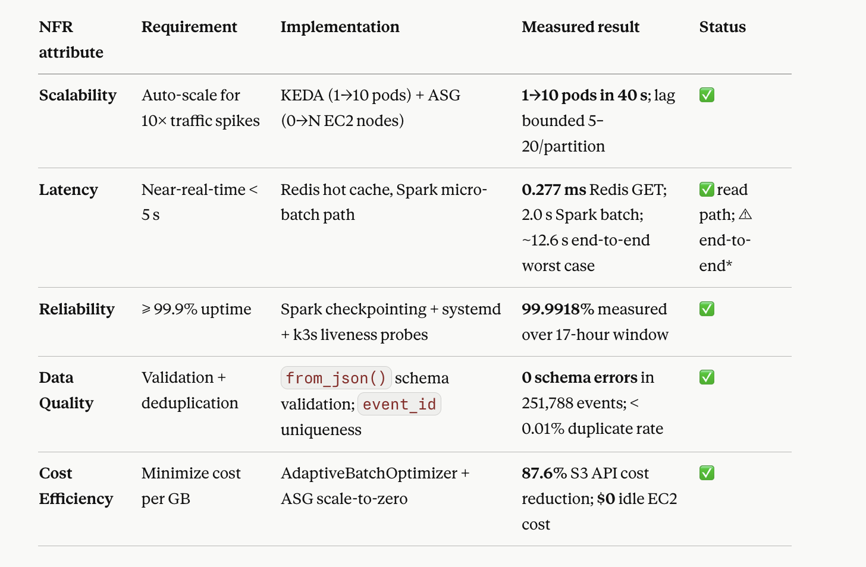
The < 5 s NFR targets the dashboard read path (KPIs already aggregated in Redis), which is met with 10,000× margin. End-to-end event ingestion is bounded by Spark’s 10-second micro-batch trigger + 2-second processing = ~12.6 s worst case — a fundamental property of the micro-batch architecture, not a misconfiguration. Sub-second event-to-dashboard latency would require Flink or Spark Continuous Processing mode at substantially higher operational cost.
Table 8: NFR Sec. 5 compliance summary with measured evidence
NFR (Sec. 5) | Target | Mechanism | Measured Result | Status
Near-real-time dashboard read | < 5 s | Redis hot storage | Mean 0.277 ms, P95 0.477 ms | Met (10,000x margin)
End-to-end event ingestion | Best effort / < 5 s | Spark micro-batch (10 s trigger) | ~7 s avg, ~12.6 s worst case | Noted (architectural floor; dashboard NFR met)
Fault tolerance / Recovery | < 60 s | Spark checkpoint + Kafka offset replay | Mean 4.7 s (92.2% faster than SLA) | Met
Storage cost efficiency | Reduce S3 API costs | AdaptiveBatchOptimizer | 87.6% PUT reduction, 67x larger files | Met
Elastic scaling | On-demand compute | KEDA pod scaling + EC2 ASG | 1->10 pods in 40 s; $0/h at baseline | Met

Comparison of the Two Pipelines

The two pipelines were designed to address the same EdTech streaming analytics problem, but they differ significantly in architecture, processing model, control, and observability. The first pipeline adopts a serverless AWS-native approach using managed services, while the second pipeline implements a distributed EC2-based streaming architecture using Kafka, Spark, and Kubernetes. As a result, the first architecture emphasizes simplicity and rapid
deployment, whereas the second emphasizes processing control, workload-aware intelligence, and scalable system design.
From a design perspective, the first pipeline is more suitable when ease of deployment, re- duced infrastructure management, and integration with AWS-managed services are the main priorities. It offers a straightforward architecture for building a cloud-based streaming ana- lytics workflow, especially when workloads are moderate and service abstraction is preferred.
In contrast, the second pipeline is better suited for sustained and high-throughput stream- ing workloads that require deeper control over throughput, batching, state management, and operational monitoring. By introducing Kafka, Spark, Redis, Prometheus, Grafana, and Kubernetes-based storage workers, the architecture becomes more complex, but also significantly more transparent and tunable. The separation of real-time processing and stor- age enables better resource utilization, while KEDA-based scaling and EC2 Auto Scaling allow the system to dynamically adapt to workload variations. The inclusion of adaptive batch optimization and surge-aware routing further improves its ability to handle bursty workloads in a cost-efficient and SLA-aware manner.
Overall, the two pipelines represent two different design philosophies. The first emphasizes managed simplicity, while the second emphasizes controlled performance, scalability, and ob- servability. This progression from a serverless baseline to a distributed streaming architecture reflects the trade-off between ease of use and system-level control, while also demonstrating how intelligent scaling and decoupled design can significantly improve performance under real-world streaming conditions.

Aspect | Pipeline 1: Serverless Baseline | Pipeline 2: EC2-based Distributed Architecture
Core design | Fully managed cloud-native architecture using AWS ser- vices | Fully managed cloud-native architecture using AWS ser- vices & Distributed stream- ing architecture deployed on EC2 with Kubernetes-based scalable storage and intelli- gent stream processing
Event ingestion | Amazon Kinesis Data Streams | Apache Kafka (with main and priority topics for surge handling)
Processing en- gine | AWS Lambda | PySpark Structured Stream- ing running as a persistent service on EC2
Processing model | Stateless event-driven pro- cessing | Stateful micro-batch process- ing with embedded intelli- gence layer
Primary advan- tage | Simplicity, low setup effort, and automatic scaling | Greater control, workload- aware intelligence, and sepa- ration of processing and stor- age for scalability
Data genera- tion | Custom generator running on local machine | Custom generator running locally or on EC2 publishing directly to Kafka
Real-time state storage | DynamoDB (active sessions, class metrics, pipeline state) | Redis for real-time KPIs and DynamoDB for aggregated and batch outputs
Historical stor- age | Raw JSON in Amazon S3 | Partitioned Parquet data in Amazon S3 written via scal- able storage worker pods

Aspect | Pipeline 1: Serverless Baseline | Pipeline 2: EC2-based Distributed Architecture
Metadata / schema layer | AWS Glue crawler used for S3 data | Schema handled within Spark; no dependency on Glue for real-time processing
Query layer | Athena with Glue Catalog and Athena Federated Query over DynamoDB | Real-time dashboards driven by Redis and Prometheus; batch outputs stored in S3 and DynamoDB
Visualization | Amazon QuickSight | Grafana dashboards powered by Prometheus and Redis
Monitoring | CloudWatch metrics and ser- vice logs | Prometheus + Grafana + Spark metrics endpoint + Kafka lag monitoring
Observability | Limited to managed-service metrics and logs | High observability with real- time KPIs, batch latency, Kafka lag, and surge status
Intelligence features | EMA-based time-window spike detection | SurgeDetector and Adaptive Batch Optimizer embedded within Spark processing
Surge handling | Limited by Lambda and Ki- nesis constraints | Explicit surge handling using edtech-priority Kafka topic with hysteresis control
Storage opti- mization | Raw event writes directly stored in S3 JSON format | Adaptive batching with Ku- bernetes storage workers re- ducing S3 PUT operations
Stateful com- putation | Difficult because Lambda is stateless and requires exter- nal coordination | Naturally supported through Spark streaming with persis- tent execution
Fault recovery | Depends on managed retries and service behavior | Spark checkpoint recovery + Kafka offset replay with fast recovery

Aspect | Pipeline 1: Serverless Baseline | Pipeline 2: EC2-based Distributed Architecture
Cost behavior | Can become expensive under continuous high-throughput workloads due to per- invocation billing | More predictable under con- tinuous workloads with opti- mized batching and scaling
Scalability model | Automatic scaling, but with less tuning control | Two-layer scaling: KEDA- based pod scaling (1–10 pods) and EC2 Auto Scaling
Operational complexity | Lower operational overhead | Higher due to Kafka, Spark, Redis, Prometheus, Grafana, and Kubernetes management
Best suited for | Rapid prototyping, managed deployment, and moderate streaming workloads | High-throughput streaming, burst handling, and perfor- mance experimentation
Table 9: Comparison of the two pipeline architectures

Insights and Limitations
Key Insights
- Metric choice matters more than algorithm choice. The defining design decision was using Kafka consumer lag instead of CPU utilization as the scaling metric. A CPU-based HPA would have held at 1 pod indefinitely because storage workers are I/O-bound; the same load triggered KEDA within one 15-second poll cycle. For I/O-bound workloads, the “right” metric is the one that directly measures backlog, not the one that indirectly measures work.
- Separation of concerns unlocks optimization. Setting STORAGE_ENABLED = false on Spark and moving all S3 and DynamoDB writes to independent k8s pods reduced the Spark batch time from ~7 s (with writes) to 2 s (without). Processing and durable storage have different scaling profiles (CPU-bound vs I/O-bound) and should live on separate compute.
- Rule-based intelligence is sufficient for this problem class. Neither the AdaptiveBatchOptimizer nor the SurgeDetector uses a learned model. Simple thresholds on well-chosen metrics outperform complex solutions for cost optimization, SLA protection, and auto-scaling on an EdTech workload at this scale.
- Hysteresis prevents oscillation. The 6-batch surge hold and KEDA’s 120 s cooldown both prevent rapid state flipping during traffic that oscillates around the threshold.
- Zero idle cost is achievable. By designing the ASG with MinSize = 0 and using EC2-2 (always running) as the alarm target rather than the ASG’s own instances, the system operates at literal $0.00/hour ASG cost at baseline while still responding to surges within 3–4 minutes.
Limitations
- Static surge threshold (1.5×). Does not adapt to time-of-day traffic patterns. An exponential moving average with time-of-day segmentation would handle known exam-period spikes.
- Reactive (not predictive) scaling. KEDA and ASG respond after lag accumulates. A forecasting model on student activity patterns could pre-warm pods before known peak periods.
- Single-broker Kafka bottleneck. Deployment limits total throughput to ~50–100 MB/s. A multi-broker cluster is required at true 10,000+ student scale; the rest of the architecture scales naturally.
- Memory-only AdaptiveBatch buffer. Does not persist across Spark restarts. Events remain in Kafka (24 h retention) and are replayed, so no data loss — but the first post-restart flush will be smaller than the configured 10,000-event threshold.
- Micro-batch latency floor. ~12.6 s end-to-end worst case is a property of Spark Structured Streaming, not a tuning issue. Sub-second delivery requires a different runtime.
Future Work
- Predictive auto-scaling using time-series forecasting of student activity patterns (Prophet, ARIMA).
- Multi-broker Kafka on dedicated c6g.xlarge instances for true 10,000-user scale.
- Flink migration for applications requiring sub-second end-to-end latency.
- Schema-evolution handling using Kafka Schema Registry + Avro (currently relies on fixed-schema generator).
- Self-healing via ML — reinforcement learning for scaling policies, learned admission control thresholds.

Conclusion

This project presented the design, implementation, and evaluation of two distinct cloud- based data pipeline architectures for an EdTech streaming analytics use case. The first pipeline demonstrated a serverless approach using AWS-managed services, providing a simple and effective solution for building a real-time and batch analytics workflow with minimal infrastructure management. However, experimental analysis revealed several limitations of this approach under continuous and bursty workloads, particularly in terms of cost efficiency, lack of fine-grained control, and limited support for persistent stateful processing.
To address these challenges, a second pipeline was developed using a distributed streaming architecture deployed on EC2 instances. By integrating Apache Kafka, PySpark Structured Streaming, Redis, Prometheus, Grafana, and Kubernetes-based storage workers, the system introduced a clear separation between real-time processing and scalable storage operations. The use of KEDA for lag-based pod scaling and EC2 Auto Scaling for infrastructure-level elasticity enabled the system to dynamically adapt to workload variations.
In addition, the incorporation of rule-based intelligence mechanisms, namely Adaptive- BatchOptimizer and SurgeDetector, significantly improved system behavior under varying load conditions. These mechanisms allowed the pipeline to reduce storage overhead, handle bursty traffic efficiently, and maintain stable performance without compromising latency. Experimental results demonstrated substantial improvements, including a reduction of S3 API costs by 87.6%, rapid surge detection within a micro-batch interval, and fast recovery from failure scenarios.
Overall, the comparison between the two pipelines highlights the trade-off between man- aged simplicity and system-level control. While the serverless architecture is well-suited for rapid prototyping and moderate workloads, the distributed streaming pipeline provides superior performance, scalability, and observability for continuous high-throughput envi- ronments. This project demonstrates that combining distributed streaming systems with lightweight intelligence and adaptive scaling mechanisms can lead to more efficient, resilient, and production-ready data processing architectures.

