**The LC3 Chip-8 Emulator**

Home directory:

C:\Users\Alifa\Desktop\lc3-backup\eclipse\LC3Chip8Emulator

**Debugging mode**

Running in debug mode:

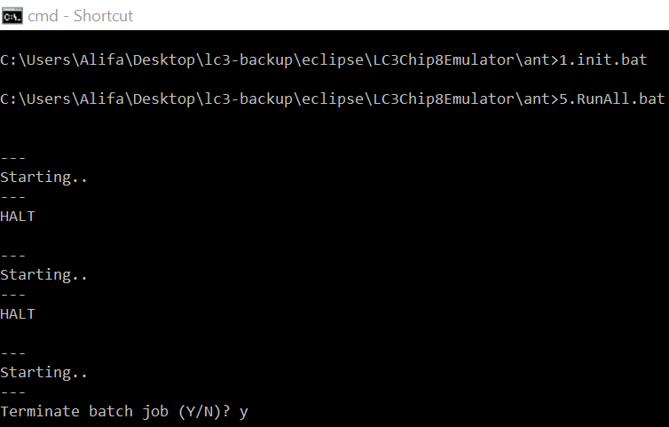

Running VM in debug mode will not show output so be careful with this option. This mode also will output the de-assembler (or disassembler) to a file on your desktop or location specified in **vmoptions** in **3.run.bat:**

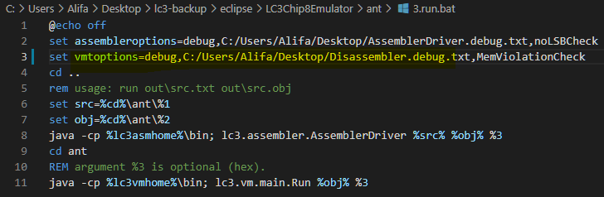

Note that your VM in debug mode will run at a speed specified in lc3.vm.chip.CPU class:

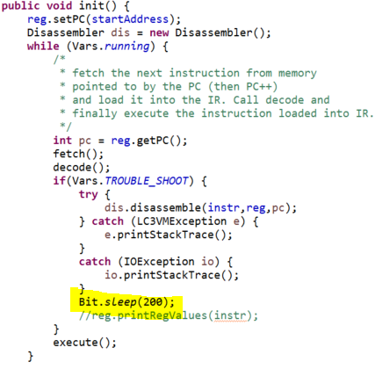

A way to check that your vm is working properly is by running the following commands under home/ant directory:

>1.init.bat

>4.compileAll.bat (converts all src files under **LC3Compiler**/ant/src/* to asm with absolute pcoffsets)

>5.RunAll.bat

Or…

>5.RunAll.bat > savedoutput.txt

Then open a new cmd window and cd to **C:\Users\Alifa\Desktop\lc3-backup**

>git status (you should **NOT** see *savedoutput.txt* as a modified file)

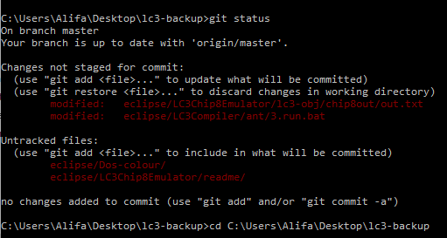

**Comparing Test Results**

**0-chip8emu.txt** is your test file which you will run to compare output.

>2.compile.bat src\chip8\0-chip8emu.lct

>3.run.bat out\0-chip8emu.lct_asm.txt out\0-chip8emu.lct_asm.obj **hex** > C:\Users\Alifa\Desktop\lc3-backup\eclipse\LC3Chip8Emulator\lc3-obj\chip8out\out.txt



***Note: It’s better to open a new cmd window instead of CD.***

>cd C:\Users\Alifa\Desktop\mystuff\faiz.dev.root\gitdir\github-fizaan\temp\vsc-java

>**1.init.bat**

>cd java

> java Chip8UnitTest.java hex

You should ***not*** see any output

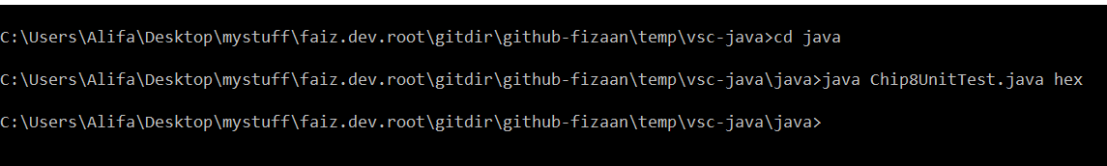

Here…