MARWADI UNIVERSITY
Rajkot, Gujarat

A Project Report on
RESTAURANT HANDLING SYSTEM

Submitted By:
Fiza Zahid
Vishwani
(BCA 3C)

Under the Guidance of:
Tirth Bhadeshiya Sir

Academic Year: 2026-27

Declaration
We hereby declare that the project titled “Restaurant Handling System” submitted to Marwadi University is a record of original work done by us under the guidance of Tirth Bhadeshiya Sir. This project has not been submitted to any other university or institution for the award of any degree or diploma.

Place: Rajkot
Signature:
1. Fiza Zahid
2. Vishwani

Acknowledgement
We would like to express our sincere gratitude to our guide, Tirth Bhadeshiya Sir, for his valuable guidance, constant encouragement and constructive suggestions throughout the development of this project. We are also thankful to Marwadi University for providing us with the necessary resources and environment to complete this project successfully.

Abstract
The Restaurant Handling System is a Java-based desktop application designed to automate the day-to-day operations of a restaurant. It provides a user-friendly graphical interface built with Java Swing and uses MySQL as the backend database through JDBC connectivity. The system manages food menus, restaurant tables, customer details and orders, and generates GST-enabled bills that can be saved for record keeping. Additional features include a live statistics dashboard showing total sales and orders, and a dark mode for comfortable usage. This project demonstrates the practical application of core Java, event handling, database connectivity and user interface design in solving real-world business problems.

Table of Contents
1. Introduction
2. Objectives of the Project
3. Scope of the Project
4. Technologies Used
5. System Design
6. Modules Description
7. Implementation & Screenshots
8. Testing
9. Advantages
10. Limitations & Future Scope
11. Conclusion
12. Bibliography

1. Introduction
In the modern food service industry, managing orders, tables, customers and billing manually is time-consuming and error-prone. The Restaurant Handling System is developed to digitalize these operations using a simple desktop application.
The application provides a secure login screen, after which the user can manage food items, restaurant tables, customer records and orders through an intuitive dashboard. Each order is automatically priced using the food menu, and a complete bill with GST can be generated and saved as a text file. A live statistics dashboard keeps the owner informed about total sales, number of orders, food items and customers at a glance.

2. Objectives of the Project
- To automate restaurant operations such as menu, table, customer and order management.
- To calculate order amounts automatically from the food menu and generate GST-enabled bills.
- To maintain all records permanently in a MySQL database instead of paper registers.
- To provide a modern, easy-to-use graphical interface with light and dark themes.
- To display live business statistics (sales, orders) on the dashboard.

3. Scope of the Project
This system can be used by small and medium restaurants, cafés and fast-food outlets to handle daily operations. The saved bill files can be used for accounting and record keeping. The modular design of the project (DAO – Model – UI separation) allows future enhancements such as online ordering, payment gateway integration and printable PDF bills.

4. Technologies Used
Technology | Purpose
Java 17 | Core programming language
Java Swing (JFC) | Graphical User Interface (GUI)
MySQL | Relational database for storing records
JDBC | Connecting Java application with MySQL
Maven | Build tool and dependency management
IntelliJ IDEA | Integrated Development Environment (IDE)

5. System Design

5.1 Architecture
The project follows a three-layer architecture:
- Model Layer – Plain Java classes (Food, Customer, RestaurantTable, Order) that represent database entities.
- DAO Layer – Data Access Objects (FoodDAO, CustomerDAO, TableDAO, OrderDAO) that perform all database operations using JDBC.
- Presentation Layer – Main.java built with Java Swing, which renders the login screen, dashboard and all dialogs.
This separation keeps the code organized, reusable and easy to maintain.

5.2 Database Tables
- food – id, name, price, category
- customers – id, name, phone
- tables – id, table_number, status
- orders – id, table_number, food_name, quantity, total_amount

6. Modules Description

6.1 Login Module
The login screen authenticates the user with a username and password. On wrong credentials the login card plays a shake animation and an error message is displayed. Successful login opens the main dashboard.

6.2 Food Menu Module
Allows viewing all food items in a styled table and adding new items with name, price and category.

6.3 Table Management Module
Displays all restaurant tables with their current status and allows adding new tables.

6.4 Customer Module
Stores customer names and phone numbers, which can be viewed in a table at any time.

6.5 Orders & Billing Module
New orders are placed by selecting a table, choosing a food item from a dropdown and entering the quantity. The total amount is calculated live as the quantity changes.

6.6 Smart Bill Generator
A table-wise, itemized bill is generated including subtotal, 5% GST and grand total. The bill can be saved as a .txt file for records or printing.

6.7 Live Dashboard & Dark Mode
The dashboard shows live statistics — total sales, total orders, food items and customers — fetched directly from the database, along with a one-click dark mode toggle.

7. Implementation & Screenshots
*(Paste screenshots of the Login Screen, Dashboard, Food Menu, Orders & Billing and Bill Generator below.)*

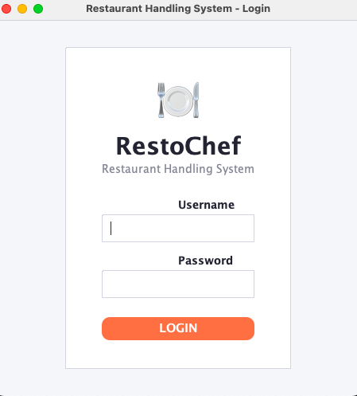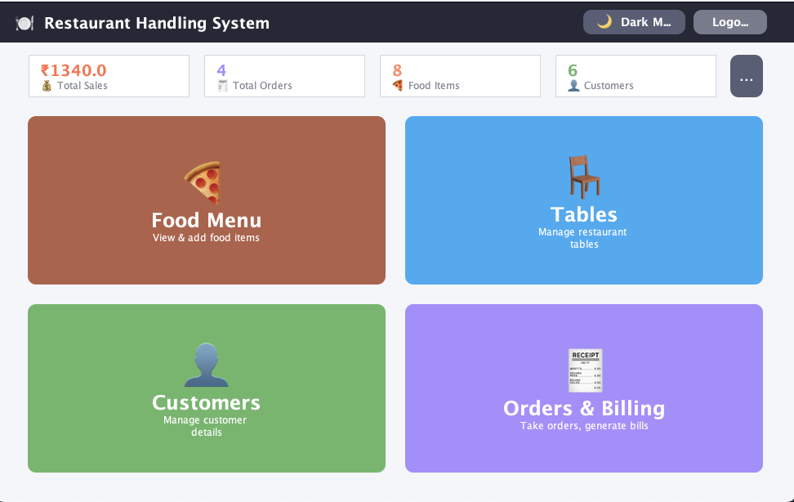

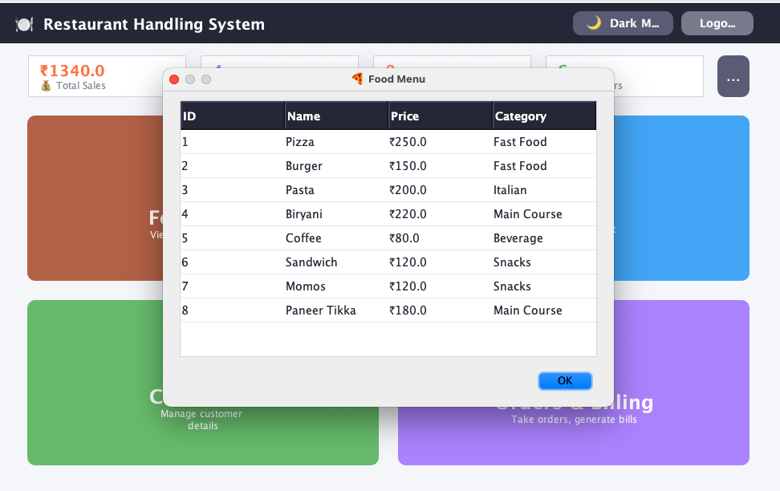
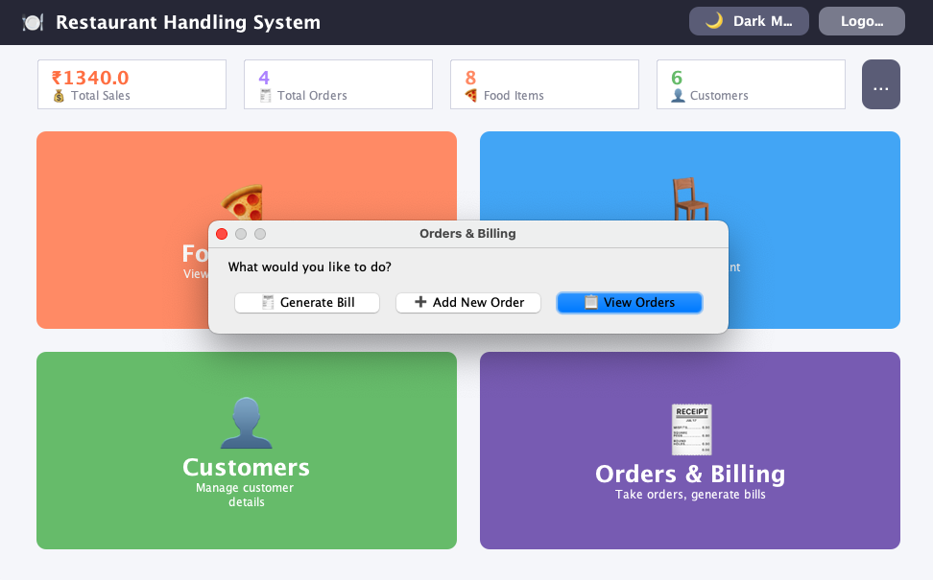

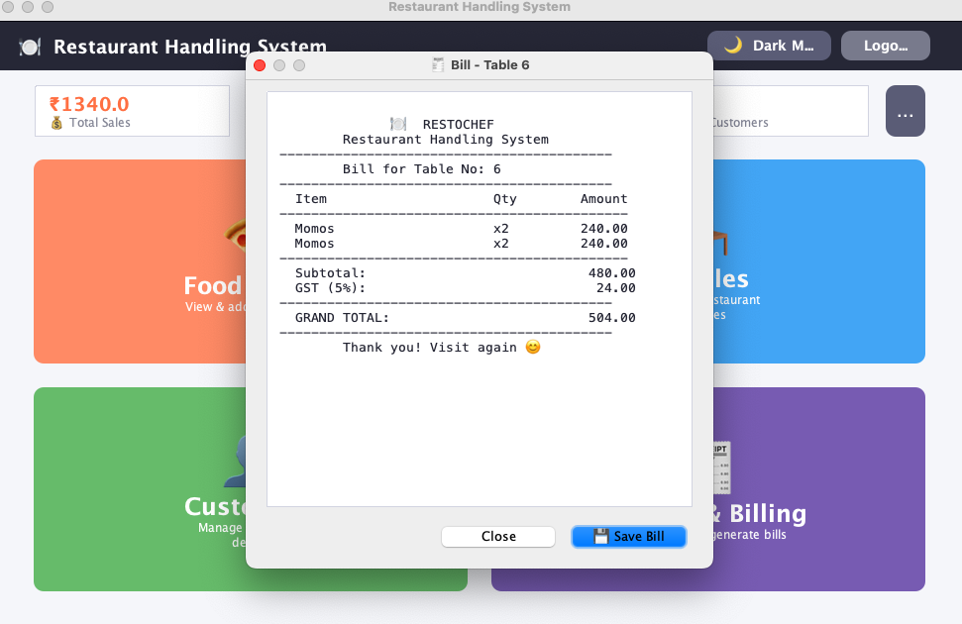8. Testing
The application was tested for the following scenarios:
Test Case | Expected Result
Login with correct credentials | Dashboard opens
Login with wrong credentials | Shake animation + error message
Add food item | Item saved and visible in menu table
Place order with invalid input | Validation error shown
Generate bill for a table | Itemized bill with GST displayed
Save bill | Bill saved as .txt file at chosen location
Dark mode toggle | Entire UI switches theme
All test cases were executed successfully and the application behaved as expected.

9. Advantages
- Faster and accurate billing with automatic GST calculation.
- Permanent digital record of customers, tables and orders in MySQL.
- Modern, attractive UI that is easy to learn and use.
- Bills can be saved and used for accounting.
- Live sales statistics help in quick business decisions.

10. Limitations & Future Scope

10.1 Limitations
- Single-user desktop application; no multi-user or online access.
- Bills are generated as text files, not PDF.

10.2 Future Scope
- Online ordering and payment gateway integration.
- SMS/Email bill sharing with customers.
- Sales charts and analytics reports.
- Multi-user roles (admin, cashier, waiter).

11. Conclusion
The Restaurant Handling System successfully automates the key operations of a restaurant using Java Swing and MySQL. With features like secure login, order management, GST billing, bill saving, live statistics and dark mode, the project demonstrates how a well-structured Java application can solve real business problems. Working on this project strengthened our understanding of core Java, JDBC, event handling and UI design, and gave us valuable hands-on experience of building a complete software product.

12. Bibliography
- Herbert Schildt, “Java: The Complete Reference”, Oracle Press.
- Cay S. Horstmann, “Core Java Volume I – Fundamentals”, Pearson.
- MySQL Documentation – https://dev.mysql.com/doc/
- Java Swing Tutorial – https://docs.oracle.com/javase/tutorial/uiswing/

