**KARACHI INSTITUTE OF ECONOMICS & TECHNOLOGY**

**PROJECT REPORT**

**PROJECT TITLE**: NOVA SUPERMAR

**Course:** Software Engineering

**Submitted by**:

|  |  |  |  |
| --- | --- | --- | --- |
| **Sno** | **Student ID** | **Name** | **Course ID** |
| 1 | 9729 | Fizra Azhar | 106269 |
| 2 | 9148 | Nabiyah Hanif | 106269 |
| 3 | 9295 | Ayesha Rahim | 106269 |
| 4 | 9352 | asha | 106269 |
| 5 | 9091 | sara | 106269 |

Supervised by

Ma’am Umaima

Table of Contents

Table of Contents ii

Revision History ii

1. Introduction 1

1.1 Purpose 1

1.2 Document Conventions 1

1.3 Intended Audience and Reading Suggestions 1

1.4 Product Scope 1

1.5 References 1

2. Overall Description 2

2.1 Product Perspective 2

2.2 Product Functions 2

2.3 User Classes and Characteristics 2

2.4 Operating Environment 2

2.5 Design and Implementation Constraints 2

2.6 User Documentation 2

2.7 Assumptions and Dependencies 3

3. External Interface Requirements 3

3.1 User Interfaces 3

3.2 Hardware Interfaces 3

3.3 Software Interfaces 3

3.4 Communications Interfaces 3

4. System Features 4

4.1 Login/Register Panel 4

4.2 User Profile 5

4.3 Orders/Bill 6

4.4 Data integrity & Security 8

5. Other Nonfunctional Requirements 8

5.1 Performance Requirements 8

5.2 Safety Requirements 8

5.3 Security Requirements 8

5.4 Software Quality Attributes 8

6. Diagrams 8

6.1 ERD 8

6.2 Class Diagram 8

# 1. Introduction

## Purpose:

## *To ensure uninterrupted supply of materials and stores without delay to various production and service departments of the organization. To prevent overstocking and understocking of materials, To minimize the storage costs. To ensure proper and continuous control over materials and to provide a system in order to manage all the entries of the store.*

## Intended Audience and Reading Suggestions

This project is most likely to be read by our project advisor Ma’am Umeima as well as critical group members. Further in this document you could find the different classes, objects and their functions in detail. It also includes the software and hardware requirements details which are necessary to use this software.

## Product Scope

The scope of this project is to provide an ease of access of all the records to management of the store.

It also provides the facility of managing all the employs, expenses and different goods records which are related to the store.

Moreover this application provides the facility to the salesmen of the store to manage the sales bill much more efficiently.

## References

* SRS documentation (IEEE standards)

## Overview

Chapter 2 of the SRS is a brief description of the characteristics of the software to be built, its functions, its users, its constraints and its dependencies.

Chapter 3 is about specific requirements, such as functional requirements, external interface requirements, performance requirements, and also design constraints and quality characteristics.

Finally, chapter 4 includes all the supporting information, such as the Table of Contents, the Appendices, and the Index.

# Overall Description

## Product Perspective

* Nova Supermart is a desktop based application supported by sql database. This project requires the user to have basic knowledge of operating the windows application.

**THE OVERVIEW ARCHITECTURE DIAGRAM**

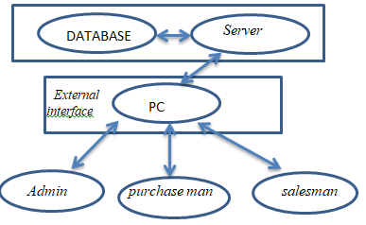

**Functions of System Components:**

**Database:**

* Stores data
* Creates reports
* Provides access to data
* Updates information

**Server:**

* Provides access to the database
* Authenticates users
* Processes reservations
* Performs backups
* Produces reports

**External Interfaces:**

**PC:**

PC is the only interface in our project because we are working on windows form in this project and there are three types of users that can use this application

* Salesman
* Purchaseman
* admin

## Product Functions

This program has the following functionalities:

* Admin, Purchasemen, Salesmen Login
* Admin, Purchasemen, Salesmen (Add,Update,Delete)
* Stock,Items,Expenses,Person,Sales,Purchases (Add,Update,Delete)
* Create Bill

### Function Relationships

### Function Descriptions (Functional Requirement Listings)

#### Login/Register Panel(MODULE 1)

##### **Description and Priority**

A login panel comprises of only 3 type of login: Admin Login,Salesmen Login, Purchasemen Login

##### **Stimulus/Response Sequences**

* Admin will login, purchasemen will login, salesmen will login
* Salesmen will redirect to dashboard after login
* Puchasemen will redirect to dashboard after login

##### **Functional Requirements**

* **Login page:**

*This page consists of 2 textboxes named Username and Password and a Submit button. And three radio buttons to select either admin, salesmen or purchasemen*

*If User typed correctly they will be redirected to the dashboard.*

#### System control and manage products(MODULE 2)

##### **Description and Priority**

Admin panel can handle all main activities in this project and have authority to make changes in any module. this module is made for controlling all activities in application to make sure that every activity works smoothly.

##### **Stimulus/Response Sequences**

* Admin will login,
* Admin can manage all the records in the database
* Admin can (Add,Update,Delete) Stock, Items, Expenses, Person, Sales, Purchases

##### **Functional Requirements**

* **Admin page:**

*This page consists of 2 textboxes named Username and Password and a Submit button. And three radio buttons to select either admin, salesmen or purchasemen*

*When user select admin and If User typed correctly they will be redirected to the dashboard.*

*Dashboard page consist of menu bar at the top from there admin can select any of them category and those menu bar buttons will redirected the admin to the desire page for example if admin click on item button this button will redirected the admin to item page*

#### Data Validation & Integrity(Database)MODULE 3

##### **Description and Priority**

Every field will be containing data validation and verification along with data integrity to make sure the application is error and bug free. Every data will be recorded in database according to every module. Validation of every data is describe in database through constraints

##### **Functional Requirements**

* **User input validation:***Each user input will be validated on its data type. The error will be showed instantly if the user enters data in an incorrect format.*
* **Data integrity:***The system will make sure if the program is stuck at any time. There will be no loss of data.*

#### Purchasing system (MODULE 4)

##### **Description and Priority**

Purchase man can add product from the list and describe quantity of the product that how much product purchase man want to purchase will also see price and this add product can generate bill

**Stimulus/Response Sequences**

* Purchase man will login,
* Purchase man can add products

##### **Functional Requirements**

* **Purchase man page:**

*This page consists of 3 textboxes named product name and quantity and date and a Add button.*

*User can see products and then order for the desired product for purchasing this order send to the sales man for confirmation*

#### Billing(MODULE 5)

##### **Description and Priority**

There will be an interface that will allow the Salesmen to manage all the items in the system. and create bills

##### **Stimulus/Response Sequences**

* salesmen can add items to in cart to generate bill.

##### **Functional Requirements**

* ***Add an item:****salesmen can add a new item using its interface.*
* ***Delete an item:****The salesmen can delete item before generating bill.*
* ***Generate Bill :****Salesmen can generate bill for the customer.*

## User Classes and Characteristics

We have three types of users admins,salesmen,purchasemen

Following user classes are identified:

**Employees:**

Will be using this portal to manage their activities.

**Item:**

Items will show to user.

**Bill:**

User will generate bill

**Sales and Purchases Graph:**

Admin can view Sales and Purchases Graph

## 2.4 Operating Environment

Operating environment for Nova SuperMart is listed below.

1. Windows based OS (7 or later)
2. SQL Server database (2008 or later)
3. Platform: Visual Studio (C#, windows form)

## Design and Implementation Constraints

There is no such constraints except for some of the few listed.

* Windows 7 or later
* Ram: 512MB or more
* System: Core2duo (2.0ghz) or above
* Database: SQL Server 2008 or later

## User Documentation

The software will be an easy to use application, there would be no manual required to operate.

## Assumptions and Dependencies

The dependencies required are:

* Microsoft Visual Studio 2010/2015
* Microsoft SQL Server (Database- 2008RS)

## <ADD OOAD REPORT DIAGRAMS HERE>

## Diagrams:

### ERD

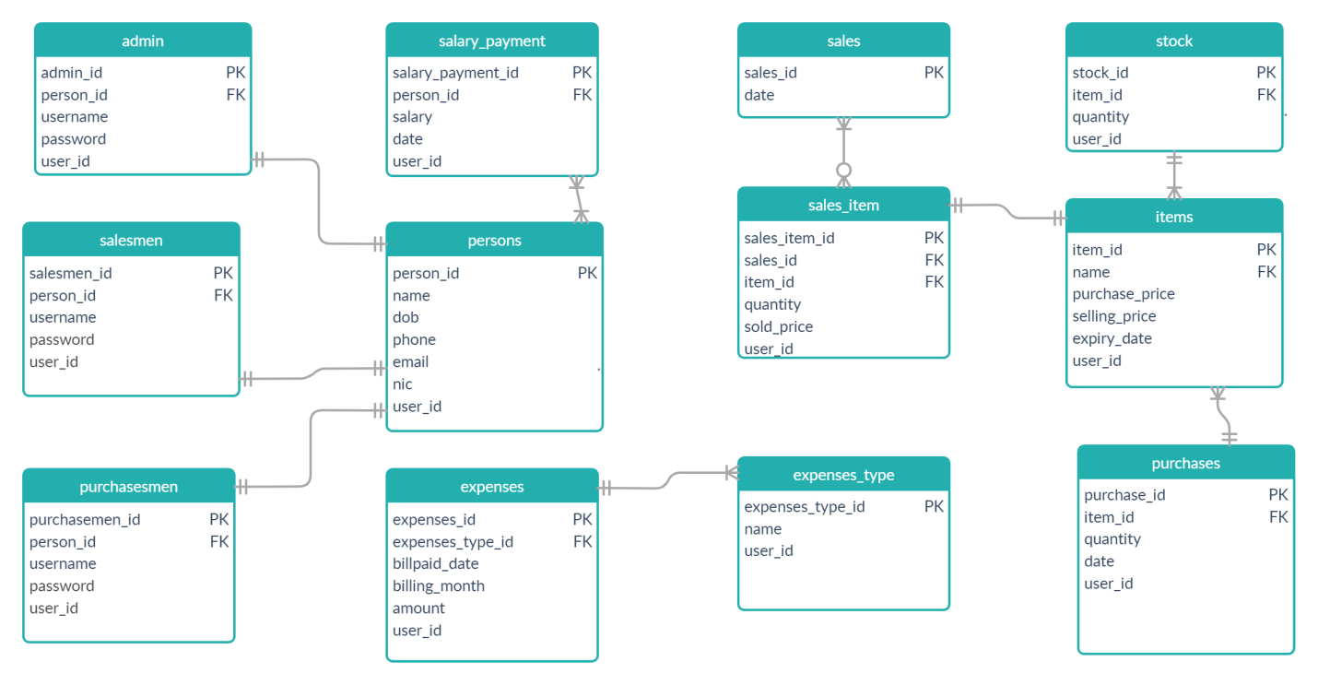

### Class Diagram

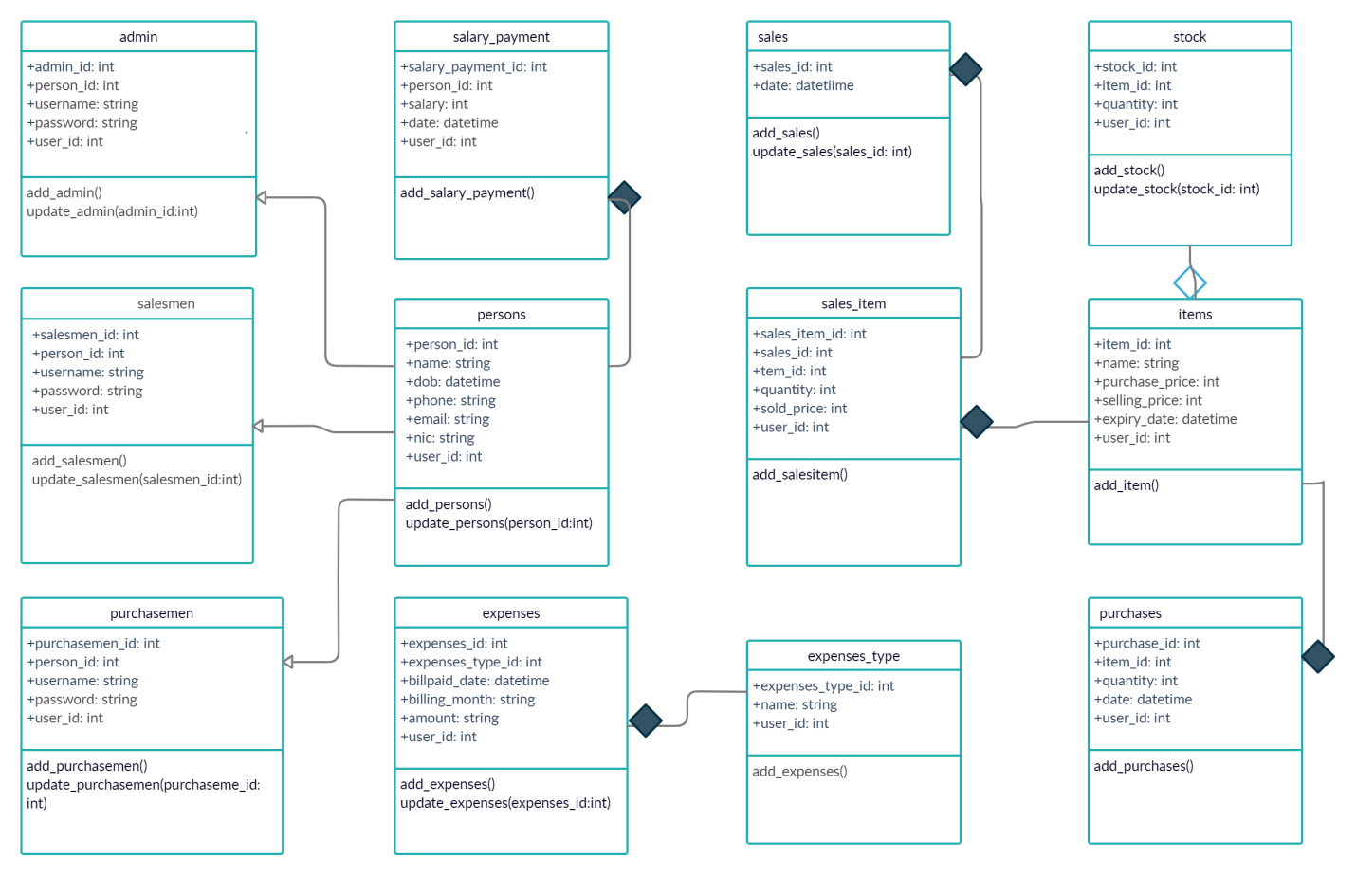

### Usecase

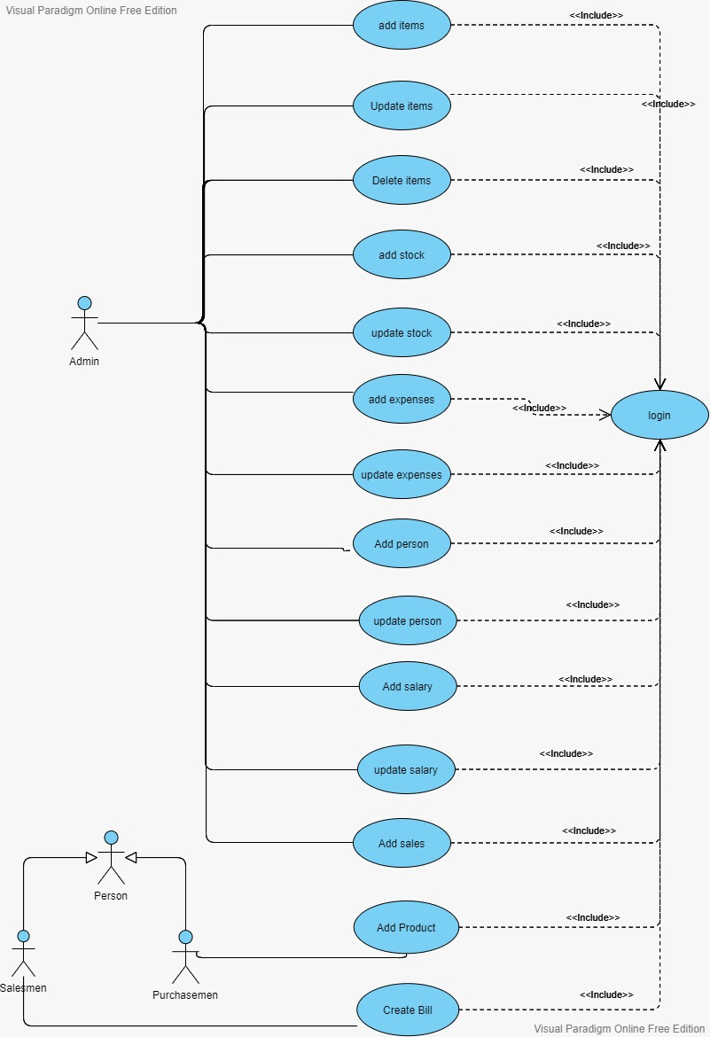

### State Chart

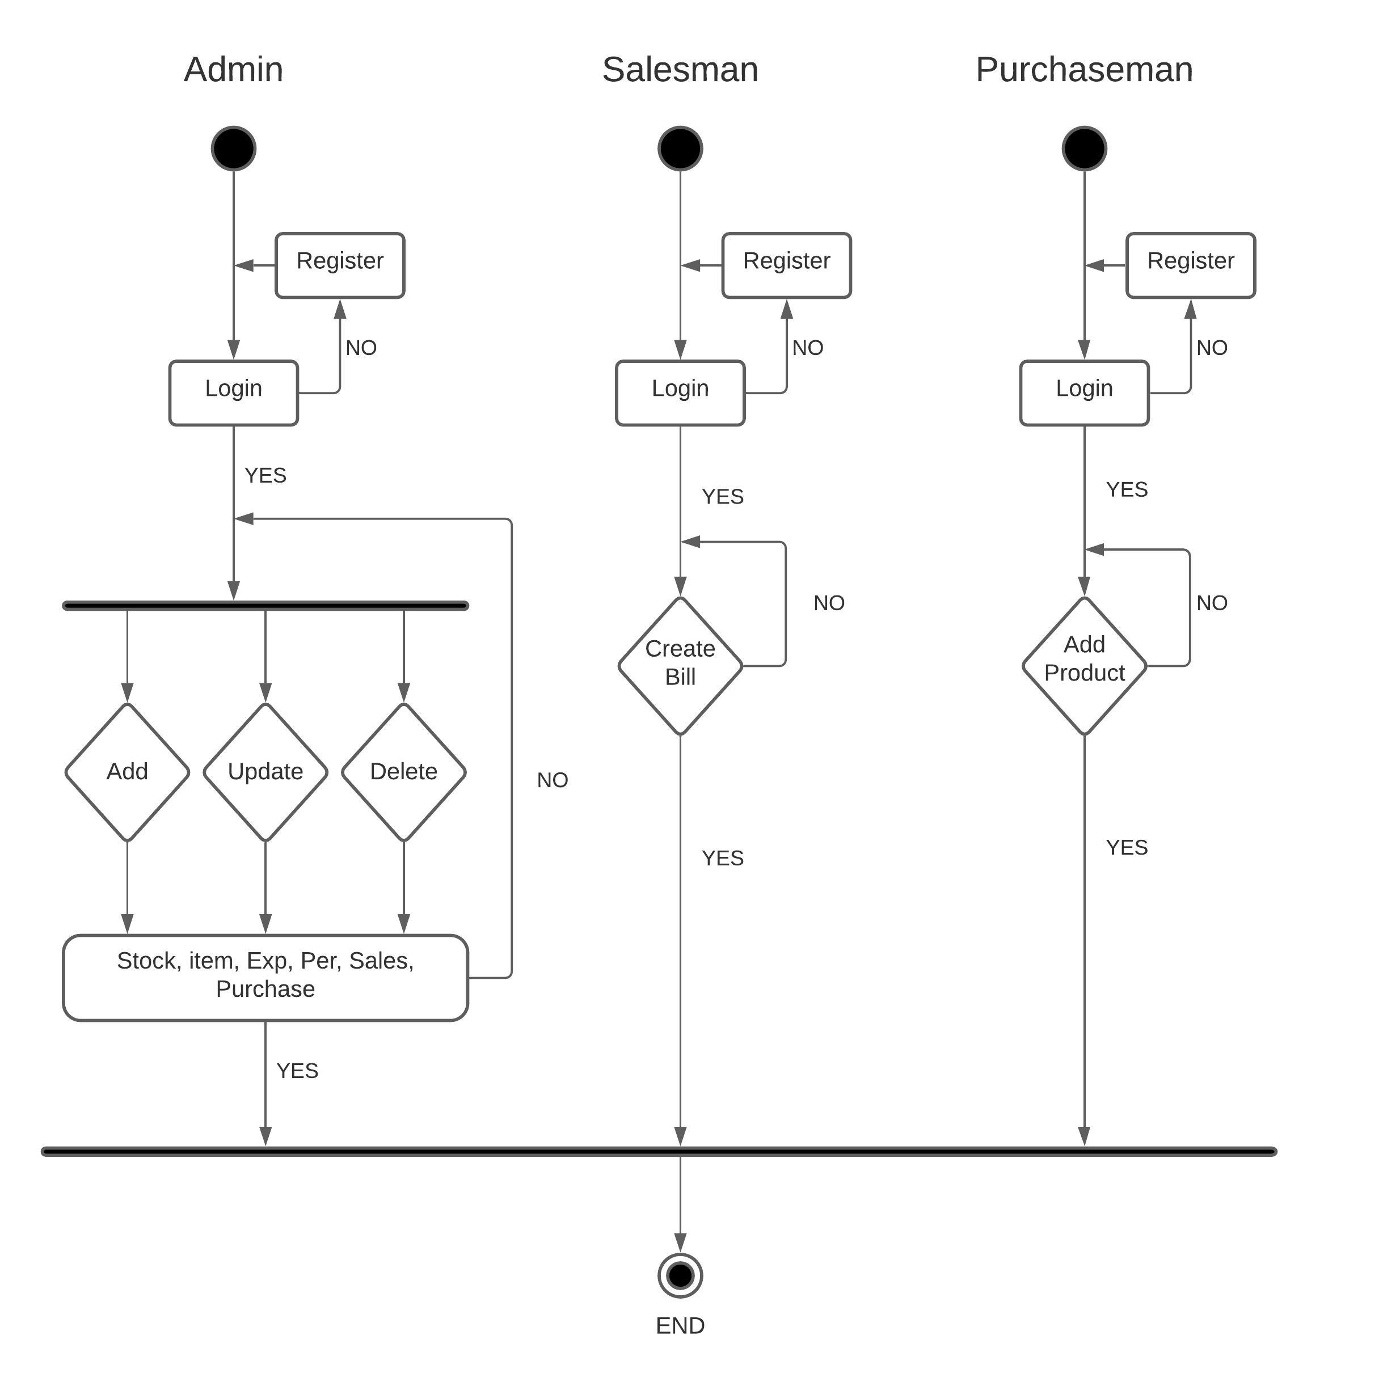

# Specific Requirements:

## Functional Requirements

### Log In Function

***Description:*** This function ensures that only authorized users gain access to the Reservation databases. An authorized user is a user who has an account on the system. Users include admin, salesman and purchaseman. The user must type a valid username and password to gain access.

1. ***Usage Scenario/ Use case Description/******Specification:***

|  |  |
| --- | --- |
| Description | Allows access to nova mart |
| Inputs | Username, password |
| Source | * User inputs username and password * Press Login Button |
| Alternate case |  |
| Outputs | Successful login; unsuccessful login |
| Destination | None |
| Precondition | Authorized User |
| Post Condition | No change to Passenger Accounts Database |
| Side Effects | Failures and successful logins are sent to Reservation Database |

### System controlling and manage products

***Description:*** this module is made to control each and every function in this application. Admin can handle this module to make sure that application can run smoothly. Admin can visit all features in this application and can [ insert , update, delete ] persons ,Items, stock , salary and view purchases, sales etc

1. ***Usage Scenario/ Use case Description/******Specification:***

|  |  |
| --- | --- |
| Description | Handle all functionalities of the application |
| Inputs | Persons, items, stock, salaries |
| Source | * Item name, quantity, date * Press add Button to add item in list |
| Alternate case |  |
| Outputs | Continuously running system and manage production |
| Destination | None |
| Precondition | Authorized User , admin can’t enter without login |
| Post Condition | Make changes in database after [add delete update ] persons, items, stock ,salaries etc |
| Side Effects | Without this module it is impossible to run the application |

### Purchasing functions

***Description:*** this module is made for purchase man who can add items in their list for purchasing. As we are working on the mart application purchase man play major role after purchases bill will be generated through sales man module.

1. ***Usage Scenario/ Use case Description/******Specification:***

|  |  |
| --- | --- |
| Description | Purchase man can login and add items that he/she wants to purchase for billing process. |
| Inputs | Item name, quantity, date |
| Source | * Item name, quantity, date * Press add Button to add item in list |
| Alternate case |  |
| Outputs | Successfully item added |
| Destination | None |
| Precondition | Authorized User |
| Post Condition | Changes in purchases table of database |
| Side Effects | No bill will be created if purchase man fails to add item in their account and no bill will be generate if sales man cancel the order |

### Billing function

***Description:*** This module is for that users who want to sale items to the purchase men and they create bills for purchase man’s selected products. And delete if product is not available.

1. ***Usage Scenario/ Use case Description/******Specification:***

|  |  |
| --- | --- |
| Description | Create bills for purchasemen and add products |
| Inputs | Item, selling price, quantity |
| Source | * Inputs Item, selling price, quantity * Press add Button * Press delete button for delete receipt |
| Alternate case |  |
| Outputs | Successful bill created |
| Destination | None |
| Precondition | Authorized User, purchase man purchase item |
| Post Condition | Changes in sales table of database |
| Side Effects | No bill will be created if purchase man fails to add item in their account |

### Data Validation & Integrity(Database)

**Description:** Every field will be containing data validation and verification along with data integrity to make sure the application is error and bug free. Every data will be recorded in database according to every module. Validation of every data is describe in database through constraints

1. ***Usage Scenario/ Use case Description/******Specification:***

|  |  |
| --- | --- |
| Description | This module is describing database functionalities |
| Inputs | Users data |
| Source | * Inputs data in fields in every form like persons information,password,username Item, selling price, quantity, date etc * Press buttons to proceed |
| Alternate case |  |
| Outputs | Successfully data entered in database |
| Destination | SQL server |
| Precondition | Connection with SQL for validation, correct data types |
| Post Condition | Changes in database |
| Side Effects | Without this module our application will not performed well there may chances of bugs and application crash |

## User Interfaces

This is a windows based application. The GUI will be user friendly. The admin will be able to view, search, add, delete, update items, persons, sales, purchases, employees, expenses etc. admin can view total sales and purchases graphically as well as in tabular form.

Salesmen can create bill for customer using its interface easily.

## Hardware Interfaces

The minimum hardware requirements are as follows:

* RAM: 1 GB
* Processor: Core2duo (2.0ghz)
* HDD: 10 GB
* Network: Ethernet or WIFI
* OS: Windows 7 or above

## Software Interfaces

* Database: MS SQL Server
* Application: Visual Studio

## Communications Interfaces

No internet is required to use the application.

# Other Nonfunctional Requirements

## Performance Requirements

If the application is supported with all the hardware and software requirements mentions above then the performance will up to mark without any error.

## Safety Requirements

At any time, the software can be stuck. Therefore, data integrity will be added along with some data backups by making database replications.

## Security Requirements

The required software will be as windows base application along with SQL server therefore the application will be protected by utilizing OOP concepts such as encapsulation and abstraction.

## Software Quality Attributes

The software will be easy to use so there would be no such manual or need of any help. The interfaces will be user friendly.