DATABASE COURSE
PROJECT REPORT

Lost & Found Management System
Database Design, Access Control, Optimization & Backup

TEAM MEMBERS
Nhean Omra
Ngoun Sovichet
Lim Vinchay

Database Systems
2026

1. Introduction
This report documents the database design and administration work carried out for Lost&Found, a web-based Lost and Found Management System. The system allows students and staff to report lost or found items, browse and search existing reports, submit ownership claims, and have those claims reviewed and resolved by an administrator.
The database is implemented in MySQL and hosted on Aiven Cloud, a managed database provider. Application code interacts with the database through Sequelize, an Object-Relational Mapper (ORM) for Node.js, which translates JavaScript model definitions and queries into SQL executed against the underlying MySQL instance.
This report covers four areas: the relational schema and entity relationships, user privileges and access control, query optimization, and backup and recovery planning. Each section reflects the actual, current state of the deployed database — including known gaps identified during review — rather than an idealized design.

2. Relational Schema (ERD)
The database consists of four tables: Users, Items, Claims, and Activities. Items is the central entity, referenced by both Claims and Activities through foreign keys. The schema below reflects the exact structure of the live database, exported via mysqldump.

2.1 Entity Overview
- Users — registered accounts, distinguished as regular users or administrators via the isAdmin flag.
- Items — lost or found item reports, the core record in the system.
- Claims — ownership claims submitted against a specific Item, tracked through a pending/approved/denied lifecycle.
- Activities — an audit log of significant actions (item created, claim requested, claim approved/denied) linked back to the relevant Item where applicable.

2.2 Table Definitions
Users
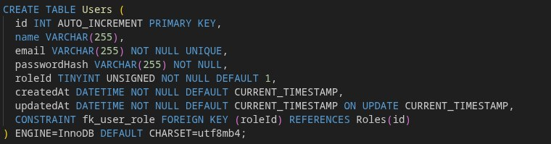
Items
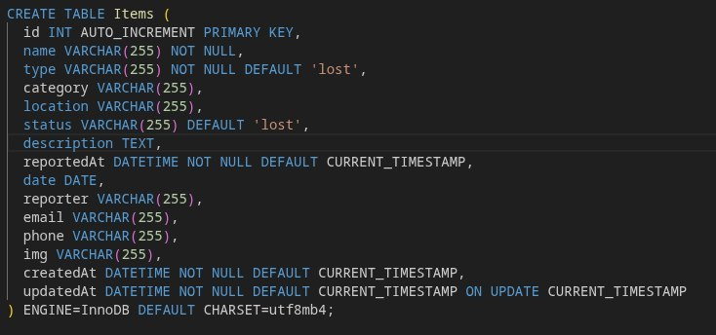

Claims
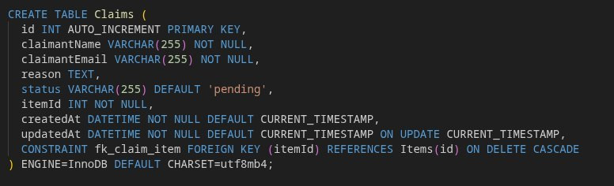

Activities

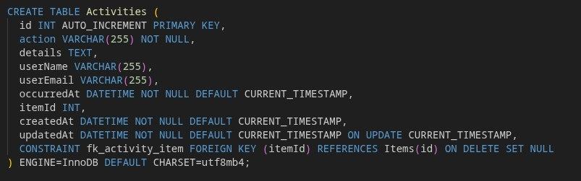

2.3 Relationships
- Items (1) -> Claims (N), ON DELETE CASCADE — deleting an item removes all claims filed against it, since a claim cannot exist without its item.
- Items (1) -> Activities (N), ON DELETE SET NULL — the activity log is preserved even if the referenced item is later deleted, since the log entry still has historical value.
- Users is not currently connected to Items or Claims via foreign key. Reporter and claimant identity are stored as free-text name/email fields rather than a userId reference.

2.4 Design Note: Missing Users Relationship
The absence of a foreign key between Users and Items/Claims is a known limitation of the current schema. It allows reporting and claiming without requiring the reporter or claimant to correspond to a row in the Users table, meaning the database itself cannot guarantee that a claimant is a registered, authenticated user. This was a simplification made during initial development and is identified as a priority improvement: adding userId foreign keys to both Items and Claims would allow the database to enforce referential integrity between actions and accounts, and would also allow features such as "my reported items" or "my claims" to be implemented as simple joins rather than email-string matching.

3. User Privileges & Access Control

3.1 Current Implementation (Application Level)
Access control in Lost&Found is currently enforced entirely at the application layer, not the database layer. Each row in the Users table has an isAdmin flag (0 or 1). Express middleware checks this flag on protected routes before allowing a request to proceed.
// middleware/isAdmin.js
module.exports = (req, res, next) => {
if (req.user?.role !== 'admin') {
return res.status(403).json({ message: 'Admin access required' });
}
next();
};

Regular users (isAdmin = 0) can report items, browse and search, and submit claims. Administrators (isAdmin = 1) can additionally review pending claims, approve or reject them, and view the full activity log.

3.2 Known Gap: Plaintext Passwords
Review of the live database revealed that passwords are currently stored in plaintext in the passwordHash column (for example, values such as 'test123' and '1234' appear directly in the Users table). The column name implies that hashing was intended, but this has not yet been implemented. This is a significant security gap: if the database were ever exposed, every user's plaintext password would be immediately readable. The recommended fix is to hash all passwords with bcrypt before storage, and to hash the existing plaintext values in a one-time migration before the system is used with real user data.

3.3 Recommended Database-Level Access Control
In addition to application-level checks, database-level privilege separation is recommended so that even a compromised application server does not have unrestricted access to the database. Rather than connecting to MySQL with a single account that has full privileges, the application and any administrative tooling should use separate MySQL accounts scoped to only the privileges they need (the principle of least privilege).
-- Application account: least privilege, no DDL rights
CREATE USER 'lostfound_app'@'%' IDENTIFIED BY 'strong_app_password';
GRANT SELECT, INSERT, UPDATE ON lostandfound.Items TO 'lostfound_app'@'%';
GRANT SELECT, INSERT, UPDATE ON lostandfound.Claims TO 'lostfound_app'@'%';
GRANT SELECT, INSERT ON lostandfound.Activities TO 'lostfound_app'@'%';

-- Administrative account: full privileges, used only for maintenance
CREATE USER 'lostfound_admin'@'%' IDENTIFIED BY 'strong_admin_password';
GRANT ALL PRIVILEGES ON lostandfound.* TO 'lostfound_admin'@'%';

FLUSH PRIVILEGES;

4. Query Optimization

4.1 Frequent Query Patterns
Three query patterns account for the majority of database load in normal use of the application:
- The Browse page filters items by status and, optionally, category.
- The Admin dashboard fetches all claims where status = 'pending'.
- The Item detail view looks up all claims associated with a specific itemId.
None of the columns used in these WHERE clauses — Items.status, Items.category, or Claims.status — currently have an index beyond the primary and foreign keys already present on the tables.

4.2 Impact and Justification
At the current data volume (17 rows in Items, 8 rows in Claims), the absence of these indexes has no measurable performance impact, since MySQL can scan the entire table in a fraction of a millisecond. However, without an index, every Browse page load or Admin dashboard refresh requires a full table scan, an approach that does not scale as the number of items and claims grows across future semesters of use. Adding indexes now is a low-cost, low-risk change that prevents this from becoming a real performance problem later.

4.3 Recommended Indexes
CREATE INDEX idx_items_status ON Items (status);
CREATE INDEX idx_items_category ON Items (category);
CREATE INDEX idx_claims_status ON Claims (status);

These can be verified using MySQL's EXPLAIN statement, which shows the access method MySQL selects for a given query:
EXPLAIN SELECT * FROM Claims WHERE status = 'pending';
-- Before adding the index: type = ALL (full table scan)
-- After adding the index: type = ref (indexed lookup)

A type of ALL indicates MySQL must examine every row in the table to find matches; a type of ref indicates MySQL can use the index to jump directly to matching rows, which is substantially faster as table size increases.

5. Backup & Recovery

5.1 Infrastructure-Level Backups (Aiven)
The database is hosted on Aiven Cloud, which provides automatic backups as a managed service feature rather than something the team configures manually. Aiven performs a full backup of the database daily, combined with continuous binary log (binlog) recording. Together, these allow point-in-time recovery (PITR) — restoring the database to any specific moment, not just to the time of the most recent daily snapshot.
These backups are encrypted and stored in the object storage of the cloud region where the service was created. They are not directly downloadable by the team; restoration is performed through Aiven's own tooling rather than by manually retrieving a backup file. The exact retention window (how far back a point-in-time restore can go) depends on the specific Aiven service plan in use.

5.2 Manual Backups (mysqldump)
In addition to Aiven's automatic backups, the team performs manual logical backups using mysqldump. This produces a portable .sql file containing both the schema (CREATE TABLE statements) and the current data (INSERT statements) for all four tables. Unlike Aiven's managed backups, a mysqldump export can be downloaded, version-controlled, or used to seed a separate local or development database.
-- Taking a manual backup
mysqldump -h [host] -u [user] -p lostandfound > lost_found_backup_$(date +%F).sql

5.3 Recovery Process
Restoring from a manual mysqldump backup is a single command. Because the dump file includes DROP TABLE IF EXISTS statements ahead of each CREATE TABLE, running the restore against an existing database produces a clean, consistent result rather than leaving old and new data mixed together.
-- Restoring from a backup
mysql -h [host] -u [user] -p lostandfound < lost_found_backup.sql
Foreign key checks are disabled during import (via SET FOREIGN_KEY_CHECKS=0 in the dump file) and re-enabled afterward, which means the four tables can be restored without regard to their dependency order — Claims and Activities can be loaded even though they reference Items via foreign key, since the constraint is not enforced mid-import.

5.4 Summary of Backup Strategy
- Primary protection: Aiven's automatic, continuous, encrypted backups with point-in-time recovery, managed at the infrastructure level.
- Secondary protection: manual mysqldump exports taken by the team, used for portability, offline verification, and as evidence of a working, tested restore process.

6. Conclusion
This report documented the current state of the Lost&Found database: a four-table MySQL schema hosted on Aiven Cloud, with clearly defined foreign key relationships between Items, Claims, and Activities. Reviewing the live database directly — rather than only the intended design — surfaced two genuine issues worth addressing before the system is used with real data: passwords are currently stored in plaintext rather than hashed, and no foreign key currently links Users to the Items or Claims they create.
The query optimization review identified three frequently filtered columns (Items.status, Items.category, Claims.status) that are not yet indexed. While this has no visible effect at the current data volume, adding these indexes now is a low-cost improvement that prevents a predictable performance problem as the dataset grows.
Backup and recovery is already handled at two levels: automatically and continuously by Aiven at the infrastructure level, and manually by the team via mysqldump for portability and verification. Both were confirmed functional as part of preparing this report.
Taken together, these findings represent a realistic, self-critical assessment of the database layer: the core relational design is sound, but access control and indexing require concrete follow-up work before the system is ready for production use beyond a course demonstration.

