**National University of Computing and Emerging Sciences, Islamabad**



**INTRODUCTION TO SOFTWARE ENGINEERING SE110**

**INVENTORY MANAGEMENT SYSTEM**

**GROUP MEMBERS:** 22I-8787 Fizza Ali

22I-2549 Mahnoor Hafeez

22I-2412 Mujtaba Khan

22I-1505 Abdul Momin

**DEGREE PROGRAM:** BS (SE)

**SECTION:** A

**SUBMITTED TO:** Dr. Isma Ul Hassan

**SUBMISSION DATE:** 29th March 2023

**Contents:**

**Features Implemented in Sprint 1** 3

**Pages made in Sprint 1** 3

**1.** **Title page** 4

**2.** **User credential pages:** 4

**3.** **Admin Page:** 5

**4.** **Employee page:** 6

**5.** **Monthly report page:** 6

**6.** **Order Page:** 7

**7.** **Search page:** 7

**Github** 8

**Trello:** 8

**Snapshot 1** 8

**Snapshot 2** 9

**Snapshot 3** 9

**Snapshot 4** 10

**Sprint Burndown Chart** 11

**Work Distribution** 12

**Mujtaba Khan (Scrum Master)** 12

**Mahnoor Hafeez (Team Member)** 13

**Fizza Ali (Team Member)** 13

**Abdul Momin (Team Member)** 13

**Planning of Sprint 2:** 13

**1.** **Search** 13

**2.** **Automatically Reordering** 13

**3.** **Employee track only shown to admin** 14

**4.** **Password reset** 14

**5. Payment details** 14

**6. Feedback** 14

**7. Expiry date of product** 15

# **Features Implemented in Sprint 1**

The features that we have implemented in sprint 1 are:

* Login/ Sign-up
* Search
* Order
* Quantity increment/decrement
* Stock monitoring
* Monthly report
* Employee record

# **Pages made in Sprint 1**

The pages we have made using figma are:

* Title page
* User credentials page
* Admin page
* Employee page
* Monthly report page
* Order page
* Search page

## **Title page**

It displays the main page of our inventory system “Invensys” and login and sign up buttons.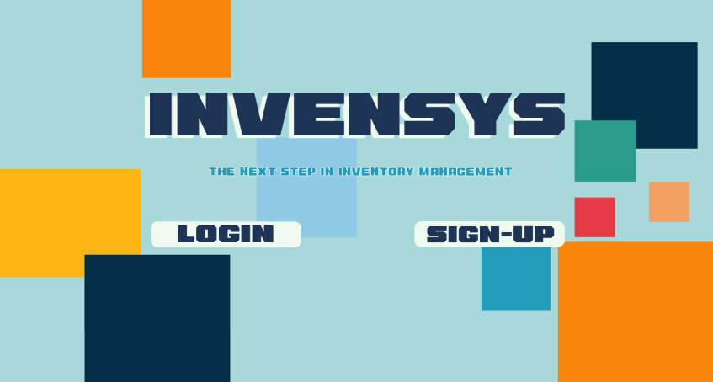

## **User credential pages:**

It displays login and sign up pages. In login page a user can login his account by entering username and password. In sign-up page a new user has to register for account on Invensys.

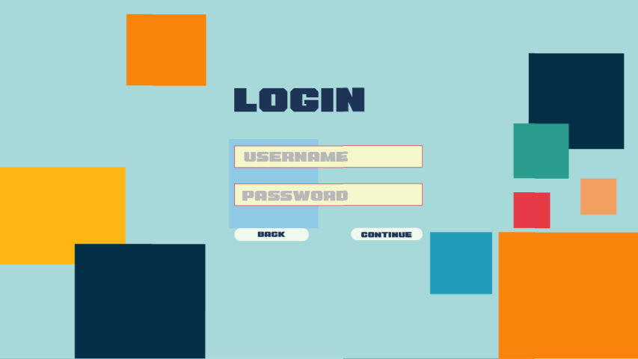

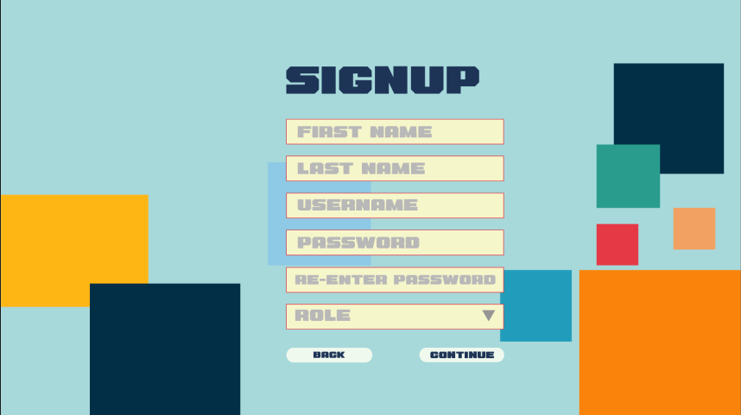

## **Admin Page:**

It is a page that can be accessed by admin only. It displays different categories such as board, stock monitoring, sales, orders and employees. Firstly board is viewed in which revenue, sales return, purchase and income is shown for the inventory system. It displays the topselling products and its chart.

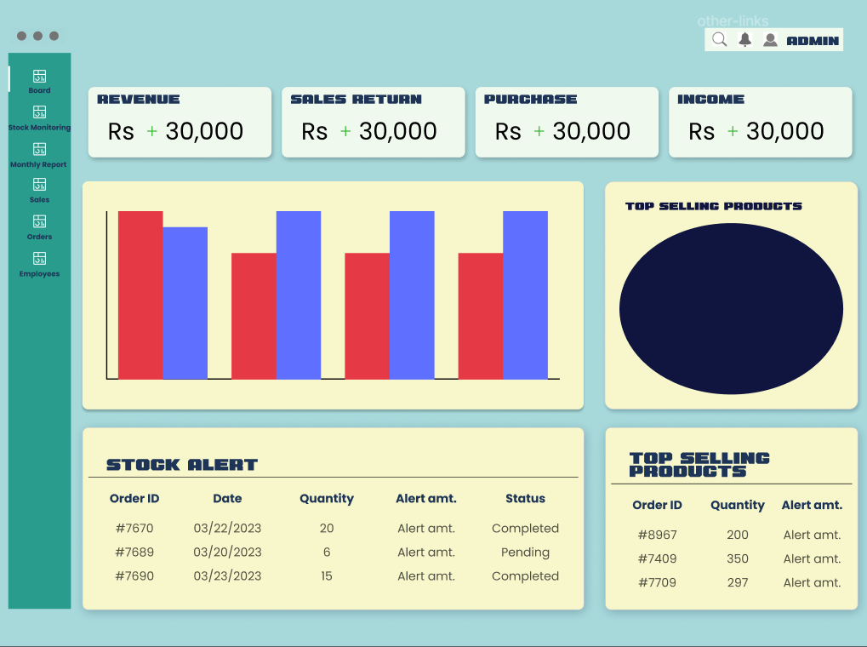

## **Employee page:**

It stores employees’ personal data such as name, email, age etc.

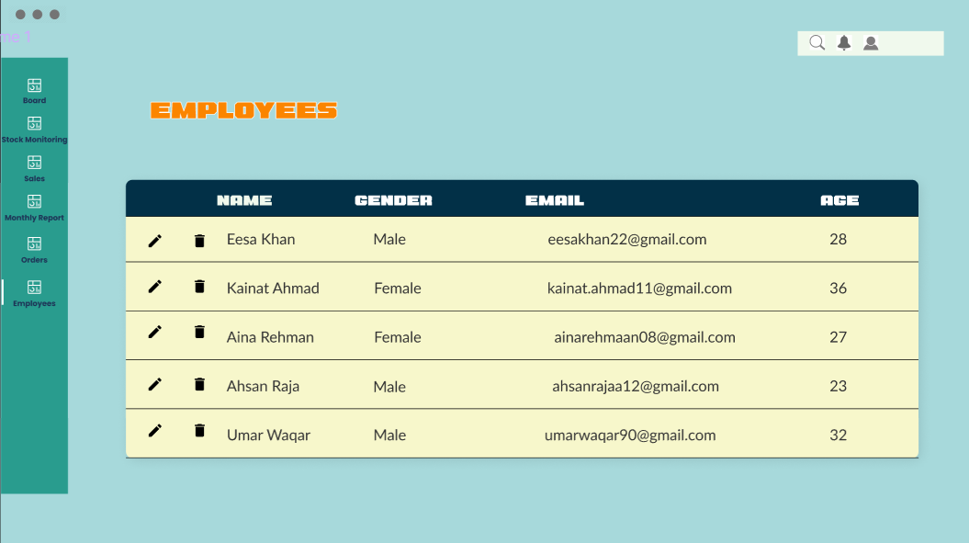

## **Monthly report page:**

In this page the monthly report regarding income and profit is displayed so that better finances can be planned for next month.

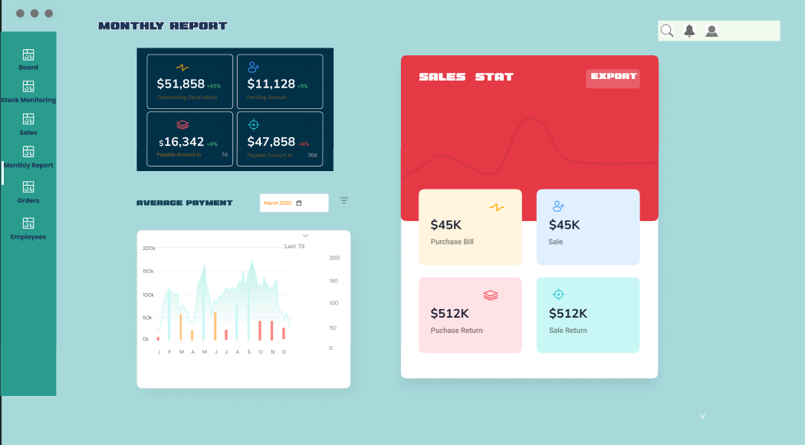

## **Order Page:**

It displays the orders and their details received by various employees. We can also view the sales and status for the product and filter that.

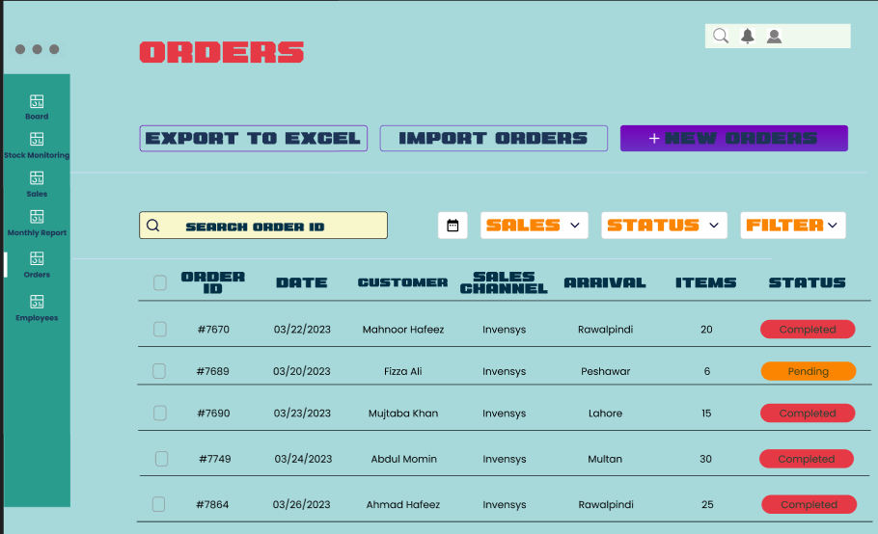

## **Search page:**

In search page, we can search any product we want and then details and dates regarding that specific product can be seen. We can also view the search history.

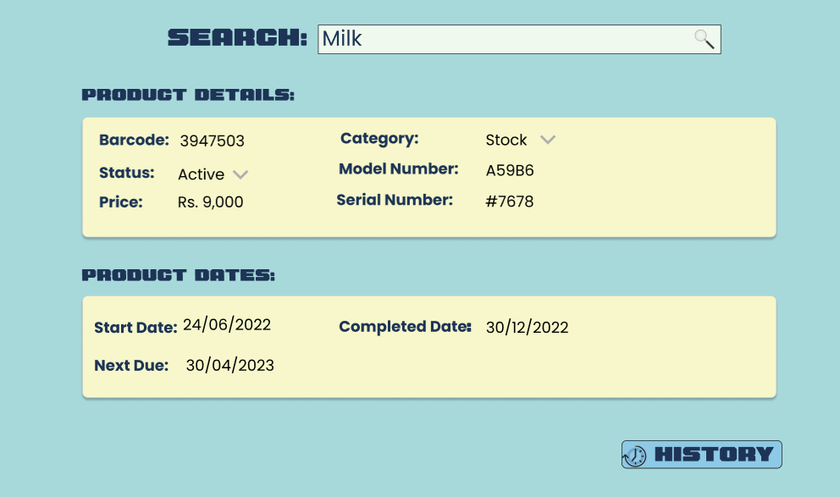

# **Github**

Click here to go to our: [Github repository](https://github.com/fizza8787/Invensys)

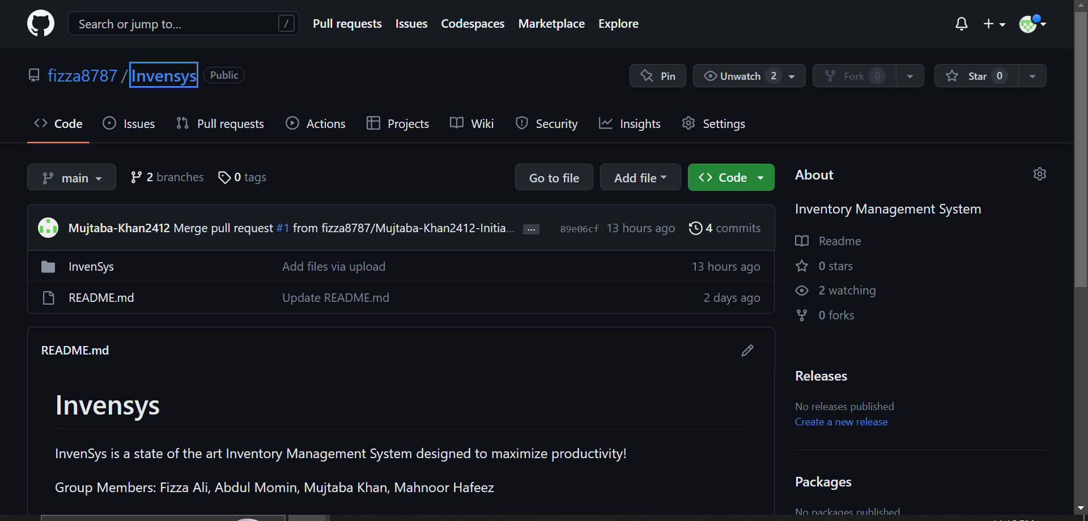

# **Trello:**

## **Snapshot 1**

It displays the product backlog and sprint backlog.

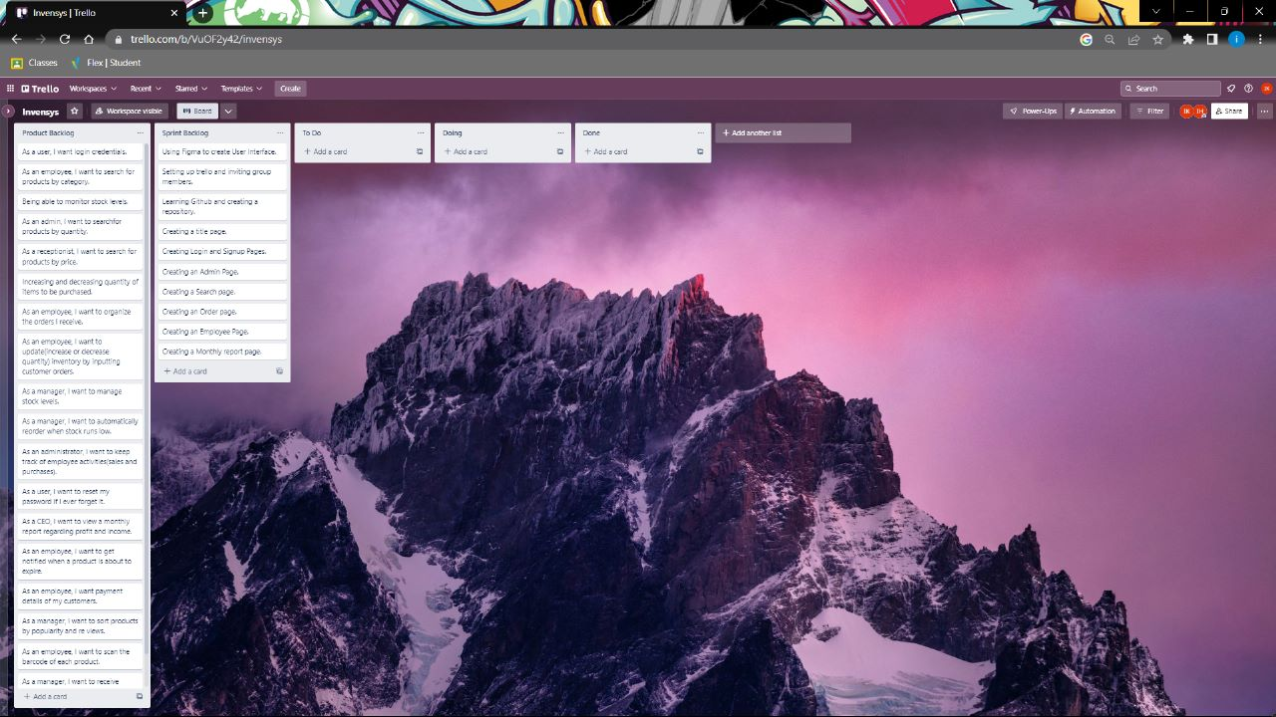

## **Snapshot 2**

It displays the cards designed in the start of sprint 1.

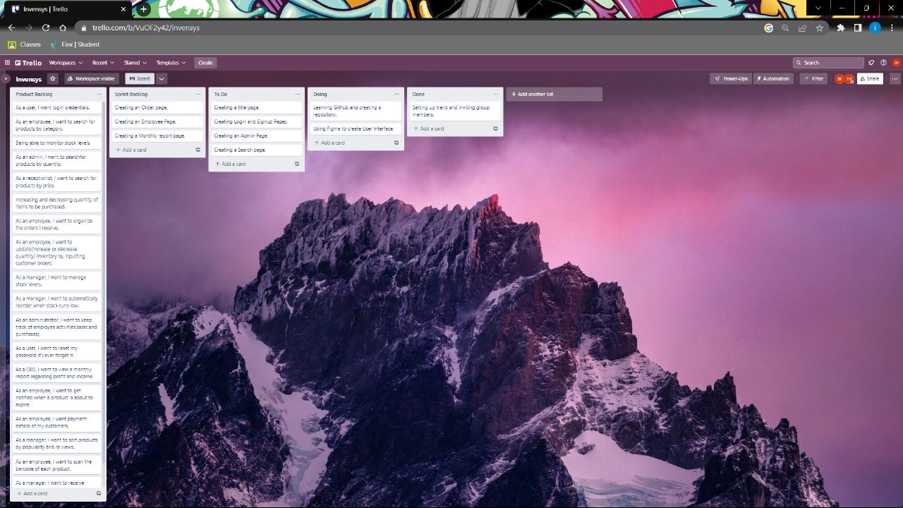

## **Snapshot 3**

It displays that all tasks for sprint 2 have been completed.

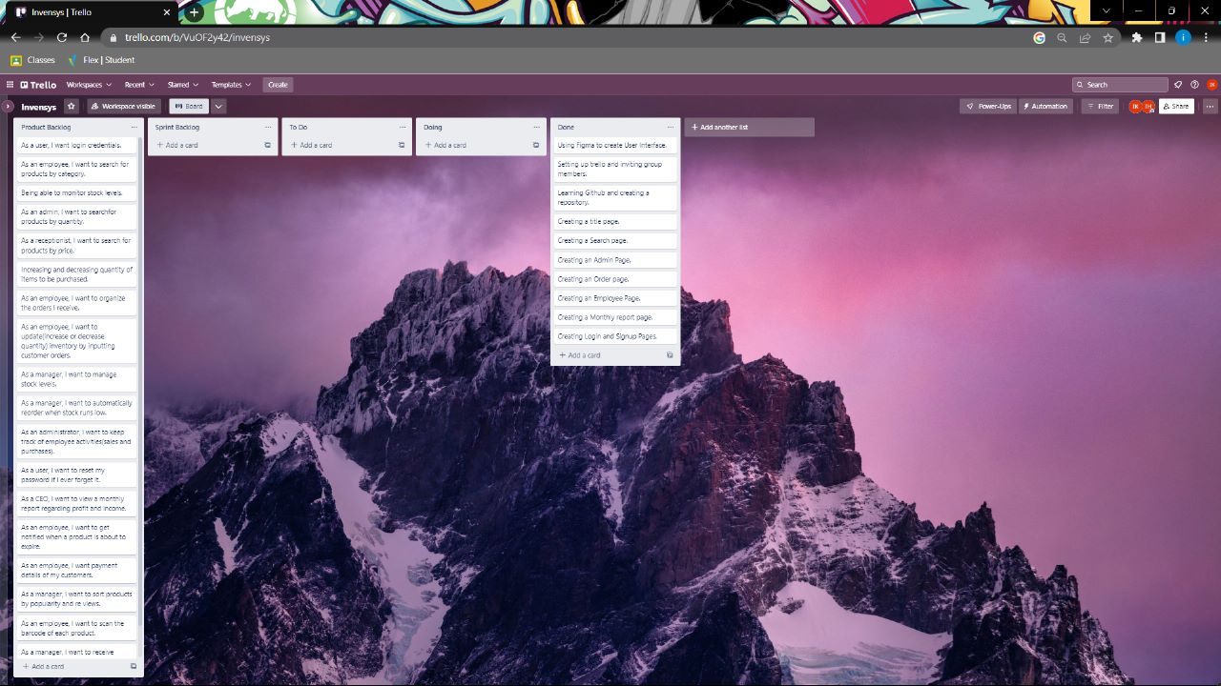

## **Snapshot 4**

It displays the activities performed by scrum master.

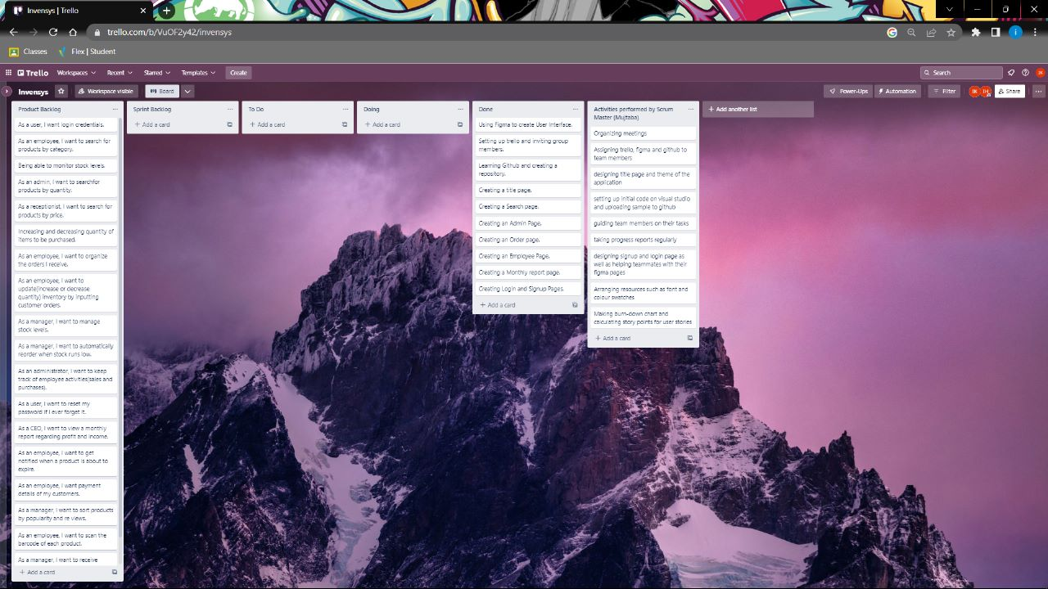

# **Sprint Burndown Chart**

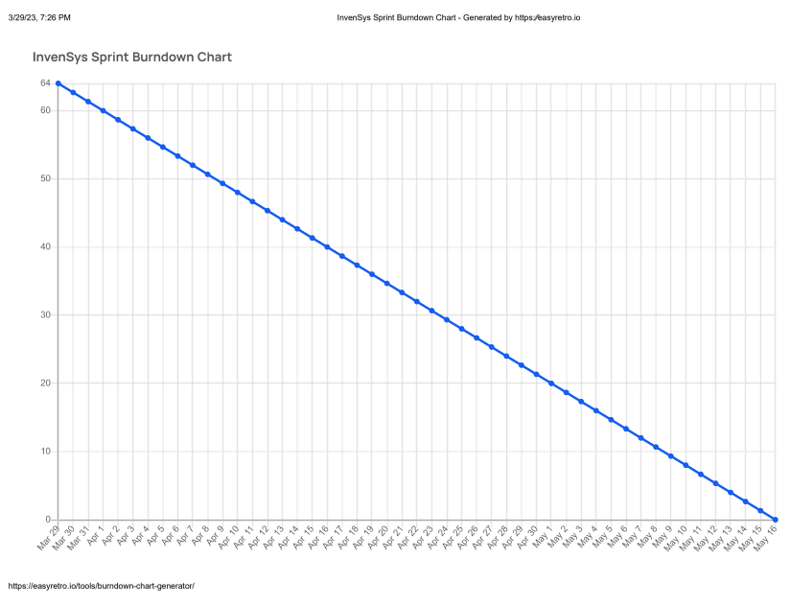

|  |  |
| --- | --- |
| Story Points  (Fibonacci) | User Story |
| 1 | * As a user I want my login credentials so that I can login my account in different devices in a secure way. |
| 2 | * As an employee I want a user interface that is easy to understand. * As a user I want to get back into my account if I ever forget my password so that I do not lose my job. |
| 3 | * As an employee I want to be able to search for products by category so that I can assist customers faster. * I want to view monthly reports regarding the income and profit so that I can plan my finances better for the next month. * As a user * I want to be notified when a product goes past its expiration date |
| 5 | * As a customer I want to add the products to the cart that I want to buy so that I can continue my shopping and it will not affect the previously selected items. * As a manager I want to automatically reorder items from the manufacturers when inventory runs low. |
| 8 | * As a manager I want to monitor the inflow and outflow of inventory so that I can prevent wastage of company resources. * As an administrator I want to keep track of employee activities such as their sales and purchases. * As a manager I want to sort products by popularity/reviews. |
| 13 | * As a customer I want to be able to pay through Google or Apple account or Sadapay/Nayapay. |
| Total Points | 1+2+2+3+3+3+3+5+5+8+8+8+13=64 |

# **Work Distribution**

## **Mujtaba Khan (Scrum Master)**

* Guided everyone how to use figma.
* Assigned tasks for team members.
* Designed theme of the UI.
* Designed main page, user credential pages
* Pulled code in Github
* Made sprint burndown chart

## **Mahnoor Hafeez (Team Member)**

* Created Trello account and invited other team members
* Managed all work related to Trello
* Designed order page and employee page on figma
* Designed monthly report page on figma

## **Fizza Ali (Team Member)**

* Created Github account and invited other group members
* Created repository in Github
* Designed admin page, search page on figma
* Compiled the video

## **Abdul Momin (Team Member)**

* Suggested pages for sprint 1
* Designed employee page on figma
* Planned meetings

# **Planning of Sprint 2:**

# **Modules for Sprint 2**

* Search
* Automatically reordering
* Employee track
* Password reset
* Payment details
* Feedback
* Expiry date of product

# **User Stories**

## **Search**

|  |
| --- |
| **User Story:**  As an employee  I want to be able to search for products by category  So that I can assist customers faster. |

|  |
| --- |
| **User Story:**  As a receptionist  I want to search for products by price  So that I can provide the best fit for my customer's budget. |

|  |
| --- |
| **User Story:**  As a manager  I want to search for products by quantity  So that I know which ones to reorder and when. |

## **Automatically reordering**

|  |
| --- |
| **User Story:**  As a manager  I want to automatically reorder items from the manufacturers when inventory runs low  So that time is not wasted on repeatedly doing the same task manually. |

## **Employee track**

|  |
| --- |
| **User Story:**  As an admin  I want to see the track for employees  So that I can ensure that the items are being delivered in right place without any other person’s involvement. |

## **Password reset**

|  |
| --- |
| **User Story:**  As a user  I want to get back into my account if I ever forget my password  So that I do not lose my job. |

## **5.** **Payment details**

|  |
| --- |
| **User Story:**  As a customer  I want to be able to pay by credit card  So that when I don’t have cash I can still go shopping |

|  |
| --- |
| **User Story:**  As a customer  I want to be able to pay through Google or Apple account or sadapay/Nayapay  So that if I forget my wallet at home i can still get groceries. |

## **6. Feedback**

|  |
| --- |
| **User Story:**  As a manager  I want to ask customers for their feedback  So that I would know how do they feel about our service |

## **7. Expiry date of product**

|  |
| --- |
| **User Story:**  As a manager  I want to get notified whenever any product gets expired  So that I would remove it from the selling items |

# **Tasks and their Estimates**