NADRA NAVIGATOR
SYSTEM DESIGN & ARCHITECTURE SPECIFICATION
AI-Powered Public Service Guidance System | DITE Hackathon 2026-27 Edition
Theme: Public Service | Duration: 5 Hours | Team Size: 3 Members
Target Platform | Responsive Web Application (React 18 + FastAPI + Gemini AI)
Hackathon | DITE Hackathon 2026-27 (Denning Institute of Tech & Entrepreneurship)
Target Domain | Public Service (NADRA Citizen Guidance & Application Simplifier)
Authoring & Date | NADRA Navigator Engineering Team — October 2026

1. Executive Summary & Problem Statement
NADRA Navigator is an intelligent web-based citizen guidance engine engineered to solve one of the most ubiquitous pain points in Pakistan's public service ecosystem: navigating National Database and Registration Authority (NADRA) services. Millions of citizens annually experience delayed applications, unnecessary multiple center visits, and rejection due to obscure requirements, confusing government terminology, and lack of personalized preparation.
Unlike generic conversational chatbots prone to hallucinations, NADRA Navigator combines semantic natural-language reasoning (supporting English, Urdu, and Roman Urdu) with a deterministic, verified rules engine. The platform translates ambiguous citizen dilemmas into structured, actionable visual journeys, dynamic document checklists, proactive form validation ('Form Doctor'), center queue intelligence, and rejection translation.
[DATA PRIVACY & LEGAL COMPLIANCE] The system is designed purely as an informational and preparation guide. In strict compliance with PECA (Prevention of Electronic Crimes Act) and DITE Hackathon ethics, the application NEVER stores or requests real citizen biometric data, raw CNIC numbers, or private identity records. All tracking and forms use synthetic demo datasets modeled after official rules.

2. 3-Person Team Allocation & Feature Division
To maximize output within the strict 5-hour hackathon window, the system's 6 core features are strictly divided into pairs across three engineering leads. This creates clear code boundaries and independent REST interfaces, eliminating merge bottlenecks.
Team Member | Assigned Features | Core Technical Domain | Deliverables
Member 1:  AI & Discovery Lead | • Feature 1: AI Case Resolver  • Feature 2: Dynamic Document Checklist | NLP Intent Classification, Multilingual Prompt Engineering, Pydantic Structured Output | POST /api/resolve-case  POST /api/checklist  Query Intake & Checklist UI
Member 2:  Interactive & Form Lead | • Feature 3: CNIC Journey Simulator  • Feature 4: Government Form Doctor | State Machine Visualizer, Regex & Cross-field Validation Engine, Bottleneck Badging | GET /api/journey/simulate  POST /api/form-doctor/validate  Animated Stepper & Review Panel
Member 3:  Operations & Tracking Lead | • Feature 5: Queue & Center Assistant  • Feature 6: Tracker & Rejection Explainer | Geographic Directory, Congestion Heuristics, Mock Tracking Pipeline, Vercel/Render Deploy | GET /api/centers  GET /api/track/{id}  POST /api/explain-rejection  Live Cloud Deployment

3. System Architecture & Component Interaction
The NADRA Navigator architecture follows a modern decoupled Client-Server model with a dedicated AI Reasoning Layer and an immutable Verified Knowledge Base. The diagram below illustrates the complete component topology:
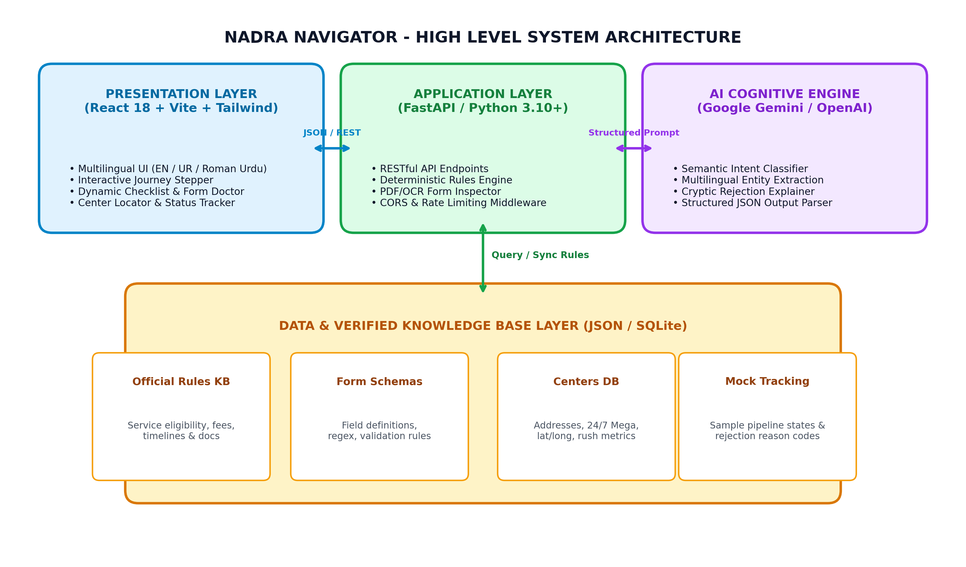
Figure 1: High-Level System Architecture of NADRA Navigator

3.1 Architectural Layers Breakdown
Presentation Layer (Frontend): Built using React 18, Vite, and Tailwind CSS. Employs Lucide icons, responsive flex/grid layouts, and state stores for managing current citizen context. Features dual English/Urdu script toggle and offline-tolerant state caching.
API Gateway & Application Layer (FastAPI): High-performance Python asynchronous server. Exposes structured OpenAPI-compliant REST endpoints. Houses deterministic validation routines, routing logic, and Pydantic data schemas.
Cognitive AI Layer (LLM Pipeline): Powered by Google Gemini 1.5/2.0 Flash (with OpenAI fallback). Utilizes strict system instructions and JSON Schema enforcement (`response_mime_type='application/json'`) to eliminate hallucinations and extract structured intent from Urdu/Roman Urdu queries.
Knowledge Base & Persistence Layer: Lightweight, read-optimized JSON/SQLite repository containing official NADRA service regulations, center operating hours, form template rules, and mock tracking records.

4. Entity-Relationship Model (ERD) & Data Schema
The data model is optimized for rapid relational querying, procedural integrity, and zero persistence of sensitive citizen data. Below is the formal Entity-Relationship Diagram:
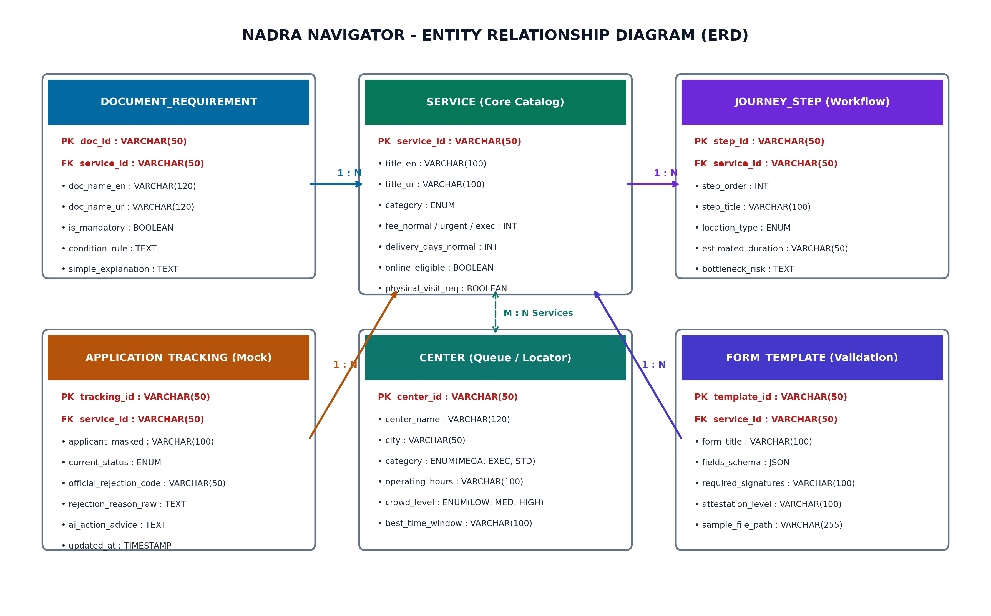
Figure 2: Formal Entity-Relationship Diagram (ERD) of Knowledge Base Entities

4.1 Data Dictionary & Table Definitions

Table: SERVICE (Core Service Catalog)
Attribute Name | Data Type | Functional Description
service_id (PK) | VARCHAR(50) | Unique slug (e.g., 'first_time_cnic', 'cnic_renewal', 'cnic_modification')
title_en / title_ur | VARCHAR(120) | Official bilingual service titles in English and Nastaliq Urdu
category | VARCHAR(50) | Classification: IDENTITY_CARD | CHILD_REGISTRATION | FAMILY_RECORD
fee_normal / urgent / exec | INTEGER | Official government statutory fees in PKR (e.g. 750 / 1500 / 2500)
delivery_days_normal / urgent / exec | INTEGER | Standard fulfillment turnaround days (e.g. 30 / 15 / 7 days)
online_eligible | BOOLEAN | True if service can be completed via Pak-ID portal without visiting center
physical_visit_req | BOOLEAN | True if physical biometrics/attestation requires in-person presence

Table: DOCUMENT_REQUIREMENT (Procedural Rules)
Attribute Name | Data Type | Functional Description
doc_id (PK) | VARCHAR(50) | Unique document rule identifier (e.g. 'doc_parent_cnic')
service_id (FK) | VARCHAR(50) | Foreign key referencing target service
doc_name_en / doc_name_ur | VARCHAR(120) | Bilingual official document names
is_mandatory | BOOLEAN | Whether the document is strictly required by NADRA regulations
condition_rule | TEXT | Expression determining requirement (e.g. 'applicant_age < 18', 'status == MARRIED')
simple_explanation | TEXT | Plain-language explanation simplifying legal terms for citizens

Table: APPLICATION_TRACKING (Mock Status & Rejection Knowledge)
Attribute Name | Data Type | Functional Description
tracking_id (PK) | VARCHAR(50) | Application reference token (e.g. 'TRK-9901', 'TRK-9902')
service_id (FK) | VARCHAR(50) | Associated NADRA service
current_status | VARCHAR(50) | State: SUBMITTED | IN_VERIFICATION | READY_FOR_PICKUP | REJECTED
official_rejection_code | VARCHAR(50) | Cryptic NADRA internal error code (e.g. 'BIO-FAIL-R14')
rejection_reason_raw | TEXT | Formal government rejection remark
ai_action_advice | TEXT | AI-translated plain Urdu/English instructions explaining resolution steps

5. RESTful API Contract & Data Exchange Specifications
All backend communications are governed by strict Pydantic models. Below are the key payload specifications for the core endpoints:

POST /api/v1/resolve-case
Classifies raw citizen queries (Urdu/Roman Urdu/English) into verified NADRA service metadata.
// Request Body
{
"query": "Meri CNIC pe father ka naam ghalat hai aur meri shaadi ho chuki hai",
"language": "roman_urdu"
}
// Response (200 OK)
{
"status": "success",
"identified_service": "cnic_modification",
"service_title": "CNIC Modification / Correction",
"confidence": 0.98,
"extracted_entities": {
"correction_type": "father_name",
"marital_status": "married",
"requires_nikahnama": true
},
"recommended_action": "Apply for Modification under Marital Status & Parental Correction.",
"in_person_required": true
}

POST /api/v1/form-doctor/validate
Executes static heuristic and cross-field checks against user-filled application fields.
// Request Body
{
"service_id": "cnic_modification",
"fields": {
"applicant_cnic": "42101-1234567-1",
"marital_status": "Married",
"spouse_cnic": "",
"father_cnic": "42101-7654321-3"
}
}
// Response (200 OK)
{
"is_valid": false,
"critical_errors": [
{
"field": "spouse_cnic",
"severity": "BLOCKER",
"message": "Spouse CNIC is missing while Marital Status is set to Married.",
"ai_urdu_guidance": "Aap ne shaadi shuda muntakhab kiya hai magar shohar/biwi ka CNIC darj nahi kiya."
}
]
}

6. AI Cognitive Pipeline & Prompt Engineering
To guarantee zero hallucination during live judging, the AI layer acts strictly as a semantic classifier and natural-language translator rather than generating procedural steps out of thin air. The model is constrained to choose from verified service slugs and predefined document schemas.
SYSTEM PROMPT ARCHITECTURE (Gemini Structured Classification):
You are the NADRA Navigator Legal Classifier. Your role is to analyze Pakistani citizen dilemmas in English, Urdu, or Roman Urdu and map them to one of four verified NADRA services: 'first_time_cnic', 'cnic_renewal', 'cnic_modification', or 'crc_bform'.
RULES:
1. Never invent or hallucinate statutory requirements outside the provided knowledge base.
2. If the user mentions marriage, father name mismatch, or address change, map to 'cnic_modification'.
3. Extract all explicit and implicit entities (age, marital status, urgency, card loss).
4. Return strictly valid JSON conforming to the CaseResolverSchema.

7. 5-Hour Execution Roadmap & Demo Video Pitch
The DITE Hackathon imposes a hard 5-hour cutoff. The following phased schedule ensures deployment and video recording are completed well before the final buzzer:
Phase / Time | Milestone Activities | Responsible Members
Hour 1  (00:00 - 01:00) | Repository initialization, verified JSON knowledge base compilation, Pydantic schemas, and Vite React boilerplate setup. | Entire Team
Hour 2  (01:00 - 02:00) | Member 1 connects Gemini Case Resolver; Member 2 implements Journey Stepper; Member 3 loads Centers directory & Tracking endpoints. | Parallel Execution
Hour 3  (02:00 - 03:00) | Frontend-backend integration: Form Doctor validation UI, Dynamic Checklist, and Rejection Explainer card. | Parallel Execution
Hour 4  (03:00 - 04:00) | Cloud Deployment: Frontend to Vercel, Backend to Render/Railway. Verification in incognito window across multiple devices. | Member 3 (Lead Deployer)
Hour 5  (04:00 - 05:00) | Screen recording of 3-5 minute demo video, upload to Google Drive (public permissions), README completion, and Google Form submission. | Entire Team

7.1 Recommended 4-Minute Demo Video Pitch Script
0:00 - 0:30 (Hook & Problem): Introduce team and DITE Public Service theme. Explain the problem: over 40% of NADRA visitors face avoidable rejection or repeated visits due to unclear guidelines.
0:30 - 1:30 (Features 1 & 2 Demo): Input raw Roman Urdu dilemma: 'Meri shaadi ho gayi hai aur card pe husband ka naam lagwana hai'. Show AI resolving case to 'cnic_modification' and generating a personalized checklist with missing document alerts.
1:30 - 2:30 (Features 3 & 4 Demo): Display visual Journey Simulator showing token, biometrics, and delivery stages with risk warnings. Switch to Form Doctor, demonstrate automated error flagging for missing spouse CNIC.
2:30 - 3:30 (Features 5 & 6 Demo): Search Hyderabad Mega Center (24/7 hours and rush-hour indicator). Enter rejected tracking token 'TRK-9902' to show AI translating cryptic 'Rule 14 Biometric Mismatch' into clear next steps in Urdu.
3:30 - 4:00 (AI Role & Safety): Highlight dual-engine architecture: AI for semantic parsing, deterministic rules for official policy. Emphasize compliance: zero real citizen PII stored.

