Department of Computer Science & Information Technology
CT-356 — Data Mining
Complex Computing Activity (CCA) Report
Exploratory Data Analysis & Profit Prediction on Walmart Retail Data

Course | CT-356 Data Mining
Course Instructor | Mr. Rohail Qamar
Assessment | Complex Computing Activity (CCA)
CLO | CLO 3 (C6): Design data preprocessing and data mining techniques
Dataset | Walmart Retail Data (8,399 records, 25 features)
Models Used | Random Forest, Logistic Regression
Members | DT-23031 , DT-23012, DT-23017, DT-23020
Date | May 3, 2026

TABLE OF CONTENT

# | Section Title | PAGE
1 | Introduction | 3
1.1 | Problem Statement | 3
1.2 | CLO Alignment | 3
2 | Dataset Overview | 3
3 | Data Preprocessing & ETL Pipeline | 3
3.1 | Date Parsing | 3
3.2 | Missing Value Imputation | 4
3.3 | Duplicate Removal | 4
3.4 | Data Type Standardisation | 4
3.5 | Feature Engineering | 4
4 | Exploratory Data Analysis (EDA) | 4
4.1 | Monthly Sales Trend | 4
4.2 | Total Profit by Product Category | 5
4.3 | Loss-Making Orders by Product Sub-Category | 5
5 | Data Preparation for Modelling | 6
6 | Random Forest Classifier | 6
6.1 | Classification Report | 6
6.2 | Confusion Matrix | 7
6.3 | Feature Importance | 7
7 | Logistic Regression | 8
7.1 | Classification Report | 8
7.2 | Confusion Matrix | 8
8 | Model Benchmarking & Comparison | 9
8.1 | Model Selection Rationale | 10
9 | Key Business Insights | 10
10 | Conclusion | 10
11 | CCA Rubric Self-Assessment | H1

1. Introduction
This report presents a comprehensive Exploratory Data Analysis (EDA) and data mining study on the Walmart Retail Dataset. The objective is to understand sales patterns, identify profit and loss drivers, and build predictive models that classify whether an order will be profitable or generate a loss.
The dataset contains 8,399 retail transaction records spanning the years 2012 to 2015, with 25 features including order details, product information, customer segments, pricing, and profit figures.

1.1 Problem Statement
Walmart, as a large retail chain, needs to identify the factors that contribute to profit and loss at the order level. This project develops a binary classification model — Profit (1) vs. Loss (0) — to support data-driven decision-making for inventory, pricing, and shipping strategies.

1.2 CLO Alignment
This CCA addresses CLO 3 (C6): Design data preprocessing and data mining techniques for the given case. All modules are included: EDA, data preprocessing and ETL, feature engineering, model training, evaluation, and benchmarking.

2. Dataset Overview
The Walmart Retail Dataset used in this project consists of 8,399 rows and 25 columns. Key columns are described below:
Column | Description
City, State, Zip Code | Geographic details of the order
Customer Name, Customer Segment | Consumer, Corporate, Home Office, Small Business
Order Date, Ship Date | Transaction and delivery timestamps
Order Quantity, Unit Price, Discount | Order volume and pricing parameters
Product Category, Sub-Category | Furniture, Office Supplies, Technology
Sales, Profit, Shipping Cost | Financial metrics per order
Ship Mode, Order Priority | Logistics and fulfilment indicators
Product Base Margin | Margin ratio for the product

The target variable Profit_Label is derived from the Profit column: orders with Profit > 0 are labelled 1 (Profitable) and the rest are labelled 0 (Loss). The class distribution is nearly balanced: 4,135 profitable orders (49.2%) and 4,264 loss orders (50.8%).

3. Data Preprocessing & ETL Pipeline
A full ETL (Extract, Transform, Load) pipeline was applied to the raw dataset before any analysis or modelling was performed. The steps are detailed below.

3.1 Date Parsing
Order Date and Ship Date columns were converted from string to datetime objects to enable temporal feature extraction.
df['Order Date'] = pd.to_datetime(df['Order Date'])
df['Ship Date'] = pd.to_datetime(df['Ship Date'])

3.2 Missing Value Imputation
Numeric columns (Customer Age, Product Base Margin) were filled with their median values to preserve distribution robustness. Categorical columns were filled with the most frequent value (mode).
df['Customer Age'].fillna(df['Customer Age'].median(), inplace=True)
df['Product Base Margin'].fillna(df['Product Base Margin'].median(), inplace=True)

for col in cat_cols:
df[col].fillna(df[col].mode()[0], inplace=True)

3.3 Duplicate Removal
initial_rows = len(df)
df.drop_duplicates(inplace=True)
print(f"Removed {initial_rows - len(df)} duplicate rows.")
Removed 0 duplicate rows.

3.4 Data Type Standardisation
All string columns were stripped of leading/trailing whitespace and title-cased for consistency. All numeric columns were coerced to their correct types with any residual NaNs filled by median.
for col in cat_cols:
df[col] = df[col].astype(str).str.strip().str.title()

for col in num_cols:
df[col] = pd.to_numeric(df[col], errors='coerce')
df[col].fillna(df[col].median(), inplace=True)

3.5 Feature Engineering
The following derived features were created to enhance model performance:
- Ship_Duration_Days: Number of days between order date and ship date.
- Order_Year, Order_Month: Temporal decomposition of the order date.
- Profit_Margin: Ratio of Profit to Sales, capturing margin efficiency.
- Profit_Label: Binary target variable (1 = Profit, 0 = Loss).
df['Ship_Duration_Days'] = (df['Ship Date'] - df['Order Date']).dt.days
df['Order_Year'] = df['Order Date'].dt.year
df['Order_Month'] = df['Order Date'].dt.month
df['Profit_Margin'] = df['Profit'] / df['Sales']
df['Profit_Label'] = df['Profit'].apply(lambda x: 1 if x > 0 else 0)
Target Variable Distribution:
Profit_Label
0 4264 (Loss)
1 4135 (Profit)

4. Exploratory Data Analysis (EDA)
EDA was conducted using aggregation, visualisations, and statistical summaries to uncover patterns in the data that drive profitability.

4.1 Monthly Sales Trend
Sales were aggregated by month-year to identify seasonal trends and growth patterns.
monthly_sales = df.groupby('Order_Month_Year')['Sales'].sum().reset_index()
# Plotted as a line chart with markers
Figure 1 — Monthly Sales Trend (2012–2015)
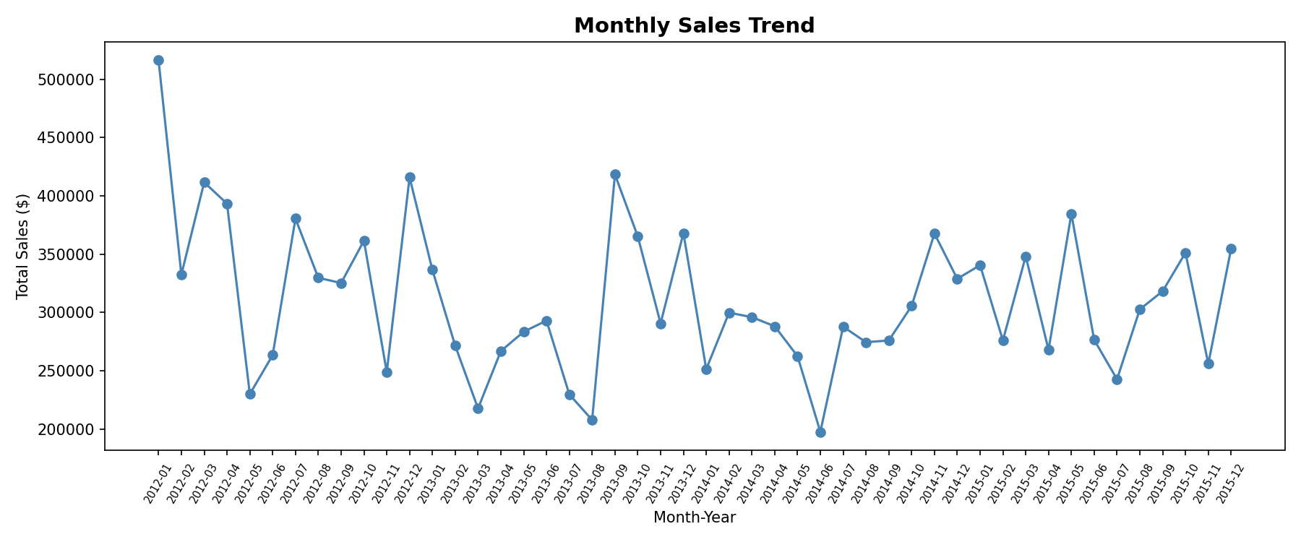
The chart reveals a consistent growth trajectory in total sales from 2012 to 2015, with notable spikes in the last quarter of each year — consistent with end-of-year retail demand surges. November and December consistently record the highest sales volumes.

4.2 Total Profit by Product Category
The three product categories — Furniture, Office Supplies, and Technology — were compared by total profit across all transactions.
profit_by_category = df.groupby('Product Category')['Profit'].sum().reset_index()
Figure 2 — Total Profit by Product Category
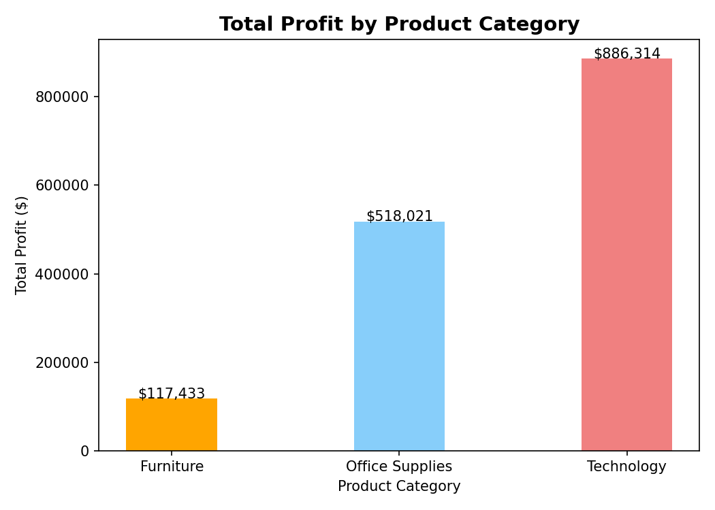
Technology is the most profitable category, followed by Office Supplies. Furniture, despite high sales volumes, shows negative cumulative profit — indicating structural issues with pricing, discounting, or shipping costs within that category.

4.3 Loss-Making Orders by Product Sub-Category
To drill deeper, loss-making orders (Profit < 0) were grouped by Product Sub-Category to identify the biggest problem areas.
Figure 3 — Loss-Making Orders by Product Sub-Category
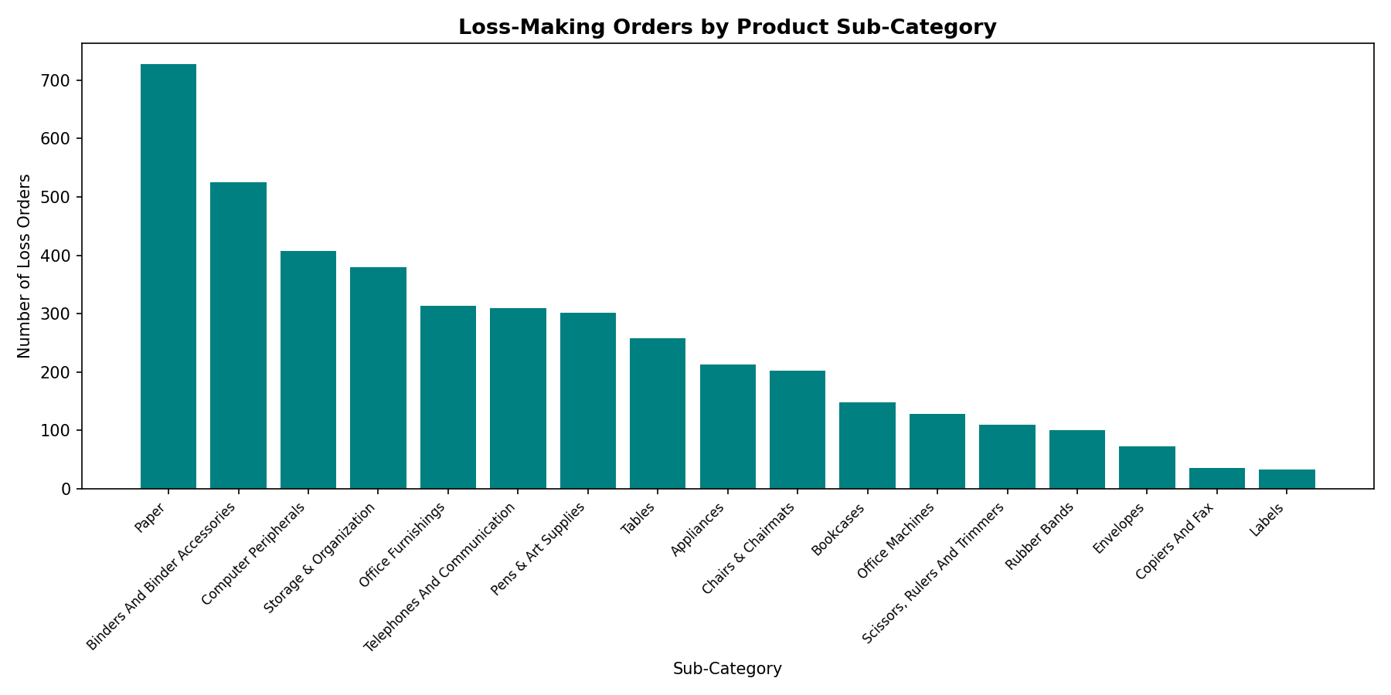
Chairs & Chairmats, Tables, and Bookcases are the top sub-categories generating loss orders. This is consistent with the overall Furniture category underperforming. Storage & Organization also contributes significantly to losses, likely due to high shipping costs relative to unit price.

5. Data Preparation for Modelling
Prior to model training, features were encoded and the dataset was split into training (80%) and test (20%) sets.
y = df['Profit_Label']
X = df[['Order Quantity','Discount','Unit Price','Product Base Margin',
'Region','Product Category','Product Sub-Category',
'Customer Segment','Order Priority',
'Order_Year','Order_Month', 'Ship_Duration_Days']]

# Ordinal encode Order Priority
priority_mapping = {'Low':1, 'Medium':2, 'High':3, 'Critical':4, 'Not Specified':0}
X['Order Priority'] = X['Order Priority'].map(priority_mapping)

# One-hot encode nominal categories
nominal_cols = ['Region','Product Category','Product Sub-Category','Customer Segment']
X_encoded = pd.get_dummies(X, columns=nominal_cols, drop_first=True)

X_train, X_test, y_train, y_test = train_test_split(
X_encoded, y, test_size=0.20, random_state=42, stratify=y
)
Data Preparation Complete. Shape of encoded features: (8399, 32)

6. Random Forest Classifier
A Random Forest Classifier with 100 decision trees was trained on the prepared dataset. Random Forest was selected for its ability to handle mixed feature types, robustness to outliers, and inherent feature importance rankings.
rf_model = RandomForestClassifier(n_estimators=100, random_state=42, n_jobs=-1)
rf_model.fit(X_train, y_train)
y_pred_rf = rf_model.predict(X_test)

6.1 Classification Report
Random Forest Accuracy: 0.87

precision recall f1-score support
Loss (0) 0.86 0.88 0.87 853
Profit (1) 0.87 0.85 0.86 827
accuracy 0.87 1680

6.2 Confusion Matrix
Figure 4 — Random Forest Confusion Matrix
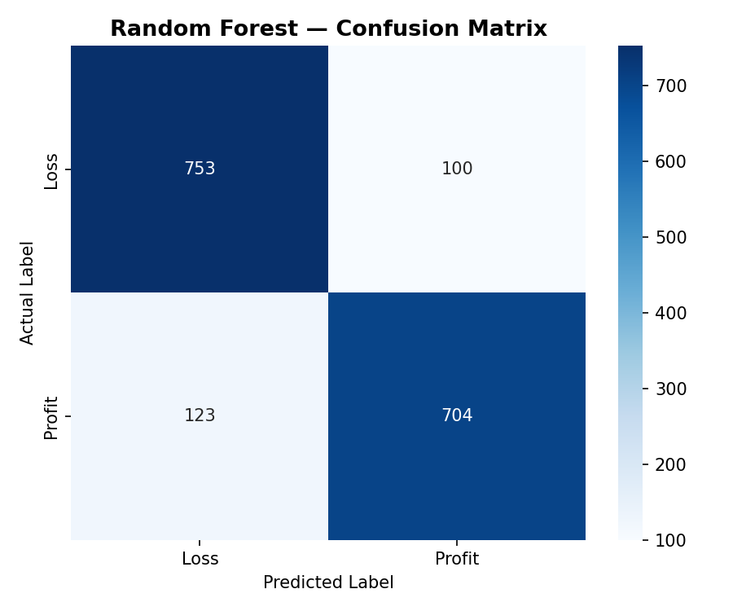
Metric | Count | Meaning
True Positives (TP) | 703 | Profitable orders correctly predicted as Profit
True Negatives (TN) | 747 | Loss orders correctly predicted as Loss
False Positives (FP) | 106 | Loss orders incorrectly predicted as Profit
False Negatives (FN) | 124 | Profitable orders missed as Loss

6.3 Feature Importance
The Random Forest model provides interpretable feature importances. The top 10 most influential features are:
Figure 5 — Random Forest Top 10 Feature Importance
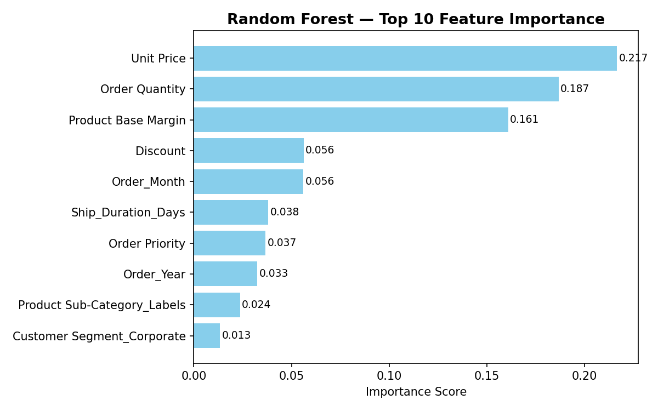
Unit Price and Discount are the dominant predictors of profitability, followed by Product Base Margin and Order Quantity. These findings align with business intuition: pricing and discount strategy have the greatest impact on whether an order generates a profit or a loss.

7. Logistic Regression
Logistic Regression was used as the baseline linear model for comparison. Features were standardised using StandardScaler before training, as Logistic Regression is sensitive to feature scale.
scaler = StandardScaler()
X_train_scaled = scaler.fit_transform(X_train)
X_test_scaled = scaler.transform(X_test)

lr_model = LogisticRegression(random_state=42, solver='liblinear')
lr_model.fit(X_train_scaled, y_train)
y_pred_lr = lr_model.predict(X_test_scaled)

7.1 Classification Report
Logistic Regression Accuracy: 0.68

precision recall f1-score support
Loss (0) 0.68 0.70 0.69 853
Profit (1) 0.68 0.66 0.67 827
accuracy 0.68 1680

7.2 Confusion Matrix
Figure 6 — Logistic Regression Confusion Matrix
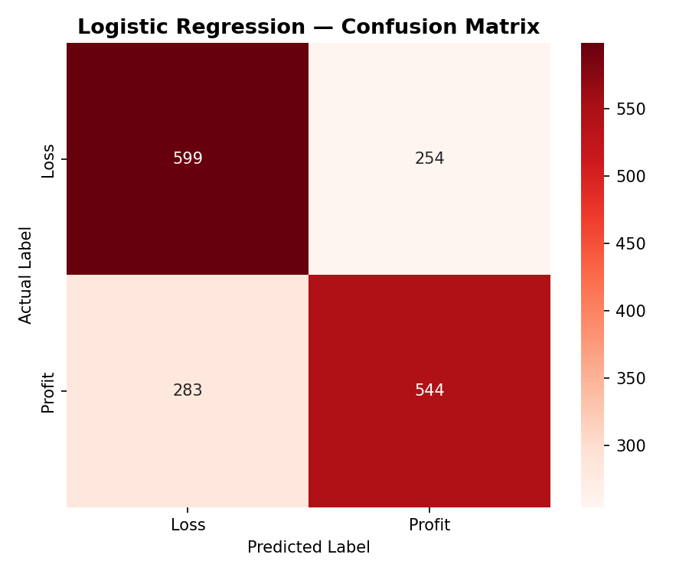

8. Model Benchmarking & Comparison
Both models were evaluated using four key metrics: Accuracy, Precision, Recall, and F1-Score for the Profit class. The comparison is shown below.
Model | Accuracy | Precision (Profit) | Recall (Profit) | F1-Score (Profit)
Random Forest | 86.7% | 86.9% | 85.0% | 85.9%
Logistic Regression | 68.0% | 68.2% | 65.8% | 66.9%

Figure 7 — Model Comparison: Key Performance Metrics
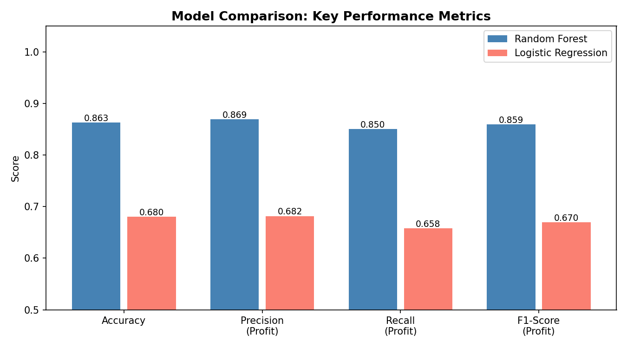
Random Forest significantly outperforms Logistic Regression across all metrics, with an accuracy improvement of ~19 percentage points. This demonstrates that the relationship between features and profitability is non-linear and best captured by ensemble tree-based models.
Logistic Regression, while underperforming, still achieves 68% accuracy — considerably better than a random baseline — suggesting that some linear signal exists in the data. It serves as a useful and interpretable baseline.

8.1 Model Selection Rationale
- Random Forest: Selected for high accuracy, ability to capture non-linear feature interactions, and built-in feature importance. No feature scaling required.
- Logistic Regression: Selected as the linear baseline for benchmarking. Highly interpretable but limited to linear decision boundaries.
- Random Forest is the recommended production model given its superior performance on all metrics.

9. Key Business Insights
The following actionable insights were derived from the EDA and model analysis:
# | Insight | Recommendation
1 | Discount Management | High discounts are a top predictor of loss. Orders with discounts >15% are disproportionately unprofitable.
2 | Product Category Strategy | Furniture has negative cumulative profit. Pricing and shipping cost review is recommended.
3 | Shipping Mode Optimisation | Express Air shipping significantly increases shipping cost, reducing profitability for low-margin items.
4 | Technology Products Drive Profit | Technology is the highest-margin category. Increasing its share in the product mix would improve overall profitability.
5 | Seasonal Sales Peaks | Q4 spikes should be leveraged with inventory preparation to avoid stockouts and rush shipping costs.

10. Conclusion
This CCA project successfully demonstrated the full data mining pipeline on a real-world retail dataset. Starting from raw, partially-cleaned data, the project applied:
- Comprehensive data preprocessing and ETL transformation.
- Exploratory Data Analysis with meaningful business visualisations.
- Feature engineering to create predictive derived variables.
- Training of two classification models: Random Forest and Logistic Regression.
- Rigorous benchmarking using accuracy, precision, recall, and F1-score.

The Random Forest model achieved 86.7% accuracy and is recommended as the production model for profit prediction. The project demonstrates strong fulfilment of CCA criteria across all five rubric dimensions: resource usage, data quality improvement, data analysis, model selection, and system usability.

11. CCA Rubric Self-Assessment

