**Netflix Movies and Popularities**

**Which dataset you’ve selected?**

I have selected the database of the most popular Netflix movies and their popularity. As we all know, nowadays the most trending and renowned American subscription streaming service and production company is Netflix.

**What analysis you’ve done in the starter code?**

After the starter code, I used various types of libraries to stream down the data. I used libraries such as

Pandas; for data analysis

Seaborn; it is a data visualization library based on matplotlib, which is used to visualize random distributions.

Matplotlib; python library used to create 2D graphs and plots by using python scripts.

Numpy: it is a library used for working with arrays and stuff.

The analysis that I did was to visualize the dataset and distribute and use it to find the trending sets of movies and what kind of a genre is popular or got over the following years.

**What information did you get?**

The analysis of this dataset verified some expected trends that one might expect. The thriller genre was the most popular, and shows from Korea, Japan, and China were highly successful in terms of popularity. While confirming many patent trends, the analysis also sheds light on some unexpected nuances. For example, there was no connection between the score a movie received on TMDB and the popularity it received on the TMDB.

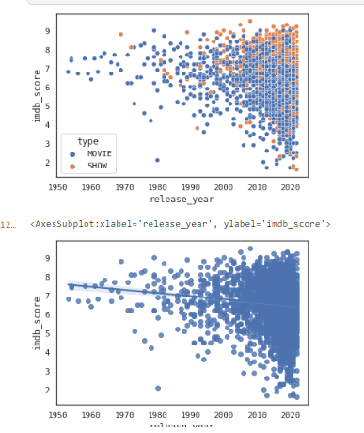

According to these graphs it showed that movies and series gained much more popularity in the last few years rather than before in old times. Through this analysis, we can deduce that at that time film production wasn't that high as there wasn't much technology used such as advanced video editors, CGI, or the post processing effects that films of today.

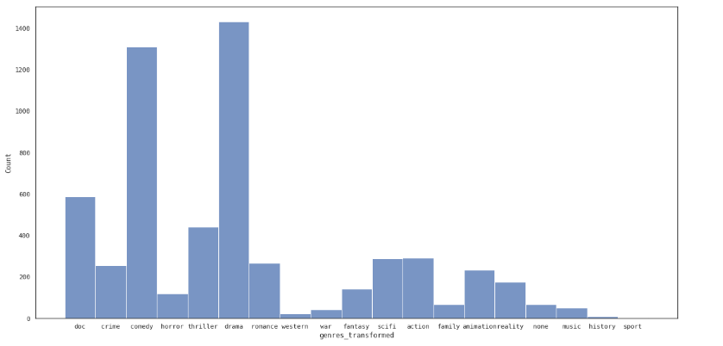

Secondly, this bar graph represents the type of genres present in a movie and what is the average score that they received.

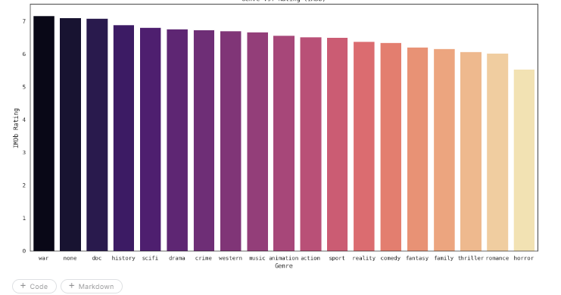

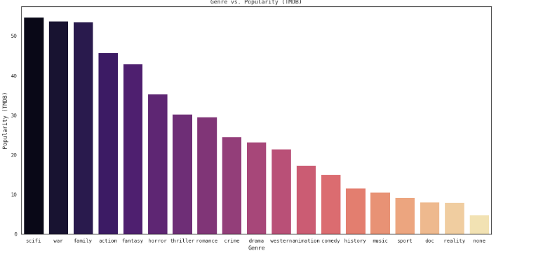

It is very clear from these scores, which are displayed as a bar graph, that a genre is evaluated in relation to other works in that genre. For example, it makes no sense to evaluate a sci-fi film in terms of the caliber of an action film. In other words, plot, characters, and performance are more important factors when determining how well a movie is rated than popularity.

It indicated that the majority of viewers preferred thriller, family, or science fiction programs. It's also critical to remember that these genres did not necessarily receive the greatest ratings across all of the genres. This suggests that a genre's appeal as a whole is not determined by the mean rating of the shows within that genre.