Data Analysis & Visualization — Research Project, Phase 3
Machine Unlearning in Large Language Models: Distinguishing Genuine Forgetting from Reversible Suppression
Hifsa Khattak (24i-2511) and Fizza Hussain (24i-2621)
FAST National University of Computer and Emerging Sciences, Islamabad
November 2026

Abstract
Unlearning methods are meant to remove selected knowledge from a large language model, but a model can look as if it has forgotten while the knowledge is only suppressed. We test 24 released unlearned checkpoints of Llama-3.2-1B-Instruct on TOFU forget10 (four methods, six configurations each) under five condition settings: low- and high-budget relearning, 4-bit quantization, paraphrased questions and mixed prompts. Every condition is also applied to a retain-only control model, and recovery is measured on ten authors that are never used for relearning. Three results stand out. First, no checkpoint meets our pre-set verdict of forgotten with at least 90% utility; 13 of 24 meet the forgetting threshold alone. Second, among those 13, high-budget relearning with only 40 examples from other authors overturns the verdict for 4 (30.8%, Wilson 95% interval 12.7–57.6%), quantization for 1, and low-budget relearning and paraphrasing for none. Third, the usual memorization metrics measured before the condition do not predict relearning recovery across checkpoints (Spearman ρ between 0.00 and 0.10), while token entropy and Truth Ratio do (ρ = −0.74 and −0.67). The study is limited to one benchmark, one model size and 24 checkpoints, so the intervals are wide and the results describe this pool only.

1. Introduction
Machine unlearning is used to honour privacy requests and to remove hazardous knowledge from a trained model without retraining it. The difficulty is verification. Earlier work shows that knowledge reported as forgotten can return after a small amount of fine-tuning [9], [10], after 4-bit quantization [11], when the question is rephrased [15], or when forget and retain questions are mixed in one prompt [19]. Phases 1 and 2 of this project reviewed 20 peer-reviewed papers and found that no reviewed study combines paraphrase or mixed-prompt testing with relearning and quantization on the same models, under matched budgets and with a retain-only control.
This phase implements the methodology designed in Phase 2 and reports the experimental evaluation. The research question is unchanged:
RQ. Under what evaluation conditions can apparent LLM forgetting be reliably distinguished from reversible information suppression?
- SQ1. For the same unlearned models, what fraction of models judged “forgotten” recover the knowledge under each condition?
- SQ2. How well does each pre-attack metric predict post-attack recovery, measured by Spearman correlation and AUROC?
- SQ3. Do these answers change across unlearning methods and hyperparameter configurations?
As in Phase 2, genuine forgetting is defined operationally as the absence of measurable recovery under the tested conditions. It is not a proof of permanent deletion from the model’s parameters.

2. Related Work
Recovery conditions. Relearning attacks fine-tune an unlearned model on a small amount of forget or related data [9], [10], [12]. Quantization to 4 bits is reported to raise retained knowledge from 21% to 83% [11]. Rephrased questions [15], other languages [14] and mixed forget-and-retain prompts [19] probe the same knowledge through a different surface form.
Evaluation and metrics. OpenUnlearning [3] provides a common implementation of methods and metrics and releases unlearned TOFU checkpoints; its meta-evaluation ranks Extraction Strength highest (0.85, Table 2 of [3]). The robustness of metrics under attack is also studied in [2], and benchmark suites are given in [4]. The preprint [21] tests whether pre-attack scores predict recovery after one relearning attack on 398 OpenUnlearning checkpoints and reports a model-level correlation of ρ = 0.35 (Table 2) and item-level AUROC between 0.504 and 0.582 (Table 3).
Robust unlearning methods. Sharpness-aware and smoothness-based training [12], [13], reference-free optimization (SimNPO) [20] and bi-level optimization [7] aim to resist recovery. Their robustness claims are conditional on the attacks each paper selects.
Position of this study. Our contribution is a controlled extension of [21]: the same checkpoints are tested under relearning at two budgets, quantization, paraphrase and mixed prompts, with a retain-only control processed under every condition.

3. Methodology and Changes from Phase 2

3.1 Implemented pipeline
The Phase 2 design was implemented as planned in its main parts: released checkpoints are evaluated, no unlearning is trained, each checkpoint is exposed to every condition (paired design), and the retain-only model is exposed to the same conditions. For each checkpoint the pipeline (i) measures the metrics before any condition (C0), (ii) applies one condition to a fresh copy of the checkpoint, (iii) measures the metrics again, and (iv) writes one row per question and metric to a CSV file. Analysis is done afterwards from these files only.

3.2 Changes made to the Phase 2 methodology
Table 1. Changes from the Phase 2 methodology and the reason for each.
Phase 2 item | What was done in Phase 3 | Reason
Step 3: “TOFU releases paraphrased answers, not paraphrased questions.” | Statement withdrawn. The TOFU forget10_perturbed split contains a paraphrased_question column. C3 still uses our own paraphrases. | Found when the data were loaded. The design of C3 is unchanged.
Six released configurations per method (no selection rule given) | For each method, all released forget10 configurations were sorted by the settings in the checkpoint name and six evenly spaced positions were taken (pool sizes: GradDiff 40, NPO 54, SimNPO 48, RMU 54). | A fixed rule, committed to the repository before any model was run, avoids selection by results.
Estimated 30–90 minutes per checkpoint; fallback to 12 checkpoints | Measured about 11 minutes per checkpoint on a Kaggle T4. The full core set of 24 was run. | Runtime was lower than estimated.
TOFU Model Utility | Replaced by a utility proxy: the mean of answer probability and ROUGE-L on a fixed sample of 200 retain90 questions. | The full utility score needs three further evaluation sets. The proxy is not comparable with published Model Utility values.
Forget Quality, PCA distance, OpenUnlearning aggregate score | Not computed. | Time. None is required to answer SQ1–SQ3.
C4 evaluated with all metrics | Only ROUGE-L is measured for C4. | Probability-based metrics are not defined in our script for a prompt with two questions, so the primary metric is unavailable for C4.
Failed paraphrases are regenerated | Of 20 hand-checked paraphrases, 15 passed and 5 were corrected by hand. The other 180 were checked automatically only. | The 5 kept the meaning but added a word that was not in the original.
Ablation A5 (evaluate on part A) | Not run. | The run script evaluates part B only.
Recovery curves over relearning steps | Not produced. | Only the final relearned model is evaluated.
LoRA settings other than rank; prompt format; retain sample size | LoRA alpha 16, dropout 0.05, learning rate 2e-4, batch size 4, gradient accumulation 4. System prompt and fixed date string as in the OpenUnlearning model configuration. 200 retain questions. | Not fixed in Phase 2. The LoRA values are our own choice.

3.3 Feedback received in class
[To be completed by the authors: state the feedback received on the Phase 2 methodology and how it was addressed.]

4. Experimental Setup

4.1 Dataset, preprocessing and splits
We use TOFU as distributed with OpenUnlearning [3] (dataset repository: locuslab/TOFU). The forget10 split has 400 question–answer pairs about 20 fictitious authors (20 per author) and retain90 has 3,600; both counts were verified, with no missing answers and no duplicate questions. The 20 forget authors were split by author with seed 0 into part A (10 authors, 200 questions, used only for relearning) and part B (10 other authors, 200 questions, used only for evaluation). Recovery on part B therefore cannot come from memorising the relearning examples. A fixed random sample of 200 retain90 questions is used for the utility proxy and for building mixed prompts.
Paraphrases (C3). Each part-B question was rewritten once with ChatGPT (free tier, default model, 11 November 2026) using one fixed prompt that required names, places, dates, titles and numbers to be kept and the answer not to be revealed. An automatic comparison found no lost names, dates or titles in the 200 rewrites. Mixed prompts (C4). Each part-B question is paired with one retain question in the form “Answer both questions. 1. … 2. …”, in both orders (400 prompts).

4.2 Models
All models are Llama-3.2-1B-Instruct checkpoints released by OpenUnlearning [3]: the original model fine-tuned on all of TOFU, the retain-only model fine-tuned on retain90 (the control: it never saw the forget authors), and 24 unlearned forget10 checkpoints, six each for GradDiff, NPO, SimNPO [20] and RMU. Appendix A lists the checkpoints by number; the full identifiers are in the repository manifest.

4.3 Conditions
Table 2. Condition settings, applied identically to every checkpoint and to the control model.
Code | Condition | Setting | Source
C0 | No condition | Part-B questions as released | –
C1-low | Relearning, low budget | LoRA (rank 8) fine-tuning on 20 part-A examples, 1 epoch, seed 0 | [12]
C1-high | Relearning, high budget | LoRA (rank 8) fine-tuning on 40 part-A examples (20% of part A), 3 epochs, seed 0 | [20]
C2 | Quantization | Simulated 4-bit round-to-nearest quantization of linear-layer weights (group size 64, symmetric); embeddings and output head kept in FP16 | [11]
C3 | Paraphrased questions | The 200 part-B questions, rewritten | [2], [15]
C4 | Mixed prompts | Part-B question combined with a retain question, both orders | [19]

4.4 Metrics
Per question we record answer probability (the primary metric), Extraction Strength, Exact Memorization, ROUGE-L recall, Truth Ratio, Min-K% Prob and token entropy. Scores are averaged over the 200 part-B questions for each checkpoint; the median is used for Truth Ratio because it is a ratio of small probabilities with extreme values. From these we compute the Phase 2 quantities:
- Residual knowledge K = (S_model − S_control) / (S_original − S_control). K near 1 means the model resembles the original; K near 0 means it resembles the model that never learned the forget set. For C3 and C4, K after the condition uses the original and control models measured on the same paraphrased or mixed prompts.
- Forgotten verdict (pre-set): K ≤ 0.10 and utility ≥ 90% of the original model. A checkpoint with K ≤ 0.10 alone is called K-forgotten.
- Control-adjusted recovery G = [(S_after − S_before) − (S_control,after − S_control,before)] / (S_original − S_control). A checkpoint is recovered if G ≥ 0.50.
- Verdict-flip rate: among checkpoints with K ≤ 0.10 before a condition, the share with K > 0.10 afterwards, computed separately for each metric.

4.5 Implementation and statistics
All runs used free Kaggle sessions with a Tesla T4 GPU, FP16 inference, greedy decoding and PyTorch 2.11. Checkpoints 1–12 and the two reference models were run by one author and checkpoints 13–24 by the other, with the same script version, configuration file and frozen data files; every result row records the script version and a hash of the configuration. An earlier run with a first version of the script, which lacked the system prompt and Truth Ratio, was discarded and is not used. All 156 model-condition runs completed without error. Flip rates are reported with Wilson 95% intervals. Spearman correlations use 10,000 bootstrap resamples over checkpoints (seed 0). AUROC is computed only when both classes contain at least five checkpoints. Cochran’s Q and exact McNemar tests with Holm correction are exploratory, because checkpoints of the same method are not independent.

5. Results

5.1 Reference models and baseline verdicts
Table 3 gives the two reference models before any condition and, for each metric used alone as a baseline verdict, how many of the 24 checkpoints it declares forgotten. The original and control models are clearly separated on every metric, so K is well defined at C0. The baselines disagree with each other: Truth Ratio marks 6 checkpoints as K-forgotten, Exact Memorization and Min-K% Prob 12, answer probability 13, and Extraction Strength and ROUGE-L 17.
Table 3. Reference models at C0 and baseline verdicts by metric (24 checkpoints).
Metric | Original | Control | Span | K-forgotten (K ≤ 0.10) | Forgotten verdict (K ≤ 0.10 and utility ≥ 90%)
Answer probability | 0.873 | 0.123 | 0.751 | 13 | 0
Extraction Strength | 0.714 | 0.085 | 0.628 | 17 | 2
Exact Memorization | 0.971 | 0.610 | 0.361 | 12 | 0
ROUGE-L | 0.790 | 0.393 | 0.397 | 17 | 2
Truth Ratio (median) | 0.483 | 0.826 | −0.343 | 6 | 0
Min-K% Prob | −0.640 | −9.255 | 8.615 | 12 | 0
Token entropy | 0.313 | 0.769 | −0.456 | – | –
Span = original − control. A negative span means that a lower value indicates more knowledge. Token entropy is an output-health feature and is not used as a verdict.

5.2 Forgetting and utility before any condition
With the primary metric, 13 of 24 checkpoints have K ≤ 0.10, but none of them keeps at least 90% of the original model’s utility; the highest utility among the 13 is 89% (SimNPO 6). The pre-set forgotten verdict is therefore met by no checkpoint (Figure 1). Checkpoints that keep about 90% or more of their utility (SimNPO 1–4, RMU 1, 2 and 4, NPO 4 and 6) all have K above 0.10, and several checkpoints with very low K have lost most of their utility (RMU 6: 4%; NPO 1: 14%; RMU 3: 17%). Because the verdict set is empty, the flip rates below are computed on the 13 K-forgotten checkpoints, which is how Phase 2 defined the flip rate.
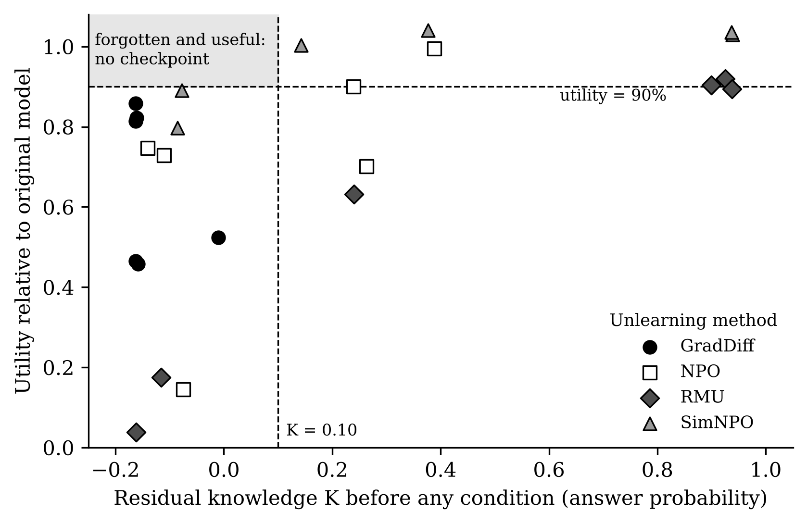
Figure 1. Residual knowledge K (answer probability) against utility relative to the original model, before any condition, for the 24 checkpoints. The shaded region is the pre-set forgotten verdict. No checkpoint falls inside it.

5.3 SQ1: how often is a “forgotten” result overturned?
Table 4. Verdict-flip rate by condition for the K-forgotten checkpoints.
Condition | Metric | Flipped / K-forgotten | Flip rate | Wilson 95% interval | Checkpoints that flipped
C1-low | Answer probability | 0/13 | 0.0% | 0.0–22.8% | none
C1-high | Answer probability | 4/13 | 30.8% | 12.7–57.6% | GradDiff 1, NPO 1, RMU 3, RMU 6
C2 | Answer probability | 1/13 | 7.7% | 1.4–33.3% | GradDiff 1
C3 | Answer probability | 0/13 | 0.0% | 0.0–22.8% | none
C4 | ROUGE-L | 1/17 | 5.9% | 1.0–27.0% | SimNPO 4
High-budget relearning is the only condition that overturns a substantial share of verdicts: 4 of 13 K-forgotten checkpoints rise above K = 0.10 after fine-tuning on 40 examples about other authors (Table 4, Figure 2). Quantization flips one checkpoint, and low-budget relearning and paraphrasing flip none. The intervals are wide because there are only 13 K-forgotten checkpoints. Figure 3 shows the control-adjusted recovery G for all 24 checkpoints: four checkpoints reach G ≥ 0.50 under high-budget relearning (GradDiff 1, RMU 3, RMU 5 and RMU 6) and none under any other condition. RMU 5 recovers although it was not K-forgotten at C0 (K = 0.24).
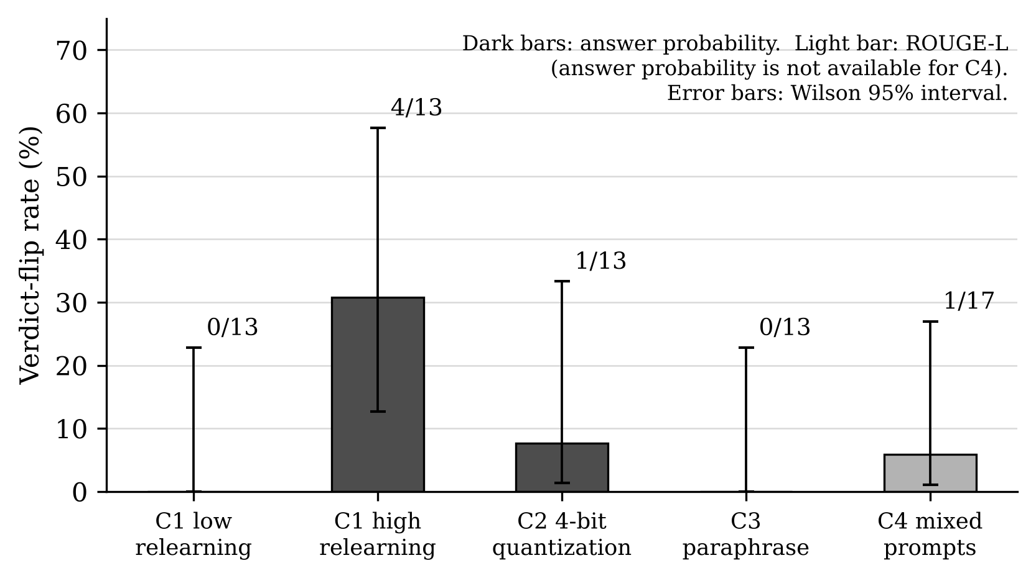
Figure 2. Verdict-flip rate per condition with Wilson 95% intervals. Labels give flipped / K-forgotten checkpoints.
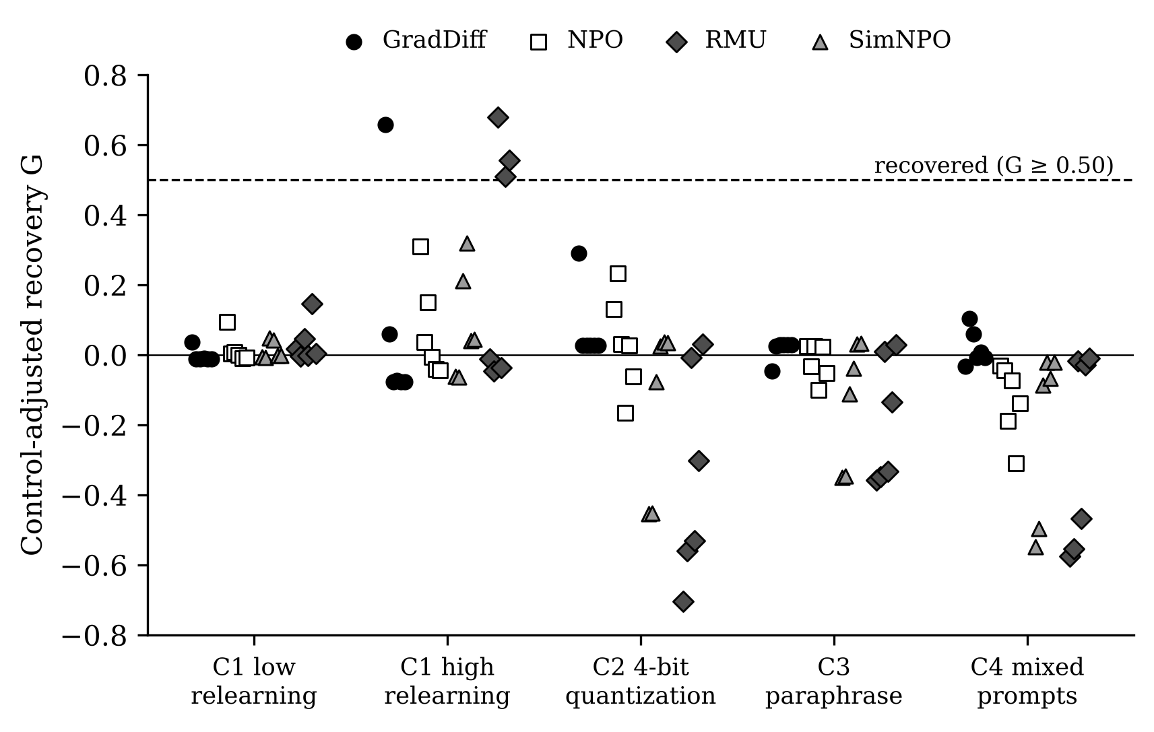
Figure 3. Control-adjusted recovery G for each of the 24 checkpoints under each condition (answer probability; ROUGE-L for C4). Points above the dashed line are recovered.
Under C2, C3 and C4 many checkpoints have negative G. These are checkpoints that still held the knowledge at C0 (for example SimNPO 1–2 and RMU 1, 2 and 4): the condition lowers their scores more than it lowers the control’s. In our setting 4-bit quantization damages the model in general: the original model’s answer probability falls from 0.873 to 0.487 and its utility proxy from 0.847 to 0.471. Quantization therefore acts mainly as damage here, not as a recovery route.
The flip rate depends on the metric used for the verdict (Table 5). Under high-budget relearning it ranges from 4 of 17 (Extraction Strength) to 6 of 12 (Exact Memorization) and 4 of 6 (Truth Ratio). Extraction Strength is the only metric for which paraphrasing flips verdicts (6 of 17).
Table 5. Flipped / K-forgotten checkpoints for each metric and condition.
Metric used for the verdict | C1-low | C1-high | C2 | C3 | C4
Answer probability | 0/13 | 4/13 | 1/13 | 0/13 | –
Extraction Strength | 2/17 | 4/17 | 1/17 | 6/17 | –
Exact Memorization | 0/12 | 6/12 | 0/12 | 0/12 | –
ROUGE-L | 1/17 | 5/17 | 0/17 | 0/17 | 1/17
Truth Ratio (median) | 1/6 | 4/6 | 1/6 | 1/6 | –
Min-K% Prob | 0/12 | 4/12 | 1/12 | 0/12 | –
C4 is measured with ROUGE-L only. For ROUGE-L the original–control span is small under C2 (0.085), C3 (0.095) and C4 (0.124), and for Extraction Strength under C2 (0.072), so K after these conditions is less stable for these metrics.
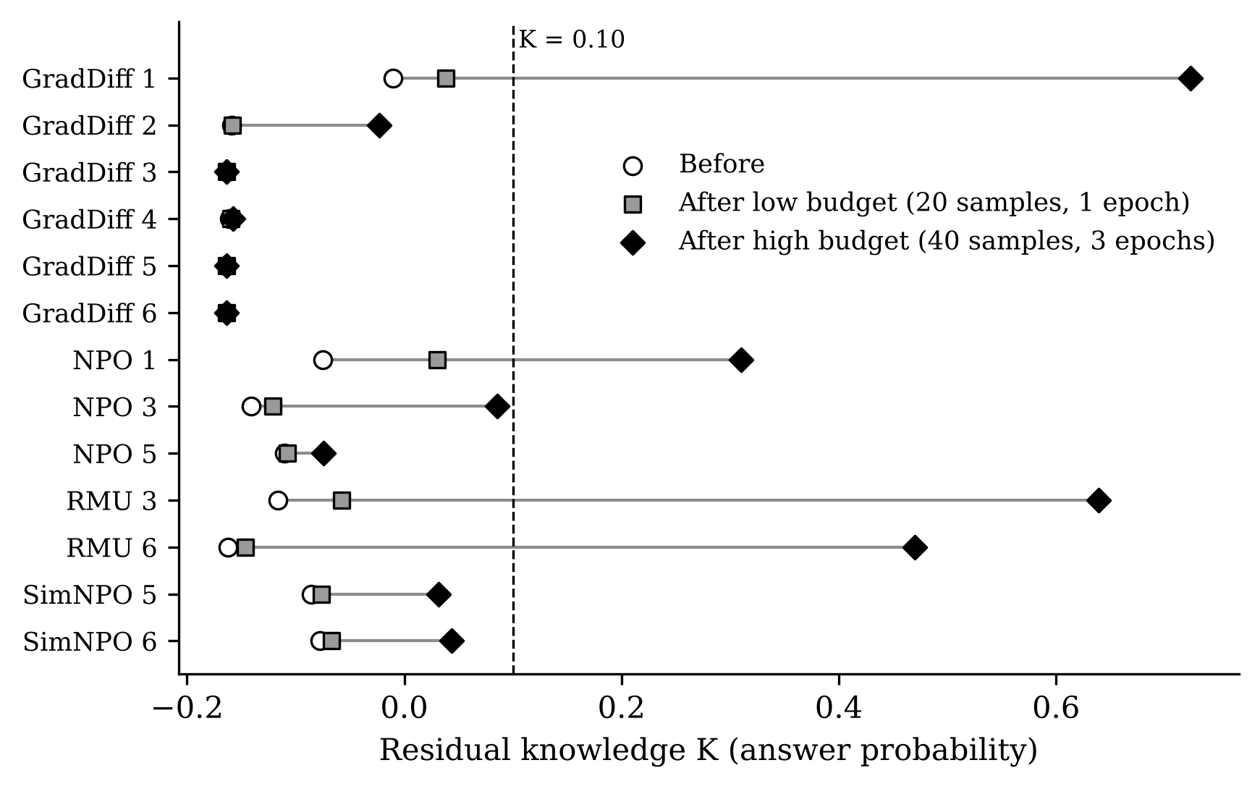
Figure 4. Residual knowledge K before relearning and after the low and high budgets, for the 13 K-forgotten checkpoints. Four cross K = 0.10 at the high budget; none does at the low budget.

5.4 SQ2: do pre-condition metrics predict recovery?
Table 6 gives the Spearman correlation between each metric measured before the condition and the recovery G, across the 24 checkpoints. For relearning at the high budget, the five memorization metrics have correlations between 0.00 and 0.10 with bootstrap intervals from about −0.5 to 0.5: a low score before the attack says almost nothing about whether the knowledge will return. Truth Ratio (ρ = −0.67) and token entropy (ρ = −0.74) are related to recovery. The sign means that checkpoints whose entropy is far from the original model’s, that is, checkpoints that answer with high uncertainty, recover more. AUROC for the recovered class was not computed at the checkpoint level because only 4 checkpoints are recovered, below the pre-set minimum of 5.
Table 6. Spearman correlation between each pre-condition metric and recovery G (24 checkpoints).
Pre-condition metric | C1-low | C1-high | C2 | C3 | C4 | 95% bootstrap interval, C1-high
Answer probability | 0.37 | 0.04 | −0.60 | −0.88 | −0.83 | −0.53 to 0.51
Extraction Strength | 0.37 | 0.05 | −0.58 | −0.88 | −0.83 | −0.51 to 0.51
Exact Memorization | 0.31 | 0.03 | −0.60 | −0.85 | −0.83 | −0.55 to 0.50
ROUGE-L | 0.26 | −0.00 | −0.65 | −0.84 | −0.81 | −0.54 to 0.46
Truth Ratio (median) | −0.37 | −0.67 | −0.30 | −0.21 | −0.05 | −0.90 to −0.27
Min-K% Prob | 0.43 | 0.10 | −0.64 | −0.86 | −0.77 | −0.45 to 0.52
Token entropy | −0.56 | −0.74 | −0.35 | −0.08 | 0.04 | −0.92 to −0.39
Predictors are expressed as K, so a higher value means the checkpoint is closer to the original model on that metric. Recovery is G for answer probability (ROUGE-L for C4). Figure 5 shows the same values.
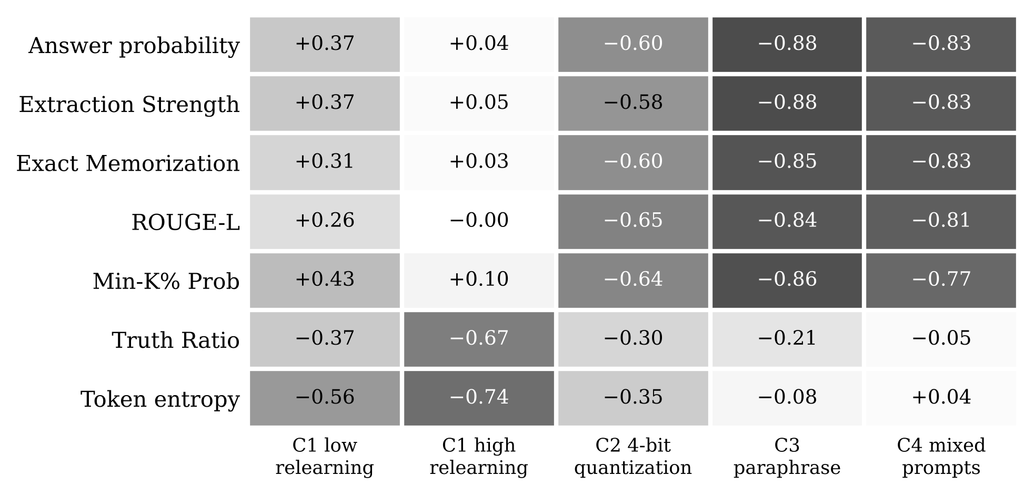
Figure 5. Spearman correlation between each pre-condition metric (rows) and recovery under each condition (columns). Darker cells are stronger correlations of either sign.
The strong negative correlations under C2, C3 and C4 (−0.58 to −0.88) should not be read as predictions of recovery. They reflect that these conditions lower the scores of checkpoints that still hold the knowledge, as described in Section 5.3. Within the 13 K-forgotten checkpoints only, the picture changes: Min-K% Prob (ρ = 0.76), token entropy (ρ = −0.73) and answer probability (ρ = 0.62) are related to relearning recovery, which indicates that small differences in residual knowledge below the threshold carry some signal. This subgroup has 13 checkpoints and is exploratory.

5.5 SQ3: differences across methods and configurations
Table 7. Results by unlearning method (six checkpoints each). Flips and recovery refer to C1-high.
Method | Flipped / K-forgotten | Recovered (G ≥ 0.50) | Mean G, C1-high | Range of G, C1-high | Mean G, C2 | Mean G, C3 | Mean G, C4
GradDiff | 1/6 | 1/6 | 0.07 | −0.08 to 0.66 | 0.07 | 0.02 | 0.02
NPO | 1/3 | 0/6 | 0.07 | −0.04 to 0.31 | 0.03 | −0.02 | −0.13
SimNPO | 0/2 | 0/6 | 0.08 | −0.06 to 0.32 | −0.15 | −0.13 | −0.21
RMU | 2/2 | 3/6 | 0.28 | −0.05 to 0.68 | −0.35 | −0.19 | −0.28
Recovery is concentrated in RMU: both K-forgotten RMU checkpoints flip, and three of the six RMU checkpoints are recovered. All six GradDiff checkpoints are K-forgotten but only one flips. Within a method the outcome depends strongly on the configuration: G under C1-high ranges from −0.08 to 0.66 for GradDiff and from −0.05 to 0.68 for RMU. Leaving out one method at a time (Table 8) moves the C1-high flip rate between 18.2% and 42.9%; without RMU only one checkpoint in 18 is recovered. The headline result therefore depends on which methods are in the pool.
Table 8. Leave-one-method-out check for C1-high (answer probability).
Method left out | Flipped / K-forgotten | Flip rate | Wilson 95% interval | Recovered / checkpoints
none | 4/13 | 30.8% | 12.7–57.6% | 4/24
GradDiff | 3/7 | 42.9% | 15.8–75.0% | 3/18
NPO | 3/10 | 30.0% | 10.8–60.3% | 4/18
SimNPO | 4/11 | 36.4% | 15.2–64.6% | 4/18
RMU | 2/11 | 18.2% | 5.1–47.7% | 1/18

5.6 Comparing conditions
Cochran’s Q indicates that the conditions differ in how often they flip a verdict (answer probability, four settings, 13 checkpoints: Q = 9.92, p = 0.019; ROUGE-L, five settings, 17 checkpoints: Q = 15.64, p = 0.004) and in how often they produce recovery (24 checkpoints: Q = 12.00, p = 0.007). No pairwise exact McNemar test is significant after Holm correction (smallest adjusted p = 0.625), which is expected with at most five discordant pairs. These tests are exploratory.

6. Comparison with Existing Research
Table 9. Comparison with published results. Only directions are compared where settings differ.
Study | Published result | Our corresponding result | What limits a fair comparison
OpenUnlearning [3], Table 2 | Extraction Strength is the highest-ranked metric in the meta-evaluation (0.85). | Extraction Strength marks 17 of 24 checkpoints as K-forgotten; 4 of 17 flip under high-budget relearning and 6 of 17 under paraphrasing. Its correlation with relearning recovery is 0.05. | Same benchmark and model family, but [3] reports an aggregate meta-evaluation score, not a flip rate or a correlation with recovery.
Quantization [11] | Retained knowledge rises from 21% to 83% after 4-bit quantization. | 1 of 13 K-forgotten checkpoints flips under 4-bit quantization. The original model itself drops from 0.873 to 0.487 in answer probability. | Different benchmark, models and quantization implementation; ours is a simulated round-to-nearest quantization of a 1B model. The published effect is not reproduced in our setting.
Recovery forecasting [21], Tables 2–3 | Model-level ρ = 0.35; item-level AUROC 0.504–0.582, for one relearning attack on 398 checkpoints. | Model-level ρ between 0.00 and 0.10 for the five memorization metrics (24 checkpoints). Item-level AUROC 0.355–0.426 for these metrics and 0.805 for token entropy (4,800 items). | Same benchmark and checkpoint source, but 24 instead of 398 checkpoints, a LoRA attack on disjoint authors, and a control-adjusted recovery definition.
Relearning budgets [12], [20] | 20 samples for one epoch [12]; 20% of a forget split for three epochs [20]. | With the same two budgets on the same checkpoints: 0 of 13 flips at the low budget and 4 of 13 at the high budget. | We use LoRA (rank 8) on FP16 weights, not full fine-tuning, so recovery may be lower than in [12] and [20].
The item-level values come from an exploratory analysis: an item (a question for one checkpoint) is counted as recovered if its control-adjusted gain in answer probability is at least 0.50 of the original–control span. Under high-budget relearning 637 of 4,800 items are recovered. AUROC values below 0.5 for the memorization metrics mean that items with lower scores before the attack are slightly more likely to recover; their distance from chance (0.07 to 0.15) is of the same order as in [21]. Like [21], we find that standard pre-attack scores are weak predictors of recovery.

7. Ablation Studies
All ablations except A5 are computed from the saved results. Table 10 summarises them and Table 11 gives the threshold analysis.
Table 10. Ablation results.
 | Change | Result
A1 | Remove the control adjustment from G | The control’s own gain under C1-high equals 0.076 in units of G. Without adjustment the mean G under C1-high is 0.200 instead of 0.124, and the number of recovered checkpoints changes from 6 to 7 at G ≥ 0.25 and from 0 to 1 at G ≥ 0.75; it is 4 either way at G ≥ 0.50. The adjustment changes borderline cases, not the main picture.
A2 | Low versus high relearning budget | 0 of 13 flips at the low budget and 4 of 13 at the high budget (Figure 4). The largest increases in G from low to high are RMU 3 (+0.63), GradDiff 1 (+0.62) and RMU 6 (+0.55). Conclusions depend strongly on the attack budget.
A3 | Drop one condition at a time | With answer probability, the conditions together catch 4 of 13 K-forgotten checkpoints. Without C1-high only 1 is caught; removing C1-low, C2 or C3 changes nothing. C1-high uniquely catches 3 checkpoints, and the single quantization flip (GradDiff 1) is also caught by C1-high.
A4 | Single metrics versus the mean of two standardised metrics | For predicting G under C1-high, the best single metric is Truth Ratio (ρ = −0.67). The best pair (answer probability with Truth Ratio, ρ = −0.65) is not better. Combining two metrics did not help.
A5 | Evaluate on part A instead of part B | Not run (Table 1).
A6 | Recovery threshold 0.25 / 0.50 / 0.75 | Recovered checkpoints under C1-high: 6, 4 and 0. Under C2: 1, 0 and 0. No other condition produces recovery at any threshold.
A7 | K threshold and utility floor | See Table 11. Without a utility floor the number of K-forgotten checkpoints is stable (13, 13, 14). With any floor of 85% or more, at most 3 checkpoints qualify.
Table 11. Ablation A7: forgotten checkpoints and flips for different K thresholds and utility floors (answer probability).
K threshold | Utility floor | Forgotten | Flips C1-low | Flips C1-high | Flips C2 | Flips C3
0.05 | none | 13 | 0 | 5 | 1 | 0
0.05 | 0.85 | 2 | 0 | 0 | 0 | 0
0.05 | 0.9 | 0 | 0 | 0 | 0 | 0
0.05 | 0.95 | 0 | 0 | 0 | 0 | 0
0.10 | none | 13 | 0 | 4 | 1 | 0
0.10 | 0.85 | 2 | 0 | 0 | 0 | 0
0.10 | 0.9 | 0 | 0 | 0 | 0 | 0
0.10 | 0.95 | 0 | 0 | 0 | 0 | 0
0.20 | none | 14 | 0 | 5 | 1 | 0
0.20 | 0.85 | 3 | 0 | 1 | 0 | 0
0.20 | 0.9 | 1 | 0 | 1 | 0 | 0
0.20 | 0.95 | 1 | 0 | 1 | 0 | 0
Only one checkpoint (SimNPO 4, at K ≤ 0.20) passes a utility floor of 90%, and it flips under high-budget relearning.

8. Error and Failure Analysis
- Falsely “forgotten” checkpoints. The four checkpoints that flip under C1-high are GradDiff 1, NPO 1, RMU 3 and RMU 6. Three of them had lost most of their utility before the attack (14%, 17% and 4% of the original), and relearning restored utility together with the forget knowledge. In these cases the low score came from general damage to the model, not from targeted removal.
- Degenerate outputs. GradDiff 3–6 have answer probability near zero and token entropy between 0.00 and 0.02, far below the original model’s 0.31: they give confident answers that are not the correct ones. None recovers under relearning (G between −0.08 and −0.01). RMU 6 is the opposite case, with entropy 9.16 and almost no utility, and it recovers strongly.
- False alarms. SimNPO 1–2 and RMU 1, 2 and 4 are judged not forgotten (K ≥ 0.90) and show no recovery under relearning because there is little left to recover.
- Prompt order. In mixed prompts, ROUGE-L for the forget answer is higher when the forget question comes first in 25 of 26 models (mean difference 0.061). The answer to the second question is more often incomplete, so order affects the measured score.
- Conditions where prediction fails. Under high-budget relearning the five memorization metrics all fail to predict recovery across checkpoints (Section 5.4).
The run script saved scores but not the generated text, so the outputs could not be read and grouped by question type as planned in Phase 2.

9. Discussion

9.1 Answers to the research questions
SQ1. Among the 13 K-forgotten checkpoints, the verdict is overturned for 30.8% by high-budget relearning, 7.7% by quantization and 0% by low-budget relearning and paraphrasing; for mixed prompts, 1 of 17 by ROUGE-L. SQ2. Across the 24 checkpoints the standard memorization metrics do not predict relearning recovery; token entropy and Truth Ratio do. SQ3. The answers change with the method (recovery is concentrated in RMU) and, within a method, with the configuration.
RQ. In this pool, apparent forgetting was separated from reversible suppression mainly by relearning at a sufficient budget on data from other authors. Quantization, paraphrasing and mixed prompts added almost no failures beyond relearning, so the minimum test set suggested by ablation A3 is high-budget relearning, read together with a utility check and an output-entropy check. This addresses the first two parts of the Phase 2 gap: the additional conditions were tested on the same checkpoints and added little, and metrics that fail to predict relearning recovery were examined under the other conditions. The third part (whether metric rankings hold across methods) is answered only descriptively.

9.2 Strengths
- Every condition is applied to the same checkpoints and to a retain-only control, so recovery is separated from what the condition teaches by itself.
- Relearning and evaluation use disjoint authors.
- The checkpoint list, the split, the thresholds and the selection rule were fixed and committed before the runs, and every number in this paper is produced by a script from the saved result files.

9.3 Limitations
- One benchmark (TOFU forget10), one model size (1B) and 24 checkpoints. Checkpoints of the same method are not independent. Intervals are wide and describe this pool only.
- No checkpoint met the pre-set forgotten verdict, so flip rates refer to K ≤ 0.10 without the utility requirement.
- Utility is a proxy measured on 200 retain questions and is not comparable with published TOFU Model Utility. Forget Quality was not computed.
- Relearning uses LoRA with one seed, so recovery may be lower than with full fine-tuning and its run-to-run variation is unknown.
- Quantization is simulated and damages the 1B model heavily, which limits what C2 can show.
- C4 is measured with ROUGE-L only, and ROUGE-L separates the original and control models poorly under C2–C4.
- Of the 200 paraphrases, 20 were checked by hand; some of the others add a word such as “literary”.
- Ablation A5 and the reading of generated outputs were not carried out.

10. Conclusion
We evaluated 24 released unlearned checkpoints under five condition settings with a retain-only control. None achieved forgetting while keeping 90% of utility. Of the 13 that met the forgetting threshold alone, about one third recovered the knowledge after fine-tuning on 40 examples about other authors, and the scores usually used to declare forgetting did not indicate which ones would. A forgetting claim based on a single low score should therefore be accompanied by a relearning test at an adequate budget and by checks of utility and output entropy. Future work should repeat the study with several seeds, full fine-tuning, larger models and a second benchmark such as MUSE-News.

Reproducibility
Code, configuration, frozen data files, per-question results and the analysis and figure scripts are available at https://github.com/fizzahussain/LLM-Unlearning-Research. The tables in this paper are generated by scripts/analyze_results.py and the figures by scripts/make_figures.py.

References
Reference numbers are those used in the Phase 1 and Phase 2 reports, so that citations stay consistent across the three phases; only the works cited in this paper are listed.
[2] Q. Wang, B. Han, P. Yang, J. Zhu, T. Liu, and M. Sugiyama, "Towards effective evaluations and comparisons for LLM unlearning methods," in Proc. Int. Conf. Learning Representations (ICLR), 2025. Available: https://iclr.cc/virtual/2025/poster/27842
[3] V. Dorna, A. R. Mekala, W. Zhao, A. McCallum, J. Z. Kolter, Z. C. Lipton, and P. Maini, "OpenUnlearning: Accelerating LLM unlearning via unified benchmarking of methods and metrics," in Advances in Neural Information Processing Systems (NeurIPS), Datasets and Benchmarks Track, 2025. Available: https://proceedings.neurips.cc/paper_files/paper/2025/hash/3e4a38f228427ab819ba7899003a44b1-Abstract-Datasets_and_Benchmarks_Track.html
[4] W. Shi, J. Lee, Y. Huang, S. Malladi, J. Zhao, A. Holtzman, D. Liu, L. Zettlemoyer, N. A. Smith, and C. Zhang, "MUSE: Machine unlearning six-way evaluation for language models," in Proc. Int. Conf. Learning Representations (ICLR), 2025. Available: https://iclr.cc/virtual/2025/poster/29559
[7] H. Reisizadeh, J. Jia, Z. Bu, B. Vinzamuri, A. Ramakrishna, K.-W. Chang, V. Cevher, S. Liu, and M. Hong, "BLUR: A bi-level optimization approach for LLM unlearning," in Proc. 19th Conf. European Chapter of the Association for Computational Linguistics (EACL), Vol. 1: Long Papers, 2026, pp. 7043-7058, doi: 10.18653/v1/2026.eacl-long.331.
[9] X. Xu, X. Yue, Y. Liu, Q. Ye, H. Zheng, P. Hu, M. Du, and H. Hu, "Unlearning isn't deletion: Investigating reversibility of machine unlearning in LLMs," in Proc. 43rd Int. Conf. Machine Learning (ICML), PMLR, vol. 306, 2026, pp. 142657-142704. Available: https://proceedings.mlr.press/v306/xu26cd.html
[10] S. Hu, Y. Fu, Z. S. Wu, and V. Smith, "Unlearning or obfuscating? Jogging the memory of unlearned LLMs via benign relearning," in Proc. Int. Conf. Learning Representations (ICLR), 2025. Available: https://proceedings.iclr.cc/paper_files/paper/2025/hash/18fd48d9cbbf9a20e434c9d3db6973c5-Abstract-Conference.html
[11] Z. Zhang, F. Wang, X. Li, Z. Wu, X. Tang, H. Liu, Q. He, W. Yin, and S. Wang, "Catastrophic failure of LLM unlearning via quantization," in Proc. Int. Conf. Learning Representations (ICLR), 2025. Available: https://iclr.cc/virtual/2025/poster/28528
[12] C. Fan, J. Jia, Y. Zhang, A. Ramakrishna, M. Hong, and S. Liu, "Towards LLM unlearning resilient to relearning attacks: A sharpness-aware minimization perspective and beyond," in Proc. 42nd Int. Conf. Machine Learning (ICML), PMLR, vol. 267, 2025, pp. 15762–15778. Available: https://proceedings.mlr.press/v267/fan25e.html
[13] H. Yan, Z. Liu, and M. Jiang, "Dual-space smoothness for robust and balanced LLM unlearning," in Proc. Int. Conf. Learning Representations (ICLR), 2026. Available: https://openreview.net/forum?id=VIMW3eys6x
[14] K. Hwang, H. Kim, S. Cho, and N. Kwak, "Knowledge beyond language: Bridging the gap in multilingual machine unlearning evaluation," in Proc. 64th Annu. Meeting Assoc. Computational Linguistics (ACL), Vol. 1: Long Papers, 2026, pp. 24085–24119, doi: 10.18653/v1/2026.acl-long.1105.
[15] H. Wang, Y. Jing, H. Sun, Y. Wang, J. Wang, J. Liao, and D. Tao, "Erasing without remembering: Implicit knowledge forgetting in large language models," in Proc. 64th Annu. Meeting Assoc. Computational Linguistics (ACL), Vol. 1: Long Papers, 2026, pp. 1962–1994, doi: 10.18653/v1/2026.acl-long.88.
[19] W. Jeung, S. Yoon, and A. No, "SEPS: A separability measure for robust unlearning in LLMs," in Proc. Conf. Empirical Methods in Natural Language Processing (EMNLP), 2025, pp. 5556–5587, doi: 10.18653/v1/2025.emnlp-main.283.
[20] C. Fan, J. Liu, L. Lin, J. Jia, R. Zhang, S. Mei, and S. Liu, "Simplicity prevails: Rethinking negative preference optimization for LLM unlearning," in Advances in Neural Information Processing Systems (NeurIPS), vol. 38, 2025, pp. 1540–1567, doi: 10.52202/085713-0058.
[21] Z. Song, H. Liu, X. Wang, S. Li, X. Li, L. Gao, J. Zhang, Z. Lu, F. Ji, X. Chang, and X. Chen, "Measure, don’t optimize: Forecasting recovery in LLM unlearning," arXiv preprint arXiv:2608.11408, 2026. (Preprint; cited as related work, not counted among the reviewed papers.)

Appendix A. Results for Each Checkpoint
Table A1. Residual knowledge K and utility before any condition, and control-adjusted recovery G under each condition, for the 24 checkpoints.
Checkpoint | K at C0 | Utility / original | K-forgotten | G C1-low | G C1-high | G C2 | G C3 | G C4 (ROUGE-L)
GradDiff 1 | −0.01 | 0.52 | Yes | 0.04 | 0.66 | 0.29 | −0.05 | −0.03
GradDiff 2 | −0.16 | 0.46 | Yes | −0.01 | 0.06 | 0.03 | 0.03 | 0.10
GradDiff 3 | −0.16 | 0.46 | Yes | −0.01 | −0.08 | 0.03 | 0.03 | 0.06
GradDiff 4 | −0.16 | 0.82 | Yes | −0.01 | −0.07 | 0.03 | 0.03 | −0.01
GradDiff 5 | −0.16 | 0.86 | Yes | −0.01 | −0.08 | 0.03 | 0.03 | 0.01
GradDiff 6 | −0.16 | 0.81 | Yes | −0.01 | −0.08 | 0.03 | 0.03 | −0.01
NPO 1 | −0.08 | 0.14 | Yes | 0.09 | 0.31 | 0.13 | 0.02 | −0.03
NPO 2 | 0.26 | 0.70 | No | 0.00 | 0.04 | 0.23 | −0.03 | −0.04
NPO 3 | −0.14 | 0.75 | Yes | 0.01 | 0.15 | 0.03 | 0.02 | −0.19
NPO 4 | 0.39 | 0.99 | No | 0.00 | −0.01 | −0.17 | −0.10 | −0.07
NPO 5 | −0.11 | 0.73 | Yes | −0.01 | −0.04 | 0.03 | 0.02 | −0.31
NPO 6 | 0.24 | 0.90 | No | −0.01 | −0.04 | −0.06 | −0.05 | −0.14
SimNPO 1 | 0.94 | 1.03 | No | −0.01 | −0.06 | −0.45 | −0.35 | −0.55
SimNPO 2 | 0.94 | 1.04 | No | −0.01 | −0.06 | −0.45 | −0.35 | −0.50
SimNPO 3 | 0.38 | 1.04 | No | 0.05 | 0.21 | −0.08 | −0.11 | −0.09
SimNPO 4 | 0.14 | 1.00 | No | 0.04 | 0.32 | 0.02 | −0.04 | −0.02
SimNPO 5 | −0.09 | 0.80 | Yes | −0.00 | 0.04 | 0.04 | 0.03 | −0.07
SimNPO 6 | −0.08 | 0.89 | Yes | −0.00 | 0.05 | 0.04 | 0.03 | −0.02
RMU 1 | 0.93 | 0.92 | No | 0.02 | −0.01 | −0.70 | −0.36 | −0.58
RMU 2 | 0.94 | 0.89 | No | −0.00 | −0.05 | −0.56 | −0.35 | −0.55
RMU 3 | −0.12 | 0.17 | Yes | 0.05 | 0.68 | −0.01 | 0.01 | −0.02
RMU 4 | 0.90 | 0.90 | No | −0.00 | −0.04 | −0.53 | −0.33 | −0.47
RMU 5 | 0.24 | 0.63 | No | 0.15 | 0.51 | −0.30 | −0.13 | −0.03
RMU 6 | −0.16 | 0.04 | Yes | 0.00 | 0.56 | 0.03 | 0.03 | −0.01
Checkpoint numbers follow manifests/checkpoint_manifest.csv in the repository (configuration 1 to 6 within each method). K and G use answer probability except in the last column.

