GRAPH THEORY
REPORT PROJECT’2023



Contributors:
Fizza Rashid (21K-3390)
Sana Khalid (21K-3421)

PROBLEM STATEMENTS
Problem: Job Assignment
Consider a scenario where there are N job applicants and M job positions available. Each job applicant has a set of skills, and each job position requires a specific set of skills. We want to find the best possible matching of applicants to positions such that each job position is filled, and applicants are assigned to positions based on their skills.
Solution: Optimised Job Assignment
The Max. Bipartite Matching provides an optimal assignment of job applicants to positions, ensuring that each position is filled with a suitable candidate.
Problem: Transportation Network
Consider a transportation network with multiple sources (e.g., factories) and sinks (e.g., distribution centres or cities). The goal is to optimize the flow of goods from sources to sinks, taking into account the capacities of the edges (roads, pipelines, etc.) connecting them.
Solution: Transportation Network Optimisation
The Max. Flow Methods provide an optimal distribution of goods from sources to sinks, ensuring that the transportation network operates at maximum efficiency.

IMPLEMENTATION & TESTING OUTPUTS
GUI IMPLENTATION
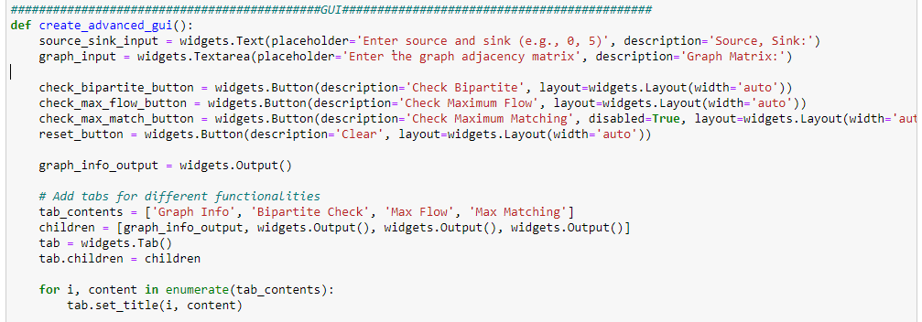

GUI DISPLAY
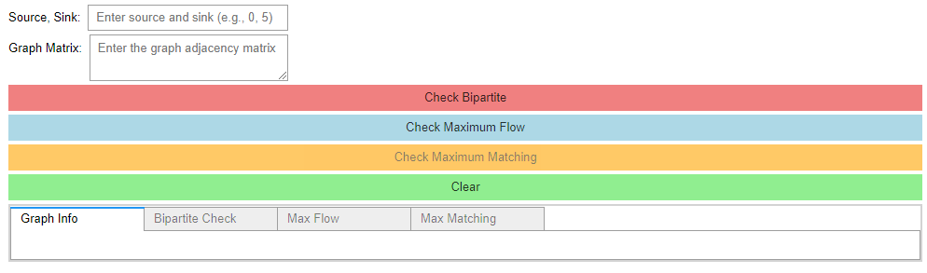

BIPARTITENESS CHECK
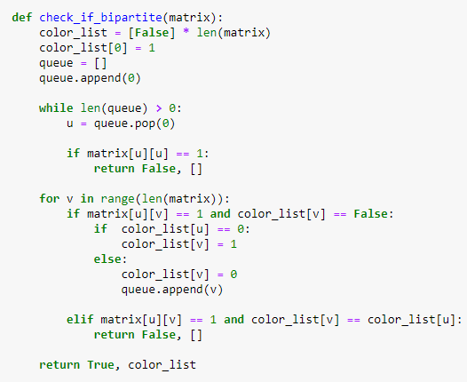
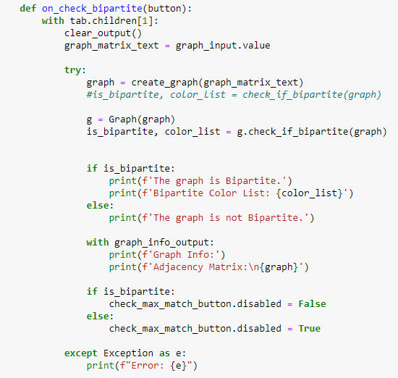

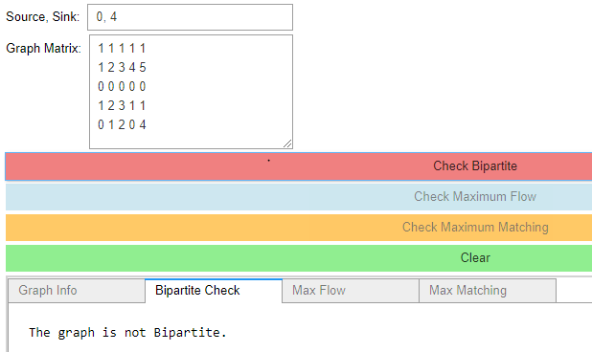
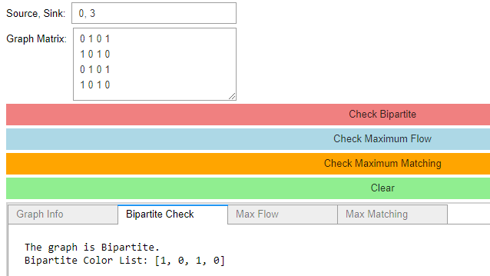
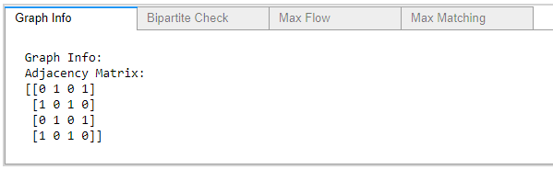
----------------------------------------------------------------------------------------------------------------------------------------

MAXIMISED FLOW BY EDMOND KARP ALGORITHM


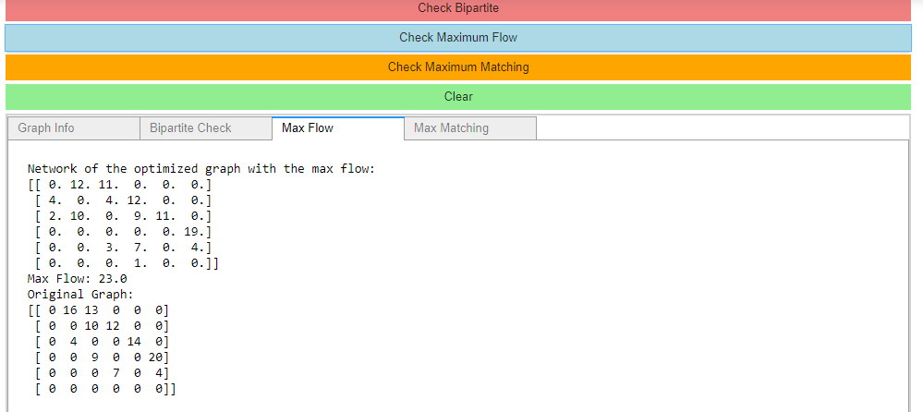

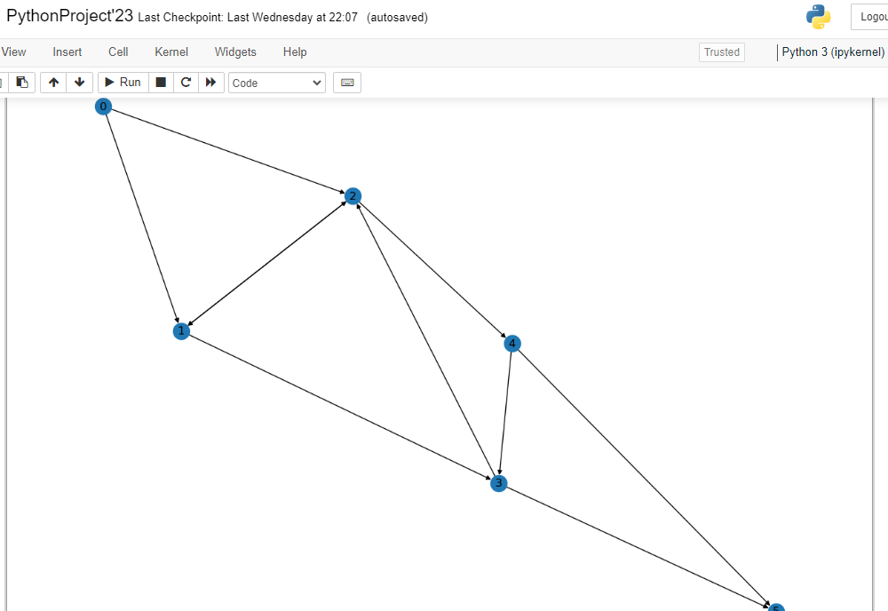

MAXIMUM BIPARTITE MATCHING ALGOROTHM
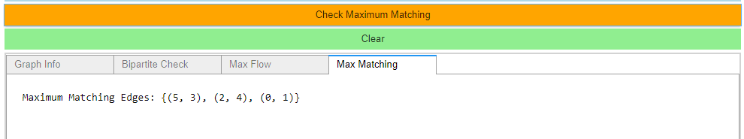
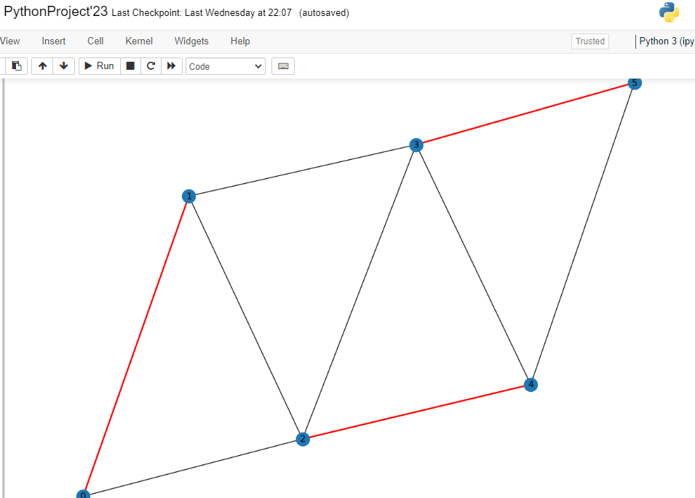

OBSERVATIONS AND RESULTS
Ford-Fulkerson is a general method for computing the maximum flow in a flow network, while the Edmonds-Karp algorithm is a specific implementation of the Ford-Fulkerson method that uses Breadth-First Search (BFS) to find augmenting paths.
Runtime Complexity:
Ford-Fulkerson: The runtime complexity is not guaranteed to be polynomial in the worst case because of its dependence on the choice of augmenting paths.
Edmonds-Karp: Guarantees a polynomial runtime of O(VE^2) due to its consistent choice of augmenting paths.
Guaranteed Termination:
Ford-Fulkerson: It may not terminate if improper augmenting paths are chosen, leading to the possibility of an infinite loop.
Edmonds-Karp: It always terminates because it chooses augmenting paths based on the shortest path criterion, ensuring convergence.

