Phase 7 — Exploratory Analysis
Vento Marketplace Intelligence Project — Portfolio Case Study
Source: ad-hoc SQL against sql/vento_marketplace.db. This is intuition-building, not the formal business-question analysis (that's Phase 8) — but three real, usable findings already came out of it.

1. Order volume & revenue: steady ramp, one clear spike, then a plateau
Vento went from a standing start in late 2016 to ~R$1.1M/month in delivered revenue by late 2017, and has held roughly steady through mid-2018. November 2017 stands out sharply — R$1,153,364 in revenue, the single highest month in the dataset, consistent with Black Friday seasonality. Growth essentially flattens after that; 2018 months oscillate between R$970K and R$1.13M rather than continuing to climb. That flattening is itself worth a management conversation, not just a chart.
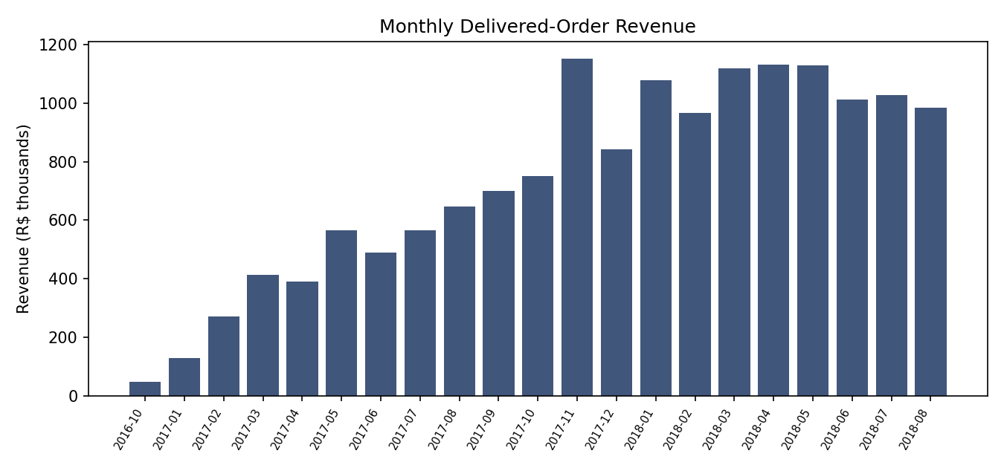

2. Category mix: Health & Beauty leads, but it's a competitive top tier
Category | Revenue
Health & Beauty | R$1,441,248
Watches & Gifts | R$1,305,542
Bed, Bath & Table | R$1,241,682
Sports & Leisure | R$1,156,656
Computers & Accessories | R$1,059,272

No single category dominates — the top 5 are within ~35% of each other. This matters for the dashboard design in Phase 9: a single “top category” headline number would be misleading; Vento's revenue is genuinely broad-based across categories.
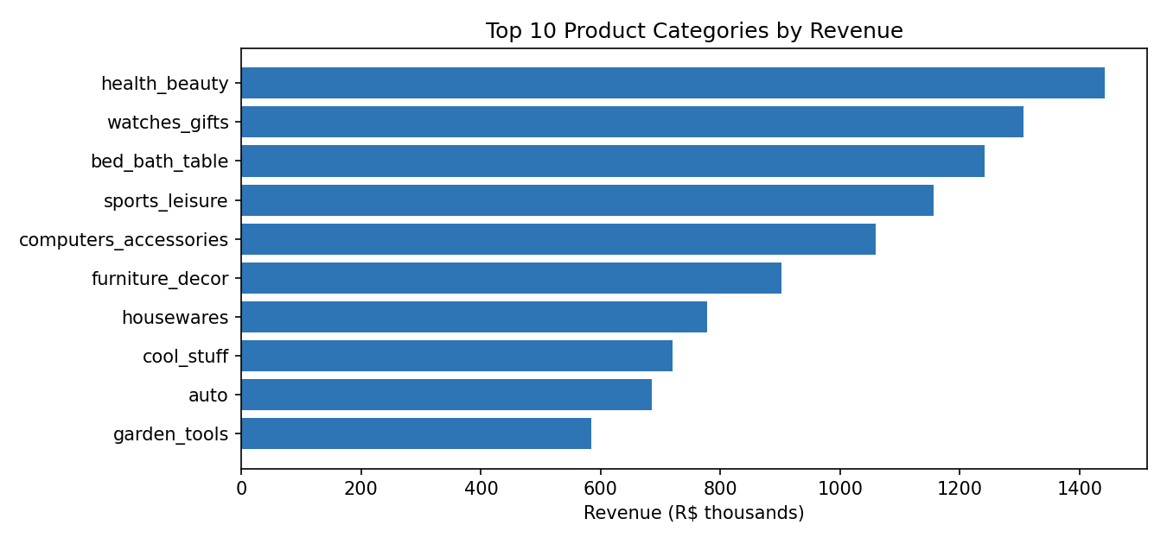

3. Payment behavior: credit card dominates, and installments are common
Payment type | Share of rows | Avg. installments | Total value
Credit card | 73.9% | 3.51 | R$12,542,084
Boleto (bank slip) | 19.0% | 1.00 | R$2,869,361
Voucher | 5.6% | 1.00 | R$379,437
Debit card | 1.5% | 1.00 | R$217,990

Credit card carries nearly 82% of total payment value and is the only method with meaningful installment usage (avg. 3.51 installments) — a real Brazilian consumer-credit pattern. Boleto (a Brazilian bank-slip payment method with no installment option) is the clear #2. This is directly relevant to the payment-risk angle from the original brief: any payment-method risk analysis in Phase 8 needs to control for installment count, since credit-card orders are structurally different from the other three methods.

4. Delivery time: median 10 days, but a long tail
Percentile | Days to deliver
10th | 4
25th | 6
50th (median) | 10
75th | 15
90th | 23
95th | 29
99th | 46
Max | 209

Half of all deliveries complete within 10 days, but the top 1% take 46+ days, with a maximum of 209 days. A single “average delivery time” KPI (12.1 days) understates how bad the worst outcomes are — the dashboard should show the distribution, not just the mean.

5. Review scores: bimodal, not a smooth curve
Score | Orders | Share
5 | 56,743 | 57.9%
4 | 18,961 | 19.4%
3 | 8,068 | 8.2%
2 | 3,103 | 3.2%
1 | 11,252 | 11.5%

Nearly 58% of reviews are 5-star, but 1-star is the second most common single score — more common than 2 or 3 stars combined. This is a classic satisfied-majority-with-a-vocal-angry-minority pattern, and it's exactly the segment the seller-risk and delivery-risk analysis in Phase 8 needs to explain.

6. Geographic concentration
São Paulo alone accounts for 40,501 of 96,478 delivered orders (42.0%) — more than the next five states combined (RJ, MG, RS, PR, SC = 37,518). Any “national” KPI on this dashboard is, in practice, heavily an SP number, which is worth stating explicitly on the executive page rather than leaving implicit.

What carries into Phase 8
The November 2017 spike and the 2018 plateau → a trend question, not just a topline number. Installment count as a required control variable for any payment-risk question. Delivery-time distribution (not just the mean) as the standard way to report on-time performance. The 1-star review spike as a specific segment to explain, tied to the seller late-delivery data from Phase 5.

Next: Phase 8 — Business Analysis
Formal SQL answers to the ~25 business questions across Executive, Operations, Finance, Customers, Product, and Risk/Data-quality categories, each following Business question → SQL logic → result → business interpretation.

